Writing about Weather
Write about the picture.
- On Sunday, it is sunny.
- _____________________________________________________________
- _____________________________________________________________
- _____________________________________________________________
- _____________________________________________________________
- _____________________________________________________________
- _____________________________________________________________
Write about the month and weather.
May stormy
- _____________________________________________________________

February snowy
- _____________________________________________________________

November chilly
- _____________________________________________________________

August sunny
- _____________________________________________________________

April rainy
- _____________________________________________________________

October windy
- _____________________________________________________________

Sunday
May 1st
Monday  May 2nd | 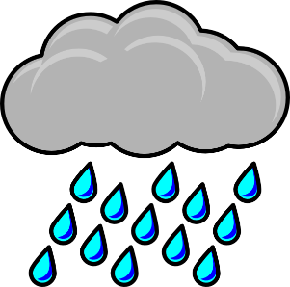
Tuesday  May 3rd | 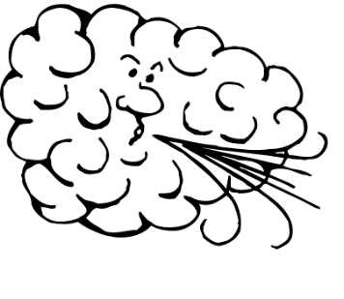
Wednesday  May 4th | 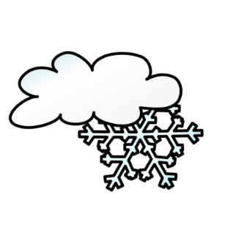
Thursday
May 5th
Friday
May 6th
Saturday
May 7th

