Product, Placement, Promotion, and Price
Product, placement, promotion, and price are four elements of the marketing mix crucial to determining a brand's unique selling proposition.

LEARNING OBJECTIVES
Show the characteristics of each of the four elements, or "Four Ps" that make up the "marketing mix.

KEY TAKEAWAYS

Key Points
- The term " product " is defined as anything, either tangible or intangible (such as a service ), offered by the firm; a solution to the needs and wants of the consumer; profitable or potentially profitable; and as meeting the requirements of the various governing offices or society.
- Placement, or product distribution, is the process of making a product or service accessible for use or consumption by a consumer or business user, using direct means, or using indirect means with intermediaries.
- The three basic objectives of promotion are to 1) present information to consumers and others, 2) to increase demand, and 3) to differentiate a branded product or service - through advertising, public relations, personal selling, direct marketing, and sales promotion.
- The price is the amount a customer pays for the product. A well chosen price should (a) ensure survival (b) increase profit (c) generate sales (d) gain market share, and (e) establish an appropriate image.
- Value is what a customer receives from a product.

Key Terms
- Placement: The process of making a product or service accessible for use or consumption by a consumer or business user, using direct means, or using indirect means with intermediaries.
- product: Anything, either tangible or intangible, offered by the firm as a solution to the needs and wants of the consumer; something that is profitable or potentially profitable; goods or a service that meets the requirements of the various governing offices or society.
- price: The cost required to gain possession of something.

Product, placement, promotion and price are the four elements of the marketing mix.

Product
The term "product" is defined as anything, either tangible or intangible, offered by the firm; as a solution to the needs and wants of the consumer; something that is profitable or potentially profitable; and a goods or service that meets the requirements of the various governing offices or society. The two most common ways that products can differentiated are:
- Consumer goods versus industrial goods, and
- Goods products (i.e. durables and non-durables) versus service products
Intangible products are service-based, such as the tourism industry, the hotel industry, and the financial industry. Tangible products are those that have an independent physical existence. Typical examples of mass-produced, tangible objects are automobiles and the disposable razor. A less obvious but ubiquitous mass produced service is a computer operating system.
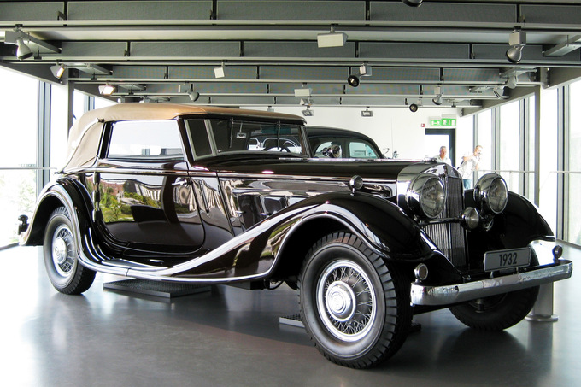
Tangible Luxury Good: A 1932 Horch 670 V12 is an example of a tangible product. Its price should reflect its image as a classic automotive collectible.
Every product is subject to a life-cycle that starts with its introduction and is followed by a growth phase, a maturity phase, and finally a period of decline as sales falls. Marketers must do careful research on the length of the product's life-cycle and focus their attention on different challenges that arise as the product moves through each stage.
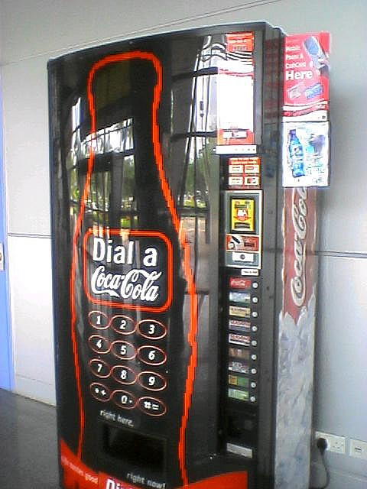
4Ps in Action: Coca Cola's marketing strategy includes elements of all four Ps.
The marketer must also consider the product mix, which includes factors such as product depth and breadth. Product depth refers to the number of sub-categories of products a company offers under its broad spectrum category. For example, Ford Motor Company's product category is automobiles. It's product depth includes sub-categories such as passenger vehicles, commercial vehicles, transport vehicles, et cetera. This broad spectrum category is also known as a product line. Product breadth, on the other hand, refers to the number of product lines a company offers.
Marketers should consider how to position the product, how to exploit the brand, how to exploit the company's resources, and how to configure the product mix so that each product complements the other. Failure to do so can result in brand dilution, which is a situation in which a product loses its branded identity, resulting in decreased sales and perceived quality. The marketer must also consider product development strategies.

Placement
Product distribution (or placement) is the process of making a product or service accessible for use or consumption by a consumer or business user, using direct means, or using indirect means with intermediaries.
Distribution Types
- Intensive distribution means the producer's products are stocked in the majority of outlets. This strategy is common for basic supplies, snack foods, magazines and soft drink beverages.
- Selective distribution means that the producer relies on a few intermediaries to carry their product. This strategy is commonly observed for more specialized goods that are carried through specialist dealers, for example, brands of craft tools, or large appliances.
- Exclusive distribution means that the producer selects only very few intermediaries. Exclusive distribution is often characterized by exclusive dealing where the re-seller carries only that producer's products to the exclusion of all others. This strategy is typical of luxury goods retailers such as Gucci.
The decision regarding how to distribute a product has, as its foundation, basic economic concepts, such as utility. Utility represents the advantage or fulfillment a customer receives from consuming a good or service. Understanding the utility a consumer expects to receive from a product being offered can lead marketers to the correct distribution strategy.

Promotion
The three basic objectives of promotion are:
- To present product information to targeted consumers and business customers.
- To increase demand among the target market.
- To differentiate a product and create a brand identity.
A marketer may use advertising, public relations, personal selling, direct marketing, and sales promotion to achieve these objectives. A promotional mix specifies how much attention to give each of the five subcategories, and how much money to budget for each. A promotional plan can have a wide range of objectives, including: sales increases, new product acceptance, creation of brand equity, positioning, competitive retaliations, or creation of a corporate image.

Price
The price is the amount a customer pays for the product. The concept of price is in contrast to the concept of value, which is the perceived utility a customer will receive from a product. Adjusting the price has a profound impact on the marketing strategy, and depending on the price elasticity of the product, often it will affect the demand and sales as well. The marketer should set a price that complements the other elements of the marketing mix. A well chosen price should (a) ensure survival (b) increase profit (c) generate sales (d) gain market share, and (e) establish an appropriate image.
From the marketer's point of view, an efficient price is a price that is very close to the maximum that customers are prepared to pay. In economic terms, it is a price that shifts most of the consumer surplus to the producer. A good pricing strategy would be the one which could balance between the price floor and the price ceiling and take into account the customer's perceived value. Common pricing strategies include cost-plus pricing, skimming, penetration pricing, value-based pricing, and many more.

https://www.coursehero.com/study-guides/boundless-marketing/introduction-to-marketing/

Curation and Revision. Provided by: Boundless.com. License: CC BY-SA: Attribution-ShareAlike

Guided Notes

Product, Placement, Promotion, and Price
Product, placement, ________________________________, and price are four elements of the marketing mix crucial to determining a brand's unique selling proposition.

LEARNING OBJECTIVES
Show the characteristics of each of the four elements, or "Four Ps" that make up the "marketing mix.

KEY TAKEAWAYS

Key Points
- The term " product " is defined as anything, either tangible or intangible (such as a service ), offered by the firm; a solution to the needs and wants of the consumer; profitable or potentially profitable; and as meeting the requirements of the various governing offices or society.
- Placement, or product distribution, is the process of making a product or service accessible for use or consumption by a consumer or business user, using direct means, or using indirect means with intermediaries.
- The three basic objectives of promotion are to 1) present information to consumers and others, 2) to increase demand, and 3) to differentiate a branded product or service - through advertising, public relations, personal selling, direct marketing, and sales promotion.
- The price is the amount a customer pays for the product. A well chosen price should (a) ensure survival (b) increase profit (c) generate sales (d) gain market share, and (e) establish an appropriate image.
- Value is what a customer receives from a product.

Key Terms
- Placement: The process of making a product or service accessible for use or consumption by a consumer or business user, using direct means, or using indirect means with intermediaries.
- product: Anything, either tangible or intangible, offered by the firm as a solution to the needs and wants of the consumer; something that is profitable or potentially profitable; goods or a service that meets the requirements of the various governing offices or society.
- price: The cost required to gain possession of something.

Product, placement, promotion and price are the four elements of the marketing mix.

Product
The term "product" is defined as anything, either ___________________ or intangible, offered by the firm; as a solution to the needs and wants of the ___________________; something that is profitable or potentially profitable; and a goods or service that meets the requirements of the various governing offices or society. The two most common ways that products can differentiated are:
- _________________________ goods versus industrial goods, and
- Goods products (i.e. durables and non-durables) versus service products
_________________________ products are service-based, such as the tourism industry, the hotel industry, and the financial industry. Tangible products are those that have an independent physical existence. Typical examples of mass-produced, tangible objects are automobiles and the disposable razor. A less obvious but ubiquitous ______________ produced service is a computer operating system.
Tangible Luxury Good: A 1932 Horch 670 V12 is an example of a tangible product. Its price should reflect its image as a classic automotive collectible.
Every product is subject to a _____________________ that starts with its introduction and is followed by a growth phase, a maturity phase, and finally a period of decline as sales falls. Marketers must do careful research on the length of the product's life-cycle and focus their attention on different challenges that arise as the product moves through each stage.
4Ps in Action: Coca Cola's marketing strategy includes elements of all four Ps.
The marketer must also consider the __________________________, which includes factors such as product depth and breadth. Product depth refers to the number of sub-categories of products a company offers under its broad spectrum category. For example, Ford Motor Company's product category is automobiles. It's product depth includes sub-categories such as passenger vehicles, commercial vehicles, transport vehicles, et cetera. This broad spectrum category is also known as a product ________________. Product breadth, on the other hand, refers to the number of product lines a company offers.
Marketers should consider how to _________________ the product, how to exploit the brand, how to exploit the company's resources, and how to configure the product mix so that each product complements the other. Failure to do so can result in brand dilution, which is a situation in which a product loses its branded identity, resulting in decreased sales and perceived quality. The marketer must also consider product development strategies.

Placement
Product distribution (or __________________) is the process of making a product or service accessible for use or consumption by a consumer or business user, using direct means, or using indirect means with intermediaries.
Distribution Types
  - _______________________ distribution means the producer's products are stocked in the majority of outlets. This strategy is common for basic supplies, snack foods, magazines and soft drink beverages.

2. Selective distribution means that the producer relies on a few intermediaries to carry their product. This _______________ is commonly observed for more specialized goods that are carried through specialist dealers, for example, brands of craft tools, or large appliances.
3. Exclusive distribution means that the producer selects only very few intermediaries. _______________________ distribution is often characterized by exclusive dealing where the re-seller carries only that producer's products to the exclusion of all others. This strategy is typical of luxury goods retailers such as Gucci.
The decision regarding how to distribute a product has, as its foundation, basic ____________________ concepts, such as utility. Utility represents the advantage or fulfillment a customer receives from consuming a good or service. Understanding the utility a consumer expects to receive from a product being offered can lead marketers to the correct distribution strategy.

Promotion
The three basic objectives of _______________________ are:
- To present product information to targeted consumers and business customers.
- To increase demand among the ____________________________________.
- To differentiate a product and create a brand ________________________.
A marketer may use advertising, _____________________________, personal selling, direct marketing, and sales promotion to achieve these objectives. A promotional mix specifies how much attention to give each of the five subcategories, and how much money to budget for each. A promotional plan can have a wide range of objectives, including: sales increases, new product acceptance, creation of ____________________ equity, positioning, competitive retaliations, or creation of a corporate image.

Price
The ________________ is the amount a customer pays for the product. The concept of price is in contrast to the concept of value, which is the perceived utility a ____________________ will receive from a product. Adjusting the price has a profound impact on the marketing strategy, and depending on the price elasticity of the product, often it will affect the demand and sales as well. The marketer should set a price that complements the other elements of the ______________________________. A well chosen price should (a) ensure survival (b) increase profit (c) generate sales (d) gain market share, and (e) establish an appropriate image.
From the marketer's ________________________, an efficient price is a price that is very close to the maximum that customers are prepared to pay. In economic terms, it is a price that shifts most of the consumer surplus to the producer. A good pricing strategy would be the one which could balance between the price floor and the price ceiling and take into account the customer's perceived value. ___________________ pricing strategies include cost-plus pricing, skimming, penetration pricing, value-based pricing, and many more.

https://www.coursehero.com/study-guides/boundless-marketing/introduction-to-marketing/

Curation and Revision. Provided by: Boundless.com. License: CC BY-SA: Attribution-ShareAlike

