Advertisement:

Waist Management: Helping to keep your world clean.

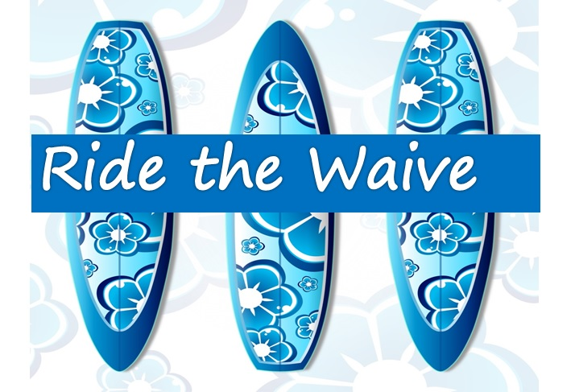Store Sign: