Hyperbolas KEY

Objectives
- Graph a hyperbola with center at $\left(0,0\right)$
- Identify conic sections by their equations

Graph a Hyperbola with Center at (0, 0)
The last conic section we will look at is called a hyperbola. We will see that the equation of a hyperbola looks similar to the equation of an ellipse, except it is a difference rather than a sum.

Hyperbola
A hyperbola is all points in a plane where the difference of their distances from two fixed points is constant. Each of the fixed points is called a focus of the hyperbola.
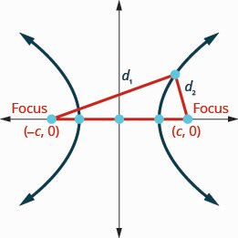
Definitions:
- The line through the foci is called the transverse axis.
- The two points where the transverse axis intersects the hyperbola are each a vertex of the hyperbola.
- The midpoint of the segment joining the foci is called the center of the hyperbola.
- The line perpendicular to the transverse axis that passes through the center is called the conjugate axis.
- Each piece of the graph is called a branch of the hyperbola.
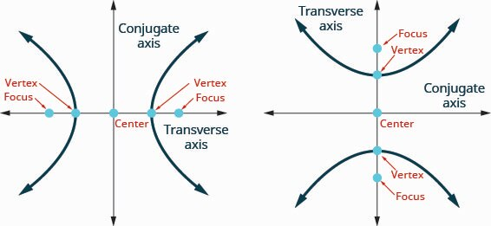

Standard Form of the Equation a Hyperbola with Center $\left(0,0\right)$
The standard form of the equation of a hyperbola with center $\left(0,0\right),$ is given two ways:
$$\frac{x^{2}}{a^{2}}-\frac{y^{2}}{b^{2}}=1 \text{or} \frac{y^{2}}{a^{2}}-\frac{x^{2}}{b^{2}}=1$$
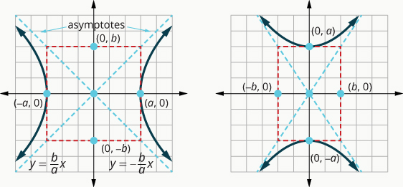
- A is the distance from the center to vertices along the transverse axis.
- B is the distance from the center to the points on the conjugate axis, used to determine how wide the hyperbola opens.
- C is the distance from the center to the foci.
- Pythagorean relationship: $c^{2}=a^{2}+b^{2}$.
- The transverse axis contains the vertices and foci and is determined by which term is positive.
Asymptotes
The asymptotes are intersecting straight lines that the branches of the graph approach but never intersect as the x, y values get larger and larger. The asymptotes are determined by the values of a and b.
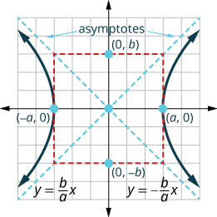
To find the asymptotes, we sketch a rectangle whose sides are based off the values of a and b. The lines containing the diagonals of this rectangle are the asymptotes of the hyperbola. The rectangle and asymptotes are not part of the hyperbola, but they help us sketch the graph.

- Graph the hyperbola.
$\frac{x^{2}}{25}-\frac{y^{2}}{4}=1$
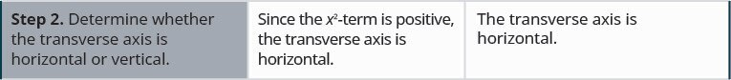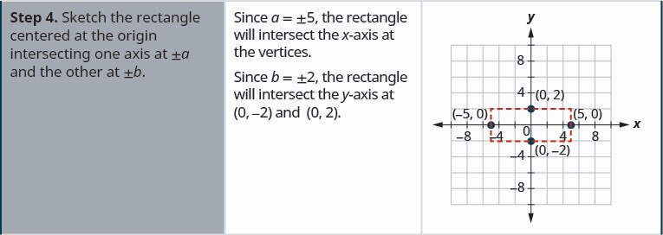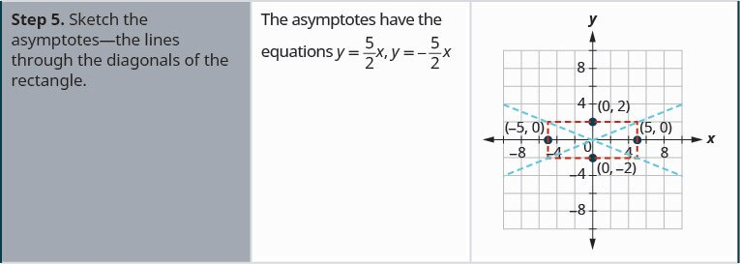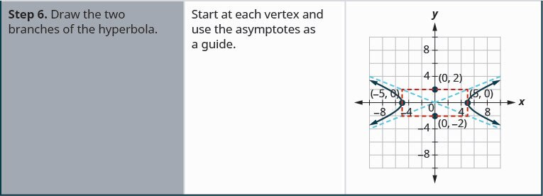

- Graph the hyperbola.
$4y^{2}-16x^{2}=64$
To write the equation in standard form, divide each term by 64 to make the equation equal to 1. | $$\frac{4y^{2}}{64}-\frac{16x^{2}}{64}=\frac{64}{64}$$
Simplify. | $$\frac{y^{2}}{16}-\frac{x^{2}}{4}=1$$
Since the y²-term is positive, the transverse axis is vertical. Since $a^{2}=16$ then $a=\text{±}4.$
The vertices are on the y-axis, $\left(0,\text{-}a\right),$ $\left(0,a\right).$Since $b^{2}=4$ then $b=\text{±}2.$ | The vertices are $\left(0,-4\right),$ $\left(0,4\right).$
The foci are on the y-axis, (0, -c), (0, c). Since $c^{2}=a^{2}+b^{2}$, we have that $c^{2}=4+16$=20. Therefore, $c=±2\sqrt{5}$. | The foci are $\left(0,-2\sqrt{5}\right), (0, 2\sqrt{5})$.
Sketch the rectangle intersecting the x-axis at $\left(-2,0\right),$ $\left(2,0\right)$ and the y-axis at the vertices.  Sketch the asymptotes through the diagonals of the rectangle. Draw the two branches of the hyperbola. | 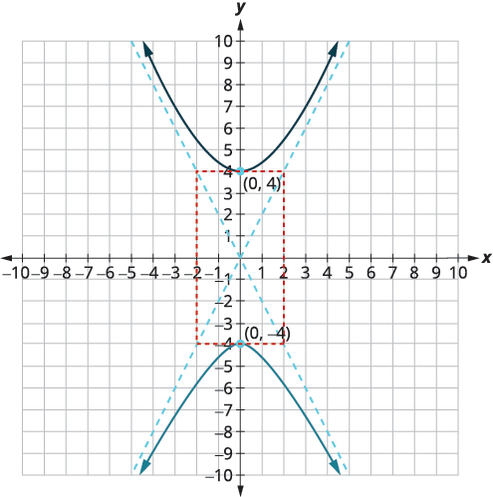
- Find an equation of a hyperbola centered at the origin with a vertex at (0,3) and a focus at (0,-6). Then sketch the graph.
The transverse axis is the y-axis, so the equation will be of the form $\frac{y^{2}}{a^{2}}-\frac{x^{2}}{b^{2}}=1$. From what is given, we have that $a=3$ and $c=6$. To find $b$, use the Pythagorean relationship. We know that $c^{2}=a^{2}+b^{2}$, meaning that $36-9=b^{2}$ and so $b^{2}=27 or b=±3\sqrt{3}$. Therefore, the equation is given by $\frac{y^{2}}{9}-\frac{x^{2}}{27}=1$.
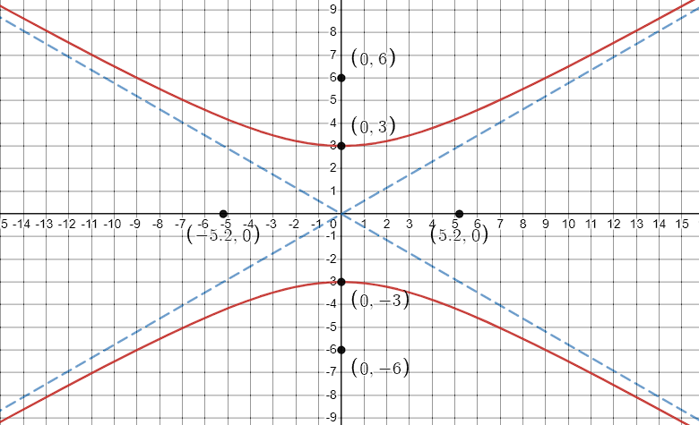

Identify Conic Sections by their Equations
To identify a conic from its equation, put the variable terms on one side of the equation and the constants on the other. It may be helpful to put the equations in standard form.
 |  | Example
Parabola | Either $x^{2}$ OR $y^{2}.$ Only one variable is squared. | $$x=3y^{2}-2y+1$$
Circle | $x^{2}\text{-}$ and $y^{2}\text{-}$ terms have the same coefficients | $$x^{2}+y^{2}=49$$
Ellipse | $x^{2}\text{-}$ and $y^{2}\text{-}$ terms have the same sign, different coefficients | $$4x^{2}+25y^{2}=100$$
Hyperbola | $x^{2}\text{-}$ and $y^{2}\text{-}$ terms have different signs, different coefficients | $$25y^{2}-4x^{2}=100$$

Identify the graph of each equation as a circle, parabola, ellipse, or hyperbola. Then put the equation in standard form
- $9x^{2}=72-36y^{2}$
 | $$9x^{2}+36y^{2}=72$$
The $x^{2}$- and $y^{2}$-terms have the same sign and different coefficients. | Ellipse
To put in standard form, divide everything by 72. | $$\frac{9x^{2}}{72}+\frac{36y^{2}}{72}=\frac{72}{72}$$
Simplify. | $$\frac{x^{2}}{8}+\frac{y^{2}}{2}=1$$
- $x^{2}+y^{2}-6x-8y=0$
 | $$x^{2}+y^{2}-6x-8y=0$$
The $x^{2}$- and $y^{2}$-terms have the same coefficients. | Circle
To put in standard form, complete the square.  $$x^{2}-6x+9+y^{2}-8y+16=0+9+16$$ | $${\left(x-3\right)}^{2}+{\left(y-4\right)}^{2}=25$$
- $y+4x=-2x^{2}-5$
 | $$y=-2x^{2}-4x-5$$
Only one variable, $x$, is squared. | Parabola
To put in standard form, complete the square.  $$y=-2\left(x^{2}+2x+1\right)-5+2$$  $$y=-2{\left(x+1\right)}^{2}-3$$ | $$-\frac{1}{2}\left(y+3\right)={\left(x+1\right)}^{2}$$
Adapted and summarized from OpenStax College Algebra 2e by the RSCC 1130 OER grant team 2022.

