Identify the following images and write down what you see
Time- 3 mins
Name: --------------------------------------------------------------

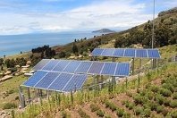 -------------------------------------------------------------------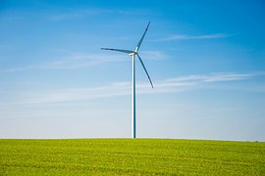---------------------------------------------------------------------
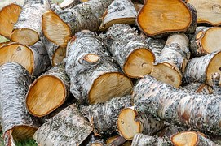---------------------------------------------------------------------
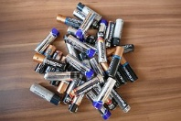-------------------------------------------------------------------
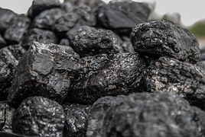------------------------------------------------------------------
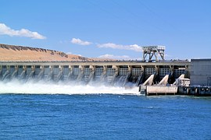-------------------------------------------------------------------
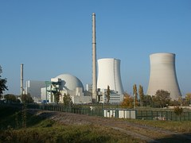----------------------------------------------------------------------

Answers:
- Solar Panels
- Wind Mill
- Firewood
- Cells
- Coal
- Dam (Hydro-electric power plant)
- Nuclear Power Plant

