Name:_______________________________

Ploidy Worksheet - Individual

Consider the cells represented below:

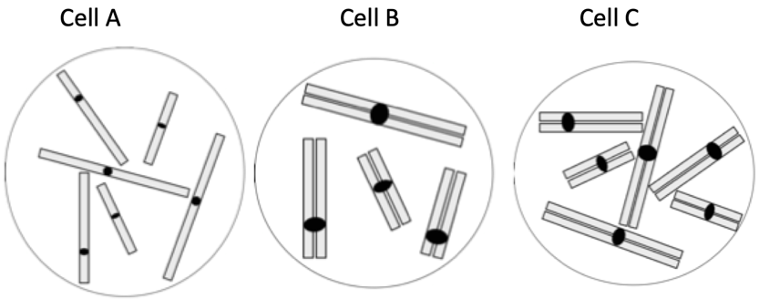

- Which cells are 1c?
- Which cells are 2c?
- Which cells are neither 1c nor 2c?
- Which cells are haploid (1n)?
- Which cells are diploid (2n)?
- Which cells are neither haploid nor diploid?
- How many chromosomes does cell A have?
- How many chromosomes does cell B have?
- Which cells are 2n=6?
- Which cells could begin mitosis right away (and what is your rationale)?
- Which cells could begin meiosis right away (and what is your rationale)?
- On the back of the sheet, draw a diagram of a cell that is 3n=6 before DNA replication.

