Meiosis Activity

Start with this card
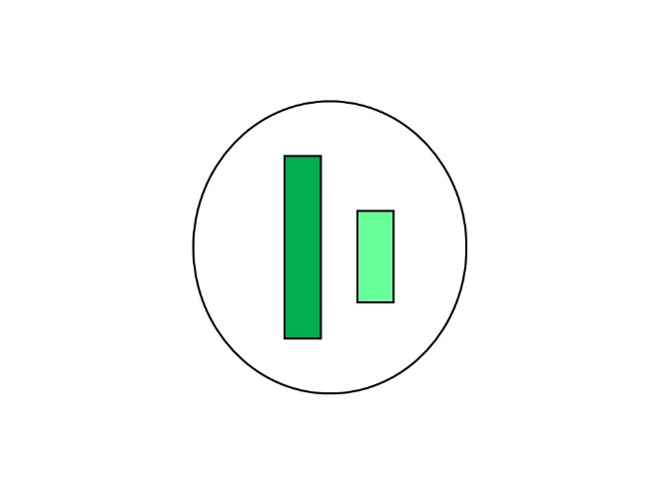

The long bar is the X chromosome the short one is the Y chromosome
Arrange the rest of the cards using chromosome duplications and cell divisions so that at the end of the process you will have 2 cells with an X chromosome and 2 cells with a Y chromosome. There is only one way to do this
When you are finished draw your diagram here. Label the following on your diagram
S phase
Meiosis 1
Meiosis 2
Homologues
Sister chromatids

