The Dog Park

A model of a dog park is shown.
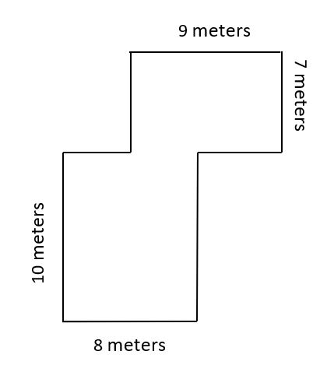
Find the area, in square meters, of the dog park.
Explain your answer using an equation or equations.
Enter your answer and your explanation using your equation or equations in the space provided.

The Dog Park II

A model of a dog park is shown.
4 meters
5 meters

If asked to find the area of this dog park, what about the structure of the problem is different?

What is the same about the structure of this problem?

If your equation for Dog Park I was:
( length * width ) + ( length * width)

How would you describe the calculation for Dog Park II using a number sentence?

How would you describe the equation for Dog Park II using words or symbols?

