IMPORTANT: Prior to applying an open license, you must determine the copyright holder for your image.
Only the copyright holder may license the resource.

SCENARIO ONE:
You have taken a photo or created an original graphic you would like to use.

A photo you took for a work-related event or created as per your job duties.
Indicate an open license by including an attribution statement. Examples below:
Graphic or picture with no people:
Use an “attribution only” open license or Creative Commons license of your choosing.
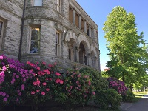
Old Capitol Building by Office of Superintendent of Public Instruction is licensed under a Creative Commons Attribution License
Shorter version: Photo by OSPI | CC BY
Picture that includes people:
Use an “attribution, non-commercial, no derivatives” open license:
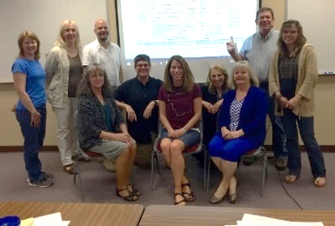
Rubric Development Team by Office of Superintendent of Public Instruction is licensed under a Creative Commons Attribution-NonCommercial-NoDerivatives License
Shorter version: Photo by OSPI | CC BY NC ND

A photo taken on your own time, not related to your job duties.
Indicate the Creative Commons open license of your choosing by including an attribution statement with the picture:
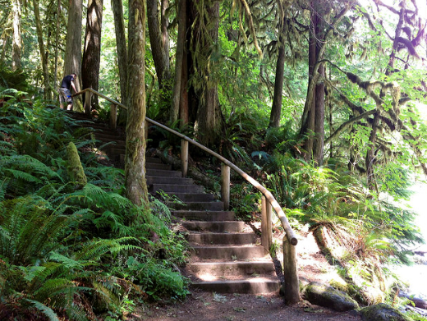
Steps by bsoots is licensed under a Creative Commons Attribution License
Shorter version: Photo by bsoots | CC BY
You could open your own Flickr account and upload the image selecting the Creative Commons license option
(CC BY preferred) to share with others.

SCENARIO TWO:
You found a perfect image on the Internet and would like to use it.

The image has an open license that allows your use or is in the public domain.
Use the image and make sure to display the license info and links.
Education Concept by Charly W. Karl is licensed under a Creative Commons Attribution NoDerivs License
Shorter version: Photo by Charly W. Karl | CC BY ND

The image does not have an open license that allows your use.
If there is no indication, anywhere on or near the picture, assume image is “all rights reserved” copyright alone and do not use.

SCENARIO THREE
You have access to an image that your school or district has purchased.
Make sure the license permits usage for your intended project.
Often licenses are specific for one project and may not be reused in other efforts!

Yes, usage for this purpose is permitted.
Include the attribution statement indicated in the license or if none is specified, use the following:
© CopyrightHolderName. Used with permission.

No, usage for this purpose is NOT permitted.
Use another image.

SCENARIO FOUR:
You need to find an openly licensed graphic.

Here are a few places to look:
American Education: Images of Teachers and Students in Action: contains original print-quality photos of real PreK–12 students and teachers all licensed CC BY NC (https://deeperlearning4all.org/images/)
CC Search – searches across multiple platforms for Creative Commons licensed images (https://ccsearch.creativecommons.org/)
Flickr – Under the License filter, select the All Creative Commons option to search for openly licensed images (https://www.flickr.com)
Google Images – filter for openly licensed work using Advanced Search and selecting Creative Commons Licenses under Usage Rights (https://images.google.com)
IF/THEN® Collection - digital library of women STEM innovators, for educational and other noncommercial use -registration and code required for download (http://www.ifthencollection.org/)
The Noun Project – icons for everything (https://thenounproject.com/)
OpenClipArt – vector graphics in the Public Domain (https://openclipart.org/)
Pexels - generates attribution clause for you (https://www.pexels.com/)
Photos for Class – generates attribution clause for you (http://www.photosforclass.com)
Pixabay – generates attribution clause for you (https://pixabay.com/)
Unsplash - generates attribution clause for you (https://unsplash.com/)
Attribution:
Once your open image has been selected and inserted into your project, be sure to give proper attribution and display the copyright holder’s name, a link to the image, and a link to the open license. Best Practices for Attribution | Creative Commons Wiki
NOTE: The contents of this document are not legal advice. Suggestions for license type are based on the Washington Office of Superintendent of Public Instruction (OSPI) open policy that states: … all original works of authorship produced by an OSPI employee within the scope of his or her employment for use in the state’s schools and programs will carry a Creative Commons Attribution License, version 4.0 or later…
Unless otherwise noted, this work by the Office of Superintendent of Public Instruction is licensed under a Creative Commons Attribution License. All logos and trademarks are property of their respective owners.
This resource contains links to websites operated by third parties. These links are provided for your convenience only and do not constitute or imply any endorsement or monitoring by OSPI.

