|  |  |  |  |  |
| --- | --- | --- | --- | --- |
| Inquiry Design Model (IDM) Blueprint™ | | | | |
| **Compelling Question** | What was the significance of the discovery of King Tut’s tomb? | | | |
| **Standards and Practices** | H2.6-8.1 Explain and analyze how individuals, movements, cultural and ethnic groups, and technology from past civilizations have shaped world history. | | | |
| **Staging the Question** | Complete a vocabulary lesson to understand key terms for this unit. | | | |
| **Supporting**  **Question 1** | | | **Supporting**  **Question 2** | **Supporting**  **Question 3** |
| How can artifacts help us understand a culture? | | | How were artifacts used in Ancient Egypt as part of burial practices? | What did the artifacts in King Tut’s tomb tell us about Ancient Egyptian culture? |
| **Formative**  **Performance Task** | | | **Formative**  **Performance Task** | **Formative**  **Performance Task** |
| Students will bring an artifact from home and explain how the artifact reflects their family/culture. | | | Create a one-pager about the contents of King Tut’s tomb | Use the RACE strategy to thoroughly answer the question. |
| **Featured Sources** | | | **Featured Sources** | **Featured Sources** |
| Source A:  “Amid a national decluttering frenzy, 5 families share the heirlooms they can’t part with”  .Source B:  Video: “2nd grade Cultural Artifacts”  Source C:  “Teacher’s Guide: Analyzing Primary Sources” | | | Source A:Video: Top Ten STUNNING Treasures Within Every Pharaonic Tomb Source B:  “Teacher’s Guide: Analyzing Primary Sources”  Source C : King Tut’s funerary mask  Source D: King Tut’s tomb  Source E: decorative boat | Source A:  Video: “The discovery of King Tut and what they’ve learned from his tomb” |
| Summative  Performance Task | **Argument** | What was the significance of the discovery of King Tut’s tomb? Construct an argument (e.g., detailed outline, poster, essay, etc.) that addresses the compelling question using specific claims and relevant evidence from historical sources while acknowledging competing views. | | |
| **Extension** | Create a Press Release (news video) announcing the discoveries King Tut’s tomb and the importance of this discovery to the world. | | |
| Taking Informed Action | UNDERSTAND: Explore the resources available at the Egyptian Museum.  ASSESS: Examine the advantages and disadvantages of discovering ancient discoveries.  ACT: Write a letter to your local school explaining the importance of learning about ancient civilizations and the impact this learning has in today’s world. | | | |

|  |
| --- |
| Overview |

This inquiry provides students with the opportunity to analyze artifacts from Ancient Egypt. Students will be asked to look at artifacts from their own family, analyze artifacts from King Tut’s tomb, and then evaluate the what we can learn from ancient artifacts. Finally, students will construct an argument and create a press release.

This inquiry is expected to take 5-10 class periods depending on the amount of time needed for additional instructional experiences. Teachers are encouraged to adapt this inquiry to meet the needs and interests of their students. Resources can also be modified as necessary to meet individualized education plans or 504 plans for students with disabilities.

|  |
| --- |
| Staging the Compelling Question |
| Compelling Question: What was the significance of the discovery of King Tut’s tomb? |

Have students complete the vocabulary lesson below to familiarize themselves with the necessary words to understand the lesson.

Vocabulary words used: tomb, pharaoh, artifacts, heirloom

Have students fold a piece of computer paper into fourths, then unfold. There will be a different word in each quarter of the paper. For each word, students will record a definition, synonyms, a sentence using the word correctly, and a symbol or picture to represent the word. See example below.

|  |  |
| --- | --- |
| Definition Synonyms  Word #1  Sentence Symbol/picture |  |
|  |  |

|  |  |
| --- | --- |
| Supporting Question 1 | |
| Supporting Question | How can artifacts help us understand a culture? |
| Formative Performance Task | Students will bring an artifact from home and explain how the artifact reflects their family/culture. |
| Featured Source | Source A: “Amid a national decluttering frenzy, 5 families share the heirlooms they can’t part with”  Source B: “2nd grade Cultural Artifacts”  Source C: “Teacher’s Guide: Analyzing Primary Sources” |

Students will bring an artifact from home, analyze it, and discuss the importance of this artifact and how it reflects his/her family’s culture.

To begin, the class will read Source A: “Amid a national decluttering frenzy, 5 families share the heirlooms they can’t part with”. As students read, have them circle the types of artifacts discussed in the article. In the margin, students will make a connection with that artifact. For example, they could make the connection that they also have a similar artifact, they know someone that has an artifact similar, or that made them think of an artifact that they have, etc. Discuss the students notes and the various items can be thought of as important family keepsakes/artifacts.

Watch Source B: “2nd grade Cultural Artifacts”. This will give them more ideas for family artifacts. Next, the teacher will share an artifact or two to give examples of items students can bring from home. Students will use the “Analyzing Primary Sources” guide from the Library of Congress to analyze the artifact and pose hypotheses about its significance. The teacher will then explain why he/she chose the artifact, what the artifact is, where it came from, and why it is important. Then, each student will bring an artifact/item from home and analyze it with the LOC guide. They will then explain to the class what it is, where it came from, how it might be perceived by other audiences, and why it is significant. Finally, the class will discuss how artifacts can be perceived differently by different audiences, the importance of analyzing who created artifacts and why, and brainstorm how artifacts can help us understand a culture and the past.

|  |
| --- |
| Supporting Question 1: Source A |

Source A: Excerpts from “Amid a national decluttering frenzy, 5 families share the heirlooms they can’t part with”, Jura Koncius. - This article discusses family heirlooms and their significance to various family members,

Complete article can be found at <https://www.washingtonpost.com/lifestyle/magazine/heirloom-intro-magazine/2019/09/12/8de3ee44-acbe-11e9-a0c9-6d2d7818f3da_story.html>

Excerpt 1:

***The small mahogany captain’s desk****in Bryant and Madeleine Mitchell’s Old Town Alexandria townhouse has lots of stories to tell. The 1870 English antique has been in Bryant Mitchell’s family for more than 100 years. He first remembers the piece, called a Davenport desk, at his grandfather’s house in his hometown of Hampton, Va.*

*“My grandfather Solomon Phillips was my best buddy. We were very close,” says Mitchell, 72, who has a commercial real estate firm in Alexandria. “This desk means a lot to me.”*

*Mitchell’s mother told him stories of when her three older sisters would receive gentlemen callers in the living room. All of a sudden, their father would come down to the desk to “pay bills.” “If Grandpa saw they were staying too late, he would come into the living room and act like he was writing at this desk,” Mitchell says. “The guys would get the hint and wrap up their visit.”*

*No one knows exactly when the tilt-front desk came into their family. The top lifts up, and there are individual slots for letters. It has unusual small drawers on the side that used to hold rolls of nickels, which were given out to Mitchell’s mother, her sisters and her brother for lunch money. (“Yes, school lunches cost 5 cents back then,” Mitchell says.) There are also stories that a family of mice had once lived in it and had chewed on a piece now missing from one of the tiny drawers.*

*Bryant and Madeleine inherited the desk in 2006 from his Aunt Agnes. She had insisted on giving it a bit of TLC before it passed to the next generation, so the inheritance included paying for it to be polished up and having loose parts reglued by Cavalier Antiques in Alexandria.*

*The desk was ready for its new home with the Mitchells and their daughter, Phillips. The family joked that “Bryant might do the same thing with this desk,” says Madeleine, a gallery director at Doris Leslie Blau, recalling Solomon Phillips’s “bill paying.” Of course he never did, and now Phillips, 28, lives in New York. The plan is that someday, she’ll start a new chapter in the history of the desk.*

© 1996-2020 The Washington Post

*Excerpt 2:*

*When Nathan Canestaro was growing up****,****he didn’t know much about his grandfather Herbert Todd’s service in the Navy in World War II.*

*“He never talked about the war,” says Canestaro, 45. “He put that phase of his life behind him. His war memorabilia was hidden in a box in the basement. When I asked him about it near the end of his life, he started crying. It broke my heart.”*

*Todd, a master carpenter in Cortland, N.Y., died in 2010 at age 89. That’s when Canestaro, a defense analyst for the federal government, started unraveling the story of Todd’s service in the Pacific. He had been a tail gunner on an Avenger torpedo bomber on the USS Cowpens, a light aircraft carrier nicknamed the Mighty Moo, from 1944 to 1945.*

*“I wanted to find out more,” says Canestaro, who lives in the District’s Shaw neighborhood with his wife, Sarah, and two young sons. “I’m interested in military history, and I didn’t want my grandfather’s things to just be another box of stuff. If you don’t pass these stories on, they get lost.”*

*The box eventually made its way to Canestaro. Included in it were two uniforms, a flak helmet, service ribbons and photos. The most intriguing find: a plastic bag full of colorful fabric maps and documents folded in tiny squares.*

*This year, he restored four of the cloths. One was a rayon “blood chit,” which aircrews were routinely issued containing a message in a local language that asks for help if stranded and offers rewards. (The term “blood chit” means that it was meant to save a life — that the U.S. government promised to pay for the life of the bearer.) The others were survival maps, navigational aids for downed aviators: two double-sided rayon maps of Pacific Ocean currents and a large silk map of Mindanao, Philippines.*

*Canestaro took the heavily creased and stained materials to conservator Julia Brennan of Washington’s*[*Caring for Textiles*](https://www.caringfortextiles.com/)*. Brennan gently cleaned the pieces and dried them on sheets of glass. Then the blood chit was mounted on an archival padded board; the maps were carefully stitched to silk organza borders for framing. The next step was taking them to Bill Butler of*[*Archival Art Services*](https://www.archivalartservices.com/)*in Alexandria. Butler put them in custom walnut frames using silk-wrapped mats and UV-filtering plexiglass. The two double-sided survival maps were placed in double-sided frames.*

*What would Todd have thought of his grandson putting so much effort into restoring, framing and displaying his war memorabilia?*

*“Honestly, I think Grandpa would have been appalled,” Canestaro says. “It was not in his nature to draw attention to himself. But I want to pass these things along to my kids, and I will only do it once.”*

*“When someone asks, ‘What is something worth to you?’ ’’ Canestaro says, “this is worth a lot.”*

© 1996-2020 The Washington Post

|  |
| --- |
| Supporting Question 1: Source B |

Source B: Video : “2nd grade Cultural Artifacts”

This YouTube video shows second grade students sharing a cultural artifact they brought from home.

<https://www.youtube.com/watch?v=mo4e-002LZ8> | Public Domain

["2nd grade Cultural Artifacts"](https://www.youtube.com/watch?v=mo4e-002LZ8) by [strobertchannell](https://www.youtube.com/user/strobertchannel/about" \t "_blank), is licensed under [CC BY 4.0](http://creativecommons.org/licenses/by/4.0)

|  |
| --- |
| Supporting Question 1: Source C |

Source C: “Teacher’s Guide: Analyzing Primary Sources” and “Primary Source Analysis Tool”

<http://www.loc.gov/teachers/usingprimarysources/resources/Analyzing_Primary_Sources.pdf>

Copyright information: ["Teacher’s Guilde: Analyzing Primary Sources"](https://nam02.safelinks.protection.outlook.com/?url=https%3A%2F%2Fwww.loc.gov%2Fteachers%2Fusingprimarysources%2Fresources%2FPrimary_Source_Analysis_Tool.pdf&data=02%7C01%7Cberickson%40warden.wednet.edu%7C0eb03900170748b0af0e08d81883042e%7Ca156563efe8d48b4b24a8c13d635b043%7C0%7C0%7C637286299156994427&sdata=jrt%2Fzyvdp3xl6Psl6Wk%2BdLWPkGthMDjQncBVvuXWCOg%3D&reserved=0) by [Library of Congress](https://nam02.safelinks.protection.outlook.com/?url=https%3A%2F%2Fwww.loc.gov%2F&data=02%7C01%7Cberickson%40warden.wednet.edu%7C0eb03900170748b0af0e08d81883042e%7Ca156563efe8d48b4b24a8c13d635b043%7C0%7C0%7C637286299156999404&sdata=2l6kEg9dx0YgaeUiBKJbT5katoa5wyKyjcEOWd6%2FlP4%3D&reserved=0) is in the [Public Domain, CC0](https://nam02.safelinks.protection.outlook.com/?url=http%3A%2F%2Fcreativecommons.org%2Fpublicdomain%2Fzero%2F1.0%2F&data=02%7C01%7Cberickson%40warden.wednet.edu%7C0eb03900170748b0af0e08d81883042e%7Ca156563efe8d48b4b24a8c13d635b043%7C0%7C0%7C637286299157004372&sdata=RYRO%2FArbZwCoAZ83Tnv8Pp4FkYYMbnpCRypMKFF86kk%3D&reserved=0)

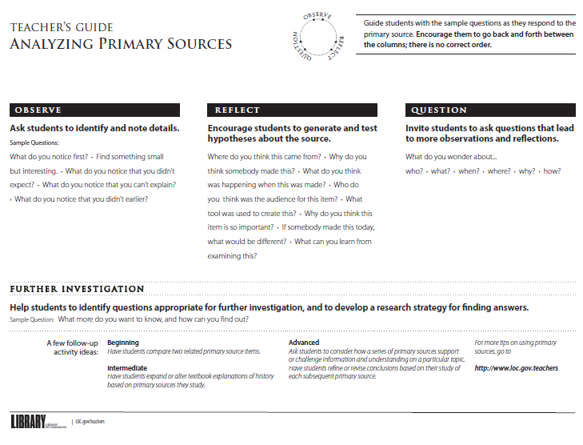



|  |  |
| --- | --- |
| Supporting Question 2 | |
| Supporting Question | How were artifacts used in Ancient Egypt as part of burial practices? |
| Formative Performance Task | Create a one-pager about the discovery of King Tut’s tomb. |
| Featured Sources | Source A: video “Top Ten STUNNING Treasures Within Every Pharaonic Tomb” Source B: Teacher’s Guide: Analyzing Primary Sources Source C: King Tut’s tomb  Source D: technicians working in King Tut’s burial chamber  Source E: decorative boat |

Have students watch the YouTube video: “Top Ten STUNNING Treasures Within Every Pharaonic Tomb”. Students will use a t-chart take notes on the various artifacts found in the tomb and what it was used for. The left side of the T-chart will be titled: artifact, while the right side of the t-chart will be labeled: Purpose of artifact. Watch the video multiple times if needed.

In small groups, give students one of the three images of artifacts provided. (You can add more images if you’d like.) Have the groups use Source B: “Teacher’s Guide: Analyzing Primary Sources”, to help them analyze the artifact you provided.

After groups have had an opportunity to examine their artifact, show its image on a document camera and have groups share their thoughts and findings.

Finally, have students work individually to create a one-pager about the contents of King Tut’s tomb. The one-pager must include a title, hand-drawn illustrations, color, your name, and facts that thoroughly answer the question: What types of artifacts were buried in pharaohs’ tombs in Ancient Egypt and what was their purpose?

|  |
| --- |
| Supporting Question 2: Source A |

Source: “Top Ten STUNNING Treasures Within Every Pharaonic Tomb”

This video show some of the treasures found in King Tut’s tomb and explains the significance of those items to the Ancient Egyptian Culture.

<https://www.youtube.com/watch?v=jlpj7ojKc8E> | Public Domain

["Top Ten STUNNING Treasures Within Every Pharaonic Tomb"](https://www.youtube.com/watch?v=jlpj7ojKc8E) by [The Story Tellers](https://www.youtube.com/channel/UCkz22sHAbFO2AlAfeED1YJw), is licensed under [CC BY 4.0](http://creativecommons.org/licenses/by/4.0)

|  |
| --- |
| Supporting Question 2: Source B |

Source B: “Teacher’s Guide: Analyzing Primary Sources”

<http://www.loc.gov/teachers/usingprimarysources/resources/Analyzing_Primary_Sources.pdf>

Copyright information: ["Teacher’s Guilde: Analyzing Primary Sources"](https://nam02.safelinks.protection.outlook.com/?url=https%3A%2F%2Fwww.loc.gov%2Fteachers%2Fusingprimarysources%2Fresources%2FPrimary_Source_Analysis_Tool.pdf&data=02%7C01%7Cberickson%40warden.wednet.edu%7C0eb03900170748b0af0e08d81883042e%7Ca156563efe8d48b4b24a8c13d635b043%7C0%7C0%7C637286299156994427&sdata=jrt%2Fzyvdp3xl6Psl6Wk%2BdLWPkGthMDjQncBVvuXWCOg%3D&reserved=0) by [Library of Congress](https://nam02.safelinks.protection.outlook.com/?url=https%3A%2F%2Fwww.loc.gov%2F&data=02%7C01%7Cberickson%40warden.wednet.edu%7C0eb03900170748b0af0e08d81883042e%7Ca156563efe8d48b4b24a8c13d635b043%7C0%7C0%7C637286299156999404&sdata=2l6kEg9dx0YgaeUiBKJbT5katoa5wyKyjcEOWd6%2FlP4%3D&reserved=0) is in the [Public Domain, CC0](https://nam02.safelinks.protection.outlook.com/?url=http%3A%2F%2Fcreativecommons.org%2Fpublicdomain%2Fzero%2F1.0%2F&data=02%7C01%7Cberickson%40warden.wednet.edu%7C0eb03900170748b0af0e08d81883042e%7Ca156563efe8d48b4b24a8c13d635b043%7C0%7C0%7C637286299157004372&sdata=RYRO%2FArbZwCoAZ83Tnv8Pp4FkYYMbnpCRypMKFF86kk%3D&reserved=0)



|  |
| --- |
| Supporting Question 2: Source C |

Source C: King Tut’s funerary mask

Can also be accessed through <https://www.nationalgeographic.com/culture/people/reference/tutankhamun/#/01-king-tut.jpg>

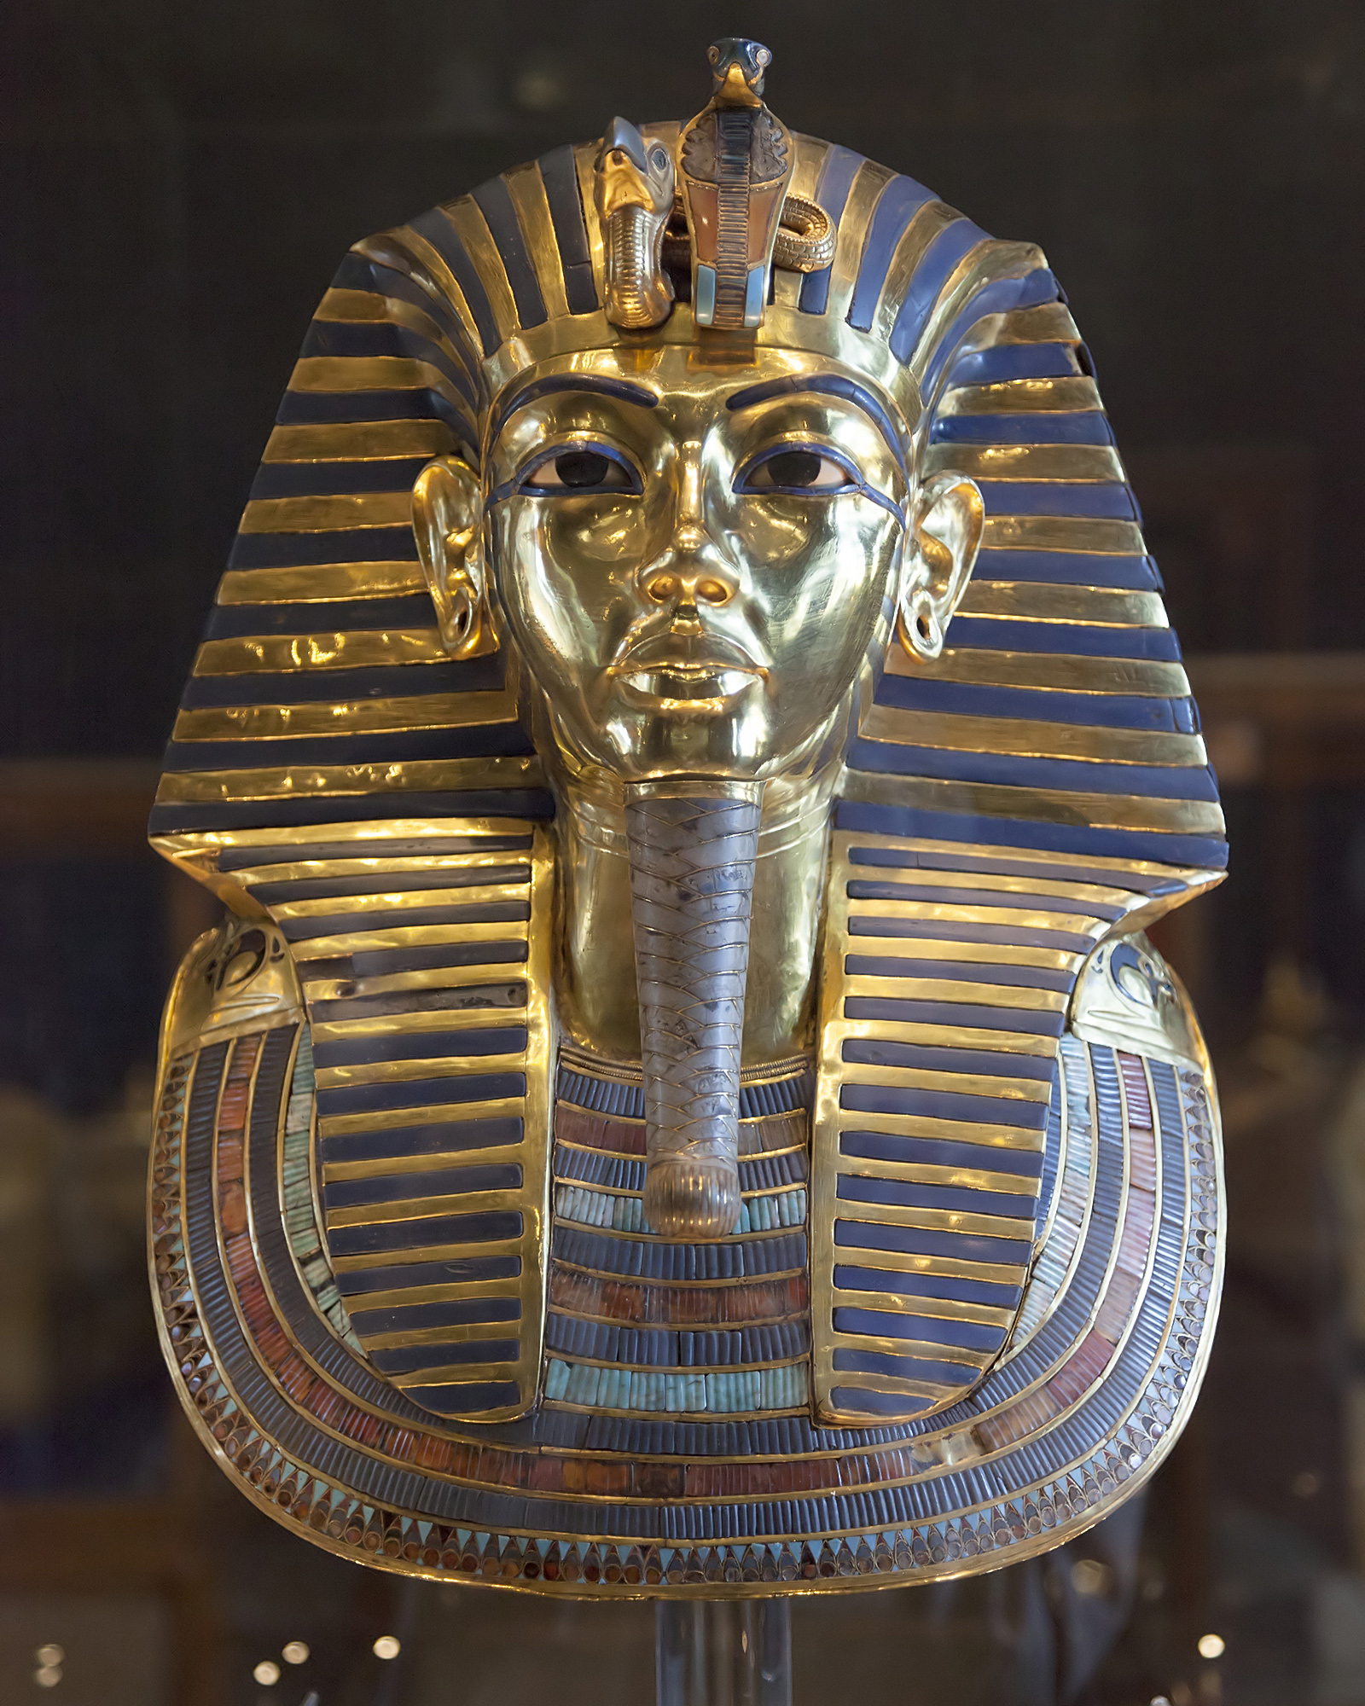

By Tarekheikal - Own work, CC BY-SA 4.0, https://commons.wikimedia.org/w/index.php?curid=80334409

|  |
| --- |
| Supporting Question 2: Source D |

Source D: King Tut’s tomb

This is a photo is a wall painting from the tomb of King Tut.

<https://www.smithsonianmag.com/smart-news/new-scans-show-there-might-be-hidden-room-king-tuts-tomb-180957248/>

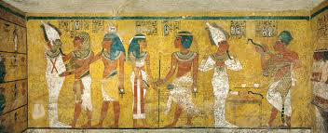

["Wall painting from the tomb of Tutankhamun"](https://www.smithsonianmag.com/smart-news/new-scans-show-there-might-be-hidden-room-king-tuts-tomb-180957248/) by Sandro Vannini/Corbis, [Smithsonian Magazine](http://smithsonianmag.com/) is licensed under [CC BY 4.0](http://creativecommons.org/licenses/by/4.0)

|  |
| --- |
| Supporting Question 2: Source E |

Source: Decorative boat

This image is of a decorative boat found in King Tut’s tomb.

<http://www.touregypt.net/museum/tutl4.htm>

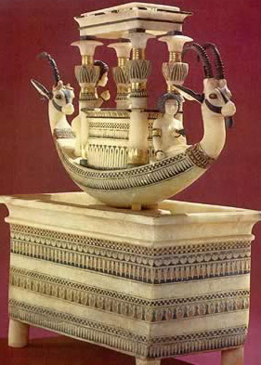

Copyright 1996-2020 Tour Egypt.

|  |  |
| --- | --- |
| Supporting Question 3 | |
| Supporting Question | What did the artifacts in King Tut’s tomb tell us about Ancient Egyptian culture? |
| Formative Performance Task | Use the RACE strategy to thoroughly answer the question. |
| Featured Source | Source A: “The discovery of King Tut and what they’ve learned from his tomb” |

Have students watch: “The discovery of King Tut and what they’ve learned from his tomb”. While watching this time, have students take notes on what archaeologists suggest the artifacts in the tomb tell us about King Tut and Ancient Egyptian culture. Have students use a T-chart. The title on the left of the T-chart should be labeled “artifact”, while the left column will be labeled “significance”.

After taking notes, students will use the RACE strategy to answer the supporting question: What did the artifacts in King Tut’s tomb tell us about Ancient Egyptian culture?

* R: Restate the question
* A: Answer the question in your own words
* C: Cite evidence to support your answer
* E: Explain your answer (connect your answer to the evidence)

|  |  |
| --- | --- |
| Supporting Question 3 – Source A | |
| Supporting Question | What did the artifacts in King Tut’s tomb tell us about Ancient Egyptian culture? |
| Formative Performance Task | Use the RACE strategy to thoroughly answer the question. |
| Featured Source | Source A: “The discovery of King Tut and what we’ve learned from his tomb” |

Source A: Video: The discovery of King Tut and what we’ve learned from his tomb”

This video shows images from King Tut’s tomb and explains what they’ve learned from studying it. This video is about King Tut and what we know about King Tub because of the discoveries in his tomb.

<https://thekidshouldseethis.com/post/the-discovery-of-king-tut-and-what-weve-learned-from-his-tomb>

Copyright: ©2011-2020 The Kid Should See This™, TKSST™, TKSST Gift Guide™

|  |  |
| --- | --- |
| Summative Performance Task | |
| Compelling Question | What was the significance of the discovery of King Tut’s tomb? |
| Argument | Construct an argument essay explaining the significance of King Tut’s tomb. |
| Extension | Create a Press Release (news video) announcing the discovery of King Tut’s tomb to the world. |
| Sources | Source A: Press Release presentation rubric |

Argument: Have students write an argument essay explaining the significance of King Tut’s tomb. A possible resource to score the essay would be the SBAC argument writing rubric.

<https://www.k12.wa.us/sites/default/files/public/ela/assessment/pubdocs/c2_t7_ela_full_write_rubric_argumentative.pdf>

Extension: Students will work in small groups (3-4 students) to put together a Press Release of the opening of King Tut’s tomb. Students will have to choose a role to play in the Press Release. Some examples are: news reporter, scientist, archaeologist, etc. In their presentation, they will be responsible for presenting the important facts about the discovery of the tomb and the contents of the tomb. They will need to answer questions such as: Who discovered King Tut’s tomb? What did they find in the tomb? When was the tomb found? Where was the tomb located? How was the tomb discovered? Why was the tomb not discovered before? Why was the discovery of this tomb important? Along with answering questions, students will create a backdrop to show where they are presenting from. For example, they could make a background that looks like they are in Egypt, a news studio, or a museum, etc. Students will also need to create at least two props to show during their presentation. Most likely, these props will be items they create to represent items found in the tomb. There is a 2 minute minimum for the presentation. See presentation rubric below.

|  |
| --- |
| Summative Performance Task: Source A |

Source B: Press Release presentation rubric <https://my.pblworks.org/system/files/documents/PBLWorks-6-8-Presentation-Rubric-CCSS.pdf>

Copyright: pblworks.org. © 2019 Buck Institute for Education

# PRESENTATION RUBRIC for PBL: for grades 6-8; Common Core ELA aligned

|  |  |  |  |  |
| --- | --- | --- | --- | --- |
|  | Below Standard | Approaching Standard | At Standard | Above  Standard  ✔ |
| Explanation of Ideas & Information | • uses too few, inappropriate, or irrelevant descriptions, facts, details, or examples to support ideas | • uses some descriptions, facts, details, and examples that support ideas, but there may not be enough, or some are irrelevant | • uses relevant, well-chosen descriptions, facts, details, and examples to support claims, findings, arguments, or an answer to a Driving Question (CC 6-8.SL.4) |  |
| Organization | * does not include important parts required in the presentation * does not have a main idea or presents ideas in an order that does not make sense * does not have an introduction and/or conclusion * uses time poorly; the whole   presentation, or a part of it, is too short or too long | * includes almost everything required in the presentation * moves from one idea to the next, but main idea may not be clear or some ideas may be in the wrong order * has an introduction and conclusion, but they are not effective * generally times presentation well, but may spend too much or too little time on a topic, a/v aid, or idea | * includes everything required in the presentation * states main idea and moves from one idea to the next in a logical order, emphasizing main points in a focused, coherent manner   (CC 6-8.SL.4)   * has an effective introduction and conclusion * organizes time well; no part of the presentation is rushed, too short or too long |  |
| Eyes & Body | * does not look at audience; reads notes or slides * does not use gestures or movements • lacks poise and confidence (fidgets, slouches, appears nervous) * wears clothing inappropriate for the occasion | * makes infrequent eye contact; reads notes or slides most of the time * uses a few gestures or movements but they do not look natural * shows some poise and confidence (only a little fidgeting or nervous movement) • makes some attempt to wear clothing appropriate for the occasion | • keeps eye contact with audience most of the time; only glances at notes or slides  (CC 6-8.SL.4)   * uses natural gestures and movements * looks poised and confident * wears clothing appropriate for the occasion |  |
| Voice | * mumbles or speaks too quickly or slowly * speaks too softly to be understood * frequently uses “filler” words (“uh, um, so, and, like, etc.”) * does not speak appropriately for the context and task (may be too informal, use slang) | * speaks clearly most of the time; sometimes too quickly or slowly * speaks loudly enough for most of the   audience to hear, but may speak in a monotone   * occasionally uses filler words * tries to speak appropriately for the context and task | • speaks clearly; not too quickly or slowly  (CC 6-8.SL.4)   * speaks loudly enough for everyone to hear; changes tone to maintain interest (CC 6-8.   SL.4)   * rarely uses filler words * speaks appropriately for the context and task, demonstrating command of formal English when appropriate (CC 6-8.SL.6) |  |

|  |  |  |  |  |
| --- | --- | --- | --- | --- |
|  | Below Standard | Approaching Standard | At Standard | Above  Standard  ✔ |
| Presentation Aids | • does not use audio/visual aids or media • attempts to use one or a few audio/ visual aids or media but they distract from or do not add to the presentation | • uses audio/visual aids or media, but they sometimes distract from or do not add to the presentation | • uses well-produced audio/visual aids or media to clarify information, emphasize important points, strengthen arguments, and add interest (CC 6-8.SL.5) |  |
| Response to Audience  Questions | • does not address audience questions (goes off topic or misunderstands without seeking clarification) | • answers some audience questions, but not always clearly or completely | * answers audience questions clearly and completely * seeks clarification, admits “I don’t know,” or explains how the answer might be found when unable to answer a question |  |
|  |  |  |  |  |
| Participation in Team Presentations | • Not all team members participate; only one or two speak | • All team members participate, but not equally | * All team members participate for about the same length of time * All team members are able to answer questions about the topic as a whole, not just their part of it |  |

**pblworks.org**