Uploading resources on Nordic University Health Hub

How to upload resources on the hub:

MANY RESOURCES FOR UPLOAD AT ONCE: If you have more than 5 resources, and your resources are already uploaded on an online platform (could be on YouTube or on a MOOC platform), we recommend upload using the metadata sheet (bulk upload method).
You can download the metadata sheet here, fill it out and send it to the project coordinator at University of Copenhagen. (maria.minard@sund.ku.dk)
If there are any questions concerning how to fill in the metadata, feel free to contact the project coordinator in order to assist you.

RESOURCES FOR UPLOAD one by one:
A simple way to upload resources is to upload them one by one, this can be done at any time, as long as you are registered as a user on NUHH. This is a good method to let people upload resources along the way, as you have new content that you want to share on the hub.

- When logged in, click “Groups” in the top menu and then choose the group of your university.
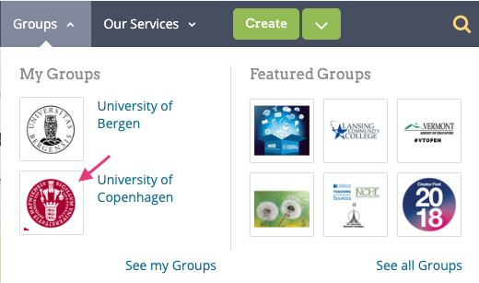

- Press “contribute to this group”. Now consider:
  - If you want to add to an URL, like a video on Youtube or other video platforms, choose “Submit from Web”. (page 2)
  - If you want to upload a file, choose “Open Author”. (page 3)

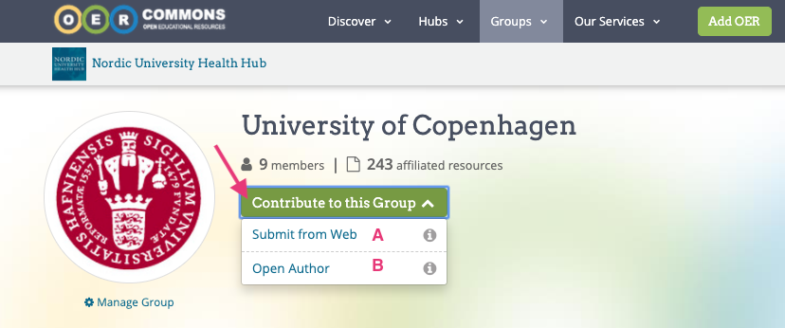
A) Submit from web
(the following example below corresponds to this video presented on Nordic University Health Hub: https://www.oercommons.org/courses/an-introduction-to-global-health-infectious-diarrheal-diseases-12-51-2?__hub_id=57)
Paste in URL and describe the resource, write name of author(s).

Step 1
Paste in the URL link. Click “Continue”.
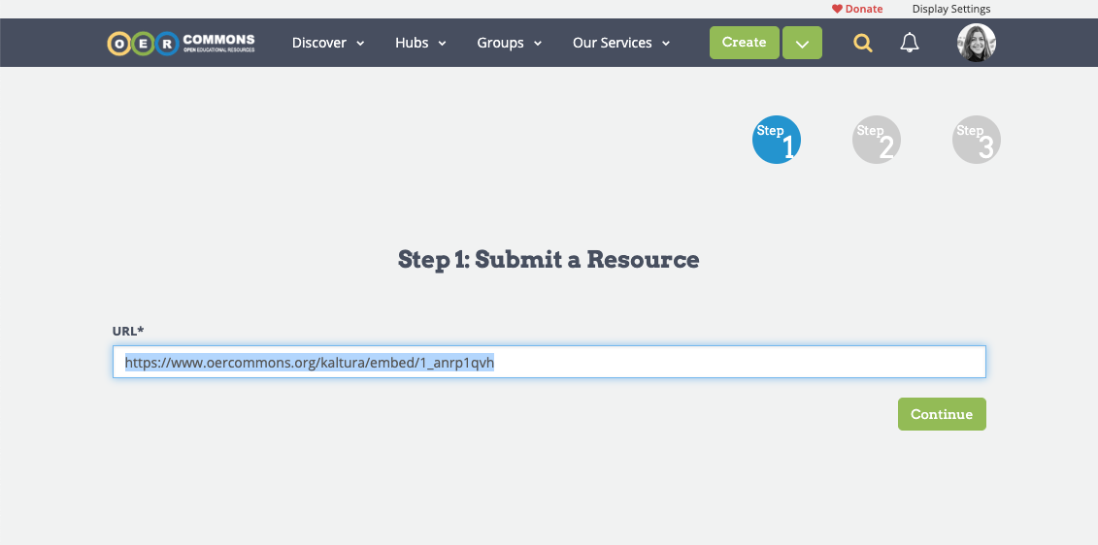

Step 2 – Describe the resource.
Only the fields marked with * are mandatory.
However, it is recommend filling out as many fields as possible.
After filling out all metadata and keywords, click “Continue”.
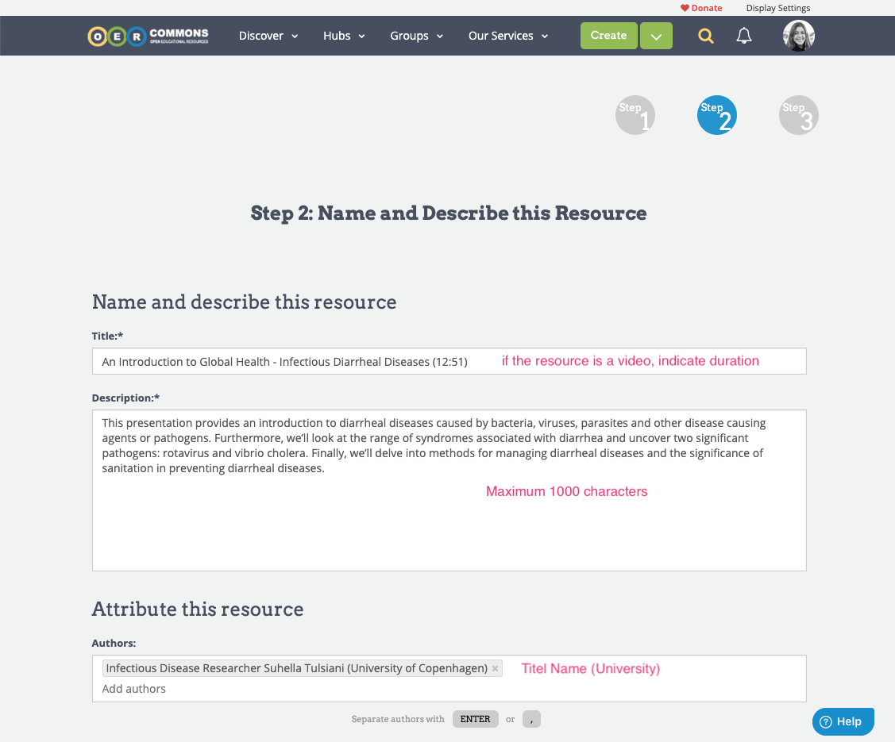

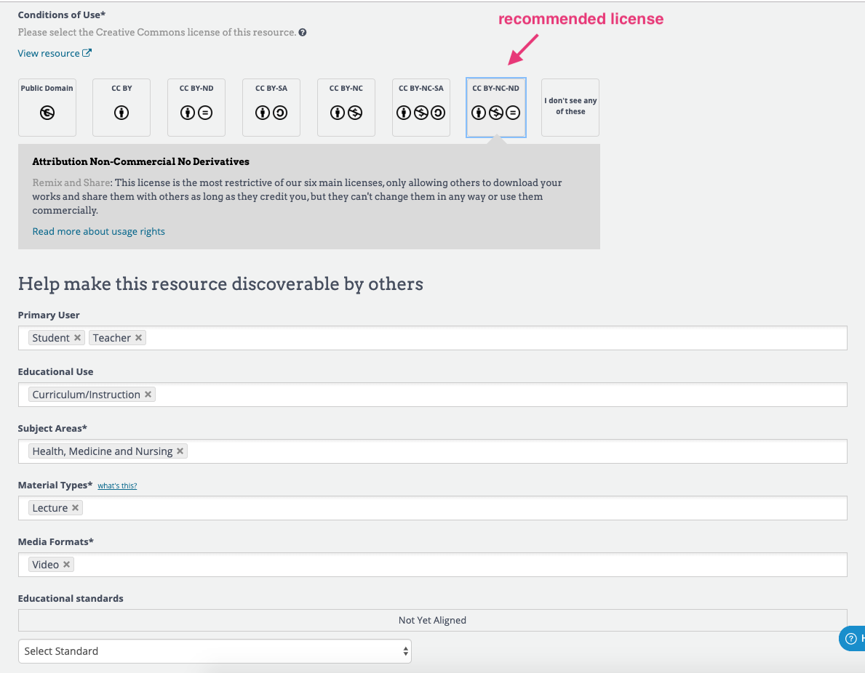

You MUST write one or more NORDIC tags/keywords from the table in the end of this document, page 9, as those tags/keywords will place your resource in the right collection on the website.

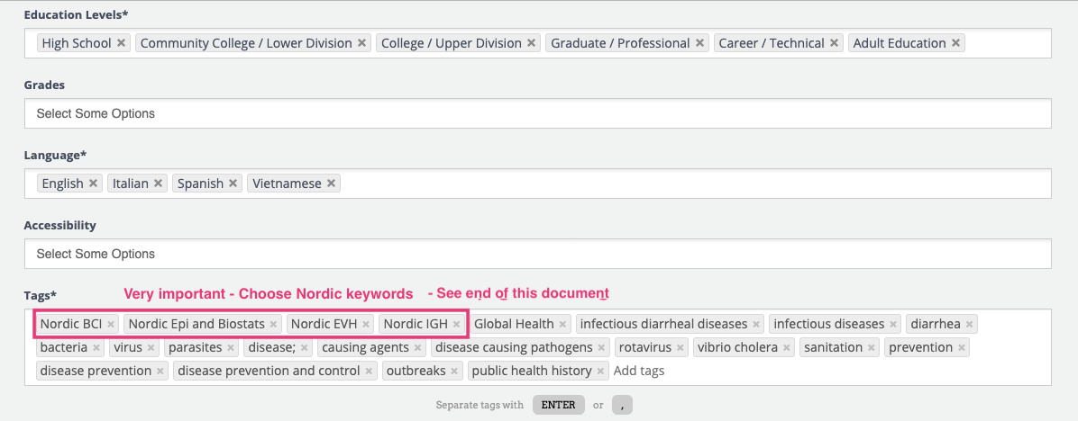

Step 3:
Replace the default cover image with a screen dump from your resource and click “Submit for review”
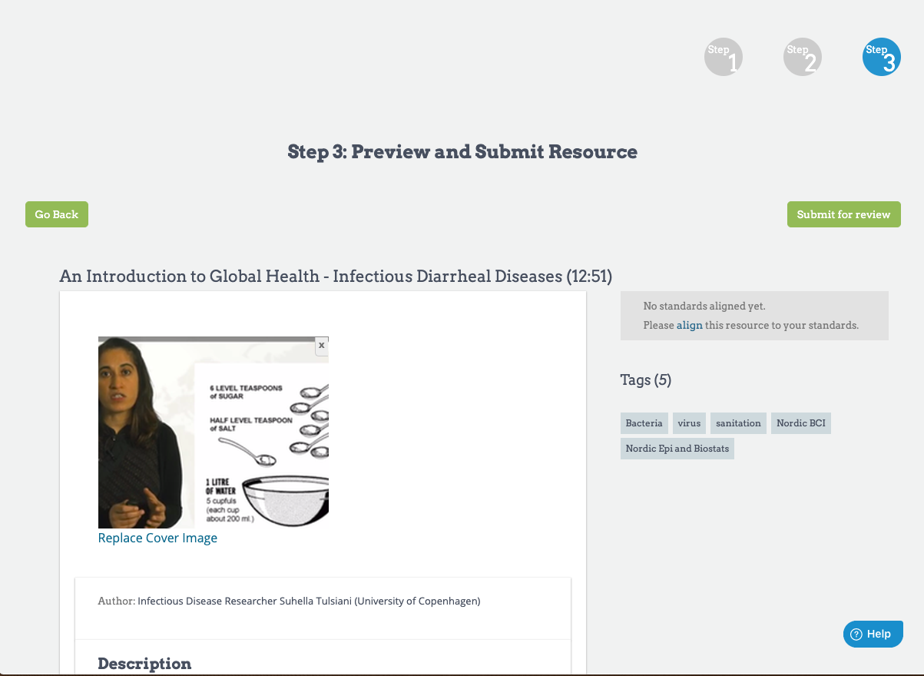

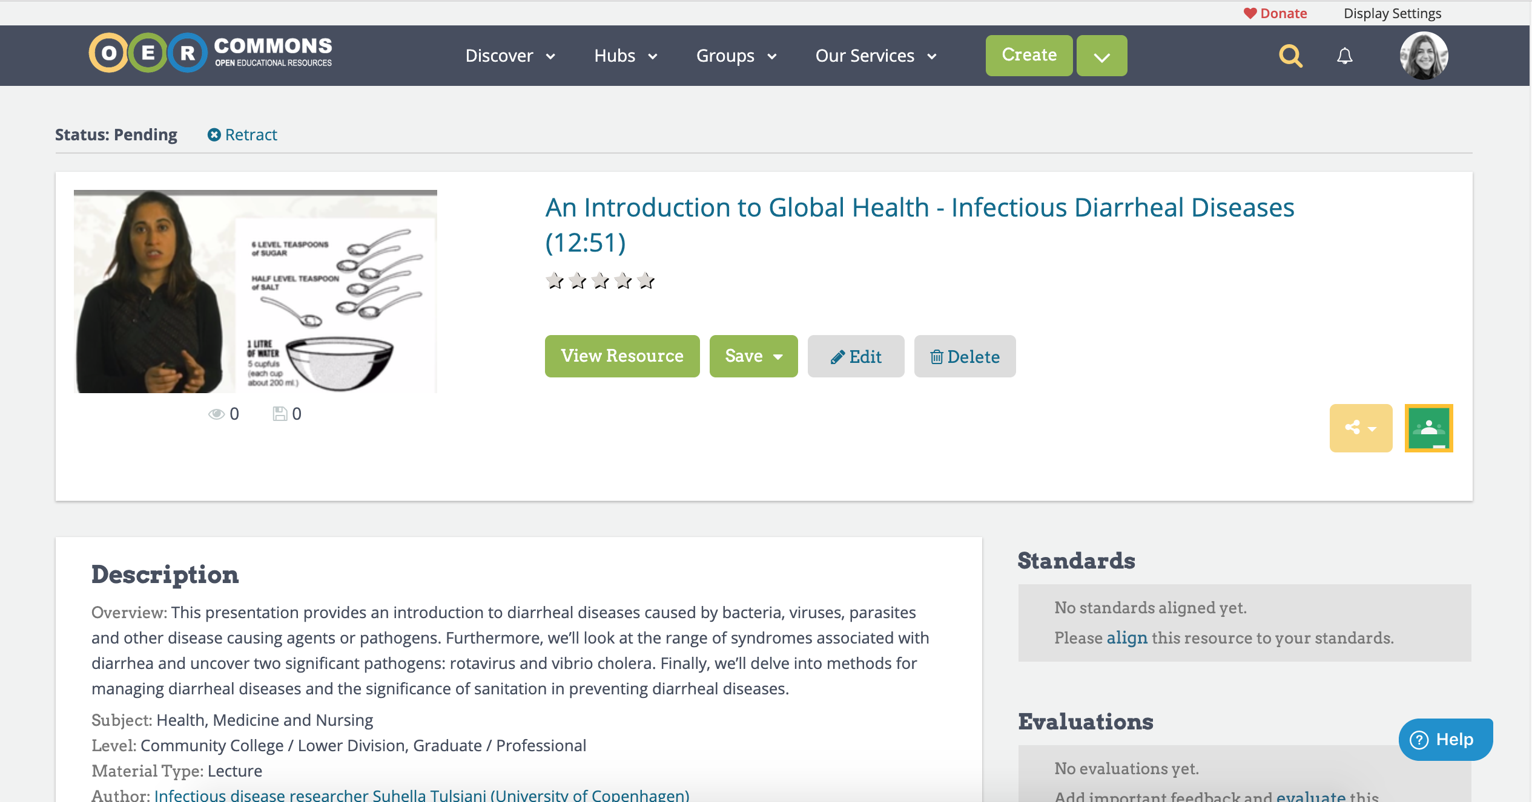
Your resource will now have the status “Pending” up to 24 hours, until the resource will be showing as published and thus public on the website.
I you wish to not publish right now, click “Retract”.
If you wish to edit the resource, click “edit”

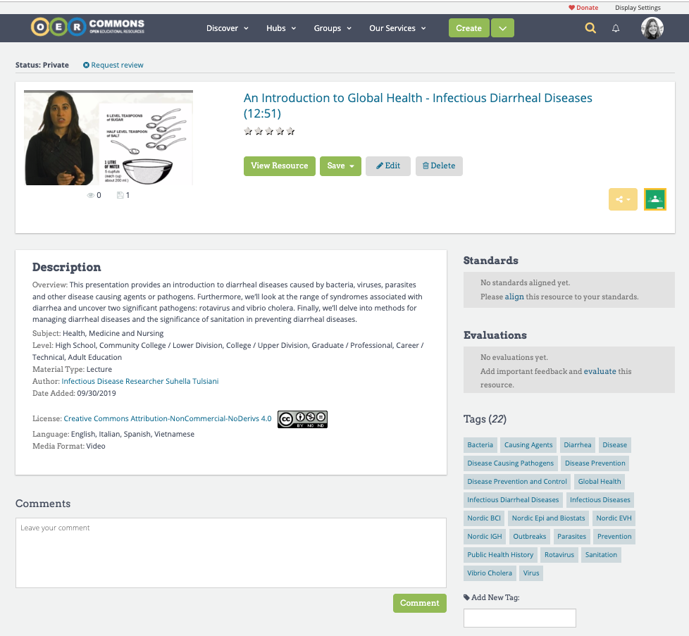
After editing the resource, be sure to click “Request review” in order to get the resource published again.

B) Open Author
Open Author is primary for uploading files or if you want to link content together, like a video with PDFs for example. Upload your media file, that could be a dataset, a PDF, sound or video file.
An example of how a resource can look like, when combining files using the Resource builder:
https://www.oercommons.org/courseware/module/57738/overview:

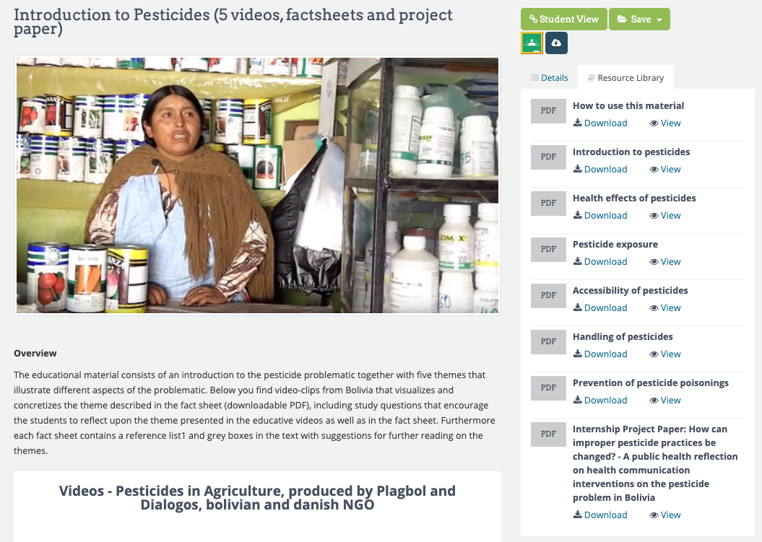

When uploading video files, the size limit is 750MB. (If your video file is larger than 750 MB, you should upload the video to a video platform and use the “A.Submit for Web” solution).

To upload a resource:
1. Go to your university group, choose Open Author (B)

2. Enter title, upload a title image, enter a section name (you can have one or many sections) and a description of the content in the section.
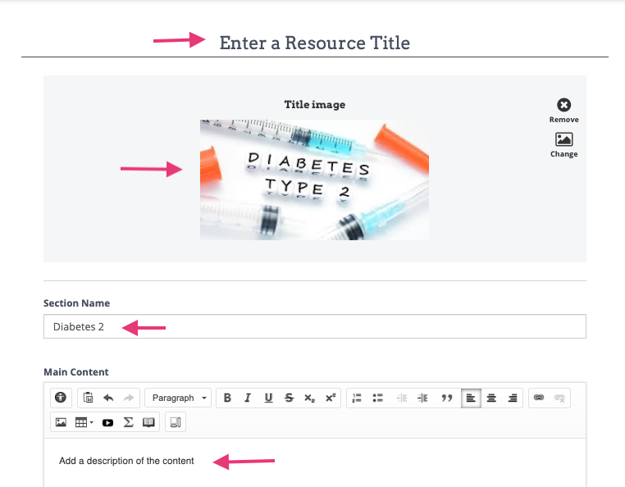

Now you can attach files to the section, like PDF's, images, Powerpoints - files will be downloadable. Chhose a file and click save. You can add many files.

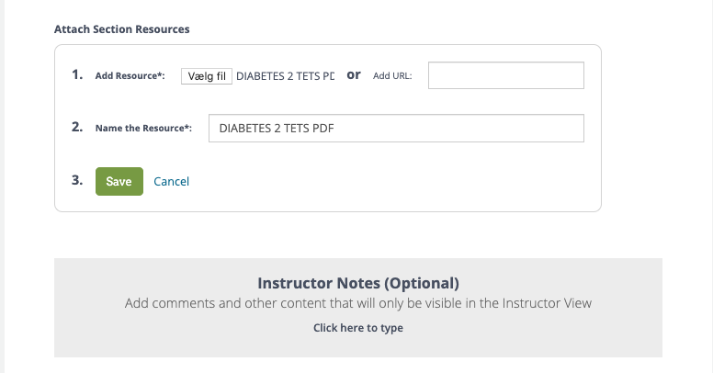
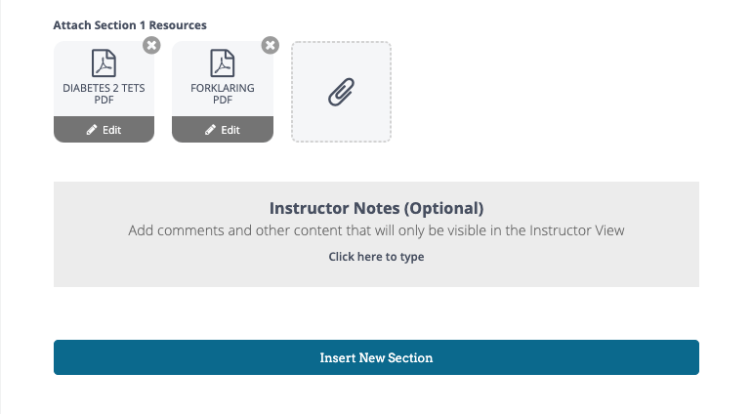
You can also insert more sections and build. When you are finished adding content and files, go to the upper right corner on the site, and click "Publish".

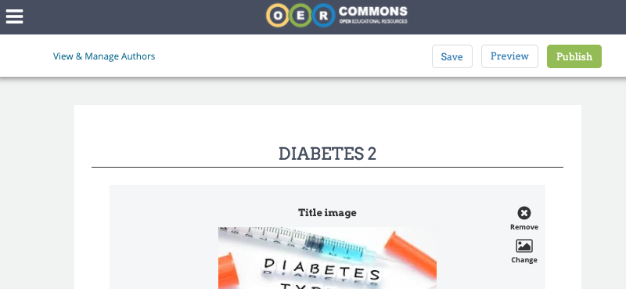

- You now have to describe the resource, the whole set of content that you have uploaded.
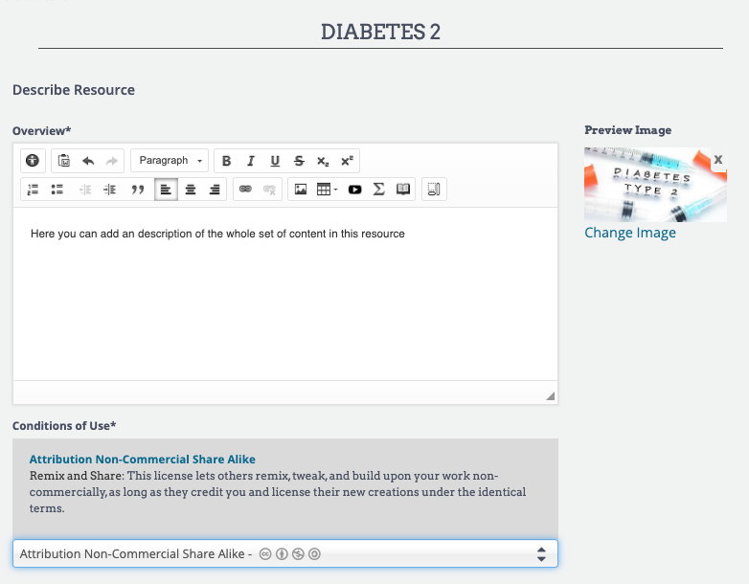
- Choose how to define the rights for the resource. We recommend license CC BY-NC-ND. This license is the most restrictive of the six main licenses, only allowing others to download your works and share them with others as long as they credit you, but users can’t change them in any way or use them commercially. Read about the licenses: https://creativecommons.org/licenses/?lang=en

- Now you must add *mandatory metadata. Add subjects, choose Health, Medicine and Nursing. Choose appropriate Education Levels, Material Types and Languages.
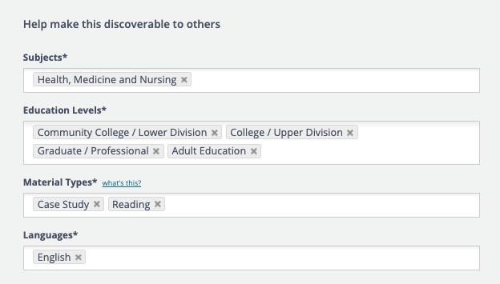

- Add additional data. Keywords are IMPORTANT. You MUST write one or more NORDIC keywords from the table on page 9 (Yellow column), as those keywords will place your resource in the right collection on the website frontpage!

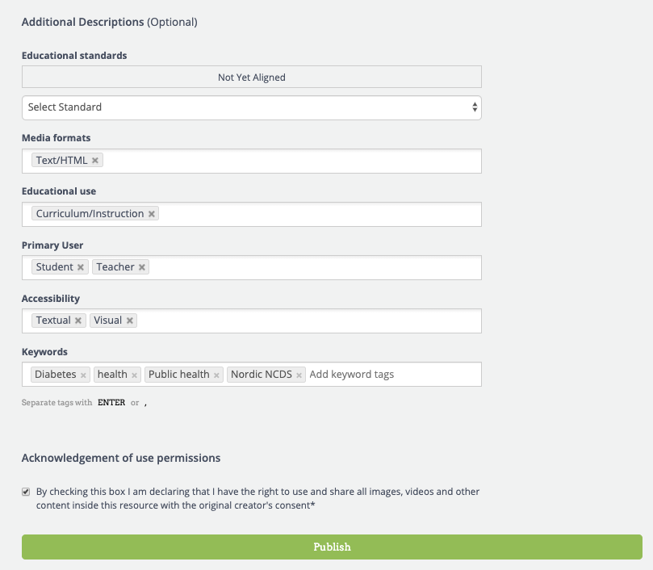

Click the checkbox and click Publish.

When you have published the resource, it will say “Published”. You can always go in and edit the resource. Or click Un- publish. Remember to click "Publish" again, after editing. Your resource will show like this for other users. Files are can be downloaded from the cloud icon. When users click "view resource - they see all the content and uploaded files.

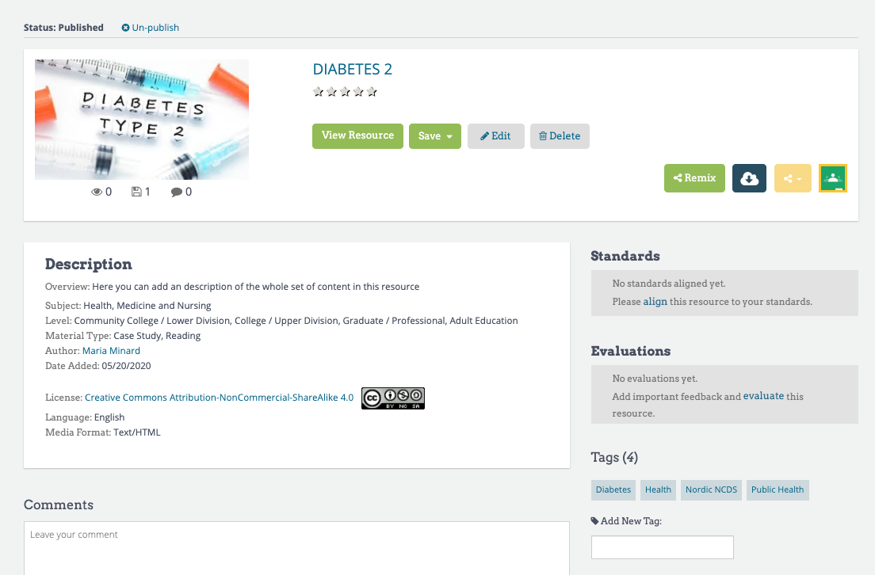

EXAMPLE: Writing the tag/keyword from the first line “Nordic NCDS”, will place your resource in the Non-Communicable Diseases, NCDs, and this collection is placed in all three Main Categories (Global Health, Public Health, Medical Science)
After adding one or more of those tags/keywords, you should write any tag/keyword that reflect the common themes in the resource, which will help people in the search for this resource.

MANDATORY TAGS/KEYWORDS:
Tags/keywords- (this places your resource in the right collection at Nordic Health Hub site) | Collection name | Collections is part of Main Category
Nordic NCDS | Non-Communicable Diseases, NCDs | Global Health, Public Health, Medical Science
Nordic MCH | Maternal and Child Health | Global Health, Public Health
Nordic SRH | Sexual, Reproductive Health and Rights | Global Health
Nordic EVH | Environmental Health | Global Health, Public Health
Nordic QM | Qualitative methods | Global Health, Public Health
Nordic OCH | Collection: Occupational health and safety | Global Health
Nordic HADM | Humanitarian Action and Disaster Management (UCPH) | Global Health, Public Health
Nordic BCI | Infectious disease | Global Health, Public Health, Medical Science
Nordic Epi and Biostats | Epidemiology and Biostatistic | Global Health, Public Health
Nordic Nutrition | Nutrition | Global Health, Public Health, Medical Science
Nordic MGH | Migration | Global Health, Public Health
Nordic IGH | Introduction to Global Health | Global Health
Nordic TMP | Teaching Methods and Course Planning | Global Health
Nordic SDG | Sustainable Development Goals | Global Health, Public Health
Nordic Neurology | Neurology | Medical Science
Nordic HSP | Health Systems, Economics and Policies | Global Health, Public Health
Nordic Hyg | Hygiene | Medical Science
Nordic GAO | Gynecology and Obstetrics | Medical Science
Nordic Ped | Pediatrics | Medical Science
Nordic OM | Occupational Medicine | Medical Science
Nordic MOAAAR | Management of Antibiotics and Antibiotic Resistance | Medical Science
Nordic DR | Disability and Rehabilitation | Global Health, Public Health

To see the collections in which you can place your resource, check the front page of the hub, under the three main categories: https://www.oercommons.org/hubs/nordic_universities

