Play Chess on-line for Free
If you have a facebook account, go to it and then:
1] in the search bar
Type in ‘chess’
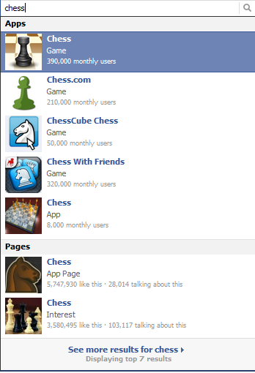
The first (top) one is good…
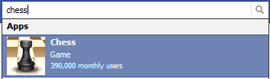
… but check out any/all of the others if you wish

