Anatomy and Physiology 1 Laboratory

The Spinal Cord & Spinal Nerves

Objectives
- Recognize and describe the major surface features of the spinal cord & minges.
- Recognize and describe the sectional anatomy of the spinal cord.
- Recognize and describe the organization of the spinal nerves

The Spinal Cord

The spinal cord is a long, thin, tubular structure made up of nervous tissue, which extends from the medulla oblongata in the brainstem to the lumbar region of the vertebral column. It encloses the central canal of the spinal cord, which contains cerebrospinal fluid. The brain and spinal cord together make up the central nervous system (CNS). In humans, the spinal cord begins at the occipital bone, passing through the foramen magnum and entering the spinal canal at the beginning of the cervical vertebrae. The spinal cord extends down to between the first and second lumbar vertebrae, where it ends. The enclosing bony vertebral column protects the relatively shorter spinal cord. It is around 45 cm (18 in) in men and around 43 cm (17 in) long in women. The diameter of the spinal cord ranges from 13 mm (1⁄2 in) in the cervical and lumbar regions to 6.4 mm (1⁄4 in) in the thoracic area.

The spinal cord functions primarily in the transmission of nerve signals from the motor cortex to the body, and from the afferent fibers of the sensory neurons to the sensory cortex. It is also a center for coordinating many reflexes and contains reflex arcs that can independently control reflexes. It is also the location of groups of spinal interneurons that make up the neural circuits known as central pattern generators. These circuits are responsible for controlling motor instructions for rhythmic movements such as walking.
Structure
The spinal cord is the main pathway for information connecting the brain and peripheral nervous system. Much shorter than its protecting spinal column, the human spinal cord originates in the brainstem, passes through the foramen magnum, and continues through to the conus medullaris near the second lumbar vertebra before terminating in a fibrous extension known as the filum terminale.

It is about 45 cm (18 in) long in men and around 43 cm (17 in) in women, ovoid-shaped, and is enlarged in the cervical and lumbar regions. The cervical enlargement, stretching from the C5 to T1 vertebrae, is where sensory input comes from and motor output goes to the arms and trunk. The lumbar enlargement, located between L1 and S3, handles sensory input and motor output coming from and going to the legs.

The spinal cord is continuous with the caudal portion of the medulla, running from the base of the skull to the body of the first lumbar vertebra. It does not run the full length of the vertebral column in adults. It is made of 31 segments from which branch one pair of sensory nerve roots and one pair of motor nerve roots. The nerve roots then merge into bilaterally symmetrical pairs of spinal nerves. The peripheral nervous system is made up of these spinal roots, nerves, and ganglia.

The dorsal roots are afferent fascicles, receiving sensory information from the skin, muscles, and visceral organs to be relayed to the brain. The roots terminate in dorsal root ganglia, which are composed of the cell bodies of the corresponding neurons. Ventral roots consist of efferent fibers that arise from motor neurons whose cell bodies are found in the ventral (or anterior) gray horns of the spinal cord.

The spinal cord (and brain) are protected by three layers of tissue or membranes called meninges, that surround the canal . The dura mater is the outermost layer, and it forms a tough protective coating. Between the dura mater and the surrounding bone of the vertebrae is a space called the epidural space. The epidural space is filled with adipose tissue, and it contains a network of blood vessels. The arachnoid mater, the middle protective layer, is named for its open, spiderweb-like appearance. The space between the arachnoid and the underlying pia mater is called the subarachnoid space. The subarachnoid space contains cerebrospinal fluid (CSF), which can be sampled with a lumbar puncture, or "spinal tap" procedure. The delicate pia mater, the innermost protective layer, is tightly associated with the surface of the spinal cord. The cord is stabilized within the dura mater by the connecting denticulate ligaments, which extend from the enveloping pia mater laterally between the dorsal and ventral roots. The dural sac ends at the vertebral level of the second sacral vertebra.

In cross-section, the peripheral region of the cord contains neuronal white matter tracts containing sensory and motor axons. Internal to this peripheral region is the grey matter, which contains the nerve cell bodies arranged in the three grey columns that give the region its butterfly-shape. This central region surrounds the central canal, which is an extension of the fourth ventricle and contains cerebrospinal fluid.

The spinal cord is elliptical in cross section, being compressed dorsolaterally. Two prominent grooves, or sulci, run along its length. The posterior median sulcus is the groove in the dorsal side, and the anterior median fissure is the groove in the ventral side.
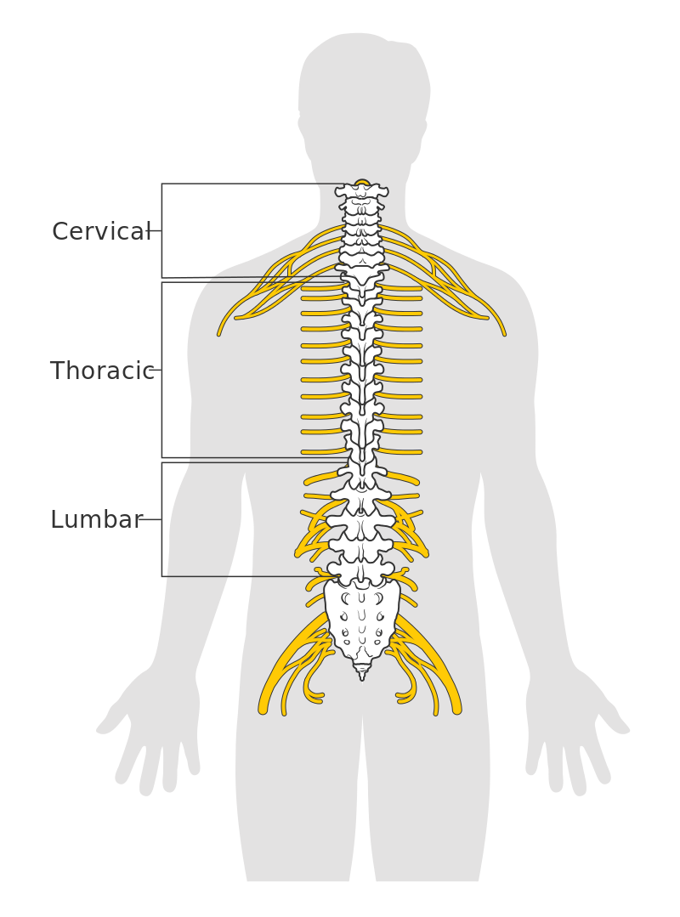
By Cancer Research UK - Original email from CRUK, CC BY-SA 4.0, https://commons.wikimedia.org/w/index.php?curid=34332941

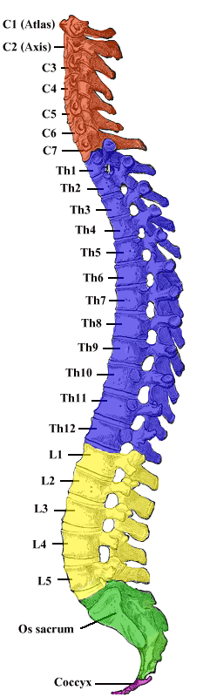 By Henry Vandyke Carter - Vertebral column image.- From: Henry Gray (1918) Anatomy of the Human Body (See "Book" section below)- Altered by User:Uwe Gille, Public Domain, https://commons.wikimedia.org/w/index.php?curid=1282158

By Medium69, Jmarchn - File:Nervous system diagram.png, CC BY-SA 4.0, https://commons.wikimedia.org/w/index.php?curid=36395693
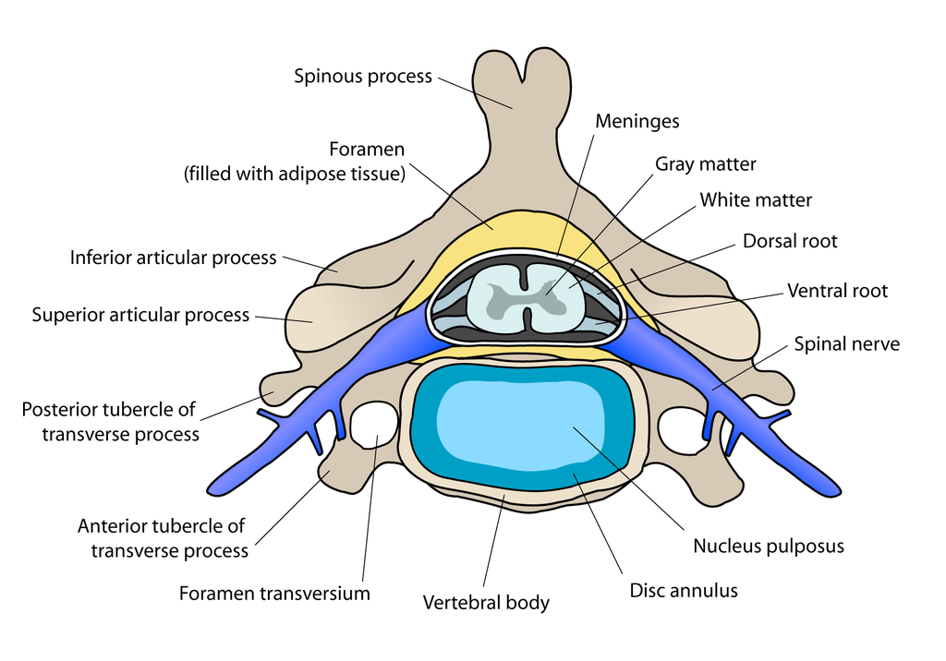By user:debivort - Own work, CC BY-SA 3.0, https://commons.wikimedia.org/w/index.php?curid=1675049
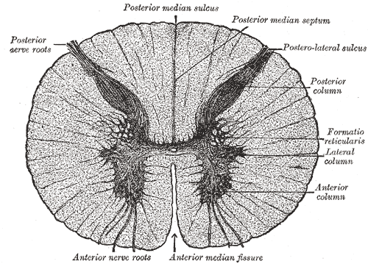
By Henry Vandyke Carter - Henry Gray (1918) Anatomy of the Human Body (See "Book" section below)Bartleby.com: Gray's Anatomy, Plate 664, Public Domain, https://commons.wikimedia.org/w/index.php?curid=541456
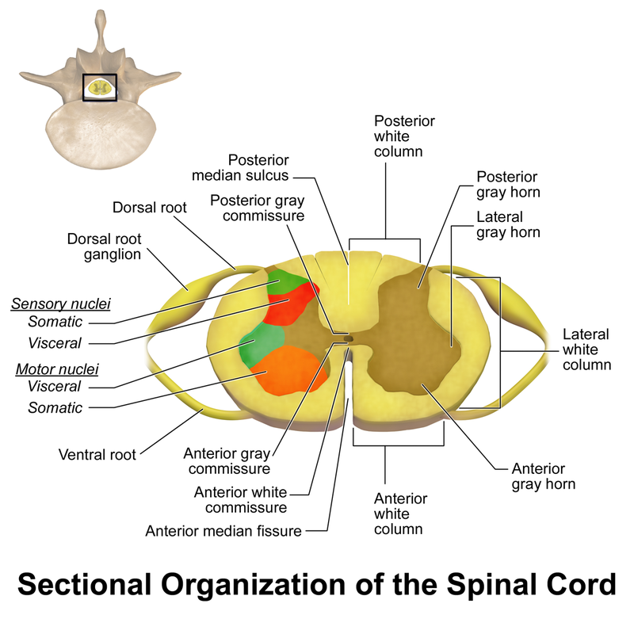
By BruceBlaus - Own work, CC BY-SA 4.0, https://commons.wikimedia.org/w/index.php?curid=46621399

Meninges

The meninges are the three membranes that envelop the brain and spinal cord. In mammals, the meninges are the dura mater, the arachnoid mater, and the pia mater. Cerebrospinal fluid is located in the subarachnoid space between the arachnoid mater and the pia mater. The primary function of the meninges is to protect the central nervous system.

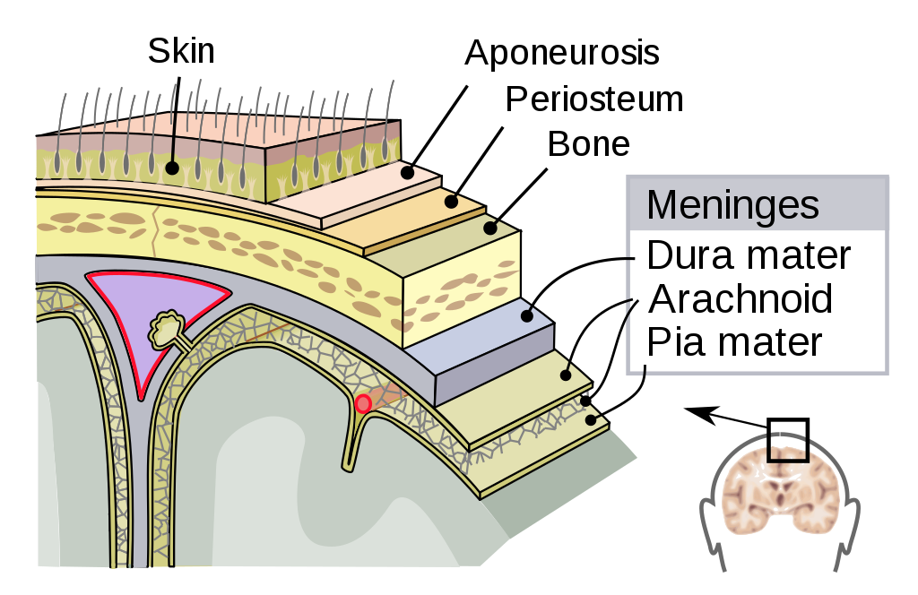
By SVG by Mysid, original by SEER Development Team [1], Jmarchn - Vectorized in Inkscape by Mysid, based on work by SEER Development Team, CC BY-SA 3.0, https://commons.wikimedia.org/w/index.php?curid=10485059
Dura mater
The dura mater is a thick, durable membrane, closest to the skull and vertebrae. The dura mater, the outermost part, is a loosely arranged, fibroelastic layer of cells, characterized by multiple interdigitating cell processes, no extracellular collagen, and significant extracellular spaces. The middle region is a mostly fibrous portion. It consists of two layers: the endosteal layer, which lies closest to the calvaria (skullcap), and the inner meningeal layer, which lies closer to the brain. It contains larger blood vessels that split into the capillaries in the pia mater. It is composed of dense fibrous tissue, and its inner surface is covered by flattened cells like those present on the surfaces of the pia mater and arachnoid mater. The dura mater is a sac that envelops the arachnoid mater and surrounds and supports the large dural sinuses carrying blood from the brain toward the heart.
The dura has four areas of infolding:
Falx cerebri, the largest, sickle-shaped; separates the cerebral hemispheres. Starts from the frontal crest of frontal bone and the crista galli running to the internal occipital protuberance.
Tentorium cerebelli, the second largest, crescent-shaped; separates the occipital lobes from cerebellum. The falx cerebri attaches to it giving a tentlike appearance.
Falx cerebelli, vertical infolding; lies inferior to the tentorium cerebelli, separating the cerebellar hemispheres.
Diaphragma sellae, smallest infolding; covers the pituitary gland and sella turcica.

Arachnoid Mater
The middle element of the meninges is the arachnoid mater, so named because of its spider web-like appearance. It cushions the central nervous system. This thin, transparent membrane is composed of fibrous tissue and, like the pia mater, is covered by flat cells also thought to be impermeable to fluid.
The shape of the arachnoid does not follow the convolutions of the surface of the brain and so looks like a loosely fitting sac. In particular, in the region of the brain a large number of fine filaments called arachnoid trabeculae pass from the arachnoid through the subarachnoid space to blend with the tissue of the pia mater. The arachnoid is composed of an outermost portion (arachnoid barrier cell layer) with tightly packed cells and no extracellular collagen; that is why it is considered to represent an effective morphological and physiological meningeal barrier between the cerebrospinal fluid and subarachnoid space and the blood circulation in the dura.
The arachnoid barrier layer is characterized by a distinct continuous basal lamina on its inner surface toward the innermost collagenous portion of the arachnoid reticular layer

Pia Mater
The pia mater is a very delicate membrane. It is the meningeal envelope that firmly adheres to the surface of the brain and spinal cord, following all of the brain's contours (the gyri and sulci). It is a very thin membrane composed of fibrous tissue covered on its outer surface by a sheet of flat cells thought to be impermeable to fluid. The pia mater is pierced by blood vessels to the brain and spinal cord, and its capillaries nourish the brain.
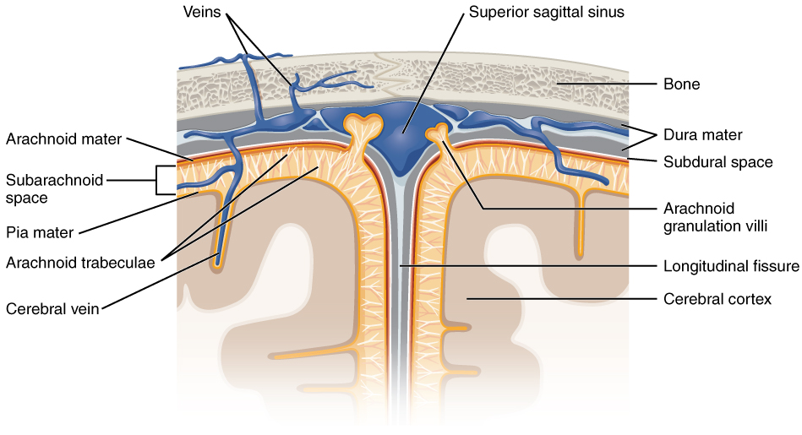
By OpenStax - https://cnx.org/contents/FPtK1zmh@8.25:fEI3C8Ot@10/Preface, CC BY 4.0, https://commons.wikimedia.org/w/index.php?curid=30147959

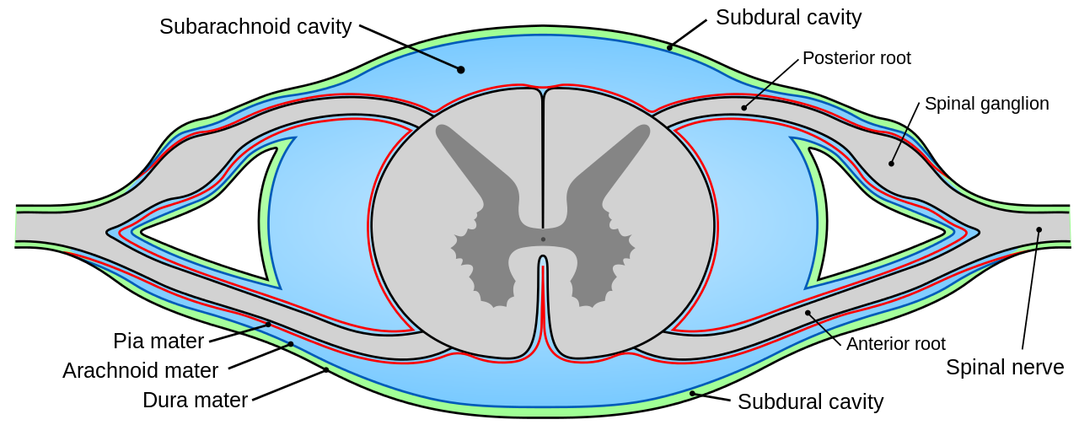
By Mysid - Made by Mysid Inkscape, based on plate 770 from Gray's Anatomy (1918, public domain)., Public Domain, https://commons.wikimedia.org/w/index.php?curid=10496507

Subarachnoid Space
The subarachnoid space is the space that normally exists between the arachnoid and the pia mater, which is filled with cerebrospinal fluid, and continues down the spinal cord. Spaces are formed from openings at different points along the subarachnoid space; these are the subarachnoid cisterns, which are filled with cerebrospinal fluid.

The dura mater is attached to the skull, whereas in the spinal cord, the dura mater is separated from the vertebrae by a space called the epidural space, which contains fat and blood vessels. The arachnoid is attached to the dura mater, while the pia mater is attached to the central nervous system tissue. When the dura mater and the arachnoid separate through injury or illness, the space between them is the subdural space. There is a subpial space underneath the pia mater that separates it from the glia limitans.

Spinal Cord Segments

The human spinal cord is divided into segments where pairs of spinal nerves (mixed; sensory and motor) form. Six to eight motor nerve rootlets branch out of right and left ventro lateral sulci in a very orderly manner. Nerve rootlets combine to form nerve roots. Likewise, sensory nerve rootlets form off right and left dorsal lateral sulci and form sensory nerve roots. The ventral (motor) and dorsal (sensory) roots combine to form spinal nerves (mixed; motor and sensory), one on each side of the spinal cord. Spinal nerves, with the exception of C1 and C2, form inside the intervertebral foramen (IVF). These rootlets form the demarcation between the central and peripheral nervous systems.

The grey column, (as three regions of grey columns) in the center of the cord, is shaped like a butterfly and consists of cell bodies of interneurons, motor neurons, neuroglia cells and unmyelinated axons. The anterior and posterior grey column present as projections of the grey matter and are also known as the horns of the spinal cord. Together, the grey columns and the gray commissure form the "grey H."

The white matter is located outside of the grey matter and consists almost totally of myelinated motor and sensory axons. "Columns" of white matter carry information either up or down the spinal cord.

The spinal cord proper terminates in a region called the conus medullaris, while the pia mater continues as an extension called the filum terminale, which anchors the spinal cord to the coccyx. The cauda equina ("horse's tail") is a collection of nerves inferior to the conus medullaris that continue to travel through the vertebral column to the coccyx. The cauda equina forms because the spinal cord stops growing in length at about age four, even though the vertebral column continues to lengthen until adulthood. This results in sacral spinal nerves originating in the upper lumbar region.

Within the CNS, nerve cell bodies are generally organized into functional clusters, called nuclei. Axons within the CNS are grouped into tracts.

There are 31 spinal cord nerve segments in a human spinal cord:

- 8 cervical segments forming 8 pairs of cervical nerves (C1 spinal nerves exit the spinal column between the foramen magnum and the C1 vertebra; C2 nerves exit between the posterior arch of the C1 vertebra and the lamina of C2; C3–C8 spinal nerves pass through the IVF above their corresponding cervical vertebrae, with the exception of the C8 pair which exit between the C7 and T1 vertebrae)
- 12 thoracic segments forming 12 pairs of thoracic nerves
- 5 lumbar segments forming 5 pairs of lumbar nerves
- 5 sacral segments forming 5 pairs of sacral nerves
- 1 coccygeal segment

Somatosensory Organization

Somatosensory organization is divided into the dorsal column-medial lemniscus tract (the touch/proprioception/vibration sensory pathway) and the anterolateral system, or ALS (the pain/temperature sensory pathway). Both sensory pathways use three different neurons to get information from sensory receptors at the periphery to the cerebral cortex. These neurons are designated primary, secondary and tertiary sensory neurons. In both pathways, primary sensory neuron cell bodies are found in the dorsal root ganglia, and their central axons project into the spinal cord.

In the dorsal column-medial leminiscus tract, a primary neuron's axon enters the spinal cord and then enters the dorsal column. If the primary axon enters below spinal level T6, the axon travels in the fasciculus gracilis, the medial part of the column. If the axon enters above level T6, then it travels in the fasciculus cuneatus, which is lateral to the fasciculus gracilis. Either way, the primary axon ascends to the lower medulla, where it leaves its fasciculus and synapses with a secondary neuron in one of the dorsal column nuclei: either the nucleus gracilis or the nucleus cuneatus, depending on the pathway it took. At this point, the secondary axon leaves its nucleus and passes anteriorly and medially. The collection of secondary axons that do this are known as internal arcuate fibers. The internal arcuate fibers decussate and continue ascending as the contralateral medial lemniscus. Secondary axons from the medial lemniscus finally terminate in the ventral posterolateral nucleus (VPLN) of the thalamus, where they synapse with tertiary neurons. From there, tertiary neurons ascend via the posterior limb of the internal capsule and end in the primary sensory cortex.

The proprioception of the lower limbs differs from the upper limbs and upper trunk. There is a four-neuron pathway for lower limb proprioception. This pathway initially follows the dorsal spino-cerebellar pathway. It is arranged as follows: proprioceptive receptors of lower limb → peripheral process → dorsal root ganglion → central process → Clarke's column → 2nd order neuron → medulla oblogata (Caudate nucleus) → 3rd order neuron → VPLN of thalamus → 4th order neuron → posterior limb of internal capsule → corona radiata → sensory area of cerebrum.

The anterolateral system works somewhat differently. Its primary neurons axons enter the spinal cord and then ascend one to two levels before synapsing in the substantia gelatinosa. The tract that ascends before synapsing is known as Lissauer's tract. After synapsing, secondary axons decussate and ascend in the anterior lateral portion of the spinal cord as the spinothalamic tract. This tract ascends all the way to the VPLN, where it synapses on tertiary neurons. Tertiary neuronal axons then travel to the primary sensory cortex via the posterior limb of the internal capsule.

Some of the "pain fibers" in the ALS deviate from their pathway towards the VPLN. In one such deviation, axons travel towards the reticular formation in the midbrain. The reticular formation then projects to a number of places including the hippocampus (to create memories about the pain), the centromedian nucleus (to cause diffuse, non-specific pain) and various parts of the cortex. Additionally, some ALS axons project to the periaqueductal gray in the pons, and the axons forming the periaqueductal gray then project to the nucleus raphes magnus, which projects back down to where the pain signal is coming from and inhibits it. This helps control the sensation of pain to some degree.

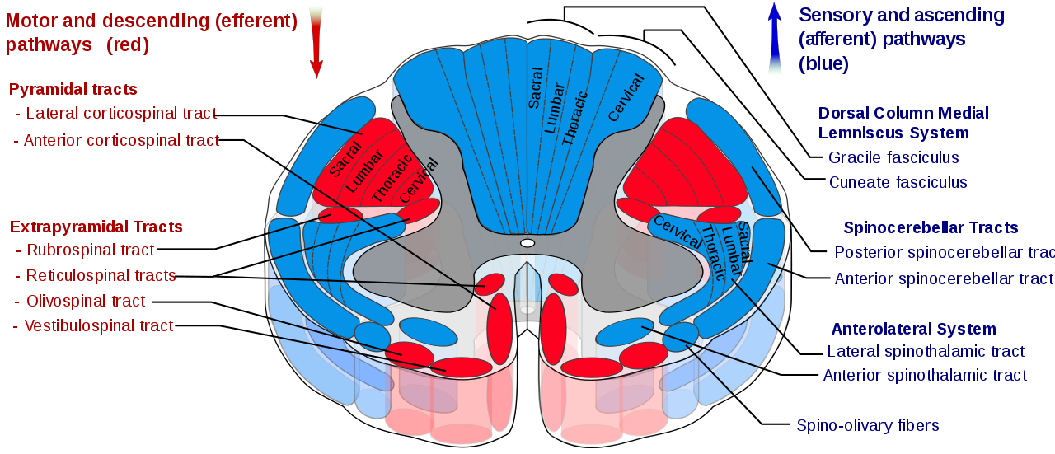
By Polarlys and Mikael Häggström - File:Medulla spinalis - tracts - English.svg by Polarlys (translation by Selket)., CC BY-SA 3.0, https://commons.wikimedia.org/w/index.php?curid=10909281

Motor Organization

The corticospinal tract serves as the motor pathway for upper motor neuronal signals coming from the cerebral cortex and from primitive brainstem motor nuclei.

Cortical upper motor neurons originate from Brodmann areas 1, 2, 3, 4, and 6 and then descend in the posterior limb of the internal capsule, through the crus cerebri, down through the pons, and to the medullary pyramids, where about 90% of the axons cross to the contralateral side at the decussation of the pyramids. They then descend as the lateral corticospinal tract. These axons synapse with lower motor neurons in the ventral horns of all levels of the spinal cord. The remaining 10% of axons descend on the ipsilateral side as the ventral corticospinal tract. These axons also synapse with lower motor neurons in the ventral horns. Most of them will cross to the contralateral side of the cord (via the anterior white commissure) right before synapsing.

The midbrain nuclei include four motor tracts that send upper motor neuronal axons down the spinal cord to lower motor neurons. These are the rubrospinal tract, the vestibulospinal tract, the tectospinal tract and the reticulospinal tract. The rubrospinal tract descends with the lateral corticospinal tract, and the remaining three descend with the anterior corticospinal tract.

The function of lower motor neurons can be divided into two different groups: the lateral corticospinal tract and the anterior cortical spinal tract. The lateral tract contains upper motor neuronal axons which synapse on dorsal lateral (DL) lower motor neurons. The DL neurons are involved in distal limb control. Therefore, these DL neurons are found specifically only in the cervical and lumbosacral enlargements within the spinal cord. There is no decussation in the lateral corticospinal tract after the decussation at the medullary pyramids.

The anterior corticospinal tract descends ipsilaterally in the anterior column, where the axons emerge and either synapse on lower ventromedial (VM) motor neurons in the ventral horn ipsilaterally or descussate at the anterior white commissure where they synapse on VM lower motor neurons contralaterally . The tectospinal, vestibulospinal and reticulospinal descend ipsilaterally in the anterior column but do not synapse across the anterior white commissure. Rather, they only synapse on VM lower motor neurons ipsilaterally. The VM lower motor neurons control the large, postural muscles of the axial skeleton. These lower motor neurons, unlike those of the DL, are located in the ventral horn all the way throughout the spinal cord.

Cervical Plexus

The cervical plexus is a plexus of the anterior rami of the first four cervical spinal nerves which arise from C1 to C4 cervical segment in the neck. They are located laterally to the transverse processes between prevertebral muscles from the medial side and vertebral (m. scalenus, m. levator scapulae, m. splenius cervicis) from lateral side. There is anastomosis with accessory nerve, hypoglossal nerve and sympathetic trunk.

It is located in the neck, deep to sternocleidomastoid m. Nerves formed from the cervical plexus innervate the back of the head, as well as some neck muscles. The branches of the cervical plexus emerge from the posterior triangle at the nerve point, a point which lies midway on the posterior border of the sternocleidomastoid. Also from the posterior ramus of C2 greater occipital nerve arises

The cervical plexus has two types of branches: cutaneous and muscular.

Cutaneous (4 branches):
Lesser occipital - innervates the skin and the scalp posterosuperior to the auricle (C2)
Great auricular nerve - innervates skin near concha auricle (outer ear) and external acoustic meatus (ear canal) (C2&C3)
Transverse cervical nerve - innervates anterior region of neck (C2&C3)
Supraclavicular nerves - innervate the skin above and below the clavicle (C3,C4) [1]
Muscular
Ansa cervicalis (This is a loop formed from C1-C3 which supplies the four infrahyoid aka strap muscles), etc. (thyrohyoid (C1 only), sternothyroid, sternohyoid, omohyoid)
Phrenic (C3-C5 (primarily C4))-innervates diaphragm and the pericardium
Segmental branches (C1-C4)- innervates anterior and middle scalenes
Additionally there are two branches formed by the posterior roots of spinal nerves:

Preauricular nerve (from the posterior roots of C2–C3)[2][3]
Postauricular nerve (from the posterior roots of C3–C4)[3]

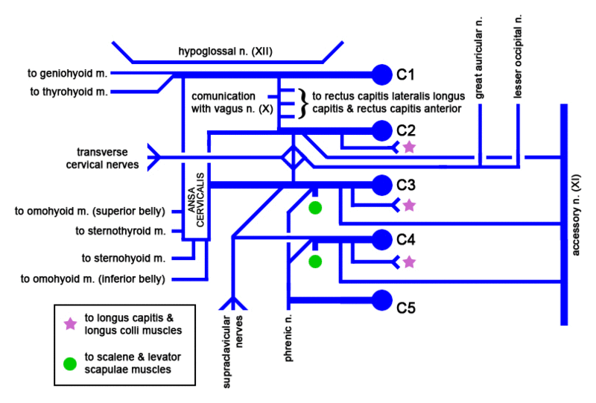
By Mikael Häggström.When using this image in external works, it may be cited as:Häggström, Mikael (2014). "Medical gallery of Mikael Häggström 2014". WikiJournal of Medicine 1 (2). DOI:10.15347/wjm/2014.008. ISSN 2002-4436. Public Domain.orBy Mikael Häggström, used with permission. - Image:Cervical plexus.gif by Juliustang., Public Domain, https://commons.wikimedia.org/w/index.php?curid=2864716

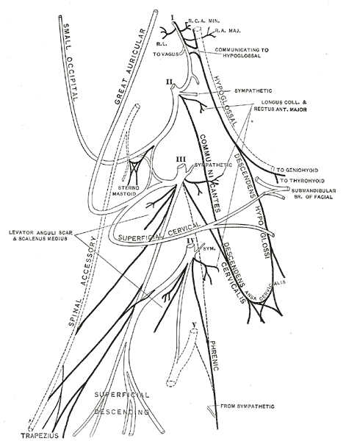
By Henry Vandyke Carter - Henry Gray (1918) Anatomy of the Human Body (See "Book" section below)Bartleby.com: Gray's Anatomy, Plate 804, Public Domain, https://commons.wikimedia.org/w/index.php?curid=531837

Brachial Plexus

The brachial plexus is a network (plexus) of nerves (formed by the ventral ramus of the lower four cervical nerves and first thoracic nerve (C5, C6, C7, C8, and T1). This plexus extends from the spinal cord, through the cervicoaxillary canal in the neck, over the first rib, and into the armpit. It supplies afferent and efferent nerve fibers to the chest, shoulder, arm and hand.
The brachial plexus is divided into five roots, three trunks, six divisions (three anterior and three posterior), three cords, and five branches. There are five "terminal" branches and numerous other "pre-terminal" or "collateral" branches, such as the subscapular nerve, the thoracodorsal nerve, and the long thoracic nerve,[1] that leave the plexus at various points along its length. A common structure used to identify part of the brachial plexus in cadaver dissections is the M or W shape made by the musculocutaneous nerve, lateral cord, median nerve, medial cord, and ulnar nerve.

Roots
The five roots are the five anterior rami of the spinal nerves, after they have given off their segmental supply to the muscles of the neck. The brachial plexus emerges at five different levels; C5, C6, C7, C8, and T1. C5 and C6 merge to establish the upper trunk, C7 continuously forms the middle trunk, and C8 and T1 merge to establish the lower trunk. Prefixed or postfixed formations in some cases involve C4 or T2, respectively. The dorsal scapular nerve comes from the superior trunk and innervates the rhomboid muscles which retract the scapula. The subclavian nerve originates in both C5 and C6 and innervates the subclavius, a muscle that involves lifting the first ribs during respiration. The long thoracic nerve arises from C5, C6, and C7. This nerve innervates the serratus anterior, which draws the scapula laterally and is the prime mover in all forward-reaching and pushing actions.

Trunks
These roots merge to form the trunks:
- "superior" or "upper" (C5-C6)
- "middle" (C7)
- "inferior" or "lower" (C8, T1)

Divisions
Each trunk then splits in two, to form six divisions:
- anterior divisions of the upper, middle, and lower trunks
- posterior divisions of the upper, middle, and lower trunks
- when observing the body in the anatomical position, the anterior divisions are superficial to the posterior divisions

Cords
These six divisions regroup to become the three cords or large fiber bundles. The cords are named by their position with respect to the axillary artery.

- The posterior cord is formed from the three posterior divisions of the trunks (C5-C8, T1)
- The lateral cord is formed from the anterior divisions of the upper and middle trunks (C5-C7)
- The medial cord is simply a continuation of the anterior division of the lower trunk (C8, T1)
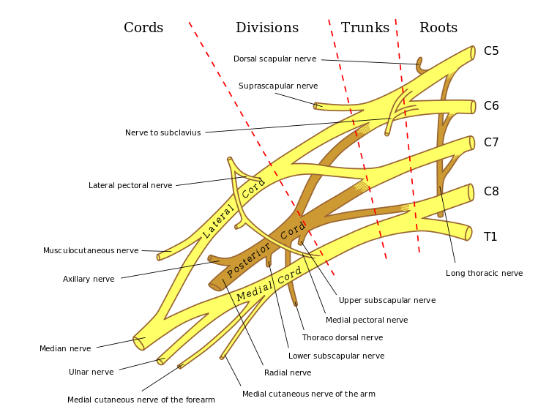https://en.wikipedia.org/wiki/File:Brachial_plexus_2.svg

