Anatomy and Physiology 1 Laboratory
Anatomy of the Brain

Objectives
- Identify the three meninges that cover the brain
- Identify the major regions of the brain and the basic function of each region
- Describe the vessels that supply the CNS with blood
- Name the components of the ventricular system and the regions of the brain in which each is located
- Explain the production of cerebrospinal fluid and its flow through the ventricles
- Identify and describe the function of the cranial nerves

The brain and the spinal cord are the central nervous system, and they represent the main organs of the nervous system. The spinal cord is a single structure, whereas the adult brain is described in terms of four major regions: the cerebrum, the diencephalon, the brain stem, and the cerebellum. A person’s conscious experiences are based on neural activity in the brain. The regulation of homeostasis is governed by a specialized region in the brain. The coordination of reflexes depends on the integration of sensory and motor pathways in the spinal cord.
The Cerebrum
The iconic gray mantle of the human brain, which appears to make up most of the mass of the brain, is the cerebrum. The wrinkled portion is the cerebral cortex, and the rest of the structure is beneath that outer covering. There is a large separation between the two sides of the cerebrum called the longitudinal fissure. It separates the cerebrum into two distinct halves, a right and left cerebral hemisphere. Deep within the cerebrum, the white matter of the corpus callosum provides the major pathway for communication between the two hemispheres of the cerebral cortex.

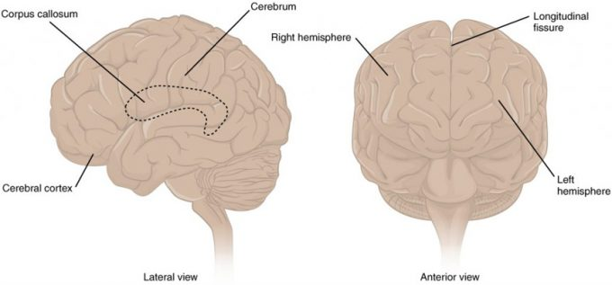
The Cerebrum: The cerebrum is a large component of the CNS in humans, and the most obvious aspect of it is the folded surface called the cerebral cortex.

Many of the higher neurological functions, such as memory, emotion, and consciousness, are the result of cerebral function. The complexity of the cerebrum is different across vertebrate species. The cerebrum of the most primitive vertebrates is not much more than the connection for the sense of smell. In mammals, the cerebrum comprises the outer gray matter that is the cortex (from the Latin word meaning “bark of a tree”) and several deep nuclei that belong to three important functional groups. The basal nuclei are responsible for cognitive processing, the most important function being that associated with planning movements. The basal forebrain contains nuclei that are important in learning and memory. The limbic cortex is the region of the cerebral cortex that is part of the limbic system, a collection of structures involved in emotion, memory, and behavior.

Cerebral Cortex
The cerebrum is covered by a continuous layer of gray matter that wraps around either side of the forebrain—the cerebral cortex. This thin, extensive region of wrinkled gray matter is responsible for the higher functions of the nervous system. A gyrus (plural = gyri) is the ridge of one of those wrinkles, and a sulcus (plural = sulci) is the groove between two gyri. The pattern of these folds of tissue indicates specific regions of the cerebral cortex.

The head is limited by the size of the birth canal, and the brain must fit inside the cranial cavity of the skull. Extensive folding in the cerebral cortex enables more gray matter to fit into this limited space. If the gray matter of the cortex were peeled off of the cerebrum and laid out flat, its surface area would be roughly equal to one square meter.

The folding of the cortex maximizes the amount of gray matter in the cranial cavity. During embryonic development, as the telencephalon expands within the skull, the brain goes through a regular course of growth that results in everyone’s brain having a similar pattern of folds. The surface of the brain can be mapped on the basis of the locations of large gyri and sulci. Using these landmarks, the cortex can be separated into four major regions, or lobes. The lateral sulcus that separates the temporal lobe from the other regions is one such landmark. Superior to the lateral sulcus are the parietal lobe and frontal lobe, which are separated from each other by the central sulcus. The posterior region of the cortex is the occipital lobe, which has no obvious anatomical border between it and the parietal or temporal lobes on the lateral surface of the brain. From the medial surface, an obvious landmark separating the parietal and occipital lobes is called the parieto-occipital sulcus. The fact that there is no obvious anatomical border between these lobes is consistent with the functions of these regions being interrelated.

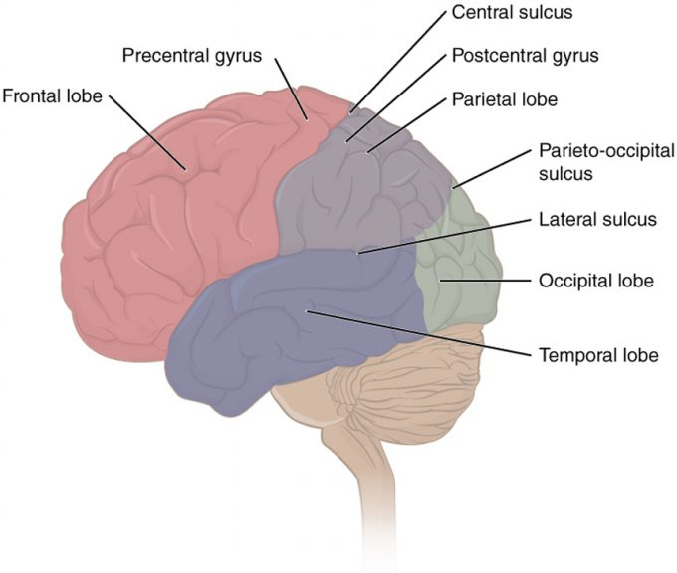
Lobes of the Cerebral Cortex: The cerebral cortex is divided into four lobes. Extensive folding increases the surface area available for cerebral functions.

Different regions of the cerebral cortex can be associated with particular functions, a concept known as localization of function. In the early 1900s, a German neuroscientist named Korbinian Brodmann performed an extensive study of the microscopic anatomy—the cytoarchitecture—of the cerebral cortex and divided the cortex into 52 separate regions on the basis of the histology of the cortex. His work resulted in a system of classification known as Brodmann’s areas, which is still used today to describe the anatomical distinctions within the cortex. The results from Brodmann’s work on the anatomy align very well with the functional differences within the cortex. Areas 17 and 18 in the occipital lobe are responsible for primary visual perception. That visual information is complex, so it is processed in the temporal and parietal lobes as well.

The temporal lobe is associated with primary auditory sensation, known as Brodmann’s areas 41 and 42 in the superior temporal lobe. Because regions of the temporal lobe are part of the limbic system, memory is an important function associated with that lobe. Memory is essentially a sensory function; memories are recalled sensations such as the smell of Mom’s baking or the sound of a barking dog. Even memories of movement are really the memory of sensory feedback from those movements, such as stretching muscles or the movement of the skin around a joint. Structures in the temporal lobe are responsible for establishing long-term memory, but the ultimate location of those memories is usually in the region in which the sensory perception was processed.

The main sensation associated with the parietal lobe is somatosensation, meaning the general sensations associated with the body. Posterior to the central sulcus is the postcentral gyrus, the primary somatosensory cortex, which is identified as Brodmann’s areas 1, 2, and 3. All of the tactile senses are processed in this area, including touch, pressure, tickle, pain, itch, and vibration, as well as more general senses of the body such as proprioception and kinesthesia, which are the senses of body position and movement, respectively.

Anterior to the central sulcus is the frontal lobe, which is primarily associated with motor functions. The precentral gyrus is the primary motor cortex. Cells from this region of the cerebral cortex are the upper motor neurons that instruct cells in the spinal cord and brain stem (lower motor neurons) to move skeletal muscles. Anterior to this region are a few areas that are associated with planned movements. The premotor area is responsible for storing learned movement algorithms which are instructions for complex movements. Different algorithms activate the upper motor neurons in the correct sequence when a complex motor activity is performed. The frontal eye fields are important in eliciting scanning eye movements and in attending to visual stimuli. Broca’s area is responsible for the production of language, or controlling movements responsible for speech; in the vast majority of people, it is located only on the left side. Anterior to these regions is the prefrontal lobe, which serves cognitive functions that can be the basis of personality, short-term memory, and consciousness. The prefrontal lobotomy is an outdated mode of treatment for personality disorders (psychiatric conditions) that profoundly affected the personality of the patient.

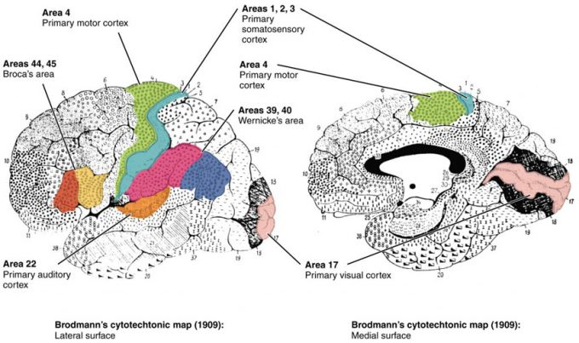
Brodmann’s Areas of the Cerebral Cortex: Brodmann mapping of functionally distinct regions of the cortex was based on its cytoarchitecture at a microscopic level.

Area 17, as Brodmann described it, is also known as the primary visual cortex. Adjacent to that are areas 18 and 19, which constitute subsequent regions of visual processing. Area 22 is the primary auditory cortex, and it is followed by area 23, which further processes auditory information. Area 4 is the primary motor cortex in the precentral gyrus, whereas area 6 is the premotor cortex. These areas suggest some specialization within the cortex for functional processing, both in sensory and motor regions. The fact that Brodmann’s areas correlate so closely to functional localization in the cerebral cortex demonstrates the strong link between structure and function in these regions.

Areas 1, 2, 3, 4, 17, and 22 are each described as primary cortical areas. The adjoining regions are each referred to as association areas. Primary areas are where sensory information is initially received from the thalamus for conscious perception, or—in the case of the primary motor cortex—where descending commands are sent down to the brain stem or spinal cord to execute movements.

Functions of the Cerebral Cortex
The cerebrum is the seat of many of the higher mental functions, such as memory and learning, language, and conscious perception, which are the subjects of subtests of the mental status exam. The cerebral cortex is the thin layer of gray matter on the outside of the cerebrum. It is approximately a millimeter thick in most regions and highly folded to fit within the limited space of the cranial vault. These higher functions are distributed across various regions of the cortex, and specific locations can be said to be responsible for particular functions. There is a limited set of regions, for example, that are involved in language function, and they can be subdivided on the basis of the particular part of language function that each governs.
A number of other regions, which extend beyond these primary or association areas of the cortex, are referred to as integrative areas. These areas are found in the spaces between the domains for particular sensory or motor functions, and they integrate multisensory information, or process sensory or motor information in more complex ways. Consider, for example, the posterior parietal cortex that lies between the somatosensory cortex and visual cortex regions. This has been ascribed to the coordination of visual and motor functions, such as reaching to pick up a glass. The somatosensory function that would be part of this is the proprioceptive feedback from moving the arm and hand. The weight of the glass, based on what it contains, will influence how those movements are executed.

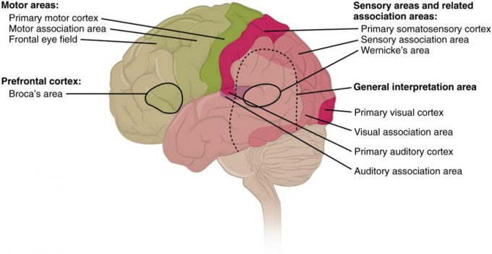
Types of Cortical Areas: The cerebral cortex can be described as containing three types of processing regions: primary, association, and integration areas. The primary cortical areas are where sensory information is initially processed, or where motor commands emerge to go to the brain stem or spinal cord. Association areas are adjacent to primary areas and further process the modality-specific input. Multimodal integration areas are found where the modality-specific regions meet; they can process multiple modalities together or different modalities on the basis of similar functions, such as spatial processing in vision or somatosensation.

Blood Supply to the Brain
A lack of oxygen to the CNS can be devastating, and the cardiovascular system has specific regulatory reflexes to ensure that the blood supply is not interrupted. There are multiple routes for blood to get into the CNS, with specializations to protect that blood supply and to maximize the ability of the brain to get an uninterrupted perfusion.

Arterial Supply
The major artery carrying recently oxygenated blood away from the heart is the aorta. The very first branches off the aorta supply the heart with nutrients and oxygen. The next branches give rise to the common carotid arteries, which further branch into the internal carotid arteries. The external carotid arteries supply blood to the tissues on the surface of the cranium. The bases of the common carotids contain stretch receptors that immediately respond to the drop in blood pressure upon standing. The orthostatic reflex is a reaction to this change in body position, so that blood pressure is maintained against the increasing effect of gravity (orthostatic means “standing up”). Heart rate increases—a reflex of the sympathetic division of the autonomic nervous system—and this raises blood pressure.

The internal carotid artery enters the cranium through the carotid canal in the temporal bone. A second set of vessels that supply the CNS are the vertebral arteries, which are protected as they pass through the neck region by the transverse foramina of the cervical vertebrae. The vertebral arteries enter the cranium through the foramen magnum of the occipital bone. Branches off the left and right vertebral arteries merge into the anterior spinal artery supplying the anterior aspect of the spinal cord, found along the anterior median fissure. The two vertebral arteries then merge into the basilar artery, which gives rise to branches to the brain stem and cerebellum. The left and right internal carotid arteries and branches of the basilar artery all become the circle of Willis, a confluence of arteries that can maintain perfusion of the brain even if narrowing or a blockage limits flow through one part.

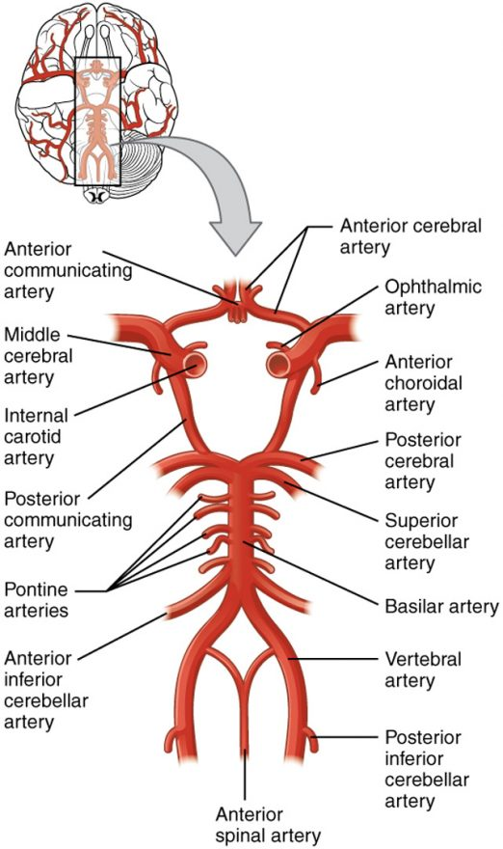
Circle of Willis: The blood supply to the brain enters through the internal carotid arteries and the vertebral arteries, eventually giving rise to the circle of Willis.

Venous Return
After passing through the CNS, blood returns to the circulation through a series of dural sinuses and veins. The superior sagittal sinus runs in the groove of the longitudinal fissure, where it absorbs CSF from the meninges. The superior sagittal sinus drains to the confluence of sinuses, along with the occipital sinuses and straight sinus, to then drain into the transverse sinuses. The transverse sinuses connect to the sigmoid sinuses, which then connect to the jugular veins. From there, the blood continues toward the heart to be pumped to the lungs for reoxygenation.

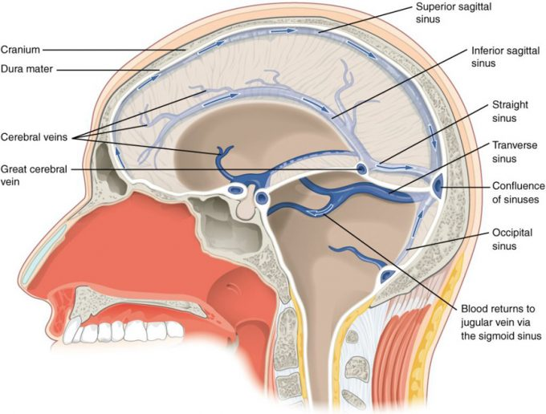
Dural Sinuses and Veins: Blood drains from the brain through a series of sinuses that connect to the jugular veins.

Protective Coverings of the Brain and Spinal Cord
The outer surface of the CNS is covered by a series of membranes composed of connective tissue called the meninges, which protect the brain. The dura mater is a thick fibrous layer and a strong protective sheath over the entire brain and spinal cord. It is anchored to the inner surface of the cranium and vertebral cavity. The arachnoid mater is a membrane of thin fibrous tissue that forms a loose sac around the CNS. Beneath the arachnoid is a thin, filamentous mesh called the arachnoid trabeculae, which looks like a spider web, giving this layer its name. Directly adjacent to the surface of the CNS is the pia mater, a thin fibrous membrane that follows the convolutions of gyri and sulci in the cerebral cortex and fits into other grooves and indentations.

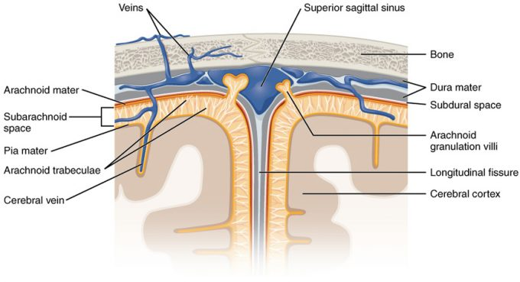
Meningeal Layers of Superior Sagittal Sinus: The layers of the meninges in the longitudinal fissure of the superior sagittal sinus are shown, with the dura mater adjacent to the inner surface of the cranium, the pia mater adjacent to the surface of the brain, and the arachnoid and subarachnoid space between them. An arachnoid villus is shown emerging into the dural sinus to allow CSF to filter back into the blood for drainage.

Dura Mater
Like a thick cap covering the brain, the dura mater is a tough outer covering. The name comes from the Latin for “tough mother” to represent its physically protective role. It encloses the entire CNS and the major blood vessels that enter the cranium and vertebral cavity. It is directly attached to the inner surface of the bones of the cranium and to the very end of the vertebral cavity.

There are infoldings of the dura that fit into large crevasses of the brain. Two infoldings go through the midline separations of the cerebrum and cerebellum; one forms a shelf-like tent between the occipital lobes of the cerebrum and the cerebellum, and the other surrounds the pituitary gland. The dura also surrounds and supports the venous sinuses.

Arachnoid Mater
The middle layer of the meninges is the arachnoid, named for the spider-web–like trabeculae between it and the pia mater. The arachnoid defines a sac-like enclosure around the CNS. The trabeculae are found in the subarachnoid space, which is filled with circulating CSF. The arachnoid emerges into the dural sinuses as the arachnoid granulations, where the CSF is filtered back into the blood for drainage from the nervous system.

The subarachnoid space is filled with circulating CSF, which also provides a liquid cushion to the brain and spinal cord. Similar to clinical blood work, a sample of CSF can be withdrawn to find chemical evidence of neuropathology or metabolic traces of the biochemical functions of nervous tissue.

Pia Mater
The outer surface of the CNS is covered in the thin fibrous membrane of the pia mater. It is thought to have a continuous layer of cells providing a fluid-impermeable membrane. The name pia mater comes from the Latin for “tender mother,” suggesting the thin membrane is a gentle covering for the brain. The pia extends into every convolution of the CNS, lining the inside of the sulci in the cerebral and cerebellar cortices. At the end of the spinal cord, a thin filament extends from the inferior end of CNS at the upper lumbar region of the vertebral column to the sacral end of the vertebral column. Because the spinal cord does not extend through the lower lumbar region of the vertebral column, a needle can be inserted through the dura and arachnoid layers to withdraw CSF. This procedure is called a lumbar puncture and avoids the risk of damaging the central tissue of the spinal cord. Blood vessels that are nourishing the central nervous tissue are between the pia mater and the nervous tissue.

The Ventricular System
Cerebrospinal fluid (CSF) circulates throughout and around the CNS. In other tissues, water and small molecules are filtered through capillaries as the major contributor to the interstitial fluid. In the brain, CSF is produced in special structures to perfuse through the nervous tissue of the CNS and is continuous with the interstitial fluid. Specifically, CSF circulates to remove metabolic wastes from the interstitial fluids of nervous tissues and return them to the blood stream. The ventricles are the open spaces within the brain where CSF circulates. In some of these spaces, CSF is produced by filtering of the blood that is performed by a specialized membrane known as a choroid plexus. The CSF circulates through all of the ventricles to eventually emerge into the subarachnoid space where it will be reabsorbed into the blood.
The Ventricles
There are four ventricles within the brain, all of which developed from the original hollow space within the neural tube, the central canal. The first two are named the lateral ventricles and are deep within the cerebrum. These ventricles are connected to the third ventricle by two openings called the interventricular foramina. The third ventricle is the space between the left and right sides of the diencephalon, which opens into the cerebral aqueduct that passes through the midbrain. The aqueduct opens into the fourth ventricle, which is the space between the cerebellum and the pons and upper medulla.
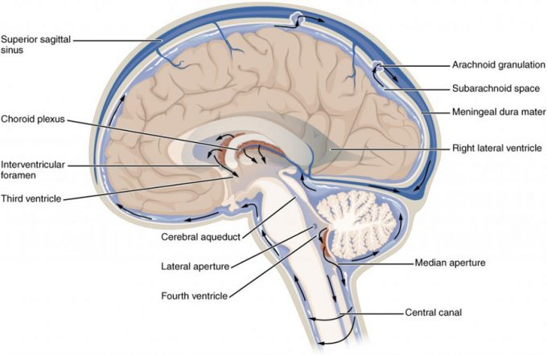
Cerebrospinal Fluid Circulation: The choroid plexus in the four ventricles produce CSF, which is circulated through the ventricular system and then enters the subarachnoid space through the median and lateral apertures. The CSF is then reabsorbed into the blood at the arachnoid granulations, where the arachnoid membrane emerges into the dural sinuses.

Cranial Nerves
Cranial nerves are the nerves that emerge directly from the brain (including the brainstem), in contrast to spinal nerves (which emerge from segments of the spinal cord). Ten of the cranial nerves originate in the brainstem. Cranial nerves relay information between the brain and parts of the body, primarily to and from regions of the head and neck.
Spinal nerves emerge sequentially from the spinal cord with the spinal nerve closest to the head (C1) emerging in the space above the first cervical vertebra. The cranial nerves, however, emerge from the central nervous system above this level. Each cranial nerve is paired and is present on both sides. Depending on definition in humans there are twelve or thirteen cranial nerves pairs, which are assigned Roman numerals I–XII, sometimes also including cranial nerve zero. The numbering of the cranial nerves is based on the order in which they emerge from the brain, front to back (brainstem).
The, olfactory nerves (I) and optic nerves (II) emerge from the cerebrum or forebrain, and the remaining ten pairs arise from the brainstem, which is the lower part of the brain.
The cranial nerves are considered components of the peripheral nervous system (PNS), although on a structural level the olfactory (I), optic (II), and trigeminal (V) nerves are more accurately considered part of the central nervous system (CNS).
Humans are considered to have twelve pairs of cranial nerves (I–XII). They are: the olfactory nerve (I), the optic nerve (II), oculomotor nerve (III), trochlear nerve (IV), trigeminal nerve (V), abducens nerve (VI), facial nerve (VII), vestibulocochlear nerve (VIII), glossopharyngeal nerve (IX), vagus nerve (X), accessory nerve (XI), and hypoglossal nerve (XII).
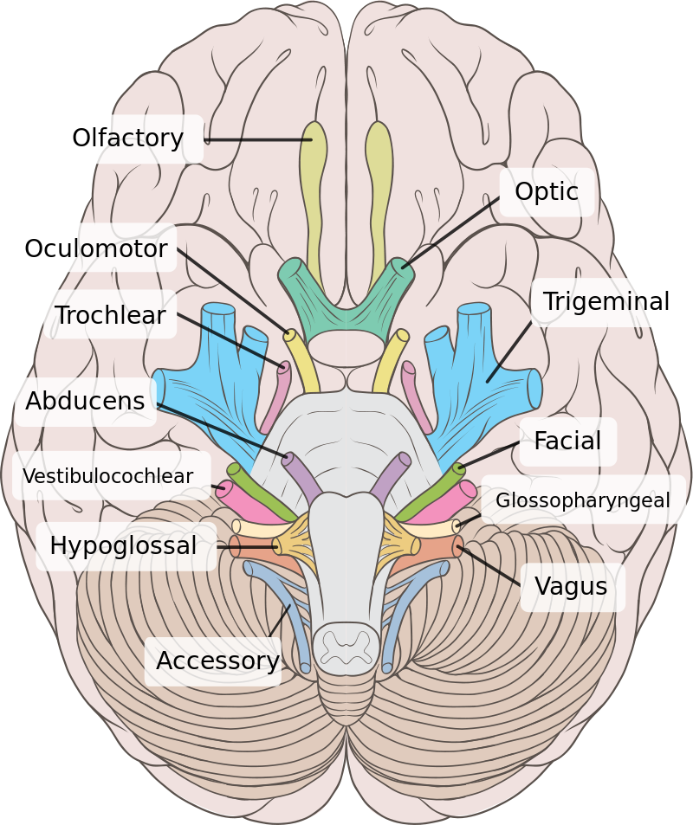
By Brain_human_normal_inferior_view_with_labels_en.svg: *Brain_human_normal_inferior_view.svg: Patrick J. Lynch, medical illustratorderivative work: Beaoderivative work: Dwstultz (talk) - Brain_human_normal_inferior_view_with_labels_en.svg, CC BY 2.5, https://commons.wikimedia.org/w/index.php?curid=15108118
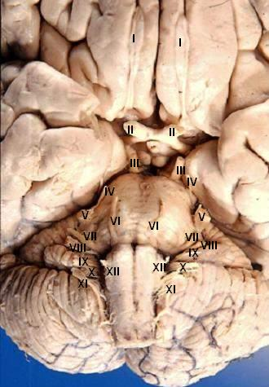
By John A Beal, PhDDep't. of Cellular Biology & Anatomy, Louisiana State University Health Sciences Center Shreveport - http://www.healcentral.org/healapp/showMetadata?metadataId=40566 (Internet Archive of file description page), CC BY 2.5, https://commons.wikimedia.org/w/index.php?curid=891480
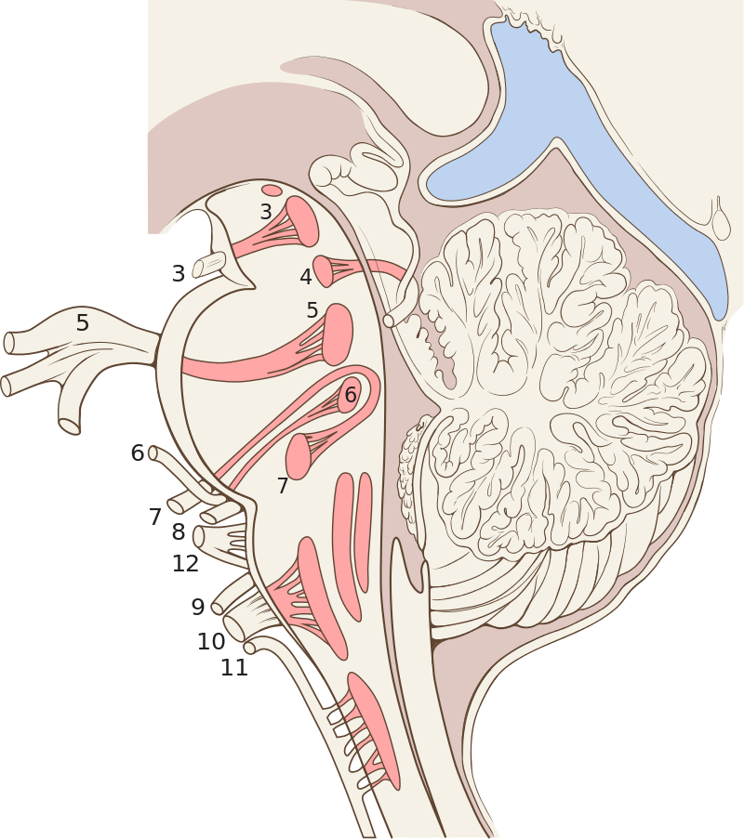
By CFCF - Own work, CC BY-SA 3.0, https://commons.wikimedia.org/w/index.php?curid=31097174

