Anatomy and Physiology 1 Laboratory

Organization of the Nervous System

Objectives:

- Describe the basic structure of a neuron and how these structures function in a neuron
- Identify the different types of neurons on the basis of shape
- List the glial cells of the CNS and describe their function
- List the glial cells of the PNS and describe their function

Nervous tissue is composed of two types of cells, neurons and glial cells. Neurons are responsible for the computation and communication that the nervous system provides. They are electrically active and release chemical signals to communicate between each other and with target cells. Glial cells, or glia or neuroglia, are much smaller than neurons and play a supporting role for nervous tissue. Glial cells maintain the extracellular environment around neurons, improve signal conduction in neurons and protect them from pathogens. Ongoing research also suggests that glial cell number matches neuron number and that they even can send signals themselves.

Neuron Anatomy
Neurons are nucleated cells with specialized structural properties. Some neurons have a single long extension (axon) that reaches great distances, others are very small, star shaped cells without obvious axons.
Though neuron shapes vary greatly, every neuron houses its nucleus in a region known as the cell body (also called soma) from which cellular activity like repair or cell membrane recycling is controlled. Neurons produce many proteins either for their cell membranes or for use when communicating with other cells and therefore also have many rough endoplasmic reticula that are visible with the light microscope; these rough ER are called Nissl bodies.
In figure below, the cell body shows both many short projections and one long projection emerging from the cell body. These short projections are dendrites which receive most of the input from other neurons or stimuli in the extracellular environment; the location of the dendrites on the neuron marks the receptive region of the neuron. Dendrites are usually highly branched processes, providing locations for other neurons to communicate with the neuron. Neurons have polarity—meaning that information flows in one direction through the neuron. In the Figure below neuron, information flows from the dendrites, across the cell body, and down the large axon emerging from the cell body at the axon hillock (axon hillock is an anatomical term to describe where the cell body and axon meet). The first section of the axon where an action potential is generated is called the initial segment. Often axons are wrapped by myelin sheaths, leaving exposed sections (node of Ranvier) between segments of myelin. Myelin is produced by oligodendrocytes (glial cells) in the CNS and acts as electrical insulation, speeding information conduction down the neuron. Once information reaches the terminal end of this neuron, it is transferred to another cell. The site of communication between a neuron and its target cell is called a synapse. The terminal end has several branches, each with a synaptic end bulb to store chemicals needed for communication with the next cell. Figure below shows the relationship of these parts to one another.

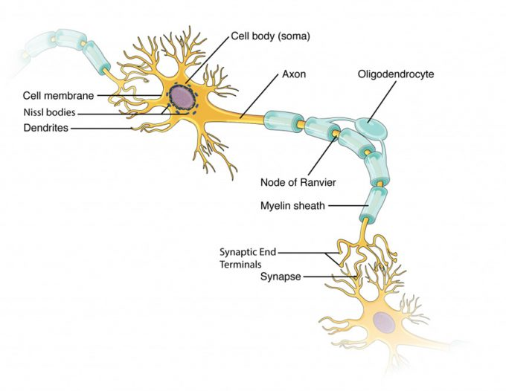

Types of Neurons

There are trillions of neurons in the nervous system and cell shape can vary widely. Three common shapes of neurons are shown in figure below.

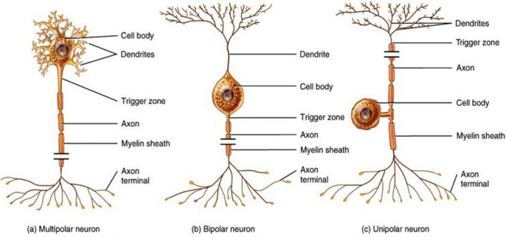
Neuron Classification by Shape: Unipolar cells have one process that includes both the axon and dendrite. Bipolar cells have two processes, the axon and a dendrite. Multipolar cells have more than two processes, the axon and two or more dendrites.

Multipolar neurons have multiple processes emerging from their cell bodies (hence their name, multipolar). They have dendrites attached to their cell bodies and often, one long axon. Motor neurons are multipolar neurons, as are most of the CNS.

Bipolar cells have two processes, which extend from each end of the cell body, opposite to each other. One is the axon and one the dendrite. Bipolar cells are not very common. They are found mainly in the olfactory epithelium (where smell stimuli are sensed), and as part of the retina in the eye.

Unipolar cells have one long axon emerging from the cell body, but the cell body is located at neither end of that axon. At one end of the axon are dendrites, and at the other end, the axon forms synaptic connections with a target cell. Unipolar cells are exclusively sensory neurons and have their dendrites in the periphery where they detect stimuli.

Glial Cells
There are six types of glial cells. Four of them are found in the CNS and two are found in the PNS. Table below outlines some common characteristics and functions.
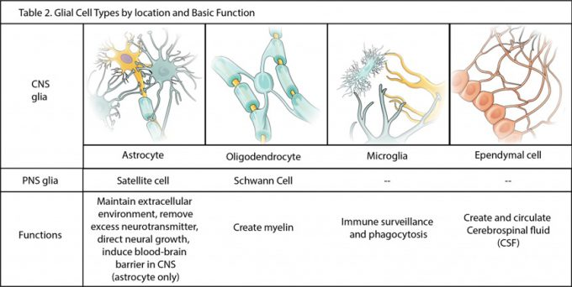

Glial Cells of the CNS
One cell providing support to neurons of the CNS is the astrocyte, so named because it appears to be star-shaped under the microscope (astro- = “star”). Astrocytes have many processes extending from their main cell body (not axons or dendrites like neurons, just cell extensions). Those processes extend to interact with neurons, blood vessels, or the connective tissue covering the CNS. Generally, they are supporting cells for the neurons in the central nervous system. Some ways in which they support neurons in the central nervous system are by maintaining the concentration of chemicals in the extracellular space, removing excess signaling molecules, reacting to tissue damage, and contributing to the blood-brain barrier (BBB). The blood-brain barrier is a physiological barrier that keeps many substances that circulate in the blood from getting into the central nervous system, restricting what can cross from circulating blood into the CNS. Usually, blood vessels are leaky because there are gaps between the cells of the vessel walls. These gaps permit rapid movement of molecules out of the blood into the extracellular space around tissue cells, delivering nutrients and hormones. However, the neurons of the brain may be affected by rapid, regular changes in extracellular concentrations preventing signal transmission. To prevent such fluctuations, astrocytes release compounds to the blood vessels, inducing tight junctions between the otherwise leaky blood vessel cells. When the BBB is intact, nutrient molecules, such as glucose or amino acids, must now pass through the vessel cells of the BBB by transcellular processes (using membrane proteins). Small, fat soluble molecules (respiratory gases, alcohol) are able simply diffuse through the cell membranes, but other large, water soluble molecules cannot. The highly restrictive permeability of the BBB may restrict drug delivery to the CNS. Pharmaceutical companies are challenged to design drugs that can cross the BBB as well as have an effect on the nervous system.

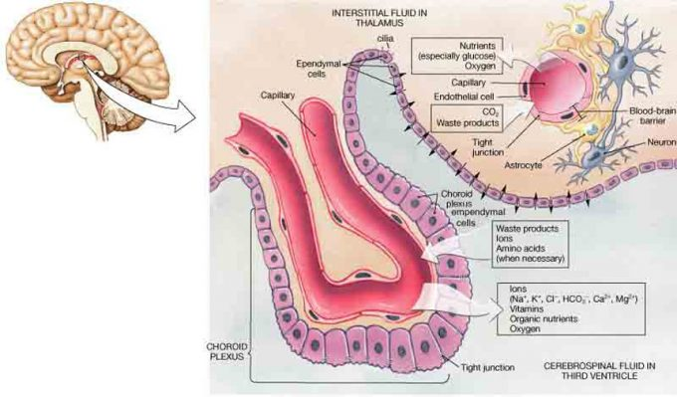
Glial Cells of the CNS: The CNS has astrocytes, oligodendrocytes, microglia, and ependymal cells that support the neurons of the CNS in several ways.

Also found in CNS tissue is the oligodendrocyte, sometimes called just “oligo,” which is the glial cell type that insulates axons in the CNS. The name means “cell of a few branches” (oligo- = “few”; dendro- = “branches”; -cyte = “cell”). There are a few processes that extend from the cell body. Each one reaches out and surrounds an axon to insulate it in myelin. One oligodendrocyte will provide the myelin for multiple axon segments, either for the same axon or for separate axons.

Microglia are, as the name implies, smaller than most of the other glial cells. Ongoing research into these cells, although not entirely conclusive, suggests that they may originate as white blood cells, called macrophages, that become part of the CNS during early development. While their origin is not conclusively determined, their function is related to what macrophages do in the rest of the body. When macrophages encounter diseased or damaged cells in the rest of the body, they ingest and digest those cells or the pathogens that cause disease. Microglia are the cells in the CNS that can do this in normal, healthy tissue, and they are therefore also referred to as CNS-resident macrophages.

Ependymal cells filter blood to make cerebrospinal fluid (CSF), the fluid that circulates through the CNS. CSF is needed in the brain to provide nutrients, remove wastes and create a stable extracellular environment because the BBB is so restrictive. In each of the brain cavities (ventricles), ependymal cells come in contact with blood vessels to filter and absorb specific components of the blood. These choroid plexuses produce enough cerebrospinal fluid everyday to fill a pint glass! Though the BBB is absent in the choroid plexuses, the ependymal cells there are connected to each other by tight connections, forming a highly restrictive boundary. More ependymal cells line the ventricles and use their cilia to help move the CSF through the ventricular space.

Glial Cells of the PNS
One of the two types of glial cells found in the PNS is the satellite cell. Satellite cells surround the cell bodies of neurons in the PNS. They provide support, performing similar functions in the periphery as astrocytes do in the CNS—except, of course, for establishing the BBB.

The second type of glial cell is the Schwann cell, which insulate axons with myelin in the periphery. Schwann cells are different than oligodendrocytes in that a Schwann cell wraps around a portion of only one axon segment and no others. Oligodendrocytes have processes that reach out to multiple axon segments, whereas the entire Schwann cell surrounds just one axon segment. The nucleus and cytoplasm of the Schwann cell are on the edge of the myelin sheath.

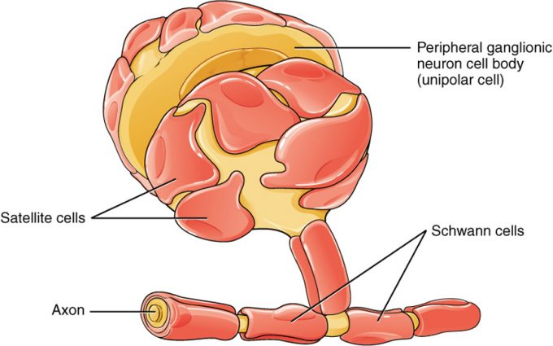
Glial Cells of the PNS: Satellite cells associate with the cell bodies, and Schwann cells associate with the axons of neurons in the PNS.

Myelin
Oligodendrocytes in the CNS and Schwann cells in the PNS provide myelin. Whereas the manner in which either cell is associated with the axon segment, or segments, that it insulates is different, the means of myelinating an axon segment is mostly the same in the two situations. Myelin is a lipid-rich sheath that surrounds the axon and by doing so creates a myelin sheath that facilitates the transmission of electrical signals along the axon. The lipids are essentially the phospholipids of the glial cell membrane. Myelin, however, is more than just the membrane of the glial cell. It also includes important proteins that are integral to that membrane. Some of the proteins help to hold the layers of the glial cell membrane closely together.

The appearance of the myelin sheath can be thought of as similar to the pastry wrapped around a hot dog for “pigs in a blanket” or a similar food. The glial cell is wrapped around the axon several times with little to no cytoplasm between the glial cell layers. For oligodendrocytes, the rest of the cell is separate from the myelin sheath as a cell process extends back toward the cell body. A few other processes provide the same insulation for other axon segments in the area. For Schwann cells, the outermost layer of the cell membrane contains cytoplasm and the nucleus of the cell as a bulge on one side of the myelin sheath. During development, the glial cell is loosely or incompletely wrapped around the axon. The edges of this loose enclosure extend toward each other, and one end tucks under the other. The inner edge wraps around the axon, creating several layers, and the other edge closes around the outside so that the axon is completely enclosed.
The axon contains microtubules and neurofilaments that are bounded by a plasma membrane known as the axolemma. Outside the plasma membrane of the axon is the myelin sheath, which is composed of the tightly wrapped plasma membrane of a Schwann cell. What aspects of the cells in this image react with the stain to make them a deep, dark, black color, such as the multiple layers that are the myelin sheath?

Myelin sheaths can extend for one or two millimeters, depending on the diameter of the axon. Axon diameters can be as small as 1 to 20 micrometers. Because a micrometer is 1/1000 of a millimeter, this means that the length of a myelin sheath can be 100–1000 times the diameter of the axon. Figures below show the myelin sheath surrounding an axon segment, but are not to scale. If the myelin sheath were drawn to scale, the neuron would have to be immense—possibly covering an entire wall of the room in which you are sitting.
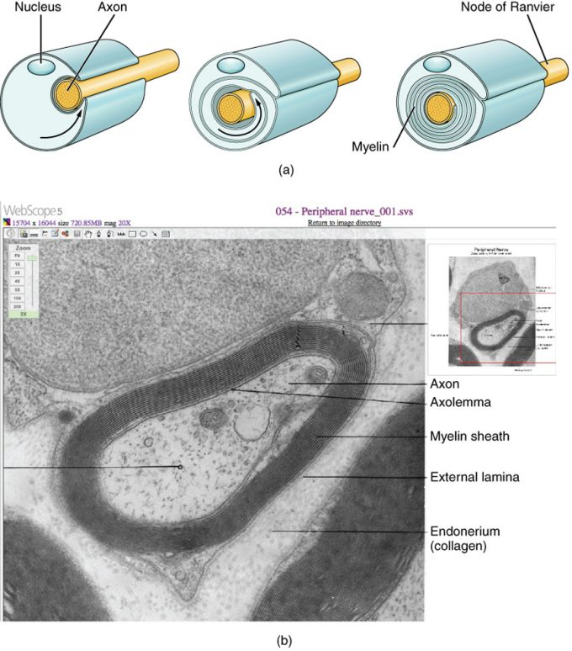
The Process of Myelination: Myelinating glia wrap several layers of cell membrane around the cell membrane of an axon segment. A single Schwann cell insulates a segment of a peripheral nerve, whereas in the CNS, an oligodendrocyte may provide insulation for a few separate axon segments. EM × 1,460,000. (Micrograph provided by the Regents of University of Michigan Medical School © 2012)

In the Lab
Examine the prepared microscope slides the neuron, nerve, & nerve fibers.
Draw & label the neuron, nerve & nerve fibers in the space provided.

Critical Thinking Questions

1. Multiple sclerosis is a demyelinating disease affecting the central nervous system. What type of cell would be the most likely target of this disease? Why?

2. Suppose a unipolar neuron has half of its axon in the CNS and the other half in the PNS. If this neuron is fully myelinated, what cells would be involved and where?

