Anatomy and Physiology 1 Laboratory

Appendicular Muscles: Pelvic Girdle & Lower Limb

Objectives
- Locate the muscles of the pelvic girdle & lower limb on laboratory charts and models.
- Recognize on the models the origin, insertion, and action of the muscles of the pelvic girdle & lower limb
- Describe and demonstrate the action of the muscles of the pelvic girdle & lower limb.

The appendicular muscles of the lower body position and stabilize the pelvic girdle, which serves as a foundation for the lower limbs. Comparatively, there is much more movement at the pectoral girdle than at the pelvic girdle. There is very little movement of the pelvic girdle because of its connection with the sacrum at the base of the axial skeleton and because the deep acetabulum provides a stable point of articulation with the head of the femur. The pelvic girdle’s lack of range of motion allows it to stabilize and support the body. The body’s center of gravity is in the area of the pelvis. If the center of gravity were not to remain fixed, standing up would be difficult. Therefore, what the leg muscles lack in range of motion and versatility, they make up for in size and power, facilitating the body’s stabilization, posture, and movement.

Muscles of the Pelvic Floor and Perineum
The pelvic floor (also referred to as the pelvic diaphragm) is a muscular sheet that defines the inferior portion of the pelvic cavity. The pelvic floor extends anteriorly to posteriorly from the pubis to the coccyx and is comprised of the levator ani and the ischiococcygeus. Its openings include the anal canal and urethra, and the vagina in women.

The large levator ani consists of two skeletal muscles, the pubococcygeus and the iliococcygeus. The levator ani is considered the most important muscle of the pelvic floor because it supports the pelvic viscera. It resists the pressure produced by contraction of the abdominal muscles so that the pressure is applied to the colon to aid in defecation and to the uterus to aid in childbirth (assisted by the ischiococcygeus, which pulls the coccyx anteriorly). This muscle also creates skeletal muscle sphincters at the urethra and anus.
The perineum is the diamond-shaped space between the pubic symphysis (anteriorly), the coccyx (posteriorly), and the ischial tuberosities (laterally), lying just inferior to the pelvic diaphragm (levator ani and ischiococcygeus). Divided transversely into triangles, the anterior is the urogenital triangle, which includes the external genitals and the posterior is the anal triangle containing the anus. The perineum is also divided into superficial and deep layers with some of the muscles common to men and women. Women also have the compressor urethrae and the sphincter urethrovaginalis, which function to close the vagina. In men, the deep transverse perineal muscle plays a role in ejaculation.

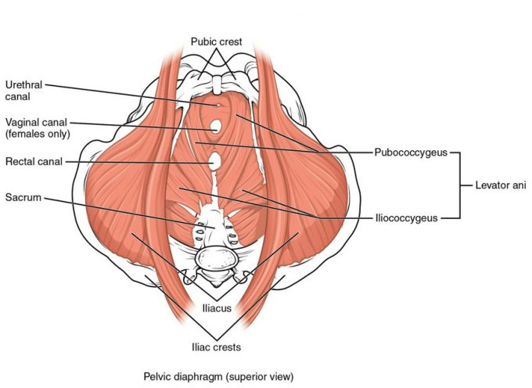
Muscles of the Pelvic Floor. The pelvic floor muscles support the pelvic organs, resist intra-abdominal pressure, and work as sphincters for the urethra, rectum, and vagina.

In The Lab
- Review the muscles of the pelvic floor & perineum in the images and tables provided
- Examine the pelvic floor & perineum muscles charts provided in lab, locate each muscle (origin, insertion & innervation) and describe its action.
- Review the movement and action of each pelvic floor & perineum muscle using your and your lab partners.

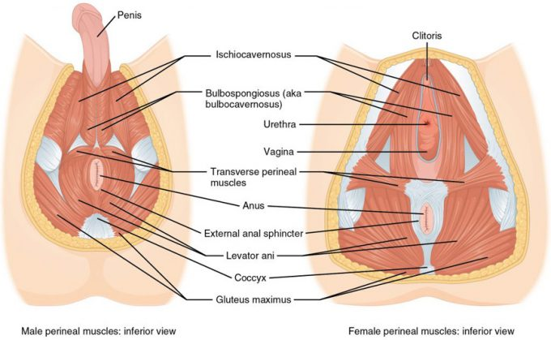
Muscles of the Perineum. The perineum muscles play roles in urination in both sexes, ejaculation in men, and vaginal contraction in women.

Muscles of the Perineum Common to Men and Women
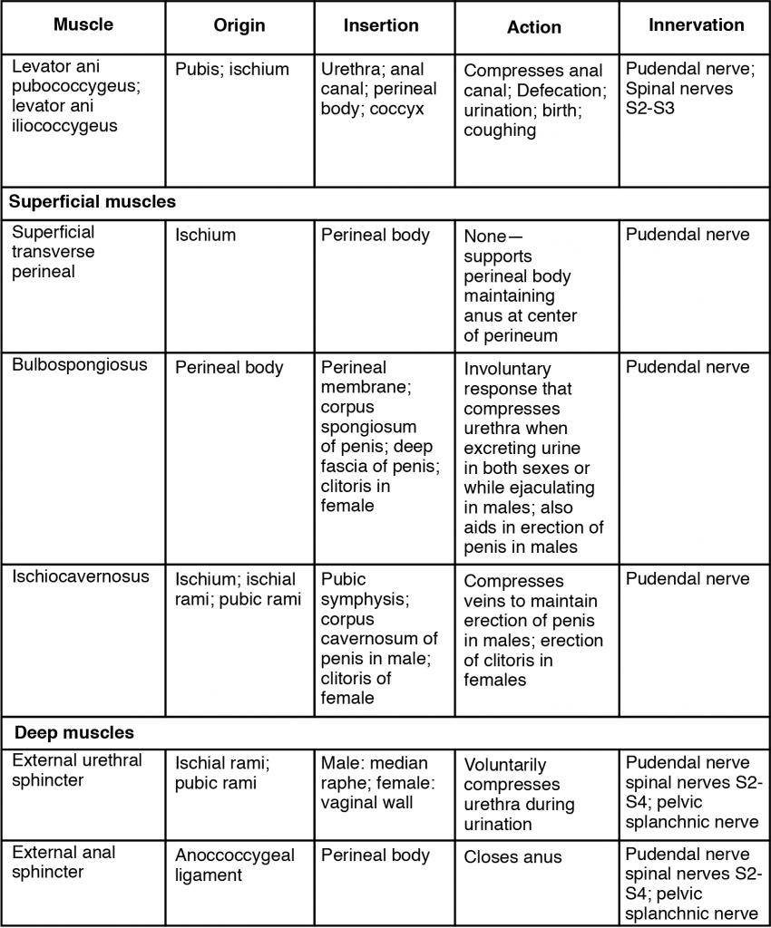

Appendicular Muscles Of The Pelvic Girdle And Lower Limbs

The appendicular muscles of the lower body position and stabilize the pelvic girdle, which serves as a foundation for the lower limbs. Comparatively, there is much more movement at the pectoral girdle than at the pelvic girdle. There is very little movement of the pelvic girdle because of its connection with the sacrum at the base of the axial skeleton and because the deep acetabulum provides a stable point of articulation with the head of the femur. The pelvic girdle’s lack of range of motion allows it to stabilize and support the body. The body’s center of gravity is in the area of the pelvis. If the center of gravity were not to remain fixed, standing up would be difficult. Therefore, what the leg muscles lack in range of motion and versatility, they make up for in size and power, facilitating the body’s stabilization, posture, and movement.

Gluteal Region Muscles That Move the Thigh

Most muscles that insert on the femur (the thigh bone) and move it, originate on the pelvic girdle. The major flexors of the hip are the psoas major and iliac which make up the iliopsoas group. Some of the largest and most powerful muscles in the body are the gluteal muscles or gluteal group. The gluteus maximus, one of the major extensors of the thigh at the hip, is the largest; deep to the gluteus maximus is the gluteus medius, and deep to the gluteus medius is the gluteus minimus, the smallest of the trio.

The tensor fascia latae is a thick, squarish muscle in the superior aspect of the lateral thigh. It acts as a synergist of the gluteus medius and iliopsoas in flexing and abducting the thigh. It also helps stabilize the lateral aspect of the knee by pulling on the iliotibial tract (band), making it taut. Deep to the gluteus maximus, the piriformis, obturator internus, obturator externus, superior gemellus, inferior gemellus, and quadratus femoris laterally rotate the thigh at the hip.

Deep fascia in the thigh separates it into medial, anterior, and posterior compartments. The muscles in the medial compartment of the thigh responsible for adducting the femur at the hip are the adductor group including the adductor longus, adductor brevis, and adductor magnus which all adduct and medially rotate the thigh. The adductor longus also flexes the thigh, whereas the adductor magnus extends it. Like the adductor longs, the pectineus adducts and flexes the femur at the hip. The pectineus is located in the femoral triangle, which is formed at the junction between the hip and the leg and includes the femoral nerve, the femoral artery, the femoral vein, and the deep inguinal lymph nodes. The strap-like gracilis adducts the thigh in addition to flexing the leg at the knee.

The muscles of the anterior compartment of the thigh flex the thigh and extend the leg. This compartment contains the quadriceps femoris group, which is comprised of four muscles that extend the leg and stabilize the knee. Within the compartment the rectus femoris is on the anterior aspect of the thigh, the vastus lateralis is on the lateral aspect of the thigh, the vastus medialis is on the medial aspect of the thigh, and the vastus intermedius is between the vastus lateralis and vastus medialis and deep to the rectus femoris. The tendon common to all four is the quadriceps tendon (patellar tendon), which inserts into the patella and continues below it as the patellar ligament. The patellar ligament attaches to the tibial tuberosity. In addition to the quadriceps femoris, the sartorius is a band-like muscle that extends from the anterior superior iliac spine to the medial side of the proximal tibia. This versatile muscle flexes the leg at the knee and flexes, abducts, and laterally rotates the thigh at the hip. This muscle allows us to sit cross-legged.

The posterior compartment of the thigh includes muscles that flex the leg and extend the thigh. The three long muscles on the back of the thigh are the hamstring group, which flexes the knee. These are the biceps femoris, semitendinosus, and semimembranosus. The tendons of these muscles form the upper border of the popliteal fossa, the diamond-shaped space at the back of the knee.

In The Lab
- Review the muscles of muscles of the pelvic girdle in the images and tables provided
- Examine the model and muscles charts provided in lab, locate each muscle (origin, insertion & innervation) and describe its action.
- Review the movement and action of each muscle using yours and your lab partners.

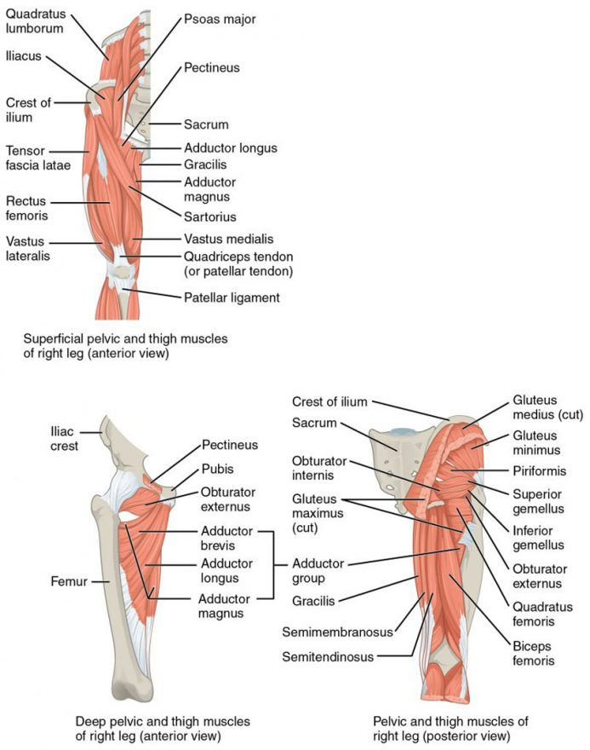
Hip and Thigh Muscles. The large and powerful muscles of the hip that move the femur generally originate on the pelvic girdle and insert into the femur. The muscles that move the lower leg typically originate on the femur and insert into the bones of the knee joint. The anterior muscles of the femur extend the lower leg but also aid in flexing the thigh. The posterior muscles of the femur flex the lower leg but also aid in extending the thigh. A combination of gluteal and thigh muscles also adduct, abduct, and rotate the thigh and lower leg.
Gluteal Region Muscles That Move the Femur
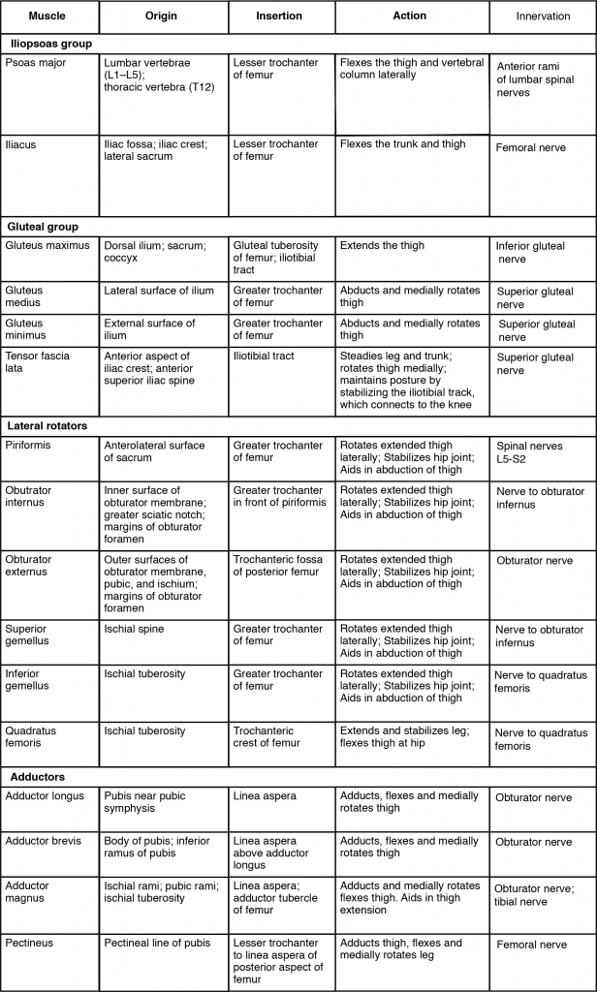

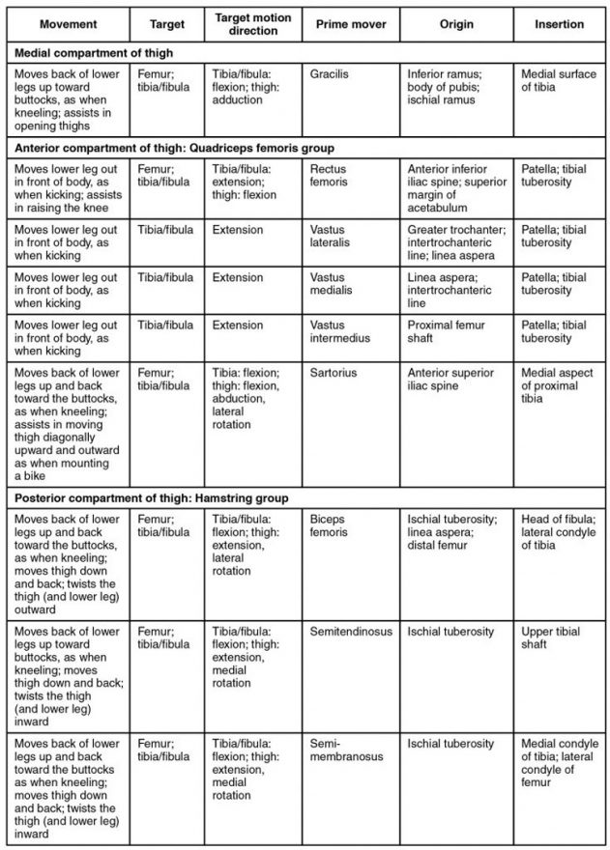
Muscles That Move the Feet and Toes

Similar to the thigh muscles, the muscles of the leg are divided by deep fascia into compartments, although the leg has three: anterior, lateral, and posterior.
The muscles in the anterior compartment of the leg all contribute to dorsiflexion: the tibialis anterior, a long and thick muscle on the lateral surface of the tibia, the extensor hallucis longus, deep under it, and the extensor digitorum longus, lateral to it. The fibularis tertius, a small muscle that originates on the anterior surface of the fibula, is associated with the extensor digitorum longus and sometimes fused to it, but is not present in all people. Thick bands of connective tissue called the superior extensor retinaculum (transverse ligament of the ankle) and the inferior extensor retinaculum, hold the tendons of these muscles in place during dorsiflexion.

The lateral compartment of the leg includes two muscles which contribute to eversion and plantar flexion: the fibularis longus (peroneus longus) and the fibularis brevis (peroneus brevis). The superficial muscles in the posterior compartment of the leg all insert onto the calcaneal tendon (Achilles tendon), a strong tendon that inserts into the calcaneal bone of the ankle, all contribute to plantar flexion. The muscles in this compartment are large and strong and keep humans upright. The most superficial and visible muscle of the calf is the gastrocnemius. Deep to the gastrocnemius is the wide, flat soleus. The plantaris runs obliquely between the two; some people may have two of these muscles, whereas no plantaris is observed in about seven percent of other cadaver dissections. The plantaris tendon is a desirable substitute for the fascia lata in hernia repair, tendon transplants, and repair of ligaments. There are four deep muscles in the posterior compartment of the leg as well: the popliteus, flexor digitorum longus, flexor hallucis longus, and tibialis posterior all contribute to plantar flexion or inversion of the foot.

The foot also has intrinsic muscles, which originate and insert within it (similar to the intrinsic muscles of the hand). These muscles primarily provide support for the foot and its arch, and contribute to movements of the toes (Figure 6 and Figure 7). The principal support for the longitudinal arch of the foot is a deep fascia called plantar aponeurosis, which runs from the calcaneus bone to the toes (inflammation of this tissue is the cause of “plantar fasciitis,” which can affect runners. The intrinsic muscles of the foot include the extensor digitorum brevis on the dorsal aspect and a plantar group, which consists of four layers.
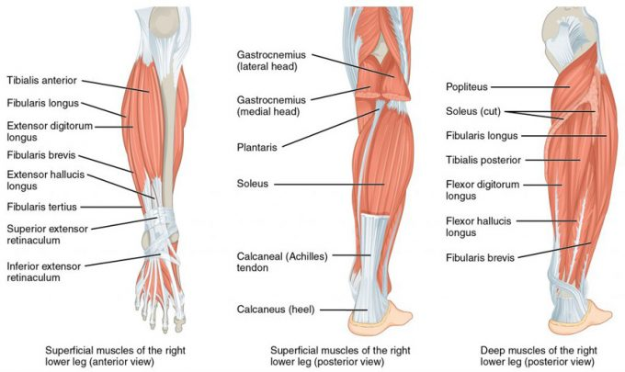
Muscles of the Lower Leg. The muscles of the anterior compartment of the lower leg are generally responsible for dorsiflexion, and the muscles of the posterior compartment of the lower leg are generally responsible for plantar flexion. The lateral and medial muscles in both compartments invert, evert, and rotate the foot.

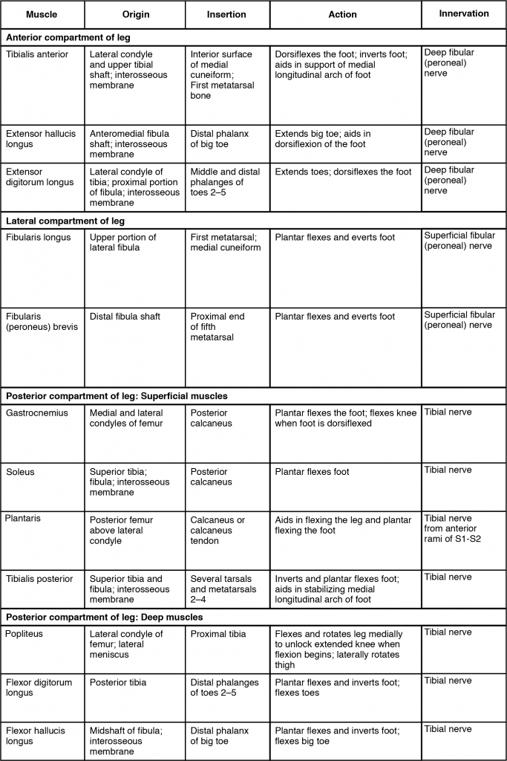
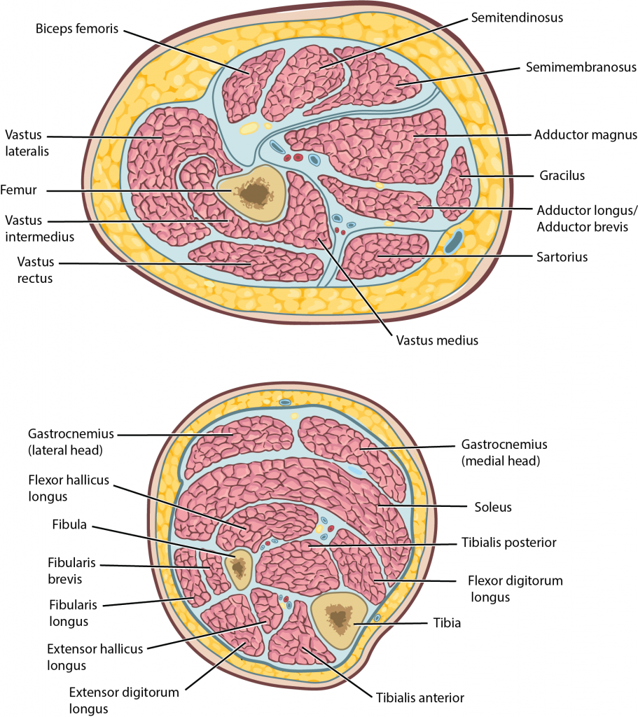

Compartments of the leg.
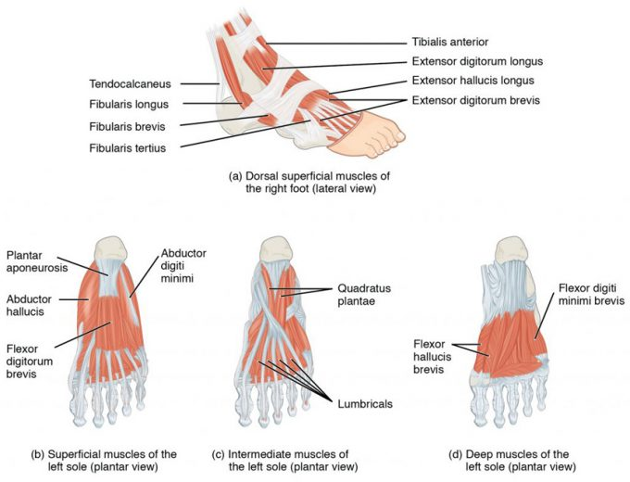
Intrinsic Muscles of the Foot. The muscles along the dorsal side of the foot (a) generally extend the toes while the muscles of the plantar side of the foot (b, c, d) generally flex the toes. The plantar muscles exist in three layers, providing the foot the strength to counterbalance the weight of the body. In this diagram, these three layers are shown from a plantar view beginning with the bottom-most layer just under the plantar skin of the foot (b) and ending with the top-most layer (d) located just inferior to the foot and toe bones.

In The Lab
- Review the muscles of the lower limb in the images and tables provided
- Examine the model and muscles charts provided in lab, locate each muscle (origin, insertion & innervation) and describe its action.
- Review the movement and action of each muscle with your lab partners

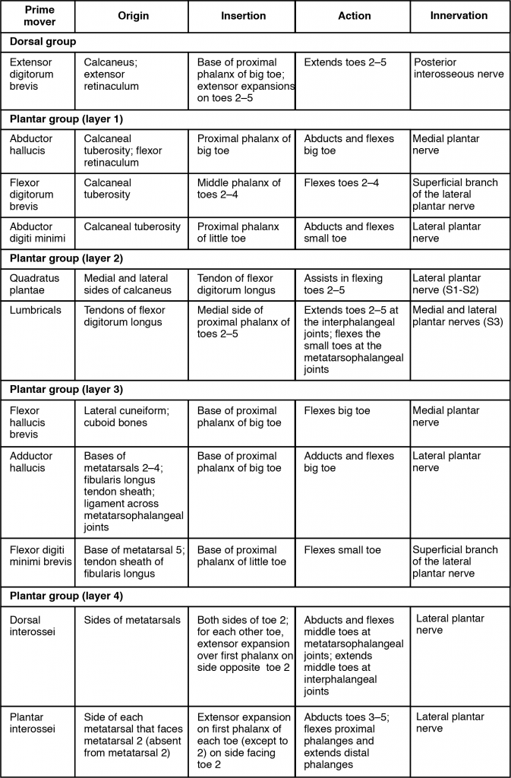
Intrinsic Muscles in the Foot

