Anatomy and Physiology 1 Laboratory

Appendicular Muscles: Pectoral Girdle & Upper Limb

Objectives
- Locate the muscles of the pectoral girdle & upper limb on laboratory charts and models.
- Recognize on the models the origin, insertion, and action of the muscles of the pectoral girdle & upper limb.
- Describe and demonstrate the action of the muscles of the pectoral girdle & upper limb.

Muscles of the shoulder and upper limb can be divided into four groups: muscles that stabilize and position the pectoral girdle, muscles that move the arm, muscles that move the forearm, and muscles that move the wrists, hands, and fingers.

Muscles That Position the Pectoral Girdle
The pectoral girdle, or shoulder girdle, consists of the lateral ends of the clavicle and scapula, along with the proximal end of the humerus, and the muscles covering these three bones to stabilize the shoulder joint. The girdle creates a base from which the head of the humerus, in its ball-and-socket joint with the glenoid fossa of the scapula, can move the arm in multiple directions. Muscles that position the pectoral girdle are located either on the anterior thorax or on the posterior thorax. The anterior muscles include the subclavius, pectoralis minor, and serratus anterior. The posterior muscles include the trapezius, rhomboid major, and rhomboid minor. When the rhomboids are contracted, your scapula moves medially, which can pull the shoulder and upper limb posteriorly.

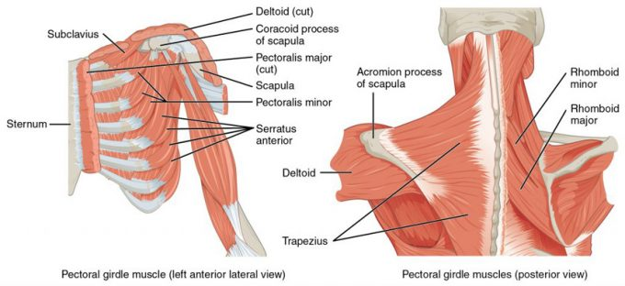
Muscles That Position the Pectoral Girdle. The muscles that stabilize the pectoral girdle make it a steady base on which other muscles can move the arm. Note that the pectoralis major and deltoid, which move the humerus, are cut here to show the deeper positioning muscles.
Muscles | Origin | Insertion | Action | Innervation
Serratus anterior | Superior & anterior margins of ribs 1-8/9 | Anterior surface of vertebral border of scapula | Rotates scapula for glenoid cavity to move upward, protracts shoulder | Long thoracic nerve (C ₅₋₇)
Subclavius | Rib #1 | Inferior border of clavicle | Protracts & depresses shoulder | Subclavius nerve (C ₅₋₆)
Trapezius | Spinous process of thoracic vertebrae, ligament nuchae, occipital bone | Scapular spine and acromion, clavicle | Extend neck  Elevate, retract, depress, rotate scapula,  Elevate clavicle | Accessory Nerve (N XI)  Cervical spinal nerves (C ₃₋₄)
Pectoralis minor | Superior & anterior surface of rubs 3-5 | Scapula; coracoid process | Protracts/elevates shoulder  Rotates scapula to allow glenoid cavity to rotate downward | Medial pectoral nerve ( C ₈ ,T ₁)
Rhomboid major | Spinous process of superior thoracic vertebrae | Scapula;vertebral border, from spine to inferior angle | Adducts scapula  Downward rotation of scapula | Dorsal scapular nerve C ₅
Rhomboid minor | Spinous process of vertebrae C ₇ - T ₁ | Scapula;vertebral border | Adducts scapula  Downward rotation of scapula | Dorsal scapular nerve C
Levator scapulae | Cervical vertebrae 1-4 (transverse processes)` | Scapula; vertebral border | Elevates scapula | Cervical nerves C _{3 – 4} & dorsal scapular nerve;  C ₅

In The Lab
- Review the muscles of the pectoral girdle in the images and tables provided
- Examine the model and muscles charts provided in lab, locate each muscle (origin, insertion & innervation) and describe its action.
- Review the movement and action of each muscle with your lab partners
Muscles That Move the Humerus
Similar to the muscles that position the pectoral girdle, muscles that cross the shoulder joint and move the humerus bone of the arm include both axial and scapular muscles. The two axial muscles are the pectoralis major and the latissimus dorsi. The pectoralis major is thick and fan-shaped, covering much of the superior portion of the anterior thorax. The broad, triangular latissimus dorsi is located on the inferior part of the back and has multiple points of origin including the lumbosacral fascia attached to the inferior 6 thoracic vertebrae, the inferior 3 ribs, the iliac crest and inferior angle of the scapula.
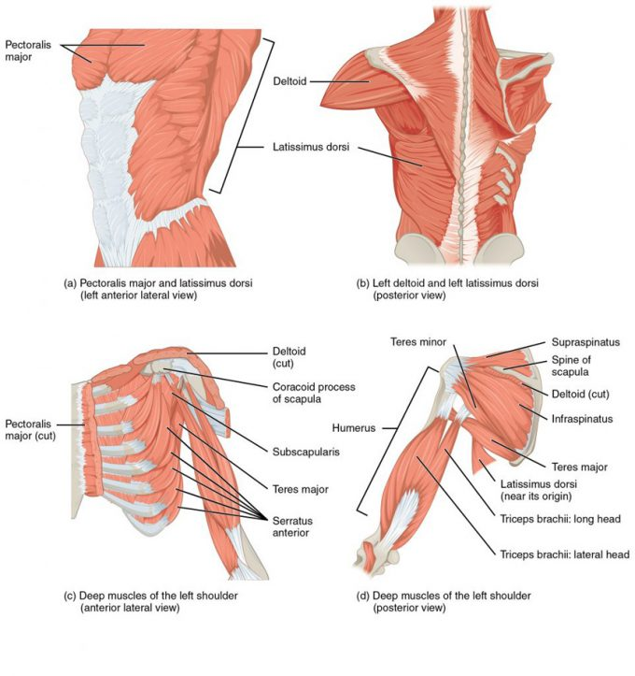
Muscles That Move the Humerus. (a, c) The muscles that move the humerus anteriorly are generally located on the anterior side of the body and originate from the sternum (e.g., pectoralis major) or the anterior side of the scapula (e.g., subscapularis). (b) The muscles that move the humerus superiorly generally originate from the superior surfaces of the scapula and/or the clavicle (e.g., deltoids). The muscles that move the humerus inferiorly generally originate from middle or lower back (e.g., latissiumus dorsi). (d) The muscles that move the humerus posteriorly are generally located on the posterior side of the body and insert into the scapula (e.g., infraspinatus).

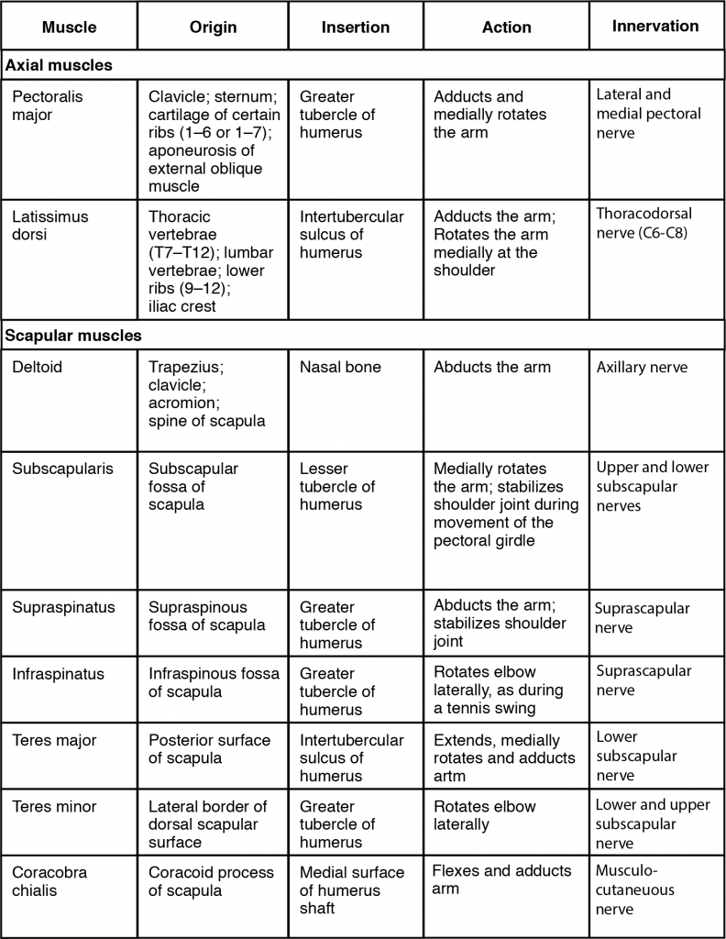

The rest of the shoulder muscles originate on the scapula and help to move the arm. The deltoid is the major abductor of the arm but also facilitates flexing and medial rotation, as well as extension and lateral rotation. The subscapularis originates on subscapular fossa and medially rotates the arm. Named for their locations, the supraspinatus (originating from the supraspinous fossa) and the infraspinatus (originating from the infraspinous fossa) abduct the arm, and laterally rotate the arm, respectively. The thick and flat teres major is inferior to the teres minor and extends the arm, and assists in its adduction and medial rotation. The long teres minor laterally rotates the arm. Finally, the coracobrachialis flexes and adducts the arm.

The tendons of the subscapularis, supraspinatus, infraspinatus, and teres minor connect the scapula to the humerus, forming the rotator cuff (musculotendinous cuff), the circle of tendons around the shoulder joint. Although the shoulder joint allows a great deal of freedom of movement due to the shallow glenoid cavity it is extremely vulnerable to downward dislocation. The muscles and tendons of the rotator cuff provide stability to the joint. When baseball pitchers undergo shoulder surgery it is usually on the rotator cuff, which becomes pinched and inflamed, and may tear away from the bone due to the repetitive motion of bringing the arm overhead to throw a fast pitch.

Movements
- Flexion and extension of the shoulder joint in the (sagittal plane).
- Flexion is carried out by the anterior fibres of the deltoid, pectoralis major and the coracobrachialis.
- Extension is carried out by the latissimus dorsi and posterior fibres of the deltoid.

- Abduction and adduction of the shoulder (frontal plane).
- Abduction is carried out by the deltoid and the supraspinatus in the first 90 degrees.
- From 90-180 degrees it is the trapezius and the serratus anterior.
- Adduction is carried out by the pectoralis major, lattisimus dorsi, teres major and the subscapularis.

- Horizontal abduction and horizontal adduction of the shoulder (transverse plane)
- Medial and lateral rotation of shoulder (also known as internal and external rotation).
- Medial rotation is carried out by the anterior fibres of the deltoid, teres major, subscapularis, pectoralis major and the lattissimus dorsi.
- Lateral rotation is carried out by the posterior fibres of the deltoid, infraspinatus and the teres minor.

- Circumduction of the shoulder (a combination of flexion/extension and abduction/adduction).

https://en.wikipedia.org/wiki/Shoulder_joint

Clinical Significance
The capsule can become inflamed and stiff, with abnormal bands of tissue (adhesions) growing between the joint surfaces, causing pain and restricting movement of the shoulder, a condition known as frozen shoulder or adhesive capsulitis.

A SLAP tear (superior labrum anterior to posterior) is a rupture in the glenoid labrum. SLAP tears are characterized by shoulder pain in specific positions, pain associated with overhead activities such as tennis or overhand throwing sports, and weakness of the shoulder. This type of injury often requires surgical repair.

Anterior dislocation of the glenohumeral joint occurs when the humeral head is displaced in the anterior direction. Anterior shoulder dislocation often is a result of a blow to the shoulder while the arm is in an abducted position. In younger people, these dislocation events are most commonly associated with fractures on the humerus and/or glenoid and can lead to recurrent instability. In older people, recurrent instability is rare but people often suffer rotator cuff tears.[citation needed] It is not uncommon for the arteries and nerves (axillary nerve) in the axillary region to be damaged as a result of a shoulder dislocation; which if left untreated can result in weakness, muscle atrophy, or paralysis.

Subacromial bursitis is a painful condition caused by inflammation which often presents a set of symptoms known as subacromial impingement.

https://en.wikipedia.org/wiki/Shoulder_joint

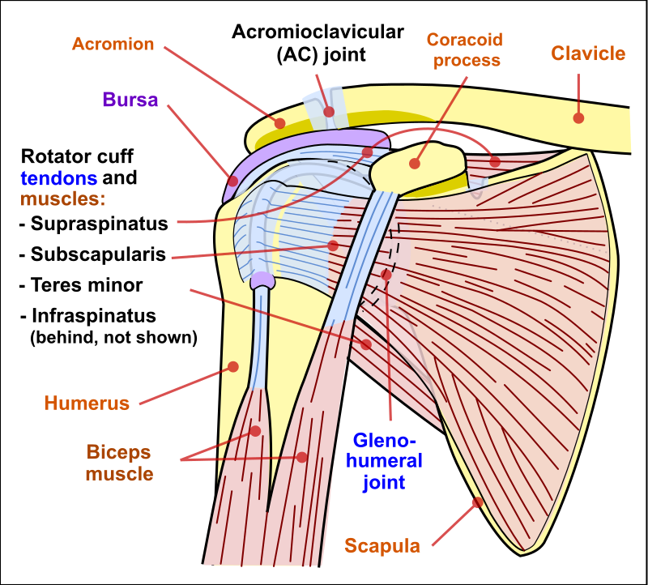
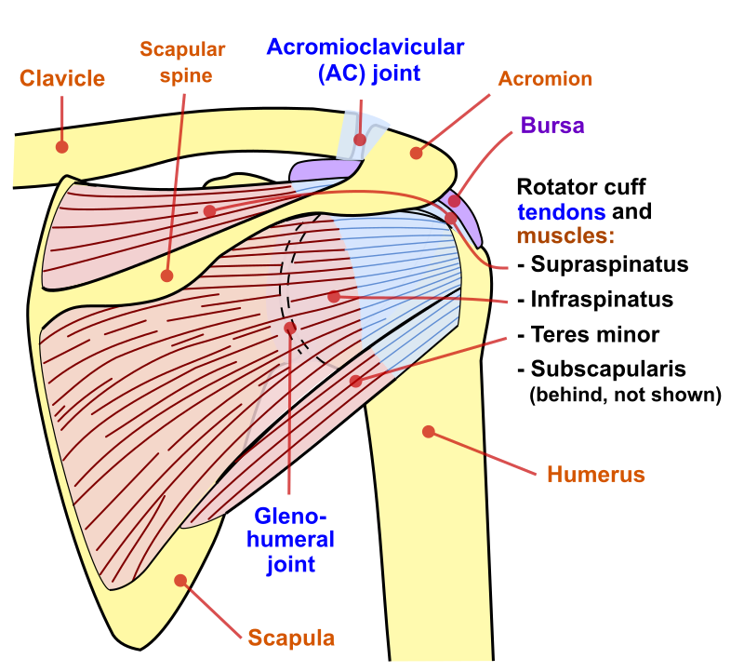

Muscles of the Forearm
The forearm, made of the radius and ulna bones, has four main types of action at the hinge of the elbow joint: flexion, extension, pronation, and supination. When the forearm faces anteriorly, it is supinated. When the forearm faces posteriorly, it is pronated. The forearm flexors include the biceps brachii, brachialis, and brachioradialis. The extensors are the triceps brachii and anconeus. The pronators are the pronator teres and the pronator quadratus, and the supinator turns the forearm anteriorly.
The biceps brachii, brachialis, and brachioradialis flex the forearm. The two-headed biceps brachii crosses the shoulder and elbow joints to flex the forearm, also taking part in supinating the forearm at the radioulnar joints and flexing the arm at the shoulder joint. Deep to the biceps brachii, the brachial is a synergist in forearm flexion. Finally, the brachioradialis can flex the forearm quickly or help lift a load slowly. These muscles and their associated blood vessels and nerves form the anterior compartment of the arm (anterior flexor compartment of the arm)

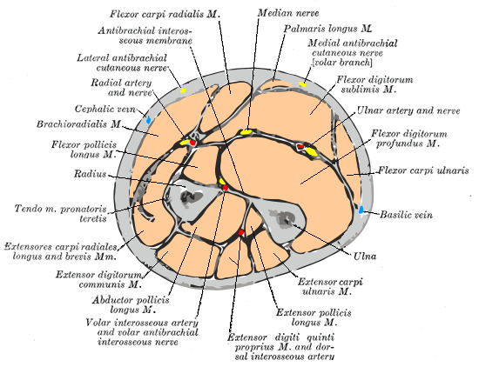
Cross-section through the middle of the forearm
https://en.wikipedia.org/wiki/Forearm#/media/File:Gray417_color.PNG
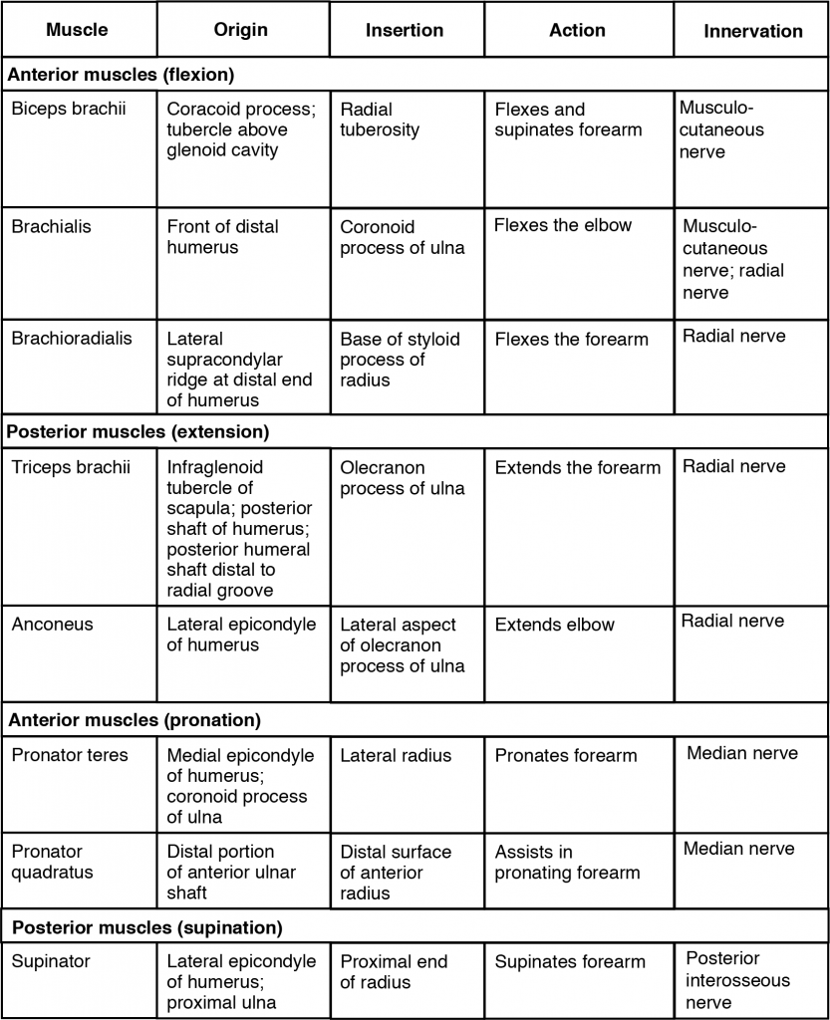
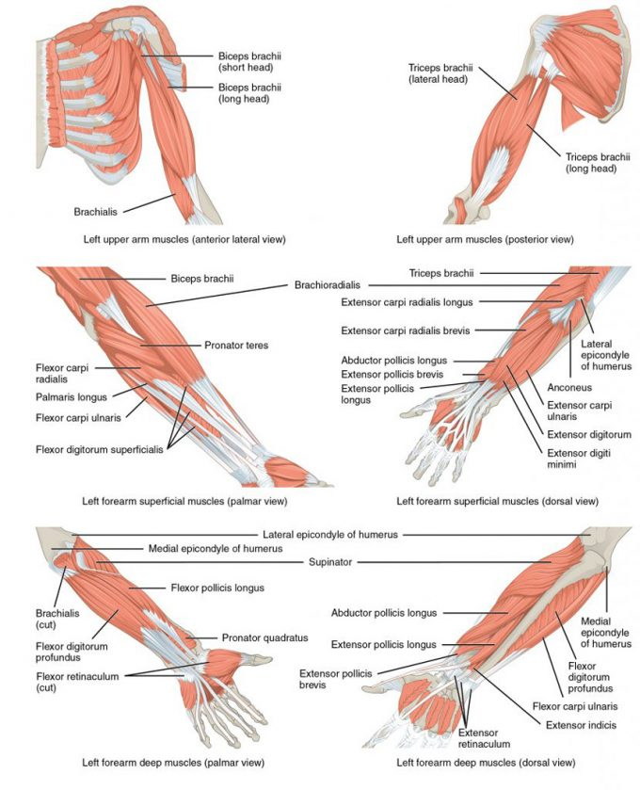
Muscles That Move the Forearm. The muscles originating in the upper arm flex, extend, pronate, and supinate the forearm. The muscles originating in the forearm move the wrists, hands, and fingers.
Muscles that move the Hand, Wrist & Fingers

Wrist, hand, and finger movements are facilitated by two groups of muscles. The forearm is the origin of the extrinsic muscles of the hand. The palm is the origin of the intrinsic muscles of the hand.

Extrinsic Muscles of the Hand

The muscles in the anterior compartment of the forearm (anterior flexor compartment of the forearm) originate on the humerus and insert onto different parts of the hand. These make up the bulk of the forearm. From lateral to medial, the superficial anterior compartment of the forearm includes the flexor carpi radialis, palmaris longus, flexor carpi ulnaris, and flexor digitorum superficialis. The flexor digitorum superficialis flexes the hand as well as the digits at the knuckles, which allows for rapid finger movements, as in typing or playing a musical instrument. However, repetitive movement with poor ergonomics can irritate the tendons of these muscles as they slide back and forth with the carpal tunnel of the anterior wrist and pinch the median nerve, which also travels through the tunnel, causing Carpal Tunnel Syndrome. The deep anterior compartment produces flexion and bends fingers to make a fist. These are the flexor pollicis longus and the flexor digitorum profundus.
The muscles in the superficial posterior compartment of the forearm (superficial posterior extensor compartment of the forearm) originate on the humerus. These are the extensor radialis longus, extensor carpi radialis brevis, extensor digitorum, extensor digiti minimi, and the extensor carpi ulnaris.
The muscles of the deep posterior compartment of the forearm originate on the radius and ulna. These include the abductor pollicis longus, extensor pollicis brevis, extensor pollicis longus, and extensor indicis.
The tendons of the forearm muscles attach to the wrist and extend into the hand. Fibrous bands called retinacula sheath the tendons at the wrist. The flexor retinaculum extends over the palmar surface of the hand while the extensor retinaculum extends over the dorsal surface of the hand.

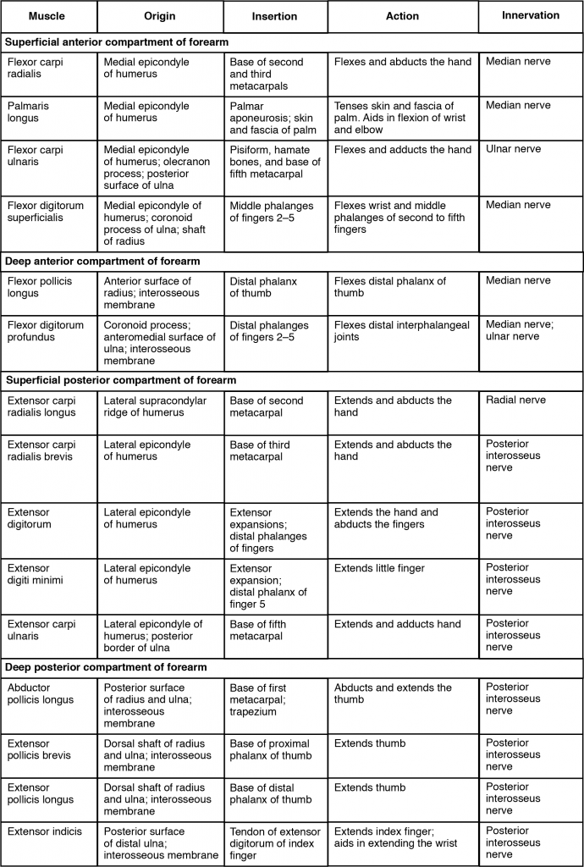 Muscles That Move the Wrist, Hands, and Forearm
Intrinsic Muscles of the Hand

The intrinsic muscles of the hand both originate and insert within it. These muscles allow your fingers to make precise movements for actions, such as typing or writing. These muscles are divided into three groups. The thenar muscles are on the radial aspect of the palm. The hypothenar muscles are on the ulnar aspect of the palm, and the intermediate muscles are midpalmar.

The thenar muscles include the abductor pollicis brevis, opponens pollicis, flexor pollicis brevis, and the adductor pollicis. These muscles form the thenar eminence, the rounded contour of the base of the thumb, and all act on the thumb. The movements of the thumb play an integral role in most precise movements of the hand.

The hypothenar muscles include the abductor digiti minimi, flexor digiti minimi brevis, and the opponens digiti minimi. These muscles form the hypothenar eminence, the rounded contour of the little finger, and as such, they all act on the little finger. Finally, the intermediate muscles act on all the fingers and include the lumbrical, the palmar interossei, and the dorsal interossei.

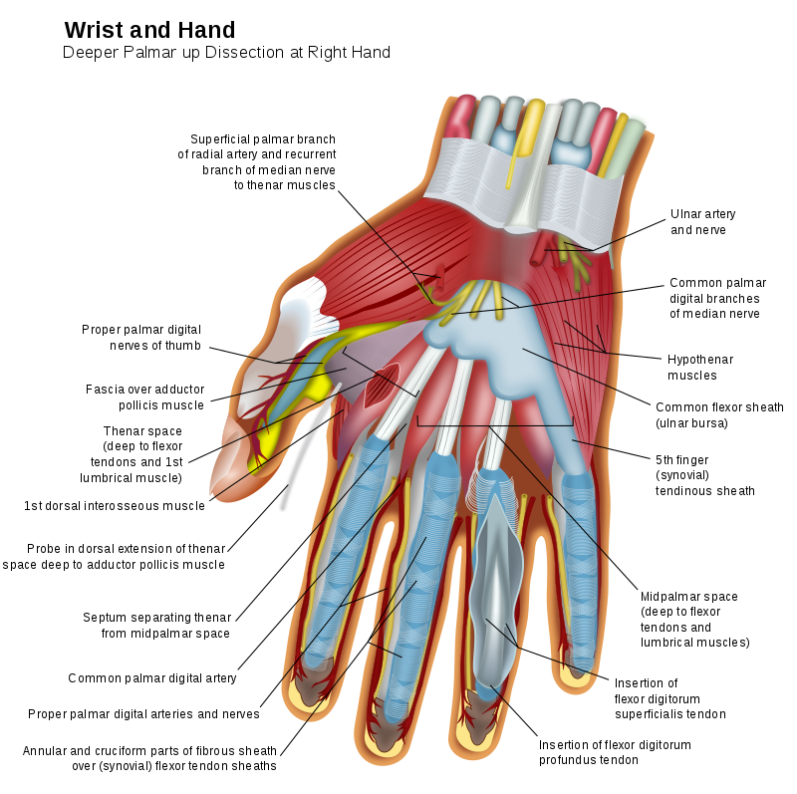https://commons.wikimedia.org/w/index.php?curid=4433126

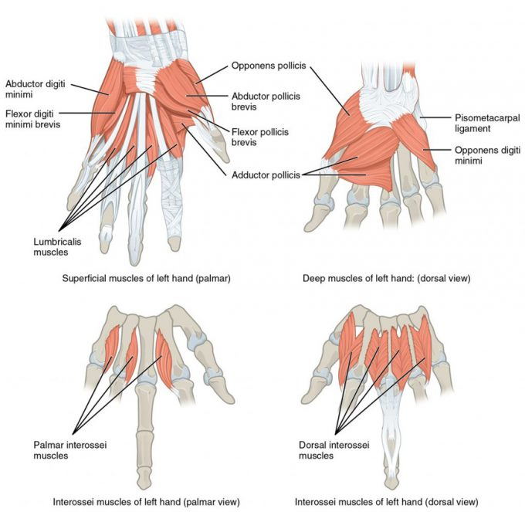
Intrinsic Muscles of the Hand. The intrinsic muscles of the hand both originate and insert within the hand. These muscles provide the fine motor control of the fingers by flexing, extending, abducting, and adducting the more distal finger and thumb segments.

Muscle | Origin | Insertion | Action | Innervation
Palmaris brevis | Aponeurosis of palmar | Medial border of hand skin | Medial border of skin moved to midline | Ulnar nerve, superficial branch C ₈
Adductor pollicis | Carpal & metacarpal bones | Thumb proximal phalanx | Adduction of thumb | Ulnar nerve, deep branch (C ₈ – T ₁)
Palmar interosseous (3-4) | Metacarpal bones (II, IV, V) | Proximal phalanges bases of fingers 2, 4, 5 | Adduction of metacarpophalangeal joints of 2, 4, 5.  Flexion at metacarpophalangeal joints.  Extension at interphalangeal joints | Ulnar nerve, deep branch (C ₈ – T ₁)
Abductor pollicis brevis | Transverse carpal ligament  Scaphoid,  trapezium | Base of proximal phalanx/thumb ; radial side | Abduction of thumb | Median nerve (C₆ – C₇)
Dorsal interosseous | Sides of metacarpals; originates from opposing faces of two metacarpal bones | Proximal phalanges of fingers 2-4 | Abduction at metacarpophalangeal joints of fingers 2&4.  Flexion at metacarpophalangeal joints.  Extension at interphalangeal joints. | Ulnar nerve, deep branch (C ₈ – T ₁)
Abductor digiti minimi | Pisiform | Little finger; proximal phalanx | Abduction & flexion of little finger. | Ulnar nerve, deep branch (C ₈ – T ₁)
Flexor pollicis brevis | Ulnar side of first metacarpal bone, flexor retinaculum, trapezium, capitate | Ulnar & radial sides of proximal phalanx of the thumb | Abduction & flexion of thumb | Branches of median & ulnar nerve
Flexor digiti minimi brevis | Hamate | Proximal phalanx of little finger | Little finger’ flexion of joints | Ulnar nerve, deep branch (C ₈ – T ₁)
Lumbricals | Tendons of flexor digitorum profundus | Digits 2-5; tendons of extensor digitorum | Digits; 2-5.  Extension at proximal & distal interphalangeal joints. | Lumbricals 1 & 2; median nerve.  Lumbricals 3 & 4; ulnar nerve (deep branch)
Opponens pollicis | Flexor retinaculum & trapezium | 1st metacarpal bone | Thumb opposition | Median nerve C ₆ _ C₇_
Opponens digiti minimi | Flexor retinaculum & trapezium | 5th metacarpal bone | 5th metacarpal bone opposition | Ulnar nerve C₈ - T₁

In The Lab
- Review the muscles of the humerus/shoulder/forearm/hand/wrist/fingers in the images and tables provided
- Examine the model and muscles charts provided in lab, locate each muscle (origin, insertion & innervation) and describe its action.
- Review the movement and action of each muscle with your lab partners

