Anatomy and Physiology 1 Laboratory

Muscles of the Head, Neck & Back

Objectives
- Locate the muscles of the head, neck & back on laboratory charts and models.
- Recognize on the models the origin, insertion, and action of the muscles of the head, neck & back
- Describe and demonstrate the action of the muscles of the head, neck & back
.
Muscles of Facial Expression
The muscles of facial expression originate from the surface of the skull or the fascia (connective tissue) of the face. The insertions of these muscles have fibers intertwined with connective tissue and the dermis of the skin. Because the muscles insert in the skin rather than on bone, when they contract, the skin moves to create facial

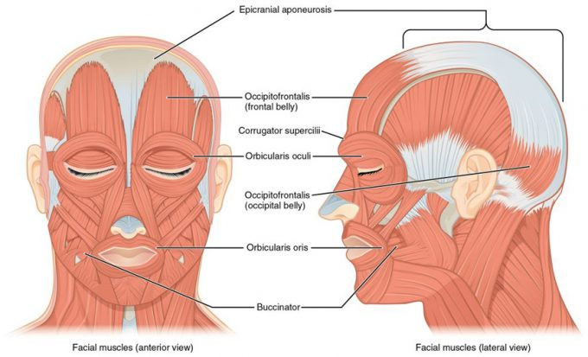

http://library.open.oregonstate.edu/aandp/chapter/11-4-identify-the-skeletal-muscles-and-give-their-origins-insertions-actions-and-innervations/
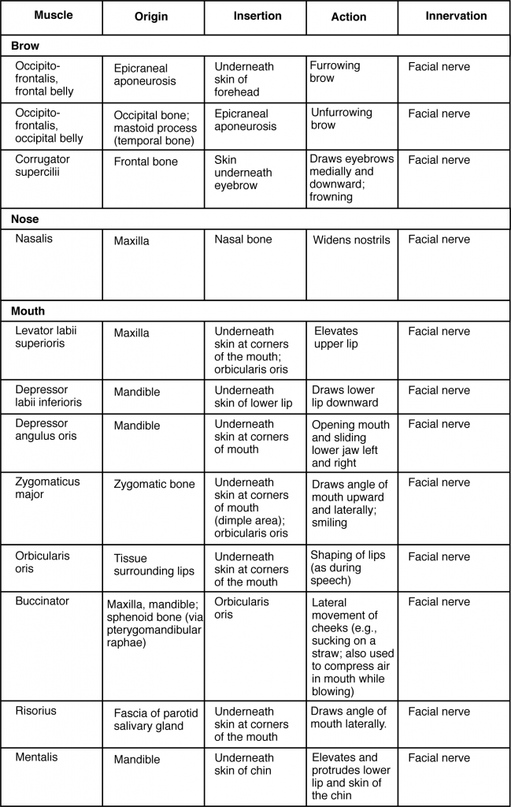

Muscles of the Eye
The movement of the eyeball is under the control of the extra ocular (extrinsic) eye muscles, which originate from the bones of the orbit and insert onto the outer surface of the white of the eye. These muscles are located inside the eye socket and cannot be seen on any part of the visible eyeball. If you have ever been to a doctor who held up a finger and asked you to follow it up, down, and to both sides, he or she is checking to make sure your eye muscles are acting in a coordinated pattern.

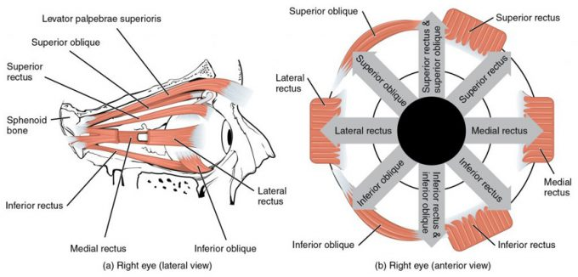

Muscles of the Eyes.(a) The extraocular eye muscles originate outside of the eye on the skull. (b) Each muscle inserts onto the eyeball.

Muscle | Origin | Insertion | Action/Movement | Innervation
Inferior rectus | Sphenoid around optic canal (Annulus of Zinn) | Inferior, medial surface of the eyeball | Eye looks down, depression. | Oculomotor nerve (N II)
Medial rectus | Sphenoid around optic canal (Annulus of Zinn) | Medial surface of eyeball | Eye looks medially, adduction | Oculomotor nerve (N II)
Superior rectus | Sphenoid around optic canal (Annulus of Zinn) | Superior, anterior surface of eyeball | Eye looks up, elevation | Oculomotor nerve (N II)
Lateral rectus | Sphenoid around optic canal (Annulus of Zinn) | Lateral, anterior surface of eyeball | Eye looks laterally, abduction | Abducens nerve (N VI)
Inferior oblique | Maxilla, anterior area of orbit | Inferior, lateral surface of eyeball | Eye rolls, looks up and laterally, excyclotorsion | Oculomotor nerve (N III)
Superior oblique | Sphenoid at optic canal | Superior, lateral surface of eyeball | Eye rolls, looks down and laterally, incyclotorsion | Trochlear nerve (N VI)
Levator palpebrae superioris | Sphenoid | Tarsal plate of upper eyelid | Elevates, retracts upper eyelid | Oculomotor nerve (N III)

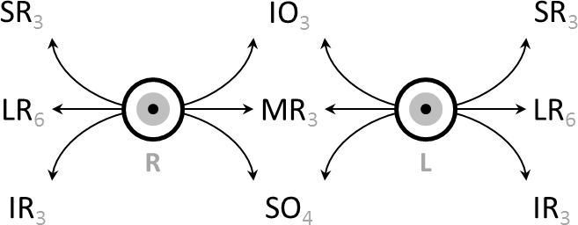
Schematic demonstrating the actions and cranial nerve innervation (in subscript) of extraocular muscles.
https://en.wikipedia.org/wiki/Extraocular_muscles#/media/File:Extraocular_muscle_actions_and_innervation.png

Movement Coordination
Intermediate directions are controlled by simultaneous actions of multiple muscles. When one shifts the gaze horizontally, one eye will move laterally (toward the side) and the other will move medially (toward the midline). This may be neurally coordinated by the central nervous system, to make the eyes move together and almost involuntarily. This is a key factor in the study of strabismus, namely, the inability of the eyes to be directed to one point.
There are two main kinds of movement: conjugate movement (the eyes move in the same direction) and disjunctive (opposite directions). The former is typical when shifting gaze right or left, the latter is convergence of the two eyes on a near object. Disjunction can be performed voluntarily, but is usually triggered by the nearness of the target object. A "see-saw" movement, namely, one eye looking up and the other down, is possible, but not voluntarily; this effect is brought on by putting a prism in front of one eye, so the relevant image is apparently displaced. To avoid double vision from non-corresponding points, the eye with the prism must move up or down, following the image passing through the prism. Likewise conjugate torsion (rolling) on the anteroposterior axis (from the front to the back) can occur naturally, such as when one tips one's head to one shoulder; the torsion, in the opposite direction, keeps the image vertical.
The muscles show little inertia - a shutdown of one muscle is not due to checking of the antagonist, so the motion is not ballistic.^{[1]}

Eye Examination
The initial clinical examination of the extra-occular eye muscles is done by examining the movement of the globe of the eye through the six cardinal eye movements. When the eye is turned out (temporally) and horizontally, the function of the lateral rectus muscle is tested. When the eye is turned in (nasally) and horizontally, the function of the medial rectus muscle is being tested. When turning the eye down and in, the inferior rectus is contracting. When turning it up and in the superior rectus is contracting. Paradoxically, turning the eye up and out uses the inferior oblique muscle, and turning it down and out uses the superior oblique. All of these six movements can be tested by drawing a large "H" in the air with a finger or other object in front of a patient's face and having them follow the tip of the finger or object with their eyes without moving their head. Having them focus on the object as it is moved in toward their face in the midline will test convergence, or the eyes' ability to turn inward simultaneously to focus on a near object.
To evaluate for weakness or imbalance of the muscles, a penlight is shone directly on the corneas. Expected normal results of the corneal light reflex is when the penlight's reflection is located in the centre of both corneas, equally.
https://en.wikipedia.org/wiki/Extraocular_muscles

In The Lab
- Review the muscles of the eye in the images and tables provided
- Examine the eye model and eye muscles charts provided in lab, locate each muscle (origin, insertion & innervation) and describe its action.
- Review the movement and action of each eye muscle using your eyes and your lab partners.

Muscles That Move the Lower Jaw/ Mastication
In anatomical terminology, chewing is called mastication. Muscles involved in chewing must be able to exert enough pressure to bite through and then chew food before it is swallowed. The masseter muscle is the prime mover muscle for chewing because it elevates the mandible (lower jaw) to close the mouth, and it is assisted by the temporalis muscle, which retracts the mandible. You can feel the temporalis move by putting your fingers to your temple as you chew. The medial pterygoid and lateral pterygoid muscles provide assistance in chewing and moving food within the mouth by moving the mandible laterally and medially to grind food between the molars.

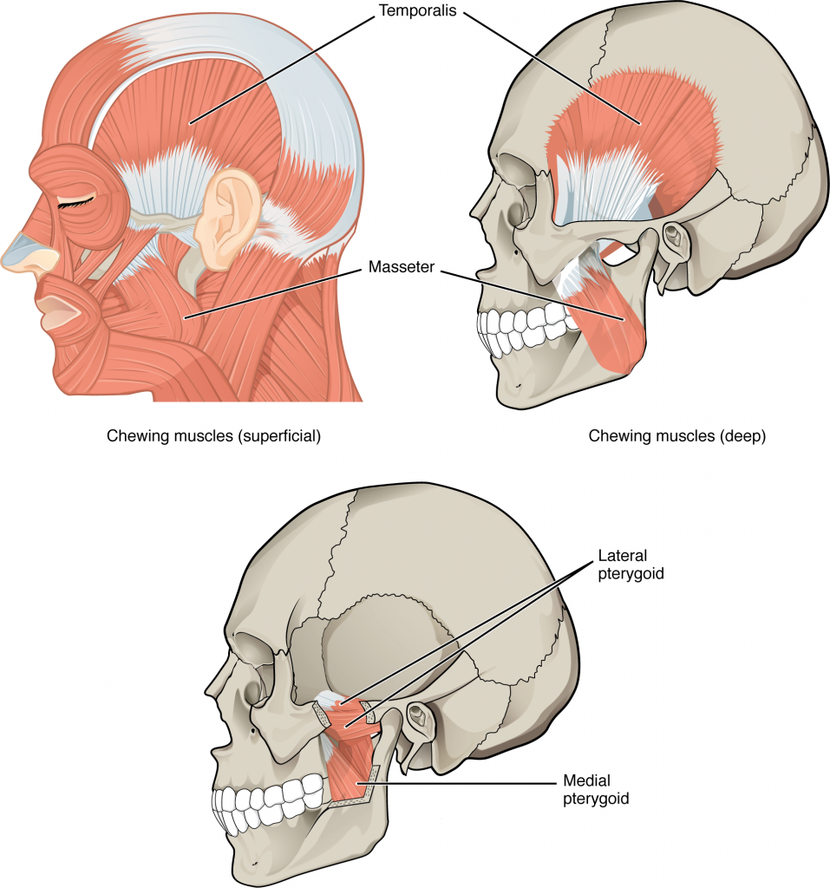
Muscles That Move the Lower Jaw. The muscles that move the lower jaw are typically located within the cheek and originate from processes in the skull. This provides the jaw muscles with the large amount of leverage needed for chewing.
http://library.open.oregonstate.edu/aandp/chapter/11-4-identify-the-skeletal-muscles-and-give-their-origins-insertions-actions-and-innervations/

Muscle | Origin | Insertion | Action | Innervation
Masseter | Zygomatic arch | Lateral surface of mandibular arch | Elevates mandible and closes jaw, aids chewing | Mandibular branch of Trigeminal nerve (N V)
Temporalis | Temporal lines of skull | Coronoid process of mandible | Elevates mandible, pulls lower jaw in under upper jaw | Mandibular branch of Trigeminal nerve (N V)
Medial pterygoid | Lateral pterygoid plate | Medial area of mandibular ramus | Elevates the mandible & closes jaw, pushes lower jaw out under upper jaw; moves lower jaw side-to-side | Mandibular branch of Trigeminal nerve (N V)
Lateral pterygoid | Lateral pterygoid plate | Medial area of mandibular ramus | Protrudes the mandible, opens jaw, pushes lower jaw out under upper jaw; moves lower jaw side-to-side | Mandibular branch of Trigeminal nerve (N V)

In The Lab
- Review the muscles of mastication in the images and tables provided
- Examine the model and muscles charts provided in lab, locate each muscle (origin, insertion & innervation) and describe its action.
- Review the movement and action of each muscle using yours and your lab partners.

Muscles of the Tongue
Although the tongue is obviously important for tasting food, it is also necessary for mastication, deglutition(swallowing), and speech. Because of its mobility, the tongue facilitates complex speech patterns and sounds.Tongue muscles can be extrinsic or intrinsic. Extrinsic tongue muscles insert into the tongue from outside origins, and the intrinsic tongue muscles insert into the tongue from origins within it. The extrinsic muscles move the whole tongue in different directions, whereas the intrinsic muscles allow the tongue to change its shape (such as, curling the tongue in a loop or flattening it).
The extrinsic muscles all include the word root glossus (glossus = “tongue”), and the muscle names are derived from where the muscle originates. The genioglossus (genio = “chin”) originates on the mandible and allows the tongue to move downward and forward. The styloglossus originates on the styloid process of the temporal bone, and allows upward and backward motion. The palatoglossus originates on the soft palate to elevate the back of the tongue, and the hyoglossus originates on the hyoid bone to move the tongue downward and flatten it.

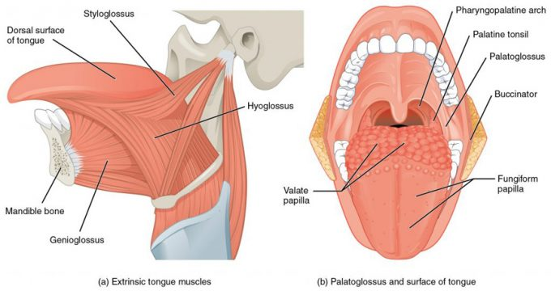
Muscles that Move the Tongue
http://library.open.oregonstate.edu/aandp/chapter/11-4-identify-the-skeletal-muscles-and-give-their-origins-insertions-actions-and-innervations/

Muscles that Move the Tongue

Muscle | Origin | Insertion | Action | Innervation
Genioglossus | Medial surface of mandible | Hyoid bone, body of tongue | Depresses & protracts tongue | Hypoglossal nerve (N XII)
Hyoglossus | Greater horn and body of hyoid bone | Side of tongue | Depresses & retracts tongue | Hypoglossal nerve (N XII)
Palatoglossus | Anterior surface of soft palate | Side of tongue | Elevates tongue, depresses soft palate | Internal branch of accessory nerve ( N XI)
Styloglossus | Styloid process of temporal bone | Side to tip of tongue base | Retracts tongue, elevates side of tongue | Hypoglossal nerve (N XII)

Muscle of the Anterior Neck
The muscles of the anterior neck assist in deglutition (swallowing) and speech by controlling the positions of the larynx (voice box), and the hyoid bone, a horseshoe-shaped bone that functions as a foundation on which the tongue can move. The muscles of the neck are categorized according to their position relative to the hyoid bone. Suprahyoid muscles are superior to it, and the infrahyoid muscles are located inferiorly.
The suprahyoid muscles raise the hyoid bone, the floor of the mouth, and the larynx during deglutition. These include the digastric muscle, which has anterior and posterior bellies that work to elevate the hyoid bone and larynx when one swallows; it also depresses the mandible. The stylohyoid muscle moves the hyoid bone posteriorly, elevating the larynx, and the mylohyoid muscle lifts it and helps press the tongue to the top of the mouth. The geniohyoid depresses the mandible in addition to raising and pulling the hyoid bone anteriorly.
The strap-like infrahyoid muscles generally depress the hyoid bone and control the position of the larynx. The omohyoid muscle, which has superior and inferior bellies, depresses the hyoid bone in conjunction with the sternohyoid and thyrohyoid muscles. The thyrohyoid muscle also elevates the larynx’s thyroid cartilage, whereas the sternothyroid depresses it.

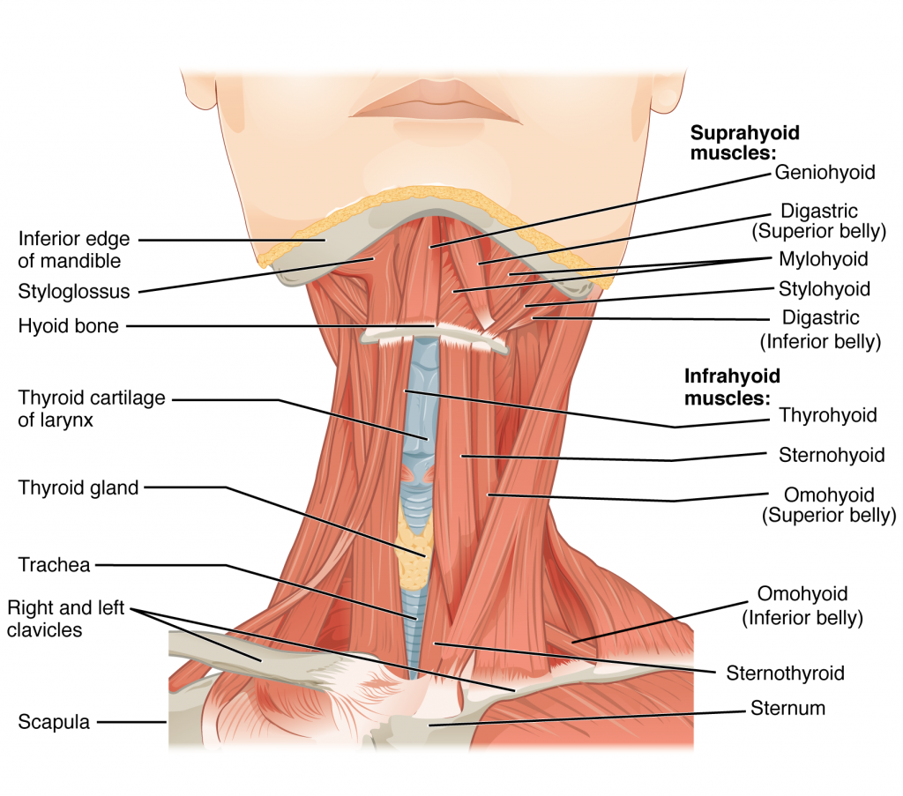
Muscles of the Anterior Neck. The anterior muscles of the neck facilitate swallowing and speech. The suprahyoid muscles originate from above the hyoid bone in the chin region. The infrahyoid muscles originate below the hyoid bone in the lower neck.

http://library.open.oregonstate.edu/aandp/chapter/11-4-identify-the-skeletal-muscles-and-give-their-origins-insertions-actions-and-innervations/

Muscle | Origin | Insertion | Action | Innervation
Digastric | Mandible at chin and temporal bone | Hyoid bone | Depresses mandible / elevates larynx | Anterior belly: mandibular branch of Trigeminal nerve (N V)  Posterior belly: Facial nerve (N VII)
Geniohyoid | Mandible medial surface | Hyoid bone | Depresses mandible / elevates larynx & pulls hyoid bone anteriorly | Spinal nerve C₁ via Hypoglossal nerve ( N XII)
Mylohyoid | Mandible | Hyoid bone; line of raphe | Elevates hyoid bone & floor of mouth. Depresses mandible | Mandibular branch of Trigeminal nerve (N V)
Omohyoid | Superior border of scapula | Hyoid bone | Depresses larynx & hyoid bone | Cervical spine nerves (C₂-C₃)
Sternohyoid | Clavicle & manubrium | Hyoid bone | Depresses larynx & hyoid bone | Cervical spine nerves (C₁-C₃)
Sternothyroid | Dorsal surface of manubrium & first costal cartilage | Thyroid cartilage of larynx | Depresses larynx & hyoid bone | Cervical spine nerves (C₁-C₃)
Stylohyoid | Temporal bone; styloid process | Hyoid bone | Elevates larynx | Facial nerve (N VII)
Thyrohyoid | Larynx; thyroid cartilage | Hyoid bone | Elevates thyroid, depresses hyoid bone | Spinal nerve C₁- C_{2,} via Hypoglossal nerve ( N XII)
Sternocleidomastoid | Clavicular head; to sternal end of clavicle  Sternal head; to manubrium | Mastoid area of skull & superior nuchal line | Rotates and tilts head to the side, tilts head forward | Accessory nerve ( N XII) & cervical spinal nerves C₂-C₃)

Muscles of the Posterior Neck and Back
The posterior muscles of the neck are primarily concerned with head movements, like extension. The back muscles stabilize and move the vertebral column, and are grouped according to the lengths and direction of the fascicles.

The splenius muscles originate at the midline and run laterally and superiorly to their insertions. From the sides and the back of the neck, the splenius capitis inserts onto the head region, and the splenius cervicis extends onto the cervical region. These muscles can extend the head, laterally flex it, and rotate it
The erector spinae group forms the majority of the muscle mass of the back and it is the primary extensor of the vertebral column. It controls extension, lateral flexion, and rotation of the vertebral column, and maintains the lumbar curve. The erector spinae comprises the iliocostalis (laterally placed) group, the longissimus (intermediately placed) group, and the spinalis (medially placed) group.

The iliocostalis group includes the iliocostalis cervicis, associated with the cervical region; the iliocostalis thoracis, associated with the thoracic region; and the iliocostalis lumborum, associated with the lumbar region. The three muscles of the longissimus group are the longissimus capitis, associated with the head region; the longissimus cervicis, associated with the cervical region; and the longissimus thoracis, associated with the thoracic region. The third group, the spinalis group, comprises the spinalis capitis (head region), the spinalis cervicis (cervical region), and the spinalis thoracis (thoracic region).

The transversospinales muscles run from the transverse processes to the spinous processes of the vertebrae. Similar to the erector spinae muscles, the semispinalis muscles in this group are named for the areas of the body with which they are associated. The semispinalis muscles include the semispinalis capitis, the semispinalis cervicis, and the semispinalis thoracis. The multifidus muscle of the lumbar region helps extend and laterally flex the vertebral column.

Important in the stabilization of the vertebral column is the segmental muscle group, which includes the interspinales and intertransversarii muscles. These muscles bring together the spinous and transverse processes of each consecutive vertebra. Finally, the scalene muscles work together to flex, laterally flex, and rotate the head. They also contribute to deep inhalation. The scalene muscles include the anterior scalene muscle (anterior to the middle scalene), the middle scalene muscle (the longest, intermediate between the anterior and posterior scalenes), and the posterior scalene muscle (the smallest, posterior to the middle scalene).

http://library.open.oregonstate.edu/aandp/chapter/11-4-identify-the-skeletal-muscles-and-give-their-origins-insertions-actions-and-innervations/

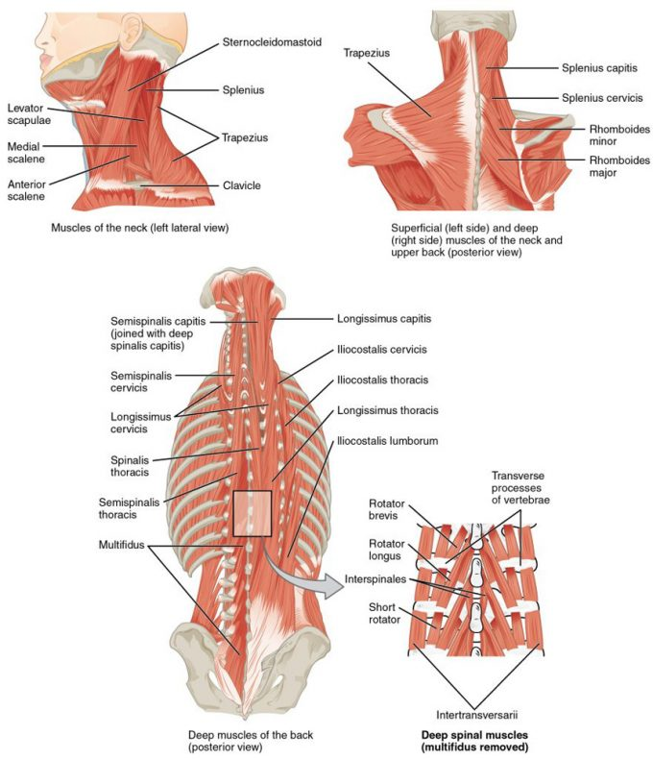
Muscles of the Neck and Back. The large, complex muscles of the neck and back move the head, shoulders, and vertebral column.
http://library.open.oregonstate.edu/aandp/chapter/11-4-identify-the-skeletal-muscles-and-give-their-origins-insertions-actions-and-innervations/

In The Lab
- Review the muscles of the tongue, anterior neck and back in the images and tables provided
- Examine the model and muscles charts provided in lab, locate each muscle (origin, insertion & innervation) and practice & describe the action of each muscle.

Review
Muscles are either axial muscles or appendicular. The axial muscles are grouped based on location, function, or both. Some axial muscles cross over to the appendicular skeleton. The muscles of the head and neck are all axial. The muscles in the face create facial expression by inserting into the skin rather than onto bone. Muscles that move the eyeballs are extrinsic, meaning they originate outside of the eye and insert onto it. Tongue muscles are both extrinsic and intrinsic. The genioglossus depresses the tongue and moves it anteriorly; the styloglossus lifts the tongue and retracts it; the palatoglossus elevates the back of the tongue; and the hyoglossus depresses and flattens it. The muscles of the anterior neck facilitate swallowing and speech, stabilize the hyoid bone and position the larynx. The muscles of the neck stabilize and move the head. The sternocleidomastoid divides the neck into anterior and posterior triangles.
The muscles of the back and neck that move the vertebral column are complex, overlapping, and can be divided into five groups. The splenius group includes the splenius capitis and the splenius cervicis. The erector spinae has three subgroups. The iliocostalis group includes the iliocostalis cervicis, the iliocostalis thoracis, and the iliocostalis lumborum. The longissimus group includes the longissimus capitis, the longissimus cervicis, and the longissimus thoracis. The spinalis group includes the spinalis capitis, the spinalis cervicis, and the spinalis thoracis. The transversospinales include the semispinalis capitis, semispinalis cervicis, semispinalis thoracis, multifidus, and rotatores. The segmental muscles include the interspinales and intertransversarii. Finally, the scalenes include the anterior scalene, middle scalene, and posterior scalene.
In The Lab
- Review the muscles of the head using table & figure provided on previous pages.
- Examine and study the head model using the muscle chart provided in lab, locate each muscle (origin, insertion, action & innervation) and describe its action.
- Find the approximate location of the muscles of facial expression on your own face and study & observe their action.
- Explain the difference between axial and appendicular muscles.
- Describe the muscles of the anterior neck.
- Why are the muscles of the face different from typical skeletal muscle?

