Anatomy and Physiology 1 Laboratory

Muscles of the Abdominal Wall & Thorax

Objectives
- Locate the muscles of the abdominal wall and thorax on laboratory charts and models.
- Recognize on the models the origin, insertion, and action of the muscles of the abdominal wall and thorax.
- Describe and demonstrate the action of the muscles of the abdominal wall and thorax.

It is a complex job to balance the body on two feet and walk upright. The muscles of the vertebral column, thorax, and abdominal wall extend, flex, and stabilize different parts of the body’s trunk. The deep muscles of the body’s core help maintain posture as well as provide stability for movement of the limbs.

Muscles of the Abdomen
There are four pairs of abdominal muscles that make up the abdominal wall: the rectus abdominis, the external abdominal obliques, the internal abdominal obliques and the transverse abdominis
There are three flat skeletal muscles in the antero-lateral wall of the abdomen. The external oblique, closest to the surface, extend inferiorly and medially, in the direction of sliding one’s four fingers into pants pockets. Perpendicular to it is the intermediate internal oblique, extending superiorly and medially, the direction the thumbs usually go when the other fingers are in the pants pocket. The deep muscle, the transverse abdominis, is arranged transversely around the abdomen, similar to a belt. This arrangement of three bands of muscles in different orientations allows various movements and rotations of the trunk. The three layers of muscle also help to protect the internal abdominal organs in an area where there is no bone.
The linea alba is a white, fibrous band that is made of the bilateral rectus sheaths that join at the anterior midline of the body. These enclose the rectus abdominis muscles that originate at the pubic crest and symphysis, and extend the length of the body’s trunk. Each muscle is segmented by three transverse bands of collagen fibers called the tendinous intersections resulting in the look of “six-pack abs”.
The posterior abdominal wall is formed by the lumbar vertebrae, parts of the ilia of the hip bones, psoas major and iliacus muscles, and quadratus lumborum muscle. This part of the core plays a key role in stabilizing the rest of the body and maintaining posture.
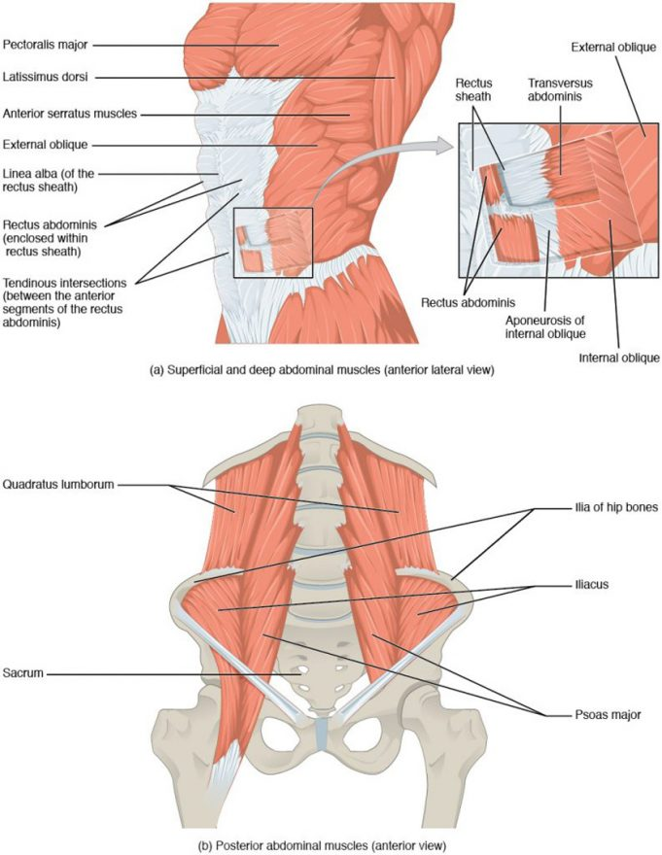
Muscles of the Abdomen. (a) The anterior abdominal muscles include the medially located rectus abdominis, which is covered by a sheet of connective tissue called the rectus sheath. On the flanks of the body, medial to the rectus abdominis, the abdominal wall is composed of three layers. The external oblique muscles form the superficial layer, while the internal oblique muscles form the middle layer, and the transverses abdominus forms the deepest layer. (b) The muscles of the lower back move the lumbar spine but also assist in femur movements.

Muscle | Origin | Insertion | Action | Innervation
External oblique | External & inferior borders of ribs 5-12 | Iliac crest & Linea alba | Bends/flexes spine, compresses abdomen, depresses ribs | Ilioinguinal intercostal, iliohypogastric nerves
Internal oblique | Iliac crest, thoracolumbar fascia | Linea alba, xyphoid process, inferior ribs | Bends/flexes spine, compresses abdomen, depresses ribs | Ilioinguinal intercostal, iliohypogastric nerves
Transversus abdominis | Ribs 6-12 cartilages, thoracolumbar fascia, iliac crest | Pubis & linea alba | Compresses abdomen | Ilioinguinal intercostal, iliohypogastric nerves
Rectus abdominis | Pubis symphysis; superior surface | Ribs 5-7; inferior surfaces of costal cartilages & xiphoid process | Bends/flexes spine, compresses abdomen, depresses ribs | Intercostal nerves (T₇-T₁₂)
Quadratus lumborum | Iliolumbar ligament & iliac crest | Transverse processes of lumbar vertebrae & last rib | Depress ribs, laterally flexes vertebral column | Thoracic & lumbar spinal nerves

In The Lab
- Review the muscles of the abdominal wall & thorax in the images and tables provided
- Examine the model and muscles charts provided in lab, locate each muscle (origin, insertion & innervation) and describe its action.
- Review the movement and action of each muscle with your lab partners.

Muscle of the Thorax
The muscles of the chest serve to facilitate breathing by changing the volume of the thoracic cavity. When you inhale your chest rises increasing the volume of the thoracic cavity. Alternately, when you exhale, your chest falls decreasing the volume of the thoracic cavity.

The Diaphragm
The change in volume of the thoracic cavity during breathing is due to the alternate contraction and relaxation of the diaphragm. It separates the thoracic and abdominal cavities, and is dome-shaped at rest. The superior surface of the diaphragm is convex, creating the elevated floor of the thoracic cavity. The inferior surface is concave, creating the curved roof of the abdominal cavity.

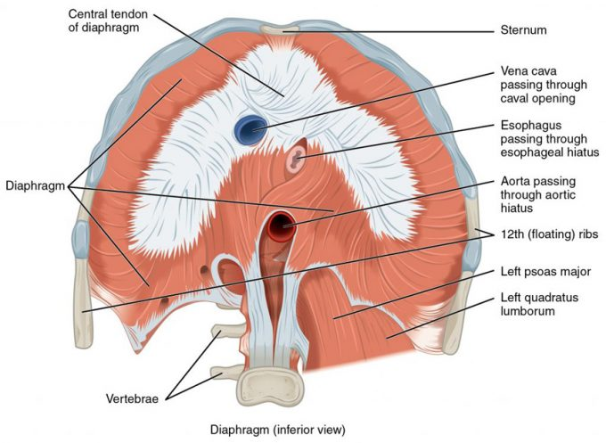

Muscles of the Diaphragm.
The diaphragm separates the thoracic and abdominal cavities.
Defecating, urination, and even childbirth involve cooperation between the diaphragm and abdominal muscles (this cooperation is referred to as the “Valsalva maneuver”). While you hold your breath the diaphragm and abdominal muscles contract increasing the pressure of the peritoneal cavity and stabilizing the core. When the abdominal muscles contract, the pressure cannot push the diaphragm up, so it increases pressure on the intestinal tract (defecation), urinary tract (urination), or reproductive tract (childbirth).
The inferior surface of the pericardial sac and the inferior surfaces of the pleural membranes (parietal pleura) fuse onto the central tendon of the diaphragm. To the sides of the tendon are the skeletal muscle portions of the diaphragm, which insert into the tendon while having a number of origins including the xiphoid process of the sternum anteriorly, the inferior six ribs and their cartilages laterally, and the lumbar vertebrae and 12th ribs posteriorly.
The diaphragm also includes three openings for the passage of structures between the thorax and the abdomen. The inferior vena cava passes through the caval opening, and the esophagus and attached nerves pass through the esophageal hiatus. The aorta, thoracic duct, and azygous vein pass through the aortic hiatus of the posterior diaphragm.

Intercostal Muscles
There are three sets of muscles, called intercostal muscles, which span each of the intercostal spaces. The principal role of the intercostal muscles is to assist in breathing by changing the dimensions of the rib cage. The 11 pairs of superficial external intercostal muscles aid in inspiration of air during breathing because when they contract, they raise the rib cage, which expands it. The 11 pairs of internal intercostal muscles, just under the externals, are used for expiration because they draw the ribs together to constrict the rib cage. The innermost intercostal muscles are the deepest, and they act as synergists for the action of the internal intercostals.

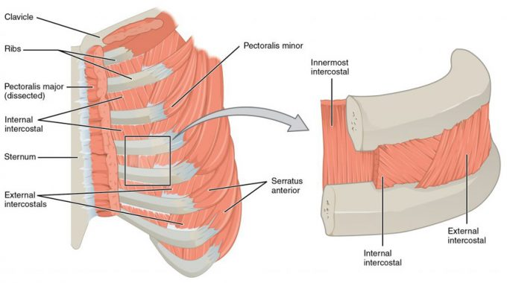
Intercostal Muscles. The external intercostals are located laterally on the sides of the body. The internal intercostals are located medially near the sternum. The innermost intercostals are located deep to both the internal and external intercostals.

Muscle | Origin | Insertion | Action | Innervation
Diaphragm | Cartilages of ribs 4-10, anterior surfaces of lumbar vertebrae & xyphoid process | Central tendinous sheet | Contracts to expand thoracic cavity | Phrenic nerve (C₃-C₅)
External intercostals | Inferior border of each rib/intercostal muscle | Superior border of each rib/intercostal muscle | Elevates ribs/ Elevation (expands thoracic cavity) | Intercostal nerves/branches of thoracic nerves
Internal intercostals | Superior border of each rib/intercostal muscles | Inferior border of each rib/intercostal muscle | Depress ribs, Movement along superior/inferior axis to bring ribs closer together | Intercostal nerves/branches of thoracic nerves
Transversus thoracis | Sternum/posterior surface | Rib cartilages | Depress ribs | Intercostal nerves/branches of thoracic nerves

In The Lab
- Review the muscles of the thorax in the images and tables provided
- Examine the model and muscles charts provided in lab, locate each muscle (origin, insertion & innervation) and describe its action.
- Review the movement and action of each muscle with your lab partners.

