Student name:

Date:

Laboratory - Muscle Tissue

Objectives
- Describe the three types of muscle tissue and describe the basic function of each.
- Describe the histological appearance of the 3 muscle tissue types.
- Identify each type of muscle tissue in microscope preparations and identify the microanatomy of the muscle fibers.

Introduction:

Muscle tissue is a soft tissue that composes muscles in animal bodies and gives rise to muscles' ability to contract. This is opposed to other components or tissues in muscle such as tendons or perimysium. It is formed during embryonic development through a process known as myogenesis.

Muscle tissues varies with function and location in the body.
In mammals the three types are: skeletal or striated muscle; smooth or non-striated muscle; and cardiac muscle, which is sometimes known as semi-striated. Smooth and cardiac muscle contracts involuntarily, without conscious intervention.

These muscle types may be activated both through interaction of the central nervous system as well as by receiving innervation from peripheral plexus or endocrine (hormonal) activation. Striated or skeletal muscle only contracts voluntarily, upon influence of the central nervous system. Reflexes are a form of nonconscious activation of skeletal muscles, but nonetheless arise through activation of the central nervous system, albeit not engaging cortical structures until after the contraction has occurred.

https://en.wikipedia.org/wiki/Muscle_tissue

A schematic diagram of the different types of muscle cells
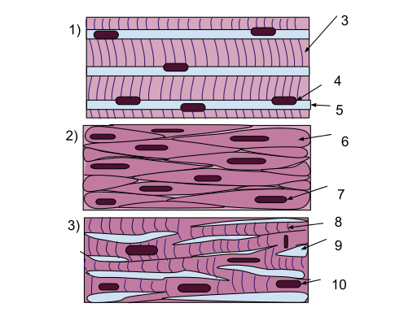

1) Skeletal muscle cells are long tubular cells with striations (3) and multiple nuclei (4). The nuclei are embedded in the cell membrane (5) so that they are just inside the cell. This type of tissue occurs in the muscles that are attached to the skeleton. Skeletal muscles function in voluntary movements of the body. 2) Smooth muscle cells are spindle shaped (6), and each cell has a single nucleus (7). Unlike skeletal muscle, there are no striations. Smooth muscle acts involuntarily and functions in the movement of substances in the lumens. They are primarily found in blood vessel walls and walls along the digestive tract. 3) Cardiac muscle cells branch off from each other, rather than remaining along each other like the cells in the skeletal and smooth muscle tissues. Because of this, there are junctions between adjacent cells (9). The cells have striations (8), and each cell has a single nucleus (10). This type of tissue occurs in the wall of the heart and its primary function is for pumping blood

https://commons.wikimedia.org/wiki/File:Muscle_Tissue_(1).svg

The 3 types of muscle tissue
Once you have found the images on the slides provided in lab, draw and label the microscopic structures of all 3 muscle tissue in the space provided.
Use the images provided on this page and previous as reference.

The body contains three types of muscle tissue: (a) skeletal muscle, (b) smooth muscle, and (c) cardiac muscle. From top, LM × 1600, LM × 1600, LM × 1600. (

https://commons.wikimedia.org/wiki/File:414_Skeletal_Smooth_Cardiac.jpg#filelinks

Skeletal Muscle
Skeletal muscle is further divided into several subtypes:
Type I, slow oxidative, slow twitch, or "red" muscle is dense with capillaries and is rich in mitochondria and myoglobin, giving the muscle tissue its characteristic red color. It can carry more oxygen and sustain aerobic activity.
Type I muscle fiber are sometimes broken down into Type I and Type Ic categories, as a result of recent research.
Type II, fast twitch muscle, has three major kinds that are, in order of increasing contractile speed.
Type IIa, which, like slow muscle, is aerobic, rich in mitochondria and capillaries and appears red when deoxygenated.
Type IIx (also known as type IId), which is less dense in mitochondria and myoglobin. This is the fastest muscle type in humans. It can contract more quickly and with a greater amount of force than oxidative muscle, but can sustain only short, anaerobic bursts of activity before muscle contraction becomes painful (often incorrectly attributed to a build-up of lactic acid). N.B. in some books and articles this muscle in humans was, confusingly, called type IIB.
Type IIb, which is anaerobic, glycolytic, "white" muscle that is even less dense in mitochondria and myoglobin. In small animals like rodents this is the major fast muscle type, explaining the pale color of their flesh.

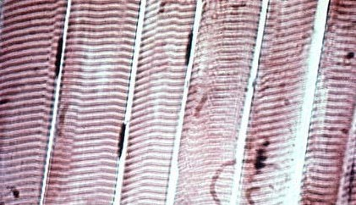
https://en.wikipedia.org/wiki/Muscle_tissue#/media/File:Musculoesqueleticovoluntario.jpg
Striated skeletal muscle cells in microscopic view.
The myofibers are the straight vertical bands; the horizontal striations (lighter and darker bands) that are visible result from differences in composition and density along the fibrils within the cells.
The cigar-like dark patches beside the myofibers are muscle-cell nuclei.

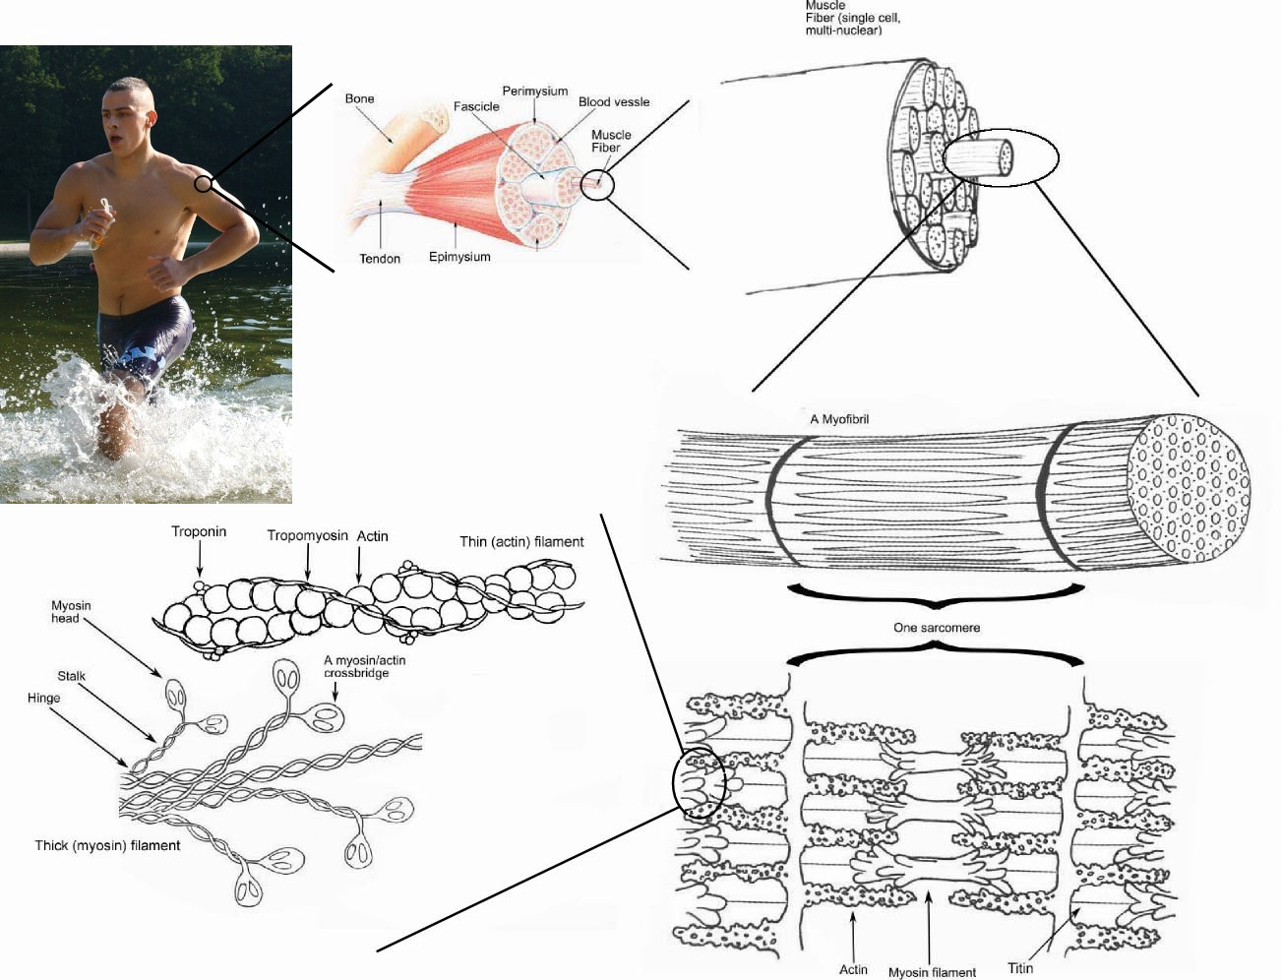

https://commons.wikimedia.org/wiki/File:Skeletal_muscle.jpg
Draw and label a sarcomere.
Identify I band, A band, H band, Z line, M line, thin and thick filaments and Zone of overlap.

Smooth Muscle
Smooth muscle is an involuntary non-striated muscle. It is divided into two subgroups: the single-unit (unitary) and multiunit smooth muscle. Within single-unit cells, the whole bundle or sheet contracts as a syncytium (i.e. a multinucleate mass of cytoplasm that is not separated into cells). Multiunit smooth muscle tissues innervate individual cells; as such, they allow for fine control and gradual responses, much like motor unit recruitment in skeletal muscle.
Smooth muscle is found within the walls of blood vessels (such smooth muscle specifically being termed vascular smooth muscle) such as in the tunica media layer of large (aorta) and small arteries, arterioles and veins. Smooth muscle is also found in lymphatic vessels, the urinary bladder, uterus (termed uterine smooth muscle), male and female reproductive tracts, gastrointestinal tract, respiratory tract, arrector pili of skin, the ciliary muscle, and iris of the eye. The structure and function is basically the same in smooth muscle cells in different organs, but the inducing stimuli differ substantially, in order to perform individual effects in the body at individual times. In addition, the glomeruli of the kidneys contain smooth muscle-like cells called mesangial cells.

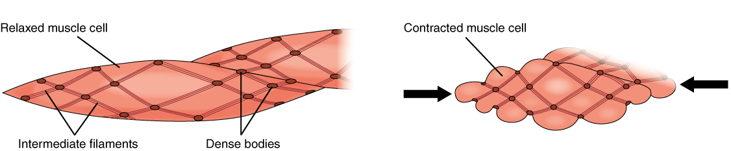
The dense bodies and intermediate filaments are networked through the sarcoplasm, which cause the muscle fiber to contract.
https://en.wikipedia.org/wiki/Smooth_muscle#/media/File:1028_Smooth_Muscle_Contraction.jpg

Smooth muscle tissue
Draw and label the microscopic structure of the smooth muscle tissue.

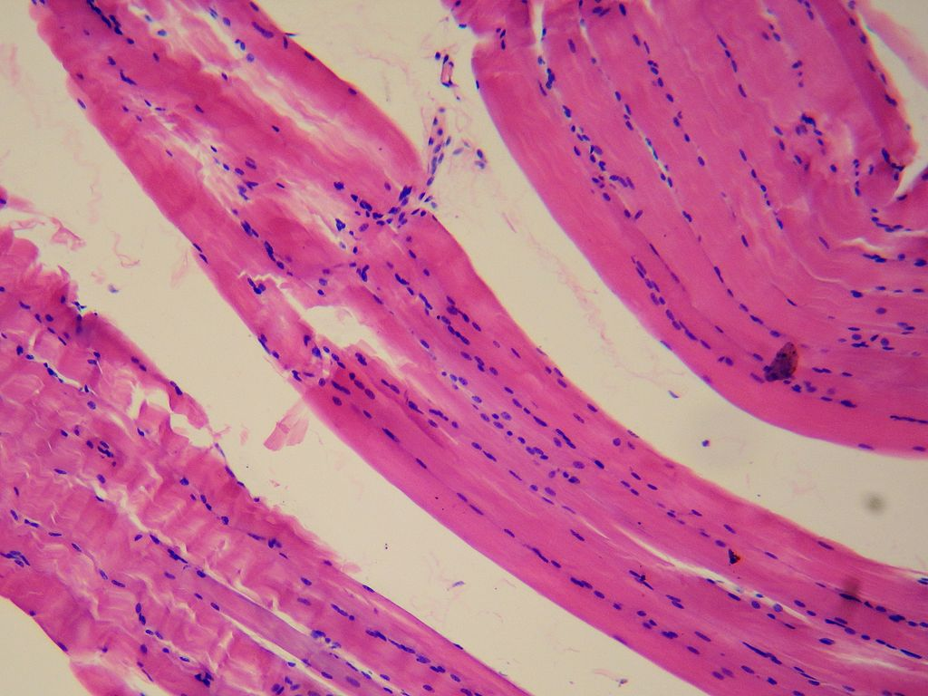
https://en.wikipedia.org/wiki/Smooth_muscle#/media/File:Smooth_muscle_tissue.jpg

Cardiac Muscle
Cardiac muscle (also called heart muscle or myocardium) is one of three types of vertebrate muscles, with the other two being skeletal and smooth muscles. It is an involuntary, striated muscle that constitutes the main tissue of the walls of the heart. The myocardium forms a thick middle layer between the outer layer of the heart wall (the epicardium) and the inner layer (the endocardium), with blood supplied via the coronary circulation. It is composed of individual heart muscle cells (cardiomyocytes) joined together by intercalated discs, encased by collagen fibres and other substances that form the extracellular matrix.

Cardiac muscle contracts in a similar manner to skeletal muscle, although with some important differences. An electrical stimulation in the form of an action potential triggers the release of calcium from the cell's internal calcium store, the sarcoplasmic reticulum. The rise in calcium causes the cell's myofilaments to slide past each other in a process called excitation contraction coupling.

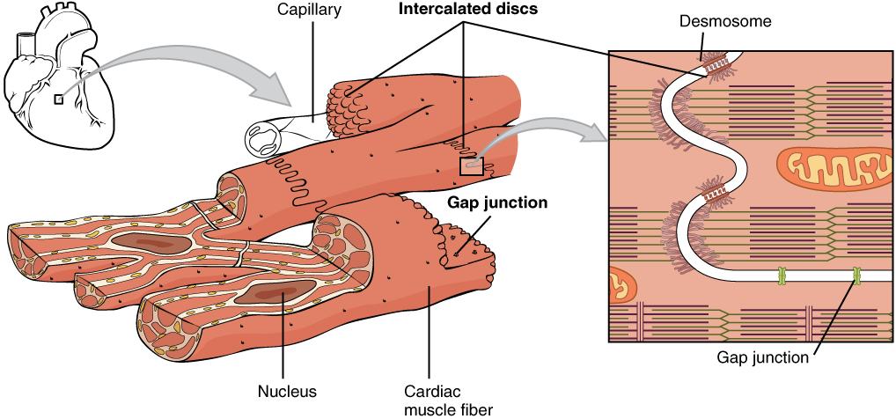
https://en.wikipedia.org/wiki/Cardiac_muscle#/media/File:1020_Cardiac_Muscle.jpg

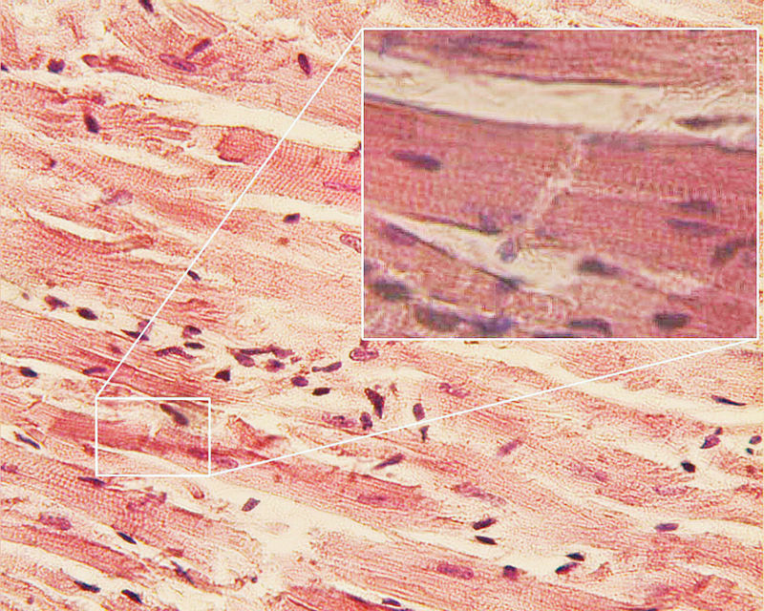
https://en.wikipedia.org/wiki/Cardiac_muscle#/media/File:Glanzstreifen.jpg

