The Skeletal System Laboratory Activity

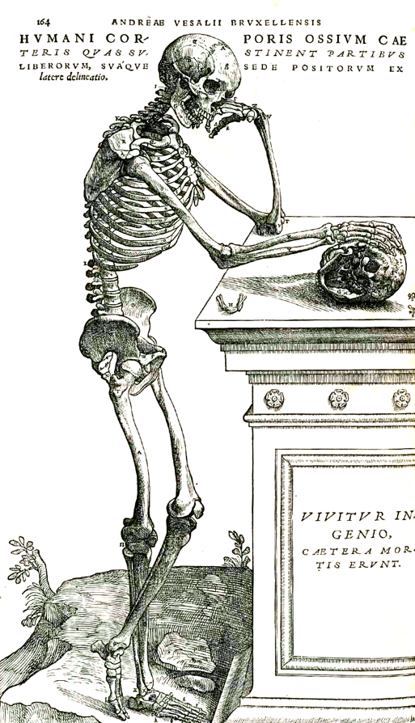
Student’s Name:

Date:

Objectives
- Define and differentiate between the axial skeleton and the appendicular skeleton
- Identify the major bones and markings of the axial skeleton
- Identify the major bones and markings of the appendicular skeleton
- Build a skeleton using disarticulated bones

Introduction
This laboratory activity will introduce the students to the bones and structures that form the human skeleton. The skeleton is the internal framework of the human body. It is composed 206 bones in the adult.
The human skeleton can be divided into two portions: the axial skeleton and the appendicular skeleton.
https://commons.wikimedia.org/wiki/File:Vesalius_164frc.png

The axial skeleton is formed by the rib cage (vertebral column, ribs, and sternum), the skull, mandible, hyoid bone and the three ossicles (inside the ear).
The appendicular skeleton, which is attached to the axial skeleton, is formed by the shoulder girdle, the pelvic girdle and the bones of the upper and lower limbs.
The human skeleton performs six major functions; support, movement, protection, production of blood cells, storage of minerals, and endocrine regulation.

Laboratory Activity
In this lab, you will learn to identify the bones of the adult human skeleton, its processes, orientation and how they articulate with each other using sets of disarticulated and articulated skeletons.

Part 1 – Identify the bones of the human skeleton. Label the bones using the images shown here.
- Axial Skeleton - Identify bones and structures of the skull

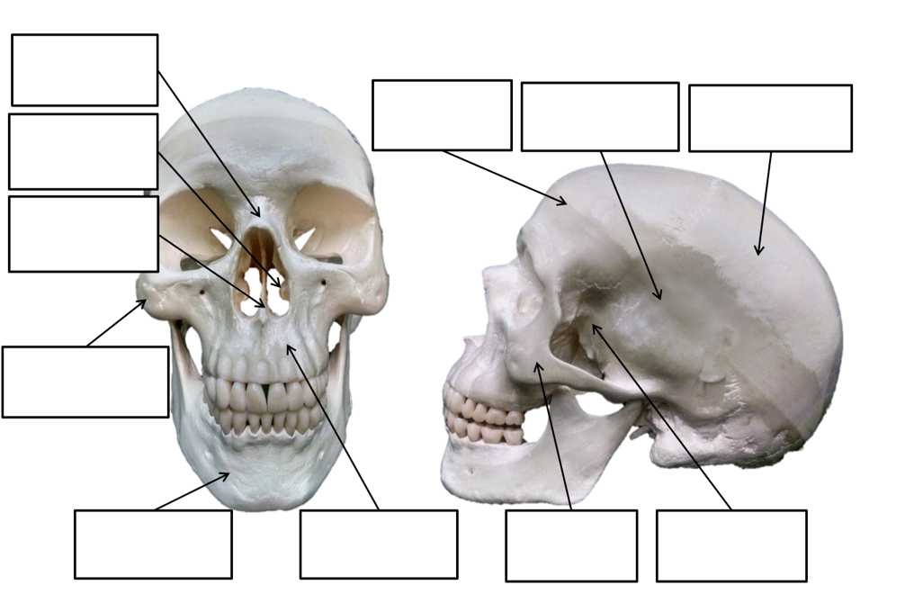

Label the following:
Zygomatic bones; Lacrimal bones, Occipital bone; Coronal suture; Sagittal suture; Superior orbital notch/foramen; Inferior orbital foramen; Glabella; Superior orbital fissure; Inferior orbital fissure.
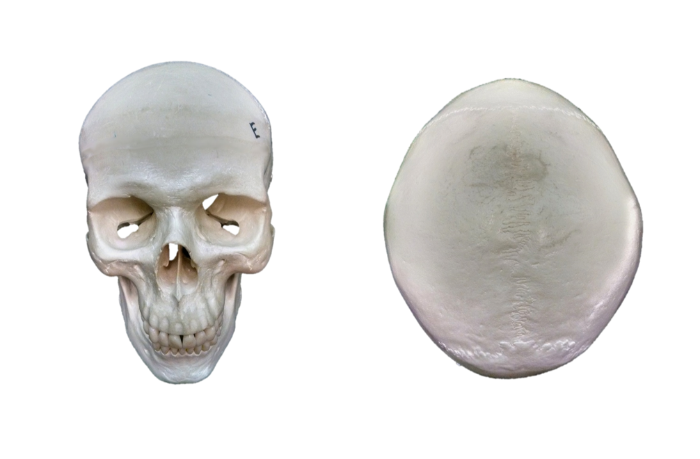
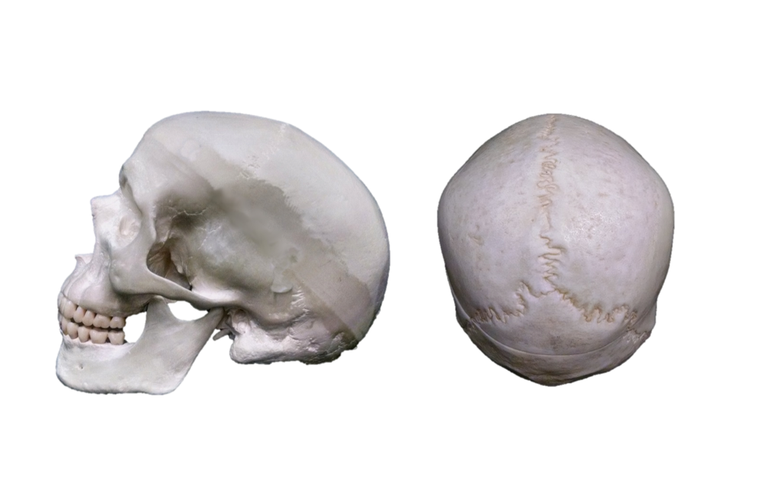

Label the following:
Occipital bone; Parietal bone; Temporal bone; Sphenoid bone; Maxilla; Mandible; Zygomatic bone; External acoustic meatus; Mastoid process; Styloid process; Lambdoid suture; Squamous suture; Zygomatic process of the temporal bone; Temporal process of the zygomatic bone; Wormian (or sutural) bones.

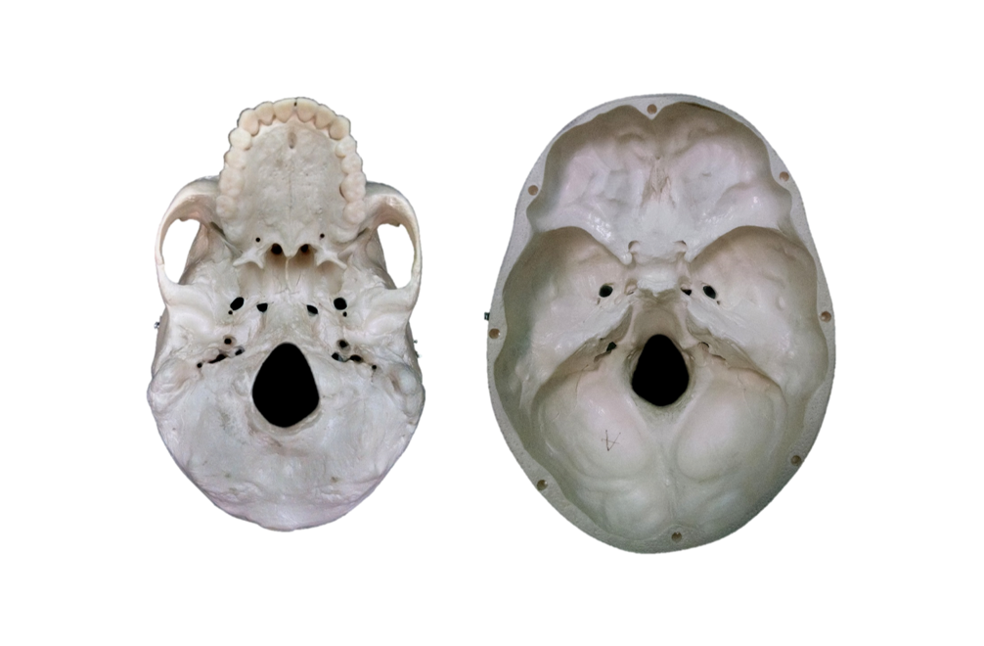
Label the following:
Zygomatic arch; Lesser wing of the sphenoid; Sella turcica; Foramen ovale; Foramen spinosum; Foramen lacerum; Jugular foramen; Carotid canal; Foramen magnum; Internal acoustic meatus; Occipital condyle; Mandibular fossa; Ethmoid bone; Crista galli; Optic canal; Anterior cranial fossa; Middle cranial fossa; Posterior cranial fossa.

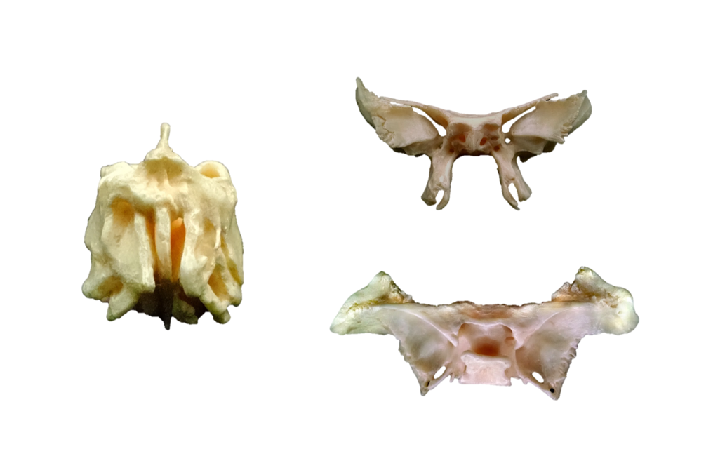

Label the following:
Ethmoid bone: Perpendicular plate; Crista galli; Lateral masses.
Sphenoid bone: Lesser wing; Greater wing; Sella turcica; Pterygoid plates; Hypophyseal fossa.

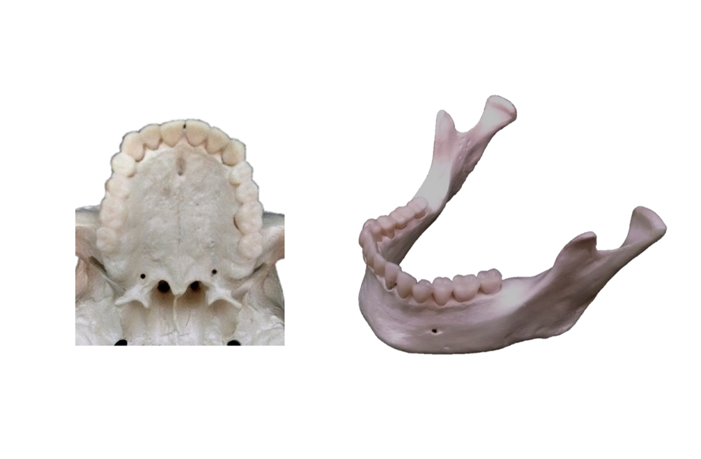

Label the following:
Maxilla; Palatine bone; Pterygoid plates; Vomer, Greater palatine foramen, Incisive foramen
Mandible; Condylar process; Coronoid process; Mental foramen; Body of mandible; Ramus of mandible; Mandibular notch.

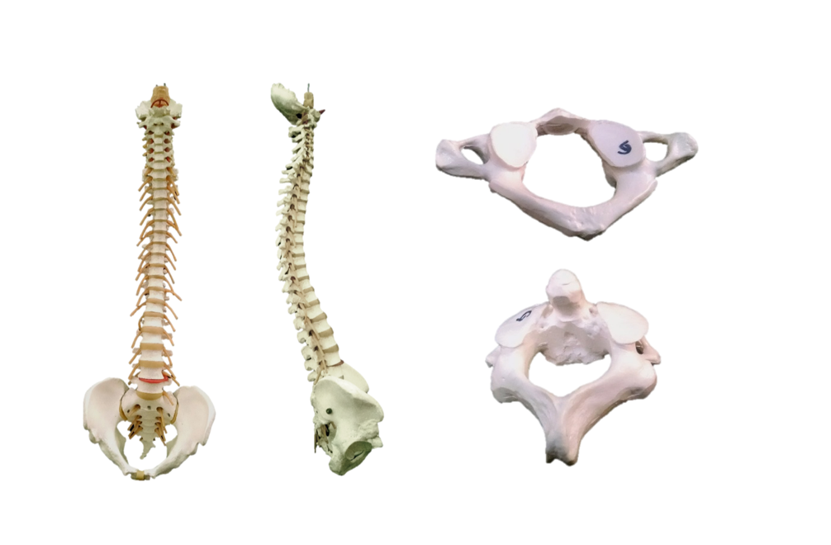

Label the following:
Cervical vertebrae; Cervical curvature; Thoracic vertebrae; Thoracic curvature; lumbar vertebrae; Lumbar curvature; Sacrum; Coccyx; 7; 12; 5.
Atlas; Axis; Dens; C1; C2; Spinous process; Superior articular facet .

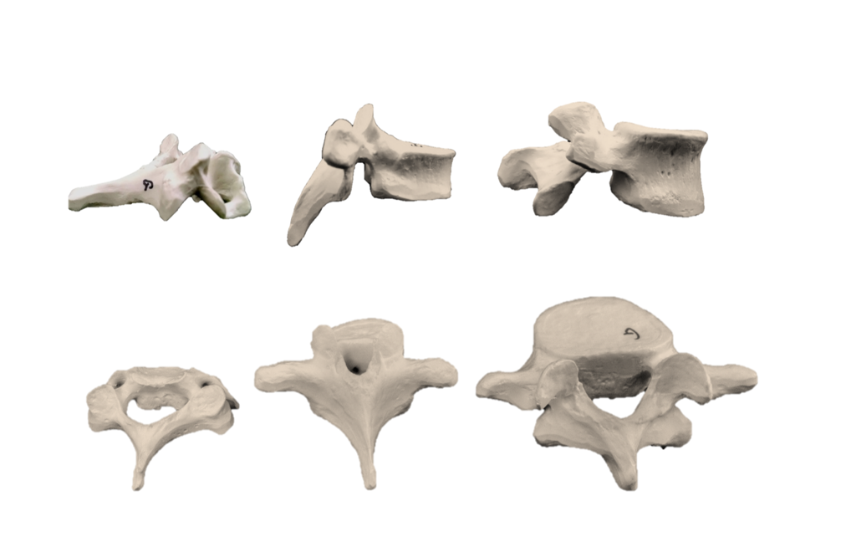

Label the following:
Cervical vertebrae; Thoracic vertebrae; Lumbar vertebrae; Transverse foramen; Superior articular process; Inferior articular process; Costal demifacet; Vertebral foramen; Body; Spine; Arch; Transverse process; Transverse facet

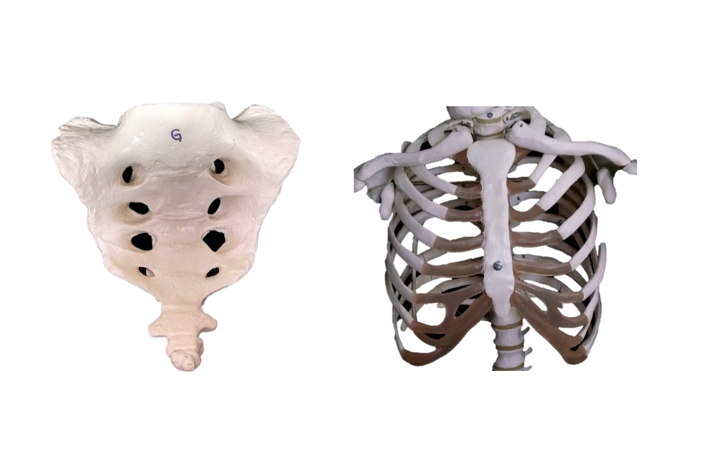

Label the following:
Sacrum: Sacral foramen; Ala (of the sacrum); Auricular surface.
Coccyx.
Sternum: Manubrium; Body; Xiphoid process; Jugular notch; Sternal angle.
True ribs; False ribs; Floating ribs; Costal cartilages.

- B. Appendicular Skeleton - Identify bones and structures of the appendicular skeleton

Label the following:
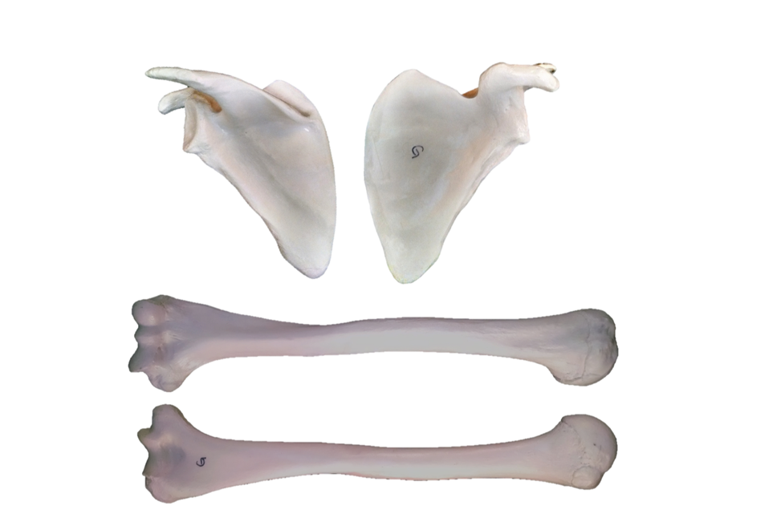

Label the following:
Scapula: Spine; Coracoid process; Acromion; Supra-spinous fossa; Infra-spinous fossa; Sub-scapular fossa; Glenoid cavity
Humerus: Head; Neck; (surgical and anatomical); Trochlea; Capitulum; Olecranon fossa; Coronoid fossa; Radial fossa; Medial epicondyle; Lateral epicondyle; Greater tubercle; Lesser tubercle
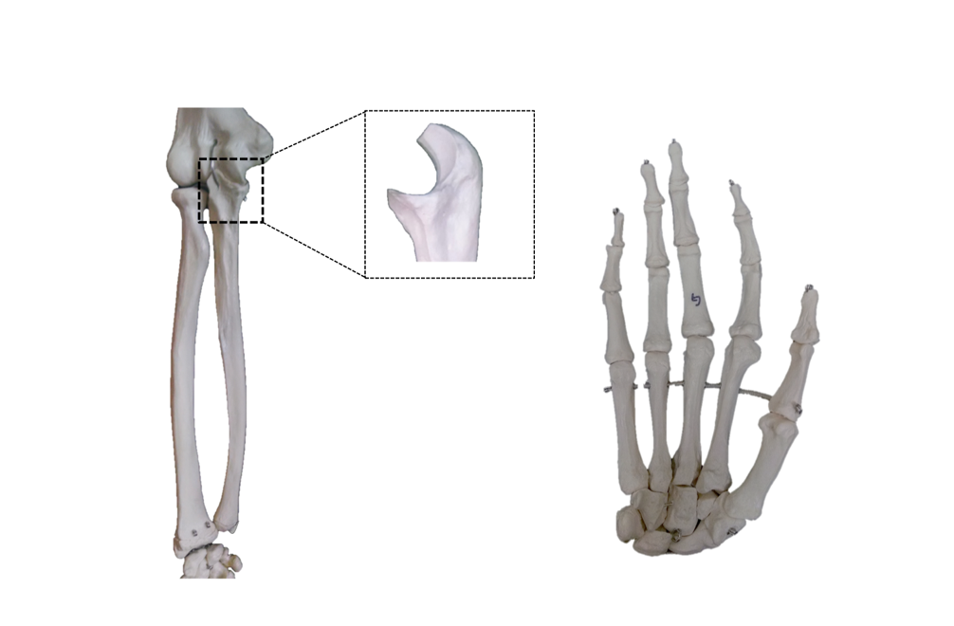

Label the following:
Radius: Styloid process; Radial head; Radial tuberosity.
Ulna: Olecranon; Trochlear notch; Coronoid process; Styloid process;
Carpals: Scaphoid; Lunate; Triquetral; Pisiform; Trapezium; Trapezoid; Capitate; Hamate.
Metacarpals
Phalanges: proximal; middle and distal
Pollex

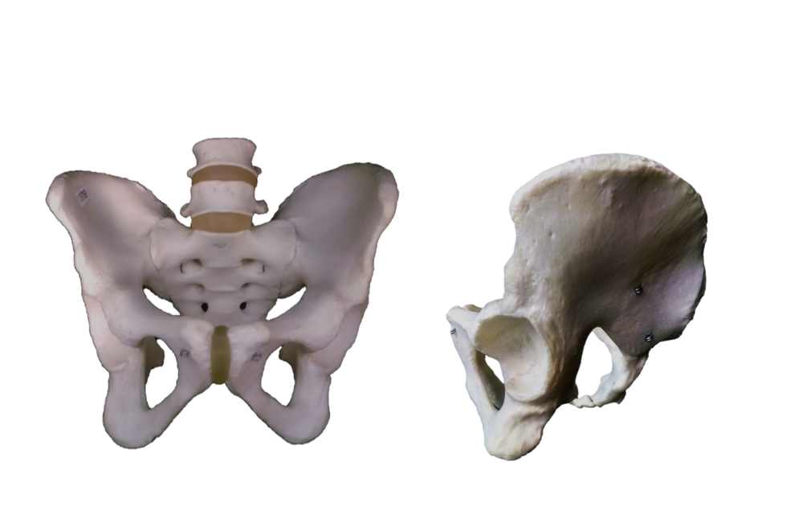

Label the following:
Ilium; Ischium; Pubis.
Obturator foramen; Acetabulum; Iliac crest; Anterior superior iliac spine; Anterior inferior iliac spine; Posterior superior iliac spine; Posterior inferior iliac spine; Pubis symphisis; Greater sciatic notch; Ischial spine; Sacrum; (male or female pelvis).
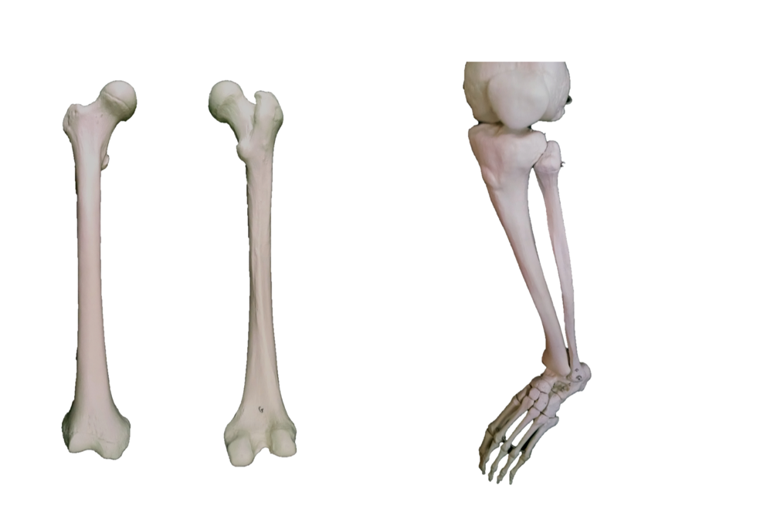
Label the following:
Femur: Head; Neck; Greater trochanter; Lesser trochanter; Medial condyle; Lateral condyle; Medial epicondyle; Lateral epicondyle; Linea aspera.
Tibia: Medial malleolus; Tibial tuberosity.
Fibula: Lateral malleolus.

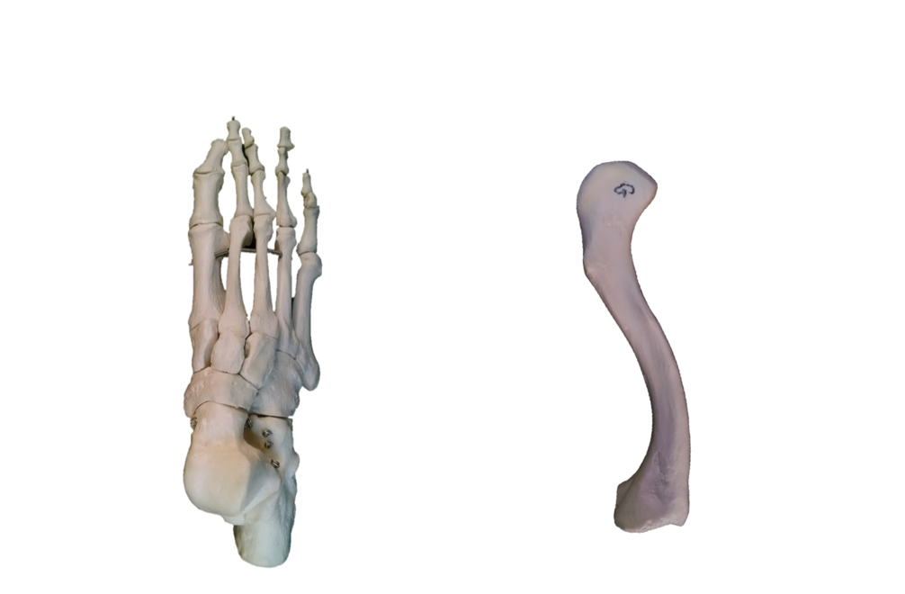
Label the following:
Tarsals: Talus; Calcaneus; Cuboid; Navicular; Medial,intermediate & lateral cuneiforms;
Metatarsals
Phalanges: proximal; middle; distal.
Hallux
Clavicle: sternal end, acromial end

Appendix A - List of bone and its structures

This is the list of bones and structures that you must be able to identify after performing this lab activity. You should use the articulated and disarticulated skeletons available in the laboratory to practice identifying all structures listed here. It is recommended to work in groups of two and to test each other as you practice the identification of all structure listed here.

Axial Skeleton

Human Skull
Cranial Bones (bones that form the cranial cavity)
Bones forming the calvarium (skull cap)
Frontal bone (1)
Supraorbital margins (ridges)
Supraorbital foramina (notches)
Parietal bone (2)
Occipital bone (1)
Foramen Magnum
Occipital Condyles
External occipital protuberance
Bones forming the Floor of the cranial cavity
Frontal (1)
Frontal sinus
ETHMOID BONE (1)
Cribriform plate
Crista galli
Olfactory foramina (passage for olfactory nerves)
Perpendicular plate (anterior and superior part of nasal septum, articulates with vomer)
Superior nasal conchae (turbinate bones)
Middle nasal conchae (turbinate bones)
Ethmoid sinus (air cells)
SPHENOID BONE (1)
Lesser wings
Greater wings
Sella turcica
Sphenoid sinus
Optic foramina
Temporal bone (2)
Squamous portion – squamous suture, zygomatic process of the temporal bone (part of zygomatic arch), mandibular fossa
Tympanic portion – external auditory meatus, styloid process and stylomastoid foramen
Mastoid portion – mastoid process and mastoid air cells
Petrous portion – internal auditory meatus, carotid foramen and canal, jugular foramen
Occipital bone (1)
Other structures of the cranial floor
Anterior, Middle and Posterior Fossae
Facial bones (bones of the face)
Mandible (1)
Mental Protuberance
Alveolar process
Rami of mandible
Angle of mandible
Body of mandible
Mandibular condyles
Mental foramina
Maxilla (2):
Maxillary sinus
Alveolar process
Palatine process (2/3 of hard palate)
Palatine bone (2) (forms posterior 1/3 of hard palate)
Zygomatic bone – ZYGOMA (2)
Temporal process of the zygomatic bone
Lacrimal bone (2)
Lacrima fossae
Nasal bone, also called Nasalis (2), they form the bridge of the nose
Inferior nasal conchae (2)
Vomer (1), forms inferior and posterior nasal septum, articulates with perpendicular plate of the ethmoid bone
BONES OF THE ORBIT
Frontal
Zygomatic
Maxillary
Sphenoid
Ethmoid
Palatine
Lacrimal
OSSICLES (three bones in middle ear)
Malleus
Incus
Stapes
Hyoid bone (supports the tongue)
VERTEBRAL COLUMN
Cervical vertebrae (7)
C1 = Atlas
C2 = Axis
Dens or odontoid process
Thoracic vertebrae (12)
Lumbar vertebrae (5).
Sacrum (5, fused sacral vertebrae)
Coccyx (4-6, fused coccygeal vertebrae) vestigial tail
VERTEBRA - Structures
Body of Vertebra
Spinous process
Transverse process
Vertebral foramen
Superior articular facet
Inferior articular facet
Intervertebral foramen
THORACIC CAGE
STERNUM
Manubrium
Body of sternum
Xiphoid process
RIBS
Ribs 1-7 (true ribs)
Ribs 8-12 (false ribs)
Ribs 11-12 (floating ribs)
Ribs - Structures:
Head
Neck
Tubercle
Body
Costal groove
Sternal end
SUTURES
Frontal or Coronal
Sagittal
Lambdoidal
Squamous
Sutural bones or Wormian bones
Fetal Skull
Anterior fontanelle
Posterior fontanelle
Anterolateral fontanelle
Posterolateral fontanelle

Appendicular Skeleton

GIRDLES AND LIMBS
PECTORAL GIRDLE
Clavicle
Acromial end
Sternal End
Scapula
Spine
Acromion
Glenoid cavity
Coracoid process
Supraspinous fossae
Infraspinous fossae
Subscapular fossae
Axillary border
Vertebral border
Superior border
Inferior border
UPPER LIMB (Humerus, radius, ulna, carpals, metacarpals, phalanges)
Humerus (brachium – arm)
Proximal end:
Head
Anatomical neck
Surgical neck
Greater tubercle
Lesser tubercle
Shaft:
Deltoid tuberosity
Distal end:
Capitulum
Trochlea
Lateral epicondyle
Medial epicondyle
Olecranon fossa
Radius (antebrachium – forearm)
Proximal end:
Head
Radial tuberosity
Distal end:
Styloid process
Ulnar notch
Ulna (antebrachium – forearm):
Proximal end:
Olecranon
Radial notch
Trochlear notch
Distal end:
Head
Styloid process
Wrist (carpus) - carpal bones (8)
Scaphoid, lunate, triquetrum, pisiform, trapezium, trapezoid, capitate, hamate
Hand (Manus - 19 bones):
Metacarpus
Metacarpal bones ( I - V)
Phalanges ( I - V)
Proximal, middle, distal phalanx
PELVIC GIRDLE (hip girdle, 2 innominate bones with sacrum)
2 coxal bones, also called innominate bones and os coxae.
Ilium:
Iliac crest
Iliac fossa
Greater sciatic notch
Acetabulum (formed by the fusion of ilium, ischium and pubis)
Ischium:
Ischial spine
Ischial tuberosity
Lesser sciatic notch
Acetabulum (formed by the fusion of ilium, ischium and pubis)
Obturator foramen
Pubis:
Pubic symphysis
Acetabulum (formed by the fusion of ilium, ischium and pubis)
Obturator foramen
LOWER LIMB (femur, patella, tibia, fibula, tarsals, metatarsals, phalanges)
Femur (thigh)
Proximal end:
Head
Neck
Greater trochanter
Lesser trochanter
Gluteal tuberosity
Shaft:
Linea aspera
Distal end:
Patellar surface
Medial condyles
Lateral condyles
Medial epicondyles
Lateral epicondyles
Patella (kneecap)
Base
Apex
Tibia (leg, lower leg)
Proximal end:
Medial condyles
Lateral condyles
Tibial tuberosity
Shaft:
Anterior crest
Distal end:
Medial malleolus
FIBULA (leg)
Proximal end:
Head
Distal end:
Lateral malleolus
ANKLE (tarsus)
7 tarsal bones: talus, calcaneus, navicular, medial, intermediate and lateral cuneiformns, cuboid
Foot (pes – 19 bones)
Metatarsus
Metatarsal bones (I-V)
Phalanges (I-V):
Proximal, middle, distal phalanx

