Introduction to Skeletal System Laboratory Activity
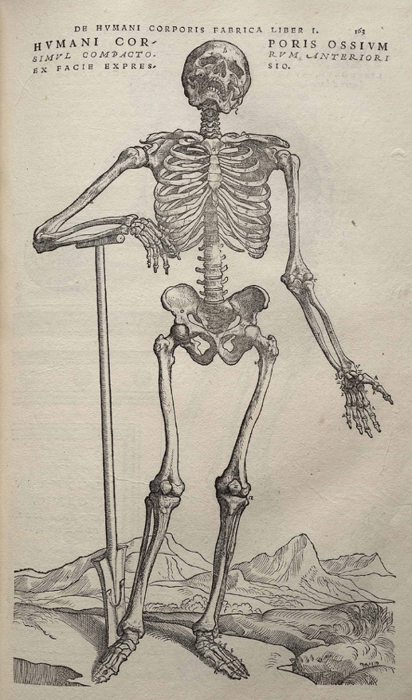
Student’s Name:

Date:

Introduction
The skeletal system consists of bones and cartilages in the body. Bones are complex organs, they are made up of different types of bone cells, protein fibers, and minerals as well as different types of tissues. The skeletal system provides support and protection to the soft tissues that make up the rest of the body. The skeletal system also provides attachment for muscles to allow movements at the joints, it is a place where to store fat and precious minerals such as calcium and phosphorous. Another function of bones is to house the bone marrow that is involved in the production of the formed element of blood.
In the human body at birth, there are over 300 bones, but many of these bones fuse together during development, leaving a total of 206 separate bones in the adult, not counting numerous small sesamoid bones. The largest bone in the body is the femur or thigh-bone, and the smallest is the stapes in the middle ear.

This lab exercise will introduce you to the components of bone, its functional units and the skeletal system as a whole. You will also learn to identify the shape of bones that form the human skeleton and selected processes of the bones.

Objectives
- Identify and label the structural and functional units of osseous tissue
- Classify bones according to shape, give examples of each
- Identify parts of a long and a flat bone
- List and describe the function of selected bone markings

Part 1 – Osseous Tissue
Bone tissue (osseous tissue) is a hard and mineralized connective tissue. Bone tissue is made up of different types of bone cells. Osteoblasts and osteocytes are involved in the formation and mineralization of bone; osteoclasts are involved in the resorption of bone tissue. Modified (flattened) osteoblasts become the lining cells that form a protective layer on the bone surface. The mineralized matrix of bone tissue has an organic component of mainly collagen called ossein and an inorganic component of bone mineral made up of various salts. Bone tissue is a mineralized tissue of two types, Compact bone (cortical) and Spongy (trabecular or cancellous) bone.
Bone is not uniformly solid, it consists of a flexible matrix and bound minerals, which are intricately woven and endlessly remodeled by a group of specialized bone cells. Their unique composition and design allow bones to be relatively hard and strong, while remaining lightweight.
Bone matrix is 90 to 95% composed of elastic collagen fibers, also known as ossein and the remainder is ground substance. The elasticity of collagen improves fracture resistance. The matrix is hardened by the binding of inorganic mineral salt calcium phosphate in a chemical arrangement known as calcium hydroxylapatite. It is the bone mineralization that give bones rigidity.
Bone is actively constructed and remodeled throughout life by special bone cells known as osteoblasts and osteoclasts. Within any single bone, the tissue is woven into two main patterns, known as cortical and cancellous bone, and each with different appearance and characteristics.

Compact or Cortical bone
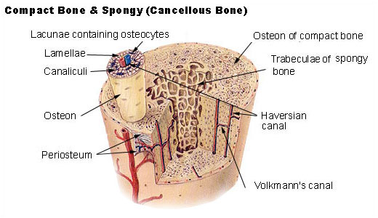
Cross-section details of a long bone
Public domain, https://commons.wikimedia.org/wiki/File:Illu_compact_spongy_bone.jpg

The hard, outer layer of bones is composed of cortical bone also called compact bone being much denser than cancellous bone. The cortical bone gives bone its smooth, white, and solid appearance, and accounts for 80% of the total bone mass of an adult human skeleton. It facilitates bone's main functions: to support the whole body, protect organs, provide levers for movement, and store and release minerals, mainly calcium and phosphorous. It consists of multiple microscopic functional units, called an osteon. The osteons (Harvesian Systems) are arrange as multiple layers of osteoblasts and osteocytes around a central canal or Haversian canal. The osteons connect with each other at right angles via the perpendicular or Volkmann's canals. Osteons are metabolically active, and as bone is reabsorbed and created the nature and location of the cells within the bone will change. Cortical bone is covered by a periosteum on its outer surface, and an endosteum on its inner surface. The endosteum is the boundary between the cortical bone and the cancellous bone. The periosteum is formed of two layer the outer fibrous layer made od dense irregular fibrous connective tissue where the blood vessels and nerves are located and the inner layer of periosteum contains osteogenic cells that become osteoblasts (build the matrix) and osteoclasts (reabsorb the matrix). The fibers of the periosteum extend to form Sharpey’s fibers that anchor the periosteum to the bone.

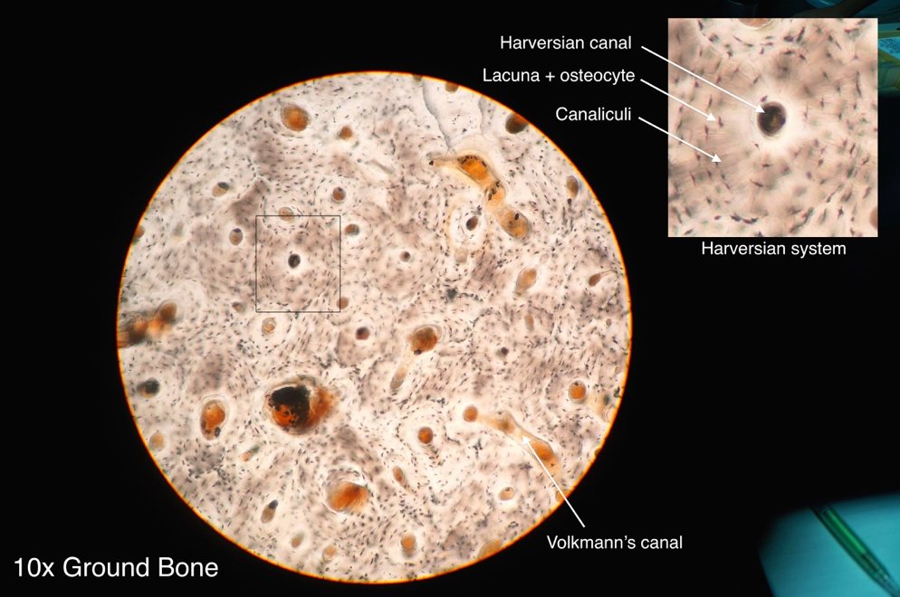
Histology of compact bone showing osteon
https://commons.wikimedia.org/wiki/File:Compact_bone_histology_2014.jpg
This file is licensed under the Creative Commons Attribution-Share Alike 4.0 International license.

Spongy, Trabecular or Cancellous bone

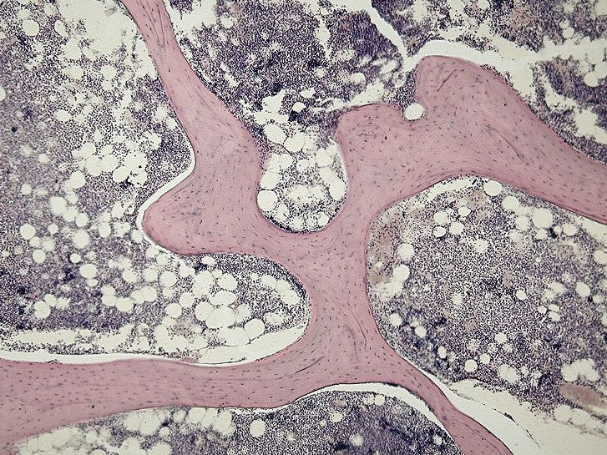
Micrograph of cancellous bone
https://commons.wikimedia.org/wiki/File:Spongy_bone_-_trabecules.jpg
This file is licensed under the Creative Commons Attribution-Share Alike 3.0 Unported license.

Cancellous bone, also called trabecular or spongy bone, is the internal tissue of the skeletal bone and is an open cell porous network. Cancellous bone has a higher surface-area-to-volume ratio than cortical bone because it is less dense. This makes it weaker and more flexible. The greater surface area also makes it suitable for metabolic activities such as the exchange of calcium ions. Cancellous bone is typically found at the ends of long bones, near joints and in the interior of vertebrae. Cancellous bone is highly vascular and often contains red bone marrow where hematopoiesis, the production of blood cells, occurs. The primary anatomical and functional unit of cancellous bone is the trabecula. The trabeculae are aligned towards the mechanical load distribution that a bone experiences within long bones such as the femur. As far as short bones are concerned, trabecular alignment has been studied in the vertebral pedicle. Thin formations of osteoblasts covered in endosteum create an irregular network of spaces, known as trabeculae. Within these spaces are bone marrow and hematopoietic stem cells that give rise to platelets, red blood cells and white blood cells. Trabecular marrow is composed of a network of rod- and plate-like elements that make the overall organ lighter and allow room for blood vessels and marrow. Trabecular bone accounts for the remaining 20% of total bone mass but has nearly ten times the surface area of compact bone.
The words cancellous and trabecular refer to the tiny lattice-shaped units (trabeculae) that form the tissue.

Bone marrow
Bone marrow, also known as myeloid tissue in red bone marrow, can be found in almost any bone that holds cancellous tissue. In newborns, all such bones are filled exclusively with red marrow, but as the child ages the hematopoietic fraction decreases in quantity and the fatty/ yellow fraction called marrow adipose tissue (MAT) increases in quantity. In adults, red marrow is mostly found in the bone marrow of the femur, the ribs, the vertebrae and pelvic bones.

Bone cells
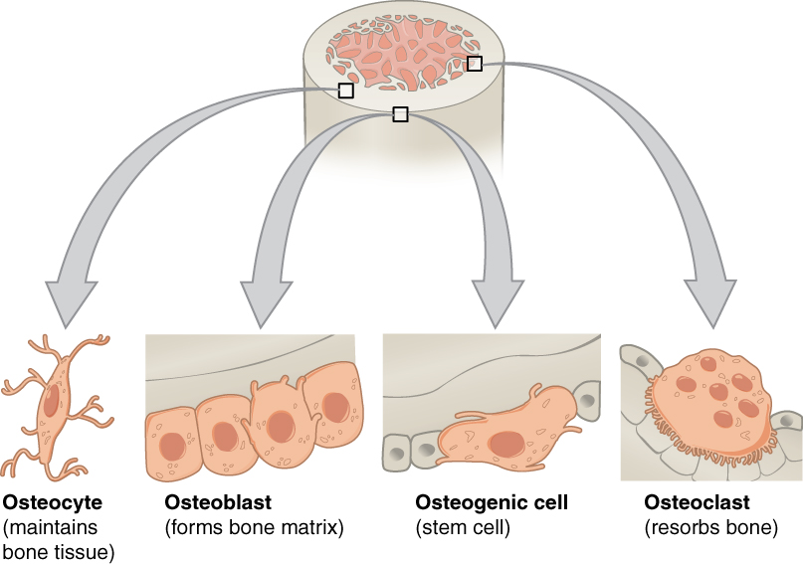
Bone Cells
https://commons.wikimedia.org/wiki/File:604_Bone_cells.jpg
This file is licensed under the Creative Commons Attribution 3.0 Unported license.

Bone is a metabolically active tissue composed of several types of cells. These cells include osteoblasts, which are involved in the creation and mineralization of bone tissue, osteocytes, and osteoclasts, which are involved in the reabsorption of bone tissue.

Osteoblast
Osteoblasts are mononucleate bone-forming cells. They are located on the surface of osteon seams and make a protein mixture known as osteoid, which mineralizes to become bone.
The osteoid seam is a narrow region of newly formed organic matrix, not yet mineralized, located on the surface of a bone. Osteoid is primarily composed of Type I collagen. Osteoblasts also manufacture hormones, such as prostaglandins, to act on the bone itself. The osteoblast creates and repairs new bone by actually building around itself. First, the osteoblast puts up collagen fibers. These collagen fibers are used as a framework for the osteoblasts' work. The osteoblast then deposits calcium phosphate which is hardened by hydroxide and bicarbonate ions. The brand-new bone created by the osteoblast is called osteoid. Once the osteoblast is finished working it is actually trapped inside the bone once it hardens. When the osteoblast becomes trapped, it becomes known as an osteocyte. Other osteoblasts remain on the top of the new bone and are used to protect the underlying bone, these become known as lining cells.

Osteocyte
Osteocytes are mostly inactive osteoblasts. Osteocytes originate from osteoblasts that have migrated into and become trapped and surrounded by bone matrix that they themselves produced. The spaces they occupy are known as lacunae. Osteocytes have many processes that reach out to meet osteoblasts and other osteocytes probably for the purposes of communication. Osteocytes remain in contact with other cells in the bone through gap junctions—coupled cell processes—which pass through small channels in the bone matrix called the canaliculi.

Osteoclast
Osteoclasts are very large multinucleate cells that are responsible for the breakdown of bones by the process of bone resorption. New bone is then formed by the osteoblasts. Bone is constantly remodeled by the resorption of osteoclasts and created by osteoblasts. Because the osteoclasts are derived from a monocyte stem-cell lineage, they are equipped with phagocytic-like mechanisms similar to circulating macrophages. Osteoclasts mature and/or migrate to discrete bone surfaces. Upon arrival, active enzymes, such as tartrate resistant acid phosphatase, are secreted against the mineral substrate. The reabsorption of bone by osteoclasts also plays a role in calcium homeostasis.

Extracellular matrix
Bones consist of living cells embedded in a mineralized organic matrix. This matrix consists of organic components, mainly type I collagen – "organic" referring to materials produced as a result of the human body – and inorganic components, primarily hydroxyapatite and other salts of calcium and phosphate. Above 30% of the acellular part of bone consists of the organic components, and 70% of salts. The collagen fibers give bone its tensile strength, and the interspersed crystals of hydroxyapatite give bone its compressive strength. These effects are synergistic.
The inorganic composition of bone (bone mineral) is primarily formed from salts of calcium and phosphate, the major salt being hydroxyapatite (Ca₁₀(PO₄)₆(OH)₂). The exact composition of the matrix may be subject to change over time due to nutrition and biomineralization, with the ratio of calcium to phosphate varying between 1.3 and 2.0 (per weight), and trace minerals such as magnesium, sodium, potassium and carbonate also being found.
Type I collagen composes 90–95% of the organic matrix, with remainder of the matrix being a homogenous liquid called ground substance consisting of proteoglycans such as hyaluronic acid and chondroitin sulfate, as well as non-collagenous proteins such as osteocalcin, osteopontin or bone sialoprotein. Collagen consists of strands of repeating units, which give bone tensile strength, and are arranged in an overlapping fashion that prevents shear stress.

Part 2 - Classification of Bones based on shape
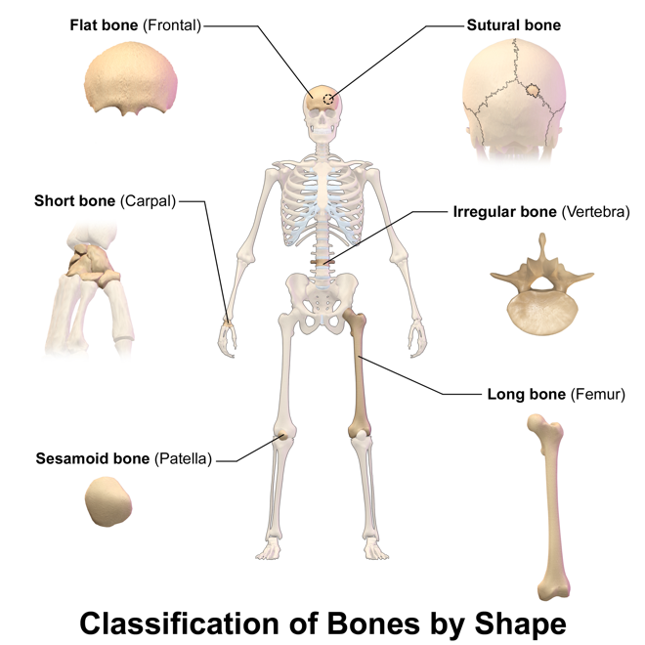
This file is licensed under the Creative Commons Attribution 3.0 Unported license.
https://commons.wikimedia.org/wiki/File:Blausen_0229_ClassificationofBones.png

There are six types of bones in the human body: long, short, flat, irregular, sesamoid and sutural.

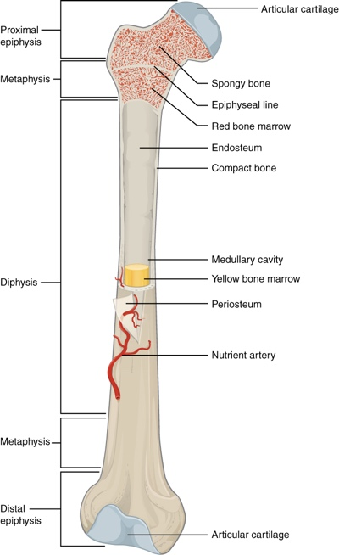
Anatomy of a long bone (femur)
This file is licensed under the Creative Commons Attribution 3.0 Unported license.https://commons.wikimedia.org/wiki/File:603_Anatomy_of_Long_Bone.jpg

Long bones are characterized by a shaft, the diaphysis, that is much longer than its width; and by an epiphysis, a rounded head at each end of the shaft. They are made up mostly of compact bone, with lesser amounts of marrow, located within the medullary cavity, and areas of spongy, cancellous bone at the ends of the bones. Most bones of the limbs, including those of the fingers and toes, are long bones. The exceptions are the eight carpal bones of the wrist, the seven articulating tarsal bones of the ankle and the sesamoid bone of the kneecap. Long bones such as the clavicle, that have a differently shaped shaft or ends are also called modified long bones.
Short bones are roughly cube-shaped and have only a thin layer of compact bone surrounding a spongy interior. The bones of the wrist and ankle are short bones.
Flat bones are thin and generally curved, with two parallel layers of compact bones sandwiching a layer of spongy bone. Most of the bones of the skull are flat bones, as is the sternum.
Sesamoid bones are bones embedded in tendons. Since they act to hold the tendon further away from the joint, the angle of the tendon is increased and thus the leverage of the muscle is increased. Examples of sesamoid bones are the patella and the pisiform.
Irregular bones do not fit into the above categories. They consist of thin layers of compact bone surrounding a spongy interior. As implied by the name, their shapes are irregular and complicated. Often this irregular shape is due to their many centers of ossification or because they contain bony sinuses. The bones of the spine, pelvis, and some bones of the skull are irregular bones. Examples include the ethmoid and sphenoid bones.
Sutural bones are small bones located between flat bones of the skull at the suture.
Also called Wormian bones.

Table 1 – Summary of Bone Shapes
Shape | Description | Example
Long bones | Longer that they are wide | Humerus, radius, ulna, femur, tibia fibula
Short bones | Length and wide are about the same | Bones of the wrist and ankle
Flat bones | They are flat | Bones of the skull, sternum, ribs, and hip
Irregular bones | Shape does not fit any of the other descriptions | Ethmoid, sphenoid bone, vertebra, sacrum
Sesamoid bones | Oval shaped bones located within tendons | Patella
Sutural bones | Small bones located between flat bones of the skull at the suture | Wormian bones of skull

Part 3 – Bone Markings
Bone markings are very important, they to allow the identification of bones and bony pieces. Bone markings enable joints to form, to slide past each other, to lock bones in place, and to provide a place of attachment and structural support to muscle and connective tissue. They also provide stabilization, protection and a pathway to nerves, vessels, and other structures.
Bone markings consist of depressions, openings and projections.
Depressions provide pathway for blood vessels and nerves travel to their target, they also allow two bones to forms a joint. Openings house and protect structures. Projections provide points of attachment for muscles via tendons and bone to bone via ligaments.

Common bone markings include the following:
Angles - Sharp bony angulations which may serve as bony or soft tissue attachments. Examples include the superior, inferior, and acromial angles of the scapula and the superior, inferior, lateral angles of the occipital bone, and the angle of the mandible.
Body - Usually refers to the largest most prominent segment of bone. Examples include the diaphysis or shaft of long bones like the femur and humerus and the body of the mandible.
Canal – passageway through a bone.
Condyle - Refers to a large rounded prominence which often provides structural support to the overlying hyaline cartilage. Examples include the knee joint, formed by the femoral lateral and medial condyles, and the tibial lateral and medial condyles and occipital condyle which allows the articulation of the occipital bone and the atlas (C1).
Crest - A raised or prominent part of the edge of a bone. Crests are often the sites where connective tissue attaches muscle to bone. An example is the iliac crest is found on the ilium.
Epicondyle - A prominence that sits atop of a condyle. The epicondyle attaches muscle and connective tissue to bone, providing support to this musculoskeletal system. Examples include the femoral medial and lateral epicondyles, and humeral medial and lateral epicondyles.
Facet - A smooth, flat surface where two bones meet to forms a joint. Examples include the facet joints of the vertebrae for flexion and extension of the spine.
Fissure - An open slit in or between bones. It usually houses nerves and blood vessels. Examples include superior and inferior orbital fissures.
Foramen - A hole in a bone through which nerves and blood vessels pass. Examples include foramen magnum, supraorbital foramen, infraorbital foramen, and mental foramen.
Fossa - A shallow depression in a bone surface. Examples include trochlear fossa, posterior, middle, and anterior cranial fossa.
Fovea – Shallow pit that allow the attachment of a ligament.
Groove - A long shallow depression on the bone surface that usually allows a blood vessel or nerve to travel along the length of the bone. Examples include a radial groove.
Head - A rounded end of a bone, it is a prominent extension of bone that forms part of a joint. Example the head of the radius and the femur.
Line – Ridge along a bone that allows a muscle to attach to the bone.
Margin - The edge of any flat bone. For example, the edge of the temporal bone articulating with the occipital bone is called the occipital margin of the temporal bone.

Meatus - A tube-like channel that extends within the bone, which may provide passage and protection to nerves, vessels, and sound. Examples include external acoustic meatus and internal auditory meatus.
Neck - The segment between the head and the shaft of a bone. For example, the anatomical neck of the humerus.
Notch - A depression in a bone which often, provides stabilization to an adjacent articulating bone. Examples include the trochlear notch on the ulna, radial notch of the ulna, suprasternal notch, and the mandibular notch.
Process – bony projection, allow for muscle attachment.
Protuberance – A bump or outgrowth on a bone.
Ramus - The curved part of a bone that gives structural support to the rest of the bone. Examples include the ramus of the mandible.
Sinus - A cavity within a bone. Examples include paranasal sinuses.
Spinous Process - A raised, sharp elevation of bone where muscles and connective tissue attach. Example spinous process of the vertebra.
Sulcus – Same as groove
Trochanter - A large prominence on the side of the bone. Some of the largest muscle groups and most dense connective tissues attach to the trochanter. The most notable examples are the greater and lesser trochanters of the femur.
Tubercle - A small, rounded prominence where connective tissues attach. Examples include the greater and lesser tubercle of the humerus.
Tuberosity - A moderate prominence where muscles and connective tissues attach. Its function is similar to that of a trochanter. Examples include the tibial tuberosity, deltoid tuberosity, and ischial tuberosity.

Laboratory Activity

Part 1 - Osseous Tissue
- Identify and label the structures of compact bone using the Anatomical Model of Bone shown below: Periosteum, Sharpey’s fibers, Endosteum, Osteon, Central canal, Osteocyte, Lacuna , Canaliculi, Perforating canal, Circumferential lamellae, Concentric lamellae, Interstitial lamellae.

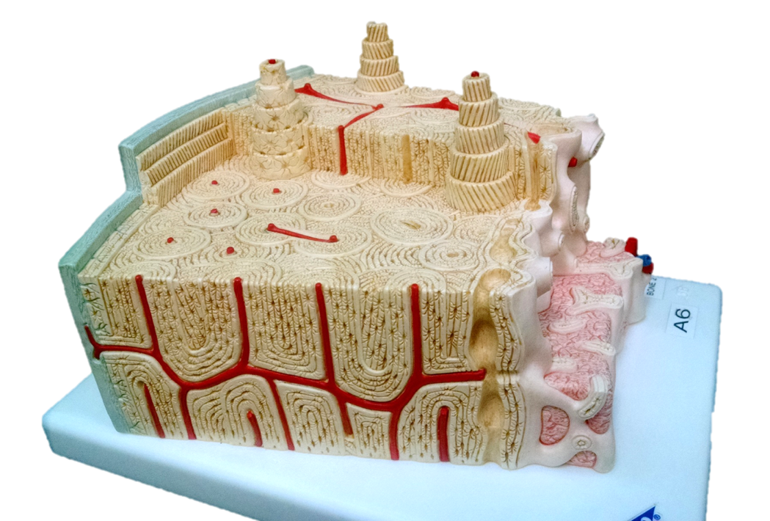

- Label spongy bone structures shown in this micrograph (arrows): trabecula, bone marrow.

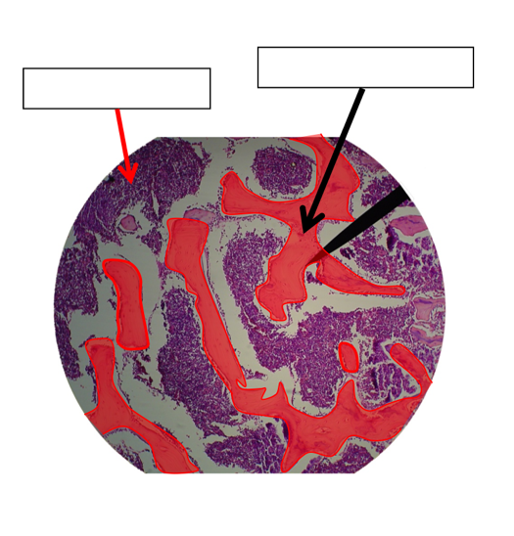
- Label the structures of compact bone shown in this micrograph (numbers)
Interstitial Lamella, Canaliculi, Osteocytes, Concentric Lamella, Osteons, Lacuna, Central Canal, Concentric Lamella

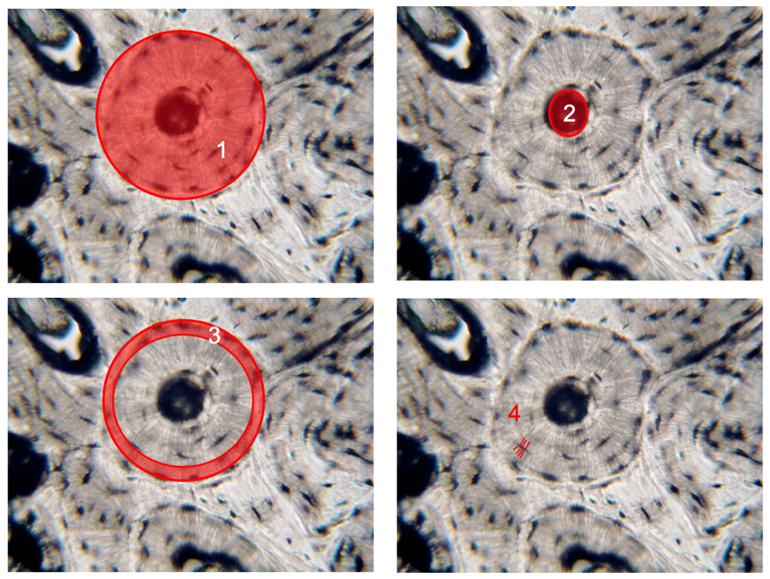
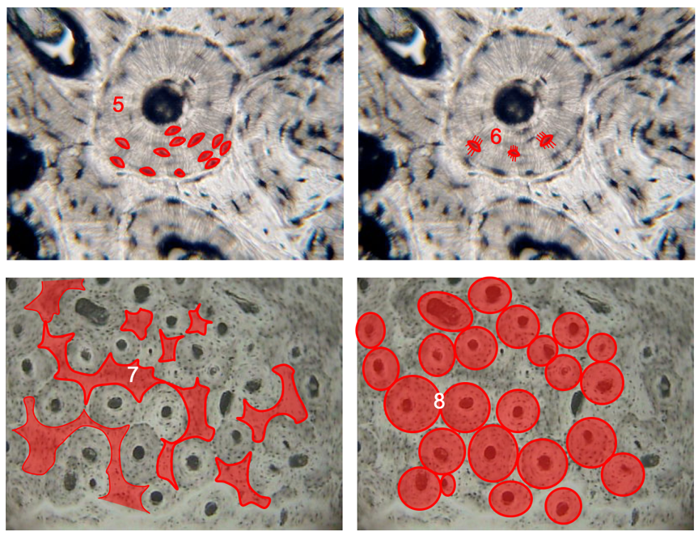

# | Structure
1
2
3
4
5
6
7
8

Part 2 – Identify Bones Shapes

- Identify the shape of the bones shown here: long, short, flat, sesamoid or irregular.

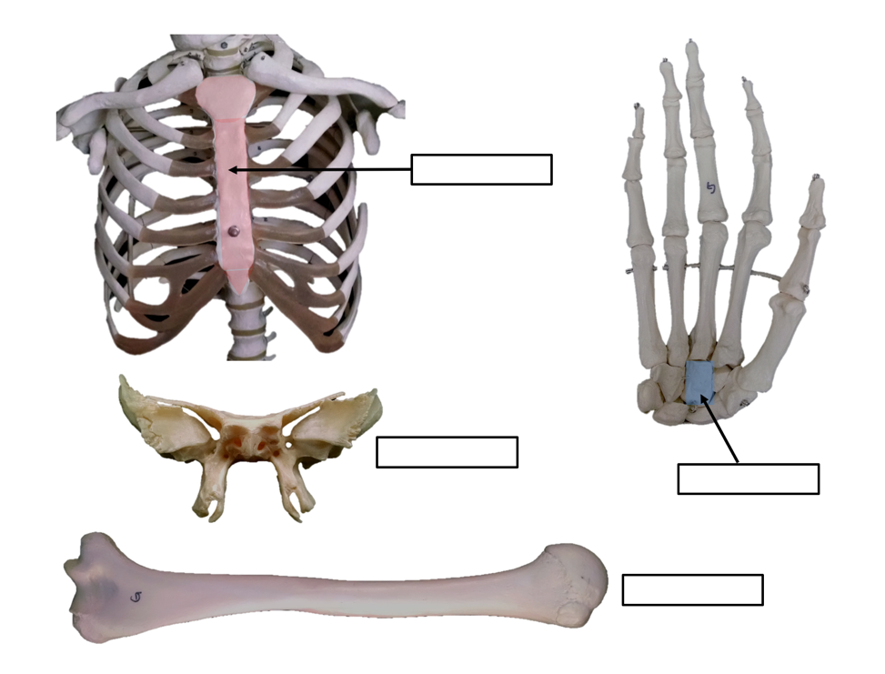

- Fill in the table shown below and give at least 3 examples of each.

Table 2 – Bone Shapes

Shape | Description | Example
Long bones
Short bones
Flat bones
Irregular bones
Sesamoid bones
Sutural bones
Part 3 – Anatomy of Long and Flat Bones

- Label the structures of a long bone shown below

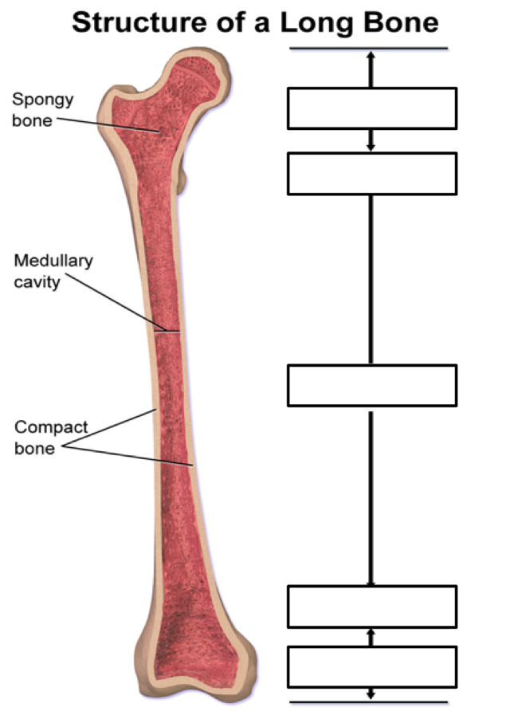
https://commons.wikimedia.org/wiki/File:Structure_of_a_Long_Bone.png
This file is licensed under the Creative Commons Attribution 3.0 Unported license.

- Label the structures of a flat bone show bellow: Trabeculae, spongy bone, compact bone, suture

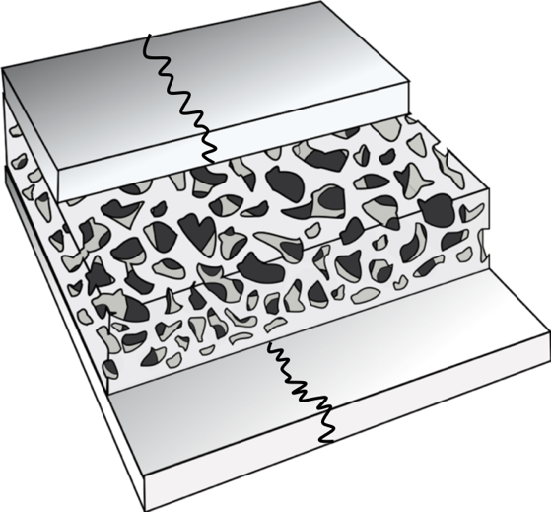

Part 4 – Identifying Bone Markings

Identify bone markings
Work in groups of two. Obtain a disarticulated bone sets located below your lab bench.
Organize the bones according to shape. Please note that you may have to look around the lab for missing bones from your box, or you may have more bones that you should, that is because the group that use the box before you were not very careful and organized, do not get discourage, the bones are in the lab, you just need a few minutes to find them and make sure you have a complete set.
Examine each bone and find the selected bone markings described in this lab exercise, you may need to refer your textbook for help.
Write at least one bone marking found per selected bone, use the table provided to complete the activity.
Table 3 – Bone markings

Bones | Markings on the bone
Frontal bone
Occipital bone
Temporal bone
Vertebra
Mandible
Sternum
Clavicle
Scapula
Ribs
Humerus
Radius
Ulna
Ilium
Ischium
Pubis
Femur
Tibia
Fibula

Part 5 - Review Key Terms
At the end of this activity you should be able to identify the following:
- Long bone anatomy:
- Periosteum
- Endosteum
- Diaphysis (shaft)
- Epiphyses, proximal and distal
- Metaphyseal line
- Perforating fibers
- Nutrient artery
- Spongy bone
- Compact bone
- Medullary cavity
- Articular cartilage
- Red marrow
- Yellow marrow
- Epiphyseal line
- Histology or Bone Tissue Models:
Compact bone
- Osteon
- Concentric lamellae
- Interstitial lamellae
- Circumferential lamellae
- Haversian canal
- Osteocyte
- Lacunae
- Canaliculi
- Perforating canal
- Periosteum
- Sharpey’s fibers
Spongy bone
- Trabeculae
- Endosteum
- Lamella
Hyaline cartilage
- Perichondrium
- Matrix
- Chondrocyte
- Lacunae
- Bone Shapes
- Long
- Short
- Flat
- Irregular
- Sesamoid
- Sutural
- Bone markings
  - Facet
  - Fossa
  - Fovea
  - Groove
  - Sulcus
  - Canal
  - Fissure
  - Foramen
  - Meatus
  - Condyle
  - Crest
  - Epicondyle
  - Head
  - Line
  - Protuberance
  - Trochanter
  - Tubercle
  - Tuberosity

Part 6 – Review of terms and Definitions
- Define long bone, and give an example
- Define short bone, and give an example
- Define irregular bone, and give an example
- Define flat bone, and give an example
- Define sesamoid bone, and give an example
- A raised rough surface on a bone where a muscle attaches to is called?
- A round opening in a bone is called a .
- What are the components of the extracellular matrix of bone?
- What is the function of the osteoclasts?
- What is the difference between the distal and the proximal epiphysis?

