Student name:

Date:

The Integumentary System

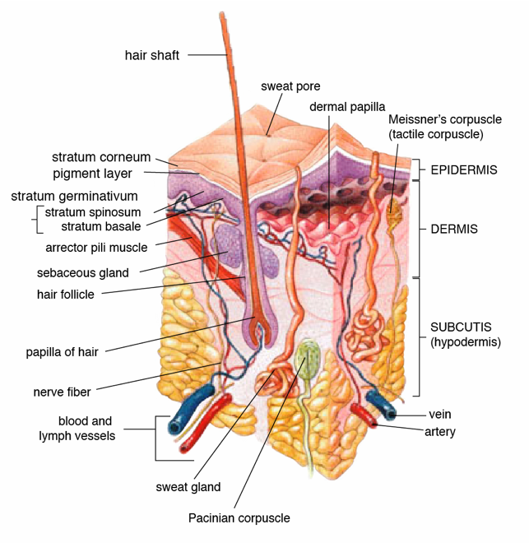
Cross-section of skin
Public Domain, https://commons.wikimedia.org/wiki/File:Skin.png

Objectives:
- Identify components of the integumentary system
- List the two types of skin
- Describe macro and microscopic anatomy of both types of skin
- List accessories structures of the skin
- Associate the layers of skin and hypodermis with burn degrees

Introduction
The integumentary system is the largest organ of the human body. It is composed four types of tissue, epithelial, connective, muscular and nervous tissues. The structures of the integumentary system include the skin, and its accessory organs; hairs, nails, accessory glands, sensory receptors. The integumentary system protects the body from dehydration, absorption of nutrients, excretion of wastes, and regulation of body temperature. It is also the attachment site certain muscles and contains sensory receptors to detect pain, sensation, pressure, and temperature and it is also involved in synthesis of vitamin D.

In this lab you will learn to identify the four types of tissues that compose the integumentary system and correlate them with their function.

Part 1 – Anatomy of the Skin
The skin is also called the cutaneous membrane. There are two types of skin, thin skin that is covered with hair (also contains sebaceous glands) and thick skin that has no hair.
The skin is composed of two layers the epidermis and the dermis. It has an associated layer below the dermis, the hypodermis.

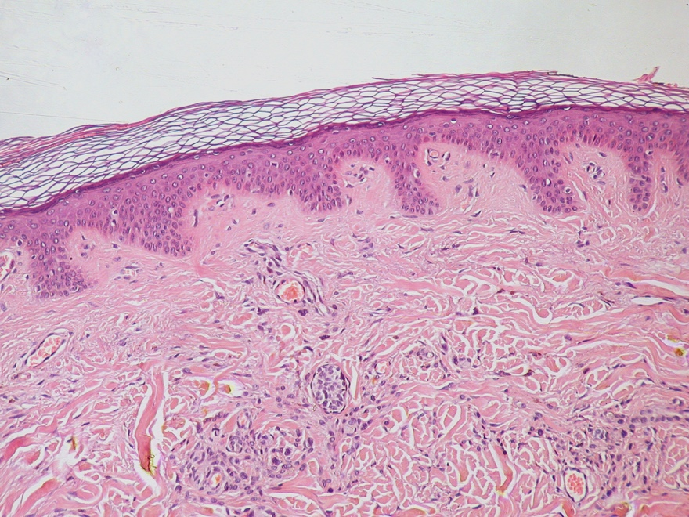

Human Skin, cross section
Public domain, https://commons.wikimedia.org/wiki/File:Normal_Epidermis_and_Dermis_with_Intradermal_Nevus_10x.JPG

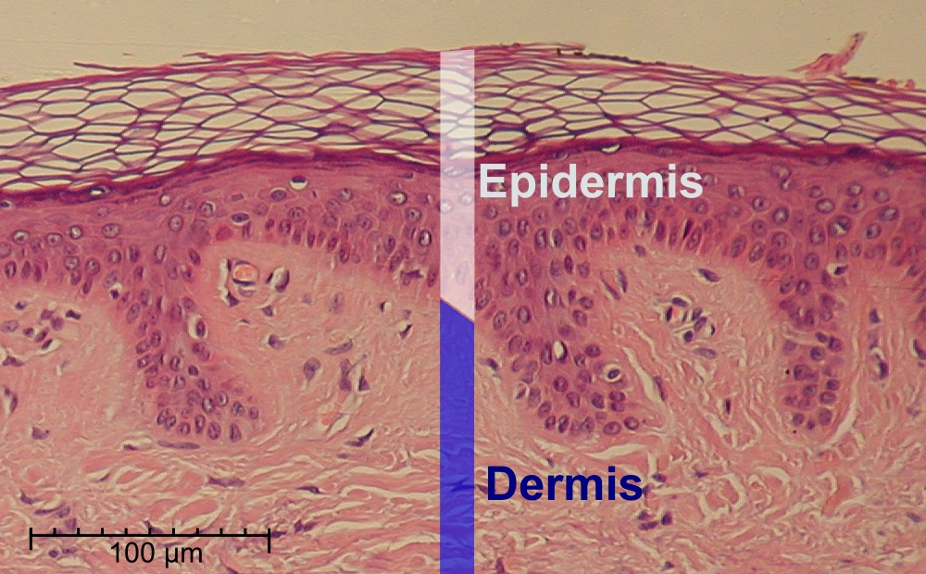

Layers of Skin
Public domain, https://commons.wikimedia.org/wiki/File:Epidermis-delimited.JPG

Epidermis
The epidermis is the top layer of skin. It avascular, meaning it does not contain blood vessels. It consists of layers of stratified squamous epithelium, and contains four types of cells (keratinocytes, melanocytes, Merkel cells, and Langerhans cells). The keratinocytes are the predominant cell type in the epidermis, they produce keratin, a fibrous protein that protects skin from mechanical stress. The majority of the skin on the body is keratinized. The only skin on the body that is non-keratinized is the lining of mucous membranes, such as the inside of the mouth.
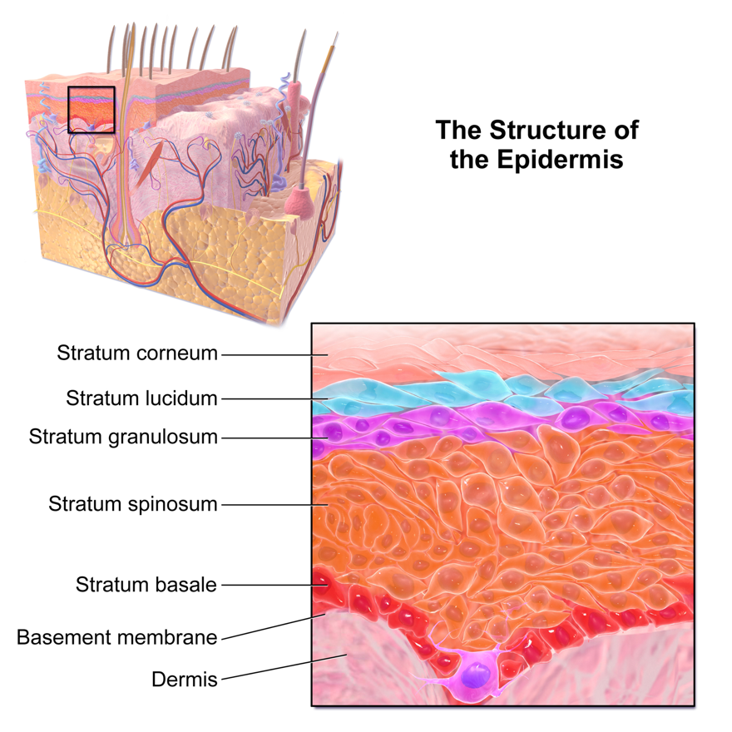
Epidermal layers
https://commons.wikimedia.org/wiki/File:Blausen_0353_Epidermis.png
This file is licensed under the Creative Commons Attribution 3.0 Unported license.

The epidermis contains 4-5 layers or strata of stratified squamous epithelium.
We will describe them from deep to superficial.
Stratum basale: Deepest layer of the epidermis, it is composed mainly of one layer of proliferating and non-proliferating keratinocytes, attached to the basement membrane by hemidesmosomes. Melanocytes are present in this layer, connected to numerous keratinocytes through dendrites. Merkel cells are also found in the stratum basale (large numbers of touch-sensitive receptors are found in fingertips and lips).
Stratum spinosum: Keratinocytes become connected through desmosomes and start produce lamellar bodies, from within the Golgi, enriched in polar lipids, glycosphingolipids, free sterols, phospholipids and catabolic enzymes. Langerhans cells (immunologically active cells) and melanin are found in the middle of this layer.
Stratum granulosum: layer in which keratinocytes lose their nuclei and their cytoplasm appears granular. Lipids, contained into those keratinocytes within lamellar bodies, are released into the extracellular space through exocytosis to form a lipid barrier.
Stratum lucidum: A clear/translucent layer of dead keratinocytes, only present in thick skin.
Stratum corneum: Superficial layer of cells, composed of 10 - 30 layers anucleated keratinocyte, with the palms and soles having the most layers. Most of the barrier functions of the epidermis localize to this layer.

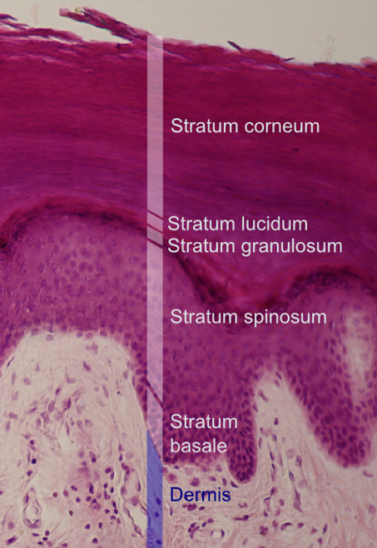
Layers of the epidermis, x.s. 400X
This file is licensed under the Creative Commons Attribution-Share Alike 3.0 Unported license.
https://commons.wikimedia.org/wiki/File:Epidermal_layers.png

Dermis
The dermis is the middle layer of skin, composed of areolar connective tissue and dense irregular connective tissue. The dermis has two layers. The papillary layer (superficial) which consists of the areolar connective tissue. The reticular layer (deep) which consists of the dense irregular connective tissue. These layers serve to give elasticity and flexibility to the integument. The dermal layer provides a site for the blood vessels, free nerve endings, pressure receptors (Pacinnian corpuscles), sweat glands, sebaceous glands, hair follicles, arrector pili muscles.
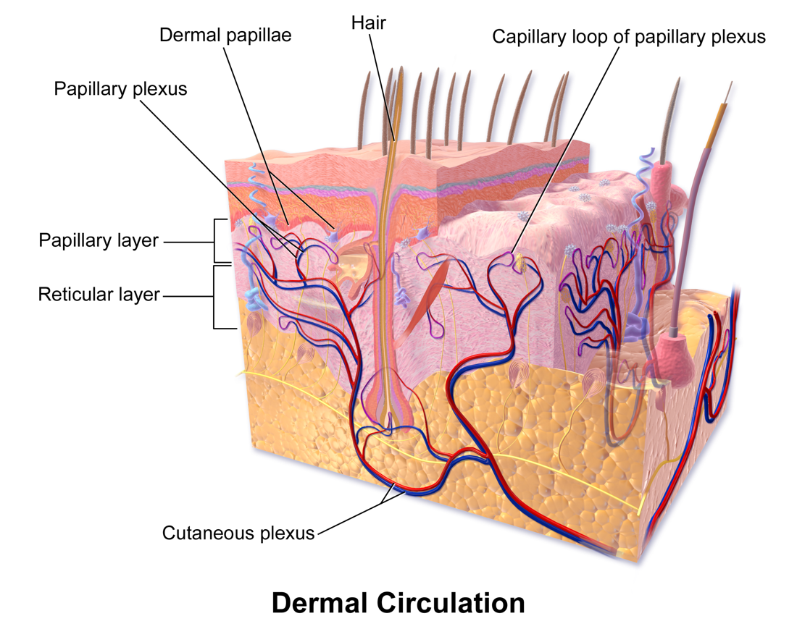
Dermal layers
https://commons.wikimedia.org/wiki/File:Blausen_0802_Skin_DermalCirculation.pngThis file is licensed under the Creative Commons Attribution 3.0 Unported license.

Hypodermis
The hypodermis, also known as the subcutaneous layer, is a layer beneath the skin. It invaginates into the dermis and is attached to the latter, immediately above it, by collagen and elastin fibers. It is essentially composed of a type of cell known as adipocytes specialized in accumulating and storing fats. These cells are grouped together in lobules separated by connective tissue. The hypodermis acts as an energy reserve. The fat contained in the adipocytes can be put brought into circulation, via the venous route, during intense effort or when there is a lack of energy providing a source for energy production. The hypodermis participates, passively in thermoregulation because the fat stored in adipocytes act as a heat insulator.

Part 2 – Anatomy of the accessory organs of the skin

Hair
Hair is a protein filament that grows from follicles found in the dermis. The human body, apart from areas of glabrous skin, is covered in follicles which produce thick terminal and fine vellus hair.

Hair fibers have a structure consisting of several layers, starting from the outside:
- Cuticle, outer covering, which consists of several layers of flat, thin cells laid out overlapping one another as roof shingles
- Cortex, which contains the keratin bundles in cell structures that remain roughly rod-like. The highly structural and organized cortex, or second of three layers of the hair, is the primary source of mechanical strength and water uptake. The cortex contains melanin, which colors the fiber based on the number, distribution and types of melanin granules. The shape of the follicle determines the shape of the cortex, and the shape of the fiber is related to how straight or curly the hair is. People with straight hair have round hair fibers. Oval and other shaped fibers are generally more wavy or curly.
- Medulla, a disorganized and open area at the fiber's center. The innermost region of the hair.
Hair growth begins inside the hair follicle. The only "living" portion of the hair is found in the follicle. The hair that is visible is the hair shaft, which exhibits no biochemical activity and is considered "dead". The base of a hair's root (the "bulb") contains the cells that produce the hair shaft. Other structures of the hair follicle include the oil producing sebaceous gland which lubricates the hair and the arrector pili muscles, which are responsible for causing hairs to stand up. In humans with little body hair, the effect results in goose bumps.
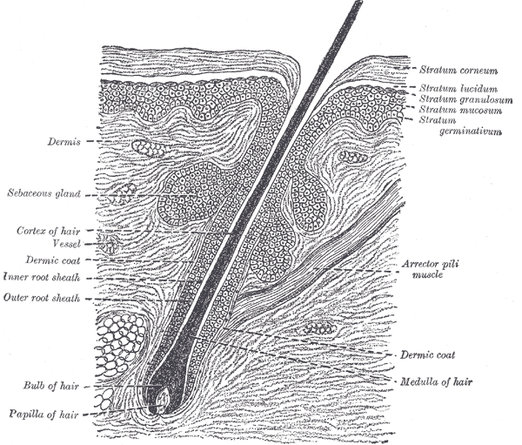
Section of skin, showing the epidermis and dermis; a hair in its follicle; the Arrector pili muscle; sebaceous glands.
Public Domain
https://commons.wikimedia.org/wiki/File:Gray944.png

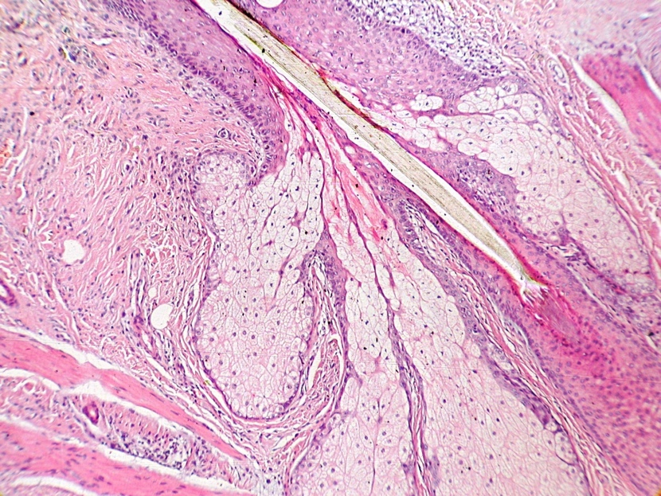

Thin skin with hair follicle, x.s., 400X, Public Domain
https://commons.wikimedia.org/wiki/File:Insertion_of_sebaceous_glands_into_hair_shaft_x10.jpg

Nails
Nails are composed like hair mostly of dead keraticocytes, the protein keratin stiffens epidermal tissue to form fingernails. Nails grow from a thin area called the nail matrix at an average of 1 mm per week.
A nail is composed of a flat nail plate surrounded by nail folds. The proximal nail fold grows over the bail plate forms a structure called the cuticle or eponychium.
Near the eponychium you can find a thickened area of the nail plate that looks like a half a moon (crescent-shape), this area is called the lunula.

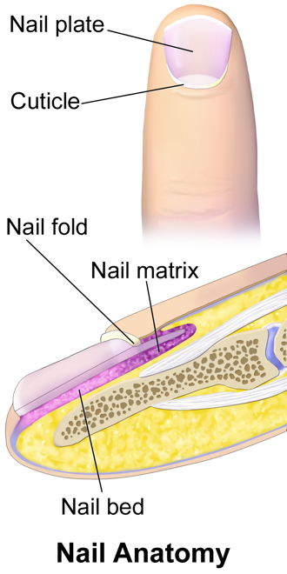
https://commons.wikimedia.org/wiki/File:Blausen_0406_FingerNailAnatomy.png
This file is licensed under the Creative Commons Attribution 3.0 Unported license.

Laboratory Activity – Skin

1. Macroscopic Anatomy of Skin
Use the Anatomical Model of Skin (Denoger Geppert #185) to identify parts of the skin (thick and thin skin):
- Epidermis (with all layers), Dermis and the associated layer the hypodermis.

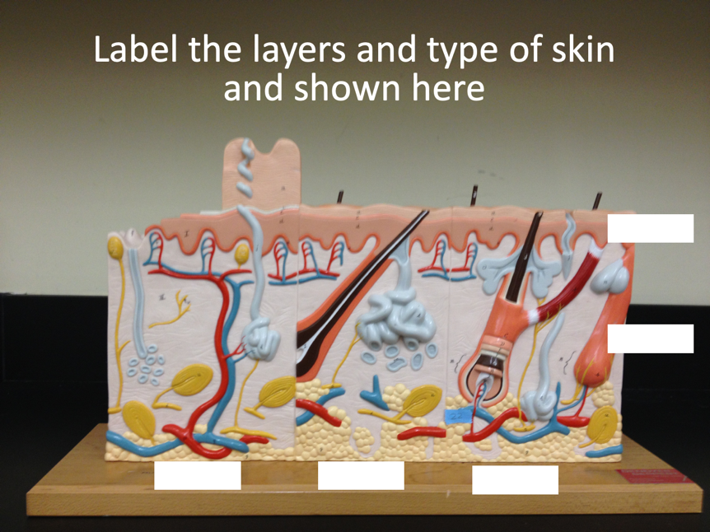

- Identify 4 types of tissue: Epithelial, muscular, connective and nervous using this model.
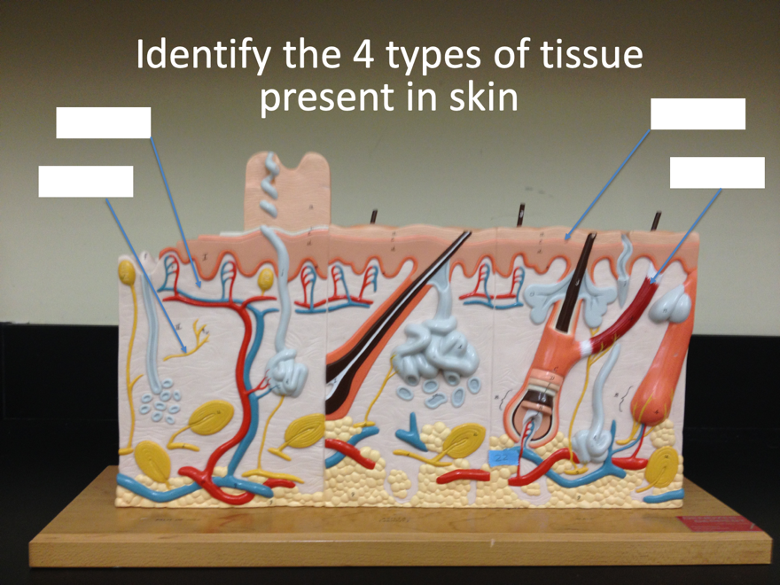

- Identify sweat glands, sebaceous glands, blood vessels, free nerve endings, Meisner corpuscles, arrector pili muscle, hair follicle, hair plexus.

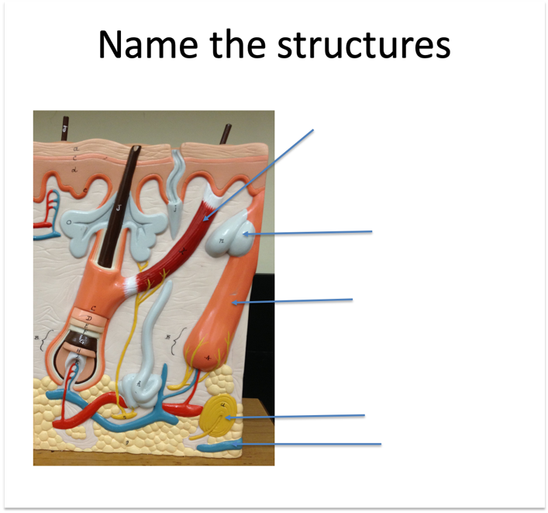
- Describe burn degrees and associate them with layers of the skin and hypodermic layer.

First degree:

Second degree:

Third degree:

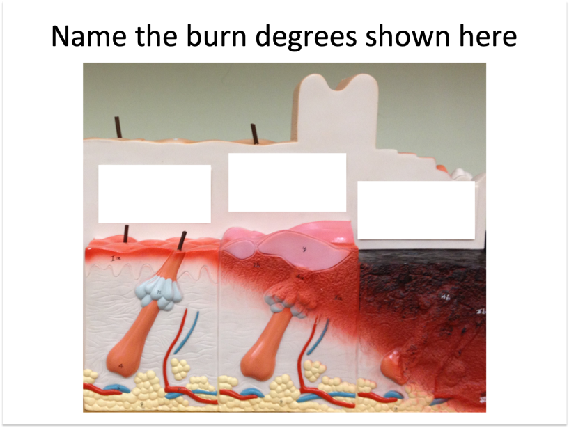

2. Microscopy Anatomy of Skin

For this lab activity you will observe different type of skin microscope slides:
1. Pigmented human skin. Draw and label the following:
  - Epidermis (all layers)
    - stratum corneum
    - stratum granulosum
    - stratum spinosum
    - stratum basale
  - Dermis
  - Subcutaneous layer

2. White human skin. Draw and label the following:
- Epidermis (all layers)
  - stratum corneum
  - stratum granulosum
  - stratum spinosum
  - stratum basale
- Dermis
- Subcutaneous layer

3. Corneum Palmar Skin. Draw and label the following:
  - Epidermis
    - stratum corneum
    - stratum lucidum
    - stratum granulosum
    - stratum spinosum
    - stratum basale
  - Dermis
  - hair follicles
  - Sebaceous glands
  - Sweat glands
  - Pacinian corpuscles
- Subcutaneous layer

4. Human Scalp c.s - Examine a longitudinal section of a hair follicle
Draw and label the following; hair shaft, hair follicle, bulb. dermal papilla, sebaceous gland, sweat gland and the region of cell division.

Apply what you have learned
Answer the following questions. You may need to use the textbook as reference to answer these questions.

- What is the predominant tissue type in the epidermis?

- What is the predominant tissue type in the dermis?

- What is the predominant tissue type in the hypodermis?

- Were you able to identify the melanocytes? In which layer do you see them? What is their function?

- Which other structures can you identify within the dermis?

- What type of tissue makes the ducts of the sweat glands? Did you find one?

- What type of tissue is present in the dermis of the skin?

- List the layers of a hair, as seen from a cross section of hair.

