Student name:
Date:

Laboratory Exercise - Tissues and Histology
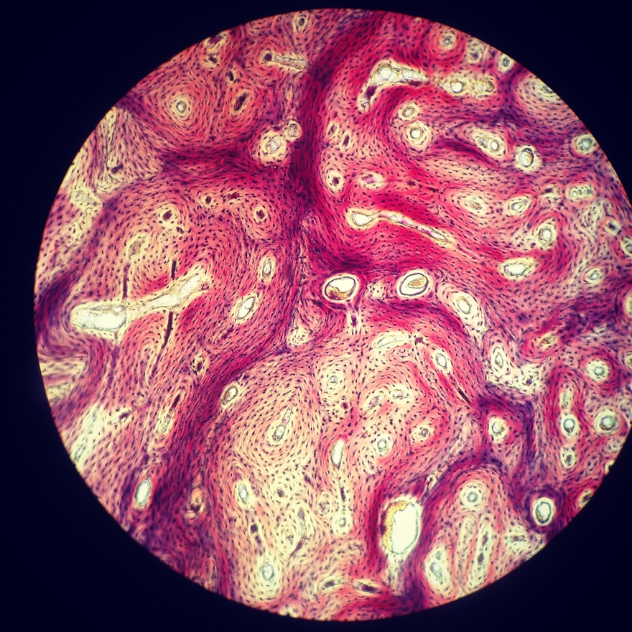

Compact bone, x.s. 400x
This file is licensed under the Creative Commons Attribution 4.0 International license.
https://commons.wikimedia.org/wiki/File:Compact_Bone.jpg

Learning Outcomes
- List the 4 main types and characteristics of tissue found in the human body
- Identify different types of epithelial tissue based on cell morphology and number of layers.
- List the location and function of selected epithelial tissues in the human body
- Identify different types of connective tissue.
- List the location and function of selected connective tissues in the human body
- Identify the three types of muscle tissue found in the human body.
- List the location and function of three types of muscle tissue in the human body
- Identify cell types in nervous tissue.
- Describe the function of cells found in nervous tissue.

Pre-Laboratory Activities - Tissues and Histology Laboratory
You should read the corresponding chapter in your textbook and then answer the questions shown below before coming to the laboratory

Epithelial Tissue
1. How is epithelial tissue classified?

2. Draw a typical epithelial cell, include the apical portion, villi, basal portion, nucleus.

3. Make a table for all epithelial tissue and its location. You will use it as reference during the lab activity.
Type of epithelial tissue | Location
Simple squamous epithelium
Simple cuboidal epithelium
Simple columnar epithelium
Pseudostratified columnar ciliated epithelium with goblet cells
Stratified squamous epithelium (non-keratinized)
Stratified squamous epithelium (keratinized)
Stratified cuboidal epithelium
Stratified columnar epithelium
Transitional epithelium

Connective Tissue
1. List 3 characteristics of connective tissue

2. Name 3 types of fibers found in connective tissue.

3. Define the following terms:
a. Fibroblast

b. Chondrocyte

c. Osteocyte

d. Matrix

Muscle Tissue
1. List the three types of muscular tissue.

2. List the characteristics of skeletal muscle

3. List the characteristics of smooth muscle

4. List the characteristics of cardiac muscle

Nervous Tissue
1. Name the two types of cells present in nervous tissue. Describe their function.

2. Draw and label a typical motor neuron (include: dendrites, body, mitochondria, endoplasmic reticulum system, nucleus, axon, Schwan cells, telodendria)

Introduction to Tissues and Histology
Tissues are defined as collections of cells and the extracellular substances surrounding that gather to perform a specific function. There are four main types of tissue; epithelial, connective, muscle, and nervous tissues. Histology is the microscopic study of tissues.

Epithelial Tissue
The epithelium consists of cells of diverse shapes that contain little extracellular matrix. The epithelium covers surfaces and lines the lumen of internal hollow organs, usually has an apical portion, a basement membrane for attachment, and it is avascular. The main function of epithelial tissue is to protect structures, it acts as barriers allowing only some substances to pass through epithelial layers. Epithelium also secretes and absorb substances depending on its location.
Epithelium is classified based on the morphology of the cells and the number of cell layers present. The types of cells can be squamous (flat), cuboidal and columnar. Epithelium may be simple (one layer) or stratified (more than one layer of cells), pseudostratified epithelium has a single layer of cells that appears stratified, because some cells do not reach the apical portion of the layer.
You can combine both to have the following types of epithelium:
- Simple squamous
- Stratified squamous (nonkeratinized or keratinized)
- Simple cuboidal
- Stratified cuboidal
- Simple columnar
- Stratified columnar
- Transitional epithelium (stratified, with cells that can change shape, cells have an apical dome shape).
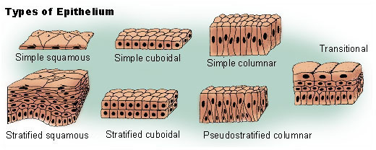
https://commons.wikimedia.org/wiki/File:Illu_epithelium.jpg
Public Domain

  - Table #1 - Summary of epithelial cells/tissues and their characteristics. (From Wikipedia, https://en.wikipedia.org/wiki/Epithelium).
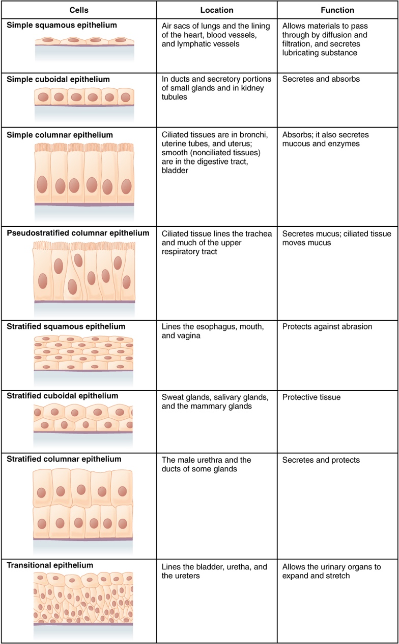

Selected histological images of Epithelial tissue
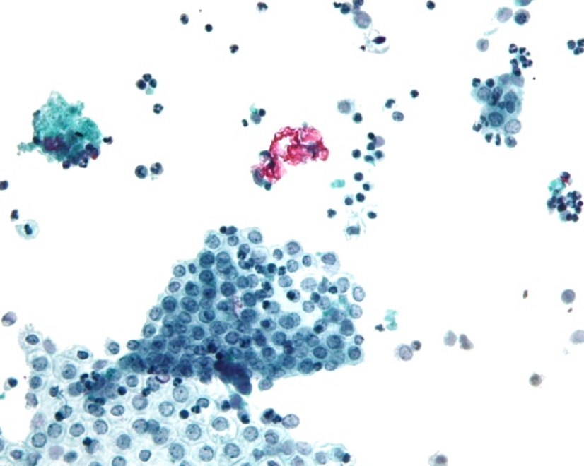
Simple squamous epithelium

This file is licensed under the Creative Commons Attribution-Share Alike 3.0 Unported license.
https://commons.wikimedia.org/wiki/File:Mesothelium_peritoneal_wash_high_mag.jpg

Stratified squamous epithelium (keratinized)
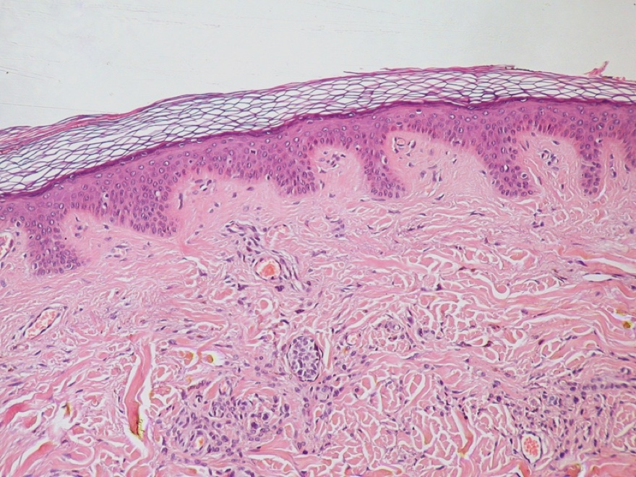

Stratified squamous epithelium

Public Domain
https://commons.wikimedia.org/wiki/File:Normal_Epidermis_and_Dermis_with_Intradermal_Nevus_10x.JPG

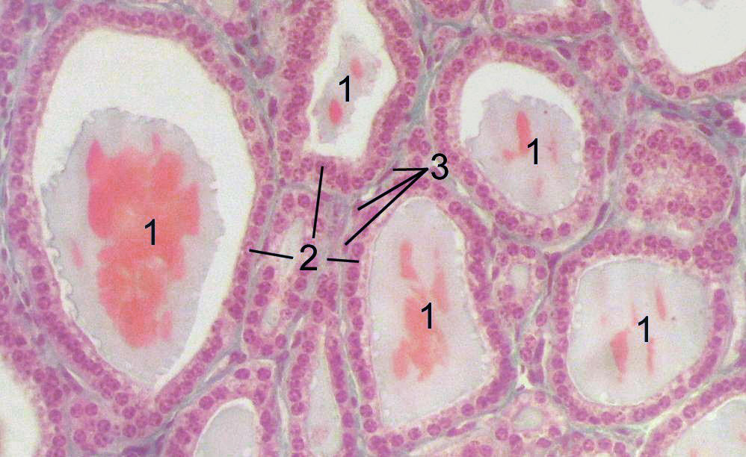
Simple cuboidal epithelium

https://commons.wikimedia.org/wiki/File:Thyroid-histology.jpg
This file is licensed under the Creative Commons Attribution-Share Alike 3.0 Unported license.

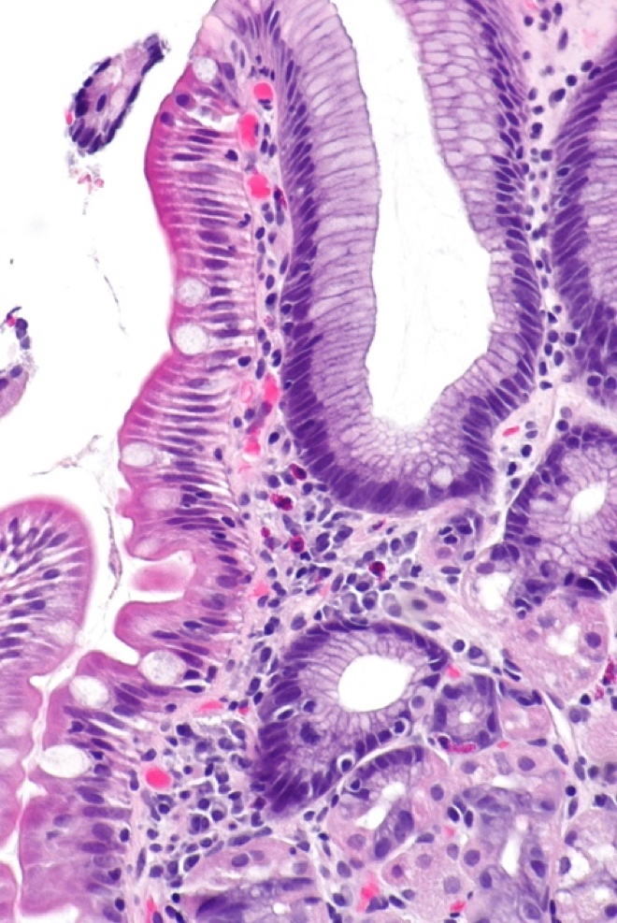

Simple columnar epithelium

https://commons.wikimedia.org/wiki/File:Gastric_heterotopia_in_the_duodenum_--_high_mag.jpg
This file is licensed under the Creative Commons Attribution-Share Alike 3.0 Unported license.

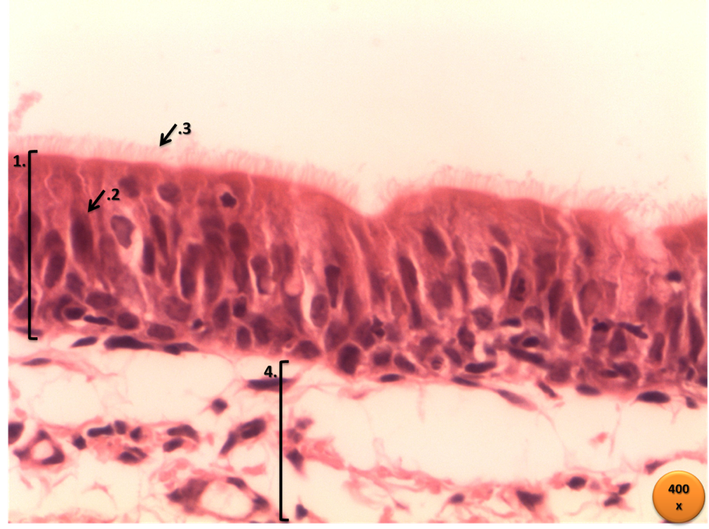
Pseudostratified columnar ciliated epithelium

Public Domain
https://commons.wikimedia.org/wiki/File:Traqueia_–_HE_–_400x.png

Transitional Epithelium
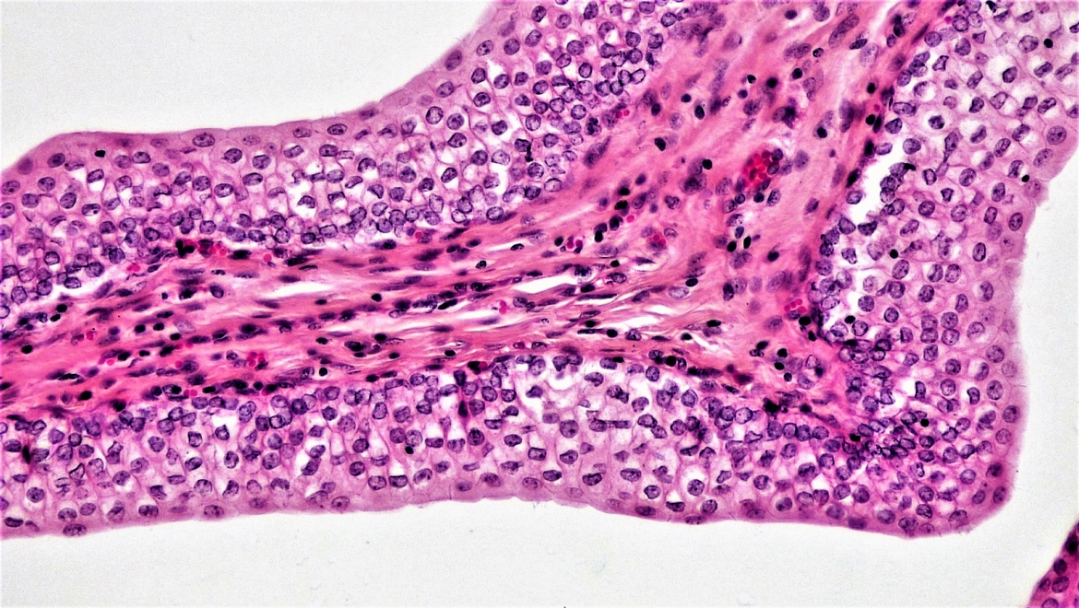

Public Domain
https://commons.wikimedia.org/wiki/File:Epithelial_Tissues_Transitional_(41850592372).jpg

Connective Tissue
Connective tissues connect one tissue to one another; acts as support and participate in movement of body parts. It also stores compounds such as calcium and phosphorous; it cushions and insulate; and enclose organs. There are many types of connective tissue, they look very different, but they share their origin and 3 main characteristics; they contain ground substance, fibers (collagen, elastic, reticular) and specialized cells (adipose cells, chondrocytes, osteocytes, blood cells, macrophages, and mesenchymal cells cells). The combination of ground substance (Hyaluronic acid and proteoglycans) and fibers is also known as the Matrix.
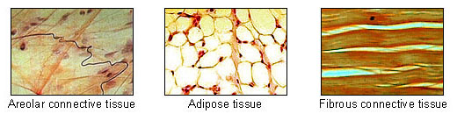
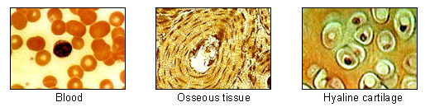
Public Domain, https://commons.wikimedia.org/wiki/File:Illu_connective_tissues_1.jpg

Connective tissue classification is based on the type specialized cells and the extracellular matrix. There are two main types of connective tissue:
1. Embryonic connective tissue is called mesenchyme, consists of irregularly shaped cells and abundant matrix, and gives rise to adult connective tissue.
2. Adult connective tissue consists of connective tissue proper, supporting connective tissue, and fluid connective tissue. The adult connective tissue is further subclassified as

Connective Tissue Proper
a. Loose connective tissue
Loose Areolar connective tissue has many different cell types and a random arrangement of protein fibers with space between the fibers. This tissue fills spaces around the organs and attaches the skin to underlying tissues.

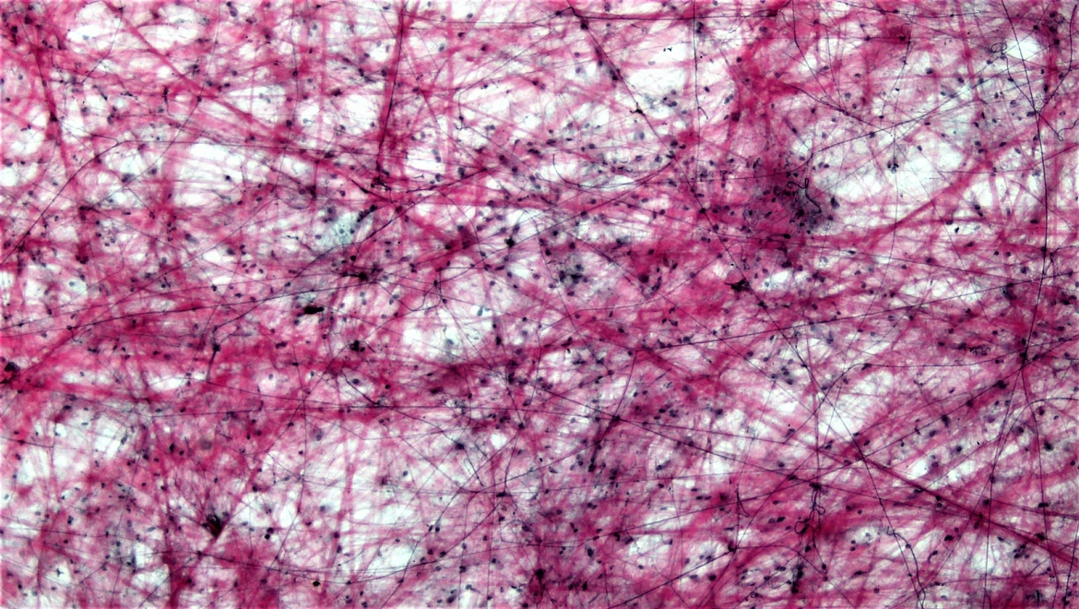

Public domain, https://upload.wikimedia.org/wikipedia/commons/d/d4/Connective_Tissue_Loose_Aerolar_%2839977986150%29.jpg
Adipose tissue has adipocytes filled with lipid and very little extracellular matrix. It protects body structures, also serves as a place for energy storage, and insulation.
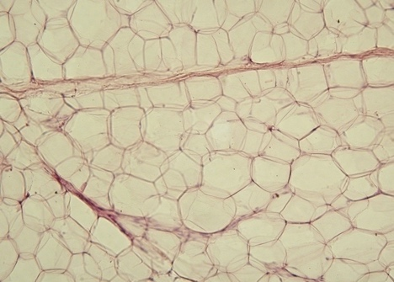
https://commons.wikimedia.org/wiki/File:Yellow_adipose_tissue_in_paraffin_section_-_lipids_washed_out.jpg

Reticular tissue is a network of reticular fibers, found in lymphatic tissue, bone marrow, and the liver.
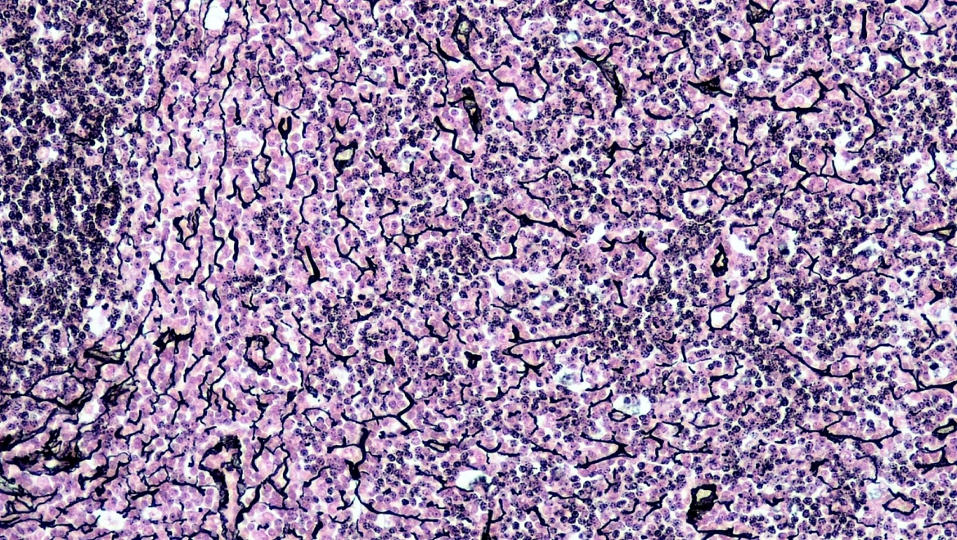

Public Domain, 400x.
https://commons.wikimedia.org/wiki/File:Connective_Tissue_Reticular_(40885193495).jpg

b. Dense connective tissue
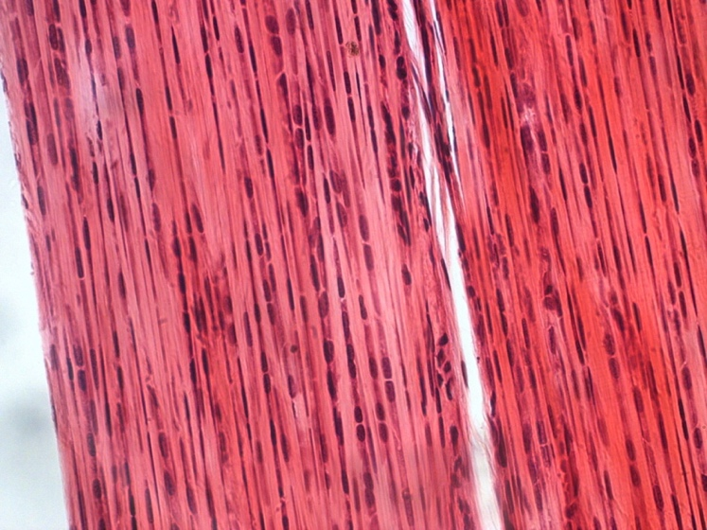
Dense regular connective tissue is composed of fibers regularly arranged in one direction. There are two types of dense regular connective tissue; collagenous (tendons and most ligaments) and elastic (ligaments of vertebrae).

This file is licensed under the Creative Commons Attribution-Share Alike 4.0 International license
https://commons.wikimedia.org/wiki/File:Dense_connective_tissue-400x.jpg

Dense irregular connective tissue has fibers organized in many directions, there are two types of dense irregular connective tissue: collagenous (found as capsules of organs and in the dermis of skin) and elastic (found in large arteries, such as the aorta).
Dense irregular connective tissue
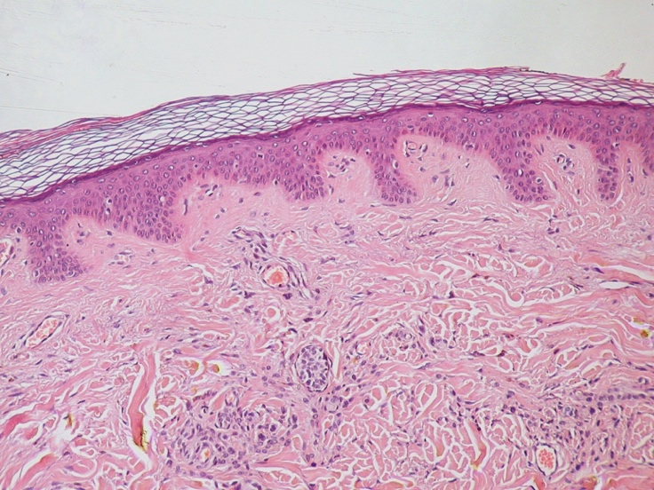

Bundles of collagen fibers

Public Domain. https://commons.wikimedia.org/wiki/File:Normal_Epidermis_and_Dermis_with_Intradermal_Nevus_10x.JPG

Elastic connective tissue
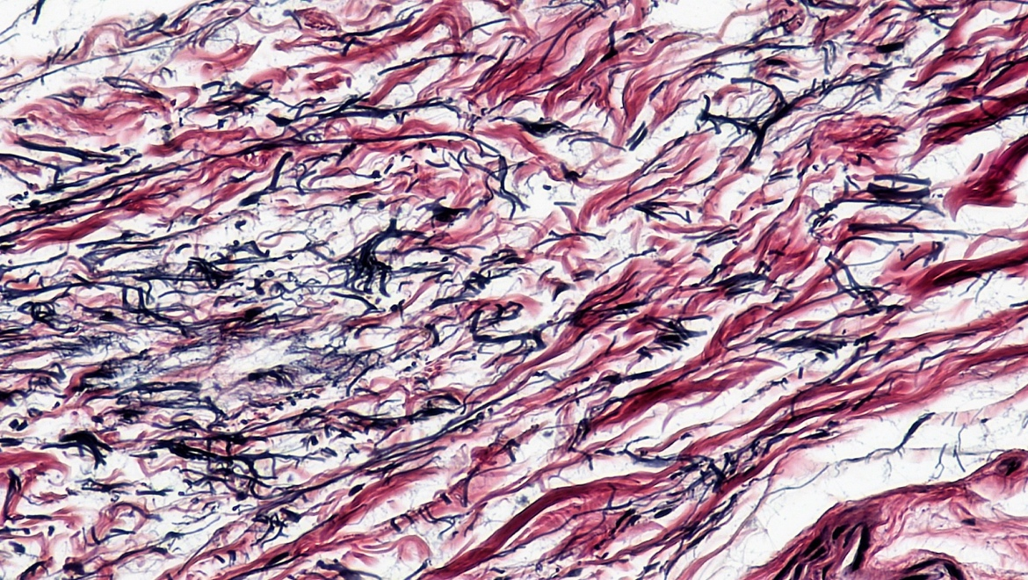

Public domain, magnification 400x.
https://commons.wikimedia.org/wiki/File:Connective_Tissue_Human_Elastic_Tissue_(40049097400).jpg

Supporting Connective Tissue

a. Cartilage
Cartilage has a relatively rigid matrix composed of protein fibers and proteoglycan aggregates. It contains mainly chondrocytes, within the lacunae. There are three types:
Hyaline cartilage with homogeneously distributed collagen fibers in the matrix and Chondrocytes in the lacunae
Fibrocartilage with homogeneously distributed collagen fibers but arranged in thick bundles and chondrocytes in the lacunae.
Elastic cartilage is similar to hyaline cartilage, but besides containing collagen fibers it also has elastin fibers.
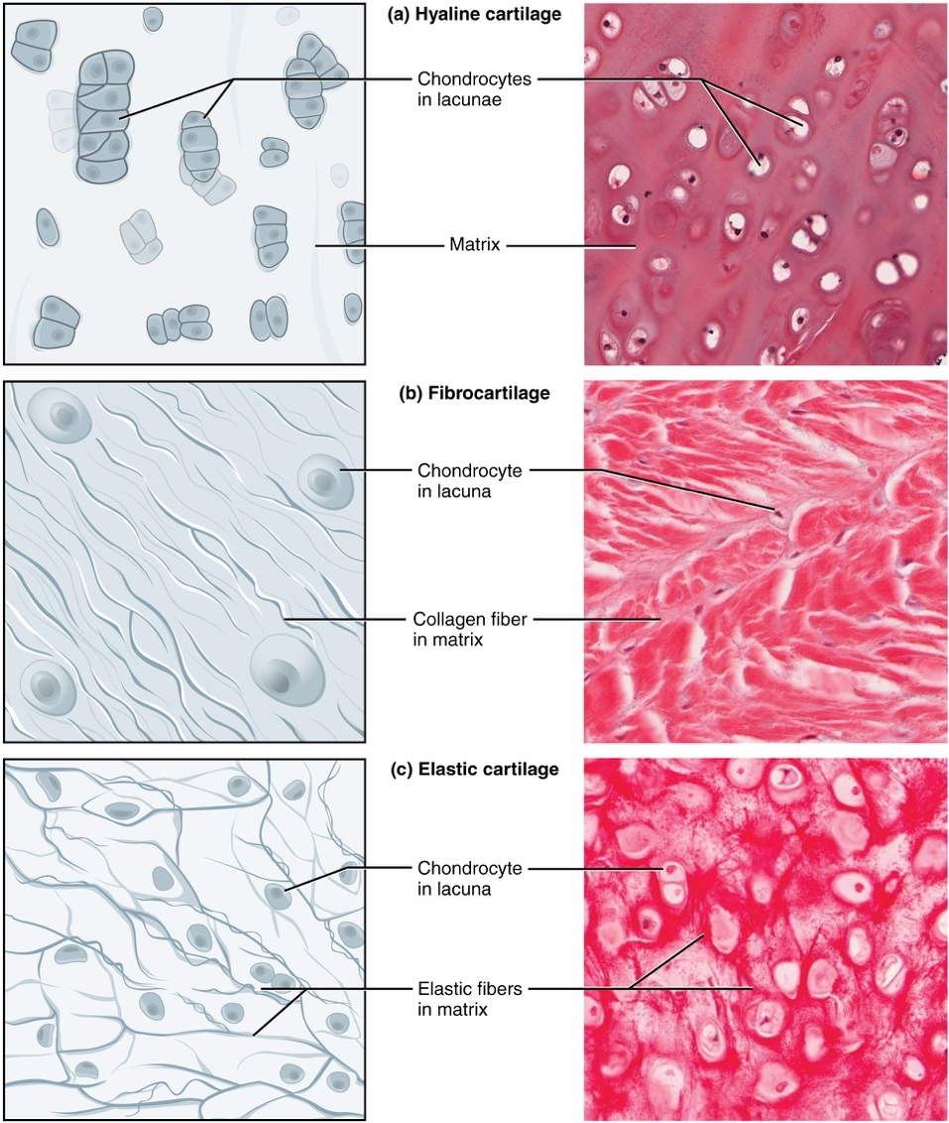
https://commons.wikimedia.org/wiki/File:412_Types_of_Cartilage-new.jpg
Illustration from Anatomy & Physiology, Connexions Web site. http://cnx.org/content/col11496/1.6/, Jun 19, 201This file is licensed under the Creative Commons Attribution 3.0 Unported license.

b. Bone
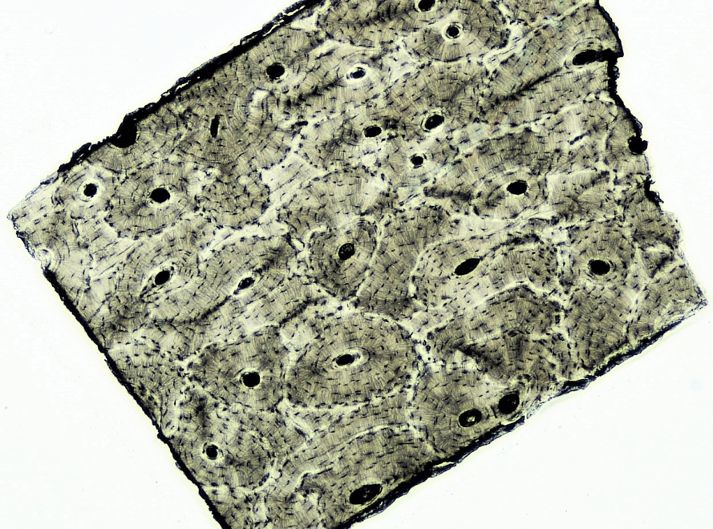
The bone cells, or osteocytes, are located in lacunae and surrounded by a mineralized matrix (hydroxyapatite). There are two types of bone; Spongy bone has spaces between bony trabeculae filled with bone marrow, and compact bone, which is more solid and composed of functional units called osteons.

Compact Bone, x.s, 40X. Public Domain, https://commons.wikimedia.org/wiki/File:Connective_Tissue_Compact_Bone_(39978304590).jpg

C. Fluid Connective Tissue
Blood
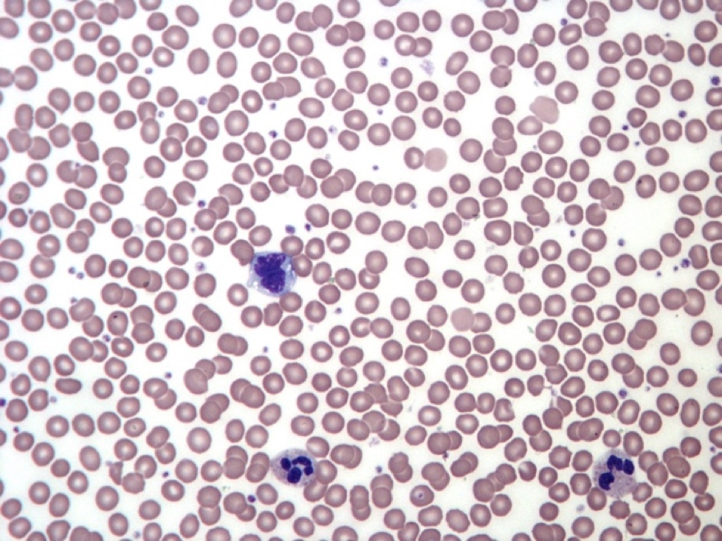
The blood has a fluid matrix and specialized cells or formed elements of the blood; red blood cells, white blood cells and platelets.

https://upload.wikimedia.org/wikipedia/commons/1/16/Normal_Adult_Blood_Smear.JPG
Creative Commons Attribution-Share Alike 3.0 Unported license.

Muscular Tissue
Muscle tissue has the ability to contract. There are three type of muscle tissue; Skeletal, smooth and cardiac muscle

Skeletal Muscle
Skeletal muscle attaches to skeleton and is responsible for body movement. Skeletal muscle cells are long and cylindrically formed from fusion of many cells during development, therefore they contain many nuclei located at the periphery. This type of muscle has a banding pattern (striated) and is under voluntary control.

Cardiac Muscle
Cardiac) muscle cells are short, branching cells with a single, central nucleus and gap junctions called intercalated disks. Cardiac muscle is only found in the heart and is responsible for pumping blood through the circulatory system. This type of muscle has a banding pattern (striated) and is under involuntary control.

Smooth muscle
Smooth muscle is found in the walls of hollow organs, the iris of the eye, and other structures. The cells are tapered or spindle-shaped with a single, central nucleus. This type of muscle does not have a banding pattern (non-striated) and is under involuntary control.
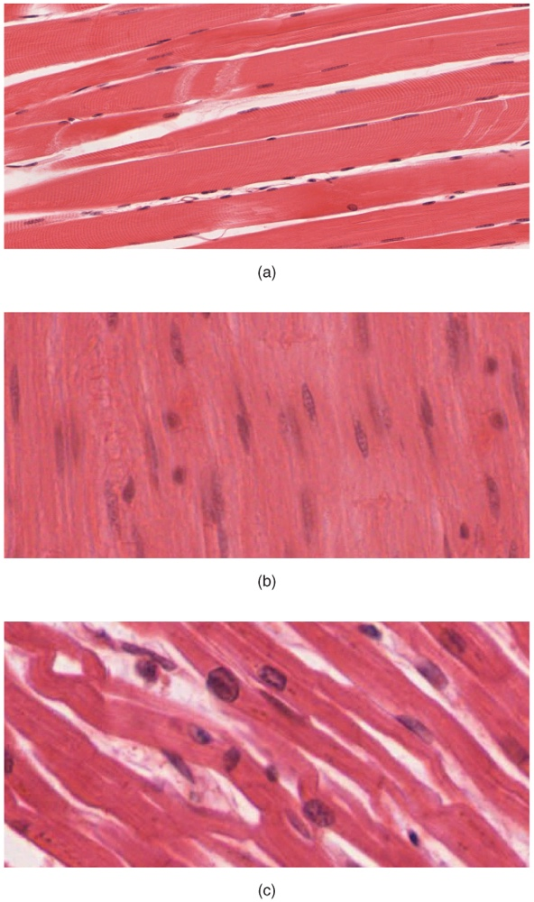
The body contains three types of muscle (x.s., 400x)
a. skeletal muscle,
b. smooth muscle,
c. cardiac muscle
https://commons.wikimedia.org/wiki/File:414_Skeletal_Smooth_Cardiac.jpg
Under the Creative Commons Attribution 3.0 Unported license

Nervous Tissue
The nervous tissue is composed of two types of cells, neurons (functional units, capable of transmitting an action potential) and neuroglia that support, nourish and monitor the neurons, they are found in an average ratio of 1: 9 (neuron: neuroglia). These cells are contained in the organs of the nervous system. The Central Nervous System (CNS) is composed of the brain and the spinal cord, the Peripheral Nervous System (PNS) is composed of all tissue located outside of the CNS, cranial and peripheral nerves.
Neurons have distinct type of cell processes; dendrites and axons. Dendrites are located on the body of the neuron, they receive electrical impulses, and axons conduct them.

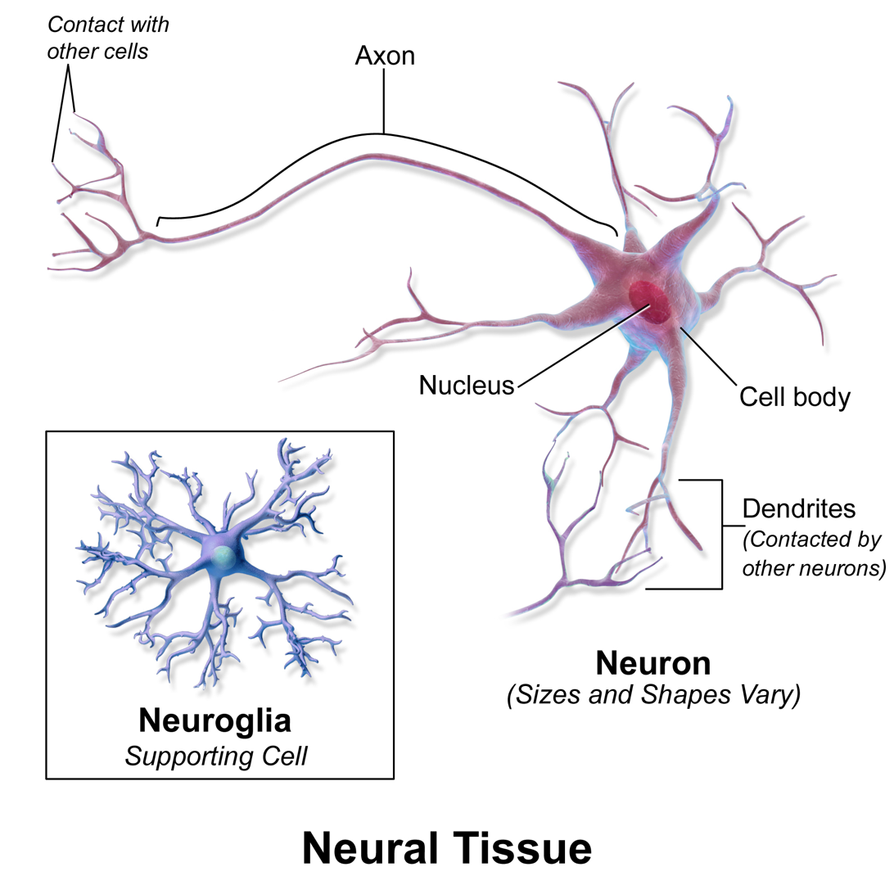
https://commons.wikimedia.org/wiki/File:Blausen_0672_NeuralTissue.png
Creative Commons Attribution 3.0 Unported license
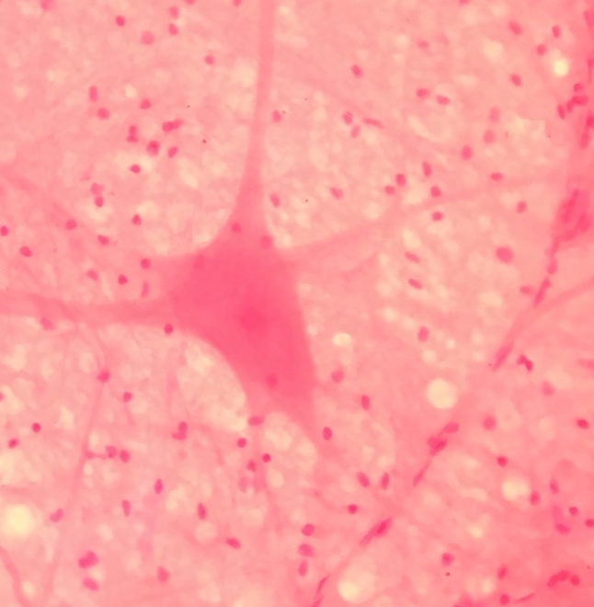

Multipolar neuronal smear, 400x
This file is licensed under the Creative Commons Attribution-Share Alike 4.0 International licensehttps://commons.wikimedia.org/wiki/File:Neuron-section.jpg

Laboratory Activities

Epithelial Tissue Activity – Draw and Identify
Use a compound light microscope to examine organ slides provided in the lab. Follow the rules of proper use and maintenance of a microscope explained to you at the beginning of the semester.
You will first need to locate the epithelial tissue, remember the slides we use are sections of organs, they may contain other types of tissues as well. Remember, epithelium has a free apical side.
Observe the epithelial tissue slides under scanning power to locate the area where the epithelium is located, microscopes are parfocal, you will change magnification without having to focus again, just use the micro adjustment know to fine tune the focusing. You do not need 100X objective for this activity.
A. Observe and draw the following epithelial tissues slides:
- Simple squamous epithelium – lung, cheek cells, bowman’s capsule in kidney slides.
- Simple cuboidal epithelium - kidney, thyroid gland
- Simple columnar epithelium – stomach, duodenum, jejunum, ileum, colon.
- Pseudostratified columnar ciliated epithelium with goblet cells, respiratory epithelium - Trachea
- Stratified squamous epithelium (non-keratinized) – esophagus, vagina, rectum
- Stratified squamous epithelium (keratinized) – thin or thick skin
- Stratified cuboidal – sebaceous glands and sweat glands in dermis of skin
- Stratified columnar epithelium – rare; eye preparations.
- Transitional epithelium – urinary bladder and ureter
Note: Label the organelles you can identify, i.e, nucleus, cytoplasm, cell membrane, basement membrane, and the free or luminal surface.
Simple cuboidal epithelium
Magnification x
Simple squamous epithelium
Magnification x
Stratified squamous epithelium (keratinized)
Magnification x
Pseudostratified columnar ciliated epithelium
Magnification x
Simple columnar epithelium
Magnification x
Stratified squamous epithelium
Magnification x
Transitional epithelium
Magnification x
Stratified cuboidal Magnification x
Stratified columnar epithelium
Magnification x
B. Identify the type of epithelial tissue seen under the microscopes
There are three microscopes set up at the instructor’s bench, identify each of them. Be specific. What is the function of each type of epithelial tissue you identified?
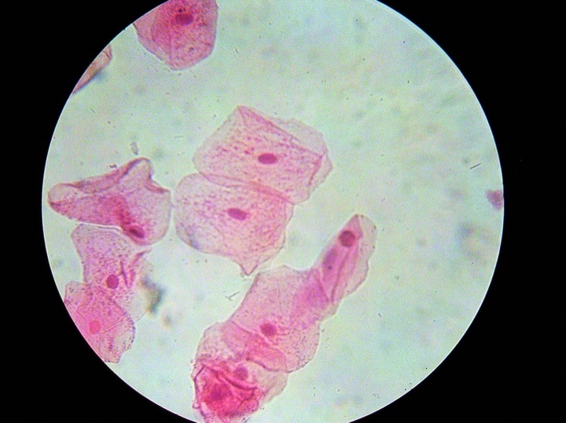

This file is licensed under the Creative Commons Attribution-Share Alike 3.0 Unported license.
https://commons.wikimedia.org/wiki/File:Cheekcells_stained.jpg

Microscope 1 – Tissue type:
Microscope 1 – Function:

This file is licensed under the Creative Commons Attribution-Share Alike 3.0 Unported license.
https://commons.wikimedia.org/wiki/File:Cheekcells_stained.jpg

Microscope 2 - Tissue type:
Microscope 2 - Function:

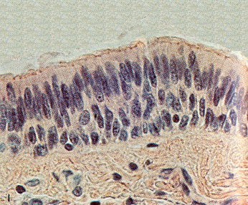

https://commons.wikimedia.org/wiki/File:COLUMNAR_ESTRATIFICADO.jpeg
This file is licensed under the Creative Commons Attribution-Share Alike 3.0 Unported license.

Microscope 3 - Tissue type:
Microscope 3 - Function:

Connective Tissue Activity – Draw and Identify
Use a compound light microscope to examine organ slides provided in the lab. Follow the rules of proper use and maintenance of a microscope explained to you at the beginning of the semester.
You will first need to locate the connective tissue, remember the slides we use are sections of organs, they may contain other types of tissues as well.
Observe the connective tissue slides under scanning power to locate the area where the tissue, microscopes are parfocal, you will change magnification without having to focus again, just use the micro adjustment know to fine tune the focusing. You do not need 100X objective for this activity.
A. Observe and draw the following connective tissues slides:
1. Loose Areolar tissue, packing material. You need to find and label the fibroblast cells, ground substance, collagen and elastic fibers
2. Adipose Tissue: Find cell membrane and nuclei.
3. Reticular connective Tissue – found lymph nodes and liver, find and label the reticular fibers and cells.
4. Regular Dense CT- Collagenous tissue (or dense regular connective tissue), found in ligaments and tendons. You need to find and label collagen fibers and fibroblast cells
5. Elastic connective tissue – (large arteries). You need to find and label circular layer of elastic fibers.
6. Irregular Dense CT – found in dermis of skin. You need to find and label bundles of collagen fibers
7. Hyaline cartilage – Find and label chondrocytes, lacunae, matrix
8. Elastic cartilage – Find and label chondrocytes, lacunae, elastic fibers
9. Fibrocartilage – Find and label chondrocytes, lacunae, collagen fibers
10. Compact bone: Find and label – Osteons: lacunae, canaliculi, osteocyte, concentric lamellas
11. Human blood smear. Find and label the formed elements of blood; RBC, red blood corpuscles (erythrocytes), WBC, white blood cells (leukocytes), neutrophils, eosinophils, basophils, monocytes and lymphocytes. Platelets (Thrombocytes). As you observe a blood smear under the microscope, draw all formed elements of the blood. Note the absence or presence of the nucleus, the nuclear shape, amount of cytoplasm, and presence or absence of granules in the cytoplasm.
Note: You will need to use immersion oil and 100X objective to see details of formed elements of blood.

Tissue:
Magnification x
Tissue
Magnification x

Tissue:
Magnification x
Tissue
Magnification x

Tissue:
Magnification x
Tissue
Magnification x

Tissue
Magnification x
Tissue:
Magnification x

Tissue
Magnification x
Tissue:
Magnification x

Tissue:
Magnification x

Answer the following questions
1. What are the 3 common characteristics of all connective tissue?

2. Where in the body is each type of connective tissue found? What is their function? Make a table.
Connective tissue type | Location

3. Name the formed elements of blood, state their function?

4. Why does the RBCs lose their nucleus?

5. What are the differences and similarities in WCBs types?

Muscle Tissue Activity – Draw and Identify
There are three types of muscle tissue, skeletal muscle, smooth muscle and cardiac muscle. You will learn how to identify each type of muscle tissue. You will first need to locate the muscle tissue, remember the slides we use are sections of organs, they may contain other types of tissues as well. Observe the muscle tissue slides under scanning power to locate the area where the tissue, microscopes are parfocal, you will change magnification without having to focus again, just use the micro adjustment know to fine tune the focusing. You do not need 100X objective for this activity.
A. Observe and draw the following muscle tissues slides:
1. Skeletal muscle (teased)– Find and label the striations, nuclei and cylindrical muscle cells (fibers)
2. Smooth muscle (teased)– Find and label the nuclei and spindle shaped cells
3. Cardiac muscle (intercalated disk stain) – Find and label the intercalated disks, striations, nuclei and branched cells.

Tissue
Magnification x
Tissue:
Magnification x

Tissue:
Magnification x

B. Identify the type of muscle tissue seen under the microscopes
There are two microscopes set up at the instructor’s bench, identify each of them. Be specific. What is the function of each type of epithelial tissue you identified?
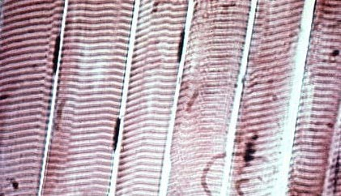
https://commons.wikimedia.org/wiki/File:Musculoesqueleticovoluntario.jpg, Creative Commons Attribution-Share Alike 3.0 Unported license,
Microscope 1 – Tissue type:
Microscope 1 – Function:
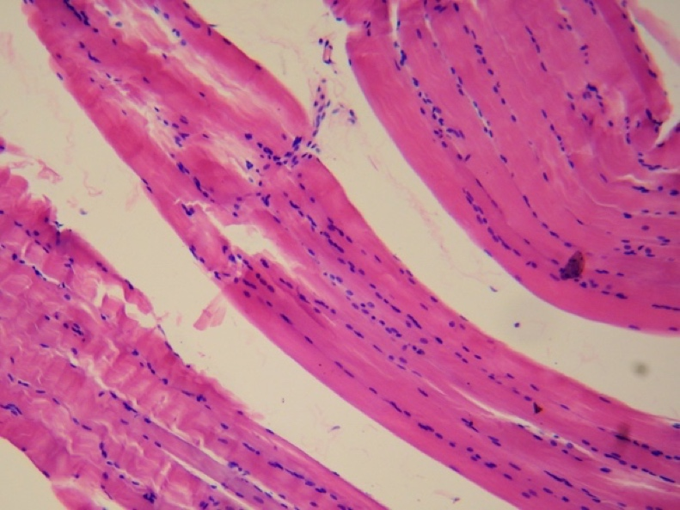

https://commons.wikimedia.org/wiki/File:Smooth_muscle_tissue.jpg, under the Creative Commons Attribution-Share Alike 4.0 International license
Microscope 2 – Tissue type:
Microscope 2 – Function:

Nervous Tissue Activity – Draw and Identify
A. Microscopy
Use a compound light microscope to examine organ slides provided in the lab. You will first need to locate the nervous tissue, remember the slides we use are sections of organs, they may contain other types of tissues as well. Observe the nervous tissue slides under scanning power to locate the area where the tissue, microscopes are parfocal, you will change magnification without having to focus again, just use the micro adjustment know to fine tune the focusing. You do not need 100X objective for this activity. Observe and draw a multipolar neuron smear slide or motor neuron, spinal cord smear, which ever one is available
Find and label the following structures:
a. Motor neurons, cell body, nucleus, Nissl bodies, dendrites and axons.
b. Neuroglia cell bodies

Tissue:
Magnification x

B. Identification of structures using the 3D neuron anatomical model. identify the following:
- Cell body
- Nucleus
- Nissl bodies
- Dendrites
- Axons
- Myelin sheath
- Node of Ranvier
- Internodes
- Synaptic terminals – Telodendria

C. Label the components of a typical motor neuron

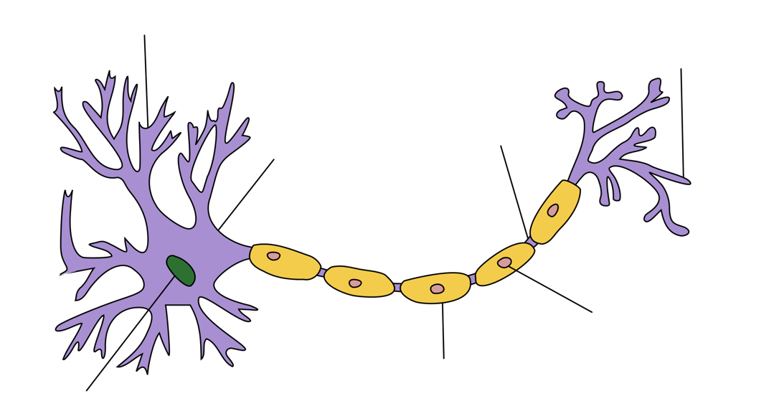

Creative Commons Attribution-Share Alike 3.0 Unported license
https://commons.wikimedia.org/wiki/File:Neuron_Hand-tuned.svg

