Gene structure and expression in eukaryotic cells

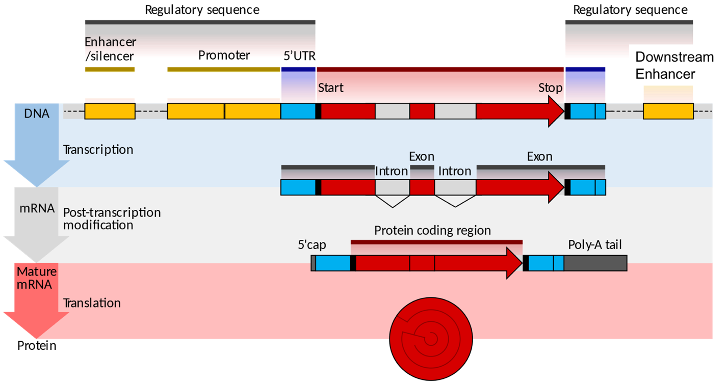
"Eukaryotic and prokaryotic gene structure" by Shafee T, Lowe R from WikiJournal of Medicine 4(1) with a CC-BY license.

- Label where in a cell each step occurs (nucleus or cytoplasm?): Transcription and post-transcriptional processing take place in the nucleus, while translation is in the cytoplasm.

- Label when splicing takes place: Splicing takes place during transcription and post-transcriptional modification.

- Label where transcription starts and where translation starts: Transcription begins after the promoter at the beginning of the 5’ UTR indicated above (the light blue box above). Translation begins at the start codon (the red box)

- Explain the function of:

- The promoter: the promoter is a DNA sequence that positions RNA polymerase so that transcription can begin

- The enhancer: the enhancer is a DNA sequence where regulatory proteins that activate transcription can bind. An enhancer can be far away in linear space from a gene promoter. DNA looping allows for the formation of activation complexes containing proteins both at the gene promoter and at an enhancer.

- The exons: the exons contain the nucleotides that specify the sequence of amino acids of the resulting proteins. During splicing, exons are linked together, while introns are removed from an mRNA molecule.

- The 5’ cap: the 5’ cap protects the end of the mRNA transcript from degradation and serves as the recruitment site for the small ribosomal subunit during translation initiation. The 5’ cap is added by a specialized enzyme after transcription has begun.

- The poly(A) tail: the poly(A) tail increases the stability of the mRNA molecule. The poly(A) tail is added by a specialized polymerase when transcription is complete.

- Does the picture above show an operon? Why or why not? No, the image shows a single gene that contains the information to build only ONE protein. Recall that operons contain multiple genes that are transcribed together and then translated. Operons are very rare in eukaryotic cells, which generally use a one geneone protein system.

