Gene structure and expression in eukaryotic cells

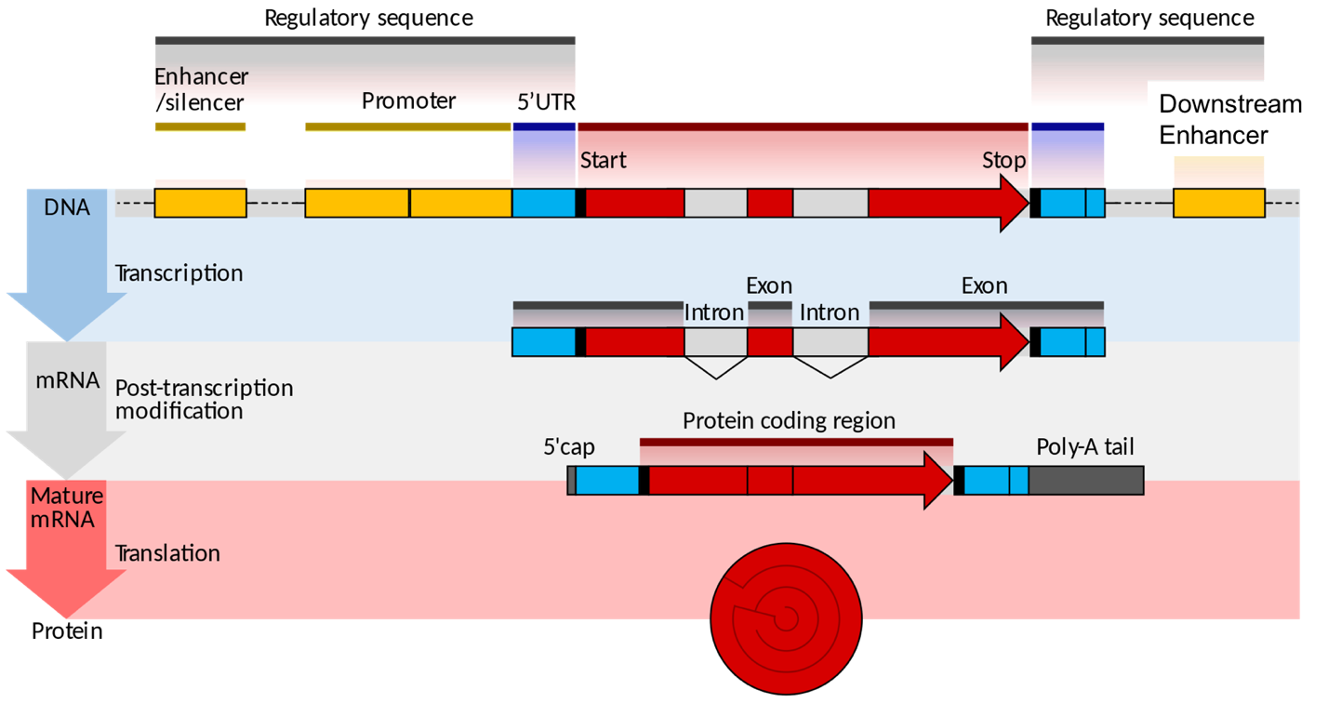
"Eukaryotic and prokaryotic gene structure" by Shafee T, Lowe R from WikiJournal of Medicine 4(1) with a CC-BY license.

- Label where in a cell each step occurs (nucleus or cytoplasm?)

- Label when splicing takes place

- Label where transcription starts and where translation starts

- Explain the function of:

- The promoter

- The enhancer

- The exons

- The 5’ cap

- The poly(A) tail

- Does the picture above show an operon? Why or why not?

