CreChapter 3 The State We’re In: Washington
Creating Washington’s Government
Teacher Guide

General Overview

Enduring Understanding
Washington’s journey to statehood is a complex cultural, economical, political, environmental, and ecological story and its impact is still felt today.

Supporting Questions
Students consider these questions - finding and using evidence to support the Enduring Understanding.
- How did pioneers impact our state?
- How are the Washington state constitution and the U.S. Constitution similar and different?
- What role did the railroad play in the formation of Washington as a state?
- Why were tidelands a debated issue in the journey to statehood?
- Why is education a “paramount duty” in our state?
- Why might our state have an Equal Rights Amendment?

Learning Targets
Students will be able to…
- Explain the impact pioneers had on native populations in our state.
- Compare the Washington State and U.S. Constitution to point out specific similarities and differences
- Explain the economic, political, and environmental impacts of the railroad on our state.
- Explain the cultural, political, and economic reasons for the protection of tidelands.
- Explain the role of education in our state.
- Explain why our state has an Equal Rights Amendment and how that impacts our citizens.

Tasks
- Launch
- Focused Notes
- Text-Dependent Questions
- Focused Inquiry

Task 1: Launch
Hooking students into the content of the chapter.
Distribute the Student handout: Launch Chapter 3 to students.
- Teachers may choose to project the pictures to make small details easier to see. .
- There is no “correct” answer. Encourage the students to explain their answer.
- If students cannot come to a consensus have the group explain why.
- For an extension activity, have students write a claim, evidence, reason paragraph about which picture they think does not belong and why.
Resource
Student Handout: Launch

Task 2: Focused Notes
Activating student thinking about the content of the entire chapter.
Distribute the Student handout: Focused Notes to students.
- As students read, they will record their understanding, thinking, and questions about the content using the handout. This can be done individually or collaboratively in pairs or small groups.
Resource
Student handout: Focused Notes

Task 3: Text Dependent Questions
Engaging students in a close reading activity about specific content in the chapter.
Distribute the Student handout: Text Dependent Questions (Chapter 3) document to students.
First Read
Have the students read the section and answer the First read questions on the Text Dependent Questions document.
Second Read
Use the Second read questions below to facilitate a small or whole group discussion about the reading section. When they are done have them use the Text Dependent Questions handout to record their notes.
- How is a territory different than a state?
- What is the symbol that is used to depict mountains on the map?
- How are reservations shown on the map?
- Why do you think that the map maker included more than just Washington on the map?
- Look up the names of the tribes in your region. Are they labeled on the map? Is there name spelled the same? What is the reason for your answers.
- Read the “Note” on the map. Why do you think this was included on the map?
Post read
After students have done a first and second read of the page, use the following questions to facilitate a class discussion. Have students capture their notes on the student handout:
- Why do you think that the map maker included notes about the abundance of trees but does not include images or symbols of them on the map?
- Use the following link to map titled, Indian reservations, allotments and ceded areas in Washington, created in 1961. What do you notice about this map compared to the one in the text? Why do you think the Native American reservations were placed where they were?
- Based on the information from the map, what kind of people were sought out to be in Washington? Use evidence from the map and the notes to support your answer.
Teacher note: You may want to use some or all the Second read or Post read questions. The purpose of the Text Dependent Question activity is to have students do multiple close reads of the text leading to discussion that engages all students. Therefore, you may need to add reading strategies that meet the needs of your students.
Resource
Student Handout: Text-Dependent Questions

Task 4: Focused Inquiry
A focused inquiry is a one to two day lesson that will have students engaging in the C3 Framework’s Inquiry Arc. The link below includes both teacher and student documents.
Compelling Question
How does bias shape our understanding of historical events?
Resource
Focused Inquiry
Except where otherwise noted, this work is available under a Creative Commons Attribution License.

Chapter 3 The State We’re In: Washington: Creating Washington’s Government

Student Launch
Which of these does not belong: In small groups, work together to figure out each picture and why it might be important for the upcoming chapter. As a group decide which if the picture does not belong. Be ready to share your answer.
A
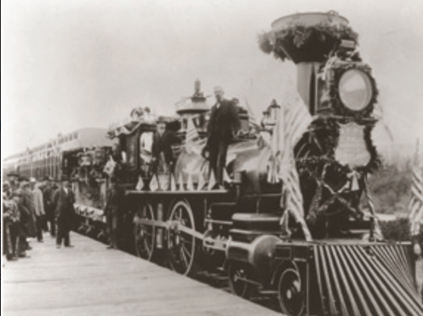
C
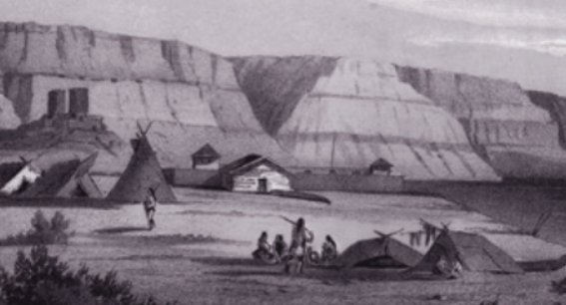
B
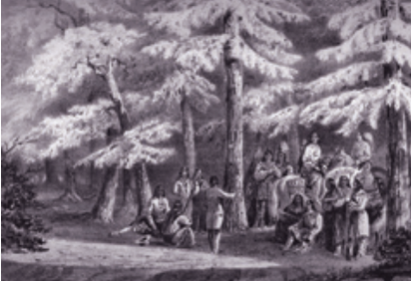
D
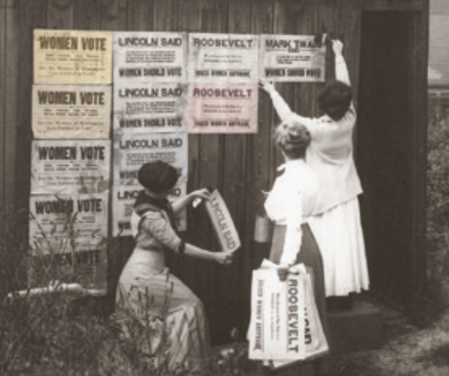

Chapter 3 The State We’re In: Washington
Creating Washington’s Government

Student Handout: Focused Notes

Section 1: Creating Washington’s Government (pps. 41-45)
Topic | Summary of information  (bullet points) | Important or interesting quote | Questions you have
Treaties with Native Americans
George Washington
Bush

Section 2: Writing Washington’s Constitution (pgs. 45-46)
Topic | Summary of information  (bullet points) | Important or interesting quote | Questions you have
Similarities to the US Constitution
Differences to the US Constitution

Section 3: Big Debates (pgs. 46-49)
Topic | Summary of information  (bullet points) | Important or interesting quote | Questions you have
Railroads
A Quick History of Voting Rights
Public and Tideland

Section 4: Statehood (pgs. 51
Topic | Summary of information  (bullet points) | Important or interesting quote | Questions you have
Washington becomes a state

Section 5: Amendments (pgs. 51-52)
Topic | Summary of information  (bullet points) | Important or interesting quote | Questions you have
Equal Rights Amendment
Other interesting amendments

Section 13: The role of citizens: Running for office (pgs. 35-36)
Topic | Summary of information  (bullet points) | Important or interesting quote | Questions you have
Offices
Money
Transparency

Section 14: Jury duty (pg. 36)
Topic | Summary of information  (bullet points) | Important or interesting quote | Questions you have
Who serves and why?

Section 15: Advocacy (pgs. 37-39)
Topic | Summary of information  (bullet points) | Important or interesting quote | Questions you have
How do people make a difference?
One person’s opinion makes a difference
Too young to vote? Don’t let that stop you.
Except where otherwise noted, this work is available under a Creative Commons Attribution License.
Chapter 3 The State We’re In: Washington
Creating Washington’s Government

Text-Dependent Questions

Text Dependent Questions for From Tribal lands to territory to Washington state- the story in maps
Use the text on pages 42-43.
First read: After you do a first read of the page, answer the following questions.
- What is shown in the map?
- When was the map created?
- Why was this map created?
- What are some the tribes depicted on the map?
- How many reservations are depicted on the map?

Notes from Second read group discussion

Notes from Post read discussion

Except where otherwise noted, this work is available under a Creative Commons Attribution License

How does bias shape our understanding of a historical event?

Focused Inquiry
In this focused inquiry, students investigate the question How does bias shape our understanding of a historical event? Students engage in deep reading of primary and secondary sources, analyzing the different perspectives of the execution of Chief Leschi. After small and large group discussions, students will develop an argument answering the compelling question using evidence about the execution of Chief Leschi from the sources.

Standards
- SSS1.6-8.1 Analyze positions and evidence supporting an issue or an event.
- SSS2.6-8.2 Evaluate the breadth, reliability, and credibility of primary and secondary sources to determine the need for new or additional information when researching an issue or event.
- SSS3.6-8.1 Engage in discussion, analyzing multiple viewpoints on public issues
- C2.6-8.2 Distinguish the structure, organization, powers, and limits of government at the local, state, and tribal levels

Learning Goals
- Students will cite and use evidence from a source to support a claim.
- Students will determine the perspective as well as the values and limitations of primary and secondary sources.
- Students will engage in small and large group discussions to share multiple viewpoints.
- Students will create a written response to the compelling question How does bias shape our understanding of a historical event?

Compelling Question
How does bias shape our understanding of historical events?

Staging the Question:
- As a class, have the students brainstorm bias that they think that people have about middle school students. Have them think of why people may have bias.
- The teacher may wish to share what are things about their life that may shape their bias (i.e. where they grew up, where they went to school, how old they are. etc.)
- Have the students watch THE LAB: A portrait session with a twist (3:16). While the students watch them have them take notes on how what the photographer was told about the man changed the way they interacted with him and how the photo looked.
- When they are done, have the students discuss with a partner “how does bias shape our understanding of historical events?” After their discussion have students write their thoughts on a scratch paper.

Supporting Question
What is the story of Chief Leschi’s execution?

Formative Performance Task:
- Use the Analysis Organizer (Appendix A) to hold thinking about the sources in Appendix B.
  - Students will use their understanding of the different sources to answer the support question “What is the story of Chief Leschi’s execution?”
Notes to teacher:
- There may be a need to activate and build general background knowledge before having students engage with the sources in Appendix B.
- Page 40 of Chapter 3 of The State We’re In: Washington has a page about Chief Leschi but it is best read after engaging with this focused inquiry as it may rob students of the opportunity to think about the compelling question without prejudice.
- The sources present views that may be hurtful and/or offensive so it is important to be able to address this depending on the nature of the environment and culture of the classroom.

Featured Source(s):
- "Execution of Leschi" Pioneer and Democrat, 2/26/1858, Page 2, Column 1
- “Leshi, Last Chief of the Nisqually” The Indian War section only
- “Historic Nisqually chief exonerated” Seattle Times 2004

Argument:
After students analyze various sources to answer the supporting question and discuss their thinking with the class, they will write a brief response to the compelling question: How does bias shape our understanding of historical events? Responses should include a claim, evidence, and reasoning and cite specific information from sources.

Taking Informed Action:
Engage students in a whole class discussion about the different strategies that they engaged in with each of the documents to detect bias. Have the students create an anchor chart that has questions and reading strategies to help then look at sources with scepticism. Have students apply questions and strategies using a current news article.
Except where otherwise noted, this Focused Inquiry by Callie Birklid, North Thurston School District, is available under a Creative Commons Attribution License. All logos and trademarks are property of their respective owners. Sections used under fair use doctrine (17 U.S.C. § 107) are marked.

Appendix A: Analysis Organizer
Source | Summary of information | What factors do you think influenced the author? | What words or phrases does the author use that shows their bias?
Document A:
Execution of Leschi
Document B:
“Leshi, Last Chief of the Nisqually: Cecelia Svinth Carpenter”
(The Indian War section only)

Document C:
“Historic Nisqually chief exonerated”

Appendix B

DOCUMENT A: "Execution of Leschi"
From Pioneer and Democrat, 2/26/1858 (excerpt)
Olympia based newspaper that was one of Washington’s first newspapers.

Olympia, Washington Territory
Friday, February 26, 1858
J.W. Wiley and E. Furste, Editors.

Execution of Leschi,

In obedience of the law, the verdict of the jury, and sentence of court, Leschi, the noted Nisqually chief, and head leader of the hostile tribes, who had combined a few years since to extirpate (root out and destroy completely) the white population from the Territory, was hung in Pierce county, on Friday last, by the deputy Sheriff of this (Thurston) county, to whom the execution of the sentence of the court had been confided, all confidence as to the ability or will of the sheriff of the former count to do so, to whom had been entrusted its former execution, having been lost.

As much interest has been [shown] by our readers and citizens in the fate of this unfortunate man, from the time of his capture to his final doom, we will briefly relate matters and things connected therewith- from personal observation of junior, who was present on the occasion.

On the day preceding that of the execution, Mr. Wm. L. Mitchell, the deputy sheriff at Thurston county (the sheriff being absent,) proceeded with a posse of twelve men, ourselves among the number, to Steilcoom, in order that he might be in readiness at the early hour of the day appointed for the execution of his order. Arriving there, he found everything far more quiet have been expected after the occurrence which transpired there on 22nd January, the day [scheduled] for Leschi’s execution. There was no excitement. There did not seem to be the least interest, and everyone seemed to have come to the conclusion to let law and justice take its course...

...From the guard-house he was conveyed on horseback to the place of execution, distant about a mile from the military post, surrounded in such a manner that escape would have been impossible, had he attempted such a thing. But of this we believe he had not the least desired. In fact, had escape been offered him, we doubt whether he would have availed himself to it. To us it seemed as if he had grown tired of life, and preferred death to a continued incarceration. Arriving at the place of execution, we found the gallows erected in a low gulch in the prairie; here the unhappy man was assisted in dismounting and immediately led to the scaffold. At the foot of the latter, looking up at the rope which hung suspended, from its sliding noose, he hesitated for a moment, but instantly collected himself, he ascended with a firm step, as if he desired to show the white man how fearlessly an Indian can meet death. The prisoner is evincing no desire to speak or make any confesion, his arms were secure behind him, when perceiving his life was drawing to a close, he bowed himself to the speculators, and for the space of some ten to fifteen minutes engaged in fervent prayer said (in the jargon of the country) that he “would soon meet his maker - that he had made his peace with God, and deserve to live no longer - that he bore malice to none, save one man,”... Having concluded, the rope was adjusted, the cap drawn over his eyes, and then 35 minutes past eleven o’clock the drop fell and Leschi, the brave in battle was launched into eternity, without having moved a muscle to indicate fear of his death (by hanging) so dreadful to an Indian. He made no disclosures whatever, and proved “a true as the needle to the pole” to his confederates.

Attribution
“Execution of Leschi.” Newspapers- Moments in History , Washington State Library, 27 June 2019. Text transcribed from newspaper image and used pursuant to fair use. Download original newspaper article at: [www.sos.wa.gov/legacy/images/newspapers/sl_dir_olympiapiondemo/pdf/sl_dir_olympiapiondemo_02261858.pdf#page=2]

DOCUMENT B: “Leschi, Last Chief of the Nisquallies”
By Cecelia Svinth Carpenter Nisqually Tribal Historian
Read Leschi, Last Chief of the Nisqualies (“The Indian War” section only)
Attribution
Leschi, Last Chief of the Nisquallies. May 14, 2009. The First People • Euro-Americans Arrive (1800 - 1872) • Little War on the Prairie by Yelm History Project [http://www.yelmhistoryproject.com/?p=687].

DOCUMENT C: Historic Nisqually chief exonerated
By Florangela Davila, Seattle Times
Read Historic Nisqually chief exonerated
Attribution
Historic Nisqually chief exonerated Copyright The Seattle Times. All rights reserved. [https://www.seattletimes.com/seattle-news/historic-nisqually-chief-exonerated]
Except where otherwise noted, this Focused Inquiry by Callie Birklid, North Thurston School District, is available under a Creative Commons Attribution License. All logos and trademarks are property of their respective owners. Sections used under fair use doctrine (17 U.S.C. § 107) are marked.

