Chapter 2 The State We’re In: Washington
The Design of Today’s Democracy
Teacher Guide

General Overview

Enduring Understanding
Washington’s government is a system guided by laws, with democratic institutions that serve the people of the state balanced with the civic engagement of its citizens

Supporting Questions
Students consider these questions - finding and using evidence to support the Enduring Understanding.
- How do the branches work together?
- How are the levels of government organized?
- How do political beliefs influence people?
- How does Washington’s democracy ensure that voting is fair to everyone?
- What role does the media play in a democracy?
- How have immigrant groups influenced our state?
- What is a citizen’s role in a democracy?

Learning Targets
Students will be able to…
- Explain how the three branches of state and federal government work to balance power.
- Compare how levels of government (federal, state, local, and tribal) interact and negotiate differences.
- Explain how peoples’ political ideals influence their party affiliations.
- Explain barriers to fairness in voting and identify potential barriers.
- Explain how the media and reliable sources can be considered valuable to a democracy.
- Explain the social, political, economic, and cultural significance of immigrant groups and their contributions in Washington State.
- Explain the various ways they can and should participate in government as citizens in a democracy.

Tasks
- Launch
- Focused Notes
- Text-Dependent Questions
- Focused Inquiry

Task 1: Launch
Hooking students into the content of the chapter.
Distribute the Student handout: Launch to students.
- Guide students in answering the prompts on the handout individually and in partners.
- There is no “correct” answer. Encourage the students to explain their thinking with each other
Resource
Student Handout: Launch

Task 2: Focused Notes
Activating student thinking about the content of the entire chapter.
Distribute the Student handout: Focused Notes to students.
- As students read, they will record their understanding, thinking, and questions about the content using the handout. This can be done individually or collaboratively in pairs or small groups. Since this chapter is lengthy, you may consider jigsawing the sections.
Resource
Student handout: Focused Notes

Task 3: Text Dependent Questions
Engaging students in a close reading activity about specific content in the chapter.
Distribute the Student handout: Text Dependent Questions document to students.
First Read
Have the students read the section and answer the First read questions on the Text Dependent Questions document.
Second Read
Use the Second read questions below to facilitate a small or whole group discussion about the reading section. When they are done have them use the Text Dependent Questions handout to record their notes.
- What does it mean to “exclude” a person or a group of people?
- Which immigrant groups were specifically excluded by the government?
- Which immigrant groups were specifically favored by the government?
- Reread the paragraph near the top of page 29 on national immigration policy. What is a policy? Who makes policy?
Post read
After students have done a first and second read of the page, use the following questions to facilitate a class discussion. Have students capture their notes on the student handout:
- Look at the images paired with each immigrant group. Choose one group and explain how the image is connected to or helps you understand the text it is paired with.
- Think about the immigrant groups in your community. What do you know about them and how do they contribute to the community?
Teacher note: You may want to use some or all the Second read or Post read questions. The purpose of the Text Dependent Question activity is to have students do multiple close reads of the text leading to discussion that engages all students. Therefore, you may need to add reading strategies that meet the needs of your students.
Resource
Student Handout: Text-Dependent Questions

Task 4: Focused Inquiry
A focused inquiry is a one to two day lesson that will have students engaging in the C3 Framework’s Inquiry Arc. The link below includes both teacher and student documents.
Compelling Question
How do people impact the economy??
Resource
Focused Inquiry
Except where otherwise noted, this work is available under a Creative Commons Attribution License.

Chapter 2 The State We’re In: Washington
The Design of Today’s Democracy

Student Launch
- Think: Who is in charge in a democracy?
With a partner, share your thinking. Brainstorm ideas and write down your thoughts below.

- With your partner, read the following quotes with the question from #1 in mind. Choose one quote that strikes you as particularly impactful or important. Circle the words that you think are important and help you answer the question.

“To keep our democracy functioning, citizens must feel free to actively engage with government and stop seeing themselves as spectators in the grandstands. Let’s take steps to make the democratic process more vibrant here in Washington state.”
Washington Supreme Court Chief Justice
Mary Fairhurst
“A democracy thrives when its citizens vote, show up for jury duty, engage in public life, are aware of civic issues, listen to other viewpoints, and interact with lawmakers.”
Margaret Fisher
Civic Learning Initiative
“It’s so important for our students to feel their role as the office of the citizen. How do we get them to feel it? To understand it? It’s a never-ending process.”
Isidore Starr
Civic Education Pioneer

- In the space below, explain why you think the quote you chose answers the question.

Except where otherwise noted, this work is available under a Creative Commons Attribution License.
Chapter 2 The State We’re In: Washington
The Design of Today’s Democracy

Student Handout: Focused Notes

Section 1: The design of today’s democracy (pps. 16-17)
Topic | Summary of information  (bullet points) | Important or interesting quote | Questions you have
Basic Principles of Democracy
Constitution

Section 2: Separation of powers (pgs. 17-20)
Topic | Summary of information  (bullet points) | Important or interesting quote | Questions you have
Different kinds of government
Three Branches of Government
Separation of Powers

Section 3: The rule of law (pg. 20)
Topic | Summary of information  (bullet points) | Important or interesting quote | Questions you have
“Government of laws rather than a government of men”

Section 4: The importance of democratic institutions (pgs. 20-21)
Topic | Summary of information  (bullet points) | Important or interesting quote | Questions you have
Respect for institutions of government

Section 5: Majority rule, minority rights (pgs. 21-20)
Topic | Summary of information  (bullet points) | Important or interesting quote | Questions you have
Two ideas:
majority rule and rule of law

Section 6: Federalism (pg. 22)
Topic | Summary of information  (bullet points) | Important or interesting quote | Questions you have
Division of responsibility

Section 7: Political parties (pgs. 22-26)
Topic | Summary of information  (bullet points) | Important or interesting quote | Questions you have
Two main parties
Conflicts that stand in the way to fairness in voting

Section 8: The art of the possible (pgs. 26-27)
Topic | Summary of information  (bullet points) | Important or interesting quote | Questions you have
Compromises between people with differing opinions and points of view

Section 9: The media (pg. 27)
Topic | Summary of information  (bullet points) | Important or interesting quote | Questions you have
“The fourth estate,” or fourth branch

Section 10: Immigration (pgs. 28-33)
Topic | Summary of information  (bullet points) | Important or interesting quote | Questions you have
Who came when, and where did they come from?
Immigrants
Refugees
Undocumented immigrants
Amnesty
Citizenship
Government Services

Section 11: The role of citizens: Elections (pg. 33)
Topic | Summary of information  (bullet points) | Important or interesting quote | Questions you have
Voting on elections and issues

Section 12: The role of citizens: Initiatives and referenda (pgs. 33-35)
Topic | Summary of information  (bullet points) | Important or interesting quote | Questions you have
Citizen control in government: Initiative
Citizen control in government: Referenda

Section 13: The role of citizens: Running for office (pgs. 35-36)
Topic | Summary of information  (bullet points) | Important or interesting quote | Questions you have
Offices
Money
Transparency

Section 14: Jury duty (pg. 36)
Topic | Summary of information  (bullet points) | Important or interesting quote | Questions you have
Who serves and why?

Section 15: Advocacy (pgs. 37-39)
Topic | Summary of information  (bullet points) | Important or interesting quote | Questions you have
How do people make a difference?
One person’s opinion makes a difference
Too young to vote? Don’t let that stop you.
Except where otherwise noted, this work is available under a Creative Commons Attribution License.
Chapter 2 The State We’re In: Washington
The Design of Today’s Democracy

Text-Dependent Questions

Text Dependent Questions for Who came when, and where did they come from?
Use the text on pages 28-29.
First read: After you do a first read of the page, answer the following questions.
- Which groups/nationalities are represented in the text?
- Why did travel/immigration to the northwest improve drastically in the late 1800’s?
- What policies were enacted to prevent/encourage immigration?
- What are a few ways that immigrants have contributed to the culture and/or development of the northwest?
- Which towns continue to celebrate their immigrant’s history?

Notes from Second read group discussion

Notes from Post read discussion

Except where otherwise noted, this work is available under a Creative Commons Attribution License

How do people impact the economy?

Focused Inquiry
In this focused inquiry, students investigate the question: How do people impact the economy? Students engage in deep reading and analysis of text, including charts, an infographic, and an interactive map. Students will examine the economic impact that foreign born people have on Washington and communicate their understanding by developing an argument (short essay, infographic, poster, etc.) that includes selection, organization and analysis of relevant content. Students will connect their claim, reasons, and evidence to the ideals set forth in the Washington State Constitution.

Standards
- SSS1.6-8.1 Analyze positions and evidence supporting an issue or an event.
- SSS2.6-8.1 Create and use research questions to guide inquiry on an issue or event.
- SSS3.6-8.1 Engage in discussion, analyzing multiple viewpoints on public issues
- SSS4.6-8.1 Analyze multiple factors, make generalizations, and interpret sources to formulate a thesis in a paper or presentation, while observing rules related to plagiarism and copyright.
- C4.6-8.2 Describe the relationship between the actions of people in Washington State and the ideals outlined in the Washington State constitution.
- C4.6-8.3 Employ strategies for civic involvement that address a state or local issue.

Learning Goals
- Students will make observations, inferences and conclusions about demographic data regarding immigrants in Washington.
- Students will engage in small and large group discussions to share multiple viewpoints.
- Use maps and data to understand a complex issue, develop a claim with reasons and evidence, and communicate their understanding by recommending a course of action or taking informed action.

Compelling Question
How do people impact the economy?

Staging the Question:
What immigrant groups are currently in Washington?
- Ask students to come up with a list of immigrant groups they think/know are currently living in Washington State.
- Show them the State Demographics data from the Migration Policy Institute: [https://www.migrationpolicy.org/data/state-profiles/state/demographics/WA]
  - Be sure to pay special attention to the definitions of “foreign born” and “US born” prior to reading.
- Ask students: We had some original thinking about which immigrant groups were living in Washington. Was our original thinking about immigrant groups confirmed or did we revise our background knowledge as a result of looking at the data?

Supporting Question
Does economic data show that Washington state benefits from immigrants?

Formative Performance Task:
- Use the Analysis Organizer (Appendix A) to hold thinking about the sources in Appendix B.
  - What does the data tell us about the impact of immigrants? Does the data suggest an economic benefit to Washington State? Does the data support a key ideal set forth by the Washington State Constitution?
  - After students fill out the Analysis Organizer, have a class discussion to answer the supporting question, “Does economic data show that Washington State benefits from immigrants?
- Students will use their understanding of the different sources to answer the supporting question “Does economic data show that Washington State benefits from immigrants?”
Notes to teacher:
- Page 28-29 of The State We’re In: Washington provides background information about immigration in Washington state. Page 37 describes a bit about the key ideals. It is best to read these pages before the inquiry to provide some foundational knowledge on immigration in Washington State. You may want to review the ideals with more depth if this is a new concept to your students.
- You may need to do pre-teaching of some vocabulary that is specific to the information that your students will see on these sources.
- The data on the sources provided is the most up to date as of the writing of this focused inquiry.

Featured Source(s):
- Infographic: Immigrants in Washington | American Immigration Council, 2017 [https://www.americanimmigrationcouncil.org/research/immigrants-in-washington]
- Interactive Map: Take a Look: How Immigrants Drive the Economy in Washington | New American Economy, 2017 [https://www.newamericaneconomy.org/locations/washington/]

Argument:
After students analyze various sources to answer the supporting question and discuss their thinking with the class, they will write a brief response to the compelling question, How do people impact the economy? Responses should include a claim, evidence, and reasoning and cite specific information from sources, including a connection to a key ideal.

Taking Informed Action:
Engage students in a whole class discussion about the different strategies that they engaged in with each of the documents. Students can then create an illustrated graphic that answers the compelling question and informs their peers about how people impact the economy of Washington State in their specific region.
Except where otherwise noted, this Focused Inquiry by Leslie Heffernan, Central Valley School District, is available under a Creative Commons Attribution License. All logos and trademarks are property of their respective owners. Sections used under fair use doctrine (17 U.S.C. § 107) are marked.

Appendix A: Analysis Organizer
Source | What data does the source provide about the impact of immigrants in Washington State? Provide a few examples from the text. | According to this source, does the data suggest an economic benefit to Washington State? Write a conclusion using information from the text/your notes to support your answer. | Does the data shown in the source support the key ideals set forth in the Washington State Constitution? If so, which ideal is supported?
Document A:
Infographic: Immigrants in Washington
Document B:
Map: Take a Look: How Immigrants Drive the Economy in Washington
Document C:
Map: Take a Look: How Immigrants Drive the Economy in Washington
(Your chosen region)

Region:
__________

Appendix B

DOCUMENT A: Immigrants in Washington
From American Immigration Council
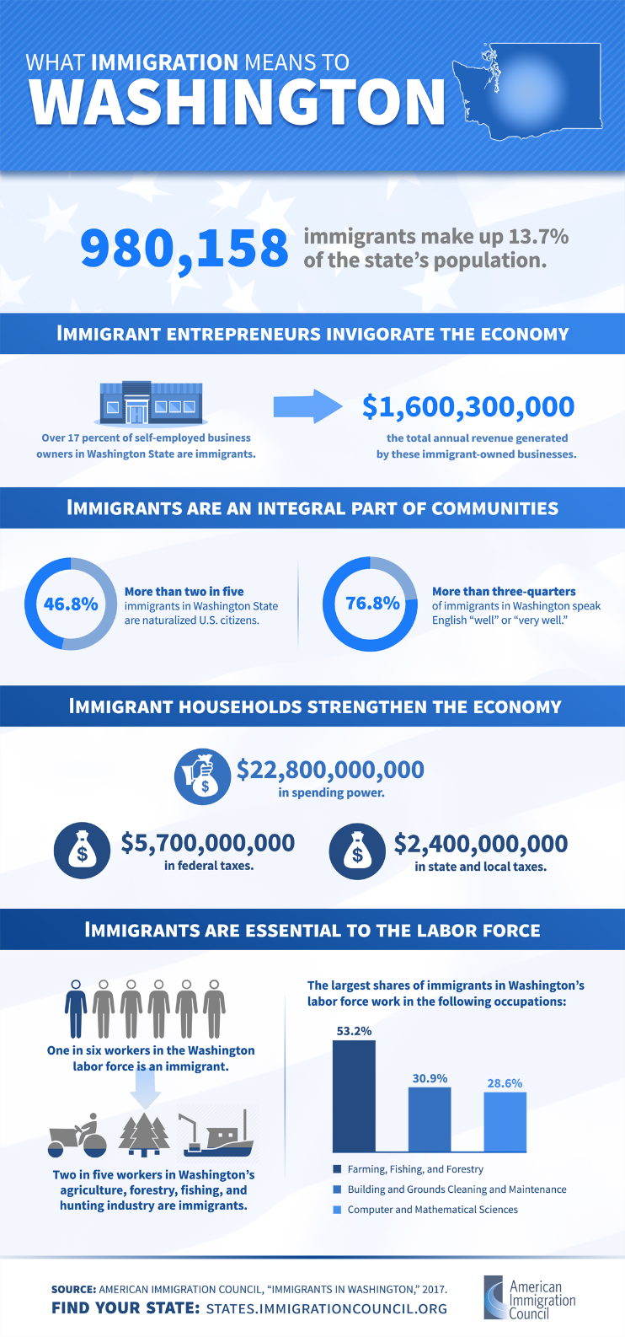
Attribution
What Immigration Means to Washington. Copyright American Immigration Council. All rights reserved. Image used pursuant to fair use. Download fact sheet and infographic on the AIC website: https://www.americanimmigrationcouncil.org/research/immigrants-in-washington

DOCUMENT B: Immigrants and the Economy in Washington
From New American Economy

Visit the New American Economy website. [https://www.newamericaneconomy.org/locations/washington/]
Reading recommendations: Scroll and skim through the categories after reading the Overview. Choose two or three to focus on for your reading. Read the short text and data that accompanies the categories you choose.
The eleven other categories include: Demographics; Entrepreneurship; Taxes and Spending Power; Workforce; Science, Technology, Engineering, and Math; Healthcare, Housing, International Students; Voting Power; Undocumented Immigrants; and the DACA-Eligible Population.
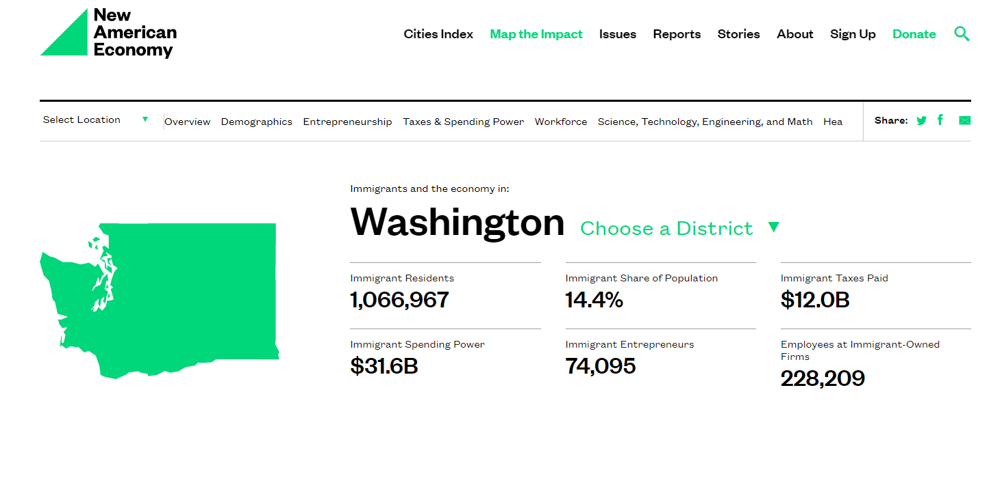
Screen preview from New American Economy website.
Attribution
Immigrants and the Economy in Washington. Copyright New American Economy. All rights reserved. Image used pursuant to fair use. Accessed from https://www.newamericaneconomy.org/locations/washington/.

DOCUMENT C: Immigrants and the Economy in Washington – Your Region
From New American Economy

Visit the New American Economy website. [https://www.newamericaneconomy.org/locations/washington/]
Reading recommendations: Click on the Select a Location dropdown arrow and click on Washington. The data for Washington is divided into 10 districts plus the Seattle Metro and Spokane Metro Areas. Choose the area in which you live. Skim through the categories after reading the Overview (the categories are the same as in Document B). Read the two or three categories you read for Document B so that you can compare data.
Screen preview from New American Economy website.
Attribution
Immigrants and the Economy in Washington. Copyright New American Economy. All rights reserved. Image used pursuant to fair use. Accessed from https://www.newamericaneconomy.org/locations/washington/.
Except where otherwise noted, this Focused Inquiry by Leslie Heffernan, Central Valley School District, is available under a Creative Commons Attribution License. All logos and trademarks are property of their respective owners. Sections used under fair use doctrine (17 U.S.C. § 107) are marked

