How do people impact the economy?

Focused Inquiry
In this focused inquiry, students investigate the question: How do people impact the economy? Students engage in deep reading and analysis of text, including charts, an infographic, and an interactive map. Students will examine the economic impact that foreign born people have on Washington and communicate their understanding by developing an argument (short essay, infographic, poster, etc.) that includes selection, organization and analysis of relevant content. Students will connect their claim, reasons, and evidence to the ideals set forth in the Washington State Constitution.

Standards
- SSS1.6-8.1 Analyze positions and evidence supporting an issue or an event.
- SSS2.6-8.1 Create and use research questions to guide inquiry on an issue or event.
- SSS3.6-8.1 Engage in discussion, analyzing multiple viewpoints on public issues
- SSS4.6-8.1 Analyze multiple factors, make generalizations, and interpret sources to formulate a thesis in a paper or presentation, while observing rules related to plagiarism and copyright.
- C4.6-8.2 Describe the relationship between the actions of people in Washington State and the ideals outlined in the Washington State constitution.
- C4.6-8.3 Employ strategies for civic involvement that address a state or local issue.

Learning Goals
- Students will make observations, inferences and conclusions about demographic data regarding immigrants in Washington.
- Students will engage in small and large group discussions to share multiple viewpoints.
- Use maps and data to understand a complex issue, develop a claim with reasons and evidence, and communicate their understanding by recommending a course of action or taking informed action.

Compelling Question
How do people impact the economy?

Staging the Question:
What immigrant groups are currently in Washington?
- Ask students to come up with a list of immigrant groups they think/know are currently living in Washington State.
- Show them the State Demographics data from the Migration Policy Institute: [https://www.migrationpolicy.org/data/state-profiles/state/demographics/WA]
  - Be sure to pay special attention to the definitions of “foreign born” and “US born” prior to reading.
- Ask students: We had some original thinking about which immigrant groups were living in Washington. Was our original thinking about immigrant groups confirmed or did we revise our background knowledge as a result of looking at the data?

Supporting Question
Does economic data show that Washington state benefits from immigrants?

Formative Performance Task:
- Use the Analysis Organizer (Appendix A) to hold thinking about the sources in Appendix B.
  - What does the data tell us about the impact of immigrants? Does the data suggest an economic benefit to Washington State? Does the data support a key ideal set forth by the Washington State Constitution?
  - After students fill out the Analysis Organizer, have a class discussion to answer the supporting question, “Does economic data show that Washington State benefits from immigrants?
- Students will use their understanding of the different sources to answer the supporting question “Does economic data show that Washington State benefits from immigrants?”
Notes to teacher:
- Page 28-29 of The State We’re In: Washington provides background information about immigration in Washington state. Page 37 describes a bit about the key ideals. It is best to read these pages before the inquiry to provide some foundational knowledge on immigration in Washington State. You may want to review the ideals with more depth if this is a new concept to your students.
- You may need to do pre-teaching of some vocabulary that is specific to the information that your students will see on these sources.
- The data on the sources provided is the most up to date as of the writing of this focused inquiry.

Featured Source(s):
- Infographic: Immigrants in Washington | American Immigration Council, 2017 [https://www.americanimmigrationcouncil.org/research/immigrants-in-washington]
- Interactive Map: Take a Look: How Immigrants Drive the Economy in Washington | New American Economy, 2017 [https://www.newamericaneconomy.org/locations/washington/]

Argument:
After students analyze various sources to answer the supporting question and discuss their thinking with the class, they will write a brief response to the compelling question, How do people impact the economy? Responses should include a claim, evidence, and reasoning and cite specific information from sources, including a connection to a key ideal.

Taking Informed Action:
Engage students in a whole class discussion about the different strategies that they engaged in with each of the documents. Students can then create an illustrated graphic that answers the compelling question and informs their peers about how people impact the economy of Washington State in their specific region.
Except where otherwise noted, this Focused Inquiry by Leslie Heffernan, Central Valley School District, is available under a Creative Commons Attribution License. All logos and trademarks are property of their respective owners. Sections used under fair use doctrine (17 U.S.C. § 107) are marked.

Appendix A: Analysis Organizer
Source | What data does the source provide about the impact of immigrants in Washington State? Provide a few examples from the text. | According to this source, does the data suggest an economic benefit to Washington State? Write a conclusion using information from the text/your notes to support your answer. | Does the data shown in the source support the key ideals set forth in the Washington State Constitution? If so, which ideal is supported?
Document A:
Infographic: Immigrants in Washington
Document B:
Map: Take a Look: How Immigrants Drive the Economy in Washington
Document C:
Map: Take a Look: How Immigrants Drive the Economy in Washington
(Your chosen region)

Region:
__________

Appendix B

DOCUMENT A: Immigrants in Washington
From American Immigration Council
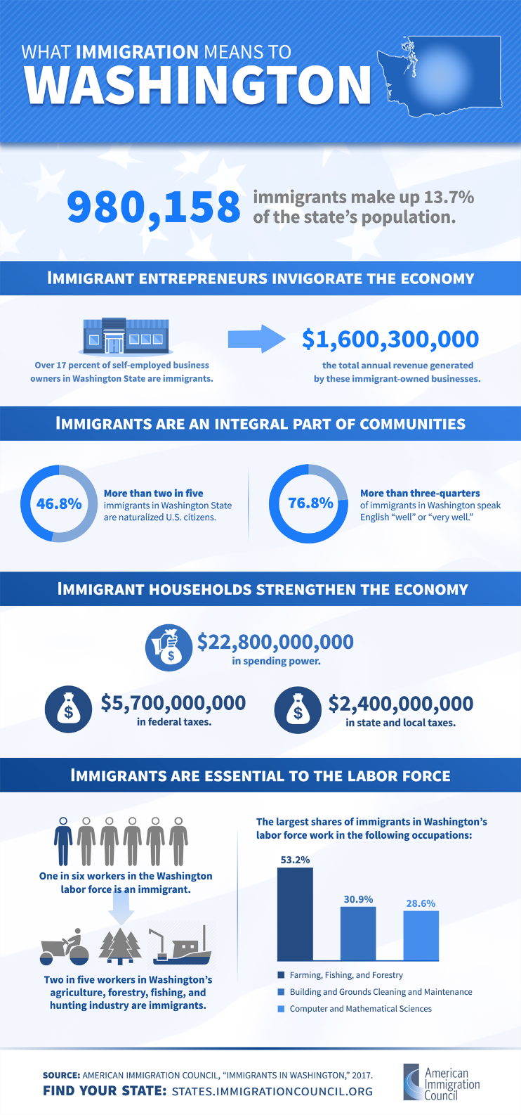
Attribution
What Immigration Means to Washington. Copyright American Immigration Council. All rights reserved. Image used pursuant to fair use. Download fact sheet and infographic on the AIC website: https://www.americanimmigrationcouncil.org/research/immigrants-in-washington

DOCUMENT B: Immigrants and the Economy in Washington
From New American Economy

Visit the New American Economy website. [https://www.newamericaneconomy.org/locations/washington/]
Reading recommendations: Scroll and skim through the categories after reading the Overview. Choose two or three to focus on for your reading. Read the short text and data that accompanies the categories you choose.
The eleven other categories include: Demographics; Entrepreneurship; Taxes and Spending Power; Workforce; Science, Technology, Engineering, and Math; Healthcare, Housing, International Students; Voting Power; Undocumented Immigrants; and the DACA-Eligible Population.
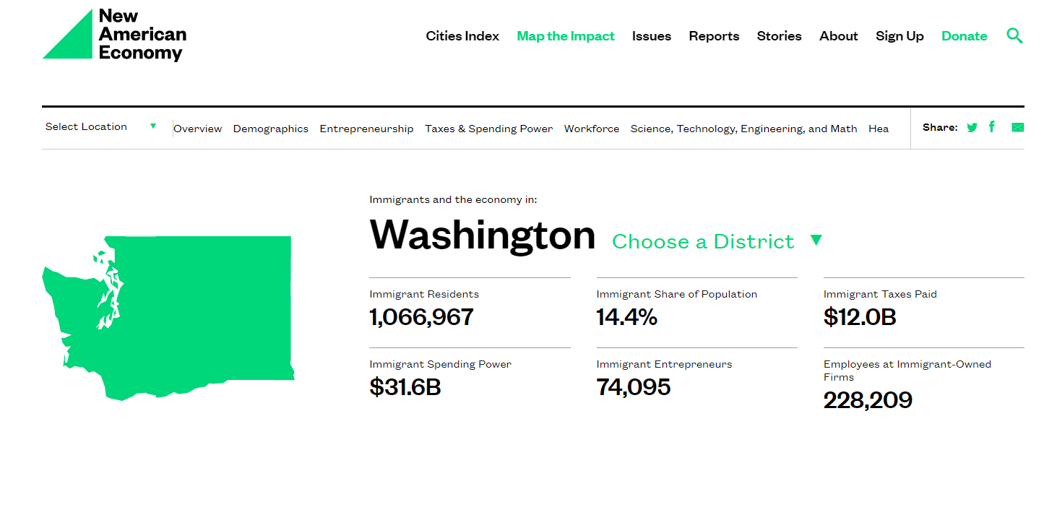
Screen preview from New American Economy website.
Attribution
Immigrants and the Economy in Washington. Copyright New American Economy. All rights reserved. Image used pursuant to fair use. Accessed from https://www.newamericaneconomy.org/locations/washington/.

DOCUMENT C: Immigrants and the Economy in Washington – Your Region
From New American Economy

Visit the New American Economy website. [https://www.newamericaneconomy.org/locations/washington/]
Reading recommendations: Click on the Select a Location dropdown arrow and click on Washington. The data for Washington is divided into 10 districts plus the Seattle Metro and Spokane Metro Areas. Choose the area in which you live. Skim through the categories after reading the Overview (the categories are the same as in Document B). Read the two or three categories you read for Document B so that you can compare data.
Screen preview from New American Economy website.
Attribution
Immigrants and the Economy in Washington. Copyright New American Economy. All rights reserved. Image used pursuant to fair use. Accessed from https://www.newamericaneconomy.org/locations/washington/.
Except where otherwise noted, this Focused Inquiry by Leslie Heffernan, Central Valley School District, is available under a Creative Commons Attribution License. All logos and trademarks are property of their respective owners. Sections used under fair use doctrine (17 U.S.C. § 107) are marked

