AN EXTENDED LOOK
AT THE EXTENDED RESPONSE

Steve Schmidt
Professional Development
Appalachian State University
Website: http://abspd.appstate.edu | Email: schmidtsj@appstate.edu

WORKBOOK CONTENTS

2014 GED Extended Response and Short Answer Written Item Type Overview 3
The Thinking Behind the Writing: Webb’s Depth of Knowledge Level 3 4
Writing Away Fear: The Write It Down Technique 5
Reasoning through Language Arts Extended Response Prompt: An Analysis of Daylight Saving Time 6
Extended Response Answer Guidelines for Reasoning through Language Arts 8
Understanding the Reasoning through Language Arts Scoring Rubric 9
Student Reasoning Through Language Arts 1 12
Student Reasoning Through Language Arts 2 13
Student Reasoning Through Language Arts 3 14
Social Studies Extended Response Prompt 15
Extended Response Answer Guidelines for Social Studies 16
Social Studies Extended Response Rubric 17
How is Social Studies Trait 1 Different from RLA? 17
How will the Social Studies Second Passage Relate to the Enduring Issue (First Passage)? 18
Student Social Studies 1 18
Student Social Studies 2 19
Student Social Studies 3 19
Writing about Reading: Quick Writes 20
Quick Write Example: GED 2014 Automated Scoring 21
Writing about Reading: What-Why-How Chart 22
Teach Writing as a Process 23
Do What? Unpacking Prompts! 24
Teach Writing Using Think Alouds 26
Practice Under Pressure 26
Reasoning through Language Arts Graphic Organizer 27
Social Studies Graphic Organizer 28
Teaching Using Models: RLA 31
GED 2014 Social Studies Extended Response Prompt 32
Teaching Using Models: Social Studies 33
Writing Frames – Reasoning through Language Arts 34
Writing Frames – Social Studies 36
Editing Extended Responses 38
Logical Fallacies 38
Reliable Evidence 39
GED 2014 Technology Skills 40
Free Technology Resources 41

2014 GED Extended Response and Short Answer Written Item Type Overview

The extended responses ask students to unpack a prompt, read source material, plan their response, type it, and then edit/revise. Students should be able to keyboard about 25 words per minute.

TEST | TIME GIVEN | WHERE FOUND | OTHER INFO
Reasoning through  Language Arts | 45 minutes | End of first half of test | - Separately timed  - 18.5% of total test score
Social Studies | 25 minutes | Last item | - Separately timed  - 18% of total test score

On the 2002 GED Writing test, a student who failed the essay failed the test. On the 2014 GED, students can score 0 points on the extended response and the short answer item types and still pass the Reasoning Through Language Arts content test and the Social Studies content test (although it is close to 20% of the test score!).

Grading and Scoring the Reasoning through Language Arts Test
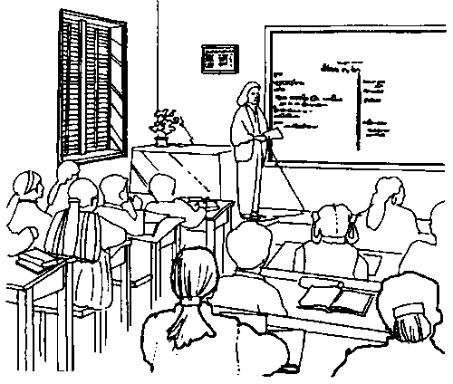
Grading: Extended responses are graded on a rubric (see pages 9 to 11) that emphasizes how well students analyze and create an argument, back it with evidence, develop ideas, have an organizational structure, and use Standard English.

Scoring: Students can score up to 6 points. Their total score is then doubled and added to the number of correct answers on the rest of the test to get their raw score. The raw score is then converted to a scale score that runs from 100 to 200.

Grading and Scoring the Social Studies Test

Grading: The grading rubric is very similar to Reasoning through Language Arts except in trait 1 students must show the connection between an enduring issue and another text and provide some historical context.

Scoring: Students can score up to 4 points. Their total score is then doubled and added to the number of correct answers on the rest of the test to get their raw score. The raw score is then converted to a scale score that runs from 100 to 200.

The Thinking Behind the Writing:
Webb’s Depth of Knowledge Level 3

ENGLISH LANGUAGE ARTS | SOCIAL STUDIES
Requires students to go beyond text. Requires students to explain, generalize, and connect ideas. Involves inferencing, prediction, elaboration, and summary. Requires students to support positions using prior knowledge and to manipulate themes across the passages. Students develop compositions with multiple paragraphs.  Examples:  - Determine effect of author’s purpose on text elements  - Summarize information from multiple sources  - Critically analyze literature  - Edit writing to produce logical progression  - Compose focused, organized, coherent, purposeful prose | - Explain, generalize, or  - connect ideas, using supporting evidence from a text/source  - Apply a concept in other contexts  - Make and support inferences about implied causes and effects  - Draw conclusions or form alternative conclusions  - Analyze how changes have affected people or places  - Use concepts to solve problems  - Analyze similarities and differences in issues or problems  - Propose and evaluate solutions  - Recognize and explain misconceptions related to concepts

Writing Away Fear: The Write It Down Technique

A student will only write successfully if they can write without fear. Math and writing create the most fear in our students. How can we help them get over this fear?

Using the Write It Down stress reduction technique:

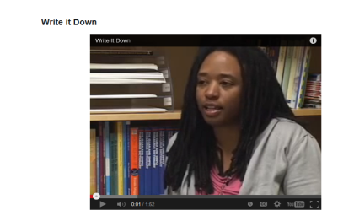
Finding the Write it Down technique:

Navigate to: http://beprepared.appstate.edu/pagesmith/6

Or, Google: ABSPD

Choose Training > then Online PD > then Be Prepared! > College Ready Skills

Reasoning through Language Arts Extended Response Prompt: An Analysis of Daylight Saving Time

1 | Twice a year, most Americans adjust their clocks before bedtime to prepare for Daylight Saving Time (DST). Every spring, clocks are moved ahead one hour. In the fall, they are moved back one hour, and all to maximize the benefits of the sun. DST was first implemented in the United States in 1918 to conserve resources for the war effort, though proponents encouraged its adoption long before then. Benjamin Franklin, for example, touted the idea of DST to citizens of France way back in 1784!
DST in America
2 | For years following DST’s U.S. debut, cities could choose if and when they wanted to participate. However, by the 1960s, the open choice resulted in various cities throughout the United States using different times. These varying times created confusion, particularly for entertainment and transportation schedules. Imagine traveling across several states, each adhering to its own little time zone!
3 | In order to remedy the confusing situation, Congress established a start and stop date for DST when it passed the Uniform Time Act of 1966. Although this act helped clarify when DST went into effect around the country, cities were not required to use DST. To this day, parts of Arizona and all of Hawaii, for example, do not use DST.
Benefits of DST
4 | Many studies have investigated the benefits and costs of DST. Research in the 1970s found that DST saved about 1% per day in energy costs. On average, most electricity used is for lighting and appliances. It makes sense that more sun at the end of the day meant less need for electricity. This follows right along with Ben Franklin’s argument over 200 years ago.
5 | Supporters of DST also claim that more sunlight saves lives. Studies have indicated that traveling home from work or school in daylight is safer. Nearly three decades of research shows an 8-11% reduction in crashes involving pedestrians and a 6-10% decrease in crashes for vehicle occupants after the spring shift to DST.
6 | Other studies reveal that, following a similar logic, DST reduces crime because people are out completing chores after their business or school day in sunlight, lessening their exposure to crimes that are more common after dark.
Arguments Against DST

7 | Opponents of DST cite other studies that disagree with these outcomes. A 2007 study in California indicated that DST had little or no effect on energy consumption that year. A three-year study of counties in Indiana showed that residents of that state spent $8.6 million more each year for energy, and air pollution increased after the state switched to DST. The researchers theorized that the energy jump was caused in part by increased use of air conditioning as a result of maximizing daylight hours.
8 | Recent research has also brought into question the safety aspect of the yearly switch to and from DST. In one study pedestrian fatalities from cars increased immediately after clocks were set back in the fall. Another study showed 227 pedestrians were killed in the week following the end of DST, compared with 65 pedestrians killed the week before DST ended.
9 | The adjustment period drivers endure each year is a dangerous time for pedestrians, and Daylight Saving Time may be the reason. Instead of a gradual transition in the morning or afternoon by just minutes of sunlight each day, the immediate shift of one hour forward or backward fails to provide drivers and pedestrians time to adjust.
10 | When you also consider the cost of the abrupt transition in terms of confusion caused by people who forget to adjust their clocks, opponents say, any benefits gained by DST are simply not worth the trouble.

PROMPT

The article presents arguments from both supporters and critics of Daylight Saving Time who disagree about the practice’s impact on energy consumption and safety.

In your response, analyze both positions presented in the article to determine which one is best supported. Use relevant and specific evidence from the article to support your response.
Source – GED Testing Item Sampler

Extended Response Answer Guidelines for Reasoning Through Language Arts

Please use the guidelines below as you answer the Extended Response question on the Reasoning Through Language Arts test. Following these guidelines as closely as possible will ensure that you provide the best response.

- You will have up to (but no more than) 45 minutes to complete this task. However, don’t rush through your response. Be sure to read through the passage(s) and the prompt. Then think about the message you want to convey in your response. Be sure to plan your response before you begin writing. Draft your response and revise it as needed.

- As you read, think carefully about the argumentation presented in the passage(s). “Argumentation” refers to the assumptions, claims, support, reasoning, and credibility on which a position is based. Pay close attention to how the author(s) use these strategies to convey his or her (their) positions.

- When you write your essay, be sure to
□ determine which position presented in the passage(s) is better supported by evidence from the passage(s)
□ explain why the position you chose is the better-supported one —remember, the better- supported position is not necessarily the position you agree with
□ defend your assertions with multiple pieces of evidence from the passage(s)
□ build your main points thoroughly
□ put your main points in logical order and tie your details to your main points
□ organize your response carefully and consider your audience, message, and purpose
□ use transitional words and phrases to connect sentences, paragraphs, and ideas
□ choose words carefully to express your ideas clearly
□ vary your sentence structure to enhance the flow and clarity of your response
□ reread and revise your response to correct any errors in grammar, usage, or punctuation

Understanding the Reasoning through Language Arts Scoring Rubric

The non-scorable (0) responses below are true for all three parts of the rubric!

Non-Scorable Responses (Score of 0/Condition Codes)

- Response exclusively contains text copied from source text(s) or prompt
- Response demonstrates that the test-taker has read neither the prompt nor the sources text(s)
- Response is incomprehensible
- Response is not in English
- Response has not been attempted (blank)

TRAIT 1: CREATION OF ARGUMENTS AND USE OF EVIDENCE
Score | Description
2 | - Generates text-based argument(s) and establishes a purpose that is connected to the prompt  - Cites relevant and specific evidence from primary and secondary source text(s) to support argument (may include few irrelevant pieces of evidence or unsupported claims)  - Analyzes the issue and/or evaluates the validity of the argument within the source texts (e.g., distinguishes between supported and unsupported claims, makes reasonable inferences about underlying premises or assumptions, identifies fallacious reasoning, evaluates the credibility of sources, etc.)
1 | - Generates an argument and demonstrates some connection to the prompt  - Cites some evidence from source text(s) to support the argument (may include a mix of relevant and irrelevant textual references)  - Partially analyzes the issue and/or evaluates the validity of the argumentation within the source texts; may be simplistic, limited, or inaccurate
0 | - May attempt to create an argument OR lacks purpose or connection to the prompt  - Cites minimal or no evidence from source text(s) (sections of text may be copied from source)  - Minimally analyzes the issue and/or evaluates the validity of the argumentation within the source texts; may completely lack analysis or demonstrate minimal or no understanding of the given argument(s)

TRAIT 2: DEVELOPMENT OF IDEAS AND ORGANIZATIONAL STRUCTURE
Score | Description
2 | - Contains ideas that are well developed and generally logical; most ideas are elaborated upon  - Contains a sensible progression of ideas with the clear connections between details and main points  - Establishes an organizational structure that conveys the message and purpose of the response; applies transitional devices appropriately  - Establishes and maintains a formal style and appropriate tone that demonstrate awareness of the audience and purpose of the task  - Chooses specific words to express ideas clearly
1 | - Contains ideas that are inconsistently developed and/or may reflect simplistic or vague reasoning; some ideas are elaborated upon  - Demonstrates some evidence of a progression of ideas, but details may be disjointed or lacking connection to main ideas  - Establishes an organization structure that may inconsistently group ideas or is partially effective at conveying the message of the task; uses transitional devices inconsistently  - May inconsistently maintain a formal style and appropriate tone to demonstrate an awareness of the audience and purpose of the task  - May occasionally misuse words and/or choose words that express ideas in vague terms
0 | - Contains ideas that are insufficiently or illogically developed, with minimal or no elaboration on main ideas  - Contains an unclear or no progression of ideas; details may be absent or irrelevant to the main ideas  - Establishes an ineffective or no discernable organizational structure; does not apply transitional devices, or does so inappropriately  - Uses an informal style and/or inappropriate tone that demonstrates limited or no awareness of audience and purpose  - May frequently misuse words, overuse slang or express ideas in a vague or repetitious manner

TRAIT 3: CLARITY AND COMMAND OF STANDARD ENGLISH CONVENTIONS
Score | Description
2 | - Demonstrates largely correct sentence structure and a general fluency that enhances clarity with specific regard to the following skills:  - Varied sentence structure within a paragraph or paragraphs  - Correct subordination, coordination and parallelism  - Avoidance of wordiness and awkward sentence structures  - Usage of transitional words, conjunctive adverbs and other words that support logic and clarity  - Avoidance of run-on sentences, fused sentences, or sentence fragments  - Demonstrates competent application of conventions with specific regard to the following skills:  - Frequently confused words and homonyms, including contractions  - Subject-verb agreement  - Pronoun usage, including pronoun antecedent agreement, unclear pronoun references and pronoun case  - Placement of modifiers and correct word order  - Capitalization (e.g., proper nouns, titles, and beginnings of sentences)  - Use of apostrophes with possessive nouns  - Use of punctuation (e.g., commas in a series or in appositives and other non-essential elements, end marks, and appropriate punctuation for clause separation)  - May contain some errors in mechanics and conventions, but they do not interfere with comprehension; overall, standard usage is at a level appropriate for on-demand draft writing

TRAIT 3: CLARITY AND COMMAND OF STANDARD ENGLISH CONVENTIONS (CONTINUED)
Score | Description
1 | - Demonstrates inconsistent sentence structure; may contain some repetitive, choppy, rambling, or awkward sentences that may detract from clarity; demonstrates inconsistent control over skills 1-5 as listed in the first bullet under Trait 3, Score Point 2 above  - Demonstrates inconsistent control of basic conventions with specific regard to skills 1-7 as listed in the second bullet under Trait 3, Score Point 2 above  - May constrain frequent errors in mechanics and conventions that occasionally interfere with comprehension; standard usage is at a minimally acceptable level of appropriateness for on demand draft writing
0 | - Demonstrates consistently flawed sentence structure such that meaning may be obscured; demonstrates minimal control over skills 1-5 as listed in the first bullet under Trait 3, Score Point 2 above  - Demonstrates minimal control of basic conventions with specific regard to skills 1-7 as listed in the second bullet under Trait 3, Point 2 above  - Contains severe and frequent errors in mechanics and conventions that interfere with comprehension; overall, standard usage is at an unacceptable level for on-demand draft writing  OR  - Response is insufficient to demonstrate level of mastery over conventions and usage

Student Reasoning Through Language Arts 1

Between the two positions in this article, the one against Daylight Saving Time is better supported. Although both positions are well organized and supported with several examples, the evidence supporting the view against DST is more specific and thorough.

The first position makes some valid points, ones that are sure to catch any reader's attention. The writer brings up expenses, safety, and crime rates, all of which are supposedly improved through the use of DST. However, the evidence he uses to support this claim seems general and outdated. In paragraph four, he mentions that one study took place in the 1970s. He also uses phrases such as "many studies" and "other studies." While the points he makes are interesting, there are no specifics. One is left wondering just how outdated or reliable these studies are, and if they even apply to the average American. Had he used less generalized phrases, he may have sounded more convincing.

The second position is much better supported, especially compared to the somewhat lacking arguments of the previous position. The writer's information is precise, and he seems to use more studies than the first author. While the first author used studies from the 1970s, this one mentions a study done in 2007. The specifics of each study also improve the quality and seeming validity of the arguments made. The writer gives the states in which the studies were conducted and the reasons why the researches believed they got those results. Also, like the first author, the issues of which he writes are ones that will catch the reader's attention: energy consumption, safety, and confusion. While they are similar to those points brought up by the first writer, this second position is far better supported through its organization and attention to detail.

Student Reasoning Through Language Arts 2

This article presents arguments from both supporters and critics of Daylight Saving Time who disagree about the practice's impact on energy consumption and safety. Both sides provide good support for their position, but the argument against Daylight Saving Time is stronger and more complete. It responds to points made in the argument in favor of Daylight Saving Time and also incorporates arguments of its own.

One of the arguments used by supporters of Daylight Saving Time is that because there is more sun at the end of the day, there is less need for electricity and thus energy costs are lowered. A statistic is provided claiming Daylight Saving Time saves "about 1% per day in energy costs". However, that information is from research conducted in the 1970s, which today is fairly outdated. The supporting argument presents data from other research findings on the subjects of car crashes and crime rates, saying Daylight Saving time reduces the number of accidents and instances of crime. These findings are again suspect because the dates of the research are not clearly stated. The accident data is pulled from "three decade of research"; the identities of these decades are unknown. The crime studies are not dated at all.

The argument against Daylight Saving Time is much more credible. For example, it provides the results of a much more recent (2007) study in California. The study showed that Daylight Saving Time "had little or no effect on energy consumption that year", thus countering the argument that Daylight Saving Time lowering energy use. Also, the results of "recent" research provide evidence against the supposed safety aspect of the yearly switch to and from Daylight Saving Time; more pedestrians were killed by cars "immediately after clocks were set back in the fall" and significantly fewer were killed the week before Daylight Saving Time ended than the following week.

The best-supported position in this article is the position against Daylight Saving Time. The argument in favor of Daylight Saving Time contains data from outdated research experiments and does not provide any counter arguments to the points made by other position. The argument against Daylight Saving Time contains more credible evidence and it also does a solid job of countering arguments made by Daylight Saving Time supporters.

Student Reasoning Through Language Arts 3

This article presents both opposing and proposing side to the issue of Daylight Savings Time (DST). Both sides argue that DST has an effect on energy consumption. Opponents of DST cite studies that have shown there is little to no effect on energy consumption based on a 2007 study completed in the state of California. Another study based in Indiana actually showed that energy consumption increases each year due to DST; furthermore, this study showed air pollution also increased. However, proponents of DST point to a study completed in 1970 that found DST reduced energy costs by 1% per day. They also indicated Benjamin Franklin made an argument for DST to the French in 1784. Unfortunately, it appears they have not considered that back in 1784 people needed daylight to be productive, while now we have electricity that allows to work all through the night, if needed.

The other reason people advocate for the use of DST is safety. Supporters of DST cite three decades of research that shows an 8 – 11% reduction in pedestrian related accidents and a 6 – 10% reduction in vehicle only crashes after the spring shift to DST. However, they have not indicated the risk of injury when DST ends in the fall. Those against the use of DST cite one study that showed an increase in pedestrian related accident immediately after the end of DST in the fall. That study indicated 227 pedestrians were killed the week following the end of DST, compared to only 65 pedestrian fatalities the week before the end of DST. It was stated that this abrupt change in daylight does not provide drivers and pedestrians enough time to adjust to the difference. In contrast, if we did not have DST to change would be gradual and allow both pedestrians and drivers the appropriate amount of time to adjust to the lower levels of sunlight.

The other factor of safety concerns is crime. One study of DST argues that it actually reduced crime because during the evening hours when people are running errands after work the additional sunlight reduces their exposure to crime, which is more common after dark. Unfortunately, the opponents of DST have yet to cite any studies that show crime is not affected by DST. Although, they did point to the fact that DST causes confusion to the people that forget to adjust their clocks; therefore, the people do not show up on time to work or appointments.

Both arguments have been backed by reputable studies; however, the studies cited by the supporters of DST seem to be outdated. While the fact that Benjamin Franklin was a proponent of DST is a significant reason for its use; his reasonings for its use are obsolete in this day and age. Furthermore, the study that found DST actually saved energy was completed in 1970 and our energy consumption needs have changed drastically since then. Also, the study that showed a decrease in pedestrian related accidents and vehicle only related accidents indicated it was completed over a period of three decades. However, it was not indicated when this study was completed, which brings into question the correlation between the current figures and the figures from the unidentified time period. While the opponents of DST were unable to cite any studies that proved crime was unaffected by DST, the supporters of DST did not indicate when the study was completed. Therefore, it is hard to confirm those statistics are still valid in the present day. While both sides of the argument have compelling facts, I believe the opponents to DST have provided a stronger case based on the facts given.
Social Studies Extended Response Prompt

Excerpt
“All, too, will bear in mind this sacred principle, that though the will of the majority is in all cases to prevail, that will, to be rightful, must be reasonable; that the minority possess their equal rights, which equal laws must protect, and to violate which would be oppression.”

-- Thomas Jefferson, 1801
Letter
June 15, 1943
To the Editor:

Students and teachers across this land say the pledge of allegiance each day to honor a republic committed to liberty and justice for all. That commitment was reaffirmed yesterday by the Supreme Court’s ruling in West Virginia State Board of Education v. Barnette. The ruling struck down as unconstitutional West Virginia’s directive that schoolchildren must daily salute the flag while reciting the pledge of allegiance or face expulsion. The Barnettes challenged the compulsory salute and pledge because it conflicts with their religious beliefs as Jehovah’s Witnesses. Even so, the Court did not make its ruling based on freedom of religion. Instead, the decision was based, in large part, on freedom of speech.

Our Constitution places certain rights beyond the reach of government officials and beyond the reach of what the majority likes. The freedom of speech is certainly such a right. Yesterday’s ruling not only affirmed the freedom of speech but expanded it to include the right not to speak. The Court has made clear that the government cannot force people to say things they do not believe.

As our nation fights a worldwide war, it is natural to seek the reassurance that comes from a shared sense of patriotism. As a society, we have looked to our public schools to help develop a love of a country in our young people. But do we want patriotism that is “demonstrated” by government-mandated expressions of allegiance by students (or any citizen)? Of course we do not!

We want a nation which commands our love and respect because the government does not infringe on personal beliefs and protects the rights of all citizens. Yesterday’s ruling helps ensure that that is the type of nation in which we and our children will live!

Amelia Parsons
Wheeling, West Virginia

Prompt

In your response, develop an argument about how the author’s position in her letter reflects the enduring issue expressed in the excerpt from Thomas Jefferson. Incorporate relevant and specific evidence from the excerpt, the letter, and your own knowledge of the enduring issue and the circumstances surrounding the case to support your analysis.

Type your response in the box. This task may require 25 minutes to complete.

Extended Response Answer Guidelines for
Social Studies

Please use the guidelines below as you answer the Extended Response question on the Social Studies test. Following these guidelines as closely as possible will ensure that you provide the best response.

- You will have up to (but no more than) 25 minutes to complete this task. However, don’t rush through your response. Be sure to read through the passage(s) and the prompt. Then think
about the message you want to convey in your response. Be sure to plan your response
before you begin writing. Draft your response and revise it as needed.

- As you read the quotation and passage, think carefully about the enduring issue expressed in the quotation given. An enduring issue reflects the founding principles of the United States and is an important idea that people often grapple with as new situations arise.

- When you write your essay, be sure to
□ develop an argument about how the ideas expressed by the author of the passage are related to
the excerpt or quotation that is presented first
□ support your explanation with multiple pieces of evidence, using ideas from both the
quotation or excerpt and the passage
□ incorporate your own knowledge of the topic’s background and historical context into your
response
□ answer the prompt directly by staying focused on the passage and the quotation or excerpt
throughout your response
□ defend your assertions with multiple pieces of evidence from the passage(s)
□ build your main points thoroughly
□ put your main points in logical order and tie your details to your main points
□ organize your response carefully and consider your audience, message, and purpose
□ use transitional words and phrases to connect sentences, paragraphs, and ideas
□ choose words carefully to express your ideas clearly
□ vary your sentence structure to enhance the flow and clarity of your response
□ reread and revise your response to correct any errors in grammar, usage, or punctuation

Social Studies Extended Response Rubric

The Social Studies rubric is very similar to the Reasoning through Language Arts rubric and has the same 3 traits. Both rubrics ask students to:

- Write a response based on the prompt
- Back up an argument with evidence from the passage(s)

The main differences between the 2 rubrics are in trait 1:

SOCIAL STUDIES TRAIT 1: CREATION OF ARGUMENTS AND USE OF EVIDENCE
Score | Description
2 | - Generates a text-based argument that demonstrates a clear understanding of the historical relationships among ideas, events, and figures as presented in the source text(s) and the contexts from which they are drawn  - Cites relevant and specific evidence from primary and secondary source text(s) that adequately supports an argument  - Is well-connected to both the prompt and the source text(s)
1 | - Demonstrates an understanding of the relationships among ideas, events, and figures as presented in the source text(s)  - Cites some evidence from primary and secondary source texts in support of an argument (may include a mix of relevant and irrelevant textual references)  - Is connected to both the prompt and the source text(s)
0 | - Demonstrates minimal or no understanding of ideas, events, and figures presented in the source texts or the contexts from which these texts are drawn  - Cites minimal or no evidence from the primary and secondary source texts; may or may not demonstrate an attempt to create an argument  - Lacks connection either to the prompt or the source text(s)

How is Social Studies Trait 1 Different from RLA?

Students must be able to:

- discover the relationship between the two texts (the enduring issue and the second passage)

- put in some information about the historical context of the passages

How will the Social Studies Second Passage Relate to the Enduring Issue (First Passage)?

- It might support or criticize the issue

- It may be an example of the issue

- It might explain the issue in a more modern context

Questions to ask:

- What does the second passage tell me about the enduring issue in the first passage?

- What is the author’s purpose in the second passage: explain, give an example, interpret, support, or criticize the enduring issue?

Student Social Studies 1

Amelia Parson's letter reflects upon Thomas Jefferson's quote about how minorities cannot be mob ruled if we are to truly be free.

Amelia talks about West Virginia State Board of Education v. Barnette, in which children were mandated to pledge allegiance to the flag. She rightfully stated sided with the dissenters.

Amelia says “Our Constitution places certain rights beyond the reach of what the majority likes. The
freedom of speech is such a right."

Jefferson would certainly agree with this, since he firmly believed that the minority have an equal level of rights that are to be protected. Having such rights so far outside the realm of public or private hands helps to ensure that we all have as close to fair treatment as possible.

Amelia talks about our nation fighting in World War 2, and that patriotism in these times is a great sense to
share with one another. However, she has the clarity to see that mandating allegiance is not patriotism at all. Jefferson would most likely agree with this, since he believed that infringing on these rights was considered oppression.

Amelia says "We want a nation which commands our love and respect because the government does not
infringe on personal beliefs and protects the rights of all citizens."

Amelia has the clarity to see that people love a place where they can be themselves, and will fight for it.
This is exactly the type of foundation that Jefferson had fought for years ago.
Student Social Studies 2

Thomas Jefferson states very clearly, and without faltering, that while the country will be represented by the desires of the majority, that the rights of the minority will not be infringed upon in the process. Ms. Parsons demonstrates that the country continues to uphold this principle almost 150 years after Thomas Jefferson made that statement.

In the issue at hand the United States Supreme Court struck down a mandate that all students recite the Pledge of Allegiance and salute the flag each morning. In some situations, such as in the case of the Jehovah's Witnesses, saying the Pledge while saluting the flag violates their religious beliefs, and so therefore of religion. However, it was not ruled to be a violation of their freedom of religion, but rather of their freedom of speech, to say or not say what they desired.

There is nothing wrong with asking children to say the Pledge of Allegiance, as pointed out by the author. It is wrong, nevertheless, to require that this be done under penalty of punishment. It resonates with Nazi idealisms of the time, that you would salute Hitler and obey the Nazi regime or face death or internment. We as a people were appalled by these revelations, but West Virginia, in their desire to prove the patriotism of their students, attempted to take the United States one step closer to this fanaticism. Despite that, the Supreme Court struck down the law and prevented one of the most basic freedoms we as Americans hold dear from being trampled upon by a majority opinion.

Student Social Studies 3

Thomas Jefferson expressed in 1801 that all people, including those in the minority, should have "equal rights, which equal laws must protect" and anything less would be oppression; he considered this to be a "sacred principle". In Amelia Parsons' 1943 Letter to the Editor, more than 100 years after Thomas Jefferson expressed his opinion on the subject, she details the exact same sentiments about a court decision that had just taken place. In West Virginia State Board of Education v. Barnette, the Supreme Court ruled that children would not be forced to say the pledge of allegiance if they did not want to. Apparently, the decision did not stem so much from the Court's desire to protect freedom of religion, but rather to protect freedom of speech. As Amelia states in her letter, “[the] ruling not only affirmed the freedom of speech but expanded it to include the right not to speak". The Court ruling in favor of American’s right to not speak was a powerful decision. This ruling declared that the American government is not allowed to force Americans to say something that they don't want to say, regardless of their reasons. Because this case was ruled under a desire to maintain freedom of speech rather than freedom of religion, those who choose not to speak do not have to explain themselves; those who choose not to say the pledge of allegiance do not have to prove that they're of a religion that forbids it. To paraphrase Amelia, although an individual may not say the pledge of allegiance it does not mean that they do not respect and love their country; rather they love their country because they don't have to say it.
Writing about Reading: Quick Writes

A Quick Write helps students think about a topic before, during, and after reading. Students are asked to respond to a question or prompt related to a text and should write down whatever comes to their mind without worrying about grammar or organization.

The writing topics are related to a text and may be:

- Summaries of learning
- An explanation of a concept or vocabulary
- A prediction, inference, or hypothesis

Give students from 2 to 10 minutes to write and be sure you as the instructor write too. Quick Writes can be used as part of instruction, assessment, or discussion. They help bring out the writer in students, build their writing confidence, and help their reading skills too!

Quick Write Example: GED 2014 Automated Scoring

Can a computer accurately score a writing test? Yes it can! Automated scoring has come a long way in the past decade, and it is being used to score extended response items on the GED 2014 test. After extended response items were field tested by being answered by adult students, they were scored by human experts who graded their responses based on the scoring rubric. These responses were then used to train the scoring engine. Once the scoring engine learned the range of acceptable response types for each score on the rubric, several hundred more responses were put through the scoring engine to test its reliability. Amazingly, each responses is evaluated on more than 100 different dimensions in relation to the score that each response is given. The engine learns how to score the responses and can replicate the human scoring process.

To ensure ongoing accuracy, GED ® Testing Service created three quality control procedures. When GED 2014 begins in January, all extended responses will be read by human scorers for a time to double check the scoring engine. After this initial phase, an audit procedure will always be in place that will randomly choose a percentage of responses (approximately five percent) to be human scored. There is also an automatic rescore process where failing tests with scores just below passing will have their responses double checked. So, human scorers will always be a part of the process as well as grading all the extended responses on the GED Ready practice test.

As the test continues to be given, the database of known response types will grow over time and will be used to retrain the scoring engine to further improve performance. Students will be able to receive their scores within three hours of taking the test, a significantly faster time than before. They will also receive specific feedback on how they did on their extended response and short answer items on their score reports. GED Testing hopes that this feedback will allow students “to continuously improve their performance.”

Source: Automated Scoring of Extended Response Items on the 2014 GED Test, GED Testing Service

Prompt

Describe two new things you learned about automated scoring from reading this passage.

____________________________________________________________________________________________________________________________________________________________________________________
____________________________________________________________________________________________________________________________________________________________________________________
__________________________________________________________________________________________
__________________________________________________________________________________________

Writing about Reading: What-Why-How Chart

What? What does the author think about the topic?

______________________________________________________________________________________________________________________________________________________________________________________________________________________________________________________________________________
WHY?  These are the author’s reasons  for thinking this way. | HOW?  These are the author’s support, evidence  and/or examples for each reason.
Adapted from GED Testing Service

Teach Writing as a Process

Teach students to tackle writing assignments using a process. A process is a standard method for doing something. For example, use URPWE as a process for writing extended responses and short answers.

U = Unpack the prompt – What are you being asked to do?
R = Read the source material
P = Plan the response
W = Write the response
E = Edit the response

Do What? Unpacking Prompts!

When we unpack a prompt, we ask
ourselves, “What am I supposed to do?”

Reasoning through Language Arts

The standard format of a Reasoning Through
Language Arts prompt is:

- A brief description of the passage and the issue

- Directions on what students should write

- Time Limit: 45 minutes

Let’s Practice:

Prompt

The article presents arguments from both supporters and critics of funding the National Aeronautics and Space Administration (NASA) who disagree about the agency’s impact on the economy and research benefits.

In your response, analyze both positions presented in the article to determine which one is best supported. Use relevant and specific evidence from the article to support your response.

DO (LOOK FOR VERBS) | WHAT

Social Studies

The standard format of a Social Studies prompt is:

- Directions on what students should write

- Time Limit: 25 minutes

Let’s Practice:

Prompt

In your response, develop an argument about how Gerald Ford’s 1974 speech reflects the enduring issue in the quotation from the United States Constitution. Incorporate relevant and specific evidence from the excerpt, the letter, and your own knowledge of the enduring issue and the circumstances surrounding the case to support your analysis.

Type your response in the box. This task may require 25 minutes to complete.

DO (LOOK FOR VERBS) | WHAT

Teach Writing Using Think Alouds

When we teach writing using think alouds, we show students what is going on in our heads as we write. This provides students with a model they can follow as they write and shows them good writing is not magic but a process they can learn.
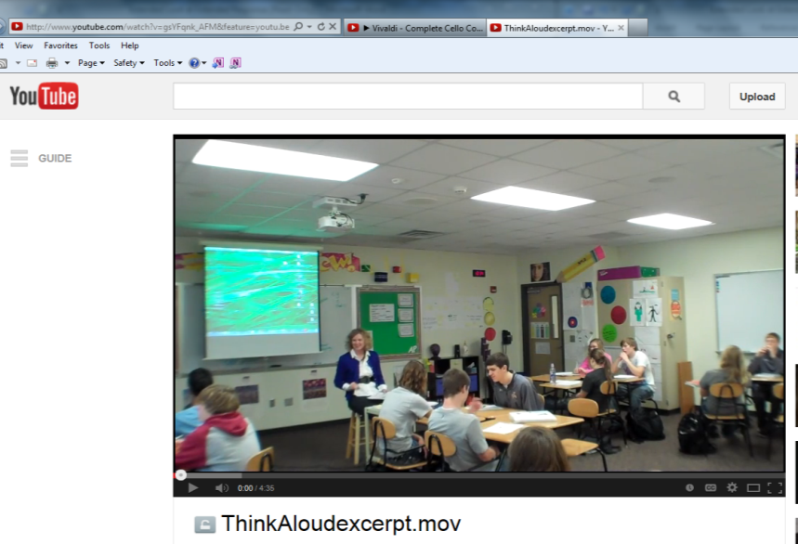
The video used to demonstrate
this technique is found here:

http://www.youtube.com/watch?v=gsYFqnk_AFM&feature=youtu.be

Practice Under Pressure

We can create similar conditions that students will face on the GED 2014 extended responses/short answers so students will be ready when they take the actual test. Give students the same time limit they have on GED 2014: 45 minutes for RLA, 25 minutes for Social Studies, and 10 minutes for Science.

To really get a feel for the actual test, have students keyboard their responses on a computer.

Sample prompts can be found at:

- GED Testing Service free practice tests: http://www.gedtestingservice.com/educators/freepracticetest

- ABSPD website: http://abspd.appstate.edu/ase-la-2-using-research-writing

- Writing for the GED Test 3, New Reader’s Press, pgs. 51 – 60, 70 – 71.

- Make your own by finding reading passages online and creating your own prompts.

To find the video for this technique, go to: http://beprepared.appstate.edu/pagesmith/6

Or Google: ABSPD and choose Training, Online PD, Be Prepared!, College Ready Skills

Reasoning Through Language Arts Graphic Organizers

Summarize The Two Arguments

Argument 1 Is Better Supported Than Argument 2 Because

First Reason Argument 1 Is Better Than Argument 2

Evidence

Second Reason Argument 1 Is Better Than Argument 2

Evidence

Conclusion – Summarize Your Main Points

Social Studies Graphic Organizer

Passage 2 Relates To The Enduring Issue In Passage 1 By

First Way Passage 2 Relates To Passage 1

Evidence From Text

My Knowledge Of The Issue

Second Way Passage 2 Relates To Passage 1

Evidence From Text

My Knowledge of The Issue

Conclusion – Summarize Your Main Points

Reasoning through Language Arts Extended Response Prompt: Analyzing Speed Limits
1 | The United States is a nation on the move. To make sure we do not move too fast, highway speed limits have been a fact of life for many years. Speed limits in America go back to 1757 in Boston when it was illegal for horses to move faster than a walking pace on Sundays. Interstate highways, first built in the 1950s, were designed to handle speeds of at least 70 miles per hour. When the energy crisis came in 1973, the National Maximum Speed Law established a 55 mile per hour limit for the entire country. By the late 1980s, lower oil prices meant states could choose to have higher speed limits which they did.
Let’s Not Race by Speed Limits, Keepit Slow, Washington Post Editorial
2 | I am concerned about a trend I see sweeping across our country. It seems that speed limits are moving ever higher. In most of the central and western parts of the United States, speed limits range from 70 to 85 miles per hour. These higher speeds waste precious fuel and endanger the lives of motorists across our land. We need to keep speed limits below 60 miles per hour.
3 | Even though our country is now on pace to be the world’s leading energy producer by 2015, we still need to be concerned about saving fuel. The US Department of Commerce did a study that showed the difference between driving under and over 60 miles per hour. They found that driving under 60 would save Americans 2 billion dollars a year in fuel costs.
4 | In another important study done in 2007, the state of Florida examined consumer spending on gas during the 1990s. They found that consumers paid $220 million more dollars on gas as speed limits were increased on Florida roads during 1990 to 1999. This sharp increase was directly related to driving faster which lowers fuel economy.
5 | Much more important than saving fuel is saving lives. From 1973 to 1987 the National Maximum Speed Law lowered the speed limit to 55 for the entire country. The National Highway Traffic Safety Administration (NHTSA) did a study on how this change impacted highway deaths. What the NHTSA found was fewer people died in traffic related accidents because of the lower speed limits.
6 | Also, other important evidence shows that lower speed limits save lives. In 2006, the Pew Trust did a study on speed limits and traffic deaths. They found that deaths increased by 1200 people each year for every mile per hour the speed limit was raised. I call on our government to once again set a national speed limit of 55 miles per hour.

Speed Demon’s Blog Post
7 | Hey, I just got back from the most awesome ride I have ever had! Of course I was out in my mean machine. You know the car I’m talking about: my 2012 Chevy Camaro. Camaros are not made to just cruise. When I want to go full throttle, I can’t go as fast as I want. I always have to put up with these stupid speed limits on the freeway. Dude, I just love to boogity, boogity, boogity. For those of you living in a cave, boogity is NASCAR slang for going fast!
8 | I just read some stupid article from somebody about why speed limits are a good thing. It’s so lame, man! It says that speed limits save lives and gas. Cars back in the day were not built like they are today. I remember my first Camaro, a 1976. It could fly but it was a piece of junk. Everybody knows that cars today are so much better made. Those robots do a much better job making cars than those drunks on the assembly line did back in the 1970s. If you get hit or hit somebody, your better made car and air bags will save you!
9 | People talk about gas prices, but I don’t see that as an issue. Yeah, I remember when gas was above four bucks in 2008. That was five years ago. That’s ancient history. Gas prices are coming down, man. Just last week I paid just over three bucks a gallon. Gas hasn’t been that cheap in so long.
10 | So in my amazing opinion (the only one that matters) speed limits are just some big government attempt to keep us from having fun. My next post will be coming at you soon. Keep it real, dudes and dudettes!

Prompt

The article presents arguments from both supporters and critics of speed limits who disagree about the practice’s impact on gas consumption and safety.

In your response, analyze both positions presented in the article to determine which one is best supported. Use relevant and specific evidence from the article to support your response.
r

Teaching Using Models: RLA

In her Washington Post editorial, Keepit Slow argues that speed limits below 60 miles per hour save gas and lives. In his blog, Speed Demon says that speed limits are not necessary because he likes to drive fast, cars today are safer, and gas prices are coming down. Keepit Slow’s editorial is the better of the two because she supports her claims with strong, recent evidence from reliable sources while Mr. Demon’s uses only his personal experience to back up his arguments.  In the editorial, Keepit Slow’s first reason why speed limits should be below 60 miles per hour is that it saves gas. She uses data from the US Department of Commerce to back her claim that driving under 60 would “save Americans 2 billion dollars a year in fuel costs.” She also points to a recent 2007 study by the state of Florida that showed consumers paid $220 million dollars more per year for gas when speed limits were raised in the 1990s.  Also, Ms. Slow shows that driving slower save lives. She uses data from the National Highway Traffic Safety Administration to show that fewer people died when speed limits were lowered in the 1970s. Keepit Slow also talked about a 2006 study by the Pew Trust that showed how “deaths increased by 1200 people each year for every mile per hour the speed limit was raised.”  In contrast to Keepit Slow, Speed Demon’s arguments are not based on strong evidence but on his personal opinion. His biggest argument was that there should be no speed limits because “dude, I just love to boogity, boogity, boogity.” He could provide no evidence for his claim that cars today were made better than in the past beyond his phrase “everyone knows that.” He based his argument that gas prices were going down on the price he paid when he filled up his car last week, not on national studies.  In conclusion, Keepit Slow’s editorial supports her opinions by using recent facts from reliable sources. Speed Demon’s blog is just his personal opinion, and he has not done any research to prove his points. | The first paragraph introduces the topic  The thesis (argument) is in bold  The criteria for evaluating evidence are underlined  Specific evidence from the text is in italics  Organization is shown through paragraph structure where first Keepit Slow’s evidence is discussed and then Speed Demon’s evidence is contrasted  Transition words like also and in contrast connect paragraphs together  Awareness of audience and purpose is shown by a conclusion which summarizes the argument

GED 2014 Social Studies Extended Response Prompt

Quotation
“This Constitution, and the Laws of the United States which shall be made in Pursuance thereof; and all Treaties made, or which shall be made, under the Authority of the United States, shall be the supreme Law of the Land.”

- United States Constitution, Article Six, 1788

Speech
In this excerpt from his August 9, 1974 speech on becoming President, former Vice President Gerald R. Ford addresses the country after becoming the first unelected President of the United States when he took office after Richard Nixon resigned during the Watergate scandal.

The oath that I have taken is the same oath that was taken by George Washington and by every President under the Constitution. But I assume the Presidency under extraordinary circumstances never before experienced by Americans. This is an hour of history that troubles our minds and hurts our hearts.

I am acutely aware that you have not elected me as your President by your ballots, and so I ask you to confirm me as your President with your prayers . . . . . If you have not chosen me by secret ballot, neither have I gained office by any secret promises. I have not campaigned either for the Presidency or the Vice Presidency. I have not subscribed to any partisan platform. I am indebted to no man, and only to one woman–my dear wife–as I begin this very difficult job.

I have not sought this enormous responsibility, but I will not shirk it. Those who nominated and confirmed me as Vice President were my friends and are my friends. They were of both parties, elected by all the people and acting under the Constitution in their name. It is only fitting then that I should pledge to them and to you that I will be the President of all the people.

Our Constitution works; our great Republic is a government of laws and not of men. Here the people rule.

. . . .I now solemnly reaffirm my promise I made to you last December 6: to uphold the Constitution, to do what is right as God gives me to see the right, and to do the very best I can for America.

Prompt

In your response, develop an argument about how President Ford’s position in his speech reflects the enduring issue expressed in the quotation from the United States Constitution. Incorporate the relevant and specific evidence from the quotation, the speech and your own knowledge of the enduring issue and the circumstances surrounding Gerald Ford’s becoming President to support your analysis.

Type your response in the box. This task may require 25 minutes to complete.

Teaching Using Models: Social Studies

The excerpt from Article 6 of the United States Constitution says the Constitution is “the supreme law of the land.” This shows the enduring principle that the United States government is founded based on laws as spelled out in the Constitution. In his 1974 speech, President Ford supports this enduring principle that the United States is a country founded on laws.  Ford’s speech was given just after President Nixon resigned because of Watergate. President Ford makes it clear that “our great Republic is a government of laws and not of men” and that even the President of the United States is not above the law. The Constitution is our country’s law and political power rests in it, not any one person.  Also, President Ford further supports this enduring principle when he says “our Constitution works.” This means that the United States government has continued for 200 years in spite of all the challenges we have had as a country. Even a President resigning and a new one taking office does not change does not change how the Constitution works.  Finally, President Ford goes on to say that he was appointed based on laws made by people “acting under the Constitution.” People were not acting on their own authority but were directed by the laws in the Constitution. So, President Ford supports the enduring principle that the Constitution is the law of the land in the United States in his 1974 speech when he became President. | The enduring principle is explained in bold  The underlined shows the connection between the enduring principle and the later speech.  Personal information on the historical context is in the first sentence of the second paragraph.  Specific evidence from the text is shown in italics  Transition words like also and finally connect paragraphs together  The paragraphs bring in evidence from both passages and explain how they support the enduring principle

Writing Frames – Reasoning through Language Arts

_________________________ makes the claim that _______________________________________________

__________________________________________________________________________________________

__________________________________________________________________________________________

_________________________ makes the claim that _______________________________________________

__________________________________________________________________________________________

__________________________________________________________________________________________

The best argument is ________________________________________________________________________

__________________________________________________________________________________________

because ___________________________________________________________________________________

The first reason _____________________________________________________________is better is because

__________________________________________________________________________________________

__________________________________________________________________________________________

__________________________________________________________________________________________

Evidence supporting this reason is ______________________________________________________________

__________________________________________________________________________________________

__________________________________________________________________________________________

There is also _______________________________________________________________________________
__________________________________________________________________________________________

__________________________________________________________________________________________

Also, the second reason ______________________________________________________is better is because

__________________________________________________________________________________________

__________________________________________________________________________________________

__________________________________________________________________________________________

Evidence supporting this reason is ______________________________________________________________

__________________________________________________________________________________________

__________________________________________________________________________________________

Another piece of evidence is __________________________________________________________________
__________________________________________________________________________________________

__________________________________________________________________________________________

In conclusion, ______________________________________________________________________________

__________________________________________________________________________________________

__________________________________________________________________________________________

__________________________________________________________________________________________

Writing Frames – Social Studies

________________________________________________________________ states the enduring principle of

__________________________________________________________________________________________

__________________________________________________________________________________________

_________________________ (explains, supports, criticizes, gives an example of) the enduring principle by

__________________________________________________________________________________________

__________________________________________________________________________________________

__________________________________________________________________________________________

The first way ___________________ (explains, supports, criticizes, gives an example of) the enduring

principle is by ______________________________________________________________________________

__________________________________________________________________________________________

__________________________________________________________________________________________

The evidence for this is ______________________________________________________________________

__________________________________________________________________________________________

__________________________________________________________________________________________

__________________________________________________________________________________________

During this time in history, ____________________________________________________________________

__________________________________________________________________________________________

__________________________________________________________________________________________

__________________________________________________________________________________________

The second way ___________________ (explains, supports, criticizes, gives an example of) the enduring

principle is by ______________________________________________________________________________

__________________________________________________________________________________________

__________________________________________________________________________________________

The evidence for this is _______________________________________________________________________

__________________________________________________________________________________________

__________________________________________________________________________________________

__________________________________________________________________________________________

During this time in history, ___________________________________________________________________

__________________________________________________________________________________________

__________________________________________________________________________________________

__________________________________________________________________________________________

In conclusion, ______________________________________________________________________________

__________________________________________________________________________________________

__________________________________________________________________________________________

__________________________________________________________________________________________

Editing Extended Responses

- Is there an introduction with a clear argument?
- Are there body paragraphs that support the argument?
- Is evidence from the text included to back up any points made?
- Do paragraphs show a logical flow from one idea to another?
- Are there transition words that help move the reader from idea to idea?
- Is Standard English being used all through the writing?
- Is there an awareness of audience (formal style)?

Logical Fallacies

Students should be aware of some common logical fallacies to help them analyze RLA arguments:

Either/Or – Instead of many solutions for a problem, there are only two. For example in advertising, either you should buy the latest iPhone or have no phone at all.

Jump on the Bandwagon – Everyone is doing it so you should too.

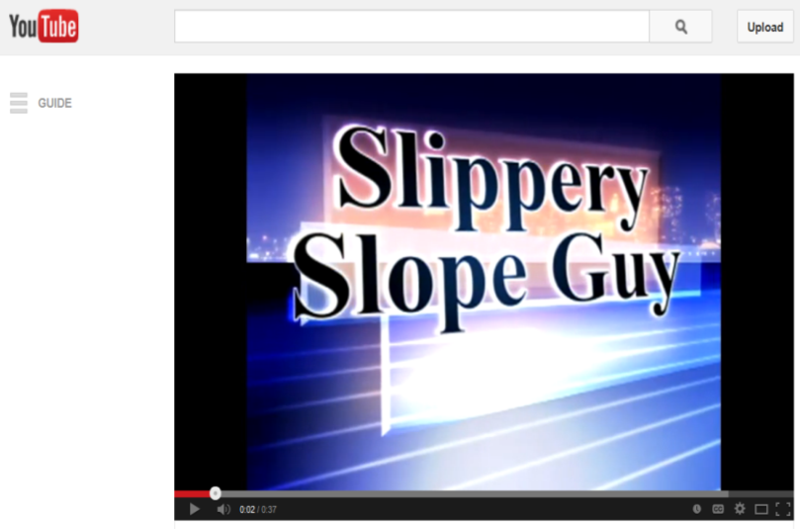
Slippery Slope – Taking one action will lead to a series of bad events. For example, having the government set limits on hand guns will lead to laws taking away all weapons from everyone.

Video of the Slippery Slope Guy – Google: slippery slope guy (Warning: contains profanity)

Personal Attack - Instead of defending their position or showing why the other position is wrong, a writer goes after the person making the other argument calling them names or questioning their character.

Reliable Evidence

As students look at the evidence presented in RLA source documents, they should consider how reliable it is. Some things to measure reliability are:

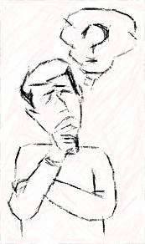
Currency

Is the evidence up to date? Studies done more recently may be better than ones conducted years ago, especially in science or technology.

Authority

Who created the source? Are they really an expert in this field? Some people talk like they are experts but are really not such as well-known movie stars.

Relevance

Does the evidence specifically relate to the topic being discussed? An example of an irrelevant argument: Ima Pro, a former professional golfer, just joined the Safety Insurance Company as an insurance underwriter. The company says she will be a great underwriter since she has experience as a golf pro. This is irrelevant as someone’s experience as a golf pro does not necessarily translate into success as an insurance underwriter.

Bias

Is the evidence from an unbiased source? Sources such as government agencies and educational institutions are usually unbiased. When a corporation funds a study, do we expect the results will support the company’s product?

GED 2014 Technology Skills

KEYBOARDING

Can your students:

☐ Type approximately 25 words per minute, fast enough to complete a 500 word extended response in 45 minutes?
☐ Use the keys: space bar, return/enter, shift, arrows, delete, backspace, tab?
☐ Use the numbers and punctuation keys?

USING A MOUSE

Can your students use a mouse to:

☐ Point to an area or word on screen?
☐ Left click, right click, double click?
☐ Highlight and select text?
☐ Cut, copy, and paste text?
☐ Select an object or window by clicking on it?
☐ Drag an object to a new location?
☐ Open/close a pop-up window?
☐ Select one or more radio and/or check buttons?
☐ Scroll horizontally and vertically?

NAVIGATION

Can your students:

☐ Use the screen navigation commands previous/next?
☐ Navigate multiple windows?
☐ Navigate toolbars and drop-down menus?
☐ Navigate screen tabs?
☐ Use the undo and redo operations?
☐ Mark a section/question as a “Flag for Review” and
return to section/question as needed?

Free Technology Resources

GCF Learn Free

This free site guides students in learning how to use a mouse and computer basics as well as helping
students learn Microsoft Office applications like Word and Excel.

Google: gcf learn free or www.gcflearnfree.org

Typing Web

This free site helps students learn keyboarding.

Instructors can register students to monitor their progress.

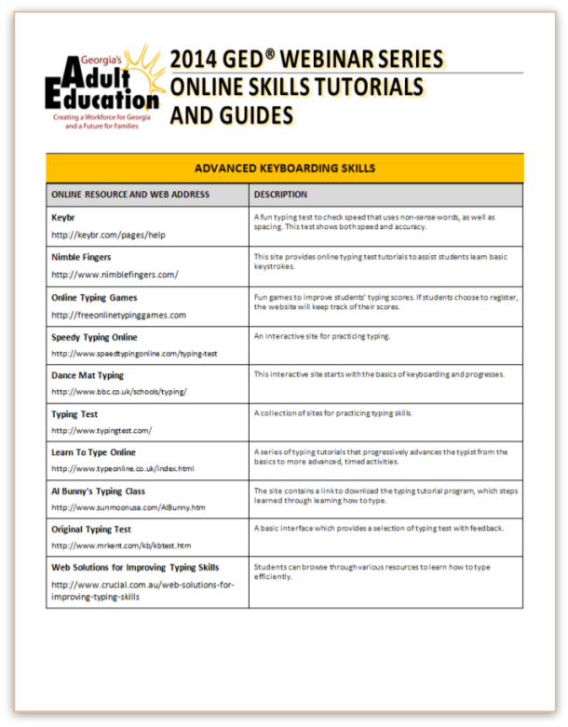
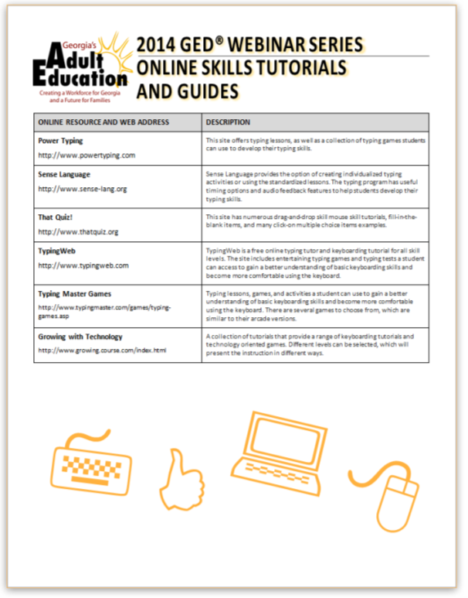
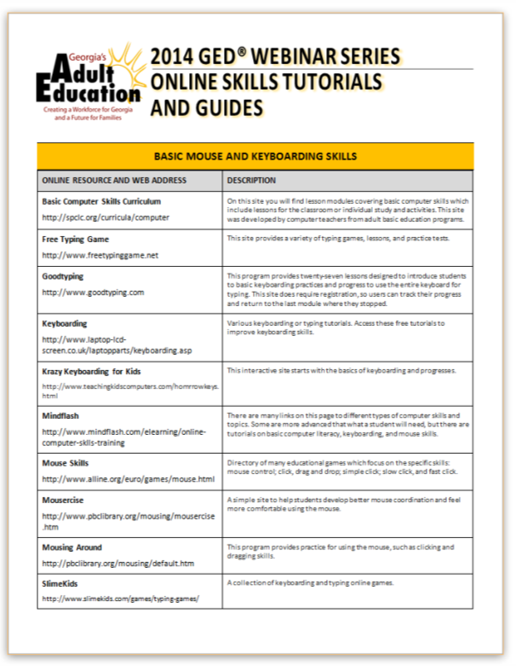
Google: typing web or www.typingweb.com

Technology Website Handout

