What’s Going On in This Picture?
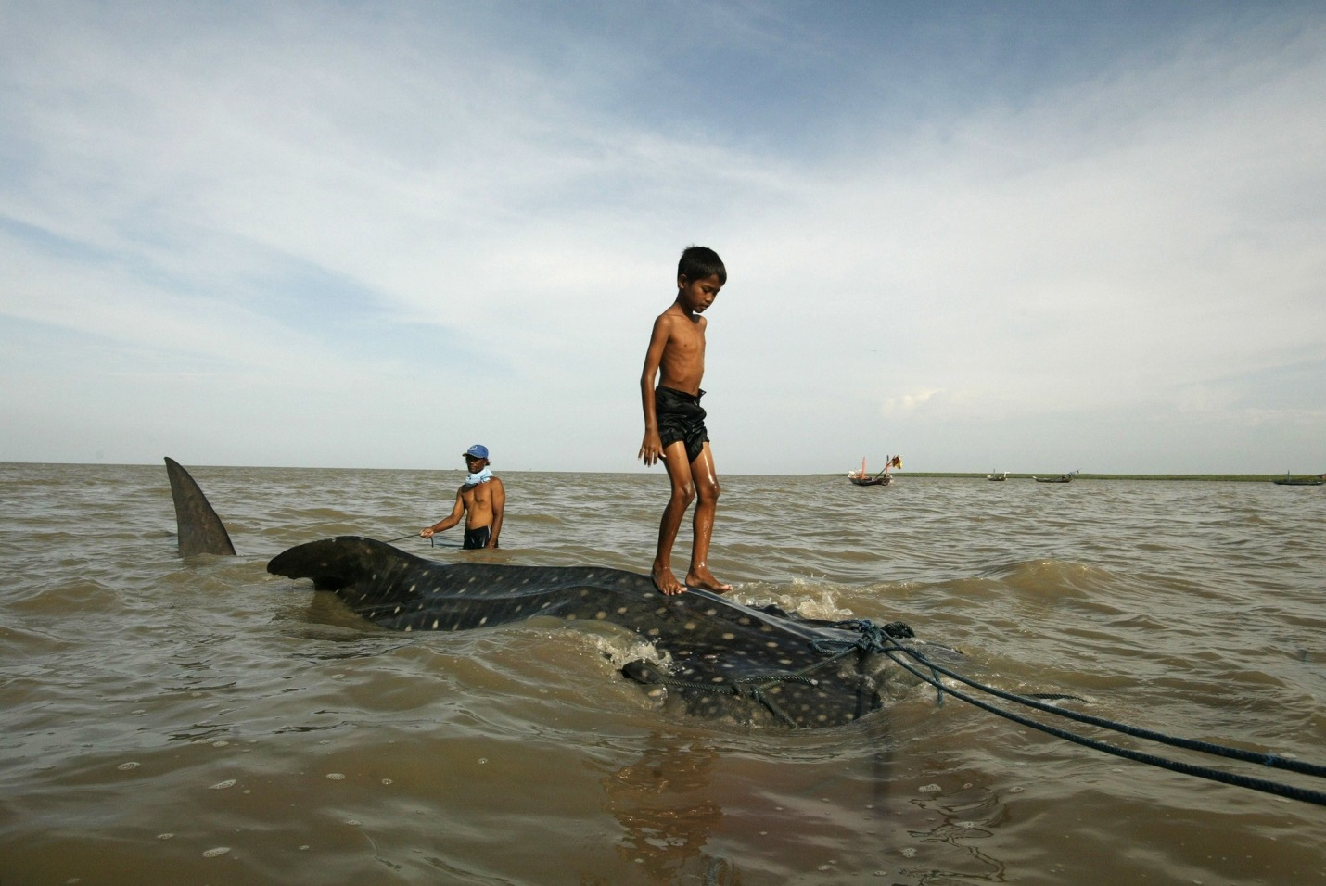

Look at the picture on the board. Answer the questions:

What’s going on in this picture? What do you see that makes you say that?

Example:

According to the picture, a young boy is standing on a whale shark in the ocean. My evidence to support this claim is that the child is small and has on only shorts, so he must be a young male, and the creature is large with spots that look like a whale shark. I can conclude the whale shark is hurt, and they are bringing it out of the water to help it. Or maybe they are bringing it out of the water to be put in an aquarium for people to see. I conclude this because I see that the whale shark has ropes tied around it, so that leads me to believe that they are bringing it somewhere. They seem to have calmed the animal and have control of it. This is evident because the man behind him is holding a rope attached to the whale shark.

Your Turn!

Look at the picture on the board. Answer the questions:

What’s going on in this picture? What do you see that makes you say that?

A claim I have about this picture is that_____________________________________________
______________________________________________________________________________

The evidence I have to support my claim is that________________________________________
______________________________________________________________________________

