Chapter 4 The State We’re In Washington
1900-2000: A Century of Change
Teacher Guide

General Overview
Chapter 4: A Century of Change focuses on the significant amount of change the state of Washington experienced from 1900 to 2000. The tasks below may be implemented separately or together to guide students toward a deeper understanding of the content therein and to develop important social studies skills.

Enduring Understanding
Washington changed a great deal in many different ways in the 20th Century (culturally, economically, politically, environmentally and ecologically).

Supporting Questions
Students consider these questions - finding and using evidence to support the Enduring Understanding.
- How have labor unions impacted our state?
- How has technology impacted our state?
- What are the most significant changes that our state has encountered?
- Can Washington balance a healthy natural environment and a successful economy in our state?
- How have human activities impacted our state over time?

Learning Targets
Students will be able to…
- explain how labor unions can impact our state (E4.6-8.3).
- explain how technology can impact our state (H1.6-8.5).
- compare various changes that have happened in our state over the last 100 years to determine the significance (SSS4.6-8.1).
- use evidence to support how Washington can balance a healthy natural environment and a successful economy (SSS4.6-8.1).
- determine how humans impact the environment of our state (G2.6-8.3).

Tasks
- Launch
- Focused Notes
- Text-Dependent Questions
- Focused Inquiry

Task 1: Launch
Hooking students into the content of the chapter.
Distribute the Student handout: Launch to students.
- If students are struggling with question 1 you may want to prompt them to think of how they have changed physically, emotionally, cognitively, etc.
- If students are struggling with question 2 you may want to prompt them to think of the changes to their neighborhood, city, county, or state.
- For the brainstorm activity encourage all ideas
- At the end of the launch you could collect all ideas onto an anchor chart for each class
Resource
Student Handout: Launch

Task 2: Focused Notes
Activating student thinking about the content of the entire chapter.
Distribute the Student handout: Focused Notes to students.
- As students read they will record their understanding, thinking, and questions about the content using the handout. This can be done individually or collaboratively in pairs or small groups.
Resource
Student handout: Focused Notes

Task 3: Text Dependent Questions
Engaging students in a close reading activity about specific content in the chapter.
Distribute the Student handout: Text Dependent Questions document to students.
First Read
Have the students read the section and answer the First read questions on the Text Dependent Questions document.
Second Read
Use the Second read questions below to facilitate a small or whole group discussion about the reading section. When they are done have them use the Text Dependent Questions handout to record their notes.
- What does population mean?
- What does majority mean?
- Why do you think that the author chose to use a line graph on the first graph instead of a bar graph like the second and third graphs on the page?
- Why did the creator of the two graphs on the bottom of the page choose to stop the vertical axis at different percentages (70% and 12%)?
- Why did the creator of the graph on the top part of the page choose to use several different colors on the people icons in the graph?
- Analyze the two graphs at the bottom of the page. Why do you think they were included on this page?
Post read
After students have done a first and second read of the page, use the following questions to facilitate a class discussion. Have students address:
- Why do you think that the author included a paragraph of text at the top of the page?
- Use the following links to graphs below to answer the question: Is the growth of different racial or ethnic groups in Washington similar to the growth projected for the whole nation? Why might this be?
  - Hispanic population growth has leveled off since the Great Recession
  - Percentage distribution of population in the United States in 2015 and 2060, by race and Hispanic origin
- Based on the information from the text and graphs on page 57, what racial or ethnic group is likely to be the largest in Washington in 2025?

Teacher note: You may want to use some or all the Second read or Post read questions. The purpose of the Text Dependent Question activity is to have students do multiple close reads of the text leading to discussion that engages all students. Therefore, you may need to add reading strategies that meet the needs of your students.
Resource
Student Handout: Text-Dependent Questions

Task 4: Focused Inquiry
A focused inquiry is a one to two day lesson that will have students engaging in the C3 Framework’s Inquiry Arc. The link below includes both teacher and student documents.
Compelling Question
Why were German-Americans and Italian-Americans not relocated and incarcerated like Japanese-Americans were?
Resource
Focused Inquiry
Except where otherwise noted, this work is available under a Creative Commons Attribution License.

Chapter 4 The State We’re In Washington
1900-2000: A Century of Change

Student Launch
Quick write
For each of the questions write down all your ideas. Be prepared to share with a partner or in a group.
- How have you changed in the past two years?

Notes from your partner(s)

- How has where you live changed in the past ten years?

Notes from your partner(s):

Brainstorm list with partner(s)
In groups write down all ideas. Be prepared to share out.
How do you think the area you live in now has changed in the past 100 years? What are your informed guesses?

How might it change in the next 100 years? What are your predictions?

Except where otherwise noted, this work is available under a Creative Commons Attribution License.
Chapter 4 The State We’re In Washington
1900-2000: A Century of Change

Student Handout: Focused Notes

Section 1: Economic Change (pps. 53-55)
Topic | Summary of information  (bullet points) | Important or interesting quote | Questions you have
The Census
Life in Washington in 1900
Life in Washington at the end of the 20th Century
Who invented the weekend?

Section 2: Change in Washington’s natural resources (pgs. 55-60)
Topic | Summary of information  (bullet points) | Important or interesting quote | Questions you have
Dams
Logging
The automobile
Preserving and restoring the health of the natural world
Saving wild salmon
Who made your shoes?

Section 3: Change in relationships between tribal and state/local governments (pgs. 60-65)
Topic | Summary of information  (bullet points) | Important or interesting quote | Questions you have
The Dawes Act
Japanese Internment
Indian Boarding Schools
The Bureau of Indian Affairs
Indian Reorganization Act
Termination Policy and the Indian Self-Determination Act

Section 3: Change in relationships between tribal and state/local governments (pgs. 60-65)
Topic | Summary of information  (bullet points) | Important or interesting quote | Questions you have
The Dawes Act
Japanese Internment
Indian Boarding Schools
The Bureau of Indian Affairs
Indian Reorganization Act
Termination Policy and the Indian Self-Determination Act

Section 4: The changing challenges of government (pgs. 65-66)
Topic | Summary of information  (bullet points) | Important or interesting quote | Questions you have
How Washington changed in the 20th Century
Science and Technology

Except where otherwise noted, this work is available under a Creative Commons Attribution License.
Chapter 4 The State We’re In Washington
1900-2000: A Century of Change

Text-Dependent Questions

Text Dependent Questions for Washington’s Changing Population
Students could do these questions independently but using these questions to facilitate discussion will turn the reading into a public construction of learning.
First read: After you do a first read of the text and graphs on page 57, answer the following questions.
- What does the vertical dotted line on the line graph mean?
- What does the line graph attempt to communicate?
- Approximately how many people lived in Washington in 1990?
- What do the two bar graphs at the bottom of the page show?
- What percent of Washington’s population is Hispanic or Latino?

Notes from Second read group discussion

Notes from Post read discussion

Except where otherwise noted, this work is available under a Creative Commons Attribution License

Why were German-Americans and Italian-Americans not relocated and incarcerated like Japanese-Americans were?

Focused Inquiry
In this focused inquiry, students investigate the question Why were German-Americans and Italian-Americans not relocated and incarcerated like Japanese-Americans were during World War II? Students engage in the analysis of multiple sources to determine an answer to the question. Students will develop an argument that includes a claim, evidence, and reason that address the compelling question of this inquiry.

Standards
- SSS1.6-8.1 Analyze positions and evidence supporting an issue or an event.
- SSS1.6-8.2 Evaluate the logic of reasons for a position on an issue or event.
- SSS4.6-8.1 Analyze multiple factors, make generalizations, and interpret sources to formulate a thesis in a paper or presentation, while observing rules related to plagiarism and copyright.
- C3.6-8.3 Identify that according to the United States Constitution, treaties are “the supreme law of the land”; consequently, treaty rights supersede most state laws.
- C4.6-8.2 Describe the relationship between the actions of people in Washington State and the ideals outlined in the Washington State constitution.

Learning Goals
- Students will be able to properly cite and use evidence from a source to support a claim.
- Students will be able to explain a reason for the incarceration of Japanese-Americans during World War II.
- Students will develop a claim with evidence and reasoning to answer the compelling question.

Compelling Question
Why were German-Americans and Italian-Americans not relocated and incarcerated like Japanese-Americans were?

Staging the Question:
- Have students do a quick-write about a time they (or someone they know) was accused of something they did not do but they had no way of proving it.
- Have students share how they felt being wrongly accused.
- Explain that something similar happened to Japanese-Americans during World War II.
- Watch the video Looking Like the Enemy to build background knowledge about the issue and history of Japanese-American incarceration during World War II. During the video, students should look and listen for reasons Japanese-Americans were targeted for removal from the west coast and imprisonment.

Formative Performance Task:
- Use the analysis organizer (Appendix A) to hold thinking about the four sources in the Appendix B.
- Answer the supporting question: “What is a common idea, tone and/or message evident in the four sources?”
Notes to teacher:
There may be a need to activate and build general background knowledge before having students engage with the sources in Appendix B.
Page 61 of Chapter 4 of The State We’re In: Washington has a sidebar on Japanese internment but it is best read after engaging with this focused inquiry as it may rob students of the opportunity to think about the compelling question without prejudice.
The images present views that may be hurtful and/or offensive so it is important to be able to address this depending on the nature of the environment and culture of the classroom.

Featured Source(s):
- Japs Keep Moving - This is a White Man's Neighborhood, photograph from 1920s California
- No Japs in Our Schools, meeting poster from 1906
- Warning Our Homes are in Danger Now!, propaganda poster from 1942
- Hold, campaign poster from 1920

Argument:
Students analyze various visual sources to answer the question, Why were German-Americans and Italian-Americans not relocated and incarcerated like Japanese-Americans were? Responses should include a claim, evidence, and reasoning and cite specific information from sources.

Taking Informed Action:
Students will write to a state legislator inquiring about efforts in the state to ensure the liberties of groups of people are not lost in times of crisis. Use article I of the Constitution of the State of Washington (pg. 5) to identify rights that were violated by Japanese-American incarceration.

Except where otherwise noted, this work is available under a Creative Commons Attribution License. All logos and trademarks are property of their respective owners. Sections used under fair use doctrine (17 U.S.C. § 107) are marked.

Appendix A: Analysis Organizer
Source | Primary Audience  Who do you think is supposed to see this? | Author  Anything you can guess about the creator of the work presented? | Idea, Tone, Message  What do you think the work is trying to communicate?
Document A:
Japs Keep Moving - This is a White Man's Neighborhood, Photograph of sign from 1920s
Document B:
No Japs in Our Schools Meeting poster from 1906
Document C:
Warning Our Homes are in Danger Now! Propaganda poster from 1942
Document D:
Hold
Campaign poster from 1920

Appendix B

DOCUMENT A: Japs Keep Moving - This is a White Man's Neighborhood
From the National Japanese American Historical Society, circa 1920
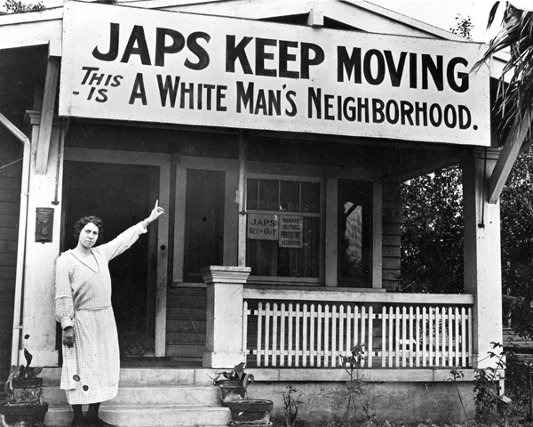
A member of the Hollywood Protective Association pointing to a sign in her neighborhood in southern California in the 1920s.
Attribution
Japs Keep Moving - This Is a White Man's Neighborhood. National Museum of American History, Smithsonian – A More Perfect Union: Japanese Americans and the U.S. Constitution, 29 May 2018, amhistory.si.edu/perfectunion/collection/image.asp?ID=411. Copyright National Japanese American Historical Society. Image used pursuant to fair use.

Document B: No Japs in Our Schools
From the Bancroft Library, University of California, Berkeley, December 10, 1906
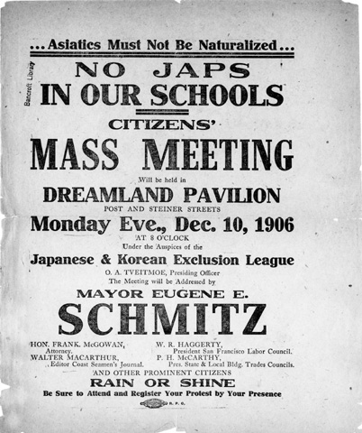
An informational poster about an upcoming community meeting.
Attribution
No Japs in Our Schools. National Museum of American History, Smithsonian – A More Perfect Union: Japanese Americans and the U.S. Constitution, 29 May 2018, amhistory.si.edu/perfectunion/collection/image.asp?ID=412. Copyright Bancroft Library, University of California, Berkeley, Image used pursuant to fair use.

Document C: Warning Our Homes are in Danger Now!
From the General Motors Corporation, 1942
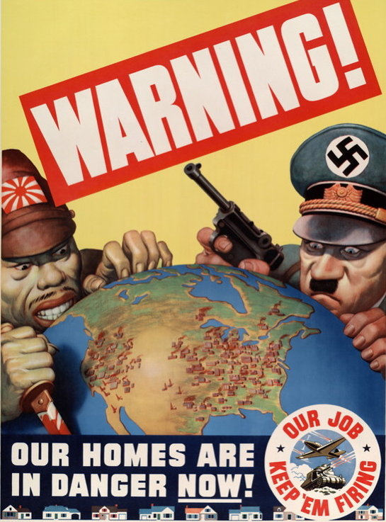
Attribution
Warning! Our Homes Are in Danger Now! poster, General Motors Corporation, 1942, National Archives, Powers of Persuasion, http://www.archives.gov/exhibits/powers_of_persuasion/warning/images_html/our_homes_in_danger.html. Image used pursuant to fair use.

Document D: Hold
From Little Tokyo, 100 Years in Pictures, 1920
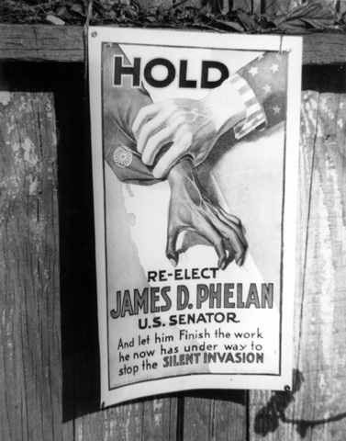
In 1919, approaching the end of his term as U.S. senator, James D. Phelan launched a new anti-Japanese campaign. He contended that the Japanese were a menace to America economically, socially and militarily.
Attribution
Anti-Japanese Campaign Poster, 1925. National Museum of American History, Smithsonian – A More Perfect Union: Japanese Americans and the U.S. Constitution, 29 May 2018, amhistory.si.edu/perfectunion/collection/image.asp?ID=741. From the book, Little Tokyo, 100 Years in Pictures by Ichiro Mike Murase. Image used pursuant to fair use.

