Focused Inquiry Analysis Organizer
Why were German-Americans and Italian-Americans not relocated and incarcerated like Japanese-Americans were?
Source | Primary Audience  Who do you think is supposed to see this? | Author  Anything you can guess about the creator of the work presented? | Idea, Tone, Message  What do you think the work is trying to communicate?
Document A:
Japs Keep Moving - This is a White Man's Neighborhood, Photograph of sign from 1920s
Document B:
No Japs in Our Schools Meeting poster from 1906
Document C:
Warning Our Homes are in Danger Now! Propaganda poster from 1942
Document D:
Hold
Campaign poster from 1920

DOCUMENT A: Japs Keep Moving - This is a White Man's Neighborhood
From the National Japanese American Historical Society, circa 1920
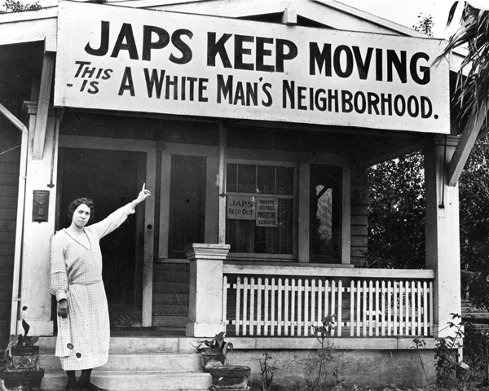
A member of the Hollywood Protective Association pointing to a sign in her neighborhood in southern California in the 1920s.
Attribution
Japs Keep Moving - This Is a White Man's Neighborhood. National Museum of American History, Smithsonian – A More Perfect Union: Japanese Americans and the U.S. Constitution, 29 May 2018, amhistory.si.edu/perfectunion/collection/image.asp?ID=411. Copyright National Japanese American Historical Society. Image used pursuant to fair use.

Document B: No Japs in Our Schools
From the Bancroft Library, University of California, Berkeley, December 10, 1906
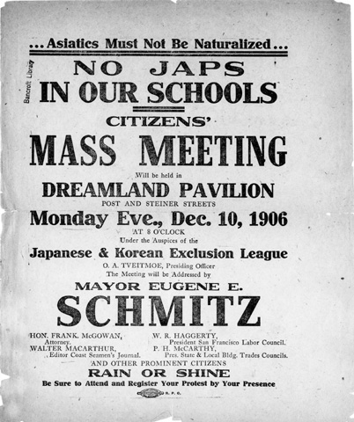
An informational poster about an upcoming community meeting.
Attribution
No Japs in Our Schools. National Museum of American History, Smithsonian – A More Perfect Union: Japanese Americans and the U.S. Constitution, 29 May 2018, amhistory.si.edu/perfectunion/collection/image.asp?ID=412. Copyright Bancroft Library, University of California, Berkeley, Image used pursuant to fair use.

Document C: Warning Our Homes are in Danger Now!
From the General Motors Corporation, 1942
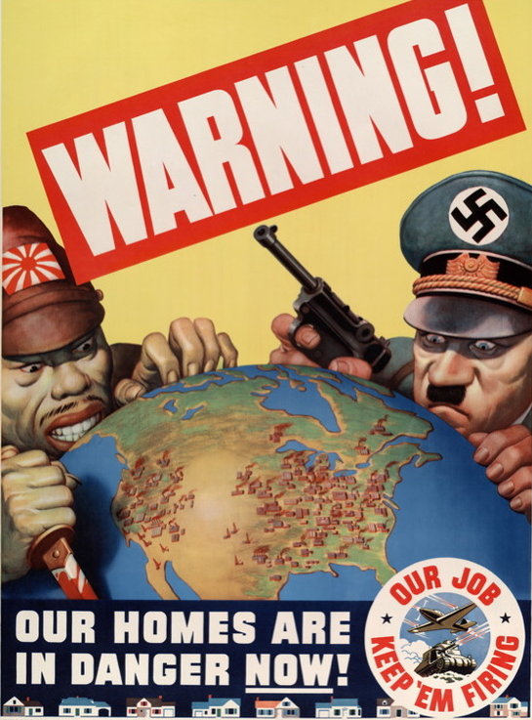
Attribution
Warning! Our Homes Are in Danger Now! poster, General Motors Corporation, 1942, National Archives, Powers of Persuasion, http://www.archives.gov/exhibits/powers_of_persuasion/warning/images_html/our_homes_in_danger.html. Image used pursuant to fair use.

Document D: Hold
From Little Tokyo, 100 Years in Pictures, 1920
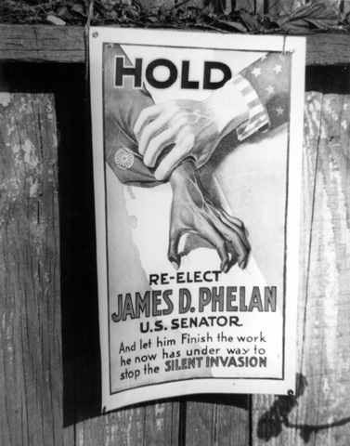
In 1919, approaching the end of his term as U.S. senator, James D. Phelan launched a new anti-Japanese campaign. He contended that the Japanese were a menace to America economically, socially and militarily.
Attribution
Anti-Japanese Campaign Poster, 1925. National Museum of American History, Smithsonian – A More Perfect Union: Japanese Americans and the U.S. Constitution, 29 May 2018, amhistory.si.edu/perfectunion/collection/image.asp?ID=741. From the book, Little Tokyo, 100 Years in Pictures by Ichiro Mike Murase. Image used pursuant to fair use.
Except where otherwise noted, this work is available under a Creative Commons Attribution License. All logos and trademarks are property of their respective owners. Sections used under fair use doctrine (17 U.S.C. § 107) are marked herwise noted, this work is available under a Creative Commons Attribution License.

