**1952:** open positions at the all-black West Area Computing section at the National Advisory Committee for Aeronautics’ (NACA’s) Langley laboratory, headed by fellow West Virginian Dorothy Vaughan. Katherine and her husband, James Goble, decided to move the family to Newport News to pursue the opportunity.

**1939:** She decided to leave school to start a family with her husband.

**1918:** Born in White Sulphur Springs, West Virginia

**1937:** Graduated with highest honors in 1937 and took a job teaching at a black public school in Virginia**.**

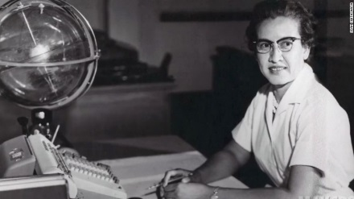

**Age of eighteen**: she enrolled in the college itself, where she made quick work of the school’s math curriculum and found a mentor in math professor W. W. Schieffelin Claytor, the third African American to earn a PhD in Mathematics.

KATHERINE JOHNSON TIMELINE

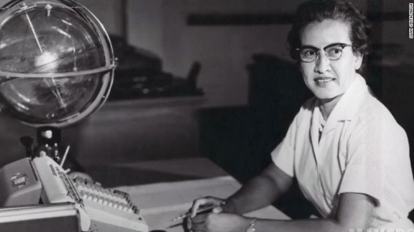

**1961:** did trajectory analysis for Alan Shepard’s May 1961 mission Freedom 7, America’s first human spaceflight.

**1960:** wrote a report laying out the equations describing an orbital spaceflight in which the landing position of the spacecraft is specified. It was the first time a woman in the Flight Research Division had received credit as an author of a research report.

**1957:** Katherine provided some of the math for the 1958 document Notes on Space Technology, a compendium of a **series** of 1958 lectures given by engineers in the Flight ResearchDivision and the Pilotless AircraftResearch Division (PARD).

**1956**: Her husband died of cancer in December

**1959:** Katherine began to work at Langley in the summer

KATHERINE JOHNSON TIMELINE

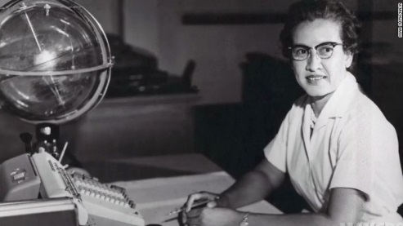

**1986:** She retired, after thirty-three years at Langley.

KATHERINE JOHNSON TIMELINE

**2016:** She was portrayed by Taraji P. Henson as a lead character in the film Hidden Figures.

**2015:** Katherine Johnson added another extraordinary achievement to her long list: President Obama awarded her the Presidential Medal of Freedom, America’s highest civilian honor. **Katherine Johnson added another extraordinary achievement to her long list: President Obama awarded her the Presidential Medal of Freedom, America’s highest civilian honor.**

Did the calculations that helped synch Project Apollo’s Lunar Lander with the moon-orbiting Command and Service Module. She also worked on the Space Shuttle and the Earth Resources Satellite, and authored or coauthored 26 research reports.

**1962:** as NASA prepared for the orbital mission of John Glenn, Katherine Johnson was called upon to do the math work.

**1956**: Her husband died of cancer in December