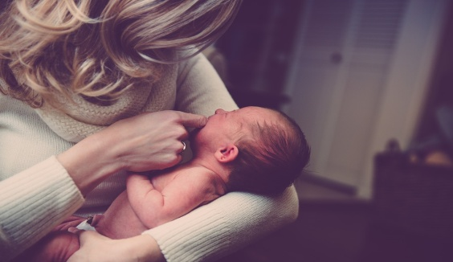 |  | WAS BORN
 | BORN
HE WAS BORN IN 1960. |  | DIED

 |  |  |  | DIED
 |  | DIE
SHE DIED IN 1990. |  |  |  | LIVE
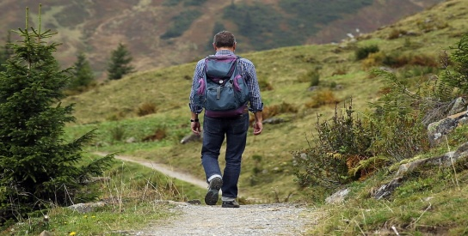 |  |  | WENT
 | GO
SHE WENT TO AUSTRALIA. |  |  | COME BACK

 |  | WROTE
 | WRITE
HE WROTE A BOOK ABOUT HIS STORY IN 2009. |  | ERASE

 |  | STARTED
 | START
HE STARTED A NEW BUSINESS IN 2011. |  | FINISH

 |  | BECAME
 | BECOME
SHE BECAME A DOCTOR IN 1980. |  | REMAIN

 |  | DECIDED
 | DECIDE
SHE DECIDED TO STAY IN TOWN TODAY. |  | HESITATE

 |  | PUBLISHED
 | PUBLISH
HE PUBLISHED A NEW WORK LAST YEAR. |  | SUPPRESSED

 |  | CAPTURED
 | CAPTURE
THE POLICE CAPTURED THE THIEF YESTERDAY. |  | RELEASED

