SCHOOL
Name: ______________________________Number:___ Class: ____

- Match.

medium height
short
slim
fat
thin
tall
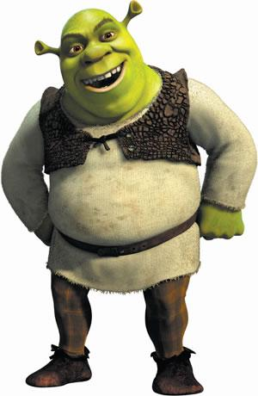

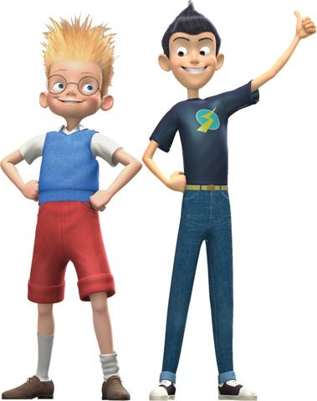

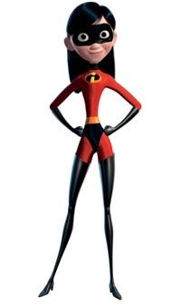

- Write sentences about the pictures.

- Shrek is______________ b) They____________________ c) She_____________
and __________________. __________________________ _________________

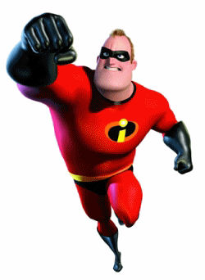
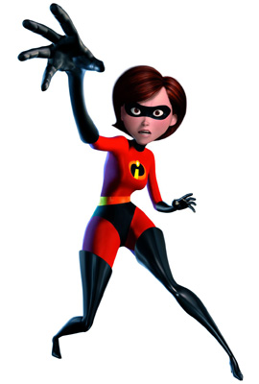
3. Match
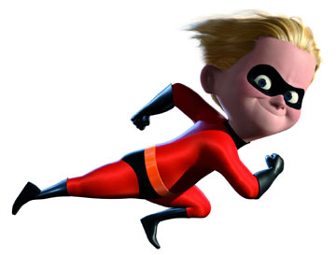

4.
3.
2.
1.
She is short and thin.
She is medium height and thin.
He is short and slim.
He is tall and fat.

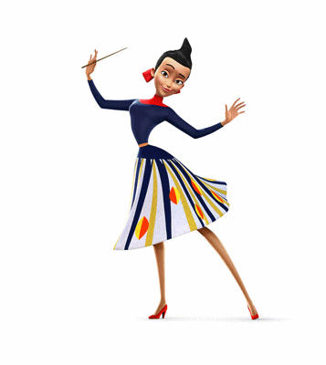
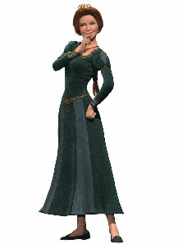
4. Describe the pictures.
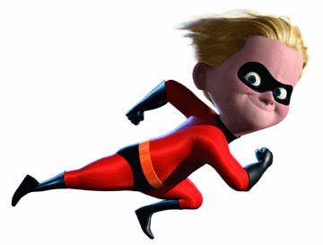

- __________________ b) ____________________ c) ____________________
and _________________. and __________________ and___________________

5. Ask and answer.
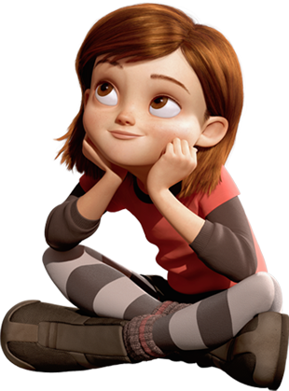

  - Is she fat? b) Are they short? c) Is he medium height?
_________________ _________________ _________________
_________________ _________________ __________________

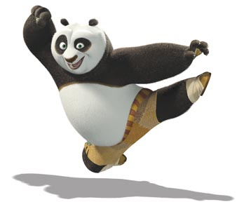

- Is he short? e) Is she slim? f) Is he thin?

_________________ _________________ _____________________
______________________ _____________________ __________________________

- Colour the pictures.
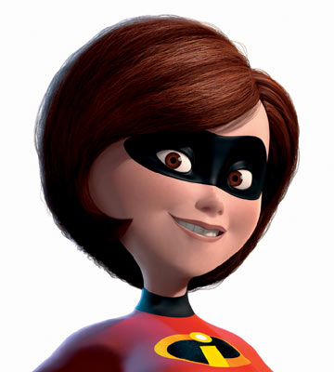
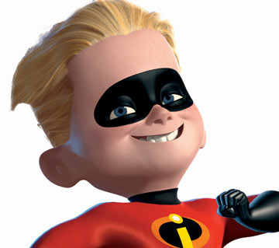
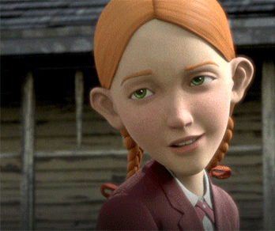

- Blue eyes b) brown eyes c) green eyes
blond hair brown hair red hair

- Complete the sentences.

- He _____ _____ b) She ______ _____ c) ______ has got
_______ hair and _____ eyes . _______ hair and ______ eyes. green ______ and red ______.

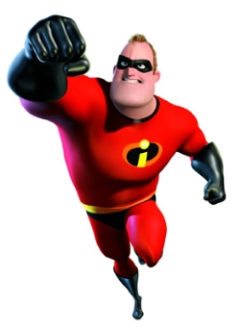
- Match.

She is medium height and thin. She has got brown hair and brown eyes.
2.
3.
1.
He is tall and fat. He has got blond hair and green eyes.
He is short and slim. He has got blond hair and blue eyes.

