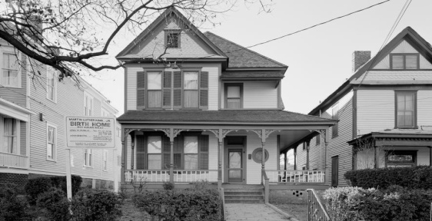 | 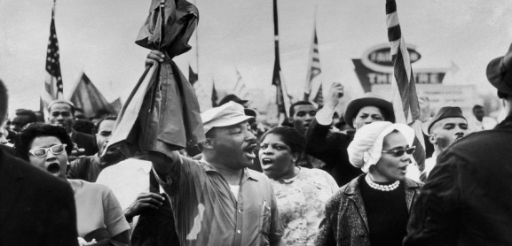
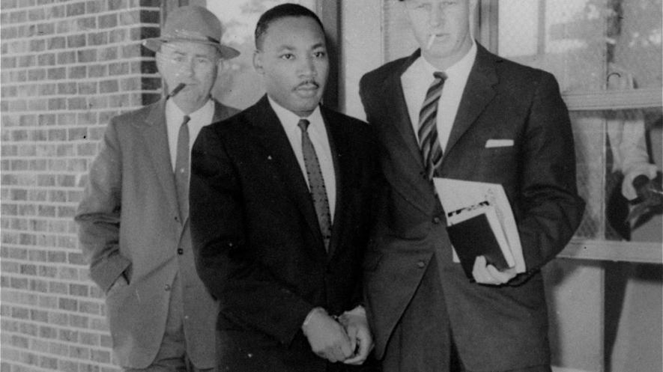 | 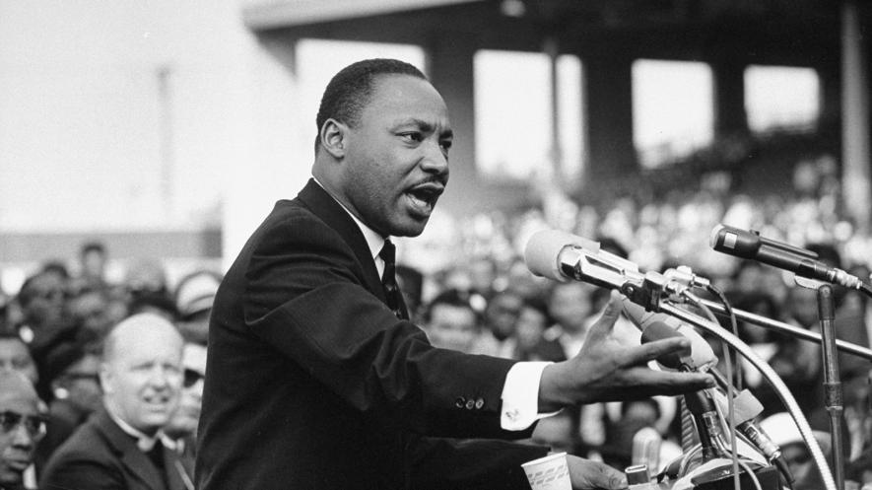
https://kids.nationalgeographic.com/explore/history/martin-luther-king-jr/

- SPEAKING OUT
- BRAVE SACRIFICES
- A HERO IS BORN
- MARCHING FORWARD

https://kids.nationalgeographic.com/explore/history/martin-luther-king-jr/

- SPEAKING OUT
- BRAVE SACRIFICES
- A HERO IS BORN
- MARCHING FORWARD

