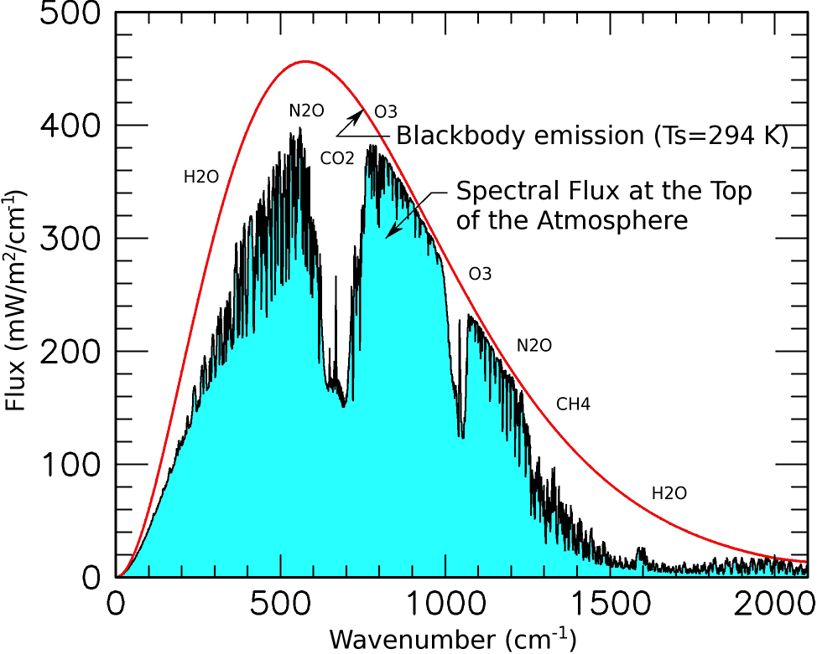
Black Body Curve from NASA Goddard Institute for Space Studies
https://www.giss.nasa.gov/research/briefs/schmidt_05/

