1) y = x - 4  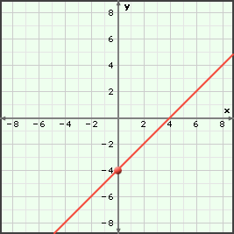  Domain:  Range:  # of X-Intercepts:  # of Turning Points (max/min):  End Behavior: | 2) y = -x² + 4x + 1  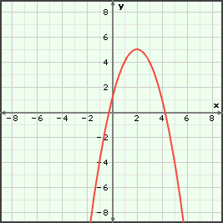  Domain:  Range:  # of X-Intercepts:  # of Turning Points (max/min):  End Behavior:
3) y = –2x + 6  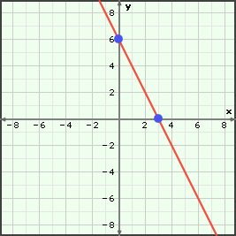  Domain:  Range:  # of X-Intercepts:  # of Turning Points (max/min):  End Behavior: | 4) y = x³ – 2x² – 5x + 6  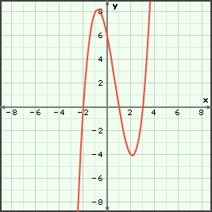  Domain:  Range:  # of X-Intercepts:  # of Turning Points (max/min):  End Behavior:
5) y = –2.9x⁴ + 5x³ + 1.6x² – 3.5x – 0.2  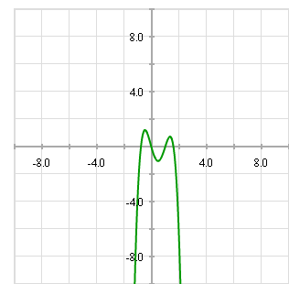  Domain:  Range:  # of X-Intercepts:  # of Turning Points (max/min):  End Behavior: | 6) y = 2x² + 7x – 1  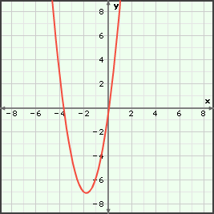  Domain:  Range:  # of X-Intercepts:  # of Turning Points (max/min):  End Behavior:
7) y = -x³ + 4x  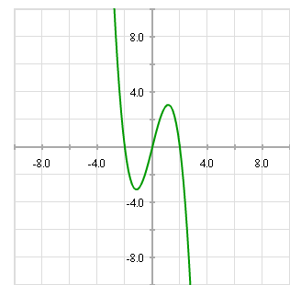  Domain:  Range:  # of X-Intercepts:  # of Turning Points (max/min):  End Behavior: | 8) y = -x + 1  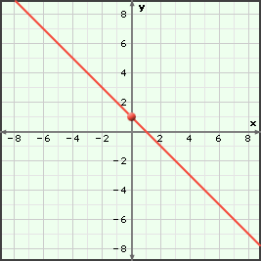  Domain:  Range:  # of X-Intercepts:  # of Turning Points (max/min):  End Behavior:
9) y = -2x² + 6x - 1  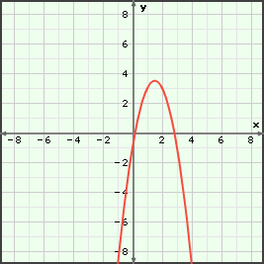  Domain:  Range:  # of X-Intercepts:  # of Turning Points (max/min):  End Behavior: | 10) y = x⁴ – 5x³ + 5x² + 5x – 6 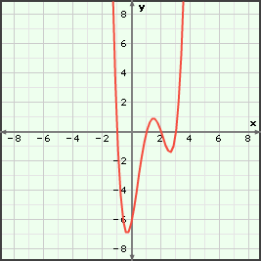  Domain:  Range:  # of X-Intercepts:  # of Turning Points (max/min):  End Behavior:
11) y = -2.6x⁴ + 5.1x³ + 4.4x² – 6.1x – 0.2  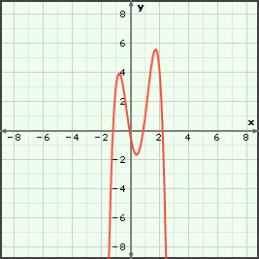  Domain:  Range:  # of X-Intercepts:  # of Turning Points (max/min):  End Behavior: | 12) y = -0.5x³ – 2.7x² – 0.8x + 1.0  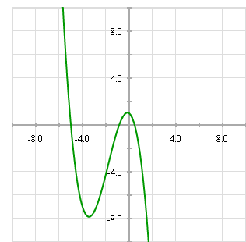  Domain:  Range:  # of X-Intercepts:  # of Turning Points (max/min):  End Behavior:

