What do a table, tripod, and house all have in common?

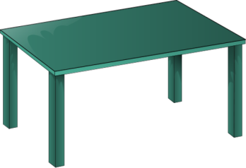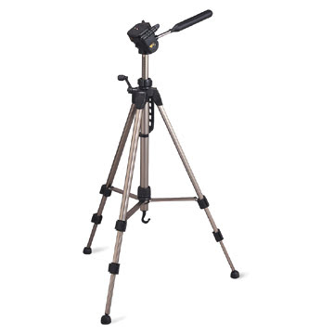C:\Program Files (x86)\Microsoft Office\MEDIA\CAGCAT10\j0185604.wmf

They all have supporting structures which hold them up!

**Supporting details** are examples of proof that hold up the **theme**, or main idea, of a writing.

You can identify the theme of a story or passage by determining what major topic is being addressed in what you are reading. Supporting details can include examples of the author’s point, reasons the author gives to back up their point, or proof that the point the author is trying to make is valid.

It is important to be able to identify the theme of something you are reading so that you can know, understand, and obtain information from what you read. Supporting details play a big role in making the author’s point valid and believable; and they allow you to discern the strength of an author’s argument.

What is the theme of the paragraphs above?

What supporting details help to get across the p oint of the theme?