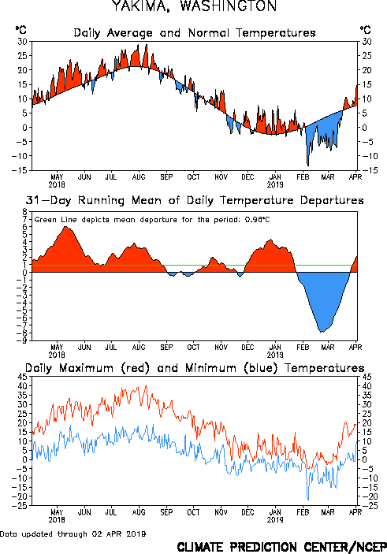
NOAA/ National Weather Service
NOAA Center for Weather and Climate Prediction
Climate Prediction Center
5830 University Research Court
College Park, Maryland 20740
Page Author: Climate Prediction Center Internet Team
Page last modified: Feb 26 2019

