Prison Escape

You are expected to participate in a team activity – ‘Prison escape’ for Assignment 1.
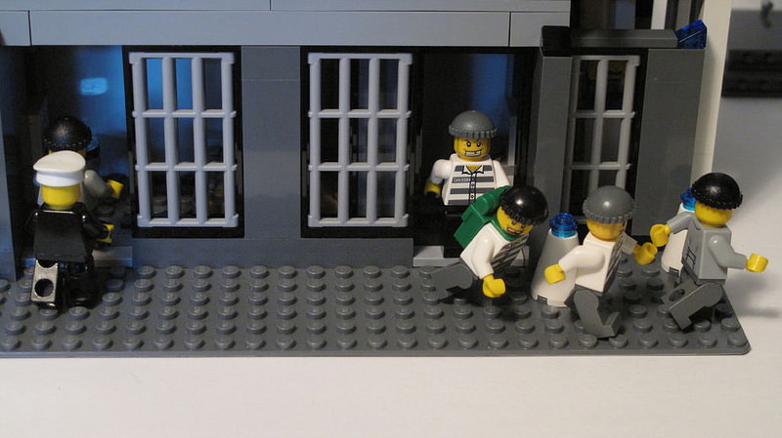

"Lego Police Station" (CC BY 2.0) by Shadowman39

Team activity - Prison escape commences in the beginning of Week 3 and ends at the end of Week 5. Your Reflective report for team activity is due on 18 April 2019.

Background information
Press Ctrl+Click above to reveal the background information of Prison Escape

Several groups of prisoners have escaped from a high-security prison this morning. They are believed to be using different types of transportation travelling to different directions.
As a police officer you will be joining other officers to catch all prisoner groups within the required time limit (please see the section of 'Important messages' in this document for further information regarding the required time limit).

Instructions and objectives

"Where did he go?" (CC BY-NC-ND 2.0) by stavos
Each group in this exercise will be assigned one of two roles - police officers, and escaped prisoners. The roles have different objectives and will use information to support these.
For police officers, your objective is to catch all the prisoners within the required time limit. The police officers achieve their objective if all escaped prisoner groups are caught before their time limit is up.
For escaped prisoners, your objective is to avoid being caught.
Please see the 'Important Messages' section for the parameters of the activity, and an example of how the turn sequences will be coordinated.

Grouping instructions

"Lego: Police Officer & Dog Handler" (CC BY 2.0) by lydia_shiningbrightly
- Your Course Examiner will assign you into a group (either a prisoner or police group).
- You need to use your delegated Moodle discussion forum to communicate with your fellow group members regarding your decisions. No communication is available between groups (e.g. from one police group to another police group). Communications between groups will have to be done through the Course Examiner.
- There are several groups of prisoners and each group contains 6-10 people.
- The rest will be grouped as police officers and each police officer group contains 6-10 people.

- Your course examiner will provide further information regarding grouping in the Moodle discussion forum. Please check your discussion Moodle forum regularly.

Important messages

Prison escape commences in Week 3 and ends in Week 5. Your Course Examiner will randomly assign each group a location (node) to start on. From this node, you and your group will need to discuss and vote on which node to move to next. The locations of the police groups will be disclosed to everyone by your Course Examiner via the Moodle discussion forum. The locations of the prisoner groups are hidden (unless at certain rounds). A prisoner group could possibly be surrounded by police groups at the beginning of the exercise. However, as their location is hidden they could well get away using different types of transportation. There are 10 rounds in 3 weeks (required time limit) to catch all the prisoners. This means each group will have to make decisions:

three times in the first week (at or before 11:55pm AEST on Monday, Wednesday and Friday of Week 3),

three times in the second week (at or before 11:55pm AEST on Monday, Wednesday and Friday of Week 4) and

four times in the last week (at or before 11:55pm AEST on Monday, Wednesday, Thursday and Friday of Week 5) for the team activity.

Each group can use a virtual map to visualise where their own group is as well as the other groups. The map will look like the one shown next page:

Each group is a team and thus all members in one group will travel together. No member in any group can travel alone.

The decisions you are required to make each week include which type of resource (i.e. the type of transportation) you will be using and which node (e.g. from AA to AB) you will be travelling to. You, as a group, are allowed to travel to more than one location (e.g. from AA to AB, then to AC). However, this will cost you more than one set of resources (e.g. 2 x Car). The maximum travel in each round for one group is two steps (e.g. from AA to AC). Please see 'Resources' below to see what resources are available to your group. Please note that once you have used up your resources you will not be able to travel any further. You are therefore advised that you should use your resources and make use of your knowledge to make decisions wisely.

The locations of the prisoner groups are hidden. They will ONLY reveal where they are at the certain rounds. Your course examiner will inform you when the prisoner groups’ locations are revealed. The reveal of the prisoners’ locations gives the police force an opportunity to collect information and re-plan what they need to do for the subsequent rounds. The police force will need to show where they are to everyone (both police and prisoner groups) at all times.

A prisoner group is considered to be caught when both a police group and a prisoner group land on the same node on the map (e.g. both a police car and a prisoner stolen car have travelled into the same location of BG). Please note that a prisoner group is ONLY considered to be caught when the prisoner group has first landed on a node, then a police group land on that same node in the same round.
Car
Police
Example

Resources
Taxis x 15
Taxi
Prisoners
Police
Bus
Buses x 10
Police
Squad cars x 8
Car
Stolen cars x 10
Helicopter
Helicopter x 1
Trains x 5
Train
Trains x 3
Train

"Statistically Correct Criminal"
(CC BY-NC-ND 2.0) by bheathr
"Policeman 71000 Lego Minifigures
Series" (CC BY-NC-ND 2.0)
by brickdisplaycase.com

How to make a decision on where to travel on the map?

To make a decision on where to travel and what type of transportation to use on the map, you need to first look at the colours on the routes. Each colour represents what type of transportation that can be travelling on a particular route (see below for details):
Taxis
Taxi
Bus
Buses
Police
Squad cars
Car
Stolen cars
Trains
Train
+

Using the node of ‘BG’ as an example, buses and trains can travel through the node of ‘BG’. However, buses cannot stop at ‘BG’. Stolen cars, police cars and taxis, however, can travel through and stop at ‘BG’ (see Example 1 and 2 below for details).
Bus
Buses
Bus
Buses
Example 1

Car
Stolen cars
Car
Car
Stolen cars
Example 2

A helicopter can fly out from and land on a helicopter landing pad ONLY (‘H’). If a police group has used a helicopter, they can then use police cars to travel from the helicopter landing pad to other areas. If a police group want to use a helicopter, they will need to travel to a helicopter landing pad by police cars first and then fly out to other helicopter landing pads (see examples on the next page for details). Note: Each step will cost resource(s). A helicopter CANNOT fly in any other nodes except the helicopter landing pads.
Helicopter
Helicopter
Police
Squad cars
Example 2
Helicopter
Helicopter
Police
Squad cars
Example 1

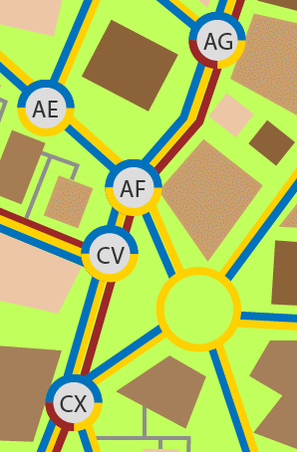
All prisoner groups’ locations are hidden (unless it is revealed at certain rounds). If a prisoner group takes, for example, a bus from AG to CX (passing through AF and CV) and a police group drives from AF to CV, the police group will NOT catch the prisoner group as the two groups only pass each other and thus this cannot be considered as the prisoner group being caught.
Police
Police
Bus
Bus

Another example: if a prisoner group uses a bus to travel from AG to CX, this is considered to be one move with one resource only as AF and CV are passing through locations. See example below as illustration:
Bus
Bus
From AG to CX using one bus

However, using police/stolen cars to travel from AG to CX will require THREE moves and thus require THREE police/stolen cars. See example below as illustration:
Police

From AG to CX using three cars
Police
Police

Police

Your Course Examiner will announce the information in your Moodle discussion forum that a prisoner group, should this happen, is caught.

The police groups achieve their objective if ALL prisoner groups are caught before the final round (i.e. Round 10).

If the police force cannot catch ALL prisoners groups before the final round ends (Round 10), the prisoners achieve their objective.

You need to use your delegated Moodle discussion forum to communicate to your fellow group members regarding your decisions. No communication is available between groups (e.g. from one police group to another police group). Communication between groups must be done through the Course Examiner. However, you should check your Moodle discussion forum regularly for any special announcement regarding the exercise.

Each round you will need to inform your Course Examiner (one decision from each group) where you are travelling to and what type of transportation you are using for each decision via your delegated Moodle discussion forum. The Course Examiner will make a decision should any dispute occur and the decision will be final.

The aims of the team activity are:

to enable you to demonstrate your understanding of the key concepts in knowledge management and the nature of knowing in a team environment

to develop your skills in presenting a balanced argument of theory and organisational practice to the reader

to encourage you to do in-depth research on the relevant topic

to develop and practise your formal report writing and referencing skills

You are expected to participate in ‘Prison escape’ for Assignment 1

There are two parts for Assignment 1:

Part 1: Reflective report (20% out of a total of 25%)
- Part 2: Peer assessment rubric (5% out of a total of 25%)

Please refer to Assessment on your Moodle discussion forum for details.
All the best

