Reading a Recipe

Read through the following recipe and answer questions 1-10 that follows.
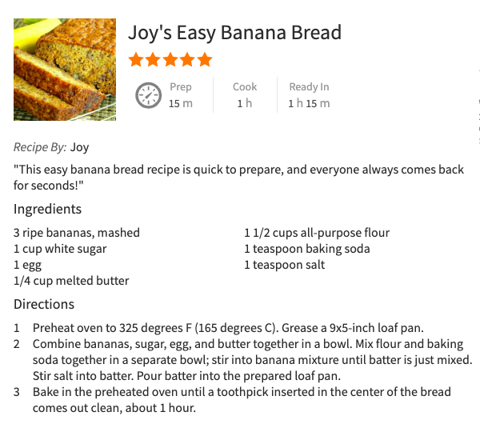
- Locate the list of ingredients and highlight all of the ingredients in yellow.
- Locate and circle each of the amounts of ingredients.
- Put a star next to the yield.
- Draw a box around the cooking temperature.
- Underline the baking time.
- After you have gotten ready for the kitchen, what is the first thing you should do when you get to your kitchen?

- How do you know if your bread is done?
- What ingredients need to be mixed together in the first bowl?
- How many people should be able to eat this loaf of bread?
- How many calories are in 1 of the 10 slices?
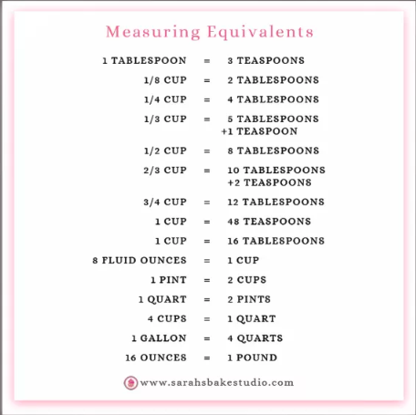
Using the table to the right, answer the following questions:

- ____ c. = 1 pt.
- ____ T. = 1 fl. oz.
- ____ oz. = 1 c.
- ____ T = 1 c.
- ____ t. = 1 T.
- ____ qt. = 1 gal.
- ____ pt. = 1 qt.
- ____ oz. = 1 lb.
- ____ c. = 1 qt.
- ____ t. = 1 c.
- ____ T. + ____ t. = 1/3 c.
12. 8 ounces = 1 _______________ 13. 3 teaspoons = 1 ___________________
14. 16 tablespoons = 1 _____________ 15. 1 pint = 2 __________________
16. 4 cups = 2 _________________ 17. 2 pints = 1 _________________
18. 4 cups = 1 _________________ 19. 4 quarts = 1 _________________
20. 1/4 c. = ____ T. 21. 1/2 c. = ____T. 22. 3/4 c. = ____ T.
23. 1/8 c. = ____ T. 24. 1/2 c. = ____ oz. 25. 3/4 c. = ____ oz.
26. 2 qt. = ____ pt. 27. 1 gal. = ____ c. 28. ______ T. = 1 gal.
29. Standard dry measuring cups come in what four sizes?
_______________, _________________, __________________, _________________

30. Standard measuring spoons come in what four sizes?
_______________, _________________, __________________, _________________
31. Measuring spoons are used when measuring less than how much? ____________
Without looking at the table below, try to write down as many abbreviations as you can remember, then with any you have left, use the chart and write down the correct abbreviations.

Tablespoon | teaspoon | cup | pint | quart | gallon | pound | degrees | Fahrenheit | Celcius | ounce | minute | hour | second | package
T. or tbsp. | tsp. | C. or c. | pt. | qt. | gal. | lb. or # | ° | F | C | oz. | min. | hr. | sec. | pkg.

1. Ounce = ______ 2. Tablespoon= ______ or ______ 3. Degrees = _____
4. Pint = ______ 5. Pound = ______ or ______ 6. Package = ______
7. Fahrenheit = ______ 8. Teaspoon = ______ 9. Cup = ______ or ______
10. Quart = ______ 11. Celcius = ______ 12. Minute = ______
13. Gallon = ______ 14. Hour = ______ 15. Second = ______
** Even if a measurement is plural, the abbreviation will always stay the same.
List the tool to properly measure the ingredient, and describe how to measure it.
Example: 1/2 t. of salt: ½ t. measuring spoon, pour salt into measuring spoon over a clean bowl, level it.

- 1/4 c. brown sugar

- 1 c. water

- 5 oz. cornstarch

- 1/3 c. butter

- 1 1/2 c. powdered sugar

- 1/4 c. peanut butter

