Identify the name of the utensil, the type of utensil (measuring, baking, mixing, thermometer, cutting, or other preparation), and describe in detail what the use(s) of the tool is.

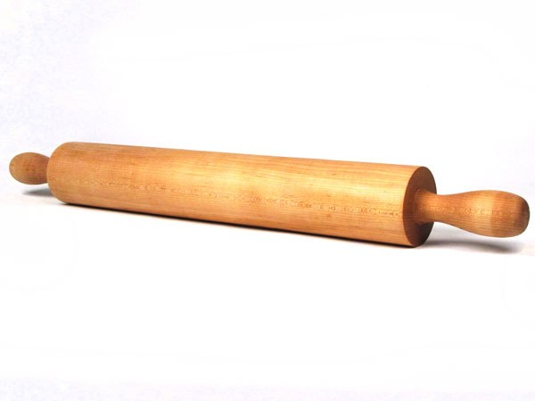
- Name:

Type:

Use:

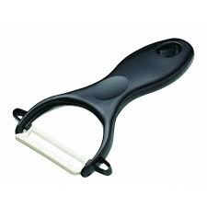

2. Name:

Type:

Use:

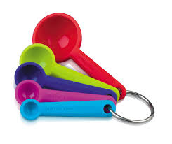

3. Name:

Type:

Use:

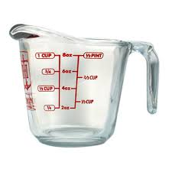

4. Name:

Type:

Use:

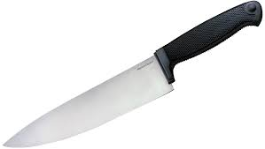
5. Name:

Type:

Use:
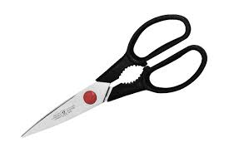

6. Name:

Type:

Use:

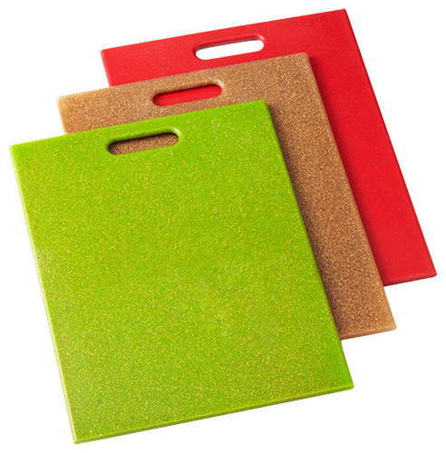

7. Name:

Type:

Use:

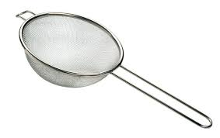
8. Name:

Type:

Use:

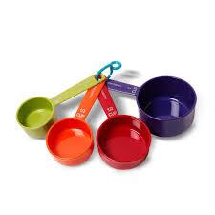

9. Name:

Type:

Use:

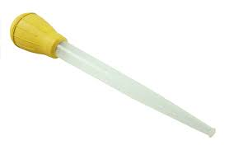
10. Name:

Type:

Use:

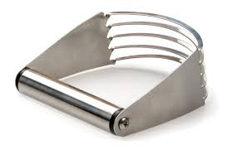

11. Name:

Type:

Use:

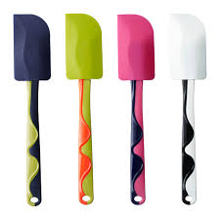

12. Name:

Type:

Use:

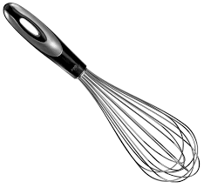

13. Name:

Type:

Use:

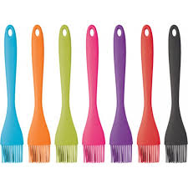

14. Name:

Type:

Use:

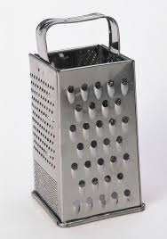

15. Name:

Type:

Use:

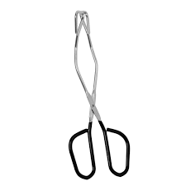

16. Name:

Type:

Use:

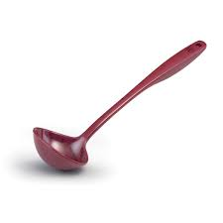

17. Name:

Type:

Use:
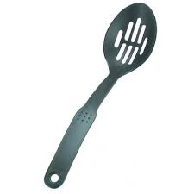

18. Name:

Type:

Use:

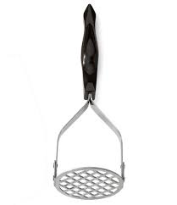

19. Name:

Type:

Use:

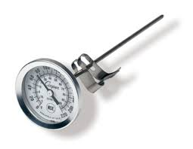

20. Name:

Type:

Use:

21. Name:
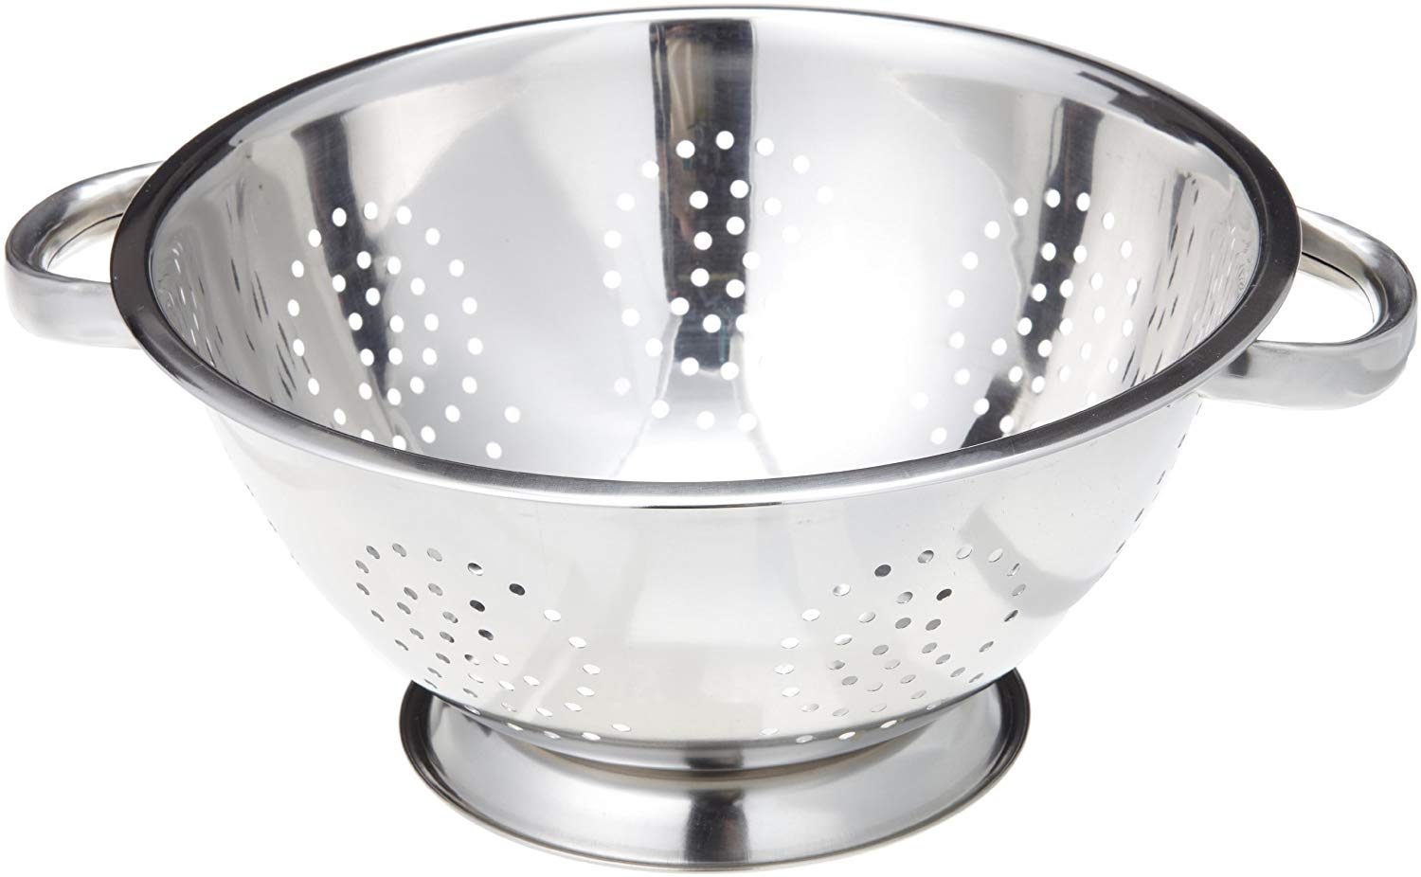
Type:

Use:

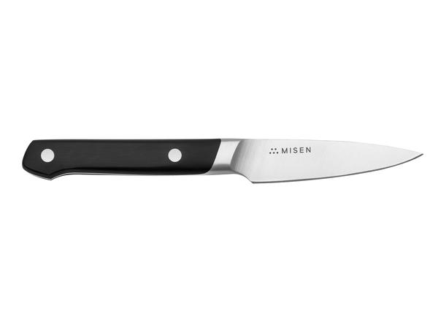
22. Name:

Type:

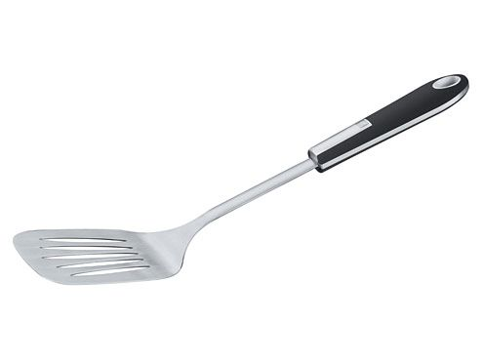
Use:

23. Name:

Type:

Use:

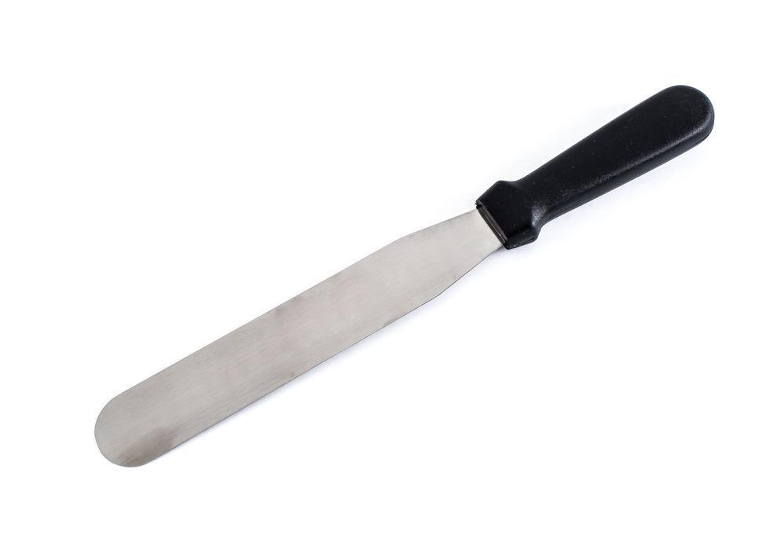

24. Name:

Type:

Use:

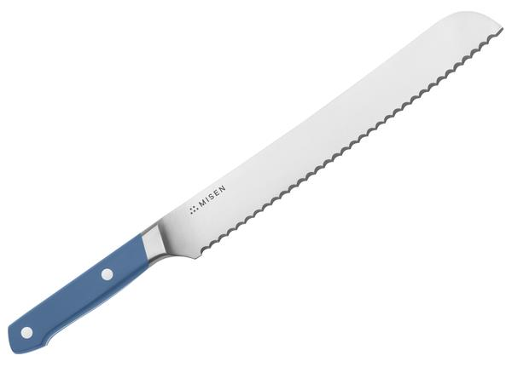

25. Name:

Type:

Use:

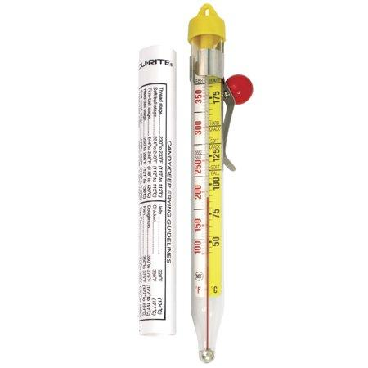
26. Name:

Type:

Use:

For the chart below, insert information on each of the material types.

Material | Pros | Cons | Picture of Cookware
1.

2.

3.

4.

5.

6.

7.

8.

9.

10.

