College Accounting
Financial Statements Quiz

Use the following information

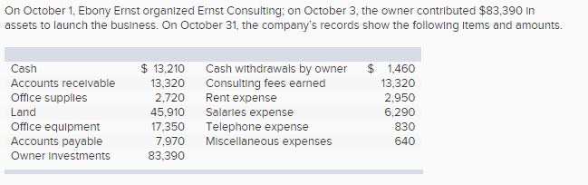

Using the above information prepare an October income statement for the business.
Using the above information prepare an October statement of owner's equity for Ernst Consulting.
Using the above information prepare an October 31 balance sheet for Ernst Consulting.

College Accounting
Financial Statements Quiz

Use the following information

Using the above information prepare an October income statement for the business.
Using the above information prepare an October statement of owner's equity for Ernst Consulting.
Using the above information prepare an October 31 balance sheet for Ernst Consulting.

College Accounting
Financial Statements Quiz

Name

