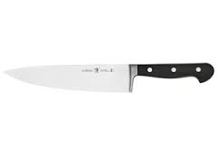
- Label the parts of the knife.

- Match the following to the correct knife:
- Chef’s Knife
- Serrated Edge Knife
- Paring Knife
- Granton/Slicing Knife
- Boning Knife
- Fillet Knife
- Chinese Cleaver
________ Cuts through crusts & tomatoes.

________ Handles are no more than 3-4” long.

________ Used in Asian cuisine.

________ Used for skinning; it is a flexible knife.

________ Used for carving meats.

________ Mostly used knife in the kitchen. Comes in 10”, 9”, or 8”.

________ Used to cut around bones, has a stiff blade.

- How do you lay your knives down when cutting food?

- Explain how to properly hold the knife and food while you are cutting.

* This DVD also goes through the different types of cuts if you want to add a section in which students have to identify each cut like the knives.
Clarissa Gillham I Hastings Public Schools I Hastings, NE

