Table of Contents
Table of Contents i
Module 1 1
Introduction 1
Lesson 1.1: Digital Technology 2
Lesson 1.1 Introduction 2
Reading: Computer 3
Reading: Technology Ecosystem 5
Lesson 1.2: Storage Media 6
Lesson 1.2 Introduction 6
Reading: Bit and Bytes 6
Reading: Digitization 8
Reading: Character Encoding 9
Reading: Binary Number System 10
Lesson 1.3: Digital Devices 11
Lesson 1.3 Introduction 11
Reading: Personal Computer (PC) 12
Reading: Mobile Devices 13
Reading: Wearables 14
Reading: Server 15
Reading: Supercomputer 16
Reading: Special-Purpose Computer 17
Module 2 19
Introduction 19
Lesson 2.1: Computer Ethics 20
Lesson 2.1 Introduction 20
Reading: Personal Computer Ethics 20
Reading: Professional Computer Ethics 21
Lesson 2.2: Government Rules and Regulations 23
Lesson 2.2 Introduction 23
Reading: Governmental Computer Ethics 23
Reading: Accessible Computing 25
Lesson 2.3: Social and Environmental Impacts 26
Lesson 2.3 Introduction 26
Reading: Green Computing 26
Reading: Digital Divide 28
Module 3 30
Introduction 30
Lesson 3.1: The Development of Computers 31
Lesson 3.1 Introduction 31
Reading: Computing History 32
Reading: Moore’s Law 34
Lesson 3.2: Processors 36
Lesson 3.2 Introduction 36
Reading: Central Processing Unit 36
Reading: Motherboard 38
Lesson 3.3: Storage Devices 39
Lesson 3.3 Introduction 39
Reading: System Storage 40
Reading: Magnetic Storage 41
Reading: Optical Storage 42
Reading: Solid-State Storage 44
Reading: Cloud Storage 45
Lesson 3.4: I/O Devices 46
Lesson 3.4 Introduction 46
Reading: Input Device 47
Reading: General-Purpose Input Device 48
Reading: Special-Purpose Input Device 49
Reading: Output Device 50
Reading: Display 51
Reading: Printer 54
Reading: 3D Printer 55
Reading: Audio and Special Media Output 57
Reading: Expansion 58
Module 4 60
Introduction 60
Lesson 4.1: Software Development 61
Lesson 4.1 Introduction 61
Reading: Computer Programming 64
Reading: Programming Languages 64
Reading: Application Programming Interface 66
Lesson 4.2: Software and Applications 68
Lesson 4.2 Introduction 68
Reading: Operating System (OS) 69
Reading: User Interface 70
Reading: File Management 71
Reading: Microsoft Windows and Windows Phone 73
Reading: Apple Mac OS and iOS 74
Reading: Google Chrome and Android 76
Reading: Linux 77
Reading: Virtual Machine Software 79
Reading: Server Operating Systems 80
Reading: Embedded Operating Systems 80
Reading: Utility Software 81
Reading: Apps – Desktop, Mobile, and Web 82
Reading: Office Suites 84
Reading: Information Apps 85
Reading: Communication Apps 86
Reading: Creativity Apps 87
Reading: Personal Information Apps 89
Reading: Entertainment Apps 90
Reading: Professional Apps 91
Lesson 4.3: The Life Cycle of Software 92
Lesson 4.3 Introduction 92
Reading: Acquiring Software 92
Reading: Software Licensing 94
Reading: Installing Software 96
Reading: Maintaining Software 97
Reading: Uninstalling Software 99
Module 5 101
Introduction 101
Lesson 5.1: The Development of Artificial Intelligence 103
Lesson 5.1 Introduction 103
Reading: AI Methodologies 103
Reading: Conventional AI 104
Reading: Expert System 105
Reading: Computational Intelligence 106
Reading: Neural Network 107
Reading: Singularity 108
Reading: Turing Test 109
Lesson 5.2: Applications of Artificial Intelligence 110
Lesson 5.2 Introduction 110
Reading: Robotics 111
Reading: Autonomous Vehicles 112
Reading: Computer Vision 114
Reading: Natural Language Processing 115
Reading: Pattern Recognition 116
Reading: Personal Digital Assistant 117
Reading: Context-Aware Computing 118
Module 6 120
Introduction 120
Lesson 6.1: Psychological Effects 121
Lesson 6.1 Introduction 121
Reading: Information Overload 121
Reading: Computer-Based Violence 122
Reading: Computer Addictions 123
Lesson 6.2: Physiological Effects 124
Lesson 6.2 Introduction 124
Reading: Distracted Driving 125
Reading: Repetitive Stress Injury 125
Lesson 6.3: Societal Changes 127
Lesson 6.3 Introduction 127
Reading: Ubiquitous Computing 127
Reading: Digital Etiquette 128
Module 7 130
Introduction 130
Lesson 7.1: Telecommunications 131
Lesson 7.1 Introduction 131
Reading: Telecommunications Signals 131
Reading: Telecommunications Media 132
Reading: Radio Spectrum 134
Reading: Telecommunications Device 135
Reading: Telecommunications Software 137
Reading: Telecommunications Networks 138
Lesson 7.2: Cellular Networks 139
Lesson 7.2 Introduction 139
Reading: Cellular Carrier 141
Reading: Cellular Plans 142
Reading: Cellular Phone 143
Lesson 7.3: Wireless Networking 144
Lesson 7.3 Introduction 144
Reading: Wi-Fi 144
Reading: Bluetooth 146
Reading: Radio Frequency Identification 147
Reading: Global Positioning System 148
Module 8 150
Introduction 150
Lesson 8.1: Internet Software and Protocols 151
Lesson 8.1 Introduction 151
Reading: Internet History 152
Reading: TCP/IP 153
Reading: Domain Name System 154
Reading: Voice over IP 155
Lesson 8.2: Internet Hardware and Media 156
Lesson 8.2 Introduction 156
Reading: Internet Backbone 157
Reading: Network Architecture 157
Reading: Internet Service Provider 158
Reading: The Internet of Things (IoT) 160
Module 9 162
Introduction 162
Lesson 9.1: Web Standards 163
Lesson 9.1 Introduction 163
Reading: URL (Uniform Resource Locator) 163
Reading: HTML (Hypertext Markup Language) 164
Reading: CSS (Cascading Style Sheets) 164
Reading: Really Simple Syndication (RSS) 165
Lesson 9.2: Web Software 166
Lesson 9.2 Introduction 166
Reading: Web Browser 166
Reading: Web Server 168
Reading: Web Development Software 168
Reading: Cookie 170
Reading: Plug-in 171
Reading: Web Programming 172
Reading: Cloud Computing 173
Reading: Cloud Services 174
Reading: Cloud Model 175
Lesson 9.3: Web Resources 176
Lesson 9.3 Introduction 176
Reading: Search Engine 176
Reading: Internet Communications 177
Reading: Social Media 179
Reading: Online Information 181
Reading: Online News 183
Reading: Financial Services 184
Reading: Online Education 185
Module 10 187
Introduction 187
Lesson 10.1: Freedom of Speech on the Web 188
Lesson 10.1 Introduction 188
Reading: Web Empowerment 188
Reading: Net Neutrality 189
Lesson 10.2: Limits to Free Speech on the Web 191
Lesson 10.2 Introduction 191
Reading: Internet Censorship 191
Reading: Internet Decency 193
Module 11 195
Introduction 195
Lesson 11.1: Digital Visual Media 196
Lesson 11.1 Introduction 196
Reading: Digital Publications 196
Reading: Ebooks 197
Reading: Online Newspapers and Magazines 198
Reading: Digital Graphics 199
Reading: RGB Color 201
Reading: Vector Graphics Software 202
Reading: 3D Modeling 203
Reading: Visualization 205
Reading: Animation 206
Reading: Digital Photography 207
Reading: Digital Camera 207
Reading: Photo Editing 209
Reading: Photo Printing 211
Reading: Online Photo Album 212
Lesson 11.2: Digital Streaming Media 213
Lesson 11.2 Introduction 213
Reading: Digital Audio 213
Reading: Sampling 214
Reading: Digital Audio Production 215
Reading: Podcast 216
Reading: Digital Music Player 217
Reading: Digital Music Distribution 219
Reading: Digital Video 221
Reading: Digital Video Camera 222
Reading: Video Editing 224
Lesson 11.3: Digital Interactive Media 225
Lesson 11.3 Introduction 225
Reading: Video Game 226
Reading: Virtual Reality 228
Reading: Augmented Reality 229
Module 12 230
Introduction 230
Lesson 12.1: Databases and Big Data 231
Lesson 12.1 Introduction 231
Reading: Database Management System (DBMS) 232
Reading: Data Hierarchy 234
Reading: Database Key 235
Reading: Relational Database 237
Lesson 12.2: Database Tools 239
Lesson 12.2 Introduction 239
Reading: Schema 240
Reading: Data Dictionary 241
Reading: Structured Query 242
Lesson 12.3: Business Databases 243
Lesson 12.3 Introduction 243
Reading: Data Warehouse 244
Reading: Data Mining 245
Reading: Data Center 245
Module 13 247
Introduction 247
Lesson 13.1: Protecting Privacy 248
Lesson 13.1 Introduction 248
Reading: U.S. Privacy-Protective Laws 248
Reading: Transparency 250
Lesson 13.2: Privacy Threats 251
Lesson 13.2 Introduction 251
Reading: U.S. Privacy-Invasive Laws 251
Reading: Surveillance 253
Reading: Behavioral Targeting 255
Module 14 258
Introduction 258
Lesson 14.1: Ecommerce 260
Lesson 14.1 Introduction 260
Reading: Business-to-Consumer Ecommerce 261
Reading: Consumer-to-Consumer Ecommerce 262
Reading: Business-to-Business Ecommerce 264
Reading: Ecommerce Tools, Techniques, and Technologies 266
Reading: Ecommerce Host 266
Reading: Online Marketing 268
Reading: Online Reputation 270
Reading: Electronic Payment Systems 271
Reading: Shipping 273
Lesson 14.2: Ecommerce Tools 273
Lesson 14.2 Introduction 273
Reading: Information Management 274
Reading: Transaction Processing System 275
Reading: Management Information System 276
Reading: Decision Making 278
Reading: Business Intelligence Analytics 279
Reading: Geographic Information System 280
Reading: Informatics 281
Reading: Enterprise Systems 281
Reading: Knowledge Management 282
Reading: Customer Relationship Management 283
Reading: Enterprise Resource Planning 284
Reading: Systems Development 285
Lesson 14.3: Globalization 287
Lesson 14.3 Introduction 287
Reading: Distributed Workforce 288
Reading: Outsourcing 289
Reading: Offshoring 291
Reading: International Business Models 291
Module 15 293
Introduction 293
Lesson 15.1: Intellectual Property Theft 295
Lesson 15.1 Introduction 295
Reading: Piracy 295
Reading: Plagiarism 296
Lesson 15.2: Intellectual Property Protections 297
Lesson 15.2 Introduction 297
Reading: Digital Rights Management 297
Reading: Digital Millennium Copyright Act 298
Module 16 301
Introduction 301
Lesson 16.1: Data Loss Prevention 303
Lesson 16.1 Introduction 303
Reading: Authentication 303
Reading: Encryption 305
Reading: Data Backup 307
Lesson 16.2: Network Security 309
Lesson 16.2 Introduction 309
Reading: Permissions 309
Reading: Interior Threats 311
Reading: Network Usage Policy 312
Reading: Wireless Security 314
Lesson 16.3: Internet Security 315
Lesson 16.3 Introduction 315
Reading: Hacker 317
Reading: Firewall 319
Reading: Software Update 320
Reading: Malware 321
Reading: Antivirus Software 323
Reading: Botnet 324
Reading: Cyberwarfare 325
Reading: Identity Theft 326
Reading: Internet Fraud (3 min.) 327
Reading: Digital Certificate 328
Reading: Phishing Scam 330
Reading: Information Security Laws 331

Module 1

Introduction
“Rain bytes" by Kevin Dooley is licensed under CC BY 2.0

Digital technology and digital electronics allow us to manipulate all types of information as digits (1s and 0s) in order to store and manage the information more efficiently and effectively.

Why This Matters
Digital technology, including all forms of computers, has extended human capabilities by allowing us to manipulate and explore information in ever-faster, more flexible, and more creative ways. The information can be expressed through words, numbers, sounds, and images. By better understanding digital technology, we improve our control over information, our lives, and our world.

Consider This
Consider the impact of digital technologies on your daily life. If you are like many people, your day might start with your mobile phone’s alarm app waking you. The smartphone is one of many digital devices that have dramatically changed people’s lives, levels of connectivity, and productivity. Throughout the day, you probably use your phone to communicate with friends and perhaps business associates, look up information on the web, check your friends’ Facebook statuses, snap photos and post them online, send email, plan your evening, play games, watch movies, and listen to music. All of these activities are possible because information and media are digital and easy to manipulate with the tiny but powerful processor in your phone.

While digital devices like smartphones, laptops, tablets, and hi-def TVs impact our daily lives, they also make businesses more productive and successful. Digital information systems provide critical information to decision makers at just the right time to optimize a business strategy. Digital technologies also make it possible to crunch large quantities of scientific data to make amazing discoveries and life-saving products. From the human genome to the possibility of life in distant galaxies, digital technologies make it possible to collect and process huge amounts of information—information that might otherwise escape our notice.

As you read this unit, consider all the ways that you interact with digital information and media each day, and the devices that you use to access it. How does digital technology assist professionals in areas that interest you? What is the greatest discovery or most important research conducted that would not have been possible without digital technologies?

Essential Information
Digital technologies are a major influence on everyone’s lives. Representing all types of information digitally allows that information to be stored, transported, shared, and manipulated in ways previously not possible. Digital technologies have become important tools in all professions and in managing our digital lives. Students in all majors spend a considerable amount of time learning the digital technologies that will assist them in their future professions.

Many of the valuable tools that we interact with every day use digital technology to increase our productivity, increase our capabilities, entertain us, and expand our experiences. Some digital technologies have become essential to modern life.

Before delving into hardware, software, networks, business systems, and other high-level topics, it is important to grasp basic principles of digital technology. This section introduces the basics and establishes a vocabulary for discussing higher-level concepts.

Ethical Dilemmas
Some fear that digital technologies are making life less personal and more stressful. Since the advent of digital technologies, software has made it possible for people to become many times more productive than they used to be. However, the pressure to be more productive can take its toll. Most of us lead a digital lifestyle, which involves looking at computer displays as much, if not more than, looking at the world around us. Such a lifestyle is not “natural,” argue some, while others counter that this is just another step in human evolution. Some see technology and the digitization of the world as the end of life as we know it, while others view it as a vast and exciting new frontier. Some think technology is turning us all into robots, while others see it unlocking our true human potential.

Whichever point of view you might agree with, or if you have your own unique point of view, certain facts remain. Some people do indeed have issues with various forms of computer addiction. Deadly accidents have increased dramatically due to distracted driving, including the use of mobile phones when drivers should be watching the road. Social etiquette is changing with each new use of technology as a tool for interacting with others. Many of us communicate less face-to-face than we do online. The digitization of media and information has caused serious concerns over intellectual property rights, privacy, and information security. In fact, dozens of ethical and societal issues have arisen or become exacerbated because of our use of digital technologies. What do you think? Do the problems raised by digital technologies outweigh the benefits? Consider this as you read about the basics of digital technologies.

Lesson 1.1: Digital Technology

Lesson 1.1 Introduction
Digital literacy refers to an understanding of how computers represent different types of data with digits and how the usefulness of that representation assists people in leading productive lives.
Digital literacy has become a requirement for most careers and a valuable asset for leading a productive, fulfilling life. Most colleges and many high schools now require students to prove that they are competent with computers and digital technology in order to graduate. Digital literacy is a fundamental difference between the economies of successful, developed countries and those of struggling countries. Today, digital literacy is closely aligned with financial opportunity and independence.

This section on digital literacy—or the basic concepts underlying computers and digital technology—describes the most elementary building blocks of computers and other digital electronics. These topics provide a foundation for understanding all things digital.

For example, by understanding how movies are digitized and stored, you can understand why movies require much more storage capacity than music. This information could assist you in purchasing a computer or a cellular plan that best meets your movie consumption needs. Similarly, by understanding how computers represent all sorts of data as bits, you can get a sense of how today’s most popular mobile phones are able to provide so many functions.

Understanding digital technologies empowered a college student named Mark Zuckerberg to establish the billion-dollar social networking business, Facebook. It also empowered citizens in Egypt and elsewhere to reclaim their governments. Digital technologies have changed lives in both subtle and dramatic ways.

Digital literacy begins with understanding what a computer is and seeing the value of computer literacy. Next, you learn how bits and bytes are used to represent words, values, sounds, music, photographs, drawings, movies, and other information that matters to people, in a digital format. You’ll also learn how a tiny device like a smartphone can provide all the hardware required for millions of apps.

This section also introduces the notion of technology ecosystems. Increasingly, companies like Apple, Google, Microsoft, and Amazon are manufacturing different types of devices—smartwatches, smartphones, tablets, and PCs—designed to work together. These technology ecosystems strongly impact the computers, devices, services, and software we purchase.

Reading: Computer

Computer
Authored by: ASUSTeK Computer Inc. License: Fair Use

A computer is a digital electronics device that combines hardware and software to accept the input of data and then process and store the data to produce some useful output.

Why This Matters
Computers have transformed the world. The ability to digitally represent and process information, including text, values, images, and sound, has allowed us to be more productive and to extend our intellect and understanding of life in this universe. The power of computing can improve every aspect of life, both professionally and personally. Along with a wide array of benefits, computers also generate a wide variety of ethical dilemmas, such as the digital divide, intellectual property rights, privacy, freedom of speech, and health-related issues associated with living a digital lifestyle.

Essential Information
Computers are made up of hardware—the tangible parts of the computer that take up physical space—and software—the electronic instructions that tell the computer what to do. The hardware and software work together to collect input, perform processing based on the input, store data, and produce output (useful results).

Input can be anything that a computer can collect, such as keyboard characters, mouse or touchpad movements, menu selections on a cell phone made with keyboard arrows or voice commands, music streamed from an Internet server to a smartphone, or a heartbeat monitored by medical sensors.

A computer performs processing using an integrated circuit designed to manipulate bits in a manner that carries out the instructions of the software. Data can be stored in a computer—that is, held temporarily or permanently, either by using electrical charges or magnetic particles on disks or tapes or by burning pits into the surface of a CD, DVD, or Blu-ray disc.

A computer produces output—the results of the processing. Output may take the form of images or words shown on a display, or printed to paper, sounds pumped through speakers or headphones, or alerts vibrating on a wrist or in a pocket. Output from a computer can also be used as input into another computing process.

One of the primary purposes of a computer is to process data—bytes stored in a computer that may represent numbers, characters, sounds, or colors—into information—data organized in such a way that provides value to the user, such as music, images, the result of calculations, or useful information from a database query.

Computers are classified as either general-purpose or special-purpose. A general-purpose computer is designed to carry out a wide variety of activities, depending on the software being used. General-purpose computers include personal computers (PCs), mobile computers, servers, and supercomputers. A special-purpose computer is designed for a specific computing purpose. Game devices, digital music players, digital cameras, GPS navigators, digital thermostats and other smart appliances, and a host of industry-specific devices, such as pacemakers, airport security scanners, and bank ATMs, are all special-purpose computers.

Computers are used in five primary areas to improve our lives, as detailed in the following table.

Primary Uses of Computers

Computer Use | Description
Computation | Computers’ computational power—their ability to calculate and analyze—is solving many of life’s biggest mysteries, such as balancing your budget as well as unraveling the mysteries of protein folding to find cures for numerous diseases.
Automation | Computers automate otherwise human actions and tasks, such as identifying explosive materials and safely disposing of them as well as recording your favorite television program while you are away.
Communication | Computers enhance human interaction through voice, text, and video communications, providing anywhere, anytime contact.
Entertainment | Computers provide entertainment through digital music and media players, interactive games, motion picture special effects, and many other forms of entertainment.
Managing information | Computers manage information, using databases that can filter and query billions of records to deliver the needed information.

Reading: Technology Ecosystem

Technology Ecosystem
A technology ecosystem is a family of devices and software designed by the manufacturer to work together.

Why This Matters
Technology touches every aspect of our lives. If you were to map out all of the hardware and software you depend on, you would end up with a diagram similar to the one below. Cloud computing has made it possible for our devices to work together harmoniously sharing files and apps across devices. This sharing works best when all of your devices are made by the same manufacturer. Consumers are increasingly pressured to buy into one manufacturer’s ecosystem.

Essential Information
Purchasing the latest gadget can have unforeseen consequences. Sure, the Apple Watch is cool, but if you purchase it, you will have to own an iPhone for it to connect to; an Android phone won’t do. If you own an iPhone, it makes sense to own an iPad so that you can share apps between the two. You’ll want to use a Macbook as well so that all of your devices can sync using iCloud, Apple’s cloud service. Apple iCloud provides free access to Apple apps, including Calendar, Contacts, Reminders, Mail, Pages, Numbers, and Keynote. It makes sense to use these apps rather than Microsoft or Google apps since they are provided on all of your Apple devices and are programmed to back up documents in iCloud. Your music and movies will have to go in iTunes and your books and magazine subscriptions in iBooks. Oh, and by the way, you should really hang out with other people who use Apple products so that you can utilize Facetime and Messages— Apple’s video chat and text messaging apps, which only connect you with other Apple users. While Apple may have one of the most restrictive technology ecosystems (sometimes called a walled garden), Microsoft, Google, and others are employing similar strategies to win consumers over to their family of products.

It is possible to utilize multiple ecosystems, but you’ll suffer some inconveniences. For example, Google has apps that run on iPhone to allow Apple users to use Google Docs, Google Now, and Gmail. Similarly, Apple iTunes is available for Android and Windows devices. Amazon is also working to build an ecosystem with its Kindle ereaders and tablets, Fire TV, Amazon Music, and Amazon Prime subscription service that provides free shipping, movies, music, and ebooks.

Smart consumers will analyze their technology use and review all of the hardware, software, and services provided by each company’s ecosystem to determine which is the best fit. Technology ecosystems can have a huge impact on our day-to-day lives with systems that extend far beyond traditional computing into our homes, cars, entertainment, health care, and finances. The image below shows some of the key features to consider when choosing a technology ecosystem.

Lesson 1.2: Storage Media

Lesson 1.2 Introduction
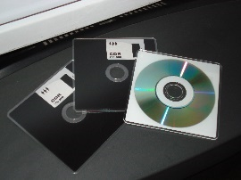
FLOPPY DISC - CD by Miquel C. is licensed under CC BY 2.0

Storage media refers to any physical objects upon which data and information can be stored while it is not actively involved in calculations or processing.

Data that is directly accessible to the central processing unit (CPU) is contained temporarily in one or more memory registers within the processor itself. Although larger, more sophisticated processors may contain dozens or even hundreds of these memory registers, the total amount of data that can be stored there is limited to a few kilobytes at most. With modern operating systems and applications measuring gigabytes in size, software must be stored elsewhere and copied into these registers as needed.

The choice of storage media depends on a compromise between several factors, including speed, size, persistence, and cost. Some storage media, such as on-chip cache memory and random access memory (RAM), are optimized for speed, but cost significantly more per bit than other media, and can only retain data so long as they are supplied with constant power. Other storage media, such as hard drives, DVDs, and even magnetic tape, retain data for years or decades, cost significantly less, but perform exponentially slower than solid-state memory. Most systems employ a combination of storage media to achieve the best cost/performance ratio for a given application.

Reading: Bit and Bytes

Bits and Bytes
A bit —short for binary digit—is a digit that can be 1 or 0. A bit is the smallest unit of information that a digital electronics device can manipulate. A group of eight bits is called a byte.

Why This Matters
Bits provide a simple manner of representing information digitally. When combined into bytes and groups of bytes, bits can represent a wide variety of information. Understanding bits and how they represent information is key to understanding the workings of computers and other digital electronics devices.

Essential Information
Information is represented with bits by assigning the information to a particular state of a bit or group of bits. For example, a bit in the 1 state might be assigned black, while a bit in the 0 state could represent white. Using this encoding, you could represent a black and white image like the one shown below. Stored on a computer, the representation would look like a long list of 1s and 0s, but when interpreted by a graphics application, the bits represent colors and are displayed across the page as a grid of pixels, resulting in the dog’s black and white face.

These photos use 1 bit for black and white colors (left), 6 bits for 64 shades of gray colors (middle), and 8 bits for 256 colors (right).

Harvey by Nate Bennett is licensed under CC BY 2.0

Combining bits provides power to represent a greater variety of values. The picture of the dog’s face could become a high-quality color photograph by increasing the number of bits used to store each pixel. Two bits can represent four colors, three bits can represent eight colors, four bits can represent 16 colors, and so on. With each additional bit, you double the amount of information that can be represented. The formula for this relationship between bits and units of information is 2^{b} = i, where b is the number of bits and i represents the units of information represented.

For example, 2⁴ = 16. High-quality photos use RGB color that employs 24 bits to represent over 16 million colors.

Eight bits equal a byte, the standard grouping for representing and storing most data. A byte can represent up to 256 units of information (2⁸ = 256). A byte provides more than enough storage for every character on a computer keyboard. A byte can represent the values 0 to 255. Bytes can represent different types of information, depending on what encoding is being applied. For example, 01011010 could represent the letter Z using ASCII encoding or the value 90 using the binary number system. It could also represent the color light-green using RGB color encoding or the note C# using sampling. Once the encoding scheme is known, the byte can be decoded and interpreted. Software is used to encode and decode bits and bytes. So, for example, a digital camera encodes an image as a long list of bits, and photo software decodes it and displays it on your computer.

Computers and digital electronic devices may work with thousands, millions, billions, trillions, quadrillions, and even quintillions of bits and bytes. The terminology in the following table is used to express these large quantities.

Units of Measure
Prefix | Value
Kilo | 1,000 | Thousand
Mega | 1,000,000 | Million
Giga | 1,000,000,000 | Billion
Tera | 1,000,000,000,000 | Trillion
Peta | 1,000,000,000,000,000 | Quadrillion
Exa | 1,000,000,000,000,000,000 | Quintillion
Zetta | 1,000,000,000,000,000,000,000 | Sextillion
Yotta | 1,000,000,000,000,000,000,000,000 | Septillion

Bytes are typically represented with an uppercase B and bits with a lowercase b. For example, KB stands for kilobyte and Kb for kilobit. These are important metrics to understand if you want to measure the power and effectiveness of digital technologies. Today’s computer hard drives store from hundreds of gigabytes (GB) to terabytes (TB) of data. High-speed Internet services deliver typically between 4 and 30 megabits (Mb) of data per second—depending on price, which might seem like a lot until you consider that a motion picture can be more than 8 GB in size, or dozens of GBs for high-definition movies. How long would a 10 GB movie take to download over a 10 Mb per second network? Cities fortunate enough to have the new Google Fiber network enjoy speeds of one gigabit per second (1000 Mb)! How long would that movie take to download on Google Fiber?

Reading: Digitization

Digitization
Digitization, also called digitizing, is the process of transforming information, such as text, images, and sounds, into a digital representation (1s and 0s) so that it can be stored and processed by computers.

Why This Matters
In order to manipulate and explore information with computers, the information must first be transformed into the digital representation that computers can process. The reason that computers have become a part of so many things that people do is because we have learned how to digitize so many different types of information.

Essential Information
Information is represented in digital form either by using a look-up table or through the use of binary numbers. The look-up table approach maps information to numbers, using a table to show the relationships. For example, the American Standard Code for Information Interchange (ASCII) uses a look-up table to show the digital representation of all the characters on a computer keyboard. ASCII declares that 01011010 is the letter Z. Since computer systems developers have accepted ASCII as a standard—and because more modern standards are based on ASCII—01011010 is recognized as the letter Z in all computer systems when dealing with character data.

The binary number system is used to represent values in computer systems. Many of the things we experience with our senses can be represented using values. Digitizing the things we sense typically requires an analog-to-digital conversion (ADC). Analog information, such as sights and sounds, varies continuously over time. If the things we see and hear are broken down into their fundamental elements at very short time intervals, it is possible to describe them as values, store them digitally, and reproduce them in a manner that fools our senses into believing they are exact copies of the original.

For example, to digitize sound, a process called sampling measures the amplitude of a sound wave thousands of times per second. Each value is stored as a binary number. The resulting list of numbers is a digital representation of the original sound—not an exact copy of the original sound wave, but close enough to fool our human ears. Digitizing images is a similar process of breaking down an analog phenomenon—by continuously varying shades of color and light—into fundamental components called, and describing those components using values that represent intensities of red, green, and blue (or RGB color).

Other technologies digitize a person’s life. For example, in lifelogging, individuals wear video cameras to capture all their daily activities. Some people broadcast the details of their daily lives in a trend called lifecasting. Others use smartwatches, fitness bands, or other activity trackers to monitor heart rate, steps, sleep, and diet. The process of collecting such detailed information about your body is referred to as the quantified self. That information can be used for self-diagnosis and treatment in a practice called bio-hacking. Millions of individuals are digitizing their lives by posting photos, videos, and ongoing narratives of their activities and thoughts on social media. Adding GPS to these technologies allows the details of a person’s activities to be attached to specific locations.

Sometimes digital information in one representation can be transformed into another representation so that the information can be processed in a different manner. For example, robotic book scanners capture digital photos of each page of a book and can digitize entire libraries of books. After the text is digitized, a technology called optical character recognition (OCR) is applied to identify the text in the image and transform it to ASCII representation, which then may be read aloud by a synthesized voice.

Reading: Character Encoding

Character Encoding

"ASCII CNC 22" by Windell Oskay is licensed under CC BY 2.0

Several standards have been designed for character encoding —the representation of characters on the keyboard with bytes—most having roots in the earliest standard, ASCII (American Standard Code for Information Interchange).

Why This Matters
Although memorizing ASCII characters is of little use to most people, recognizing this broadly accepted standard and seeing how characters are represented in computer systems are valuable for understanding how computers process data.

Essential Information
ASCII was published in 1963 as a character-encoding scheme for the English alphabet and other characters. ASCII maps characters to values that are represented as binary numbers in the computer. For example, in ASCII, 01000001 represents an uppercase A, 010000010 is B, and 01100001 is a lowercase a. The table below shows the ASCII codes for uppercase characters of the English alphabet. The full ASCII chart includes these as well as lowercase letters, numbers 0–9, punctuation, and a wide variety of symbols not found on a computer keyboard.

Although the characters in the alphabet have no particular value, they are sequential and are mapped to a sequence of values. While ASCII is the grandfather of character encoding and serves as a great example of the technique, many other more powerful encoding schemes based on ASCII have been developed. Today, another encoding scheme named Unicode has arisen to take over for ASCII for many applications. Unicode is able to handle all types of international character sets yet is backward compatible with ASCII.

Reading: Binary Number System

Binary Number System
The binary number system, which uses only two digits, 1 and 0, is commonly used for representing values in computers.

Why This Matters
There are an infinite number of number systems, each as powerful as the next. Four number systems are commonly used by computer scientists: decimal, hexadecimal, octal, and binary. Decimal, or base 10, serves people well, perhaps because we have 10 fingers. Binary, or base 2, serves computers well because a bit has only two states—perfect for the on and off electronic switches in computers. Octal and hexadecimal number systems provide shorthand methods of representing binary numbers. Understanding the binary number system is key to understanding how computers operate.

Essential Information
Just as the decimal number system is referred to as base 10 because it has 10 digits (0 through 9), the binary number system is called base 2 because it has only two digits (0 and 1). Consider decimal, where each column is a base 10 number; from right to left there are the ones column, the tens column, the hundreds column, etc. Another way to represent decimal (base 10) numbers is the 10⁰ (ones) column, then the 10¹ (tens) column, then the 10² (hundreds) column, etc. When we represent values in binary (base 2), the columns change to the 2⁰ (ones) column, then 2¹ (twos), then 2²(fours), etc. So, the decimal number 2 is 10 in binary since the second column of binary numbers is the 2s column (which explains the caption for the image above). The decimal number 3 is 11 in binary—the 2s column plus the 1s column.

Binary to Decimal
Binary | Decimal
0 | 0
1 | 1
10 | 2
11 | 3
100 | 4
101 | 5
110 | 6
111 | 7
1000 | 8
1001 | 9
1010 | 10

Zero is 0 in all number systems. The number 1 is the same in all number systems as well because any number to the power of 0 is 1. Notice that binary numbers take a lot more digits to express large values than decimal numbers do. The value 9 takes only one digit in decimal but requires four digits in binary, 1001. The decimal number 9999 is 10011100001111 in binary. The lower the base number in a number system, the more digits are required to represent values.

This page gives only a brief overview of binary numbers—enough to make the point that any mathematical process achievable with decimal numbers is achievable with binary numbers. Since computers can only work with binary numbers—1s and 0s—this is an important fact to realize. As you work with computers, you may run across other number systems. The hexadecimal number system, or base 16, is used in digital graphics as a shorthand for RGB color representation. Also known as Hex, this number system includes 16 digits: 0, 1, 2, 3, 4, 5, 6, 7, 8, 9, A, B, C, D, E, and F. Octal, or base 8, is another number system used by computer scientists as a shorthand method of communicating values stored in bytes.

Lesson 1.3: Digital Devices

Lesson 1.3 Introduction

Computing Platforms
A computing platform describes a computer’s architecture in terms of hardware and software.

Why This Matters
Many computing platforms have emerged to support computing in different environments for different purposes. Knowing about the variety of computing platforms available is useful when deciding on the best computing tool to support a particular computing need.

Essential Information
The expression “computing platform” is used in a variety of scopes. It can be used to address small but important differences in one particular kind of computer. For example, in cellular networks, there is the GSM platform and the CDMA platform. GSM phones cannot operate on CDMA networks, and CDMA phones cannot operate on GSM networks. Personal computers are available in several platforms that include Microsoft Windows, Apple Mac, and Linux. Software developed for one of these platforms will not function on another unless it is re-engineered to do so.

“Computing platform” can also be used to describe computers in more general terms, as is done in this section: personal computers (laptops and desktops), mobile computers (tablets and smartphones), wearable computers (watches and glasses), servers, supercomputers, and special-purpose computers. Each of these general categories of computing platforms applies specific kinds of computing power to a particular type of use and environment.

Reading: Personal Computer (PC)

Personal Computer (PC)
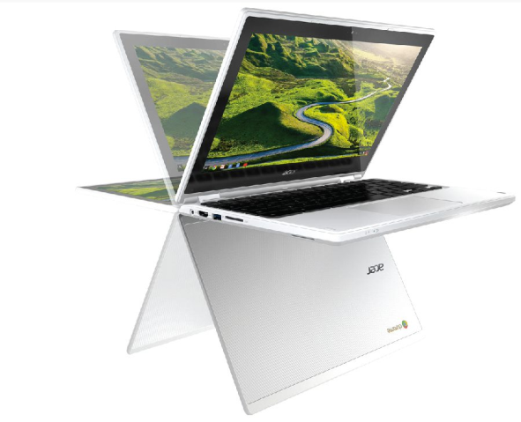
Authored by: Acer License: Fair Use

A personal computer, or PC, is any general-purpose computer designed to meet the many computing needs of one individual.

Why This Matters
Personal computers come in a variety of sizes and models to support computing in all environments—from a sofa, to an office desktop, to a subway train, to a mountaintop. Users are limited in what they can do with their computers only by the software that is available, and for most personal computer platforms, applications number in the millions. Perhaps the most valuable use of a personal computer is connecting to the Internet to access seemingly limitless information and communications and an increasing number of software services. Because computing is such an important part of all professions, computers have been developed for access in all environments.

Essential Information
Personal computers are considered general-purpose, single-user computers. They are general-purpose in that they are designed to run all kinds of software to serve a wide variety of needs. Servers and other large computer systems serve many users simultaneously over a network, but the personal computer is designed to serve one user at a time. That’s what makes it personal!

While this strict definition of PC covers everything from desktops to smartphones, in general usage, the term PC means different things to different people. Some think of PCs as desktop computers; others think it means a Windows computer (PC vs. Mac). This unit uses the term PC to refer to any kind of desktop or laptop computer. We will refer to tablets and smartphones as mobile devices and to smartwatches and glasses as wearable tech or just wearables.

The desktop PC is the original personal computer, providing computing power through circuit boards housed in a tower case called the system unit or sandwiched in the display case in an all-in-one PC. The PC is controlled through input devices such as a touch screen, keyboard, and mouse, using output devices including a display, speakers, and a printer—all connected with cables or wireless technology. Since desktop PCs are not intended to be portable, computer manufacturers can pack in more computing power. High-end desktop computers are used by those who need a lot of computing power for things like media and gaming. Desktop PCs are often classified by the operating system as being a Windows PC, an Apple Mac, or a Linux computer.

The laptop PC, also called a notebook PC, is the most popular type of PC. It provides nearly all the power and functionality of a desktop PC in a portable, all-in-one case. Laptops come in a variety sizes. Ultra-portable laptops are popular with business travelers. Low-priced netbook computers are typically small laptops, designed primarily to access Internet services such as the web, email, and online software like Google Docs. On the other end of the spectrum, Ultrabooks are slim and sleek, providing state-of-the-art processing power at premium prices. Deciding on a laptop often comes down to balancing size, weight, portability, and cost against processing power and capabilities in order to suit your individual usage habits.

PCs have been custom designed to suit many unique needs. There are underwater PCs for use by divers, ruggedized mobile PCs for use in construction and other rough environments, and handheld PCs for collecting census data. There are wearable PCs that clip onto a belt and are controlled with spoken commands. There are PCs designed for cars, aircraft, tanks, and spacecraft.

Reading: Mobile Devices

Mobile Devices
Authored by Google, License: Fair Use

Mobile devices are battery-powered handheld devices, like smartphones and tablets, which provide access to computing, communication, information, and entertainment anywhere, anytime.

Why This Matters
Several technologies, including small processors, touch displays, cellular networks, the Internet, and rechargeable batteries, are responsible for launching the mobile revolution. Today, digital technologies go with us wherever we roam, empowering us with access to information, entertainment, and people anywhere, anytime.

Essential Information
Smartphones are cell phones that possess computing capabilities, including Internet access. A high-end smartphone can offer the benefits of several digital devices in one: a computer, a cell phone, a digital music player, a portable video player, a digital camera and video recorder, a handheld gaming system, a GPS, and much more. Today, smartphones travel with people wherever they go. Many people can be typically observed in any public space with phones in hand, earbuds in ear, and eyes on screen, seemingly oblivious to the world around them. People are increasingly interacting with their phones via voice commands and dictation using personal digital assistants like Siri or Google Now.

Apple iPhone and Google Android smartphones support millions of computer applications (apps) and are the most popular smartphone platforms. Android is the most popular smartphone, controlling roughly 84 percent of the global market (53 percent in the U.S.) and running on handsets produced by several manufacturers, including Samsung, LG, Sony, and Motorola. The iPhone is a proprietary phone manufactured by Apple and holds around 15 percent of the global market (44 percent in the U.S.). Microsoft, Blackberry, and other brands hold a steadily shrinking percentage of the global smartphone market, currently hovering around 1 percent of the market combined.

A tablet PC is a mobile device that is roughly the size of a writing tablet—around nine to ten inches when measured diagonally. The key feature of a tablet is a multitouch display. Fingers are used to zoom, scroll, select, and type on a keyboard displayed on the screen. Tablet PCs are useful in environments where you have to access your computer on the go or on your feet. Tablets are also popular for viewing movies, reading books, playing games, and keeping up with online communications. They assist physicians and nurses in hospitals, store clerks in shops, and professionals across industries. By adding a keyboard accessory, a tablet becomes a small laptop computer. Today, more people are buying tablets than PCs.

There are a number of devices that fall in between typical smartphones, tablets, and laptops in size and function. Laptop computers, like Microsoft’s Surface, that feature both a multitouch display and detachable keyboard can serve as either a tablet or a laptop. Another mobile device that falls between tablets and smartphones in size, called a phablet, has become an attractive option for shoppers who can afford only one mobile device.

Reading: Wearables

Wearables
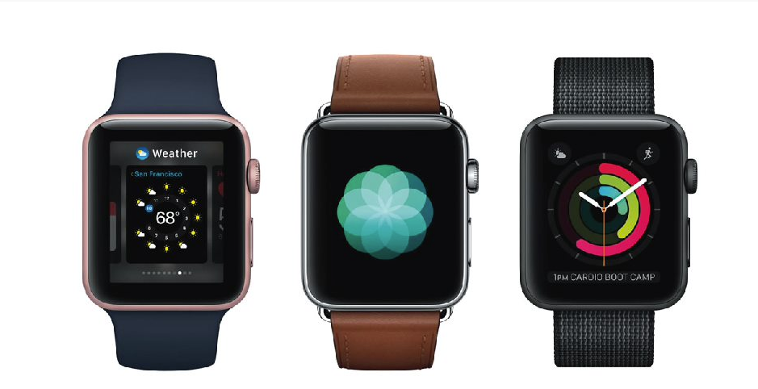
Authored by: Apple, License: Fair Use

Wearables are clothing and accessories that incorporate digital technologies.

Why This Matters
Computing is increasingly integrated into our daily lives. Mobile phones provide access to information and communication whenever we take them out of our pockets or bags. Wearables go a step further by providing access to information continuously whenever they are worn. The only way to become more connected to technology would be through implants!

Essential Information
A number of computing devices have arisen to provide more convenient access to information through hands-free wearable devices. They include smartwatches, bracelets, and glasses.

Fitness bands (sometimes called activity trackers) from Fitbit, Jawbone, and others were perhaps the first wearables to find widespread success. These wristbands use sensors to collect information including heart rate, steps taken, distance covered, calories burned, floors climbed, time asleep, and location, and then pass that information to an app that analyzes the user’s fitness level. Fitness bands are also offered in appealing high-fashion jewelry deigns.

Smartwatches have followed on the success of fitness bands to provide even more information to the wearer. Smartwatches replace the watch face with a display to serve as an interface to your phone. Smartwatch wearers receive notifications on their wrists for incoming calls, text messages, and email via vibrations and on-screen text. They can even view and send messages from the watch. Some smartwatches accept voice commands and dictation. A smartwatch can provide turn-by-turn navigation, provide controls for your phone’s music player, remind you of appointments, and of course provide the time and date. Some smartwatches also provide full fitness band capabilities.

Similar to the smartphone industry, the smartwatch industry is dominated by Google and Apple. Android Wear was one of the earliest wearable computing platforms. It powers smartwatches from Samsung, Motorola, Asus, Sony, and LG. The Apple Watch provides more functionality and style than many of the Android watches.

Google Glass blazed the path for smart glasses. The Google Glass interface uses a small display that is suspended off the corner of the user’s right eye on a glasses frame. Glass connects with the user’s smartphone to provide all the functionality of smartwatches plus a camera for grabbing photos and video and a full web browser. Glass accepts voice commands or menu navigation through a touchpad at the temple. Glass also includes support for headphones. Google Glass has failed in the consumer market due to privacy concerns that stem from its ability to collect photos in public without people’s consent. However, it has been enthusiastically received by professionals in health care, law enforcement, armed forces, and aviation who require access to a computer while keeping their hands free.

Wearables will not be limited to wristbands and glasses for long. The garment industry is working on smart clothing, also known as e-textiles, that can measure and report vital signs for inpatient or outpatient healthcare, fitness training, or the handling of hazardous materials. Jewelry from companies like Cuff and Ringly provide smartphone alerts through necklaces, bracelets, rings, and other jewelry. Lechal smart shoes and insoles from Ducere Technologies not only gather fitness information while you run, but also vibrate the left or the right shoe when your GPS indicates that it’s time to turn. As the Internet of Things grows, many everyday objects will be gifted with the ability to communicate over wireless networks.

Reading: Server

Server
A server is a powerful computer that often utilizes many processors to provide services to many users simultaneously over a network.

Why This Matters
Servers are the past, present, and future of computing. The earliest computers from the International Business Machines (IBM) Corporation were servers that supported employees throughout an organization over a local area network. Today, servers provide everything that is accessible on the Internet and web, not to mention cellular networks, corporate networks, and government networks. Servers are becoming even more important as networks become ubiquitous through cloud computing, providing all software, services, and information that people require anytime, anywhere.

Essential Information
Servers come in many sizes to suit many needs. The term “server” has replaced other older terms, such as minicomputer, midrange computer, and mainframe computer, used to describe various sizes of servers. Today, companies like IBM, HP, and Dell offer servers ranging in price from a few thousand to millions of dollars. Servers can utilize a single CPU or thousands of CPUs and can serve from one person to millions of people. Mainframe servers are the largest of all servers, typically serving thousands of users. Blade servers pack multiple, perhaps dozens of, motherboard modules into a rack to create a modular server that is easy to maintain and expand (see image above).

Servers play a key role in local area and wide area networks. They allow individuals in an organization spread over large areas to access common data anywhere from a central location. Employees at most large corporations do the majority of their work on servers.

The Internet and most of its uses, including the web, are considered client/server networks. The web, email, instant messaging, and many other online applications depend on servers running continuously. Backup servers are often put in place so that if the primary server suffers an outage, the backup can come online to provide uninterrupted service.

Servers are typically designed and purchased for a particular purpose.

Types of Servers
Type | Description
Application server | Runs or delivers applications to users on the network
Communications server | Manages network traffic and communications
Database server | Stores data and provides methods for accessing specific data
Email server | Stores and manages email
File server | Stores and delivers files
Print server | Manages jobs sent to a shared printer
Game server | Runs multiplayer games
Web server | Stores and delivers webpages and content

Reading: Supercomputer

Supercomputer
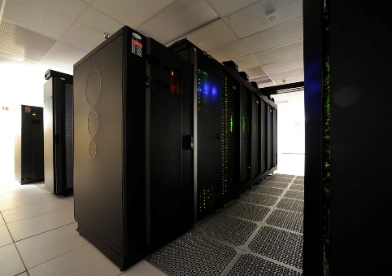
"Discover Supercomputer 4" by NASA Goddard Space Flight Center is licensed under CC BY 2.0

Supercomputers are the most powerful type of computer, often utilizing thousands or even tens of thousands of processors to solve the world’s most difficult problems.

Why This Matters
Personal computers assist us in our individual lives, and servers assist groups of people, organizations, and businesses. Supercomputers assist humanity in extending our intellectual capabilities through massively powerful computation.

Essential Information
Supercomputers are massively parallel processing computers consisting of thousands of processors synchronized to work together to solve complex problems. Supercomputers use specially designed software to distribute a processing task over many processors. The Sunway TaihuLight uses 10.65 million computer cores.

Supercomputers are used for research in industry, government, and academics. They excel in solving highly calculation-intensive problems in many fields.

Meteorologists use supercomputers to model environmental conditions that affect weather over the short, mid, and long term. Police departments use supercomputers to simulate crime scenes. The U.S. Department of Defense uses supercomputers for simulating atomic explosions and researching advanced weapons systems design. Auto manufacturers use supercomputers to experiment with the aerodynamics of car designs in virtual environments. Animation studios and motion picture special-effects artists utilize supercomputers to create virtual 3D environments and animated actors. Financial analysts use supercomputers to predict the ups and downs of the market. Supercomputers are also used to simulate the functioning of the brain to create artificial intelligence.

There are efforts to create supercomputers by joining individual computers together over the Internet. Hundreds of thousands of users have volunteered their computers and game consoles for use by Stanford’s Folding@home project to simulate protein folding in hopes of curing diseases. Folding@home is a powerful distributed computing cluster utilizing home computers connected to the Internet when they are not in use by their owners. Berkeley’s SETI@home project similarly uses Internet-connected computers to search for extraterrestrial life.

In December 2015, Google and NASA announced that the D Wave 2X experimental quantum computer successfully solved an optimization problem in mere seconds—roughly 100 million times faster than a computer using a standard processor. While quantum computers are in the very early stages of development and excel at solving particular types of problems, it’s useful to note that they may soon make traditional supercomputers appear slow by comparison.

Reading: Special-Purpose Computer

Special-Purpose Computer
Special-purpose computers are computers designed to meet a specific need and are more prevalent, yet less noticeable, than general-purpose computers.

Why This Matters
It is important to recognize the often-overlooked use of computers in millions of electronics devices that we depend on every day.

Essential Information
Some special-purpose computers are simply general-purpose computers programmed for one particular task. For example, kiosks are increasingly springing up in public places. A kiosk is a computer station that provides the general public with specific and useful information and services. Usually equipped with a touchscreen, kiosks provide everything from online store catalogs to boarding passes, maps, and exhibit information. The ATM where you can withdraw money from your bank account is a kiosk. Kiosks that allow customers to print photos from their digital cameras have become very popular. There are even church kiosks that accept donations and respond with a blessing.

Other special-purpose computers are embedded in consumer electronics, appliances, medical equipment, and a host of other devices. Referred to as embedded systems, and sometimes microcontrollers, these special-purpose computers are designed to control the electronics devices in which they reside. Here are a few examples of uses for embedded systems:
- Media devices such as iPods, DVD players, and HDTVs
- Ereaders
- Digital cameras and video recorders
- Telecommunications devices such as wireless access points and routers
- Digital watches and clocks
- Home appliances like refrigerators, microwaves, dishwashers, ranges, washers, and dryers
- Air-conditioning and heating systems
- Medical equipment such as pacemakers and hearing aides
- Hospital equipment such as MRI machines, electronic stethoscopes, and heart-rate monitors
- Traffic lights, elevators, and toll booths
- Automobile, aircraft, and seacraft controls and engines
- Factory assembly lines
- Nuclear power plants
New tiny chips are allowing all types of physical objects to become “smart” by acquiring the ability to sense and transmit data. These objects networked together are referred to as the Internet of Things.

Module 2

Introduction
"Proffessional-ethics-2" by Ars Skeptica is licensed under CC BY-SA 2.0

Ethics is a branch of philosophy that deals with issues of morality, that is, consideration of which human actions and reactions are morally right and wrong.

Why This Matters
It is important to make intelligent decisions from an ethical perspective about the actions that we take—that is, to consider whether our actions feel right or wrong to us and why. These actions range in scope from personal actions to the actions of our businesses and organizations, the actions of our governments, and ultimately the actions of our species. Digital technologies have provided new opportunities and dangers for our species and many new ethical considerations.

Consider This
In recent years, we have seen the rise of a new type of hacker group. Hacker activists, or hacktivists, hack computer networks for a perceived righteous cause. Hack collectives such as Anonymous, LulzSec, and AntiSec have claimed responsibility for breaking into the networks belonging to hundreds of businesses, law enforcement agencies, and government agencies, including the FBI and U.S. defense contractors, all in the name of “justice.” Typically, hacktivists choose their targets based on some injustice that has occurred or in order to retaliate against agencies that threaten hacktivists. In one case the hacktivist group Anonymous took on the Ku Klux Klan by taking down several KKK websites with denial of service attacks and hijacking major KKK Twitter accounts.

Once a target is hacked by a hacktivist organization, the group may publish embarrassing or revealing stolen information on the web. For example, a group of hackers, calling themselves the Impact Team, hacked the database of cheating site AshleyMadison.com, threatening to publish the personal information of 32 million users unless Avid Life Media, owner of AshleyMadison and its companion site Established Men, took down the two sites. The sites were not taken down and the private data was published.

Today many hack attacks are carried out for some righteous cause rather than for money. In some cases, the result of hacktivist attacks has had the intended effect: embarrassing the targeted company and those associated with it. However, hacking is still illegal. Dozens of hackers have been jailed for their participation in these hacker collectives. Many law-abiding individuals and businesses live in fear of these digital vigilantes. The web has certainly empowered many to advance righteous causes. What do you think? Should hacktivist groups be condemned by the public or supported? Why?

Essential Information
This unit addresses ethical issues surrounding the use of digital technologies. Although computer ethics is typically defined as relating to ethical issues confronted by computing professionals, this section addresses computer ethics in a broader sense. Computing touches everyone—not just computing professionals—at home, at work, and in our roles as citizens. We confront important ethically charged computer-related decisions in all of these areas. This section discusses personal ethics, professional ethics, and governmental ethics, along with related topics.

Lesson 2.1: Computer Ethics

Lesson 2.1 Introduction
Computer ethics refers to the responsible use of computers in all contexts and applications, by individuals, organizations, and governments.

It is easy to forget that computers and their users do not exist in a vacuum; every action involving computers, from the time they are designed and manufactured until they are decommissioned and disposed of, involves choices that impact society and the environment in significant ways.

Even before a computer has been powered on for the first time, many ethical decisions have been made. Computer components are manufactured in facilities around the globe, and building a manufacturing plant has an impact on local ecosystems and economies that should be carefully considered. How much do workers assembling computers get paid, and are they able to afford the same products they spend many hours building? Are the minerals that are refined and processed into chips and components mined responsibly, or does their extraction leave local environments and societies burdened with toxic byproducts? Once assembled, packaged, and shipped to retailers, are computers priced and marketed to all users, or as luxury goods only available to a few? How has your computer changed the world before you’ve pressed the power button?

Reading: Personal Computer Ethics

Personal Computer Ethics
Personal computer ethics refers to the responsible use of computers by individuals outside of professional environments.

Why This Matters
Computer users face many ethical choices in their casual use of today’s technologies. Some software and online services make it possible to engage in unethical and sometimes illegal behavior—they may even encourage it. It is important for computer users to consider their actions carefully and intelligently to determine the course of action that best matches their own code of ethics and sense of responsibility. Too many computer users follow the pack and adopt others’ sense of ethics, even when it goes against their own beliefs and conscience. Today’s best leaders have a solid sense of what they hold to be ethical and unethical, and they exemplify those beliefs through their actions, while remaining open to new ideas and intellectual growth.

Essential Information
Each person has his or her own sense of what is right and wrong regarding computer use and behavior. Often computer ethics are learned from our parents and teachers. As we mature, those ethics are altered to suit our own belief systems. Personal computer ethics is a highly subjective topic, except in issues of local, state, and federal law, where ethical issues are clearly defined. Using a computer to create and distribute malware, steal credit card numbers, invade privacy with spyware, or steal copyright-protected work or someone else’s intellectual property is illegal. Those who participate in such activities might pay a price in terms of jail time and fines.

However, when a significant portion of a population in a democratic society opposes a law, there arises substantial pressure on the government to change the law or change conditions in society. For example, the digitization of music, movies, photos, and other creative work has created a situation where many otherwise law-abiding individuals may be actively violating copyright law by copying and enjoying media files (music, movies, photos, books) without securing a license by purchasing the item. In many such cases, courts have affirmed that owners of the intellectual property, the record companies, movie companies, or independent artists, deserve compensation. Through a process of court battles, technological solutions, and adjustments in the market, a slow but purposeful change has been occurring in views on intellectual property and the manner in which it is distributed and protected. An ideal solution accommodates both the public’s need for robust, easy, and inexpensive access to intellectual property—such as art, music, and videos—and the creator’s need to make a living.

This is how governance and law evolve. These institutions should not be rigid and unchanging, but flexible and responsive to society as it evolves. Good laws evaluate a situation from all perspectives and implement a solution that provides the greatest public good. If individuals can examine situations intelligently and unselfishly, then personal ethics will also serve the greatest public good.

Personal ethics regarding computer use typically combine legal considerations, what is best for the public good, and what is best for the person in terms of mental, physical, and spiritual well-being. Fear of the law may keep an individual from hacking a computer network. A feeling of social responsibility may guide a computer user to treat others online with respect. A person’s own sense of morality may keep that person from becoming involved with web content that has a negative impact. What that content is may differ for each individual. Personal computer ethics requires an examination of one’s own conscience and the weighing of benefits against costs in terms of personal, social, and legal considerations.

Reading: Professional Computer Ethics

Professional Computer Ethics
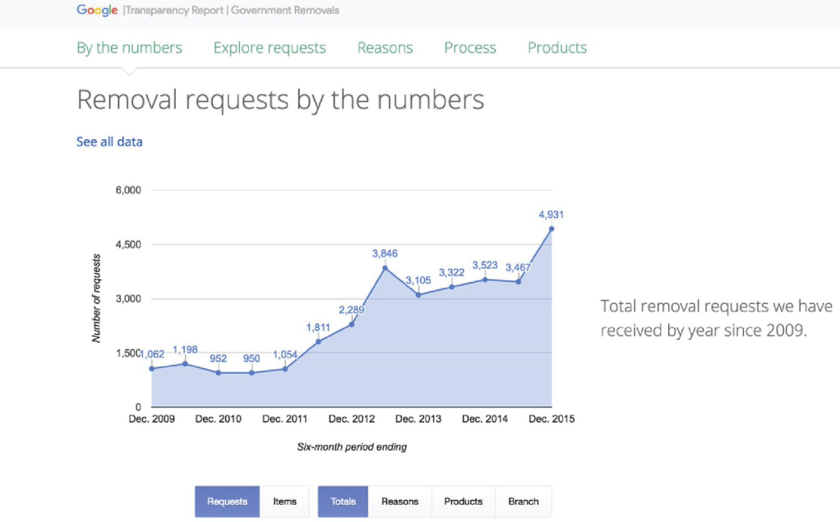
Authored by: Courtesy of Google Inc. License: Fair Use
Professional computer ethics involves the ethical issues faced by professionals in their use of computer systems as part of their jobs.

Why This Matters
The ethical issues faced by professionals who use computer systems as part of their jobs include a responsibility to customers, coworkers, employers, and others with whom they interact and who are impacted in some way by their computer use on the job. Because computer systems are integral tools in today’s businesses, professional computer ethics often equates to business ethics. In today’s connected professional environments, businesses need to be concerned with more than the bottom line. They should also be concerned with the ethical treatment of their customers and employees, protecting private information, and protecting the interests of investors. Businesses that create technologies need to consider the impact their products have on humanity and the natural world. Business computer systems and computer products provide powerful tools for both unethical and ethical behavior.

Essential Information
Professional computer ethics involves those who produce computers, software, and information systems as well as those who use them at work. Besides governing personal behavior, laws are also designed to govern professional behavior and the behavior of businesses. For example, the Identity Theft Protection Act of 2005 requires businesses to secure sensitive data physically and technologically and to notify consumers nationwide when such data is compromised. The Children’s Online Privacy Protection Act of 2000 prohibits businesses from collecting personal data online from children under the age of 13. This is the primary reason Facebook and other online services either do not allow children under 13 to become members or require parental consent. This type of ethics is imposed upon a business by the government.

Many organizations and associations go beyond what is required by law and establish their own codes of ethics. Codes of ethical conduct can foster ethical behavior in an organization and give confidence to people who interact with the organization, including clients and customers. Some organizations and associations that have developed a code of ethical conduct include:
- Computer Professionals for Social Responsibility (CPSR)
- Association of Information Technology Professionals (AITP)
- The Association for Computing Machinery (ACM)
- The Institute of Electrical and Electronics Engineers (IEEE)
- The British Computer Society (BCS)
Such codes of ethics typically include consideration for general imperatives, such as avoiding harm to others and being open and honest, as well as more professional responsibilities, such as achieving high quality in your work, respecting intellectual property, and respecting client privacy.

Lesson 2.2: Government Rules and Regulations

Lesson 2.2 Introduction
"No Fishing" by Bruce Berrien is licensed under CC BY 2.0

Government rules and regulations are intended to balance the needs of citizens and business for freedom, opportunity, and security.

The rapid pace of change in the digital economy poses an acute challenge to lawmakers responsible for protecting citizens and businesses from threats on the Internet. Additionally, the complexity and interconnectedness of digital technology means that there are seldom simple answers to difficult questions, and any legislation designed to address those questions will necessarily be a compromise between conflicting interests.

Computers and the Internet have highlighted the tension between governmental guarantees of security and freedom. In order to provide protection against potential threats, governments need to be aware that they exist. When billions of people are online and able to communicate instantly with anyone else, this means that a few threats may be hidden within incomprehensible volumes of private conversations. Monitoring all of this data traffic is an enormous undertaking, and one that threatens privacy in order to provide an incomplete promise of security.

Reading: Governmental Computer Ethics

Governmental Computer Ethics
Governmental computer ethics refers to a government’s responsibility to create laws to protect citizens from unethical computer use and provide citizens with equal access to computers and information technologies as well as their benefits.

Why This Matters
Governments face many of the same ethical considerations as businesses with respect to their use of computers and information systems. However, governments have the added responsibility of guiding the influence of technology on their population. They create laws that govern the use of technology so that citizens are protected from those who abuse others through the use of technology. Besides keeping information and people safe, the government also has a responsibility to give everyone equal access to technology in order to enjoy the associated benefits.

Essential Information
Governments shoulder the computer-related ethical responsibilities of entire countries and cultures. These responsibilities generally fall into two categories: protection and empowerment. A government should protect its citizens from those who wield computing powers in unethical ways. A government should also empower its citizens so that all socio-economic groups can benefit from the power of computing.

Many computer-related social issues are impacted by governmental regulation. Our political representatives are responsible for creating laws that protect us by regulating business use of technologies that are invasive to our privacy. For example, the FCC has passed net neutrality policies preventing Internet service providers from controlling what content users can view and charging more for some online services than others. Governments determine what types of information may be dangerous to the population and should be censored. Governments also wrestle with ethical issues when determining what situation constitutes the use of technology for surveillance and how to balance that with a citizen’s right to privacy.

The government is responsible for defending a country’s critical infrastructure from foreign governments, cyber criminals, and terrorist groups. This can be a challenge when much of that infrastructure is owned by private corporations. Some in government believe that companies operating power plants, communication systems, chemical facilities, hospitals, train lines, airlines, and other suppliers of critical national resources should be required to meet performance standards to prove they can withstand attacks or recover quickly from them. However, others in government are against placing unfunded mandates on private corporations, even if it does mean a less secure nation. These are ethical dilemmas that a government faces. In either case, it is clear that the government must partner with businesses to protect the country.

Many governments are also trying to ensure that all citizens have the same basic privileges and opportunities. In the United States and some other countries, these efforts now extend beyond food, housing, and education to include access to computing and information technologies. Many governments are making efforts to extend the reach of the Internet to every citizen, even those living in remote locations. During his time in office, President Obama supported a broadband expansion plan focused on expanding high-speed Internet to rural areas of the country. The plan provides high-speed Internet to 98% of U.S. citizens so that everyone has the opportunity to benefit from what the Internet provides.

At times, some governments have felt compelled to shut down the Internet to stop or slow communication for their citizens. This generally arises in situations where anarchy exists in the population and law and order is needed. Shutting down the Internet is often the last act of a desperate, oppressive regime as it is about to be overthrown by its people.

Some governments withhold access to the Internet from citizens. In North Korea, only 4% of the population has access to the Internet; Burma and Cuba also severely restrict Internet access. The governments of Saudi Arabia, Iran, China, Syria, and Tunisia block sites considered anti-government in nature.

Reading: Accessible Computing

Accessible Computing
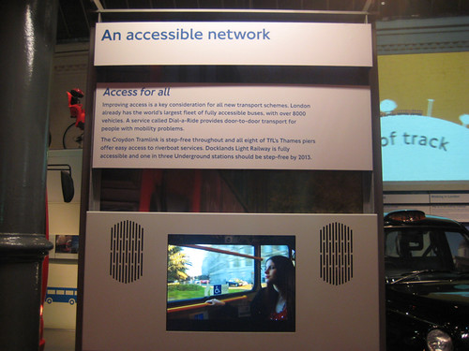
"Accessible Network film from London Transport Museum" by Annie Mole is licensed under CC BY 2.0

Accessible computing refers to the provision of equal access to computers and information technology for individuals with disabilities.

Why This Matters
Computer and information technologies must be designed in a manner that is easily accessible to all users. Unfortunately, in some cases, designers fail to consider the needs of disabled users, and their valuable products become unusable by individuals who have hearing, sight, or motor disabilities.

Essential Information
There is a growing body of law and policy in many countries that addresses accessibility of information and communications technology (ICT), including the Internet and web. Laws differ from country to country. Some treat access to ICT as a human or civil right; others mandate only that government-controlled ICT is accessible to all, including the disabled; others specify that ICT sold in a given market must be accessible.

Section 255 of the U.S. Telecommunications Act of 1996 requires telecommunications manufacturers and service providers to make their products and services accessible to people with disabilities, if readily achievable. The World Wide Web Consortium (W3C) has developed Web Content Accessibility Guidelines for businesses and organizations to use in making their web content accessible to users with disabilities, such as those who are unable to see, hear, or move (see video).

The U.S. Department of Education has developed Requirements for Accessible Software Design to ensure that all software used in schools is accessible to all students, faculty, and staff. The Americans with Disabilities Act of 1990 requires businesses to provide equal access to individuals with disabilities, including access to web content and services. Many countries and regions, including Australia, Canada, Denmark, Finland, France, Germany, Hong Kong, India, Ireland, Italy, Japan, New Zealand, Portugal, Spain, the United Kingdom, and the European Union, have instituted similar laws and considerations for the disabled.

Numerous software and hardware tools are available to assist the disabled in using PCs. Individuals may use screen enlargement software to make computer screens easier to read and use. Screen reader software like JAWS enables blind users to interact with the computer by using text-to-speech technology to read words displayed on the screen. The user manipulates the software, using predefined hotkeys, or shortcut keys. Some phone companies offer a service that uses a webcam attached to a hearing-impaired person’s computer. When the person makes a call and uses sign language to communicate, an operator translates the hand signals to a hearing person at the other end of the line.

Lesson 2.3: Social and Environmental Impacts

Lesson 2.3 Introduction
Social and environmental impacts refer to the consequences of computer use beyond the immediate context in which they are used, specifically the indirect effects on society and the world in which we live.

Billions of digital devices are manufactured and used annually, which means that small changes to their design can have significant effects on the environment and society. Manufacturers who make a commitment to reducing their use of toxic materials and incorporating recycled components can eliminate tons of pollutants. Designers who incorporate accessibility features empower computer users who would otherwise be excluded from the benefits of digital technology.

Advances in digital technology have created highly visible benefits for users in recent years, but the negative consequences have often been more subtle and less obvious. At the same time that some users have been able to leverage access to these technologies to build tremendous wealth and find new opportunities for creative and social endeavors, many others have been left behind, receiving little or none of these benefits. While computer users in developed nations reap the benefits of computer-aided design and entertainment, those living in developing nations struggle to catch up while dealing with the hidden byproducts and consequences of the digital age. This situation can be resolved, but it will take a commitment to green computing and inclusion from everyone.

Reading: Green Computing

Green Computing
"Green Computing" by Chad Kainz is licensed under CC BY 2.0

Green computing refers to the efforts of individuals, businesses, and governments to utilize environmentally conscious practices in the manufacturing and use of digital technologies.

Why This Matters
At the same time that many people are spending increasing amounts of their lives online in virtual space, the serious reality of climate change has given many of us a heightened awareness of our natural environment and the dangers it faces. Individuals, organizations, and governments are making efforts to reduce their carbon footprint—the amount of greenhouse gases they produce—and to manufacture and use computing resources in an environmentally conscientious manner.

Essential Information
The Intergovernmental Panel on Climate Change has determined that the buildup of greenhouse gases resulting from human activity, such as burning fossil fuels and deforestation, is primarily responsible for recent trends in global warming. Digital technologies contribute to global warming through the large amounts of energy they require, causing coal-burning power plants to generate increasing amounts of electricity and carbon emissions.

In an effort to improve the world, and perhaps their reputations in the process, many companies are going to great lengths to implement green computing initiatives. Green computing initiatives generally fall into one of two categories: energy efficiency or ecology.

There are many ways that the energy used in the manufacturing and use of computers can be reduced. Companies that manufacture computers are turning to reusable energy sources for a portion of their energy requirements. They are also streamlining manufacturing processes to be more efficient and less energy demanding.

New computing technologies are being invented that use less energy. For example, solid-state drives (SSD) are replacing hard disk drives, providing faster data access and dramatic energy savings. Processor manufacturers such as Intel are working hard to create new, more powerful processors that require less energy to run. New battery technologies are providing environmentally friendly materials that store energy more economically.

In addition to creating more energy-efficient hardware, software can be written in a manner that requires fewer processor cycles, decreasing a computer’s power consumption, especially for the operating system. Also, operating systems can incorporate energy-saving features used to power down a computer when not in use.

The Energy Star program was created in 1992 by the U.S. Environmental Protection Agency (EPA) to inspire energy conservation in electronics products. Computers that are Energy Star certified save 20% to 30% on energy consumption on average. The ENERGY STAR 5 requirements for computers went into effect in 2009 and have the strictest energy requirements to date.

The power consumption of an individual PC is a drop in the bucket compared to that of corporate data centers. Some data centers have power requirements equal to that of medium-sized cities. Data centers require massive amounts of power for processing and especially for cooling. Most companies are working to reduce the energy requirements of their data centers. Many companies are replacing older, power-hungry servers with more efficient models and are using virtual servers that allow a single physical server to behave like several servers. Virtual servers maximize the amount of work that can be managed by a single hardware server.

Computer technologies have not traditionally been very ecologically friendly. Dangerous compounds and chemicals are used in the manufacturing of some computing equipment, and recycling programs for digital electronics components have been far from robust.

E-waste refers to discarded digital electronics devices and components. The Environmental Protection Agency estimates that 400,000 tons of e-waste is sent to recycling centers each year. Much of that waste contains dangerous contaminants such as lead, cadmium, and beryllium as well as brominate flame retardants. There is concern that digital electronics are being discarded at a rate that will soon overflow our landfills. There is also a concern about recycling practices that are hazardous to those involved and to the environment. Roughly 80% of recycled e-waste is shipped (often illegally) to poorer, developing areas such as Guiyu, China, and Lagos, Nigeria. Working for pennies an hour, workers dismantle, burn, or give acid baths to components to salvage valuable metals such as copper and gold, often at the cost of their health and the health of their environment. Children are exposed to dioxins, soil is poisoned with heavy metals, and the water becomes undrinkable.

Computer manufacturers are working hard to reduce the amount of dangerous contaminants in their products and are implementing take-back programs to assist customers with recycling.

Computer manufacturers are also working to avoid the use of conflict materials—natural resources that are extracted in conflict zones and sold to perpetuate the fighting. For example, cassiterite (for tin), wolframite (for tungsten), coltan (for tantalum), and gold ore are extracted from eastern Congo and used to manufacture consumer electronics. Electronics companies like Intel are avoiding the use of these minerals in order to help end conflict in the Congo.

Reading: Digital Divide

Digital Divide
Authored by: Courtesy of Project Loon, License: Fair Use

The digital divide refers to the social and economic gap between those who have access to computers and the Internet and those who do not.

Why This Matters
The digital divide highlights the issue of access and the difference in opportunities between the “haves” and the “have-nots.” Most agree that those without access to digital technologies are seriously disenfranchised in today’s world. The have-nots in this scenario may be unable to access technology due to a physical disability, financial limitations, geographic isolation, or political or social repression. There are digital divides based on gender, ethnicity, race, age, income, location, and disability.

Essential Information
Although a significant concern, the economic digital divide in the United States has been shrinking since the turn of the millennium. The number of Internet users in the low-income range (earning less than $25,000 per year) has soared, making them the fastest-growing segment of Internet users.

The global digital divide provides a greater social and ethical challenge. The World Economic Forum website states that countries need developed Information and Computing Technologies (ICT) systems to allow new models of collaboration, increase efficiency and boost productivity. The lack of skills in these areas leaves these populations with poor educational systems that do not support the new age of entrepreneurship and innovation enjoyed by the rest of the globe.

Several organizations and companies are working to bring computing and the Internet to everyone on earth. Intel is working with the Chinese government to provide Chinese university students with low-priced laptops. An international consortium, including Indian and American companies as well as the World Bank, is building thousands of rural Internet centers in India. Each center connects to the Internet by land lines or satellite links and includes five to ten inexpensive, thin client PCs to provide access to government, banking, and education services in isolated villages. Google has launched Project Loon, which delivers Internet access to remote areas of the globe via large weather balloons. Facebook, Nokia, Samsung, Qualcomm, and others have created a global partnership to bring Internet access to unserved populations around the world via drone aircraft.

If humans are to utilize the Internet to build a global community, it is clear that the more affluent “neighborhoods” in this community cannot ignore the needs of the less fortunate. Those seeking to assist developing nations believe that societies must move from “divide” to “include” as the central organizing principle of their analysis and actions. Passing out PCs and providing Internet access is the first step; providing education is the next step; and including all humans in the information economy is the important last step.

Bridging global digital divides requires extensive commitment and organization. Many feel that it is an important investment worth the expense and effort. Although the information and communication technology revolution offers genuine potential, there is a risk that a significant portion of the world will lose out if humans do not take a global perspective. As technology reaches out to the world with fiber-optic, wireless, and high-speed connections, the world must be able to respond and participate. The Internet has created a seemingly smaller world and, in so doing, has called attention to social and economic problems. It is up to developed nations to recognize these problems and help develop solutions. However, if countries adopt a self-serving and opportunistic approach to technology, the digital divide will grow, as will global unrest.

Module 3

Introduction
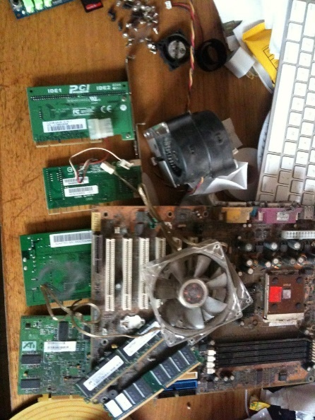
Before. Authored by: Nick Sears, License: CC BY 2.0

Hardware refers to the tangible parts of a computer or digital device and typically includes support for processing, storage, input, and output.

From huge servers that support the needs of thousands of users, to slim laptops, to tiny smartwatches, computing devices share certain characteristics. They all manipulate digital data and share the same fundamental processes. By learning about these underlying processes and their components, you can develop a better understanding of what computing devices are capable of and how you can benefit from those capabilities. You can become empowered to competently use digital devices whether they are old or the latest rage. Understanding hardware will also allow you to be a wise consumer, purchasing computers and digital devices that best suit your needs.

Consider all of the computer hardware brands in existence today. Which would you say has had the biggest impact on the market in recent years? If you said Apple, you are on the mark. Apple has grown from the underdog computing platform to one of the largest PC, smartphone, and wearable manufacturers in the world. In fact, Apple has held the title of being the largest company in the world by market value since 2015! Once considered a brand appropriate only for some households, Apple is now a major force in digital technology at home, at school, and in business. Macs, iPhones, and iPads are seeing rapidly increasing adoption among enterprise users. Nearly all Fortune 500 companies approve and support iPhones and iPads on their networks.

In many cases, the move to Apple isn’t the idea of corporations but originates with the employees. In a trend called BYOD (for “bring your own device”), workers who have fallen in love with their iPhones, iPads, and MacBooks at home are bringing them to work and pressuring employers to support Apple products at work. Similarly, companies have to deal with employees bringing Android phones and tablets to work.

Many people have multiple digital devices to serve different needs: desktop and laptop PCs, tablets, smartphones, and now wearables. For individuals, deciding on the best hardware requires a careful analysis of their computing and communication needs as well as of the environments in which they live and work. Special consideration must be given to processing power, storage capacity, and input and output requirements for each device. As you read this unit, consider the ideal combination of devices that will serve your needs as a professional. Also consider the computing needs of your personal and home life. Which tech company’s ecosystem best serves your unique hardware needs?

Hardware is the foundation on which digital technologies and services are built. The hardware we use directly impacts our computing experiences. Hardware manufacturers like HP, Dell, Apple, Microsoft, Google, LG, Samsung, Motorola, and thousands of others compete to provide their customers with the best user experience. Whether it’s a desktop computer, a mobile computer, a smartphone, or a smartwatch, if your hardware is outdated or not well suited for your activities, your experience is likely to be frustrating. Matching hardware to specific needs is an important skill for getting the most out of digital technologies.

This section explores the intricacies of hardware devices, which can be organized into three categories: processing hardware, storage hardware, and input/output (I/O) hardware. Here you will learn how microprocessors work to power computers, mobile phones, digital cameras, and a host of other digital electronic devices. You will gain insight into how to choose the best computer for your needs. You will learn about different types of storage options that provide convenient access to information and services wherever they are needed. You will also learn about new ways to interact with computers through innovative I/O devices.

In this unit you will once again face the fact that computers are becoming increasingly intelligent and that humans are becoming increasingly dependent on them for fundamental and essential tasks. While continually increasing processing speeds mean new opportunities for humanity, they also imply a tilt in the balance between responsibilities given to human intelligence and those delegated to computer intelligence.

The growing reliance on mobile computing and cloud computing supports an environment where work and communication can take place wherever and whenever possible. While some find this liberating, others feel that they can never escape the pressures of work. Streamlined interfaces like Apple’s Siri, Google Now, Amazon’s Alexa, and Microsoft’s Cortana have provided the first step toward reliable digital assistants that are able to provide information as soon as it is needed and with very little effort. The current pace of development of hardware (and software) technologies has humanity on the brink of colossal changes in the way we live and work. As you read this unit, consider how new developments in hardware technologies impact the way you live and work.

Lesson 3.1: The Development of Computers

Lesson 3.1 Introduction
Computers were, prior to the invention of electricity, and its subsequent application to programmed mathematical and logical calculations, any mechanical device or person that performed these same calculations.

Mathematics and formal logic are disciplines that have been studied and practiced by humans throughout recorded history. Unlike more subjective disciplines, such as art, music, and literature, math and logic follow strict, unambiguous rules that solve specific problems with regular, reproducible procedures, a fact that did not escape the notice of mechanical engineers and inventors.

Ada Lovelace in 1852. Authored by: Henry Phillips, License: CC0 1.0 Universal (CC0 1.0)

Before the development of electronic computers, numerous mechanical devices were designed and built to perform many of the same tasks now handled by digital devices. In some way, mechanical clocks can be considered special-purpose mechanical computers, and the Antikythera mechanism, found in a shipwreck off the coast of the Greek island of the same name, maybe have been an early, but surprisingly sophisticated, navigational computer.

In many ways, all modern computers are successors to Charles Babbage’s Analytical Engine, and all programmers are heirs to the pioneering code written for it by Ada Lovelace.

Reading: Computing History

Computing History
The history of the electronic computer dates from around 1940 where it played a significant role in World War II, initially using electric relays for processing, progressing to vacuum tubes, then to diodes and transistors, and finally to the integrated circuits used today.

Why This Matters
Humankind has progressed through a series of technological revolutions, each of which has propelled us to a higher level of existence. The agricultural revolution brought a dependable source of food production; the scientific revolution brought higher-level thinking and understanding through mathematics, physics, astronomy, biology, and chemistry; the industrial revolution brought more productive manufacturing processes; and the digital revolution provided us with higher order computational capabilities, advanced communications, and powerful information processing. The computer is responsible for ushering us into the digital age. Understanding its evolution assists us in understanding its impact on humanity.

Early computers such as ENIAC filled large rooms with cabinets full of vacuum tubes, diodes, relays, resistors, capacitors, and wiring.

U.S. Army. Authored by: Collections of the University of Pennsylvania Archives, License: Public Domain

Essential Information
During the late 1930s, a German engineer by the name of Konrad Zuse, began working on a machine that could carry out Boolean operations (those that govern processing with 1s and 0s) using electrical relays like those used in telephones. Zuse’s third generation of that machine, named the Z3, was completed in 1941 and is considered by most to be the first working programmable, fully automatic, digital computer. The Z3 was used to perform statistical analyses of wing flutter.

Zuse’s work was cut short by World War II because computer research was not considered “war-important.” Ironically, at the same time that Zuse lost his funding, enemies of Germany were busy building computers to use against Germany.

Several generations of early computers were funded by the war effort. An electro-mechanical machine called Enigma, invented by the German engineer Arthur Scherbius at the end of World War I (1918), was used for enciphering and deciphering secret messages. In 1939, at the start of World War II, England created a more sophisticated device called the Bombe to help decipher German Enigma-machine-encrypted secret messages. The battle of ciphers and code breaking became increasingly complex between Germany and its enemies. In 1943, Colossus—the first programmable electronic digital computer—was developed by British codebreakers. Colossus used 1,500 vacuum tubes and rolls of punched paper tape to test code solutions, reducing the time required to crack a code from weeks to hours.

Shortly after the war, in 1946, a computer named ENIAC was designed by John Mauchly and J. Presper Eckert to calculate artillery firing tables for the United States Army’s Ballistic Research Laboratory. ENIAC is considered the first fully electronic general-purpose computer. One of ENIAC’s first jobs was to study the feasibility of the hydrogen bomb. ENIAC contained 17,468 vacuum tubes, 7,200 crystal diodes, 1,500 relays, 70,000 resistors, 10,000 capacitors, and around 5 million hand-soldered joints. People joked that whenever ENIAC was switched on, lights in Philadelphia dimmed. ENIAC’s input and output utilized punched cards. ENIAC inspired a whole generation of computers that used vacuum tubes to store and route bits of data.

In 1947, the transistor was unveiled by Bell Labs. Transistors were able to function like vacuum tubes but were much smaller and more reliable. Computer engineers gradually moved from vacuum tubes to transistors for processing. In the late 1950s, Jack Kilby of Texas Instruments and Robert Noyce of Fairchild Semiconductor developed a method to integrate multiple transistors into a single module called an integrated circuit. The invention of the integrated circuit (also called microchips or simply chips) allowed electrical engineers to create more complicated electrical circuits in a much smaller package.

Today, chips utilize silicon-based transistors with two types of silicon, called n-type silicon and p-type silicon for the negative and positive aspects of their electrons (shown as n and p in the figure). By applying and removing voltage to the gate and drain of the transistor, electrons are allowed to flow through the transistor or are stopped. When electricity is flowing through a transistor, it represents a 1; when it is not flowing, it represents a 0. By combining transistors and using the output from one or more transistors as the input to others, computers control the flow of electricity in a manner that represents mathematical and logical operations.

The trend in digital technologies has always been toward smaller, more powerful, and faster devices. Chip manufacturers strive to reduce the size of transistors and the connections between them so that electrons flow more quickly through the circuits. A circuit is created by combining transistors, and sometimes other components, in a manner that accomplishes a specific task. Intel was able to create a circuit for storing data in flash memory that is only 25 nanometers in size. It would take about 4,000 of these microscopic circuits to span the width of a human hair. The transistors in today’s processors are so small that over two billion can be stored on a surface the size of your thumbnail.

Reading: Moore’s Law
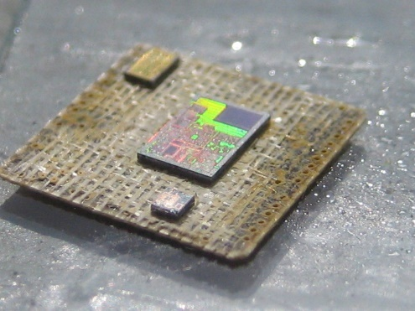
MC13224. Authored by Travis Goodspeed, License: CC BY 2.0
Moore’s Law states that the number of transistors on a chip will double about every two years.

Moore’s Law provides an understanding of the exponential rate of advancement in processor technologies. A processor that has double the amount of transistors is twice as fast and powerful. Using Moore’s Law, we can gauge how fast processors might be in coming years.

Why This Matters
Moore’s Law states that the number of transistors on a chip will double about every two years. This is illustrated by the fact that in 2006, there were 1 billion transistors on Intel’s most powerful chip; and in 2008, Intel announced a chip with 2 billion transistors. Similarly, in 2008, CPUs were engineered using 45 nm technology; in 2009, it shrunk to 32 nm; in 2012, 22 nm; and now we’re at 14 nm processors built into 3D processing cubes for even faster processing. Utilizing Moore’s Law, one could guess at processor size and speeds over the next decade.

Essential Information
It is also important to note that most experts, including Moore himself, believe that Moore’s Law will eventually exhaust itself as transistors become too small to be created out of silicon. Intel started using hafnium in place of silicon to create transistor gates and reduce the scale of transistors from 75 nm to 32 nm. Such a reduction would have been impossible using silicon gates due to the physical properties of silicon. Many other materials and processing technologies are being studied in order to continue, if not speed up, the progress of technological innovation. For example, IBM was able to store one bit of data using only 12 iron atoms, using an unconventional form of magnetism. Japanese scientists built a processor from a single layer of molecules that calculates in parallel like the human brain. Google’s D-Wave quantum computer is able to process and run certain operations 100 million times faster than a traditional silicon processor. The table below lists some of the most promising new processing technologies.

New Processing Technologies
Technology | Description
High-k materials | The use of materials with a high dielectric constant (k), such as hafnium and zirconium, creates smaller transistors than silicon can support.
Optical computing | Some companies are experimenting with chips called optical processors that use light waves instead of electrical current. The primary advantage of optical processors is their speed. It has been estimated that optical processors have the potential to be 500 times faster than traditional electronic circuits.
Three-dimensional processing | Recently, Intel has made the transition from two dimensions on a thin wafer to three dimensions on a cube. Stacking wafers into 3D arrays speeds processing by allowing it to occur horizontally and vertically simultaneously.
Quantum computing | Quantum computing proposes the manipulation of quantum states to perform computations far faster than is possible on any conventional computer. A quantum computer doesn’t use bits, but rather a fundamental unit of information called a quantum bit or qubit. The qubit displays properties in adherence to the laws of quantum mechanics, which differ radically from the laws of classical physics.
DNA computing | DNA computing, or molecular computing, is a very promising new technology emerging from nanotechnology and based on DNA. Israeli scientists built the first “programmable molecular computing machine,” composed of enzymes and DNA molecules, that can perform 330 trillion operations per second—more than 100,000 times the speed of the fastest PC.

Lesson 3.2: Processors

Lesson 3.2 Introduction
smashed cpu. Authored by: fab:ian, License: CC BY 2.0

Processing carries out the instructions provided by software, using specially designed circuitry and a well-defined routine to transform data into useful outputs.

Processing is at the core of computing. Understanding how processors function can help users appreciate the abilities and limitations of computers and can be of great value when shopping for computers.

Digital devices process bits of data into useful information and services. The output from processing can include life-changing information like the genetic code for human DNA, or it could be poll results for a presidential election, an entire 3D animated motion picture, a cell phone conversation, or the music you listen to on your way to class. Any type of output from a digital device is the result of processing.

New types of processors are released every year, each one more powerful than its predecessor. Processors are designed to excel in a particular type of activity. There are processors designed for computer graphics, for general-purpose personal computing, for artificial intelligence, for industrial use in mainframe computers, and for use in special-purpose computers like ebook readers, digital cameras, and medical equipment.

This section takes you on a tour of processors: how they work, what different types are available, and how they interact with other components in a computer to process data into information.

Reading: Central Processing Unit

Central Processing Unit
The central processing unit (CPU) is a group of circuits that perform the processing in a computer, typically in one integrated circuit called a microprocessor.

Why This Matters
The development of the CPU enabled computer engineers to further consolidate transistors from several chips and circuit boards to a single chip called a microprocessor. The CPU is a microprocessor that governs all actions that a computer of any type carries out.

Essential Information
Over time, the number of transistors on a chip increased as technology enabled them to be produced on increasingly smaller scales. Processing became faster because electrons had shorter distances to travel. In the early 1970s, it became possible to fit all the circuitry needed for a computer on one chip. The CPU, or microprocessor, was born.

The CPU is made up of many components. The quality of its components establishes the quality of the CPU. The following table lists the main components of a CPU along with their functions.

CPU Components
CPU Component | Function
Control unit | Sequentially accesses program instructions, decodes them, and coordinates the flow of data in and out of the ALU, the registers, RAM, and other system components, such as secondary storage, input devices, and output devices
Arithmetic/logic unit (ALU) | Contains the millions of circuits created to carry out instructions, such as mathematical and logical operations
Registers | Hold the bytes currently being processed
Cache | A temporary storage area for frequently accessed or recently accessed data; speeds up the operation of the computer; size measured in megabytes (MB)
Clock speed | Speed of the processor’s internal clock, which dictates how fast the processor can process data; usually measured in GHz (gigahertz, or billions of pulses per second)

Most of today’s computers use microprocessors that contain multiple CPUs, or cores. Multicore processors, such as dual core (two processors) and quad core (four processors), use an architecture that allows the cores to work together for faster processing. Intel has recently developed 3D processing technologies that allow multiple surfaces of circuits to be joined together in 3D connections. Rather than a single plane of circuits, 3D processing utilizes processing cubes.

CPU performance influences the quality of the device that it powers. No one enjoys waiting for information to be delivered. A state-of-the-art CPU can deliver information and services nearly instantaneously. For this reason, devices using top-of-the-line CPUs are more expensive than others with less powerful CPUs. Other components can also affect device performance, including size and type of RAM, bus speed, size and type of graphics processor and memory, and network bandwidth. Of these components, the processor has the greatest impact on quality and price.

Multiprocessing, also called parallel processing, is processing that occurs using more than one processing unit to increase productivity and performance. The most powerful computers in all categories rely on multiple processors working together to solve problems. From the Mac Pro PC, which can be configured with two 6-core processors, to China’s TaihuLight supercomputer, which has 10.65 million processing cores, multiprocessing defines ultimate processing power.

Reading: Motherboard

Motherboard
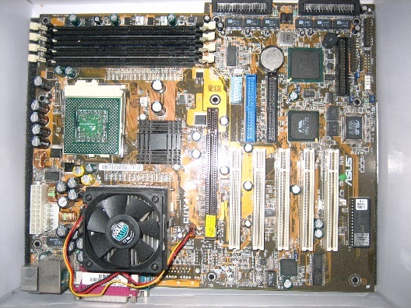
Motherboard. Authored by: Iwan Gabovitch, License: CC BY 2.0

The motherboard is the primary circuit board of a computer to which all components are connected, including the CPU.

Why This Matters
The motherboard connects all of a computer’s components and enables them to communicate. Both general-purpose and special-purpose computers utilize motherboards.

Essential Information
Desktop PCs, laptop PCs, tablets, smartphones, smartwatches, servers, supercomputers, and almost all digital electronic devices have a motherboard that holds system components and allows outside devices to be connected to the system components.

A typical personal computer motherboard includes a socket for the microprocessor, RAM, ROM, expansion slots, and many other components, along with electrical pathways called buses that connect the components.

There are different types of buses that connect different system components. The most important bus on a PC motherboard is the front front-side bus, or FSB. On Intel processors, the FSB connects the CPU to the northbridge, a memory controller hub that controls access to RAM and graphics systems. The FSB feeds data and instructions to the CPU at least as quickly as the CPU can process those instructions. For that reason, FSB speed is important and is typically listed with the specifications of a computer.

The motherboard dictates the form factor of the system components. It may be small and tightly packed with components for tablets or smartphones. Or, it can be large and spacious with powerful components and advanced cooling systems.

Small, inexpensive motherboards containing entire computer systems and costing less than $40, have inspired a generation of makers and hackers. Amateurs and professionals alike are using circuit boards from Arduino and Raspberry Pi to build all kinds of electronic gadgets from robots, to objects on the Internet of Things, to fully functional computers. They are also used as standard computers in poorer regions of the world where standard computers are too expensive to afford—just hook up a keyboard, mouse, and display and you’re ready to go!

Lesson 3.3: Storage Devices

Lesson 3.3 Introduction
Storage. Authored by Marcin Wichary, License: CC BY 2.0

In computing and digital technologies, storage refers to the ability to maintain data within the system temporarily or permanently.

Breakthroughs in storage technologies have empowered individuals to access information anywhere and anytime, easily share information with others, and maintain huge libraries of documents, music, photographs, movies, and other digital information—sometimes in a device no larger than a fingernail.

Storage technologies allow us to carry billions of bytes of data in our pockets to access anywhere, anytime.

Many different types of storage are available to support a wide variety of computing needs. From fast access RAM that supports today’s fastest processors to robotic-delivered magnetic tape cartridges storing petabytes in storage silos, storage is accessed at varying speeds. From ultra-portable micro SD cards and USB flash drives to optical CDs, DVDs, and Blu-ray discs, to huge terabyte hard drives accessed directly on a device or wirelessly in the cloud, storage has many forms and various capacities.

Storage devices and technologies vary in terms of access speed, capacity, portability, and price. Storage media that provide faster access speeds are generally more expensive than media that provide slower access.

The term storage device is used for the hardware that stores and retrieves data. The term storage media is used for the material on which the data is stored. A DVD drive is the storage device, and the DVD is the media where data is stored. In some cases, the device and media are considered one and the same, such as with USB drives and hard drives.

RAM, random access memory, is also called primary storage because it is the main store for data being processed. Secondary storage refers to permanent storage that holds data without the need for electricity. Other forms of storage include ROM (read read-only memory) and graphics memory.

Secondary storage can be classified as either sequential access, as in the case of tape, or direct access, as with disks. Methods of storage include magnetic storage, optical storage, and solid-state storage. A storage device may be located on the computer or device in use, in which case it is considered local storage; or it may be accessed over a network, in which case it is considered network storage. Data may also be stored on Internet servers, in which case it is called cloud storage. This section covers these technologies and shows the benefits and drawbacks of each.

Reading: System Storage
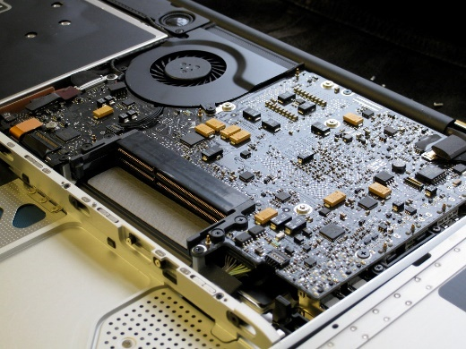
aluminum MacBook memory upgrade. Authored by: blakespot, License: CC BY 2.0

System Storage
System storage refers to storage used by a computer system in its normal operations, which includes RAM, ROM, and video memory.

Why This Matters
The processor works hand-in-hand with system memory, from the moment a computer is turned on to the time it is powered off. System memory provides the instructions required to start the computer. Instructions and information is shuffled in and out of system memory as the processor runs software. Without system memory, the processor would not function.

Essential Information
Read-only memory (ROM) provides permanent storage for data and instructions that do not change, such as firmware—programs and data from the computer manufacturer, including the boot process used to start the computer. ROM stores data, using circuits with states that are fixed. Therefore, the data represented by this combination is not lost if the power is removed. ROM stores a program called the BIOS (basic input/output system). The BIOS stores information about your hardware configuration along with the boot program. The boot program contains the instructions needed to start up the computer. After running some system diagnostics, the boot program loads part of the operating system into RAM and turns over control of the processor to the operating system.

Random access memory (RAM) is temporary, or volatile, memory that stores bytes of data and program instructions for the processor to access. RAM acts as the primary storage area in a computer for software and the data that it works with. RAM plays a crucial role in computer systems and can contribute to or detract from a computer’s performance. Having too little RAM or using low-quality RAM that cannot deliver instructions quickly enough to the processor can cause a computer to drag. Typically, computer manufacturers install RAM in a computer to match the processor’s abilities. Today’s PC operating systems and software require at least 1 GB of RAM for minimal performance quality. Even the most basic computers today come with at least 4 GB of RAM.

RAM exists as a set of chips grouped together on a circuit board called a single in-line memory module (SIMM) or a dual in-line memory module (DIMM). Most of today’s PCs use DIMMs, which have a 64-bit data path—twice that of a SIMM. RAM DIMMs are inserted into slots in the motherboard near the processor. A new desktop computer typically comes with two or four RAM slots, half of which are occupied with DIMMs and half left available for future expansion. Laptop computers typically have two RAM slots. Tablet computers and smartphones have embedded RAM not designed for access by users.

Video memory, sometimes called video RAM, VRAM, or graphics memory, is used to store image data for a computer display in order to speed the processing and display of video and graphics images. Video memory and graphics processing provide important capabilities for today’s graphics-intensive computer systems. Microsoft Windows, Mac OS and today’s demanding 3D computer games require high-capacity video memory and sophisticated graphics support to provide a rich and realistic graphics environment for work and play.

Reading: Magnetic Storage

Magnetic Storage
Magnetic storage is a storage technology that uses the magnetic properties of iron oxide particles rather than electrical charges to store bits and bytes more permanently than RAM.

Why This Matters
Data stored in a computer’s RAM is temporary and only available while the computer is powered on. Magnetically stored data lasts years, even decades, before deteriorating. Magnetic storage, in the form of a hard disk drive (HDD), provides an inexpensive, high-capacity form of permanent storage that acts as the main storage medium in most low-end desktop and laptop computers.

Essential Information
In magnetic storage, a surface is coated with a layer of particles that are organized into addressable regions (formatted). In the process of reading and writing data, a read/write head passes over the particles to determine, or set, the magnetic state of a given region. Two types of media use magnetic storage: disks and tapes.

Magnetic disks are thin steel platters. When reading data from or writing data onto a disk, the computer can go directly to the desired piece of data by positioning the read/write head over the proper track of the revolving disk. Thus, the disk is called a direct access storage medium.

Magnetic disk storage varies widely in capacity and portability. Fixed hard disk (hard drive) storage has large storage capacity—storing terabytes of data on many new laptop and desktop PCs. For these reasons, personal computers rely on the hard drive as the main secondary- storage medium. External hard drives connect to a computer through its USB port and provide a convenient extension to storage or a backup medium to safeguard data. With the price of solid -state drives (SSDs) dropping, many computer manufacturers are moving to SSDs over HDDs since they are much faster than HDDs at delivering data. All Apple MacBooks use SSDs.

Magnetic tape is used by businesses and organizations that need to store and back up large quantities of data. Similar to the kind of tape found in the old audio or video cassettes, magnetic tape is Mylar film coated with iron oxide particles. Magnetic tape is an example of a sequential access storage medium because data is written and read in sequential order from the beginning of the tape to the end. Although access is slower, magnetic tape is usually less expensive than disk storage. For applications that require access to very large amounts of data in a set order, sequential access is ideal. For example, government agencies, such as the U.S. Census Bureau, and large insurance corporations store large quantities of data on tape.

Businesses and organizations often provide large quantities of storage to employees over a network. Server computers can provide a central store for important corporate data for employees to share. Arrays of disks can be formed and used in groups to handle terabytes of data. A technology called a storage area network, or SAN, links many storage devices over a network and treats them as one huge disk. Cloud storage utilizes magnetic disk drives connected to Internet servers to make them accessible anywhere, anytime.

Reading: Optical Storage

Optical Storage
Optical storage media, such as CDs, DVDs, and Blu-ray discs, store bits by using an optical laser to burn pits into the surface of a highly reflective disc.

Why This Matters
Optical storage provides an extremely portable storage medium for quantities of data up to several gigabytes. Although it does not match the high capacity and data access rates of magnetic and solid-state storage, it is ideal for storing music, movies, photos, software, and data for mobile access and sharing.

Essential Information
The 1s and 0s stored on optical discs are read from the disc surface by using a low-power laser that measures the difference in reflected light as it passes over pits burned into the disc surface. Audio CDs that store music, data CDs that store software and computer files, and DVDs and Blu-ray discs that typically store motion pictures and high-def movies all use the same fundamental technology. See the table at the bottom of this page for more details.

The popularity of the CD and DVD rose with the introduction of recordable optical discs. The process of writing to an optical disc is sometimes called burning. Manufacturers use R to indicate that a medium is recordable; that is, it can be written to only once. RW, for rewritable, is used to indicate that a disc can be rewritten numerous times just like a hard drive. Some new PCs come with a combination drive that functions as a CD and DVD burner. Some support Blu-ray as well. Most ultrabooks are so slim that there isn’t room for an optical disk drive.

Since users are increasingly accessing software, music, and movies from the cloud rather than from DVDs, the need for optical disks is diminishing. MacBooks and other super thin laptops have sacrificed their optical drives for a thinner body. Users of these laptops that want to access optical disks must purchase an external device.

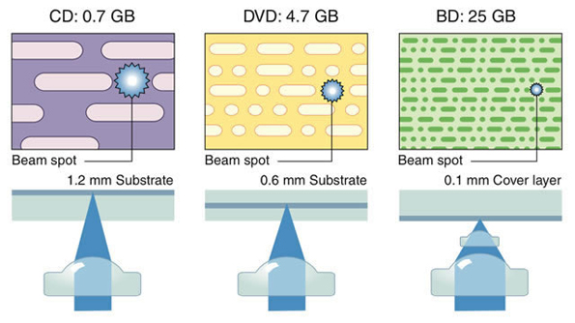
Authored by Cengage Learning, License: CC BY 4.0

Optical Media
Media | Description
CD | A compact disc read-only memory (CD-ROM), commonly referred to as a CD, is an optical medium that stores up to 700 MB of data. CDs are used for music distribution, software distribution, and various forms of data storage.
DVD | A digital video disc read-only memory (DVD-ROM) stores more than 4.7 GB of data in a fashion similar to CDs, except that DVDs can write and read much smaller pits on the disc surface and can sometimes write to and read from multiple disc layers. Unlike a CD, a DVD can store an entire digitized motion picture.
Blu-ray | Blu-ray discs (BDs) make use of the shorter wavelength of blue light to read and write even smaller pits on the optical disc surface for higher capacity. Just as the DVD was developed primarily for motion picture distribution, Blu-ray was developed for high-definition movie distribution. A single-layer disc (25 GB) can hold a 135-minute high-definition movie and still have room for two hours of bonus material in standard definition. Two-layer discs storing 50 GB are available, and there is talk of 100 and 200 GB versions coming soon.

Reading: Solid-State Storage
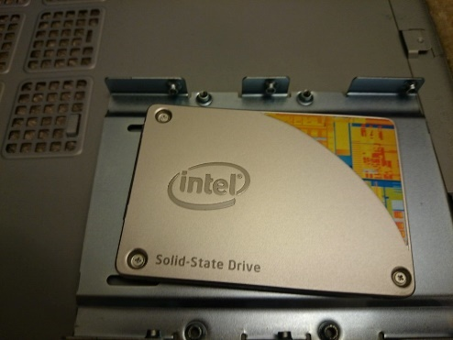
Solid State Drive. Authored by: ericnvntr, License: CC BY 2.0

Solid-State Storage
A solid-state storage device stores data using solid-state electronics such as transistors and, unlike magnetic and optical media, does not require any moving mechanical parts.

Why This Matters
Magnetic storage devices have high capacity and are convenient in terms of read and write ability, but they have slow data access rates due to the use of mechanical moving parts. Optical storage media is convenient in terms of mobility but has limited storage capacity and is slow to write to. Solid-state storage devices offer fast access times because they have no moving parts. They are also increasing in capacity, and dropping in price each year and can store nearly as much as hard drives. As the cost of solid-state storage continues to decrease, it will continue to replace uses of magnetic storage on many devices.

Essential Information
Solid-state storage devices store data permanently without any moving parts or the need for electricity. Flash memory is a form of solid-state storage that updates (flashes) the data it holds in large blocks. Unlike other secondary storage, such as magnetic disks and tapes and optical CDs and DVDs, flash memory requires no moving parts to read and write data. It is therefore much faster and much quieter, requires less power, and produces less heat. Because of these significant benefits, solid-state storage looks to be the wave of the future. The slightly higher price of the technology is the only thing holding it back from replacing other forms of secondary storage; however, prices are rapidly dropping. Solid-state storage devices include flash memory cards, USB flash drives, and solid-state drives.

A flash memory card is a small chip encased in a plastic housing that stores data permanently without the need for power. Flash chips are small and can be easily modified and reprogrammed, which makes them popular in computers, smartphones, digital cameras, and other products. When used in devices such as digital cameras, camcorders, and digital music players, flash memory cards are sometimes referred to as media cards. Secure Digital (SD) cards, mini SD cards, and micro SD cards are popular flash memory cards for mobile phones, digital cameras, and other devices that need to store a lot of data in a tiny package.

A flash drive—also called a USB drive or thumb drive—is a small flash memory module about the size of your thumb or smaller that conveniently plugs into the USB port of a PC or other digital electronics device to provide convenient, portable, high-capacity storage. Although they are called drives, they contain no moving parts. A 64 GB flash drive can be purchased for around $15.

As flash drives grow in capacity and capability, they are threatening the future of magnetic hard drives as the first choice for secondary storage in PCs. Samsung produced the first solid-state disks (SSDs) using flash technology to replace the traditional magnetic hard drive in PCs. An SSD reads data 300 percent faster and writes data 150 percent faster than a traditional hard drive. It boots up a computer much faster, is lighter and more durable, uses less power, and runs cooler and quieter than a hard drive (in fact, it is silent). SSDs are being used in MacBooks, ultrabooks, and small, light sub-notebooks and are making their way into the mainstream market. SSDs are also used as the storage media for tablets, smartphones, and digital media players.

Reading: Cloud Storage

Cloud Storage
Cloud storage stores data on Internet servers for access from any Internet-connected device.

Why This Matters
Cloud storage is fundamentally changing the way people use digital technologies. It offers important benefits, including the ability to store files and media in a single location for access from any location or device. Also, it makes it easy to share and collaborate on files. The drawback is that if you lose Internet connectivity, you may no longer have access to your files.

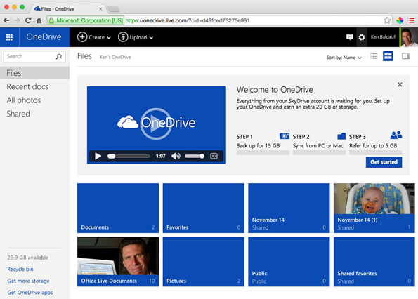
Authored: Courtesy of Microsoft Corporation, License: Fair Use

Essential Information
People are storing increasing amounts of data and information online. Photos are uploaded to Facebook, iCloud, or some other online service; movies and music are streamed from Netflix, iTunes, Amazon, or Google; email, calendar, and contacts are stored online; and more and more files are being stored on Microsoft OneDrive, iCloud, Google Drive, Dropbox, and other services.

A few years ago, the Internet was given a new catchy name: the cloud. The name comes from the use of a cloud image to represent the Internet on network diagrams. Many functions and services that used to be managed by local computers, are now being managed by Internet servers in “the cloud.” Storage is among the most useful of those services.

The ability to store and access files and media from the cloud across all of your devices has eliminated the need to manually “sync” files between devices. It has also made sharing documents with others much easier. Several group members can edit a single document. Each person’s edits are marked for easy reference. Versioning features allow old versions of a document to be accessed.

Microsoft, Google, and Apple allow members generous amounts of storage space for documents. Cloud storage is an important consideration when choosing a technology ecosystem. The more files that are stored in the cloud, the more difficult it becomes to move them to a new cloud storage provider. This is especially true for media such as movies, music, and books.

The down side of cloud storage is that, usually, documents and media are not available unless you have access to the Internet. This can become a significant problem in underserved areas. The most popular cloud storage services now have tools that allow users to store copies of documents on their devices for access while offline. It is easy to imagine a time in the not-too-distant future when the idea of storing files on a device will be an unusual concept. Someday you will be telling your grandchildren about the old days, before the cloud, when files were stored on drives.

Lesson 3.4: I/O Devices

Lesson 3.4 Introduction
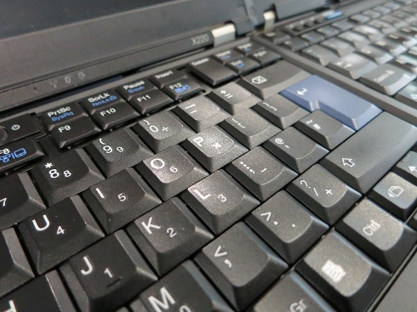
Non-shiny new X220 keyboard. Authored by: Kai Hendry, License: CC BY 2.0
I/O refers to input and output —the manner in which data is received into a computer system, and the manner in which information and the results of processing are provided to the user.

Users interact with computers through input and output (I/O) devices. Of all the computer hardware components, I/O devices have the most direct impact on a user’s computing experience. To accommodate a wide variety of data and the many environments in which data is processed, there are literally hundreds of different input devices on the market. By learning about input devices, you also learn what computers are capable of. Output devices connect directly with our senses. Although most output from a computer is visual, much is auditory, and some more exotic devices even affect our other senses.

Personal computers typically use only a handful of I/O devices. Nearly everyone is familiar with the keyboard, mouse, display, and printer. More recent product designs present new methods of input. Touch pads and multitouch displays make it simple to navigate the interfaces of mobile devices. Speech recognition systems like Siri, with audible responses, make it possible to interact with devices without touching a thing or looking at a display.

Professional environments sometimes require specially designed input devices in order to capture data more directly. From drawing tablets used by graphic artists, to magnetic ink character readers used by banks, to bar code readers used at the supermarket, a variety of input devices have been designed to accommodate the unique needs of professionals.

In addition to input and output devices, many computers accommodate other types of devices, such as wireless adapters and external storage. Many different types of devices can be connected to computers and mobile devices to expand their capabilities. One example is a sensor that can be connected to an iPhone to test food for allergens. The ability to increase the capabilities of a computer system by connecting external devices, referred to as peripherals, is called expansion.

Reading: Input Device

Input Device
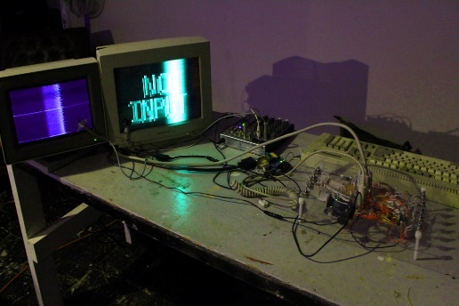
No input - Arcanebolt. Authored by Rosa Menkman, License :CC BY 2.0
An input device assists in capturing and entering data into a computer system.

Why This Matters
Getting data into a computer system rapidly and accurately is the purpose of input devices. Some activities have very specific needs for input, requiring devices that perform specific functions. For example, many reporters use digital recorders to record and transcribe human speech to ease the stress of typing late-breaking stories. The more specialized the application, the more specialized the associated I/O device. Self-checkout systems include many input devices such as touch screens, keypads, bar code scanners, sensors, and scales.

Essential Information
Different types of input devices are designed to accept different types of data. Human-readable data can be directly read and understood by humans. A sheet of paper containing lists of customers is an example of human-readable data. In contrast, machine-readable data is read by computer devices. Customer data that is stored on a disk is an example of machine-readable data. It is possible for data to be both human-readable and machine-readable. For example, people and computer systems can both read the scantron sheets used for some multiple-choice exams.

Regardless of how data gets into the computer, it is important that it be captured near its source to avoid data entry errors. Source data automation involves automating data entry where the data is created, thus ensuring accuracy and timeliness. Source data automation is used by librarians who use scanners to check out and check in library materials. Rental-car companies use automated scanners that scan vehicles as they exit and enter the rental lot. The scanner collects data on the vehicle, including gas gauge data, mileage, date, and time, and prepares a customer invoice before the customer returns to the counter.

Input devices can be classified as either general-purpose or special-purpose. A general-purpose input device is designed to be used for a wide variety of computing activities. This category of I/O devices includes keyboards and mice. A special-purpose input device is designed for one unique purpose. An example of a special-purpose input device is the pill-sized camera from Given Imaging, called the PillCam, which, when swallowed, records images of the stomach and the small intestine as it passes through the digestive system.

Reading: General-Purpose Input Device

General-Purpose Input Device
A general-purpose input device is an input device that is designed to be used for a wide variety of computing activities.

Why This Matters
Many computing activities across platforms have common input needs. For example, many computer devices require a way in which to input characters and to select items on the display. For these purposes, a keyboard and pointing device are ideal. There are many different variations of these two common general-purpose input devices. On mobile devices, input is typically accepted through touch screen and voice commands.

Essential Information
QWERTY keyboards, named after the first five characters used in the keyboard’s design, are alphanumeric data entry devices used on all types of personal computers as well as mobile devices. They provide fast, one-character-at-a-time input for users with keyboarding skills. Some variations on the traditional QWERTY keyboard are available, including Microsoft’s ergonomic keyboard, which that was designed to reduce the risk of carpal tunnel syndrome (CTS). Soft keyboards (or software keyboards) provide a picture of a keyboard for typing on touch-sensitive displays. They are used primarily on tablet computers and smartphones. Some people have difficulty typing on soft keyboards due to the lack of tactile feedback. Soft keyboards also take up valuable screen real estate. External keyboards can be connected to tablets to make typing easier and to reclaim screen space.

Several types of pointing devices are used to select objects on a display. A mouse is used on desktop and laptop PCs to move the mouse pointer on the display. On laptop PCs, a touch pad can be used in place of a mouse. On devices with touch screens, a pointing device isn’t necessary since the user simply touches the display to select items.

Touch screens used on some smartphones, tablets, and kiosks, allow the user to select items on the screen by touching them directly with a finger or stylus—a pen-like device. Some touch screens support handwriting recognition, enabling the user to write letters or words on the display with a stylus and automatically translating them into ASCII characters through the use of artificial intelligence. Multitouch displays allow the user to use two, three, or up to all 10 fingers on a touch display to manipulate objects on the display. For example, two fingers moving apart on the screen causes an object to zoom in, the opposite motion zooms out, and a twisting motion rotates an object.

Microphones serve as yet another general-purpose input device. Microphones can take human speech as input, digitize the sound waves, and use natural language processing to translate the input into dictated text that appears on the screen or into commands. Apple’s Siri, Google Now, and Microsoft Cortana, and Amazon Alexa, serve as AI-driven personal assistants to send messages, request information, schedule meetings, place phone calls, and complete other tasks.

Speech recognition software can also be used to take dictation, translating spoken words into text. Voice recognition, a similar technology, can be used by security systems to allow only authorized personnel into restricted areas.

Reading: Special-Purpose Input Device

Special-Purpose Input Device
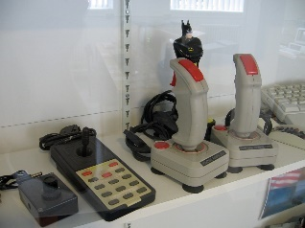
Input devices. Authored by Marcin Wichary, License: CC BY 2.0
A special-purpose input device is designed to provide input for one specific type of activity.

Why This Matters
Many software applications require unique input devices to input specialized types of data in a convenient and reliable manner. The medical profession utilizes hundreds of such devices to collect biological information. Businesses use varying types of scanners to automate the collection of standardized information. Special-purpose input devices are available for nearly every industry and for many personal applications.

Essential Information
Video game enthusiasts enjoy specialized input devices that let them quickly react to game action. Most gamers prefer to use a game controller device to control game characters and objects; some games, such as flight simulators, are easier to navigate using a joystick, a device resembling a stick shift. The Nintendo Wii brought entirely new forms of input to gaming, utilizing motion sensors in handheld controllers to control gaming action, and with Wii U, a tablet controller with a second display. Microsoft developed Kinect, a motion motion-detecting controller for the Xbox that allows gamers to control game characters just by moving their body. The Kinect can also be used to control television programming with hand gestures and voice. Leap Motion designed a gesture control input device that can be attached to a laptop computer. Games designed for smartphones make use of the built-in accelerometer, which allows for controlling game-play by holding the device at different angles. Guitar Hero and Rock Band video games make use of toy instruments that act as input devices to play virtual instruments in the game.

A digital camera can be connected to a PC or embedded in a laptop computer to provide photo and video input to the computer. A webcam is an inexpensive video camera that has become popular for video chat over the Internet.

You can input both image and character data using a scanning device. Both page scanners and handheld scanners can convert monochrome or color pictures, forms, text, and other images into digital images. Biometric scanners and software can verify an individual’s identity by examining biological traits such as retinal or iris patterns, fingerprints, or facial features.

Businesses and organizations use a number of special-purpose scanners and optical readers to collect data. A magnetic ink character recognition (MICR) device reads special magnetic-ink characters such as those written on the bottom of checks. Optical mark recognition (OMR) readers read “bubbled-in” forms commonly used in examinations and polling. Optical character recognition (OCR) readers read hand-printed characters. Point-of-sale (POS) devices are terminals or I/O devices connected to larger systems, with scanners that read codes on retail items and enter the item number into a computer system.

Card swipers are yet another way to collect data into a computer. Card swipers are used to verify the identity of individuals wishing to access secure locations. Card swipers are also used to facilitate credit card transactions. Devices from Square and PayPal allow smartphone users to use their phones as card swipers to conduct credit card transactions over the Internet. Wireless technologies such as near field communication (NFC) are beginning to replace card swipes. Using Google Wallet or Apple Pay, customers can swipe their smartphones across a receiver pad at checkout to pay for their purchases. This is an example of how output from one device can serve as input to another.

Reading: Output Device

Output Device
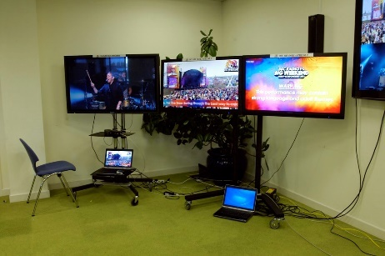
Output. Authored by Steve Bowbrick, License: CC BY 2.0
An output device allows a user to observe the results of computer processing with one or more senses.

Why This Matters
Output devices communicate the results of processing to the computer user. Output devices are evaluated by the efficiency and effectiveness with which they communicate different types of information in different types of environments. A good output device delivers information—visual, audio, or other—in a manner that allows the information to be interpreted easily and, in some situations, enjoyably.

Essential Information
Computer output consists of the results of processing produced in a manner that is observable by human senses or that can be used as input into another system. Output can be visual (on a display or printed page) or audio (through speakers or headphones). In the case of virtual reality systems, output can even be tactile and olfactory to recreate realistic environments. High-quality output can provide realistic impressions. Telepresence uses large high-def displays and surround sound to allow individuals to meet around a virtual conference table and hold meaningful remote discussions without the need for travel.

Output from one system can be provided to another system as input. For example, a smartphone can be used as a remote control for a television, and a GPS navigation system can be used to control an auto-pilot system on an unmanned aerial vehicle (UAV).

Reading: Display

Display
A display provides visual computer output for observation on a monitor or screen.

Why This Matters
The most common form of computer output is visual on a display. There is a wide assortment of displays and display technologies, each designed to provide an appropriate quality image for specific environments and applications. From checkout counter displays to hi-def television displays, from small smartphone displays to jumbo LCD displays at stadiums, displays are an ever-increasing part of our daily lives.

Essential Information
Remarkable progress has been made with display screens (sometimes called monitors), including those used with personal computers. With today’s wide selection of monitors and displays, price and overall quality can vary tremendously. The table below lists the primary types of display technologies used today.

The first consideration when selecting a display is typically size, measured diagonally, from corner to opposite corner, across the screen. Many sizes are available to meet every computing and media need. Smartphone displays range roughly from 3 to 5 inches; tablets and ebook readers from 5 to 10 inches; 11 to 17 inches for laptop computers; and 17 to 27 or more inches for desktop displays.

There are several types of display technologies in use today (listed in the table at the bottom of this page). Most computers use LCD (liquid crystal display) technology, although LED (light-emitting diode) and OLED (organic LED) are becoming more common on high-end laptop PCs. The trend has been toward technologies that provide clearer, crisper images that require less power. Perhaps the only exceptions to this trend are ebooks. The original ebook reader, the Kindle, sacrificed image quality for lower power consumption. The e-ink displays used in the early ebook readers do not use a backlight, are easy to read in outdoor light, and provide a monochrome image that is ideal for displaying the pages of a book.

Traditional computer displays use a 4:3 format: four units wide and three units tall. More recently, a widescreen format has become popular that uses either a 16:9 or 16:10 ratio. Widescreen formats are used by motion pictures and are also handy for viewing documents side-by-side on the display.

The quality of a display image is often measured in pixels—picture elements, that combine to form an image on a display. Display resolution is a measure, in width by height, of the number of pixels on the screen. Display resolutions range from 1334-by-750 for an iPhone 7, to 2880-by-1800 for a 15″ laptop display, to 3840 × 2160 resolution for a top-of-the-line 78″ 4K Ultra HD Smart TV, to 5120- by- 2880 for a top-of-the-line 27″ desktop computer display. Note that the 27″ desktop display actually has a higher resolution than the 78″ HD TV, which works well because the audience is sitting much further back from the TV than the computer user is sitting from the display.

A video card (graphics card) controls the video output for computers. These circuit boards combine video processing and storage onto an expansion card or integrate them onto the motherboard to manage video images for display. Today’s high-end graphics cards include a graphics processing unit (GPU) to process the graphics and take the load off the CPU. They also include video memory, video BIOS, and a RAM digital-to-analog converter or RAMDAC. Support for special 3D processing in high resolution and highly detailed colors and shading may also be included. The quality of the graphics card has a big impact on the virtual environments of computer games.

Today’s display technologies offer many options for televisions as well as computers. High definition TV (HDTV) delivers a resolution of 1920×1080p, called 1080p, that is more than twice that of traditional television displays for sharper, crisper images. HDTV uses a widescreen format, which means it uses the same height and width ratio used in movie theaters. HDTVs have begun using OLED technology to produce even sharper images with deeper blacks on large displays that consume less power than plasma or LCD TVs. The latest TV display technology is called Ultra HDTV (UHDTV) or 4K for short since it delivers roughly 4,000 horizontal pixels (3840 x 2160 to be precise), that’s twice as many pixels delivered by 1080p hi-def.

3D displays use polarization technologies that generally require the viewer to wear special glasses to experience the 3D effect. These displays add depth and realism to sports, movies, and computer games. Content providers are working hard to create content that takes advantage of 3D displays. Manufacturers are working to refine 3D technologies so that viewers need not wear special glasses. 3D displays have also been used for handheld games, smartphones, and computer displays.

While 3D televisions aren’t selling as manufacturers had hoped, virtual reality (VR) systems sales are increasing significantly. VR systems use headset displays that place the wearer right in the middle of the action. Augmented reality uses glasses that allow the wearer to see the real world with computer-generated objects overlaid across the scene.

Display Technologies
Technology | Description
Liquid crystal display (LCD) | A thin, flat display that uses liquid crystal—an organic, oil-like material—placed between two pieces of glass to form characters and graphics images on a backlit screen. LCDs are popular for all types of personal computers and televisions.
Plasma display | A thin, flat display that uses plasma gas between two flat panels to excite phosphors and create light. Plasma displays are used primarily for televisions and compete head-to-head with LCD in that market.
Light emitting diode (LED) display | A thin, flat display that utilizes LEDs to provide the backlight for the display rather than the fluorescent light used in traditional LCDs. LED is gaining in popularity as a green technology that uses less energy, does not require the use of mercury in its production, and presents a bright, brilliant image.
OLED (organic light-emitting diode) | Similar to LED, with the ability to create the best picture quality of any technology with deep blacks and brilliant colors on a super-thin display.
Electronic paper (e-paper) | A technology that does not use backlighting like other display technologies but instead uses pixels made of particles or oils that reflect light to more closely resemble the pages of a book. E-paper requires less energy and is easier to see in outdoor lighting but is impossible to read in the dark. E-paper is used for ebook readers like the Kindle, although some more recent ebook readers use color LED displays.
Flexible display | Samsung and others are working on delivering flexible displays that provide color images on a flexible film of plastic. The new technology not only provides some interesting new display applications but also provides us with displays that won’t shatter if you drop them.
Cathode ray tube (CRT) display | Deep, relatively bulky display that uses a large vacuum tube in which an electron gun shoots an electron beam rapidly across a fluorescent screen to create moving images. CRT displays have effectively been replaced by thin display technologies.
Head-up display (HUD) | A transparent display that presents data as a layer on top of a normal field of view. Used by fighter pilots, and more recently by the general population with the release of Google Glass, a glasses-mounted display, and Microsoft Hololense.
Virtual reality (VR) headset | A headset strapped over the head covering the eyes with a box containing two displays (one for each eye) that provide a 3D view of a virtual world that can be navigated with hand controls and viewed by rotating the head.
LCD projector | LCD projectors are designed to project presentations from your computer onto a larger screen. Typically costing thousands of dollars, these portable devices are a must-have item for businesspeople who make presentations to large audiences.

Reading: Printer

Printer
Printer. Authored by: projectidea, License: CC BY 2.0
A printer is an output device dedicated to providing computer output printed on paper.

Why This Matters
Computer users often wish to create printed copies of the work they’ve created. It may be output that is as simple as a grocery list, or it may be something as serious as a work of art ready for framing. There are many types of printers that provide varying quality of paper-based output, as well as specialized printers that produce three-dimensional output.

Essential Information
A useful and popular form of output is called hard copy, which is paper output from a printer. A variety of printers with different speeds, features, and capabilities are available.

The speed of a printer is typically measured by the number of pages printed per minute (ppm). The quality of resolution of printers is similar to the resolution of displays. A printer’s output resolution depends on the number of dots printed per inch. A printer with a 600 dots-per-inch (dpi) resolution prints more clearly than one with a 300-dpi resolution. When shopping for a printer, consider the quality of the output (judged by resolution specs and personal evaluation of the printed copy), the speed of the printer (pages per minute or ppm), the price of the printer, and how quickly the printer consumes toner or ink along with the price of toner refills. Also consider which printers work with your computer platform. Not all printers work with Mac computers, for example. The initial investment in a printer typically pales in comparison to the price of toner or ink cartridge refills over time.

Some printers combine printing capabilities with other useful functions. All-in-one, or multifunction, printers combine printing, copying, and faxing functions. Wi-Fi printers connect to your home or work Wi-Fi network so that they are accessible to any device on the network. More recent innovations, such as Google’s Cloud Print, allow printers to connect to the Internet so they can be accessed from any computer with an Internet connection.

Types of Printers
Printer Type | Description
Laser printer | A laser printer uses techniques similar to those of photocopiers to provide the highest-quality printed output. Color laser printers can be rather expensive, so many home users settle for either a less expensive black and white laser or a color ink-jet printer.
Ink- jet printer | An ink-jet printer sprays droplets from ink cartridges onto paper to create pixels. Although ink-jet printers create good-looking hard copy, it is not quite as polished as what laser printers provide. Also, ink may run if it gets wet, so use care when printing addresses onto envelopes and hope they aren’t delivered on a rainy

Reading: 3D Printer

3D Printer
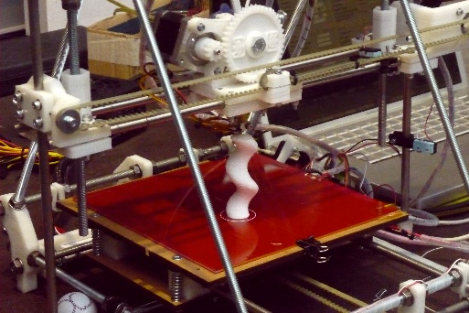
3D printer. Authored by Mirko Tobias Schäfer, License: CC BY 2.0
A 3D printer builds 3D objects by adding one layer of material at a time from the bottom up until the object is completed.

Why This Matters
Just as digitization changed the world by allowing us to represent real-world objects digitally, 3D printing is changing the world by allowing us to turn bits into tangible objects. 3D printing is empowering individuals to transform ideas into usable objects, powering the “maker” revolution. In addition to inspiring hobbyists, 3D printing is transforming every industry from healthcare to food and fashion, to engineering and manufacturing by allowing professionals to test ideas, and easily manufacture custom products.

Essential Information
Many people have seen or heard about simple 3D printers that print small plastic objects. These printers are available at Walmart, Home Depot, and other retail stores for around $1,000. Using these consumer-grade printers and raw material called filament, individuals can print out small toys and novelty items as well as useful utensils for the home.

What many people don’t realize is that these small consumer 3D printers make up only a small portion of the 3D printing movement. Today, people are printing in just about every available material, including plastic, nylon, wood, clay, concrete, and metals, and even glass and carbon fiber using printers ranging in cost from $500 to $500,000.

A more sophisticated and accurate name for 3D printing is additive manufacturing. There are four techniques for additive manufacturing, shown in the table below:

3D Printing (Additive Manufacturing) Techniques
Technique | Description
Fused deposition modeling (FDM) | A model is produced by extruding small beads of material, which harden quickly to form layers.
Granular materials binding | A model is produced by laying out one layer of powder at a time and applying heat or liquid to selective areas of each layer to bind the powder into a solid.
Lamination | A model is produced by bonding layers of a material—typically sheets of paper—and cutting each layer at specific points.
Stereolithography | Produces a solid part from a liquid polymer one layer at a time, solidifying the polymer with UV light.

3D printers print objects from an STL (stereolithography) file (STL stands for stereolithography). There are several ways to acquire STL files. Many printers come with a catalogue of files to print. They are also freely available at thingiverse.com. Another way to acquire STL files is to scan physical items with a 3D scanner. A final way to produce an STL file is to create it from scratch using CAD or 3D design software such as AutoCAD, Maya, Rhino, Blender, or Tinkercad.

3D printing is most useful for rapid prototyping and customization. Rapid prototyping allows engineers and designers to experiment with designs for parts and products quickly and easily. Prior to 3D printing, it was costly and time consuming to have models created from designs. 3D printing is especially useful for creating one-of-a-kind products, something costly and time consuming for traditional mass production systems.

The following table shows how 3D printing is impacting many professions and industries.

3D Printing Professional Uses
Profession | Possible uses
Engineer, architect, interior design | 3D printing allows these professionals to test their designs and view them in three dimensions rather than on the computer screen.
Sculptors, potters, and artists | 3D printing is being used to create sculpture and ceramics. Artists can create works of art with clay or other materials and then further craft the objects with their hands.
Construction | Using massive 3D printers, buildings and building parts can be constructed in any shape and design that can be imagined.
Physicians | Bio printing is a form of 3D printing that builds organs from stem cells.
Chefs and nutritionists | 3D printing makes it possible to create food items from specific ingredients in a variety of shapes to meet an individual’s nutritional needs and tastes. Meat and leather are being printed from cow cells. Chefs are creating candy confections from chocolate and sugar.
Fashion | Designers are printing shoes, headwear, jewelry, and even clothing from a variety of materials in unique shapes and forms.
Education | Classroom lab objects and manipulatives can be printed for a fraction of the cost that schools typically pay. Museums are also making their collections available to download and print.

Reading: Audio and Special Media Output

Audio and Special Media Output
Speakers. Authored by futureshape, License: CC BY 2.0
There are a number of audio and special media output devices designed to provide output to all of the senses.

Why This Matters
Since the early days of the PC, speakers have been used to provide audio output to users. With the development of mobile digital media devices and their rapid adoption by the public, headphones have become popular for enjoying audio output. As computer scientists work to create more realistic virtual environments, output devices have been designed to provide information to all of the senses.

Essential Information
Most of today’s personal computers include at least low-quality speakers to output sound. Sound is used by the computer’s operating system and other software to cue the user to certain events—for example, the flourish of music that plays when Microsoft Windows starts up and shuts down. Other event-driven sounds draw the user’s attention to important information, such as a beep when something goes wrong or a ding when a new text message arrives.

Sound systems also support entertainment applications. Headphones are used for portable digital music players and mobile phones or in situations where the user wishes to listen to media without disturbing others.

Multimedia and video gaming enthusiasts often purchase more expensive sound systems for their computers. For example, a surround sound system with a subwoofer can provide additional realism to games in a virtual reality simulation or to a hi-def movie.

A computer’s ability to output sound is particularly important to make computing more accessible to individuals with limited vision. Screen-reader programs, such as JAWS by the Freedom Scientific Corporation, read aloud the text displayed on the screen.

Output devices have been designed for every human sense. When you silence your mobile phone, you may set it to vibrate to alert you to arriving calls. Output that you can feel is referred to as haptic output. Digital scent technology includes a USB device that can deliver thousands of fragrances as commanded by the computer. One company even produced an experimental printer that printed flavored pieces of paper for tasting samples sent over the Internet.

The area of virtual reality has produced a number of unique and interesting I/O devices as well. For example, the virtual reality headset—a type of head-mounted display—can project output in the form of three-dimensional color images. Spatial sensors in the headset act as input devices, and when you move your head, images and sounds in your headset change. Virtual reality devices allow architects to design and “walk through” buildings before they begin construction. They allow physicians to practice surgery though virtual operations and pilots to simulate flights without ever leaving the ground. Head-mounted displays have entered the consumer market in the form of opaque spectacles that allow the user to view video from a media player or computer.

Reading: Expansion

Expansion
Expansion refers to a computer’s capacity to interface with a variety of external devices, such as I/O devices, network devices, and storage devices, by connecting through ports, slots, and wireless technologies.

Why This Matters
Many computer systems accommodate different types of I/O devices as well as network connections and external storage. The ability to increase the capabilities of a computer system by connecting external devices, referred to as peripherals, is called expansion. Expansion allows computer users to enjoy computing benefits above and beyond those provided by the computer alone.

Essential Information
Most computers provide users with the means to add devices and expand their computer’s functionality. A desktop computer user might wish to add a video card for high-quality gaming; a laptop user might want to add a cellular connect card to gain access to the Internet; and a tablet user might want to add a Bluetooth keyboard for more convenient typing.

The universal serial bus, commonly referred to as USB, was invented to standardize computer interfaces around one type of connection. Today’s computers come with a number of USB ports that all kinds of devices can use. It is not unusual to find six or more USB ports on a new computer, into which you can plug the keyboard, mouse, and additional devices of your choice, such as mobile phones, digital cameras, network devices, musical instruments, joysticks, memory modules, and other devices, all using a common connector design. USB provides not only a connection to the computer for data transfer but also a power line that can be used to power a number of useful and entertaining gadgets, such as keyboard lights, fans, hard drives, and even miniature Christmas trees. There are three versions of USB, each faster than the previous. The fastest, USB 3.0, is used on many of today’s new PCs.

More specialized peripheral devices may come with their own circuit board, called an expansion board or expansion card, to be installed in a desktop computer. Installation of these devices is not as convenient as simply plugging in a USB connector, but typically it is straightforward. The method of installing expansion cards varies from machine to machine, so users should consult their owner’s manual for specific instructions.

Wireless technologies can also be used to expand the capabilities of a computer. For example, a cell phone can be connected to a headset over a Bluetooth wireless connection to provide hands-free operation.

Module 4

Introduction
Software. Authored by: trendingtopics, License: CC BY 2.0
Software refers to the electronic instructions that govern a computer’s actions in order to provide a computing service.

Today, software goes by many names, including applications, apps, and programs. The 21st century has seen an explosion of all sorts of software. The mobile computing revolution and cloud computing have created opportunities for millions of apps that provide services anywhere, anytime for every need across desktop and mobile platforms. Today it’s more important than ever to learn about the apps that are available, how they work, and how they are created.

Apps are becoming a major force in the U.S. and global economies. The most innovative and successful companies—Apple, Google, Microsoft, Adobe, Intuit, and dozens of others—have made fortunes off seemingly simple apps that serve a valuable purpose. The U.S. is looking to its youth for the entrepreneurial spirit that can continue innovating and help the country to maintain its leadership role in the global economy. But, is the U.S. educational system supporting these expectations?

There is a big push to encourage students to study STEM subjects: Science, Technology, Engineering, and Math. However, programming and computer science have not become core subjects in the K–12 curriculum. Is it possible for young entrepreneurs to carry their visions through to reality without understanding computer code? If programming, like math, was taught to all students at an early age, would it impact the amount of interesting software produced in the U.S. in the next decade or two? How about you? Do you have any ideas for a cool new app? Do you have the skills to implement them? Are you interested in learning how?

A decade ago, the thousands of apps developed by professional software companies for PCs seemed excessive; today, there are millions of apps, many of which are created by students like you. Traditional apps for PCs and businesses are as important today as ever, but now they are accessible across desktop and mobile devices and joined by hundreds of thousands of mobile apps to meet every need. In addition to installed apps on PCs and mobile devices, there are thousands of web apps that run in browsers on any Internet-connected device, and apps designed to run in and with popular online services like Facebook and Twitter.

If you boil down all of the millions of apps available for all the different types of computers and devices, you end up with two basic types: system software and application software. System software assists computer hardware with the work it is designed to do. Examples include operating systems and antivirus software. Application software, on the other hand, assists people with the work and activities that people do. Examples include spreadsheet software and social media software. There are many different types of system and application software as well as various methods of acquiring them.

Software is designed and developed by software engineers who use programming languages to encode the logic of the software in a manner that a processor can execute. Software usually consists of a number of files, ranging from a single file to dozens of files or more. At least one of the files associated with a program is an executable program file—the file that contains the processing instructions for the processor to execute.

There are many ways to start or run software. The most common way is to click or tap an icon on the desktop or in a program’s or application’s menu to launch the executable program file. When a program such as a word processor is started, machine-level program instructions are copied from the executable program file in permanent storage into the computer’s RAM. Once in memory, the instructions are transferred to the CPU and executed.

This unit provides information on how software is created, acquired, used, maintained, and managed.
Apple and Google have very different approaches to controlling the software allowed onto their mobile devices. Apple applies strict controls over what software is allowed in its App Store, where hundreds of thousands of apps are available for download. Applications that are ethically or morally questionable are not allowed. You will not find any porn apps in Apple’s App Store, nor will you find any apps that promote hate crimes, warn you of police speed traps, or insult the sensibilities of law-abiding, ethically minded citizens. Apple has been criticized for censoring its app selection. Because Apple is a private company, its software is proprietary, and it is not obligated to support freedom of expression. The iPhone remains the best-selling smartphone on the market.

Google, in contrast, has an open-door policy in its Google Play store, where hundreds of thousands of apps are available for users of Android smartphones, tablets, and Chromebooks. Android is an open-source operating system, and Google figures its app store should be open as well. All kinds of possibly offensive apps can be found in Google Play. It also has hundreds of apps that are written specifically to hack users’ phones and steal their data. As Google learns of apps that have illegal intentions, or malware, it removes them from its store. However, Android has become a popular target for hackers and suffers from more virus attacks than Microsoft Windows, while the iPhone remains relatively unscathed. Nonetheless, Android fans appreciate the freedom that Google provides its developers and users. The many varieties of Android phones on the market combined outsell the iPhone.

Which approach do you prefer for your own smartphone needs? Which do you think is a better business model? Which is the best model to drive innovation in the market?

Lesson 4.1: Software Development

Lesson 4.1 Introduction

Software Development
Software development is the systematic process of transforming a software idea into functional software.

Why This Matters
Software begins as a concept or idea for some new or improved use for a computer. Today’s software developers, sometimes called software engineers, create software for many different types of computers, including PCs, tablets, smartphones, servers, and supercomputers. Understanding what computers are capable of is very useful in determining if a software concept is feasible. A developer who specializes in mobile software needs to understand the platforms: Apple iOS, Google Android, and Microsoft Windows Phone. The developer also needs to know the capabilities of the handsets, including processor capabilities, storage capacity, display size, wireless technologies, and whether they have GPS, an accelerometer, a compass, or other sensors. Understanding these capabilities provides the developer with ideas for new apps. For example, the iPhone includes an RFID chip that allows app developers to include contactless payments in apps. iPhone developers also need to learn how to utilize the iPhone’s fingertip scanner for authentication. Apple, Google, Microsoft, Facebook, and others provide tools to make it easier to develop software for their platforms. Today, all types of people are developing new apps.

Authored by Google, License: Fair Use

Essential Information
Software development is a process typically guided by a model that provides sequential steps to take software from concept to reality. The most common model is called the software development life cycle or sometimes the software life cycle.

The software development life cycle (SDLC) is a five-stage process that begins with requirements analysis, proceeds to the design stage, and is followed by implementation, verification (testing), and maintenance. The SDLC is sometimes referred to as the waterfall model because development flows from one stage to the next.

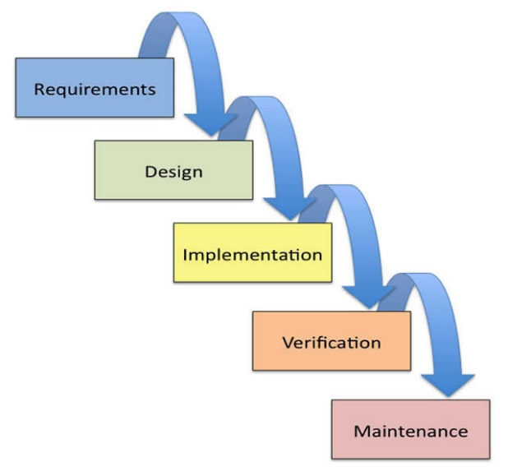
Authored by: Cengage Learning, License: CC BY 4.0

The SDLC is a cycle because often when software is in its final stage, the maintenance stage, an improved version of the software begins development in the first stage. In this manner, many software packages are in a continuous improvement cycle over many years. Also, although the SDLC is like a waterfall in most ways, when errors are identified and corrections are needed, it requires the water to “flow uphill,” back to a previous stage.

Although the waterfall model is popular and has been in use for many years, newer models are finding favor with some developers. Agile software development techniques such as Extreme Programming (XP) use an iterative process where development steps are small and incorporate frequent testing and user feedback to verify that each step is successful.

Distributed revision control systems (DRCS) such as Github have become important tools for groups of developers working together to create and improve software. Using Github, multiple programmers can add new features to software simultaneously without concern for overwriting each other’s work. Github maintains a history of the revisions and allows a central coordinator to pick and choose which features to implement in the final version. Many open source software products are managed using these types of systems.

Whether software is being developed by a team of dozens of software engineers for a major software vendor, by a group of individuals volunteering time on an open source project, or by an individual working on a personal project, using an orderly, stepwise development process is the key to effectively and efficiently developing software.

The Five Stages of the SDLC
SDLC Stage | Description
Requirements | Software begins typically as an abstract idea of some end result or output. Requirements analysis is the process of transforming an abstract description into a concise and complete list of input requirements and a full description of how the software should behave from the user’s perspective.
Design | From the requirements analysis, software developers create the software specification. Use cases—various ways that the software will be used—are explored. Tools such as flowcharts and pseudocode may be used to create an algorithm for processing the input to create the desired output.
Implementation | In this stage, the detailed software specification is translated into actual programming code, using a programming language.
Verification | Sometimes called testing, verification may use in-house alpha testing and external beta testing to expose errors in the code. Errors may be either syntax errors (a misuse of the programming language) or logic errors (flaws in the programming logic and algorithms).
Maintenance | Maintenance refers to repairs or enhancements to software that are applied after the software has been formally released.

Reading: Computer Programming

Computer Programming
Computer programming, or coding, is the process of creating software through the use of logic, algorithms, and programming languages.

Why This Matters
In the very early years of computing, computer programming was accomplished by manually setting various switches and circuits within a computer. Later, programmers encoded software instructions as a series of holes punched on cards that were fed into the computer. After punched cards, the development of programming languages allowed software to be typed as a series of commands that the computer interpreted into binary code. Since then, software has been created to assist programmers in writing code and finding errors. More recently, toolkits have been released that make coding for specific platforms, such as Facebook or iPhones, even easier. Computer programming has gotten substantially easier over the years, making it increasingly accessible to people in every profession.

Essential Information
Program code is the set of statements that instruct the CPU to perform circuit-switching operations. Software exists as sets of program code with a specified purpose. Computer programmers, sometimes called coders, are people who write or create the instructions or statements that become complete software programs. Within the computer industry, programmers are often called software engineers. In recent years, many people outside the computer industry have begun programming. Computer programming, or coding, has become a valuable skill in many professions. It teaches logical thinking and problem solving, useful skills no matter what your profession.

Before writing program code, software developers map out the logical design of software, using a variety of tools. When the logical design for the software is complete, it is time to code it using instructions that the computer can follow. Software may either be installed on the user’s computer or mobile device or installed on a server and accessed through a web browser from any device. All software, including system software and application software, is written using coding schemes called programming languages.

Many tools are available to assist programmers with the coding process. Code editors are text editors that assist the programmer in using a particular programming language. A code editor often features automatic command completion, the ability to suggest useful commands, and color-coding that illustrates the relationship between commands. Debugging software is able to evaluate programming code to determine if and where errors, or bugs, occur. An integrated development environment (IDE) integrates all of the above tools and provides other helpful features. But, no matter how helpful an IDE, a programmer still needs to be thoroughly educated in programming languages.

Reading: Programming Languages

Programming Languages
Programming languages provide a set of symbols, commands, and rules (syntax) used to write program code.

Why This Matters
Programming languages automate the tedious process of creating the detailed step-by-step machine instructions used in software. Programmers, or coders, use programming languages, or code, to create software, using English-like statements and high-level logic that are then translated into the low-level machine instructions that run in the CPU. Programming languages have transformed the programming process from tedious labor to a creative intellectual endeavor for problem solving.

Essential Information
Software typically solves some problem or need through a logical sequence of steps. Whether the software is intended to create an online presentation, calculate a tax return, post a message for friends to view, or navigate a game character through a virtual landscape, logic plays a huge role in the development process. Since computers process software instructions sequentially in tiny steps, software development requires programmers to step through the process of problem solving logically. Talented programmers are masters of problem solving with logic.

All programming languages share a core set of tools (see the table below), with each language excelling in some type of application. Each language has a particular syntax—the rules that guide how programming statements are constructed. By combining these common programming tools in unique ways and taking advantage of special traits of specific programming languages, developers create useful new apps.

Programming Language Tools
Tool | Description | Example
Variables | Named storage for specific types of data | X = 12 assigns the value 12 to the variable named x
Strings | A collection of characters | Str = “algernon”  Assigns the word algernon to the variable named str
Arrays | A collection of variables | myCars = [“Saab”,“Volvo”,“BMW”]  myCars[0] is Saab, myCars[1] is Volvo, etc.
Arithmetic operations | The ability to carry out math equations with variables | x = 12 + 3  y = x + 8  x holds 15, and y holds 23
Comparison operations | The ability to compare data using comparison operators | (x >= 12) would be true only if the value in x is 12 or greater
Conditional statements | The ability to choose different operations depending on a condition | If (x >=12){print x}  x will be printed to the screen only if it is 12 or greater
Iteration | The ability to repeat an operation as long as a condition remains true | While (x < 12){print x}  Prints x repeatedly until x is 12 or greater

Object-oriented programming (OOP) has become the dominant programming paradigm. In object-oriented programming, data, instructions, and other programming procedures are grouped together, or encapsulated, in reusable objects. Objects are linked in a manner that creates a useful program: one object’s output serves as another object’s input. Objects can be connected in different ways to create different applications. Object-oriented programming is popular because it approaches problem solving in a manner that mimics the real world, and also because it saves development time.

Utilizing a programming language’s syntax, programmers create a source code file that is translated into an object code file containing the machine-level instructions that the processor carries out. Most software is developed using a software tool called a compiler. A compiler takes source code—a program written in a programming language—and produces object code, which contains an executable file and supportive files, as output. Some programming languages use an interpreter rather than a compiler to create object code. An interpreter translates source code to object code one command at a time, while the software is executing. A compiler takes source code as input and outputs an executable file.

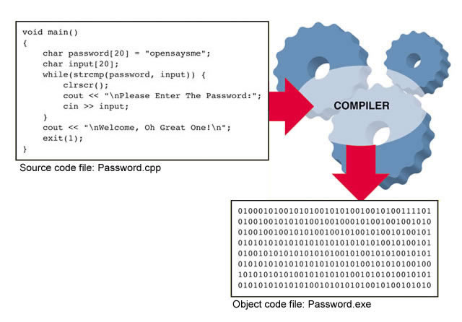
Authored by Cengage Learning, License: CC BY 4.0
Popular Programming Languages
Languages | Description
C | General-purpose language popular on UNIX and Linux platforms
C++, Java, Python | General-purpose object-oriented languages; Java is perhaps the most popular programming language and is used for developing Android apps. Python is a popular beginner’s language that is easy to learn.
JavaScript, Jquery, AJAX | Based on JavaScript, these languages are used mostly for client-side web programming.
PHP, Ruby, Perl | Popular web server-side programming languages
SQL, MySQL | Database manipulation languages
C#, VB, .NET | Popular for Microsoft Windows programming
Objective-C | Used to develop iOS apps for iPhone and iPad

Reading: Application Programming Interface

Application Programming Interface (API)
An application programming interface is a set of programming tools specifically designed for developing apps for a particular platform.

Why This Matters
An API allows others besides the manufacturer to develop software to run on the system or device. Without APIs, only Microsoft would develop software for Windows computers, only Apple would develop software for the Mac and iPhone, and only Sony would develop software for the PlayStation. APIs provide users with a rich variety of software and provide an opportunity for less experienced programmers to make valuable software contributions.

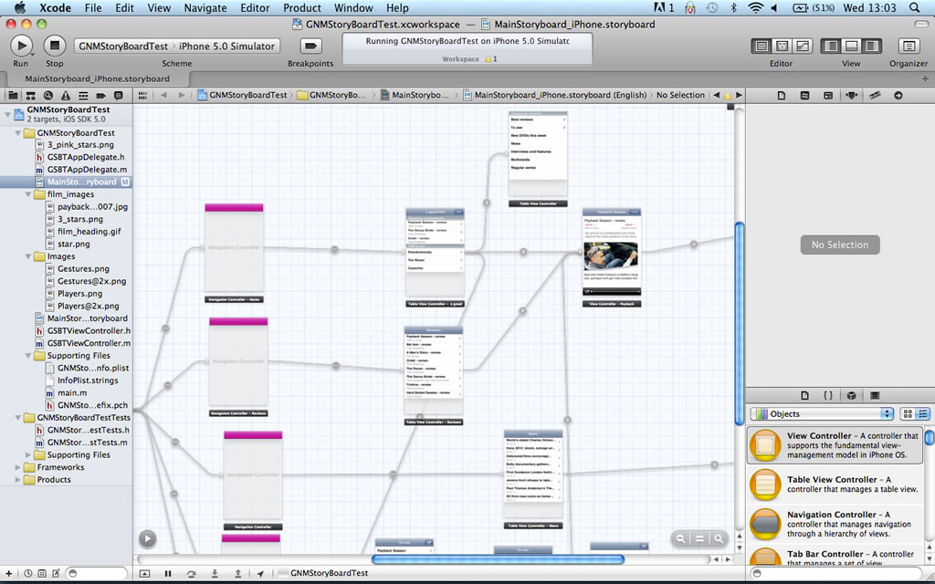
Authored by: Courtesy of Xcode, License: Fair Use

Essential Information
An API might be restricted to one particular programming language, or it could support many languages. For example, Facebook designed its API to require the PHP scripting language. Microsoft Windows, however, supports many programming languages that can manipulate the Windows environment using the programming tools provided by the Windows API.

Some APIs are combined with an SDK. An SDK, or software development kit, is a programming environment designed to write software for a particular computing platform. Facebook, iPhone, Google Maps, and Google Android all provide SDKs for software developers. The iPhone SDK is shown in the above figure. Notice that the SDK provides an iPhone storyboard that allows developers to visualize use-case sequences.

APIs may be made publicly available or may be licensed to specific software developers. For example, the PlayStation API is available only to software companies that Sony has approved for developing software for its gaming console.

SDKs make software development less complicated. For example, to develop applications for iPhone, Android, or Facebook, the SDKs require only basic programming skills and knowledge of the capabilities of the device or environment. This provides opportunities for amateurs to try their hand at software development. Many of the hundreds of thousands of iPhone apps were designed, developed, and published by amateurs. Amateurs may not have the skills to develop a full desktop application, but they often can learn the smaller skill set required to use the SDK.

Lesson 4.2: Software and Applications

Lesson 4.2 Introduction
System software is any software that coordinates the activities of the hardware and assists the computer in functioning safely, effectively, and efficiently.

Controlling the operation of computer hardware is one of the most critical functions of system software. System software includes operating systems that interact with the computer hardware, creating a layer of insulation between the hardware and application software and keeping computer systems running smoothly and safely. System software also includes utilities like security software, file management software, and DVD burning software. System software is essential for all types of computers from smartphones to supercomputers, to special-purpose computers and other digital devices.

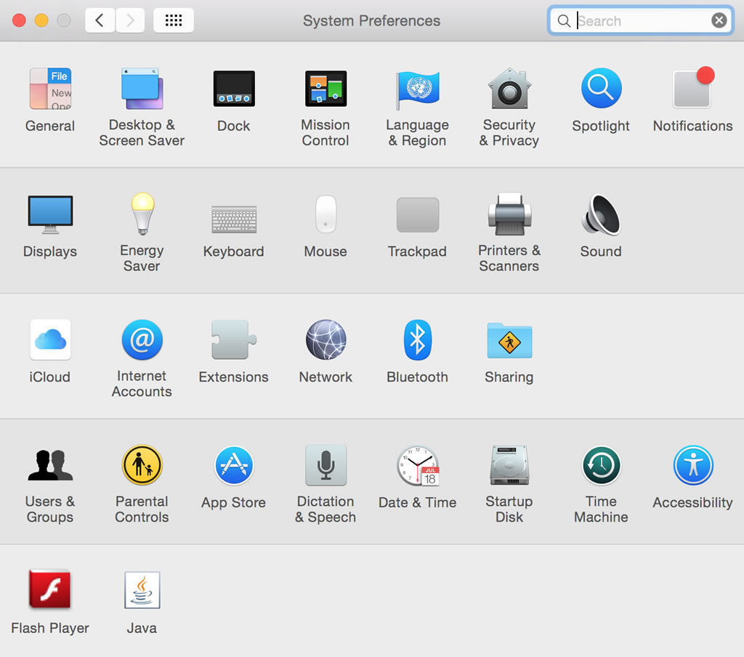
Authored by: Apple Inc., License: Fair Use

System software includes operating systems, such as Microsoft Windows, Mac OS, Android, and iOS, that are essential for all computers to operate. Other system software, such as disk management tools and antivirus software, is designed to keep the computer running safely, smoothly, and effectively. System software, especially the operating system, is written for a specific CPU and set of hardware. The hardware configuration of the computer system combined with the particular operating system in use is known as the software platform. For example, a mobile software developer might specialize in developing apps for the Android platform.

Reading: Operating System (OS)

Operating System (OS)
An operating system is a set of computer programs that runs or controls the computer hardware and acts as a user interface.

Why This Matters
The operating system plays a central role in the functioning of any computer system. Operating systems run on most digital devices. Nearly all operating systems perform certain similar tasks, such as controlling computer hardware, managing RAM, managing the processor(s), controlling input and output devices, storing and managing files, and providing a user interface. The operating systems also provide networking functionality.

Essential Information
When a computer of any kind is powered on, a boot process, hard wired into the device, runs some self-checks and then loads the operating system into memory. From that point on, the operating system takes control of all computing activities.

Operating systems control many common hardware functions, such as providing a user interface, managing the processor and memory, managing files and storage, communicating with peripheral devices and accessories, capturing user input, and providing output. Operating systems are designed to work with specific types of computers and processors. Application software is written to operate on a particular type of operating system, not on a particular type of computer. For example, there are apps that run only on Android, and others that run only on iPhone. PC apps run on Windows, Mac, or Linux platforms. If a developer wants to have an app on the two most popular mobile platforms, he or she needs to create multiple versions of it, using at least two APIs and programming languages—one each for iPhone and Android.

The selection and quality of apps available for a platform has a large impact on the popularity of the platform. A decade ago, Windows computers vastly outsold Macs, primarily because of the amount of software available for each. More recently, iPhone and Android phones vastly outsold Windows Phones, primarily for the same reason.

The operating system provides a user interface that allows the user to interact with the system. The user interface is what defines the user’s computing experience and causes some users to prefer Windows over Mac, or iPhone over Android.

The operating system also provides a structure for system storage. Typically, data is stored in files, and the files are organized with folders and subfolders. Windows has added the ability to store commonly used files in libraries. Cloud storage from Apple iCloud, Google Drive, Microsoft OneDrive, and other providers makes it possible to easily access files, apps, and app settings across multiple devices.

“Underneath the hood,” so to speak, the operating system controls processing and memory use. The OS retrieves instructions from the running software, decodes it, and sends it to the CPU for execution, storing any resulting data. Most PC and mobile operating systems multitask, running multiple applications at the same time.

The OS also controls input and output. It receives input from a keyboard, mouse, touch screen, microphone, or other input device, and then returns the results of processing to the display, printer, speakers, or other output device. The OS can communicate with many different external devices and accessories, called peripherals, such as scanners, printers, keyboards, and displays. To do so requires a device driver—software that is installed for each device connected to a PC, which allows the OS to communicate with that device.

Mobile versions of operating systems for tablets and smartphones are lightweight versions of their PC equivalents. They require fewer system resources, and so can run on smaller processors with less storage and provide a streamlined user interface for smaller touchscreens. Microsoft, Apple, and Google have all recently unified their operating systems across devices so that users can have a common experience across their PCs, tablets, and smartphones.

Reading: User Interface

User Interface
A user interface (UI) allows one or more people to have access to and command of a computer system or computer software.

Why This Matters
One of the most important functions of any operating system is providing a user interface. An OS user interface allows one or more people to have access to and command of the computer system. The user interface defines the computing experience for the user.

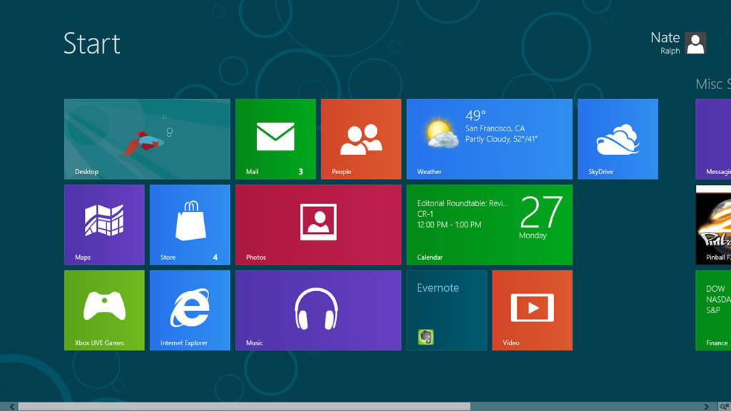
Authored by: Courtesy of Microsoft Corporation, License: Fair Use

Essential Information
The first user interfaces for servers and personal computers were command based. A command-based user interface requires that commands be typed at a prompt in order to perform basic tasks. Most operating systems still provide access to a command line to allow system administrators and advanced users to interact more directly with the operating system. However, the default user interface today is the graphical user interface.

A graphical user interface (GUI) uses a keyboard and mouse, touch screen, joystick, or other pointing device to manipulate graphics images on the display to issue commands to the computer system. A graphical user interface offers many advantages over a command-based user interface. For example, a GUI is very intuitive. Often you can simply explore to figure out how to perform some task; and if you can’t figure it out, help menus and wizards can assist you. A multitasking GUI allows you to view several applications at once and copy data between applications.

The most popular graphical user interfaces on personal computers include similar features and functionality; however, the style of those features may differ from OS to OS. GUIs generally include icons, a desktop, windows, menus, dialog boxes, an information bar (taskbar or dock), a trashcan, program launch area, file viewer and organizer, system viewer, and system settings. It typically doesn’t take long for an experienced computer user to switch to a new computer platform. Many Windows users have switched to Mac computers in recent years, some motivated by the iPhone, the iPad, and Apple’s ecosystem.

There is a GUI battle raging on smartphones. The iPhone ushered in the age of smartphones with a user interface that featured pages and pages of app icons. The Android operating system introduced the notion of smartphone “widgets” that allow applications to display information on the home screen along with app icons. Microsoft introduced “live tiles” that provide app information on tiles and a new way of interacting with information and apps.

Wearable user interfaces are the next big trend. Google Glass utilizes a head-mounted display and voice commands to interact with mobile apps. Apple, Samsung, Microsoft, Google, and others have developed smart bands and watches that connect wirelessly to a smartphone for easy access to text messages and mobile apps. The new generation of Virtual Reality systems provide yet another opportunity to explore new ways to interact with the system. The HTC Vive, for example, allows users to pull up menus with a click of a button on the handset controller and select options by shooting them with a laser beam in the virtual space.

Reading: File Management

File Management
File management refers to the physical and logical storage system and practices provided for managing data on a computer.

Why This Matters
The operating system keeps track of files stored on disk and sometimes in the cloud, and manages all storage devices within and attached to the system. When you save a file to a hard drive or flash drive, store it in the cloud, or burn it to a CD or DVD, the operating system finds space on the device to store the file in an efficient manner and records the location so the file can be accessed later. Maintaining an organized file system makes it easy to find files and information.

Mac OS provides several options for viewing files, including “cover flow,” which provides a preview of the file contents.
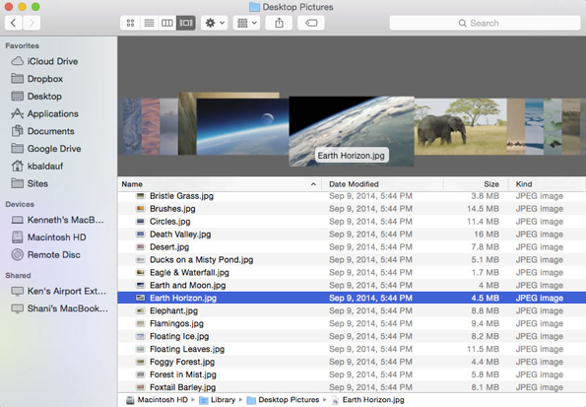
Authored by: Apple Inc., License: Fair Use

Essential Information
The storage-management portion of an OS converts a logical request for data into the physical location where the data is stored. A logical view of data is the way a user thinks about data—for example, C:/Users/Johnson/Documents/Homework/report.doc. That is, the report.doc file is stored in the Homework folder, which is in the Documents folder in the Johnson folder in Users on the C drive. With a logical view, the user doesn’t have to know where the data is physically stored in the computer system. However, a computer can translate the logical view of data into the physical view of data—for example, hard disk, track 1, sector 3.

The operating system performs this task through the use of a file system—a way of organizing how data and files are physically stored and how they are logically manipulated. Windows operating systems use the New Technology File System (NTFS). The Linux and UNIX operating systems use several different file systems such as ext3 and UFS. Mac OS uses a file system called HFS+ (HFS stands for Hierarchical File System). Popular operating systems also provide options for encrypting files as they are stored on disk for heightened security.

Operating systems provide tools for managing files. Microsoft Windows 10 uses File Explorer (called Windows Explorer in earlier Windows versions) to manage files, while Mac OS uses Finder. Computers of all types and sizes store and manipulate files that can contain data, program instructions, or both. Operating systems allow you to organize files into folders, sometimes referred to as directories. Folders can hold one or more files. Organizing files into folders or subfolders makes it much easier to locate files, compared to having all files in one large folder or directory. Windows also provides libraries, which allow you to view files and folders from various locations as a single collection. Lists of folders and files on a computer can be viewed alphabetically, by size, by type, or by the date they were created or last modified. Operating systems typically provide several types of views of files, including list view, icon view, thumbnail view, or cover flow view.

Operating systems allow files to be copied from hard disks to portable media such as USB drives and CDs and DVDs. Increasingly, files are being stored in the cloud, where they can be accessed from many locations and devices. Microsoft Windows and Office provide access to One Drive when files are accessed or saved. Android has a similar feature for Google Drive, and Apple has the ability to back up files to iCloud.

Each OS has conventions that specify how files can be named and organized. In Windows, Mac, and Linux, file names can be up to 256 characters long, both numbers and spaces can be included in the file name, and upper- and lowercase letters can be used. Windows and Mac permit spaces in file names while Linux does not. Mac and Linux file names are case sensitive while Windows file names are not. Certain characters, such as \, *, <, and >, cannot be used in file names. File names may have an extension such as .docx, .html, .jpg, or .txt. Extensions help identify the type of file, such as Word document, webpage, photo, or text file. Windows and Mac both have settings to hide file name extensions from view, which are turned on by default.

Reading: Microsoft Windows and Windows Phone

Microsoft Windows and Windows Phone
The Microsoft Windows platform includes the Microsoft Windows OS for PCs and tablets and Windows Phone for smart phones.

Why This Matters
Microsoft Windows runs on roughly 90 percent of all personal computers. The latest version of Windows provides a single platform across all devices, altering features to suit the device. Since Windows is by far the dominant OS and is found in most business environments, it is useful for everyone to be fluent in its use.

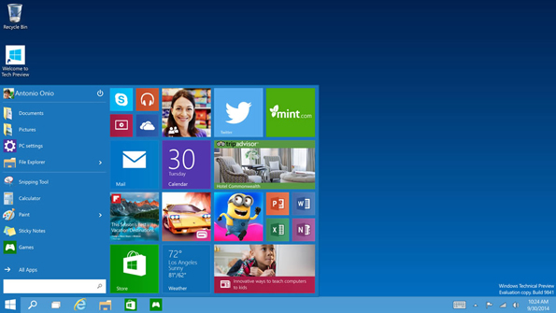
Authored by: Courtesy of Microsoft Corporation, License: Fair Use

Essential Information
Over the years, there have been many versions of Microsoft Windows: Windows NT, ME, 2000, XP, Vista, 7, 8, and now 10, each version adding features and improvements over previous editions. Windows 10 claims to be a whole new start for Windows: a universal operating system for everything from phones to laptops, tablets, big touchscreen PCs, and everything in between.

Windows 10 was intended to fix the mistakes of Windows 8. Microsoft decided to skip Windows 9 altogether, perhaps to put some distance between the new generation Windows and the failed last attempt.

With Windows 10, Microsoft brought back the Start menu and a unified system so that users don’t have to choose between the new tile interface and the old desktop as they did in Windows 8 and 8.1. Now, users can access whatever they need from one desktop.

Rather than trying to force a tablet interface on PC users, Windows 10 knows if it is on a desktop or tablet and configures accordingly. When a transformable PC switches from notebook to tablet mode, the user is asked which interface he or she prefers. Windows 10 features improved navigation, search, and file management and features Cortana, a voice-controlled assistant similar to Apple’s Siri.

Windows 10 is a unified system. Developers use one development kit for developing apps across all devices. There is one Microsoft store for all versions of Windows 10: PCs, Surface, tablets, Xbox, and Phone.

Reading: Apple Mac OS and iOS

Apple Mac OS and iOS
Apple Mac OS, iOS, and Watch OS are the native operating systems for Apple Macs, the iPad and iPhone, and Apple Watch.

Why This Matters
The Mac OS has gained popularity as Mac computers have grown in market share. The most recent version of the Mac OS is called macOS Sierra, and it is competitive with Windows 10 in terms of performance and capabilities. The previous 11 versions of Mac OS were categorized as updates to the tenth version with a roman numeral X. With this latest version of its operating system, Apple has dropped the X naming convention, calling it macOS rather than Mac OS X. Mac users prefer macOS over Windows because of its ease of use and relative smooth and safe operation.

Authored by: Apple Inc., License: Fair Use

Essential Information
Like Windows, Apple operating systems have gone through revisions and changes to make them more useful. Easy-to-use graphical user interfaces have always been a hallmark of Apple systems. The latest version of macOS continues to be easy to learn and use. Simplicity does not mean that macOS is not powerful, however. Mac systems offer outstanding graphics capabilities and are popular with professionals working in art, photography, motion pictures, animation, and music. Because high-end Macs offer powerful processing, they are also popular with mathematicians and scientists.

The macOS is built on the UNIX operating system, an industrial-strength OS originally developed for mainframe systems and renowned for its stability and security. Like Windows 10, macOS Sierra is designed to provide a seamless user interface between platforms: Macs, iPads, iPhones, and Apple Watch. It incorporates the personal digital assistant, Siri, as a voice interface used to find files, launch apps, and other useful tasks. Like Microsoft Windows 10, Sierra utilizes cloud computing to share apps, media, and files across devices. Sierra automatically logs in users wearing an Apple Watch, and authenticates online payments with fingerprint validation on an iPhone.

Apple’s iOS for the iPhone and iPad blends seamlessly with macOS. The most recent version, iOS 10, features advanced photo editing and organizing; messaging with advanced features that support handwritten notes, cartoon characters, and quick prerecorded responses; the map app that allows you to make reservations and book a ride through Lyft; Apple Pay for wireless payments, and touch ID for unlocking the device with a fingerprint. The Apple ecosystem extends to your wrist; Apple Watch OS provides a platform for apps to run on a small watch face.

Mac users often use apps from Apple, downloaded from its App Store. Safari is Apple’s web browser, Mail is the Mac email program, Address Book stores contacts, and iChat is for instant messaging with or without video. These and many other useful software tools are provided free with macOS. The Mac iLife suite of apps (sold separately) includes iChat, iPhoto, iMovie HD, iDVD, iTunes, iWeb, and GarageBand. Mac iWork software (also sold separately) includes the Pages word processor, Numbers spreadsheet, and Keynote presentation software. These apps can be downloaded independently from Apple’s App Store for between $15 and $20 each. Many of the popular apps for macOS are also available for iOS with the ability to share files on iCloud. Since many of Apple’s apps run only on Apple devices, users may be unable to use them to connect with non-Apple-using friends.

Because Apple makes both the hardware and the operating system for its computers, and because macOS is built on UNIX technology, Macs have a reputation of being more stable and secure than Microsoft Windows PCs. Mac users also do not face as large a threat from viruses and spyware as do Windows users, although that is changing as some Mac users are being tricked into downloading malware on the web. The macOS provides file encryption, password protection, and a firewall to keep hackers out of your files, and some Mac users install additional antivirus software, like Sophos Antivirus, as recommended by Apple.

Reading: Google Chrome and Android

Google Chrome and Android
Google Chrome and Android are Google’s operating systems that extend over phones, tablets, laptops, desktops, watches and other wearable devices, TV, and autos.

Why This Matters
Android is the most popular mobile OS, controlling around 86 percent of the global smartphone market and 65 percent of the global tablet market. Android’s open and free architecture is popular with many users on a budget. Its market share has attracted developers who are interested in selling more apps.

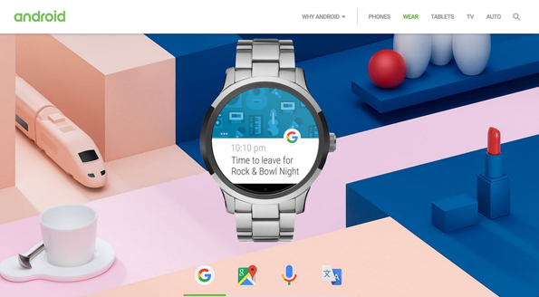
Authored by Android, License: Fair Use

Essential Information
After the iPhone launched the mobile revolution, Android was the first OS to challenge iOS. Android is based on free and open-source Linux, and so any device maker could use it for its phones. And use it they did! The tidal wave of low-priced smartphones running Android quickly surpassed Apple’s market share, making Android the most popular mobile OS. Like iOS, Android offers millions of apps in its Google Play store.

A similar iPhone vs. Android phenomenon has occurred in the tablet market with tablets running Android overtaking the iPad’s market share. The iPad remains the most popular tablet, but all of the tablets running Android combined have a greater share of the market.

Android is designed for several platforms: phones, tablets, wearable devices, TV, and autos. However, Android does not extend to desktops and laptops. For computers, Google offers Chrome OS. Chrome OS is Google’s attempt to do away with installed apps and move our computing life to the web. Google Chrome runs on low-priced Chromebooks designed to run only web apps: Gmail, Google Calendar, Google+ with Hangouts, Google Docs, Sheets, and Slides with all files stored on Google Drive. Google offers hundreds of other web apps from a variety of developers. The latest version of Google Chrome is also able to run the millions of apps designed for Android.

The Asus Chromebook Flip provides full laptop features with a hi-def touchscreen and 8 hour battery life for $250.
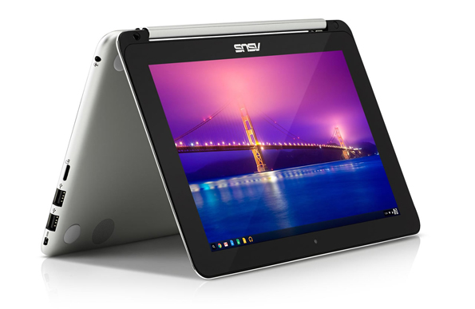
Authored by Asus, License: Fair Use

Google has begun expanding its offerings into the hardware realm. At http://madeby.google.com Google shows off its Google-branded cell phone, named Pixel – the first Android phone that reviewers claim equals or surpasses the quality of iPhone. Pixel includes Daydream View (a virtual reality headset that works with Pixel), a personal digital assistant for the home named Google Home, Google Wifi, and Chromecast media-streaming devices.

Reading: Linux

Linux
Linux is a free, open-source operating system for PCs, servers, and other types of computers.

Why This Matters
Linux owns a small percentage of the PC operating system market but is mostly popular with technically inclined individuals, with users looking for free and open-source software, and with some corporations. Because it is open-source, Linux can be customized to meet specific needs. Businesses and organizations appreciate this feature. Linux is growing in popularity as a lightweight and inexpensive operating system for mobile computing devices such as laptops, tablets, and smartphones.

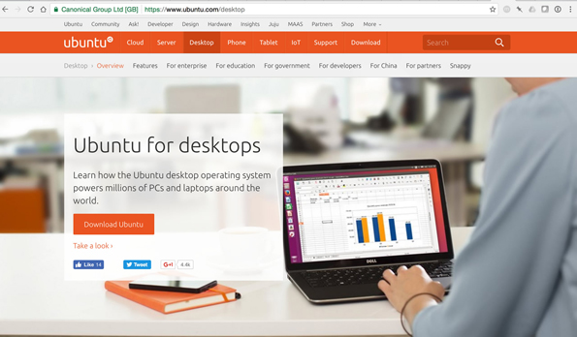
Authored by: Ubuntu Linux, License: Fair Use

Essential Information
Linux was developed by Linus Torvalds in 1991. It was designed to provide a powerful, free, UNIX-like operating system that would run on desktop PCs. As with UNIX, Linux can be used as a command-line operating system or through a graphical user interface such as GNOME. Today, it is used on computers ranging from smartphones to servers. The operating system is available for free to users under a General Public License (GPL) arrangement. Some vendors also offer commercial (not free) versions of Linux that include more features and offer user support.

Many versions, called distributions or distros, of Linux have been designed by the user community. Because Linux is open source, it has many more customized versions than Microsoft Windows or Mac OS. Distributions based on Debian Linux feature free, unencumbered software and have a reputation for being very stable; the popular Ubuntu distro falls under this category. Red Hat Enterprise–based distributions are designed for large corporate systems and servers, with a free community version called Fedora. Slackware-based distributions are highly customizable and are favored by techies.

Specialized distributions are created for specific devices such as smartphones. Ubuntu for phones and tablets has received notoriety recently for providing a free alternative to the big three smartphone platforms: iPhone, Android, and Windows Phone. Ubuntu won the Best in Show award at the 2014 Mobile World Congress, the world’s largest mobile technologies convention. Like the latest versions of Windows and macOS, the latest version of Ubuntu is designed to work seamlessly across desktop and mobile devices, utilizing the cloud to share apps, media, and files across devices.

Linux has a big advantage over proprietary operating systems such as Windows and Mac OS X: People can not only get copies of Linux free of charge or at low cost, but they can also develop utilities, applications, and enhancements to the operating system. Besides including all the standard OS functionality, settings, and support, Linux Ubuntu comes loaded with free open-source applications. Ubuntu includes several productivity applications, Internet apps, references apps, graphics and media apps, accessories, and games. The downside of using Linux is that it does not support many of today’s popular software titles. Some Linux fans get around this by setting up their PC to dual boot—that is, to have the option of running either Linux or Windows on a single PC.

Reading: Virtual Machine Software

Virtual Machine Software
Virtual machine software, also referred to as virtualization software, allows one operating system to run on top of another by creating a virtual machine on which the guest operating system can run.

Why This Matters
Virtual machine (VM) software is useful for users who wish to run more than one operating system on a computer. This includes programmers who need to develop software for multiple platforms. It also includes professionals who wish to access specific software that is only available for a certain OS. Also, home users may enjoy having access to multiple operating systems to support diverse interests and needs.

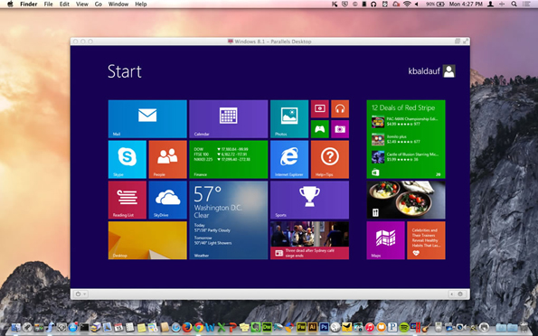
Authored by Courtesy of Ken Baldauf, License: Fair Use

Essential Information
There are several virtual machine applications available for PCs and Macs. VirtualBox software from Oracle allows Linux to run in a window on a Windows PC or Mac. It can allow Windows to run on a Mac, and practically any OS to run on any other. Parallels Desktop VM and VMware are other popular virtual machine software packages. Microsoft provides the Hyper-V virtualization client with some Windows 10 editions. Because of the amount of resources required for two operating systems to run simultaneously, VM software is most successful when run on more powerful PCs. Users should also be aware that running multiple OSs on a single computer requires you to purchase multiple OSs and the software that runs on them, and to maintain the OSs and keep them secure. For this reason, running VMs can be costly in terms of expense, time, and effort.

Virtualization is also used on servers to make more efficient use of server resources. Server virtualization allows one physical server to run several individual virtual servers and different server operating systems. Virtual servers have become very popular in data centers as a means of getting more computing out of the hardware, reducing the number of physical servers needed, and supporting green computing by saving energy and helping the environment.

Reading: Server Operating Systems

Server Operating Systems
Server operating systems control large networked systems and servers.

Why This Matters
Server computers operate in a much more complex manner than PCs and require an operating system that can manage multiple processors—sometimes hundreds or even thousands of processors—and many users. Companies that manufacture the systems, such as IBM and Oracle, typically design and provide the operating system with the hardware.

Essential Information
Some operating systems are designed specifically for larger computer systems or computer systems that require a server. Network management functions are an important element, as is the ability to manage multiple processors, complex storage architectures, massive amounts of RAM, and many users. Today’s server OSs support the latest trends in technology, including virtual machine functionality and cloud computing. Windows Server, Linux, and Oracle Solaris are examples of server operating systems. Windows Server 16 is the most recent version of Windows Server and contains many of the client features of Windows 10.

Oracle Solaris is the most popular version of the UNIX operating system for industries. The online marketplace eBay uses Solaris servers, software, storage, and services to run its operations. The Idaho National Laboratory uses the Solaris operating system to conduct research in its work to design more efficient and safe nuclear reactors.

Large mainframe server manufacturers typically provide proprietary operating systems with specific hardware, such as z/OS, a 64-bit operating system for IBM’s large mainframe servers. IBM says that z/OS can support thousands of workloads concurrently while delivering service levels to meet the most demanding customer requirements. The OS is used by the largest banks, financial organizations, and service organizations.

Reading: Embedded Operating Systems

Embedded Operating Systems
Embedded operating systems, or just embedded systems, are hardwired into a computer component, such as ROM or flash memory, to control a special-purpose computer.

Why This Matters
There are several thousand different types of special-purpose computers and computer-driven devices in the world. Computers control medical equipment, cars, elevators, kitchen appliances, media players, televisions, and most of the electronic devices that we interact with on a daily basis. Every computer is controlled by an operating system. While general-purpose computers use operating systems stored on disk, the many special-purpose computers typically employ an embedded operating system, or embedded system (for short).

Essential Information
Embedded systems typically are designed to perform a relatively limited number of tasks. Consider the functions of a dedicated GPS navigation device. Compared to a general-purpose computer, GPS navigation is very limited. Or consider the fuel injection system of a car that regulates the flow of fuel to the engine. The embedded system that controls it has an even more limited set of instructions than that of the GPS device.

Because embedded systems are developed for specific tasks, they can be optimized more easily, which increases reliability and performance and reduces size and cost. Some embedded systems are classified as real-time operating systems. A real-time operating system (RTOS) is an operating system that has time constraints placed on its functionality: When a button is pushed or a command is delivered, the system must execute the command within a certain amount of time. Consider systems that control an aircraft or the scheduling of online airline ticket sales. In both examples, when a command is given—extend left flap, or reserve seat—the amount of time it takes for that command to be executed is crucial.

Reading: Utility Software

Utility Software
Utility software is any system software besides the OS that assists in maintaining, managing, and protecting computer system resources.

Why This Matters
Utility software helps keep computers running smoothly and safely. With operating systems growing more complex and risks associated with Internet-connected computers increasing, utilities are more important than ever before.

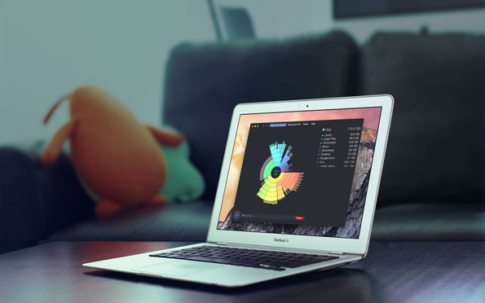
Authored by: daisydiskapp.com, License: Fair Use

Essential Information
Utility programs often come installed on computer systems; a number of utility programs can also be purchased. As operating systems have developed, they have incorporated features that were originally found in separate utility programs, such as disk maintenance.

The following are common utilities that protect computer systems and keep them running smoothly:

- Defragmentation and disk utilities: Maintain files on disk and arrange them in a manner that allows for fast access
- Backup utilities: Safeguard files by creating backup copies
- Security software: Search for and remove malware such as viruses and spyware from computers, and guard against attacks
- Windows cleaners: Remove unwanted programs and leftover traces of programs from the system and maintain the Windows Registry for smoother OS operation
- Diagnostic software: Provide a view of system resources in a graphical format to see how the CPU, RAM, and other resources are performing

A number of utilities are designed to assist users in managing and transferring files:

- File management utilities: Provide tools for copying, deleting, renaming, and organizing files
- File compression utilities: Allow files to be bundled together into one compressed file to save storage space and allow for easier transfer
- CD/DVD burners: Copy and store files on CDs and DVDs
- File transfer utilities: Move and share files across computer networks
- Search utilities: Find files on a computer system
- Synchronization software: Synchronize files across multiple computers, such as a desktop, laptop, tablet, and smartphone

Other utilities provide a way to customize your computing environment and make computing resources more convenient to access:

- Desktop enhancements: Provide customization tools for desktops, including icons, shortcuts, color schemes, and other visual elements of the desktop
- Screensavers, skins, themes, and wallpaper: Provide a visual style for the desktop
- Automation software, macros, and shortcut keys: Allow the user to automate frequent commands and command sequences and assign them to a shortcut key or group of keys (i.e., Ctrl+Alt+R)

Reading: Apps – Desktop, Mobile, and Web

Apps – Desktop, Mobile, and Web
Apps, or application software, consist of programs written to perform tasks or solve problems for people, groups, and organizations on PCs, mobile devices, and wearables.

Why This Matters
You’ve learned that there are two general categories of software: system software and application software. In the last section you learned all about system software. Now it’s time to turn your attention to apps. While system software is useful to the machines that run them, application software is what makes computers useful to people. Millions of applications have been developed to assist people in all professions and in their personal lives.

Essential Information
If you were to list all of the software that you use, chances are, each app would fall under one of the following categories:
- Productivity and office suites – apps that allow you to be more productive, of which the most common are office suites
- Information – apps that provide you with information
- Communication – apps used to communicate with others
- Creativity – apps that allow you to create things
- Personal Information – apps that help you to organize and manage your life
- Entertainment – apps that entertain
- Professional – apps you use for your job
One of the major benefits of computers is that they can make us more productive. Our ability to manage information, crunch numbers, calculate solutions to problems, and connect with one another has transformed our culture into a super-productive colony of thinkers and doers. From a simple clock app that allows you to set an alarm, to project management apps that track the expenses and resources of massive projects over time, productivity apps have become an important part of our daily lives.

Perhaps the most widely used productivity apps are those included in office suites: word processing, spreadsheet, and presentation apps. These apps are just the tip of the iceberg when it comes to productivity. There are thousands of apps for taking notes, making to-do lists, and recording ideas, and thousands more for making calculations of all kinds: budgets, taxes, payroll, statistics, projections, mortgage calculators, and many more.

The Internet has made an abundance of information available to the world. Apps that assist us in gathering useful information are another form of productivity app. Apps that connect us with others through text, voice, and video communication and allow us to share information also support productivity.

Apps support all types of creativity, including music composition and performance, artistic creation, video editing, and software development. Apps enable communication through text, voice, and video. They also entertain us with music, movies, television programs, games, and books.

Although many of today’s applications are designed to be used by a single individual, it is becoming increasingly common to work on electronic documents in groups. Collaborative software is any software that facilitates group collaboration within the software. Google Docs is a good example of collaborative software, as it supports multiple users editing a common document from different locations over the web. Microsoft Office has adopted similar online collaborative features in Office Online.

Many types of application software are provided through a web interface. Web technologies provide developers with the tools to create powerful applications that run in a web browser without the need for any installation on the local computer. Web apps are a popular form of cloud computing since they run on web servers, and they typically also store user data on web servers so that it can easily be shared with collaborators and others.

As computing has gone mobile, people are using mobile apps as much as, if not more than, they use desktop apps. In fact, many apps are available across all computing platforms so that users can work anywhere, anytime, on any device.

Many of the apps used by businesses are custom apps designed to provide some unique function valued to the business. Businesses today invest heavily in apps in order to gain a competitive advantage over their competition.

Reading: Office Suites

Office Suites
Office suites are software collections that include a word processor, a spreadsheet app, presentation software, and sometime database and other useful software.

Why This Matters
Office suites are the most common type of software used at work, school, and home. These apps have many common uses: recording ideas (word processing), making calculations (spreadsheet) and creating graphic depictions (presentation). These apps provide many useful functions for many different situations.

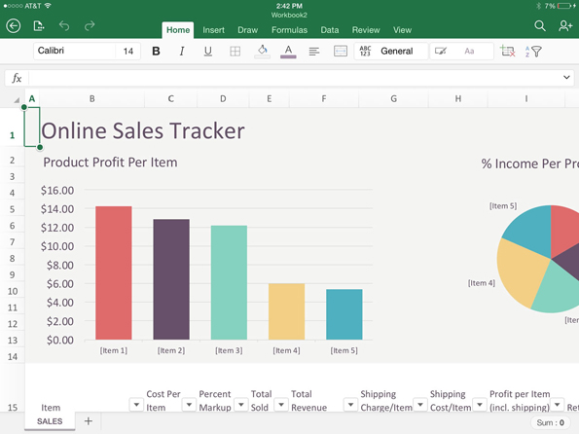
Authored by: Apple Inc., License: Fair Use

Essential Information
A software suite is a collection of applications sold together as a package. Office suites typically include word processors, spreadsheets, and presentation software, and they sometimes include database-management systems, personal information managers, and other applications. Office suites aren’t just useful at work; they also assist individuals in managing home life, school work, and other activities.

Microsoft Office is by far the most popular software suite. Microsoft Office is available for Windows and Mac platforms and includes Word, Excel, PowerPoint, Access, and other tools depending on the version. Office is also available online and as mobile apps for iOS and Android devices.

Other office suites include Google Docs (Docs, Sheets, and Slides) and Apple iWork (Pages, Numbers, and Keynote). Office suites are an important part of technology ecosystems from Microsoft, Apple, and Google. Apache OpenOffice, a free open-source productivity suite, is compatible with Microsoft Office and available for Microsoft Windows, Solaris, Linux, and Mac OS. Zoho Office Suite is a free web-based suite of applications, including Writer, Sheet, Show, Wiki, Notebook, Projects, CRM, Creator, Planner, and Chat.

Google Docs was one of the first office suites in the cloud, and now Microsoft Office and Apple iWork have cloud-based versions of their software. Mobile versions of office suites have also become very popular for staying productive while on the go. Generally speaking, cloud-based and mobile apps are less powerful with fewer features than installed apps. But, combined with cloud drives, these apps are ideal for mobile access and collaborating with others on documents and projects.

Office 365 is the latest version of Microsoft Office that is sold as a monthly subscription. For $8.25 per month, a user gets:

- The latest version of Word, Excel, PowerPoint, Outlook, Publisher, and OneNote for use on up to 5 PCs or Macs per user
- Office Online Web Apps: Word, Excel, PowerPoint and OneNote
- Office mobile apps on up to 5 tablets and 5 phones
- One TB of storage in the cloud
- Outlook Email, Calendar and Contacts

The subscription model for Microsoft Office means never having to make major software upgrades. Office apps are updated and improved incrementally as needed.

Reading: Information Apps

Information Apps
Information apps provide useful information on a variety of topics.

Why This Matters
The Internet provides seemingly limitless amounts of information on every topic. Some information is more useful than others. For this purpose, apps have been developed to deliver valued information on demand. Information apps are available for access to public and private information.

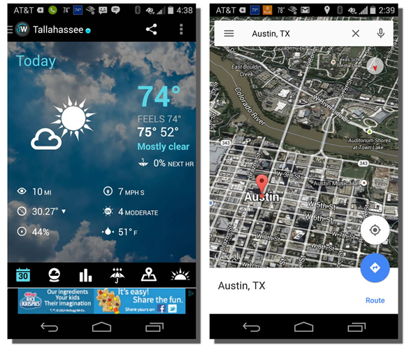
Authored by Courtesy of Google, License: Fair Use

Essential Information
A popular app on many smartphones is the weather app. People are always interested in the constantly changing weather. Weather apps from weather.com and others are one example of information apps. Another popular category of information app is maps and navigation. Map applications from Microsoft, Google, Apple, and others not only allow you to explore the landscape and find your way across new territories, but may also provide turn-by-turn navigation.

Personal assistant apps like Siri, Google Now, Google Assistant, and Microsoft Cortana provide answers to questions that are posed by sifting and sorting through online information sources. There are health apps that provide caloric information for all known food products, medical apps that inform on every illness and injury, news apps, sports apps, and all kinds of reference apps.

Reading: Communication Apps

Communication Apps
Communication apps support communication between people and groups through text, voice, and video.

Why This Matters
The Internet supports all kinds of communications between people. There have been many apps developed to support forms of communication. Learning about the communication apps available provides many options for staying close and connected to others.

Authored by: Courtesy of Softpedia, License: Fair Use

Essential Information
Cellular carriers provide voice and text communication over the cellular network. With the birth of Voice over Internet Protocol (VoIP), telephone style voice communication moved to the Internet. Now there are many apps available to support all kinds of communication over the Internet, accessed on computers of all types as well as mobile devices.

WhatsApp is a good example of an app that saves cellular users money by utilizing an Internet connection rather than a cellular plan to send and receive text messages. Facebook understands the value of online communication and bought WhatsApp in 2014 for $22 billion.

It’s a similar story for Skype. Skype is an app that takes online communications a step further than WhatsApp by providing free video, voice, or text chat over the Internet between computers, tablets, or mobile phones. Microsoft bought Skype for $8.5 billion in 2011.

Naturally, wherever Microsoft is investing, so are Google and Apple, and vice versa. Google provides its Google+ members with Hangouts, and Apple has Facetime; both apps are similar to Skype. Communication apps sometimes include the ability to video chat with a group of people as well as the ability to share your computer desktop with others, which is useful in teaching computing skills or getting tech support.

There are hundreds of communication applications available for all platforms for computers and mobile devices. The one drawback to adopting a communication app is that the people you communicate with must use the same app. Because of that, companies that already have huge user bases, such as Facebook, Twitter, Google, Apple, and Microsoft, have a huge advantage in the market. View the Internet Communications page for more details on the topic.

Reading: Creativity Apps

Creativity Apps
Creativity apps include any software that assists people in creating items of value like art, music, video, and even software used to create software.

Why This Matters
Some fear that computers are depriving us of our humanity, while others use computers to enhance and express their humanity. Apps that assist people in creating objects of beauty, whether they be songs, artwork, movies, or software algorithms, are perhaps the most rewarding of all.

Apple’s GarageBand app includes guitar lessons that allow you to play along; it even corrects your mistakes.
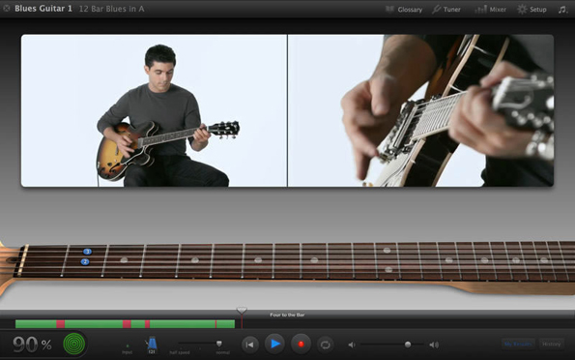
Authored by: Courtesy of Apple Inc., License: Fair Use

Essential Information
Categories of creative apps include music and audio recording, graphics editing, video editing, photo editing, and software development. These topics are covered in various units throughout Emerge. Here, we look at popular apps in these categories.

Apple’s GarageBand (for Mac and Windows) is popular software that amateurs and professionals use to record music and audio. The software is designed to make it easy to lay down tracks and loops in all kinds of music styles. It also has lessons to teach users how to play instruments. More advanced recording software like Logic Pro provides professional-grade recording studio features. Audacity, an alternative to GarageBand, is a free open-source audio editor and recorder.

There are many fun music apps for mobile devices. For example, NodeBeat lets anyone create music by adjusting settings and moving various musical elements around visually in the mix. WavePad is an app that allows you to record voice or music, edit the recording and add sound effects, and clean up background noise to create high quality audio recordings. The Caustic app turns a mobile device into a rack of synthesizers and sampling rigs. Use the DJStudio app to mix the music for your next party.

Software from Adobe has dominated graphics editing, photo editing, and video editing for the past decade. Now, similar software is provided on mobile devices as standard equipment. Apple’s iOS advertises that you can make every photo look even better immediately after you’ve taken it with powerful new editing tools, no matter your skill level. SketchBook Express from Autodesk allows users to create magnificent works of art on their mobile devices. Adobe offers a suite of 13 mobile apps for creating and editing graphics, photos, and videos.

The process of creating apps and software can be as expressive as creating artwork. Apps like Udacity Learn to Code teach you how to code. Once you’ve learned coding, apps like Codeanywhere allow you to code all the time!

There are many creative activities that people participate in, and there are apps to support nearly every one of them. Be sure to read the Digital Media unit for more in-depth coverage of creativity apps.

Reading: Personal Information Apps

Personal Information Apps
Personal information apps assist people in managing their personal lives, including their contacts, calendar, to-do list, health, and money.

Why This Matters
Computers and software were originally designed to support business needs. Today, computers and software are assisting people with every aspect of their personal lives as well. Contacts, calendar, and to-do list apps have been around for a while. Now, health apps and money apps are becoming popular. Stores like Publix provide apps to organize your shopping. People who use personal information apps are able to free up more time for fun while leading a better managed and healthier lifestyle.

Personal info apps like Publix, Apple Pay, and Fitbit help us organize our lives and stay healthy.

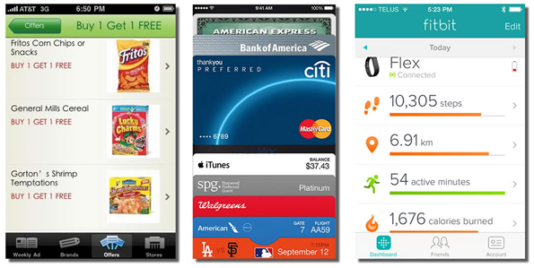
Authored by: Courtesy of Publix Markets, Apple Inc., and Fitbit, License: Fair Use

Essential Information
Microsoft Outlook is the most popular traditional personal information management (PIM) software, included in the Microsoft Office suite. Google and Apple provide PIM software as well. PIM typically includes calendaring applications to keep track of appointments, contact lists to keep track of the contact information of those you deal with, to-do lists, and email. PIM software needs to be accessible from both PCs and mobile devices so that it can be accessed anywhere, anytime. PIM data is often shared among colleagues to allow the easy scheduling of meetings and to provide support for collaborative work.

New software has emerged to assist people with all aspects of their personal, at-home lives. Two growth areas in personal information management software are financial software and health software. These have arisen in parallel with new hardware technologies.

Apple and Android phones that incorporate NFC (near field communication) technology have the potential to replace old-fashioned wallets. By swiping a smartphone across a pad, bank accounts or credit cards can be automatically charged for the purchase. The ability for Google, Apple, Samsung, or other companies to collect all financial records for an individual provides opportunities for financial management. For example, Apple Pay can assist a consumer in viewing all purchases for the past year and deciding where to cut back in order to meet financial goals. A task that used to require a person to collect information from numerous sources could be handled automatically by financial software. Google Wallet, Apple Pay, Microsoft Wallet, or Samsung Pay would be happy to manage this for you.

Wearable technologies make it possible to collect information about a user’s physical activities—steps taken, heart rate, location, sleep, and speed. Having access to this information, along with information on food consumed, allows the software to guide a user in how much additional activity or what dietary changes are required for a healthy lifestyle. Apps available for this purpose includes Fitbit, Android Wear, Apple Health, and Microsoft HealthVault.

With smart home technologies and smart car technologies beginning to take off, software will soon be able to learn more about people’s activities and provide more suggestions for improving life. As you might guess, many people have privacy concerns about these technologies.

Reading: Entertainment Apps

Entertainment Apps
Entertainment apps are any apps that are used for enjoyable leisure time activities, including listening to music; watching TV, videos, and movies; reading books and magazines; and playing games.

Why This Matters
The entertainment industry is one of the biggest in the country because after working hard, we all value our leisure time and like to have fun. Entertainment apps play an important role in leisure-time activities. We engage with computer games, sometimes for hours at a time, on game consoles at home, or for short breaks on our phones or tablets throughout the day. Some of us listen to music on our phones for a majority of our waking hours. We enjoy videos on YouTube and Netflix and read or listen to ebooks as we exercise and fade off to sleep at night. When you think about it, some of our greatest enjoyments of life occur thanks to entertainment apps.

Essential Information
Computer games have been around nearly as long as computers. Today, game consoles are standard equipment in most households. We enjoy games in many categories, including sports, racing, adventure, arcade, role playing, and board games, at home on consoles and computers and out and about on tablets and smartphones.

Increasingly, Internet-connected devices are complementing, if not replacing, televisions. Microsoft, Google, Apple, and Amazon all have devices that transform TVs into Internet entertainment centers. Microsoft’s Xbox connects to your TV to provide access to games, television, online videos and movies, music, photos, and your online community of friends, and is controlled through game controllers, Kinect, or your mobile device. Google has Google TV and Chromecast that connect to your TV to provide apps for finding cable TV content and over 100,000 movies and TV episodes from on-demand Internet sources like Netflix and YouTube as well as games, web browsing, and other entertainment apps. Apple offers Apple TV that connects to your TV to provide similar services controlled with an iPhone or iPad.

Music apps, including iTunes, Google Play Music, Xbox Groove, Amazon Music, Spotify, Pandora, and others have become the source for most music listening enjoyment. You can store your entire music collection in the cloud using music apps or let the apps discover new music based on your musical tastes. One should consider which technology ecosystem offers the best options for music and movie access since it is cumbersome to move purchased music and movies from one ecosystem to another.

Ebooks and emagazines are yet another form of entertainment delivered through apps like Amazon Kindle, Apple Bookshelf, Google Play, and many others. Amazon’s Audible is an app that provides books read aloud so that you can “read” any time, even when you are driving or running.

Be sure to read the Digital Media unit for more in depth coverage of entertainment apps.

Reading: Professional Apps

Professional Apps
Professional apps are general-purpose, custom apps required for use at work.

Why This Matters
The specialized skills required in many professions require the use of professional apps. Software suites that include word processing, spreadsheet, and presentation apps are standard equipment for professionals. Software designed for more specific activities, such as project management, graphics design, and customer management are used depending on the professional’s responsibilities. Employees of large corporations often use custom-designed software on their computers and mobile devices to access and manipulate corporate data.

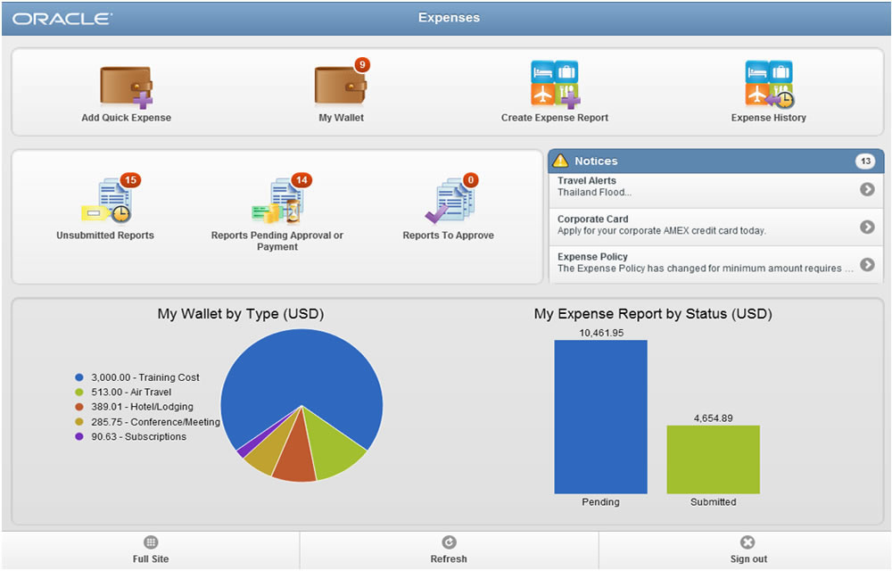
Authored by: Courtesy of Oracle Corporation, License: Fair Use

Essential Information
There are many business applications that are critical to professionals in specific industries and professions. Computer aided drawing (CAD) software is essential to many engineers and product designers. Desktop publishing software is used by publishers. Statistical software and math software like MATLAB are useful to scientists and engineers. Financial management software packages and tax preparation software are critical to accountants.

Project management software helps project leaders organize complex projects that involve many resources and coordinated activities. It is used to plan, schedule, allocate, and manage people and resources (money, time, and technology) to complete a project according to a schedule. Microsoft Project is the most popular project management software. There are several alternatives, including OpenProj, which you can download and use for free, and SeeNowDo, which is a free lightweight app for managing tasks.

Enterprise systems provide software for manipulating enterprise data including transactions, payroll, customer, and financial data. Recently, enterprise data and software has been migrating to the cloud. Knowledge management software, Customer Relationship Management (CRM), Enterprise Resource Management, Business Intelligence, and other key systems are utilizing cloud services from PeopleSoft, SAS, Oracle, Microsoft, and others and accessing the valuable information from these systems using desktop and mobile apps. See the Business Systems unit for more detailed information about business apps.

There are more professional apps than there are professions. In most instances, the app that is used and the skill level of the user provide advantages to the user over others in the profession. Many professionals no longer work just 9 to 5 Monday through Friday, but integrate work with their life whenever and wherever necessary. Because of this, professionals need to make sure that the technology infrastructure that they choose for their personal life integrates with the requirements of the professional life. For example, a Mac user may find it difficult to carry out professional obligations in a company that demands Windows PCs.

Lesson 4.3: The Life Cycle of Software

Lesson 4.3 Introduction
Managing software refers to activities required to acquire, install, maintain, and remove software and apps from computers and mobile devices.

Computers and mobile devices are only as useful as the software that runs on them. In order to maximize the benefits of owning a mobile phone, tablet, or PC, users should research software that will be most useful to their lifestyle, interests, and activities. Selecting and managing software is one of the most important responsibilities of a computer user.

Although computers and mobile devices typically come with many software applications (or apps) preinstalled, most users find it beneficial to add software selected to meet their individual needs. Smart users spend considerable time and effort seeking out new and useful software for use on both computers and mobile devices. The process typically entails reading reviews, consulting with friends, finding the source where software is available, downloading the software, and installing it. Once installed, the software must be maintained and eventually uninstalled when it is no longer useful. This section discusses all of these software management activities.

Reading: Acquiring Software

Acquiring Software
Acquiring software refers to the several methods by which software can be purchased or accessed, including packaged software, downloaded software, cloud apps, and custom designed software.

Why This Matters
The manner in which software is acquired has changed over the years. At one time, it was delivered on floppy disks; then, as software required more storage space, it was made available on CDs and DVDs. Today, new software is often downloaded from an online app store or market. Increasingly, software is run on web servers and accessed through a web browser. It is useful to consider the many ways in which software is made available for business and personal use. Microsoft Office 365 and many other software packages are moving to a subscription purchase model.

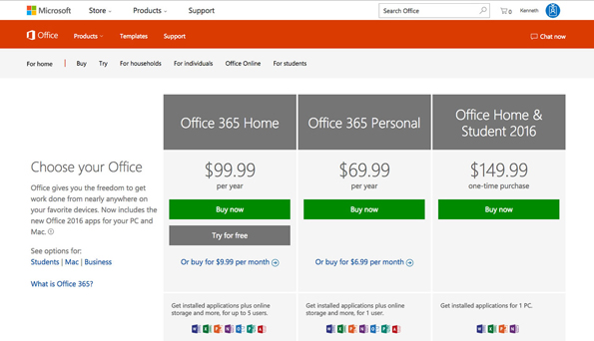
Authored by: Courtesy of Microsoft Corporation, License: Fair Use

Essential Information
Today’s PC users typically use both installed software and apps accessed on the web. They might use Microsoft Office applications installed on their computers as well as Gmail, Facebook, Google Docs, and YouTube on the web. Apps accessed on the web are called cloud apps because they run on web servers that exist on the Internet or in the cloud. The data files created in cloud apps are typically stored in the cloud as well. Businesses are increasingly turning to cloud apps for enterprise applications like Customer Relationship Management and Supply Chain Management. Cloud apps are convenient because they require no installation or maintenance, they are accessible from any Internet-connected device, and data is easily shared among users. Even Microsoft Office has transitioned to the cloud, with Office 365. Office 365 charges users a yearly subscription fee and automatically updates Office on the user’s PC while storing data files in the cloud and providing access to web versions of Office apps. The downside of cloud apps is that you may need to be connected to the Internet to use them, although Google, and Microsoft both have options to edit documents stored in the cloud even when offline. Some people are concerned about the privacy and security of data when stored in the cloud. Can the company providing the service view the data? Who accepts responsibility if hackers access the data or if the data is lost due to equipment malfunction?

While most apps may soon become cloud apps, many of today’s most popular and powerful apps require installation on your computer or mobile device. Installing software on computers allows the software to take advantage of specific hardware features. For example, software installed on mobile devices can take advantage of hardware features such as GPS and accelerometers. Locally installed apps are also able to respond and load files more quickly and are able to include more functionality because they are not limited by web browser functionality.

Apple was the first to offer an app store dedicated to distributing apps for a specific platform. At first it was for the iPhone, and then it extended to the iPad. Finally, Apple created an app store for its Mac software. Google followed Apple’s example with its Android Market, which later became Google Play. Microsoft joined in with the Windows Phone Marketplace and later with the Microsoft Store. Since Google Android is an open platform, Amazon was able to set up its own Appstore for Android. App stores and marketplaces are convenient for users. They also provide control of app availability to the manufacturer who typically takes a percentage of each sale and controls which apps are available.

Increasingly, apps that are purchased can be shared across one user’s devices. So, for example, if you download a game for your iPhone, you may also find it available to download to your iPad. Apple has also implemented a family share program that allows apps to be shared between family members.

Sometimes, a business has unique needs that can’t be addressed by cloud apps, packaged software, or downloaded software. In such cases, a business might create its own custom-designed software by hiring programmers or outsourcing the work to a software development company. Software has become central to business effectiveness and often gives a company a competitive advantage. Because of this, businesses invest heavily in software development and information management systems and guard such systems as trade secrets.

Reading: Software Licensing

Software Licensing
Software licensing defines the permissions, rights, and restrictions assigned to the person who purchases a copy of software.

Why This Matters
A license is the primary tool used to protect intellectual property. Individuals and companies that create software can support themselves as businesses by setting a price for the use of their software by individuals and groups. A software license allows the owners of the software (their intellectual property) to define legal use of the software and exercise legal authority over its distribution and use. Software may be protected by a traditional license, may incorporate a more liberal license policy like Creative Commons or the General Public License (GPL), or may be freeware.

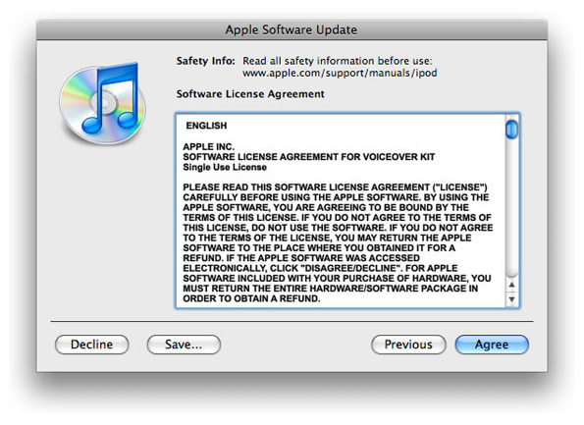
Authored by: Apple Inc., License: Fair Use

Essential Information
A copyright defines exclusive rights legally granted to the owner. A software license defines the permissions, rights, and restrictions provided to the person who purchases a copy of the software. The two are legally tied together in that the copyright certifies certain rights to the owner and the license informs the buyer of what he or she can legally do with the software according to the copyright.

A software license typically addresses questions such as how many users can access the software and how many computers the software can be installed on. Software licenses are typically written to protect and favor the software company. Penalties and fines for violating the terms of a software license can be severe. U.S. copyright law allows for penalties of up to $150,000 per infringed software title.

Software Licenses
License | Description
Single-user license | Permits the user to install the software on one or, sometimes, two computers used by one person—typical for software on PCs
Multiuser license | Specifies the number of users allowed to install the software on their computers
Concurrent user license | Designed for network-distributed software; specifies the number of users that can use it concurrently (at the same time)
Site license | Permits the software to be used anywhere and by everyone on a particular site, such as a college campus

The Creative Commons license is designed to grant certain freedoms to users while providing the creators of intellectual property with some control and the ability to profit from distribution of the work. There are four license conditions available in Creative Commons licenses, which can be combined to form a very specific license:

- Attribution: You let others copy, distribute, display, and perform your copyrighted work—and derivative works based upon it—but only if they give credit the way you request.
- Share Alike: You allow others to distribute derivative works only under a license identical to the license that governs your work.
- No Derivative Works: You let others copy, distribute, display, and perform only verbatim copies of your work, not derivative works based upon it.
- Non-Commercial: You let others copy, distribute, display, and perform your work—and derivative works based upon it—but for non-commercial purposes only.

Freeware is software that is made available to the public for free. Some examples of freeware include the Thunderbird email client, Pidgin instant messaging software, Adobe Reader, AVG antivirus software, all web browser software, and OpenOffice productivity software. Also, many popular web applications are provided free of charge, like Facebook, Picasa, and Google Docs. There are several reasons software developers might give away their product. Some wish to build customer interest and name recognition, and some make money from sponsors that advertise within the software. Freeware may use a software license to impose some restrictions on the use of the software.

Freeware differs slightly from a classification of software known as free software. Freeware simply implies that the software is distributed for free. Freeware typically is proprietary software that cannot be altered. The term free software was coined by Richard Stallman and the Free Software Foundation, and implies that the software is not only freeware, but it is also open source.

Open-source software is distributed, typically for free and with the source code so that it can be studied, changed, and improved by its users. Open-source software evolves from the combined contributions of its users. Linux, the most well-known open-source software, is an operating system based on the original GNU operating system. Businesses and governments have been attracted to open-source software because it gives them more control over the software. Open-source software can be altered to meet a business’s particular needs.

Open-source software is not completely devoid of restrictions. Much of the popular open-source software in use today is protected by the GNU General Public License (GPL). The GPL grants users the right to run the program for any purpose, study how the program works and adapt it to their needs, redistribute copies, improve the program, and release improvements to the public.

Reading: Installing Software

Installing Software
Installing software is the process by which software is added to a computer so that it is available for use.

Why This Matters
Installing software on PCs, tablets, and smartphones is a common activity for computer users. Installing software allows computers to be customized to meet the user’s needs. All computer users should be familiar with the process.

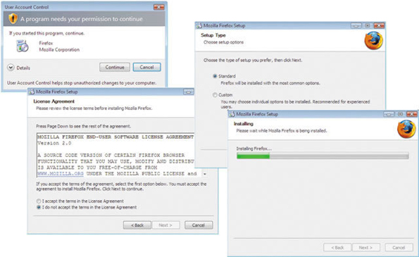
Authored by: Courtesy of Mozilla Firefox, License: Fair Use

Essential Information
Much of today’s software is able to run in a web browser. This includes software like Facebook, Gmail, Google Calendar, and YouTube. However, the majority of the most useful apps are installed on PCs, Macs, and mobile devices in order to take advantage of the hardware for the best performance.

Software for tablets and smartphones is typically installed from an online app store, which automates the installation process to a greater degree. To install new software on a mobile device, you often just agree to the conditions of the license and click an Install button. The app store approach so popular with mobile devices is being adopted for PCs as well. The most recent versions of Mac OS and iOS allow software to be installed once across all Apple devices owned by the same user. So, if you install the latest version of Angry Birds on your iPhone, it will automatically be available on your iPad and Mac. Google and Microsoft plan to offer similar options.

Installing large applications on a PC can be a little more complicated. PC software is typically downloaded as a compressed file from the web. The table below shows the steps of a typical PC installation process. Once the software is installed, you will find a launch icon on your desktop, the Start menu, or wherever your particular operating system stores its applications.

Typical PC Software Installation Steps
Installation Step | Description
1. Run the installation file | Download the installation file, or access it on disk. Installation software will often include instructions for installation at the website or in an associated README text file.
2. Interact with the installation wizard | Once the installation process has begun, follow the instructions as they appear on the screen. You likely will be given choices during the installation. Most software products have recommended default installation settings. Default settings are those chosen in advance for you as typical settings.
3. Agree to the license terms | You will probably be asked to agree to the terms of the software license. You have no choice if you wish to install the software; you cannot progress without agreeing.
4. Select the install location | You may be asked where on your hard drive you wish to install the software. Unless you have an unusual system, the default choice is best.
5. Choose standard or custom | You may be asked to choose standard installation or custom installation. Standard installation installs the most commonly used components of the software, or perhaps all of it. Custom installation allows you to select which components of the software you wish to install.
6. Register and/or activate the software | Once the software is installed, you might have to register or activate the software before it can be used. This is usually done over the Internet.

Reading: Maintaining Software

Maintaining Software
Maintaining software involves applying software updates to correct software bugs, improve the software, or add new features.

Why This Matters
To get the most out of your software investment, and to keep your computer safe and secure, it is wise to update both system software and application software as soon as updates are made available. Updates are provided by software companies in order to fix bugs, patch security holes, improve functionality, and add features. Updates to apps on tablets and smartphones are important as well.

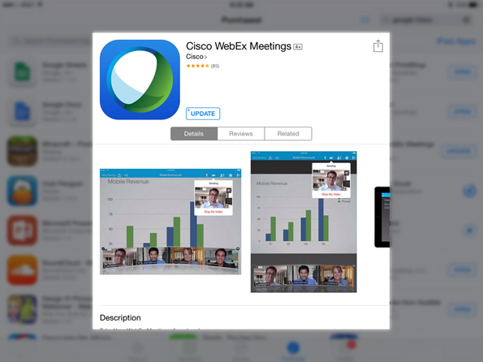
Authored by: Courtesy of Cisco WebEx, License: Fair Use

Essential Information
There are a number of reasons why software is updated throughout its lifetime. Software is often complex, involving tens of thousands of lines of code. Developers often discover improvements that can be made after the software is released. Most updates are intended to make software run more effectively or to add new features. Most operating systems, including mobile operating systems like iOS and Android, have built-in notifications for software updates. It’s not unusual for smartphone users to approve updates for a few apps each week.

Software patches are intended to secure holes caused by software bugs. Software bugs consist of one or more defects that prevent the software from working as intended or working at all. Software bugs are classified as “critical” when they allow hackers to take control of a system. Microsoft issues software patches for Windows on the second Tuesday of each month. Newer Windows subscriptions apply patches as soon as they are released. Apple releases patches as needed.

Here are some things you can do to overcome pesky software bugs:

Be careful when buying or acquiring the latest software. Some people prefer to get software that is a year old or older to make sure that most errors have been found and fixed.

Read the documentation that accompanies the software to discover any known issues and special instructions.

Register the software with the software company. Software companies will often alert you if there is a problem or bug and give you steps to follow to eliminate it.

Respond to update requests quickly. Updates eliminate known bugs and patch security holes.

If software is malfunctioning, try running the setup program again. Sometimes it contains a utility to fix software problems. If it doesn’t have such an option, you can try uninstalling and reinstalling the software.

Use search engines to find information on specific software bugs and possible solutions.

If all else fails, carefully document exactly what happened when you found the bug and then contact the software vendor for a solution.

Reading: Uninstalling Software

Uninstalling Software
Uninstalling software refers to the process of completely removing software from a computer.

Why This Matters
Users should uninstall software that they no longer use in order to free up disk space and streamline their system. Because installed software maintains a presence in many areas of an operating system, it is important to use proper procedures to remove all of it. Removing software requires a special process that deletes all files and references related to the software. The process varies slightly between computing platforms and mobile platforms.

Operating systems provide a method to safely and completely remove software from the system.

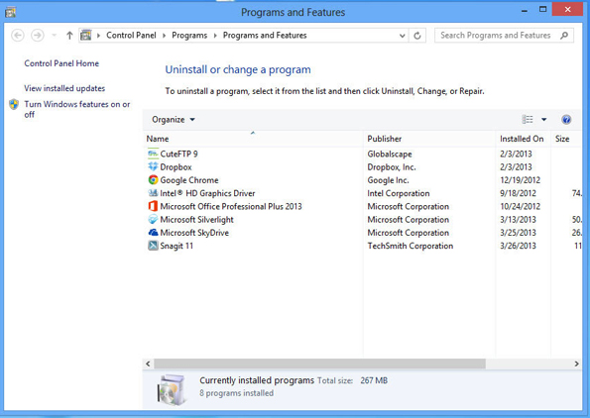
Authored by: Courtesy of Microsoft Corporation, License: Fair Use

Essential Information
Operating systems provide a method for safely and completely removing software from the system. In Microsoft Windows, you use the “Uninstall a program” feature in the Control Panel. In Mac OS, you simply drag the program icon from the Applications window to the Trash. On iPhones and iPads, you press and hold the program icon, and then click the X. On Android devices, you go to the Application Manager, tap the app icon, and tap Uninstall.

On desktop and laptop PCs, even the proper procedure sometimes does not uninstall the software correctly, which creates system problems. This is especially a problem for Windows users and is addressed by a number of system utilities. For example, Norton Utilities and McAfee Registry Power Cleaner help eliminate unwanted elements of software you have removed to help your system run smoothly.

Mac users should regularly use the Disk Utility app found in the Utilities folder, to verify and repair the Disk and Disk permissions. This process cleans up files left behind by old apps and arranges files on the disk for smoother and faster loading.

Module 5

Introduction
Artificial intelligence (AI) refers to the art and science of creating computer systems that simulate human thought and behavior.

Research in artificial intelligence, or AI, is of interest to many professionals, including computer scientists, psychologists, philosophers, neuroscientists, engineers, data scientists and others who often collaborate on AI research. While AI research is the domain of scientists, AI applications are impacting all industries and touching all of our lives. Most of us use AI technologies every day without even knowing it. Web search engines and personal digital assistants like Siri use AI to provide useful information and search results. Ecommerce websites display products that you are likely to buy based on your previous behavior and purchases. From face recognition for photos in Facebook, to driverless vehicles, and a million other applications in between, AI is providing new, revolutionary services every day, often with complex, controversial ethical considerations.

After years of relative neglect, new levels of computing power has brought AI back as one of the hottest areas of investment and research in the tech industry. Google’s $600 million acquisition of DeepMind was just one of over one hundred acquisitions or AI companies made by companies like Facebook, Google, Apple, and Twitter since 2011. The U.S. government has invested billions of dollars in AI research over the past three years including $100 million to the "BRAIN Initiative" intended to reverse engineer the brain to find algorithms that allow computers to think more like humans. The recent AI fever isn’t just in the U.S.—it’s global. Chinese search giant Baidu has invented a powerful supercomputer devoted to an AI technique to provide software with more power to understand speech, images, and written language. AI has brought computers to the cusp of human intelligence and beyond, and every government and company wants to be the first to capitalize on that power.

AI is the power behind most of the biggest areas of technological innovation today. It is essential in mining useful information from big data. For example, one AI algorithm analyzes tweets to determine which restaurants might make you sick. AI is key to making sense of the Internet of Things. For example, Pittsburgh has implemented a smart traffic signal technology that analyzes traffic patterns to control when traffic lights change, reducing travel time for residents by 25 percent and idling time at stop lights by over 40 percent. Google is developing an AI system that will get rid of the need for passwords on Android phones. A phone will recognize its human owner by analyzing usage and location patterns.

Some have estimated that the human brain operates at roughly 30 times faster than today’s fastest supercomputers. Today’s fastest supercomputers operate at more than 100 petaflops (100 thousand trillion floating point operations per second). That’s 100 followed by 15 zeros. While the human brain is not increasing in its processing speed, computers are getting faster every year. Moore’s Law states that computers double in speed approximately every two years. By 2020, it is expected that supercomputers will achieve exascale performance—that is 1,000 petaflops. At petaflop speeds, supercomputers are nearing human thought speed. Bill Gates believes that machines will outsmart humans in some areas within a decade. Facebook CEO Mark Zuckerberg thinks that within five to ten years, artificial intelligence could advance to the point where computers can see, hear, and understand language better than people.

What do you think it will take for computers to “think” like humans? What will happen when scientists can simulate the functions of the neurons and synapses in the human brain? Will they be able to create a thinking machine? What is thinking? What is the difference between human intelligence and computer intelligence?

At a Dartmouth College conference in 1956, John McCarthy proposed the term artificial intelligence to describe computers with the ability to simulate human thought and behavior. Many AI pioneers attended that first AI conference; a few predicted that computers would be as smart as people by the 1960s. That prediction was proven wrong by a long shot. The failure of early AI research to produce thinking machines caused many to give up on the field. But now, after years of relative neglect, new levels of computing power and insight has brought AI back as one of the hottest areas of investment and research in the tech industry. Just as “mobile” has been the hot technology growth area of the past decade, “AI” looks to be the big area of growth for the next decade.

Google’s acquisition of DeepMind in 2014 was just one of over one hundred acquisitions or AI companies made by tech giants like Facebook, Google, Apple, and Twitter since 2011. The U.S. government has invested billions of dollars in AI research over the past three years including a $100 million "BRAIN Initiative" intended to reverse engineer the brain to find algorithms that allow computers to think more like humans. BRAIN in this case, stands for Brain Research through Advancing Innovative Neurotechnologies.

The recent AI fever isn’t just in the U.S.—it’s global. Chinese search giant Baidu has invented a powerful supercomputer devoted to an AI technique to provide software with more power to understand speech, images, and written language. AI has brought computers to the cusp of human intelligence and beyond, and every government and company wants to be the first to capitalize on that power.

To imbue computers with intelligence, we must be able to recognize the traits of intelligent behavior so that we can recognize them in computers. Certainly our ability to use our senses to observe the world around us and store knowledge (i.e., remember) is an important element of intelligence. Another important element is our ability to reach conclusions and establish new understandings by combining information in new ways. Yet another important element in exhibiting intelligence is our ability to communicate and use language. All of these characteristics of intelligence are being duplicated in machines.

This unit begins looking at the various methodologies used in AI research, and then turns to the most useful AI applications being developed today.

The area of artificial intelligence has been controversial since its origin. The thought of computers gaining intelligence that rivals human intelligence could threaten our very existence. The Singularity, a future time when computers exceed humans in intelligence, promises computers with “superintelligence.” Would these computers continue to serve humankind or enslave us?

Some safeguards against rouge AIs are being developed. The White House has called on AI researchers to share information across the industry so that all involved can make informed decisions. Amazon, Google, Facebook, IBM, and Microsoft have formed a not-for-profit organization, called Partnership on AI to Benefit People and Society, to educate the public about AI technologies and reduce anxieties around its application. Google’s AI research lab in London, DeepMind, teamed up with Oxford University’s Future of Humanity Institute to develop a software “panic button” to interrupt a potentially rogue AI agent.

Still, AI is bound to create ethical dilemmas. Expert systems and robotics can carry out repetitive procedures with pinpoint accuracy, never tiring, getting bored, or complaining. Such systems have displaced many human workers. Some would argue that these systems free up the human workforce for more interesting and fulfilling careers. That argument fails, however, when the unemployment rate rises and government and industry are unable to educate displaced workers with new marketable skills.

As driverless cars enter the market, how will they be programmed to make choices in life or death situations? In an accident scenario in which sacrificing the driver’s life will save a bus full of children, how should the AI navigate the car? Should an AI decide who should live or die?

AI and robotics serve many national defense applications. Drone aircraft are remotely controlled to carry out attacks in cities hundreds of miles away from their operators. Robots hunt down bombs and improvised explosive devices (IEDs), saving many lives. Other military and police robots are being armed with automatic weapons and explosives and being sent into combat situations. Critics of military and surveillance robots are concerned about what happens when these robots malfunction or fall into the wrong hands. As with all technologies, the good that is accomplished with AI is tempered by the associated threats.

Lesson 5.1: The Development of Artificial Intelligence

Lesson 5.1 Introduction
Artificial intelligence describes a wide range of software that is modeled on or imitates human intelligence to various degrees. Human intelligence is notoriously difficult to define, however, so any software development project tasked with perfectly replicating the human capacity for creativity, intuition, and inspiration is immediately faced with daunting technological and philosophical challenges. A much more productive approach to AI has been to choose a smaller subset of human intellectual skills, such as the ability to recognize faces or voices, and leverage the exponentially increasing processing power of computers to meet, and surpass, human abilities in those areas.

Reading: AI Methodologies

AI Methodologies
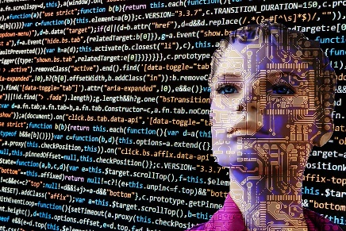
Aartificial-intelligence-2167835_1280. Authored by: 6eotech, License: CC BY 2.0
Artificial intelligence methodologies consist of the various approaches to AI research that generally fall under one of two categories: conventional AI or computational intelligence.

Why This Matters
AI researchers have developed many approaches to AI in order to meet a wide variety of goals. From simple systems that offer suggestions as you type in a key term in Google, to systems that offer professional medical advice, to systems that mimic the biological functioning of the human brain, the goals for AI systems cover a broad spectrum of applications. Understanding AI methodologies helps us to understand the complexities of human thought.

AI systems typically include three components:

A set of logical rules to apply to input in order to produce useful output

Instructions for how to handle unexpected input and still produce useful output—i.e., the ability to “wing it”

The ability to learn from experience to continuously improve performance, referred to as machine learning

Several formal methods are used to create intelligent software that has these components and capabilities. They fall under two categories:

Conventional AI methodologies—such as expert systems, case-based reasoning, Bayesian networks, and behavior-based AI—that rely on the programmer to instill the software with logical functionality to solve problems

Computational intelligence methodologies—such as neural networks, fuzzy systems, and evolutionary computation—that set up a system whereby the software can develop intelligence through an iterative (cyclical) process

It is often the case that AI developers combine methods from different methodologies to achieve their goals.

Reading: Conventional AI

Conventional AI
Conventional AI —also called symbolic AI, logical AI, or neat AI—uses programming that emphasizes statistical analysis to calculate the probability of various outcomes in order to find the best solution.

Why This Matters
Conventional AI has led to the development of software that is more intuitive to use and systems that can automate the decision-making process in certain professional activities. Conventional AI techniques such as expert systems, case-based reasoning, Bayesian networks, and behavior-based AI systems are embedded in many of today’s popular software applications, making them easier to use and to control robots and autonomous vehicles.

Essential Information
In conventional AI, advanced programming techniques are leveraged in order to imbue software with human qualities. Heuristics (rules of thumb) are used to assist software in reaching conclusions and making recommendations.

Case-based reasoning is an area of conventional AI in which the AI software maintains a library of problem cases and solutions. When confronted with a new problem, it adjusts and applies a relevant previous solution to the new problem. Case-based reasoning relies on the four Rs for solving new problems:

- Retrieve: Find cases in the case library relevant to the new problem.
- Reuse: Map the solutions from a previous case(s) to the variables of the new problem, adjusting where necessary.
- Revise: Test the solution and revise if necessary.
- Retain: Store the new problem and its newly acquired successful solution as a case in the library.

AI software built on case-based reasoning is useful for help-desk support, medical diagnosis, and other situations where there are many similar cases to diagnose.

A Bayesian network, sometimes called a belief network, is a form of conventional AI that uses a graphical model to represent a set of variables and their relationships and dependencies. A Bayesian network provides a model of a real-life scenario that can be incorporated into software to create intelligence. Bayesian networks are used in medical software, engineering, document classification, image processing, military applications, and other activities. For example, the Combat Air Identification Fusion Algorithm (CAIFA) Bayesian network is used in missile defense software and draws on multiple, diverse sources of ID evidence to determine the allegiance, nationality, platform type, and intention of targeted aircraft.

Behavior-based AI is a form of conventional AI that is popular in programming robots. It is a methodology that simulates intelligence by combining many semi-autonomous modules. Each module has a specific activity for which it is responsible. By combining these simple modules, the resulting system exhibits intelligent behavior—it becomes smarter than the sum of its parts.

Expert systems are very successful forms of conventional AI and are covered next.

Reading: Expert System

Expert System

Artificial Intelligence & AI & Machine Learning. Authored by: mikemacmarketing, License: CC BY 2.0
An expert system (ES) is a form of conventional AI that is programmed to function like a human expert in a particular field or area.

Why This Matters
Many professional activities are tedious, redundant, and dangerous. In such cases, expert systems can assist human professionals. In other cases, decisions are made that can be programmed using AI techniques. In these cases, expert systems can provide solutions as a human expert would, freeing the human expert to focus on more creative and productive activities.

Essential Information
Expert systems are created with the assistance of a human expert who provides subject-specific knowledge. The rules applied by the expert to perform some activity are programmed into the expert system software.

Like human experts, computerized expert systems use heuristics, or rules of thumb, to arrive at conclusions or make suggestions. A heuristic provides a solution to a problem that can’t necessarily be proven as correct but usually produces a good result.

Many expert systems are used in various professions every day. Computerized expert systems have been developed to diagnose diseases given a patient’s symptoms, suggest the cause of a mechanical failure of an engine, predict weather events, assist in designing new products and systems, test and evaluate chemical reactions, or detect possible terrorist threats. Some expert systems have become commonplace; users think of them simply as helpful software. For example, tax preparation software is yet another implementation of expert systems.

Reading: Computational Intelligence

Computational Intelligence
aman_geld 03.01.04 (neural network). Authored by: cea +, License: CC BY 2.0
Computational intelligence is an offshoot of AI that employs methodologies such as neural networks, fuzzy systems, and evolutionary computation to set up a system whereby the software can develop intelligence through an iterative learning process.

Why This Matters
Rather than programming intelligence into software through the use of statistics and probabilities, as in conventional AI, computational intelligence creates software that can learn for itself. Computational intelligence is where the big tech companies are investing their research dollars in order to develop systems that can go beyond human capabilities in analyzing large amounts of data.

Essential Information
There are many mathematical and logical techniques that contribute to successful computational intelligence algorithms. Two of the more important techniques are fuzzy logic and evolutionary computation.

Computers typically work with numerical certainty: certain input values always result in the same output. However, in the real world, certainty is not always the case. To handle this dilemma, a specialty research area in computer science called fuzzy systems, based on fuzzy logic, has been developed. Fuzzy logic is derived from fuzzy set theory, which deals with reasoning that is approximate rather than precise. A simple example of fuzzy logic might be one in which cumulative probabilities do not add up to 100%, a state that occurs frequently in medical diagnosis.

Evolutionary computation includes areas of AI that derive intelligence by attempting many solutions and throwing away the ones that don’t work—a “survival of the fittest” approach. A genetic algorithm is a form of evolutionary computation that is used to solve large, complex problems where a number of algorithms or models change and evolve until the best one emerges. If you think of program segments as building blocks similar to genetic material, this process is similar to the evolution of species, where the genetic makeup of a plant or animal mutates or changes over time. Some investment firms use genetic algorithms to help select the best stocks or bonds.

Neural networks, covered next, are a very popular form of computational AI that attempts to simulate the functioning of a human brain.

Reading: Neural Network

Neural Network
A neural network, or neural net, uses software to simulate the functioning of the neurons in a human brain.

Why This Matters
Simulating a human brain in a neural network provides many useful applications. However, an additional, perhaps even more important, result is a deeper understanding of how the human mind functions. Advances in neural networks are providing insight into treatment for mental illness and other brain-related diseases. Ultimately, the study of neural networks may reveal the essence of the human soul.

Essential Information
Just as human brains gain knowledge by generating paths between neurons through repetition, neural networks are programmed to accomplish a task through repetition. A neural network typically begins by running a random program. The output is measured against a desired output, which positively or negatively affects the pathways between simulated neurons. When the neural net begins getting closer to the desired output, the positive effects on the system begin to create circuits that become trained to produce the correct output. Similar to a child’s learning, a neural net discovers its own rules. For example, a neural net can be trained to recognize the characteristics of a male face, and once trained, may be able to accurately identify faces in photos as male or female.

Once a neural net is trained, it can process many pieces of data at once with impressive results. Some specific features of neural networks include:

- The ability to retrieve information even if some of the neural nodes fail
- The ability to quickly modify stored data as a result of new information
- The ability to discover relationships and trends in large databases
- The ability to solve complex problems for which all of the information is not present
Neural networks excel at pattern recognition, and this ability can be used in a wide array of applications, including voice recognition, visual pattern recognition, robotics, symbol manipulation, and decision making.

Recently, researchers have developed new neuron modeling techniques in a technology known as deep learning. Deep learning is a class of computer algorithms that use many layers of processing units to mimic the brain’s parallel-processing patterns. Each successive layer uses the output from the previous layer as input to tackle more complex problem scenarios. Deep learning was the technique Google’s DeepMind unit used in developing its winning Go algorithm (see video). Google and the other big tech companies are investing heavily in developing expertise around these computational methods. They may be the key to unlocking the truly intelligent machine.

Reading: Singularity

Singularity
The Singularity, or more specifically, the technological Singularity, is the point in time at which computers exceed humans in intelligence, launching a new era of innovation.

Why This Matters
Should it come to pass, a technological Singularity could completely change life as we know it. Those who subscribe to the theory believe that the Singularity will usher in an era of deeper understanding and rapid advancement. Others believe that the Singularity will never occur or that if machines become more intelligent than humans, they are liable to take over the world.

Essential Information
The theory of a technological Singularity was originally proposed by mathematician and sci-fi author Vernor Vinge. Vinge believed that advances in AI and human biological enhancement would eventually lead to “superintelligences” with the ability to advance science and technology well beyond what is possible with the human brain alone. Since these superintelligences have knowledge beyond humans, it is impossible to predict what might transpire after the Singularity. In his book The Singularity Is Near, Ray Kurzweil takes an optimistic view of the near future and the impending Singularity. He classifies the days ahead as the “most transforming and thrilling period in history.” He goes on to say, “It will be an era in which the very nature of what it means to be human will be both enriched and challenged as our species breaks the shackles of its genetic legacy and achieves inconceivable heights of intelligence, material progress, and longevity.”

The rationale behind the theory of the Singularity is tied to Moore’s Law and other technological trends. For the past four decades, processing power has grown exponentially. Unless something arises to interrupt it, it will continue to grow to become more powerful than the human brain.

The Blue Brain project is a bold attempt to simulate a human brain at a molecular level in software running on one of the world’s fastest supercomputers, IBM’s Blue Gene. The project has succeeded in simulating the functioning brain of a mouse. Some speculate that we will have effective software models of the human brain in the next few decades. Kurzweil placed the date for the Singularity somewhere in the mid-2040s. He expects that shortly thereafter a single computer will become smarter than the entire human race. The concept of machines with intelligence that exceeds human intelligence is referred to as strong AI.

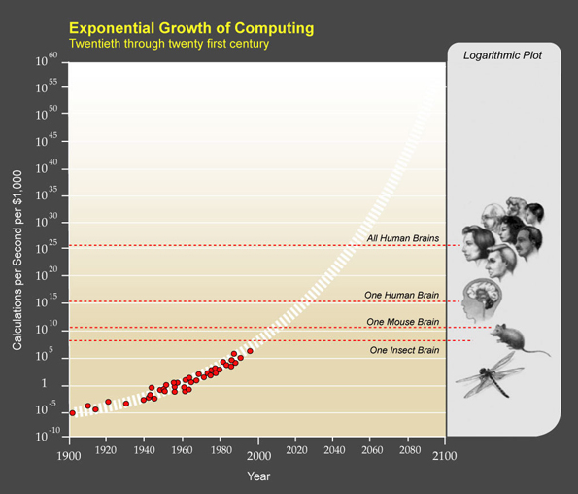
Authored by: Courtesy of Wikipedia, License: Fair Use

Reading: Turing Test

Turing Test
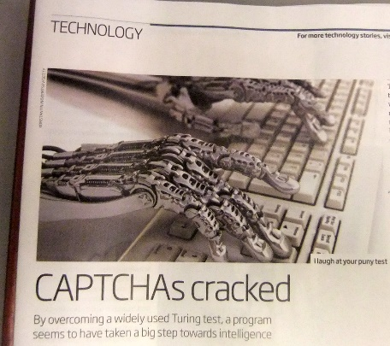
Turing Test. Authored by Gwydion M. Williams, License: CC BY 2.0
The Turing Test was devised by Alan Turing as a method of determining if a machine exhibits human intelligence.

Why This Matters
How can you tell if a computer has acquired the capability for human-level intelligence? This is an important question, especially now that supercomputers have become as powerful at processing information as the human brain. Alan Turing thought it was an important question as well when he wrote his famous paper decades ago. Turing believed that thinking machines were just around the corner. Researchers today, over 65 years later, are thinking the same thing.

Essential Information
Alan Turing was an English mathematician, logician, and cryptographer who is well known for his belief that computers would someday be as intelligent as humans. In his 1950 paper entitled “Computing Machinery and Intelligence,” Turing proposed a test, now known widely as the Turing Test, which he claimed would be able to determine if a computer exhibited human intelligence.

Turing described his test as follows: “A human judge engages in a natural language conversation with two other parties, one a human and the other a machine; if the judge cannot reliably tell which is which, then the machine is said to pass the test.” Passing Turing’s test is no simple feat. In June of 2014, a computer simulating a 13-year-old boy was able to fool 33% of the judges and claim the prize at a competition hosted by the Royal Society in London.

The intelligence of any computer passing the Turing Test is likely to be disputed. Many AI researchers have challenged Turing’s assumption, claiming that clever use of language does not necessarily imply intelligence. However, many of us are getting used to carrying on limited conversations with machine intelligences named Siri, Cortana, Alexa, Google, and others. It is no longer a stretch of the imagination to picture full conversations with such artificial personalities as if they were our human friends.

Lesson 5.2: Applications of Artificial Intelligence

Lesson 5.2 Introduction
AI applications are ways in which AI methodologies are applied to solve problems and provide services.

Research and innovation in artificial intelligence are impacting lives in subtle and not-so-subtle ways. From software that anticipates the user’s needs to robots that assist the elderly, to applications that predict trends in the stock market, to cars that drive themselves, artificial intelligence is being used in many applications.

Artificial intelligence has many and varied applications. AI techniques can be integrated into systems and applications to make them more intuitive. AI software is used to automate various types of decision-making logic. AI software can be connected to sensors and mechanical apparatus to create a variety of robots and other devices. Auto manufacturers are testing self-driving cars that utilize AI to detect and automatically respond to their surroundings. Amazon, UPS, and others are developing autonomous drones to deliver packages. This section explores these and many other common AI applications.

Reading: Robotics

Robotics
Robotics. Authored by: TheDigitel Myrtle Beach. License: CC BY 2.0
Robotics involves developing mechanical or computer devices to perform tasks that require a high degree of precision or are tedious or hazardous for humans.

Why This Matters
In recent years, robots have become a form of entertainment in toys for children and a necessity in many manufacturing processes. Contemporary robotics combines both high-precision machine capabilities and sophisticated AI controlling software. In recent years, robot capabilities have improved greatly, and it is likely that robots will soon be commonplace in many environments.

Essential Information
There are many applications of robots, and research into these unique devices continues. For many businesses, robots are used to do the three Ds: dull, dirty, and dangerous jobs. Manufacturers use industrial robots to assemble and paint products. Medical robots enable doctors to perform surgery via remote control. Sitting at a console, the surgeon can replace a heart valve or remove a tumor. Some surgical robots cost more than $1 million and have multiple surgical arms and sophisticated vision systems.

Some robots can propel themselves by rolling, walking, hopping, flying, snaking, or swimming. Other robots are designed to interact with humans using speech recognition and gesture and facial expression interpretation. Increasingly, robots are being used to transport items in office buildings. Robots have become commonplace in combat zones, flying overhead and traversing mined roads to deactivate bombs. Some have predicted that robots will become common household appliances within the next decade.

Honda claims that its ASIMO is the world’s most advanced humanoid robot. ASIMO can navigate a variety of terrains, walk up and down stairs, play sports, and serve drinks. Boston Dynamics has developed a team of biped and quadruped robots that are able to walk, run, and perform all sorts of physical functions. The iRobot company makes robots for the home that vacuum the carpets, clean the gutters, and more. Recently, iRobot spun off its military robotics division into a company named Endeavor Robotics.

Since technologies have advanced to the point where the construction of useful humanoid robots is not only feasible but also affordable, more researchers and companies are investing in robotics research. Many predict that household robots will become commonplace over the next decade. In other cases, robotics is used to augment human capabilities. A Pittsburgh woman who is paralyzed from the neck down has recently taken control of robotic arms that, through a brain implant, she controls with the fluidity of a natural arm.

Reading: Autonomous Vehicles

Autonomous Vehicles
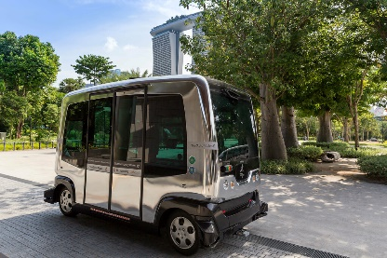
Autonomous Vehicle. Authored by: wuestenigel, License: CC BY 2.0
Autonomous vehicles include aircraft, ground vehicles, and watercraft that operate autonomously, without the aid of a human pilot, driver, or captain, such as driverless cars and drone aircraft.

Why This Matters
Advances in artificial intelligence, processing speed, and other technologies have made it possible for moving vehicles (cars, trucks, aircraft, boats, and ships) to navigate and control themselves through all kinds of environments according to existing rules and laws. The primary thing holding these technologies back from going mainstream is the lack of provisions in laws that would allow autonomous vehicles to join human-controlled vehicles in traffic. Such provisions are being crafted and soon we all will be taking advantage of the opportunities that autonomous vehicles provide.

Essential Information
Of all the AI-driven technologies, autonomous vehicles probably get the most media attention. Self-driving cars from Google, Tesla, and others are already on public roads being tested, with human drivers at the ready should they need to intervene. Amazon, UPS, and others are testing drone-delivery systems that promise same-day delivery. These fantastic inventions are poised to take off, but are humans ready to give up control?

Self-driving, sometimes called driverless, cars have been in development for years. In 2004, DARPA held the first Grand Challenge with a prize of $1 million for the autonomous vehicle that could traverse a course across the Mojave Desert. None of the entrants were able to complete the challenge. By 2005, five vehicles completed a more challenging DARPA Grand Challenge, and in 2006, six vehicles autonomously navigated through empty city streets in the Urban Challenge. Since then car and truck manufacturers have been working hard to refine the technology so that it is safe for populated city streets.

There are several approaches to developing self-driving cars and vehicles. Small autonomous golf-cart-sized vehicles are available as a cab service on some private campuses. IBM’s Watson is the intelligence behind OLLI, the shuttle that transports pedestrians through the streets of National Harbor, Maryland. Some auto manufacturers are adding automation gradually so that drivers gradually get used to giving up control of the vehicle. Many cars now have the ability to park themselves. Tesla evolved its driver assist features to the point where its current models can now completely drive themselves. Others, like Google, are creating fully autonomous vehicles right from the start, hoping consumers will be ready for the dramatic shift. Think of what autonomous vehicles will mean to a company like Uber! The company is testing its self-driving technology on the streets of Pittsburgh. Soon you might be able to call up a driverless Uber ride in your town. Uber is also investing in self-driving semi-trucks.

Self-driving cars offer benefits by reducing driver error and saving fuel and time. Drivers can give up the controls and become productive during their commutes. Autonomous vehicles are believed to be safer than human-driven vehicles. They eliminate concern about distracted drivers, drunk drivers, or incompetent drivers. As self-driving vehicles gain the ability to communicate with each other and traffic signals over wireless mesh networks, savings and safety will increase even more.

Autonomous vehicles will mean huge savings for the commercial delivery industry. Autonomous trucks from traditional manufacturers like Freightliner and new companies like Otto Motors are poised to reshape the trucking industry. Beyond removing human error from the equation, autonomy also provides new ways for trucks to collaborate. In a technique called platooning, several autonomous trucks link together in a tightly knit convoy, with the lead truck in control. The technique is believed to save 20 percent in fuel costs and additional savings in human resources. On the down side, truck drivers are concerned about the future of their livelihood.

In 2013, Amazon CEO Jeff Bezos caused quite a stir when he unveiled a new delivery system in development that involved autonomous drones. It was soon discovered that Google had been working on the same technology for years, and soon everyone from UPS to the convenience store 7-Eleven were working on drone delivery systems. This was during the same period that hobbyist remote-controlled drones were coming down in price and becoming popular. The Federal Aviation Association became quite alarmed at the potential threat to air traffic and public safety and passed new rules that require licenses for flying remote-controlled drones and disallowed autonomous drones. Since then companies have been working to convince the FAA to allow the use of drones for delivery.

In the meantime, companies like Starship Technologies are developing small, six-wheeled robots to deliver packages to businesses and homes. Mercedes has created a “Robovan” to transport eight robots to a neighborhood and launch them into the streets to deliver their packages. The typical volume of deliveries for a human delivery person is 180 packages per nine-hour shift. The Robovan and its robots will more than double that to 400 packages.

In Amsterdam, autonomous vehicles have taken to the water. “Roboats” are programed to motor pedestrians to their destination via canal routes. The small, two-person platforms can also be joined together to create a bridge across the canal.

It is clear to see from these examples that there is a new world around the corner—one filled with autonomous vehicles and robots. How will these technologies impact our daily routines? Will they increase human safety and efficiency? Or will this constitute the first step of the AI-controlled robotic takeover?

Reading: Computer Vision

Computer Vision
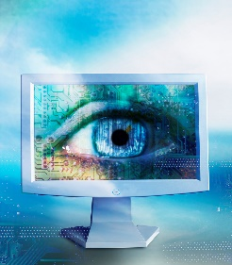
Computer Vision Syndrome. Authored by downloadsource.fr, License: CC BY 2.0
Computer vision combines hardware (cameras and scanners) and AI software that permit computers to capture, store, and interpret visual images and pictures.

Why This Matters
Computer vision enables software to react to visual input. This ability provides all sorts of opportunities for automation. No longer does the computer need to wait for manual input; it can be programmed to automatically react to movement or objects in its environment. This is useful in all forms of robotics, in security systems, in games, and in a wide variety of applications that benefit from visual input.

Essential Information
Although seeing is second nature for most humans, it is a complicated capability to program into computers. To process input from video cameras or simply to analyze a photograph requires complicated AI techniques. Through those techniques, computers have learned to notice irregularities in video and still photos and to distinguish colors, motion, and depth. And they’re getting better all the time! At the 2016 Large Scale Visual Recognition Challenge—hosted by Stanford, Princeton, and Columbia Universities—the accuracy in computers’ correctly identifying objects in common photos increased to 66.3%. All contestants utilized deep learning techniques in their algorithms.

Computers are used to interpret medical images like x-rays and ultrasonic images. They are used in pattern recognition, such as face recognition in security systems. Computer vision is used in the military to guide missiles, and in space exploration to guide the Mars Rovers.

Microsoft brought computer vision into the living room with the Kinect Xbox 360 controller. The set-top box allows players to put away their handheld controllers and control game action with body action. Kinect applications have been developed to help stroke victims and children with autism, to assist doctors in the operating room, to create new forms of art, to assist the disabled, and to implement other valuable services.

Computer vision systems are also being developed to assist in human sight. Dr. William Dobelle designed a system that has brought a form of vision to totally blind individuals. The system combines a small video camera mounted in sunglasses, a powerful but small computer worn in a belt, and a brain implant that stimulates the visual cortex. By connecting an array of electrodes to the areas of the visual cortex, the system can provide vision with a grid of. By enabling a video camera to control the intensity of power to the electrodes, one patient has been able to see well enough to drive a car.

Reading: Natural Language Processing

Natural Language Processing
Natural language processing uses AI techniques to enable computers to generate and understand natural human languages, such as English.

Why This Matters
Natural language processing makes it possible to interact with computer systems using spoken words. Apple’s Siri, Microsoft’s Cortana, Google’s Assistant, and Amazon’s Alexa act as personal digital assistants that attempt to answer any question spoken by a user using natural language processing. Xfinity’s X1 system allows users to speak into the remote to call up any television show, movie, channel, or actor. Natural language processing is useful for individuals who cannot use a keyboard and mouse because they are disabled or because their hands are needed for other work. Increasingly, people are taking advantage of natural language processing to dictate voice input to a computer rather than typing text or commands.

Authored by Business Wire, License: Fair Use

Essential Information
One area of natural language processing that is evident in today’s software and business systems is speech recognition. Speech recognition enables a computer to understand and react to spoken statements and commands. With speech recognition, it is possible to speak into a microphone connected to a computer, or into a mobile phone, and have the spoken words converted to commands or text displayed on the screen. Like Siri and Cortana, Alexa on Amazon’s Echo device fields spoken questions and commands, but from a shelf in your home. Google Home performs the same function.

Current versions of many desktop and mobile operating systems have utilities that enable you to speak commands to the computer as well. Microsoft Word has a speech utility that enables you to dictate to the computer instead of typing. Dragon NaturallySpeaking, which allows users to dictate text as they would naturally speak, is popular software for both PCs and cell phones. As with all dictation software, you must speak punctuation characters and commands to place the cursor in a new location. For example, you might dictate this statement, closing with “period – new line.”

Google Voice is able to deliver voicemail as text transcriptions. Google recently improved its transcription capability by 50% with new technology developed through deep learning technology.

Speech recognition is not to be confused with voice recognition, which is a different technology used in the security field to identify an individual by the sound of his or her voice.

Speech recognition must utilize AI methodologies to overcome some difficult obstacles:

- Speech segmentation: If you listen to a person speak from a computer’s perspective, you will notice that there is roughly the same length of pause between syllables in words as there is between words in a sentence (roughly none). How is the computer to determine where one word ends and the next begins?
- Ambiguity: There is no difference between the sound of the words “their,” “there,” and “they’re.” When spoken, how is the computer to know which one is intended?
- Voice variety: Everyone speaks differently. The English language has many regional and personal dialect variations. It is difficult for one program to understand both Arnold Schwarzenegger and Kim Kardashian.

Using AI, speech recognition software “learns” a dictionary of words to determine how to parse a sentence into individual words. It must also learn grammatical rules in order to overcome the problem of ambiguity. In addition, it must have some insight into human thinking to understand a sentence such as “Time flies like an arrow.” Increasingly, speech recognition relies on context to help determine what is being spoken. Google, for example, has access to massive amounts of user data that it collects through Gmail, Google Search, YouTube, Android OS, and other Google software. This information provides Google with a context in which to interpret and satisfy a user’s needs.

Reading: Pattern Recognition

Pattern Recognition
pattern. Authored by Curt Smith, License: CC BY 2.0
Pattern recognition is an area of AI that develops systems that are trained to recognize patterns in data.

Why This Matters
Many useful applications are based on computers’ ability to recognize patterns in data. Pattern recognition is used to find exceptions to trends in data for businesses in a process called data mining. Such findings can help in discovering fraud or other unusual business activities. Pattern recognition is also useful for training AI computer vision systems to recognize faces, handwriting, or other visual patterns.

Essential Information
Speech recognition, handwriting recognition, and facial recognition all fall under the AI category of pattern recognition. Handwriting recognition uses AI techniques in software that can translate handwritten characters or words into computer-readable data. The technology is useful in mobile devices, like Microsoft’s Surface Pro, where a stylus can be used to write on the touch display.

For governments and other organizations concerned with security, facial recognition is a hot area of AI research. Facial recognition uses cameras and AI software to identify individuals by unique facial characteristics. Facial recognition is used in authentication—verifying a person’s identity before allowing access to secure areas or systems—and in surveillance. The Australian SmartGate system uses facial-scan technology to compare the traveler’s face against the scan encoded in a microchip contained in the traveler’s ePassport. Disney is experimenting with foot recognition to identify visitors in its theme parks without infringing on their privacy.

Facial recognition is catching on as a handy tool for organizing photos as well. Apple’s iPhoto, Facebook, and other photo software uses facial recognition technology to automatically recognize and tag friends in digital photos. The tool is trained to recognize individuals with the help of the user who corrects the software when it incorrectly identifies a face. Over time the facial recognition gets more competent and can call up all the photos that include a specified person.

Pattern recognition is used in the iPhone, iPad, and MacBook Touch ID technology that allows users to bypass an access code with the press of a fingertip. Using physical characteristics such as fingerprints to access computers is referred to as biometric authentication.

Perhaps the most valuable use of pattern recognition is in mining big data. The amount of data being generated by online systems has grown beyond our ability to manage it. By 2020, the amount of digital data produced is expected to exceed 40 zettabytes, of which roughly 33 percent of will contain valuable information. Artificial intelligence is needed to explore that data, using pattern recognition techniques, to find trends and outliers, and produce useful, actionable information.

The Internet of Things is expected to add another 400 zettabytes to data generated by 2018. This is data generated by sensors, appliances, cameras, and many other physical objects. Utilizing pattern recognition in AI technologies like deep learning will give computers the ability to make predictions about a variety of environments and human behavior to serve humanity in small ways, like designing homes and products, to critical ways, like saving the planet from greenhouse gasses.

Reading: Personal Digital Assistant

Personal Digital Assistant
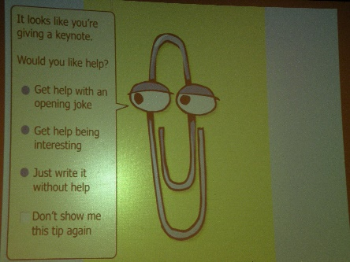
Clippy!. Authored by: Matt DiGirolamo, License: CC BY 2.0
A personal digital assistant is a program that draws from a knowledge base in order to answer questions and perform tasks for a person.

Why This Matters
One of the earliest personal digital assistants was a little animated paperclip named Clippy who assisted Microsoft Word users. Clippy would say things like “It looks like you’re writing a letter. Would you like some help?” While sometimes helpful, Clippy soon developed a reputation of being annoying. For decades, we predicted that computers would someday have the ability to anticipate a user’s needs and make life easier, but only recently have we seen that technology begin to emerge. Apple’s Siri, Microsoft’s Cortana, Google Assistant, and Amazon’s Alexa have provided us with a glimpse of how personal digital assistants can serve humanity.

Essential Information
Software referred to as intelligent agent software has been used for years to carry out specific tasks such as searching for data on the web. This software has evolved into general-purpose software designed to assist with all types of questions and tasks. Siri, Cortana, Alexa, and Google Assistant have taken intelligent agents to a whole new level.

Apple’s Siri interface ushered in the era of the personal digital assistant for the iPhone. Google followed close behind with its Google Now app (updated to Google Assistant) that runs on Android and iOS devices, and Microsoft followed suit with its Cortana personal digital assistant for Windows devices. Amazon introduced a home device named Echo, which features Alexa as the personal assistant that responds any time her name is called in the house. Google responded with Google Home, a tabletop device that behaves like Echo with the ability to answer questions and carry on more complex conversations. Meanwhile, Cortana expanded into Windows PCs, and Siri into Macs and MacBooks. So now, people have the opportunity to call on their personal digital assistant conveniently from any location to get assistance with Internet-related services, phone services, home-related questions, and personal computer-related tasks. Clearly the battle of the personal assistants is in full swing.

Using natural language processing, these apps allow users to ask questions or issue commands using natural spoken language such as “Remind me to pick up milk on my way home” and “Any good burger joints around here?” The app responds to commands and questions with a human-like voice that answers the question directly or provides a related website. These apps work their magic by sending a query to a server (in the cloud), where AI software dissects the request, runs it through the most appropriate online service, and responds with a solution.

Since the technology is far from perfect, mistakes are inevitable and sometimes humorous. There are several websites dedicated to amusing Siri mistakes. However, the technology continues to improve. Google Assistant remembers the previous questions and is able to reply to follow up questions in a conversational manner. It is likely that these technologies will continue to improve through AI technologies like deep learning, until they can easily pass the Turing Test.

In addition to accepting commands and fielding questions, a personal digital assistant can also take dictation and send it through email or text message. Many people dictate text messages through a digital assistant while driving so that they don’t have to take their hands off the wheel.

Reading: Context-Aware Computing

Context-Aware Computing
Context-aware computing refers to software that uses artificial intelligence to provide services based on environmental context.

Why This Matters
Traditional software has no awareness of the environment in which it is running. That is all changing. Like Siri, Cortana, and Google Assistant, most software will soon be able to tap into who is using it and where and how it is being used, to provide services specifically designed for that moment and situation. In other words, software is becoming much smarter.

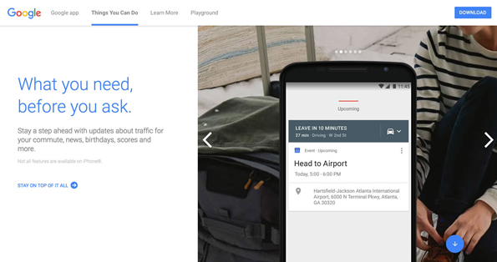
Authored by: Courtesy of Google Inc., License: Fair Use

Essential Information
Context-aware software is able to tap into user preferences, current location and time, social connections, and other attributes to improve services. For example, context-aware security is an early application of this new capability. By understanding the context of a user request, a context-aware security application can adjust its response to better protect the user. Have you ever had a bank or credit card company contact you because your account was accessed in an unusual way—from a foreign location or multiple times within an hour? This is an example of a context-aware security system.

Google is working to do away with the need for passwords on Android phones by using a context-aware technology it calls “trust scores.” Factors including typing speed, vocal inflexions, facial recognition, and proximity to familiar Bluetooth devices and Wi-Fi hotspots are used to calculate the score, and if the score is high enough you can access apps without passwords.

Intelligent software is the product of our increasingly connected lives. Our mobile devices provide detailed information about our location and activities at any given moment. This information informs information systems about our lifestyle and preferences. As the Internet of Things continues to grow, increasing amounts of environmental information will be at the disposal of software and information systems. Although some may consider the collection of all of this information an invasion of privacy, it will give software the ability to provide information and services we need exactly as we need them.

Module 6

Introduction
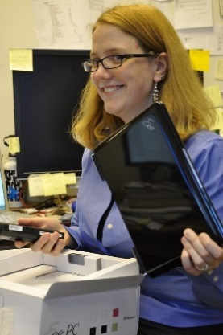
"Unboxing an Eee" by jblyberg is licensed under CC BY 2.0

Digital life refers to the influence of digital technologies on the manner in which people live their lives.

The digitization of just about everything, from arts to information to communication, has had a dramatic impact on life. Pervasive networks—especially cellular and other wireless networks—allow people to access all kinds of information, services, and entertainment, and to communicate with friends and colleagues, anywhere and anytime. Ready access to so many resources has caused many to plunge into a digital lifestyle where more time is spent online than off. This major shift in behavior has had a profound impact on the productivity of individuals and organizations as well as on our mental and physical states. It is wise to consider all the implications of our digital lifestyle in order to make informed decisions on how best to incorporate digital technology into our lives.

Virtual reality headsets like the Oculus Rift and HTC Vive are poised to be the next big thing in home entertainment. These headsets allow the viewer to virtually enter environments where entertaining and interactive challenges await. Augmented reality technologies like Microsoft Hololens and Magic Leap bring virtual objects into the real world. In 2016, millions of people hunted virtual creatures around city streets playing Pokemon Go causing clashes between those pursuing the virtual and those pursuing the real. Increasingly the virtual, digital world is encroaching on our real-world activities and experiences. What types of benefits does this trend provide humans? What costs? What do you imagine will come next?

As people spend increasing amounts of time online, changes occur in social structures and mechanisms. These personal and social changes have both benefits and costs. A student benefits from the ability to talk with a friend on a mobile phone at the conclusion of class but may miss out on an opportunity to meet someone new sitting in a neighboring seat. Citizens benefit from the use of technologies in law enforcement to create safer living conditions but might pay a price in terms of personal privacy. Big businesses benefit from outsourcing labor at the expense of the shrinking job market at home. The benefits and costs range in scale from personal to global. Balancing the benefits of digital technologies against the costs, and determining which outweighs the other, is a highly personal and subjective but important activity for everyone.

The digital revolution has left the global population with numerous challenges to address. Most people feel pressure from the growing mountain of information and online relationships to manage. Many are unable to find time away from technology and its demands. New types of etiquette are being defined for acceptable and unacceptable online behavior. New laws are being created, including those that address distracted driving, to keep people safe in our new digital environment. Parents are concerned about the impact that ultra-violent, first-person shooter video games are having on children. Professionals are learning to collaborate with partners and team members scattered around the globe. We are testing the boundaries of what is required for living a healthy, productive digital lifestyle, with some individuals crossing the line into unhealthy behavior. This unit studies all of these digital lifestyle phenomena and more.

Lesson 6.1: Psychological Effects

Lesson 6.1 Introduction
Computers, smartphones, and other digital devices have become integral parts of our lives, influencing everything we do from the moment we wake until long after we should have gone to sleep, when we find ourselves scrolling through social media feeds, reluctant to disconnect ourselves. At the same time, these technologies allow us to communicate with friends and family scattered around the globe, and collaborate with business associates in ways that were previously impossible. The psychological changes caused by computing devices are neither entirely beneficial nor detrimental, but there is no doubt that they have been profound.

Reading: Information Overload

Information Overload
"globe" is licensed under CC0 1.0

Information overload refers to individuals and organizations’ inability to cope with the huge and growing amount of information being collected, stored, analyzed, and delivered.

Why This Matters
One of the greatest challenges of the information age is managing big data—the huge and growing amount of data collected from every transaction and activity taking place online. Businesses and governments recognize the importance of gleaning actionable knowledge from collected information and so collect as much data as possible. The problem is, information systems can’t keep up with the amount of data being collected and stored. Individuals are struggling as well. As people become increasingly connected, they must maneuver through increasing amounts of information and communications to quickly determine how to make the best use of their time and energy. The most valuable technologies that will be developed in coming years will be those that are able to store, organize, and quickly extract valuable information from mountains of data.

Essential Information
The digital lifestyle is chock-full of information. The amount of digital information is now measured in zetabytes; that’s

1,000,000,000,000,000,000,000 bytes:

a 1 followed by 21 zeroes! And the amount of digital information is doubling every year. The amount of digital information is surpassing the capacity of storage devices available to store it all. Each person’s digital shadow—that is, the digital information generated about a person by businesses and organizations on a daily basis—surpasses the amount of information that an individual person generates in a lifetime. Finding specific information at a specific time among this much data can be like finding a needle in a haystack.

IDC—a provider of market intelligence for the information technology, telecommunications, and consumer technology markets—warns that unless businesses implement enterprise-wide data storage and management procedures and policies, the amount of information will outpace our ability to manage it. Big data has become a priority. Corporations and individuals who have the skills to manage big data are among the top sought-after employees.

Information overload is impacting individuals as well. One example is email. The average professional spends roughly 28% of his or her week managing email. The average CEO gets 200 to 300 emails per day! Email has become such a distraction that some businesses are banning email and replacing it with social-media style systems.

Finding information online can be challenging. A Google search yields thousands of results. Hopefully, the user is able to find useful resources on the first couple pages of those results. Many of us have to keep track of numerous sources of communication; email, text messages, Facebook and Twitter posts, and other forms of communication compete for our attention throughout the day.

The next generation of web technologies is confronting information overload by applying artificial intelligence and better organized data to get users the information they need more quickly and with less effort. Personal digital assistant technology like Apple Siri, Google Assistant, Amazon Alexa, and Microsoft Cortana provide information as you need it by analyzing your habits, environment, location, and time of day. When driving to the airport, Google Assistant will automatically guide you along the least congested route, tell you about the weather at your destination, and inform you of flight delays and gate changes.

Reading: Computer-Based Violence

Computer-Based Violence
Computer-based violence refers to acts of interactive simulated violence provided by computer games.

"Screen shot 2011-03-18 at 11.47.48 PM" by niftybottle is licensed under CC BY 2.0

Why This Matters
Never before has it been so easy to commit brutal acts of violence in realistic environments without causing harm to others. Although playing violent video games does no physical harm, psychologists, parents, governments, and others wonder how violent role-playing affects the minds of gamers. Are violent gamers more likely to be aggressive in the real world, transferring what they learn in the gaming environment to real life? This is a hotly debated issue that involves many people and governments around the world.

Essential Information
In efforts to engage teen and older gamers, games have progressively moved to more violent themes. The popular and controversial Grand Theft Auto (GTA) remains a topic of great debate due to its graphic depiction of extreme violence and law breaking. Some people have become concerned about the effects of prolonged exposure to violence on game users. GTA was banned in Thailand after a disturbed teenager allegedly killed a taxi driver, reenacting a scene from the game. Six teens in New York City were arrested after going on a GTA-inspired crime spree. More recently, the school massacre in Newtown, Connecticut created more pressure on video-game makers and retailers as Washington and advocacy groups grew even more concerned about possible links between violent games and violent crime. The United States, the United Kingdom, Australia, and other countries have all gone back and forth on banning GTA in response to outcries from concerned parents and other constituents.

GTA isn’t the exception, however, it’s become the norm. There are hundreds of first-person shooter games available. First-person shooter games are those in which the player becomes the game character that does the shooting and killing. They include war games like Halo, Call of Duty, Gears of War, and Splinter Cell Conviction. There are also police games like Crackdown and Condemned: Criminal Origins. There are fantasy games like Aliens vs. Predators. In some games, the player fights to save the world; in others, the player fights as the villain. In all cases, virtual shooting, maiming, and killing become second nature. In an attempt to distance itself from real-life violent acts, game maker Electronic Arts, responsible for first-person shooter games like Medal of Honor and Battlefield, decided to end its licensing deals with gun makers whose brand-name hardware it had featured in its games for years.

Studies on the impact of violent games on users have been inconclusive. As video games become increasingly realistic, providing interactive virtual worlds that are less discernable from reality, it seems logical that the violent acts carried out in games will more easily transfer to real life. Also, as individuals spend more time in violent, high-anxiety situations, it is logical that some desensitization to violence occurs, along with other effects to the psyche. Although these assumptions seem logical, some studies support them and others show them to be untrue.

Reading: Computer Addictions

Computer Addictions
Computer addictions refer to the compulsive use of digital technologies such as the Internet, video games, online gambling, and pornography.

"The Digital #13" by hitchinssamson is licensed under CC BY 2.0

Why This Matters
Too much of any activity can lead to an unbalanced life and, sometimes, to a lack of control over your own actions. To some people, the rich virtual environment of the Internet and its many applications is preferable to their own lives and physical environments. Some become obsessive and spend increasing amounts of time engaged in online activity. When a person is unable to control an impulse to engage in some activity, that person is addicted. Addictions may require psychological treatment to cure.

Essential Information
The use of the Internet can be addictive. Some people spend most of their time connected to the Internet and staring at the computer screen. When this behavior becomes compulsive, it can interfere with normal daily activities, including work and relationships. Often, Internet addiction means that a person is isolated and doesn’t interact with other people unless they are also online. Internet addiction may exist if people are online for long periods of time, cannot control their online usage, jeopardize their career or family life as a result of excessive Internet usage, or lie to family, friends, and coworkers about their Internet usage. Scientists studying Internet addiction categorize several types: pornography, gambling, online multiplayer gaming, e-shopping, and social networking addictions.

The abundance of free pornography on the web has caused some individuals to become addicted. It has been estimated that 12% of Internet content is pornography. Viewing and sharing pornography in large quantities can alter an individual’s perception of what is socially acceptable and normal. Also, in efforts to supply increasingly outlandish pornography, some have crossed the line into unhealthy and illegal practices. Many individuals from a variety of backgrounds have sought professional help in dealing with Internet-based pornography and sexual addictions.

Compulsive gambling is a problem for some people using the Internet. Compulsive gamblers find using the Internet much easier than driving to a gambling casino.

Internet gambling is legal in some states in the U.S. and has been legal in other countries for quite some time. Online gambling has grown into a $37 billion industry, one of the biggest businesses on the Internet. In 2006, President Bush signed the Unlawful Internet Gambling Enforcement Act, which makes it illegal for U.S. citizens to gamble on the Internet, no matter where the online casino is located. In 2011, President Obama signed an opinion stating that the Unlawful Internet Gambling Enforcement Act only applies to bets on sporting events. Since then several states have drafted legislation to allow online gambling.

Other Internet users become addicted to massively multiplayer online role-playing games (MMORPGs). Some gamers find the virtual worlds of online games more interesting and rewarding than real life and spend increasing amounts of time in virtual worlds. Others are addicted to online shopping and online social media. Although these activities are not unhealthy in reasonable quantities, spending more time online than offline can become problematic.

Many feel that the best way to avoid or recover from any computer-related health issue—physical or mental—is to live a balanced life. A balanced life includes technology time and time away from technology; time alone and time spent in the company of others; time on the phone and time in face-to-face interaction; time indoors and time with nature. Some psychologists feel that many young people suffer from nature deficit disorder. They believe that people tend to stay healthier when they stay in touch with nature. The more balance you have in your life, the more balanced your mental and physical health and development will be. If you feel that you suffer from any of the above-mentioned health problems, try spending prolonged time away from technology. If you find that you are unable to do so, consider seeking help from a physician or counselor.

Lesson 6.2: Physiological Effects

Lesson 6.2 Introduction
In addition to changes in the way we interact with other people and ourselves, computers and other digital devices have also changed the way we interact with the physical world around us. On a fundamental level, computers are tools. If used properly, they can multiply the productive potential of an individual, but when used carelessly, as a distraction or without proper techniques, the results can be bodily harm or death. In this lesson we’ll examine a few examples of these physiological effects.

Reading: Distracted Driving

Distracted Driving
Distracted driving occurs when drivers focus on their cell phones or other distractions rather than on the road.

"sign" by ford is licensed under CC BY 2.0

Why This Matters
Digital life and ubiquitous computing and communications mean that people are spending increasing amounts of time online. While anywhere, anytime text messaging, mobile web browsing, and phone conversations provide substantial conveniences and an increase in productivity, they also pose some risks. The largest risk occurs when attempting to operate heavy machinery while engaged online. Many governments have passed laws prohibiting people from driving while using digital devices.

Essential Information
Around the world, law enforcement agencies are finding increases in cell phone-related automobile accidents. Many of these accidents are the result of texting while driving. Dialing a mobile phone while driving is dangerous enough, but typing or reading text messages takes drivers’ eyes off the road for several seconds at a time. At 30 to 60 miles per hours, a six-second lag in attention can take a vehicle one-tenth of a mile, providing many opportunities for accidents.

Some governments have passed laws banning the use of cell phones while driving. In the U.S., 46 states, D.C., Puerto Rico, Guam, and the U.S. Virgin Islands ban text messaging for all drivers. The U.S. federal government has banned cell phone use while driving for all military personnel. The U.S. Department of Transportation has banned texting while driving for all U.S. commercial truck drivers.

Statistics show that distracted driving due to cell phone use is as dangerous as drinking while driving. Despite anti-texting efforts and distracted driving laws, thousands still die each year in crashes involving distracted drivers. Research shows that a texting driver is 23 times more likely to get into a crash than a non-texting driver. While laws may vary, drivers are wise to pull off the road to use their cell phones.

Reading: Repetitive Stress Injury

Repetitive Stress Injury (RSI)
Repetitive stress injury (RSI) occurs when a particular physical motion is repeated frequently, to the point of injury.

"Woman typing" by Mad Fish Digital is licensed under CC BY 2.0

Why This Matters
One downside of leading a digital life is the amount of time physically spent on digital devices. While engaged and interacting online, portions of the body are sometimes placed in awkward positions for extended periods of time, which can lead to repetitive stress injuries. For example, your wrists can suffer when you type on a keyboard, your thumbs when you text message, and your eyes and neck as you focus on a display. Being aware of common ailments and how to minimize them can help users avoid RSI.

Essential Information
Working and living with computers and digital technologies can lead to potential health problems. As people increasingly use computers at work and at home, more people are suffering from computer-related health problems. Along with increases in computer use, insurance claims relating to repetitive stress injury have increased greatly since people began using computers. RSI is an injury, such as tendinitis or tennis elbow, caused by a repetitive motion. The most common RSI for computer users is carpal tunnel syndrome. Carpal tunnel syndrome (CTS) is the aggravation of the pathway for nerves that travel through the wrist (the carpal tunnel), typically caused by long hours at the computer keyboard with wrists cocked and fingers typing.

Engaging in any repetitive physical motion will cause ailments. Just as the prolonged use of desktop and notebook computer keyboards can cause CTS, texting on a phone can cause a similar problem in thumb muscles; utilizing a game controller for hours on end can cause arm, wrist, and hand pain; and the overuse of a kinetic controller to bowl or play tennis can cause injury as well.

Staring at a computer screen without proper light for many hours can cause a variety of vision problems. In some cases, your eyes get tired, itch, or even burn. In more severe cases, double or blurred vision can result, making it unpleasant to work and reducing your efficiency. In addition to wrists and eyes, you can get a sore back, sore arms, and headaches from long hours working with computer systems without taking adequate breaks. The solution to avoiding repetitive stress injury is to carefully gauge the amount of time spent carrying out repetitive motions, take frequent short breaks or change positions, and practice ergonomic methods for reducing strain on the body.

Some individuals who use computers all day long opt for a standing desk. Some studies suggest that sitting at a desk all day increases the risk of heart disease by up to 147%. So many office workers are switching to standing desks—taller desks, or adjustable desks, that allow a computer user to stand and type comfortably. Typically, a soft rubber mat is used as well to decrease strain on the legs and back.

Ergonomics is the study of designing the work environment and positioning computer equipment in a healthy manner. Knowing how to address the strains and stresses on your body from using digital technologies will help you to lead a healthier digital lifestyle. Ergonomics studies all possible ill effects of digital technologies on your body and recommends ways to avoid them.

There are many ergonomic approaches to reducing computer-related health problems. The slope of the keyboard, the position and design of displays, and the placement and design of computer tables and chairs have been carefully studied. Flexibility is a major component of ergonomics and an important feature of computer devices. People of different sizes and tastes require different positioning of equipment for best results. For example, some people want to have the keyboard in their laps; others prefer to place the keyboard on a solid table. Because of these individual differences, computer designers are attempting to develop systems that provide a great deal of flexibility.

Lesson 6.3: Societal Changes

Lesson 6.3 Introduction
In addition to the physical and mental impacts on an individual, computers and digital technology have also had tremendous ramifications for whole societies. With constant, always-on access to the sum total of knowledge of humanity at our fingertips, has come unprecedented opportunities for cooperation and social growth, but the risks of misunderstanding and misinformation have increased just as rapidly. Our ability to recognize and adapt to these challenges will be a significant factor in the future development of our communities and cultures.

Reading: Ubiquitous Computing

Ubiquitous Computing
Ubiquitous computing refers to a culture where digital technologies are embedded in the environment, making interaction with the technologies second nature.

"Is this being social?" by Scrap Pile is licensed under CC BY 2.0

Why This Matters
Digital information and services are essential commodities in today’s world. The goal of those that provide such commodities is to make them available to customers anywhere, anytime, with maximum convenience. Digital services of all kinds delivered by numerous Internet-connected devices are increasingly becoming part of our environment. For example, Amazon Go uses computer vision, sensor fusion, and deep learning in a new kind of store with no checkout required. Shoppers swipe their phone at the entrance, pick an item off the shelf, toss it in their bags and walk out of the store. The technology is able to tell what shoppers take off shelves and automatically debit their accounts.

Essential Information
Pervasive computing refers to the ability to access computing and information technologies at any time, in any place. Ubiquitous computing goes beyond pervasive computing to the point where computing is a part of the environment. The Internet of Things and artificial reality are ushering in the era of ubiquitous computing, providing everyday objects with the ability to sense their environment and relay information over a network. Mark Weiser, a researcher at Xerox PARC coined the term ubiquitous computing. He envisioned a world of “calm technology,” where technology is so prolific that it is no longer even noticed. Just as we can stroll a city street without consciously noticing the dozens of signs and billboards that our eyes are automatically taking in, in the age of ubiquitous computing, we take for granted the digital technology that surrounds us.

Digital communication has also become pervasive. Mobile phones put us in near continuous contact with colleagues, family, and friends as well as give us instant access to information and a world of products and services. While we have access to all of this anytime, anywhere, others also have access to us anywhere, anytime. Our every move is recorded by cellular networks, and our every online activity is recorded and analyzed by innumerable agencies. Although ubiquitous computing provides many conveniences, it brings with it threats to individual privacy.

Reading: Digital Etiquette

Digital Etiquette
Digital etiquette refers to using digital technologies in a manner that is respectful to others.

"etiquette" by Muffet is licensed under CC BY 2.0

Why This Matters
People are spending more time interacting with each other through digital technologies. These new forms of remote communication bring with them new opportunities for misunderstanding, rudeness, and hurt feelings. It is important for people to consider which types of communication over digital devices are acceptable, and which are not, and to learn to treat each other with respect online and in person.

Essential Information
The concept of digital etiquette first arose around issues in email and chat rooms. Email users are well aware of misunderstandings that can arise from poorly worded email messages. Users of chat rooms, online discussion groups, and other forms of Internet communication have experienced rude behavior from anonymous sources wishing to stir up trouble. With experience, users learn how to carefully word text messages to avoid misunderstandings and to go out of their way to be courteous and respectful to others online while ignoring those with no manners. This type of network etiquette is sometimes referred to as netiquette.

As with all forms of etiquette, levels of tolerance vary from person to person. In general, consideration should be shown to those with whom we interact and those around us.

The use of mobile phones in public places sometimes offends traditional notions of courtesy and etiquette. Cell phone users should be mindful not to inconvenience or disturb those around them. They should also remember not to make important calls over unreliable connections.

Netiquette has extended to social media as well. Many users of Facebook and other social media have experienced or witnessed embarrassing interactions. The table below provides some useful tips for safely navigating relationships on social media.

Social Media Etiquette and Safety
Topic | Tip
Friends | Select friends wisely. Make sure your posts are mindful of who is in your collection of friends. It may be unwise to mix your friends with your business associates and superiors.
Sharing | Be conservative on the number of posts and the topics you post on. If you post frequently and on issues of little interest, your friends may soon tune you out or block you. Do not argue with friends in a public forum; save it for private communication when necessary.
Photos | Use discretion with the photos you share. Make sure they show you and others in the photo in a positive light.
Consideration | Do nothing to embarrass your friends on the network. Many friendships have been ruined due to poor judgment in photos and posts.
Chat | Just because friends are online doesn’t mean they are interested in chatting. Don’t infringe on your friends’ time and privacy with trivial chat.
Tag lightly | Don’t tag your friends in photos unless you are certain they won’t mind.
Settings | Make sure to go through every privacy and security setting on your social network and share your content only with those you are comfortable sharing with.
Games and Apps | Think twice before allowing games and apps to share info with your friends. Many users don’t appreciate friends that use their relationship for app ads. Also be mindful that most apps can access your personal profile information and that of your friends.

Module 7

Introduction
"P7300543" by indrora is licensed under CC BY 2.0

Telecommunications refers to the electronic transmission and reception of signals for voice and data communications.

Telecommunications (telecom) networks play a vital role in our daily activities. From the global telecom networks that make up the Internet, to short-range wireless technologies that pass data back and forth between a mobile phone and an automobile’s media system, telecommunications technologies keep people and devices continuously connected.

Today, more than 72% of U.S. citizens own a smartphone. Statistics are similar in many developed nations around the world. A recent Pew survey found that smartphone ownership rates in emerging and developing nations are rising at an extraordinary rate, climbing from a median of 21% in 2013 to 37% in 2015. The survey concludes that overwhelming majorities in almost every nation surveyed report owning some form of mobile device, even if they are not considered “smartphones.”

Smartphone and tablet popularity, combined with growing cellular and Wi-Fi network availability, is creating an environment where people are no longer bound to desks or any particular location to do work and be productive. Laptop, tablet, and smartphone sales are skyrocketing while PC sales are tanking. Mobile apps, GPS, and easy access to information further support and even encourage a mobile workforce and lifestyle.

What is gained, in terms of productivity and job satisfaction, by the ability to be mobile? Is anything lost? How does mobility impact professionals in careers that interest you?

Telecommunications technologies affect our lives in many ways every day. Telecommunications technologies produced the Internet and the many ways of accessing it. These methods include wired connections through Internet service providers and wireless connections through a variety of technologies. Telecommunications technologies provide voice, video, text, and other forms of communications to a wide variety of clients worldwide, from individuals to corporate offices. From small home networks to large private global networks, telecommunications technologies give us access to public and private information, communication, and services wherever we may be, whenever we need them. This section begins by presenting the fundamental technologies that support all types of telecommunications networks. It then progresses to focus on cellular network technologies and wireless data communications.

Today, nearly all of our communication and information access is accomplished through telecommunications systems: cellular networks, Wi-Fi networks, corporate networks, metropolitan area networks, cellular networks, and of course, the Internet. The companies or entities that control these networks have tremendous responsibility and power. They control who can access information. They also control what information can travel over their networks. Issues of censorship and privacy have arisen when network providers have filtered data that flows over their networks. Internet service providers can block users who download movies from illegal sources, and cellular providers can collect confidential user information from mobile phones, including location information. Ethical issues arise when network providers offer services only to densely populated areas in order to maximize profits, creating a digital divide.

Today, more than ever before, information is power. In order to provide information access equally to all people, governments often step in to provide incentives and regulate how telecom companies behave. Do you think this is wise? Should the market alone drive what telecom companies do? How much, if any, government intervention is required, and in what form? In their efforts to fight crime and terrorism, governments and law enforcement agencies have been known to ask telecom companies for confidential information about customers. Should government access to network information be regulated?

Lesson 7.1: Telecommunications

Lesson 7.1 Introduction

"caged sky" by mh.xbhd.org is licensed under CC BY 2.0

In telecommunications, infrastructure refers to the hardware, software, and protocols that support telecommunications.

Both voice and data communications have become an important part of our daily lives. Understanding the hardware, software, and protocols that support this useful technology can help you select telecommunications services that are best suited to your needs.

As with all forms of communications, telecommunications requires a sender, a receiver, a signal that contains information, and a medium over which the signal travels. For telecommunications to function as intended, both the sending device and the receiving device need to speak the same language. The rules that define the language of telecommunications are called protocols. Telecommunications media, such as cables and the air, carry the mostly digital signals that represent the information being sent. Telecommunications devices, such as mobile phones, routers, network adapters, Wi-Fi access points, cellular towers, and satellites, send and receive the signals, employing telecommunications software that governs their operations. Various combinations of devices, media, software, and protocols can provide varying qualities of service. This section looks at the most important components of telecommunications infrastructure and the effects they have on the quality of communications.

Reading: Telecommunications Signals
Telecommunications signals are analog or digital electronic transmissions for the purpose of communication.

Why This Matters
Companies go to great lengths to send telecommunications signals to every corner of the globe. The signals used to send information over voice and data networks can vary in speed and strength. Understanding how the speed and strength of signals impact a network’s performance can help you when choosing and using network services.

Authored by: Cengage Learning License: Creative Commons Attribution 4.0 International (CC BY 4.0)

Essential Information
If you were to measure the voltage on an old-fashioned home telephone wire during a phone conversation, you would see fluctuations in voltages similar to the signal shown on the left in the figure. This type of signal is called an analog signal, and it fluctuates continuously, creating a curved waveform. Originally, many types of telecommunication, such as phones and radios, were based on analog systems because they were designed to carry the sound of a voice, and sound waves are analog signals. Today, even signals like voice that traditionally were analog are being digitized and sent using digital technology, using the same technology that computers use to communicate.

In contrast to analog systems, if you measure the voltage on network cables used to connect PCs, you will probably see something comparable to the signal in the middle of the figure. This signal, at any given time, is either high or low. This type of discrete voltage state—either high or low—is called a digital signal and has a box-like waveform. The two states are used to represent the state of a bit: high for 1 and low for 0. Digital signals are designed to carry computer data, which is digitally represented as bits.

The speed at which an electronic communications signal can change from high to low is called the signal frequency, illustrated in the figure on the right. A faster frequency means a faster data transmission rate. Signal frequency is measured in hertz (Hz), or cycles per second. In computer networks, the data transmission rate is also referred to as the bandwidth and is measured in bits per second (bps). Today’s bandwidth options fall into one of two categories: narrowband or broadband.

Broadband media are those advertised by Internet service providers as “high-speed.” In home use, the terms broadband and high-speed Internet refer to a connection providing download speeds of 6 Mbps (megabits per second) up to over 100 Mbps. New 4G cellular technologies are bringing similar speeds to cellular networks. For most areas, broadband has become the norm for business, home, and mobile use. Some cities, such as Kansas City and Austin, have access to fiber networks such as those installed by Google, AT&T, and Verizon. These cities enjoy “gigabit Internet speeds” of over 1 Gbps—hundreds of times faster than typical broadband. Some rural areas, however, are still bound by the limits of old technologies that measure speed in kilobits per second rather than megabits per second. Narrowband is considered any medium with speeds in the Kbps range. With the efforts by governments to bring high-speed networking to all, narrowband connections are a shrinking minority.

Reading: Telecommunications Media
Telecommunications media include anything that carries a signal and creates an interface between a sending device and a receiving device.

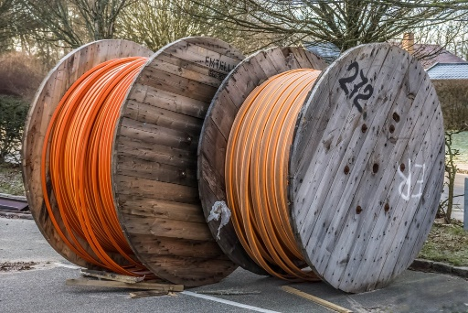

"CABLE REELS" by kunst.ftf is licensed under CC BY 2.0

Why This Matters
Various types of media are used for telecommunications networks. Each medium has its own characteristics, including transmission capacity, speed, convenience, and security. When developing a network, the selection of media depends on the environment and use of the network. Media should support the needs of the network users in a given environment at the least cost, taking into account possible future needs of the network. Using the wrong type of media can reduce productivity or waste money.

Essential Information
Different communications media connect systems in different ways. Some media send signals with low voltage or light along physical connections such as cables, but others send signals through the air using radio waves.

Different physical cables offer a bandwidth range from narrowband to broadband. Cables have an advantage over wireless options because some cables support much higher data transfer rates than wireless technologies and are considered by some to be more secure. The disadvantage of cables is their physical presence. Cables need to be installed, typically in an inconspicuous manner. They are run underground, undersea, and through utility tunnels; strung from pole to pole through attics and basements and above ceiling tiles; pulled down inside walls, through walls, and around the interior of a room. Depending on the environment, laying cable can take a considerable amount of time and effort. Three types of transmission cables are typically used to connect data communications devices: twisted pair copper cable, coaxial cable, and fiber-optic cable (see table below).

Types of Cable
Cable | Description
Twisted pair | Pairs of twisted wires covered with an insulating layer, used for telephone and computer networks. Available in varying categories (“cats”) to support a wide range of bandwidths.
Coaxial | An inner conductor wire surrounded by insulation, a conductive shield, and a cover used for cable TV and other applications. Supports faster data speeds, but is more expensive than twisted pair.
Fiber-optic | Consists of thousands of extremely thin strands of glass or plastic bound together in a sheathing (a jacket); transmits signals with light beams. Much faster than coaxial and twisted pair, but also much more expensive. Used for backbones of telecom networks and in some wide area and local area networks.

Telecommunications signals can also travel through air using radio waves. A radio wave is an electromagnetic wave transmitted through an antenna. All wireless telecommunications—cell phones, wireless Internet, AM and FM radio—make use of radio waves designated to certain frequencies. The radio spectrum is divided up by government agencies for various uses on various frequencies. In the United States, the FCC (Federal Communications Commission) oversees the radio spectrum.

Reading: Radio Spectrum
Radio spectrum, part of the electromagnetic spectrum, refers to all of the frequencies available for radio waves from about 10 KHz to 300 GHz and their assigned uses.

Why This Matters
The U.S. Federal Communications Commission (FCC) assigns different frequencies of the electromagnetic spectrum for different uses in the United States. For example, FM radio, cell phones, baby monitors, and garage door openers all operate at different radio frequencies. If these devices were on the same frequency, they would cause interference for each other, and your cell phone conversation might trigger your garage door to open. The figure, courtesy of NASA, illustrates some attributes of the seven types of waves and rays in the electromagnetic spectrum. To show all frequency assignments would take a chart several feet tall. Such a chart is available in the On the Web links below. The radio spectrum allows for many different uses of radio signals and attempts to safeguard those uses from interference.
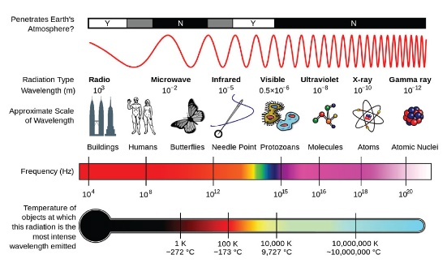
Source: Courtesy of NASA Attribution: Public Domain

Essential Information
Thousands of radio waves are passing through the air and your body as you read this. AM and FM radio waves, television, wireless phones, wireless computer networks, global positioning systems, ham radios, CB radios, police and emergency communications, and satellite communications all make use of radio waves. All it takes to receive the information being transmitted on a specific frequency is a device with an antenna that allows you to tune in to that frequency. For example, when you tune your car radio to 98.9 FM, you are selecting the signal being broadcast at 98.9 MHz, and your receiver translates the fluctuations of the radio waves it receives into sound.

Some wireless applications require very little bandwidth. For example, AM radio requires a relatively low bandwidth to carry its low-quality mono audio signal in the low KHz range. FM radio provides a higher quality, stereo audio signal in the low MHz range. The mid MHz range is ideal for high-speed wireless Internet and cell phone use.

Waves sent at the high end of the radio spectrum, between 1 and 300 GHz, are called microwaves. These high-frequency waves have numerous uses. As you may have guessed, microwave ovens use microwaves (2.45 GHz) to cook food. Microwave signals are also used for high-speed, high-capacity communication links and satellite communications.

Above microwaves in the spectrum comes infrared light, used to send signals from television remote controls, and then visible light, ultraviolet light, x-rays, and gamma rays, none of which are commonly used to carry telecommunications signals.

Reading: Telecommunications Device
Telecommunications devices include the wide variety of computer hardware designed to support telecommunications activities for individuals and businesses.

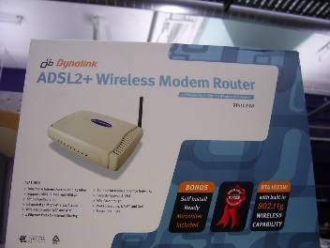

"Waiting for Telstra" by Lachlan Hardy is licensed under CC BY 2.0

Why This Matters
Not long ago, networking devices were of interest only to network technicians. Today, the increase in home networking and wireless networks has provided a reason for everyone to acquire a basic understanding of the most common networking devices, such as modems, network adapters, access points, and others.

Essential Information
Telecommunications devices range in size and purpose from small Mi-Fi wireless adapters that fit in the palm of your hand and share a cellular connection with a computer, to satellites that manage data communications for thousands of users. A modem is a device that modulates and demodulates signals from one form to another, typically for the purpose of connecting to the Internet. The following table shows the various devices that enable computers to connect to networks and the Internet.

Network Connection Devices
Device | Description
Dial-up modem | Provides narrowband Internet connections over phone lines
Cable modem | Provides Internet access to PCs and computer networks over a cable television network
DSL modem | Similar to a cable modem but provides high-speed Internet service over telephone lines
Network adapter | A computer circuit board, PC card, or USB device installed in a computer so that the computer can be connected to a network
Network interface card (NIC) | A circuit board or PC card that, when installed, provides a port for the device to connect to a wired network with traditional network cables
Wireless adapter | A circuit board, PC card, or an external device that connects through an antenna-equipped USB port that is able to send and receive network radio signals
Cellular devices | Cellular network carriers provide several options for connecting computers to the Internet. Cellular connect cards are USB devices that connect a laptop to the Internet through a cellular data plan. Some carriers allow users to “tether” or wirelessly connect computers to mobile phones to access the Internet. Mi-Fi routers, also referred to as personal Wi-Fi hotspots, are palm-size devices that wirelessly connect computers to the Internet through a mobile phone’s data service using Wi-Fi technology.
For multiple computers to communicate over a computer network, special devices are required to control the flow of bits over the telecommunications medium and to ensure that information that is sent reaches its destination quickly and securely. A number of different network control devices handle this responsibility. The table below provides brief descriptions of those that are most commonly used.

Network Control Devices
Device | Description
Hub | A small electronic box used as a central point for connecting a series of computers; sends the signal from each computer to all the other computers on the network. Hubs have largely been replaced by switches in today’s networks.
Switch | A fundamental part of most networks; a switch makes it possible for several users to send information over a network at the same time. Switches direct signals to the intended recipient only.
Repeater | Connects multiple network segments; listens to each segment and repeats the signal heard on one segment onto every other segment connected to the repeater. Repeaters are helpful in situations where a weak signal requires a boost to continue on the medium.
Bridge | Connects two or more network segments, as a repeater does; a bridge also helps to regulate network traffic.
Gateway | A network point that acts as an entrance to another network.
Router | Determines the best path for passing a data packet between networks to its destination.
Wireless access point | Typically a Wi-Fi device, connected to a wired or cellular network to send and receive data to wireless adapters installed in computers and other devices; it allows devices to connect to a network wirelessly.
Firewall | Device or software that filters the information coming onto a network; it protects the network computers from hackers, viruses, and other unwanted network traffic. Many routers include firewall capabilities.

Large corporations and telecommunications companies require expensive, heavy-duty devices to manage large amounts of network data, often using microwave or satellite transmission.

Microwave transmission, also called terrestrial microwave, is a line-of-sight medium, which means that a straight line between the transmitter and receiver must be unobstructed. Microwave transmissions can be sent through the air up to distances of approximately 31 miles (50 kilometers). Microwave towers are placed along interstate highways and other unobstructed stretches to carry thousands of simultaneous communications channels.

In areas where microwave towers are impractical, or in order to send data long distances, communications satellites are employed. A communications satellite is basically a microwave station placed in outer space. Satellites receive a signal from one point on earth and then rebroadcast it at a different frequency to a different location. Most of today’s satellites are owned by telecommunications companies that rent or lease them to other companies. However, several large companies have their own satellites.

Television news organizations make use of small mobile satellite systems mounted on trucks that allow them to broadcast from remote locations. Some companies lease dedicated lines from telecommunications companies to maintain long-distance connections. A T1 line supports high data transmission rates by carrying 24 signals (64 Kbps) on one line. T3 lines carry 672 signals on one line and are used by telecommunications companies; some act as the Internet backbone.

Reading: Telecommunications Software
Telecommunications software is software based on telecommunications protocols used to control, monitor, and troubleshoot data traveling over a telecommunications network.

Why This Matters
As you have no doubt learned, hardware is useless without the software necessary to drive it—and so it is with telecommunications networks. Networking software performs a number of important functions in a computer network. It monitors the load, or amount of traffic, on the network to ensure that users’ needs are being met. It provides error checking and message formatting. In some cases, when there is a problem, the software can indicate what is wrong and suggest possible solutions. Networking software can also provide data information security and privacy.

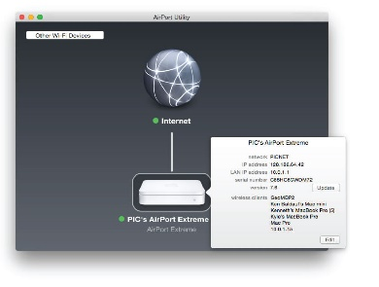
Source: Apple Inc. Attribution: Fair Use

Essential Information
Telecommunications companies have many custom-designed software utilities that they use to manage the flow of data over their networks. These industrial-strength applications are the domain of the professionals that use them. This section focuses on software used in private computer networks, and leaves the industrial systems to the professionals.

Servers that manage the data flowing over networks and the Internet use operating systems created specifically for the task, sometimes called network operating systems (NOS). Network operating systems are responsible for creating data packets to send over a network; sending those packets; and receiving packets sent from other computers, or nodes, on the network. Today’s PC and mobile operating systems include networking features.

Network management software allows system administrators to monitor the use of individual computers and shared hardware (such as printers), scan for viruses, and ensure compliance with software licenses. Network management software also simplifies the process of updating files and programs on network computers. Changes can be made through a communications server instead of on each individual computer. Some of the many benefits of network management software include fewer hours spent on routine tasks (such as installing new software), faster responses to problems, and greater overall network control.

Network management software isn’t only for administrators. Many smartphones also have the capability to provide diagnostics, such as providing data usage information and allowing the user to set an alarm to sound when the phone is nearing its monthly data limit. This helps users avoid penalties for going over their limit.

Routers, switches, firewalls, modems, and other telecommunications devices include software interfaces that allow you to change device settings. Once the device is connected to the network, its software interface can be accessed from a network computer. A wireless access point’s software can be accessed to change security settings so that unauthorized users cannot access the network. The image on this page shows an Apple Airport setup utility; this is where users can configure a host of settings. A router’s software can be used to divide a physical network into multiple virtual networks. A firewall’s software can be used to specify which data packets to allow in and which to keep out.

A protocol is an agreed-upon format for transmitting data between two devices. A standard is an agreed-upon way of doing something within an industry. In the world of networking, protocols and standards are essential for enabling devices to communicate with each other. Protocols define the format of the communications between devices, and standards provide the physical specifications of devices and how they interconnect. The Internet uses the TCP/IP family of protocols. They have become the default protocols for most private networks as well.

Ethernet is the most widely used network standard for private networks. This standard defines the types of network interface cards, control devices, cables, and software required to create an Ethernet network. Other network standards, such as token ring, use unique hardware and software that are not compatible with Ethernet. Special devices such as routers or gateways are required to connect networks that use different standards.

Reading: Telecommunications Networks
Telecommunications networks include computing and/or communications devices connected together for communications, information, and resource sharing.

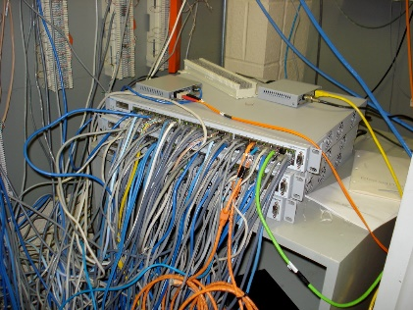

"DSC00366.JPG" by dcmorton is licensed under CC BY 2.0

Why This Matters
Telecommunications networks connect people and devices. When they are used for connecting computers, they may be referred to as computer networks. But whether they are used for communicating or computing, they use the same fundamental digital technologies and allow people to communicate and share information and resources within homes, organizations, and around the world. These networks have become an essential component in managing and organizing many facets of our professional and personal lives.

Essential Information
Within a computer network, computing resources are shared in order to maximize computing power and organizational effectiveness. You have learned that a computer includes devices for input, processing, storage, and output. These components can be distributed throughout a computer network. This is referred to as a distributed network. For instance, you may connect to your corporate network through a Wi-Fi connection and work on a server shared by all employees in the organization. In such a scenario, your computer provides the input and output devices, but the processing and storage may be handled at some other location. You may store your files on a network drive that exists on a file server and send your print jobs to a printer in a shared area of your office. A computing system may be distributed over components in one small office building or around the world on a network operated by a global corporation.

Networks are classified by size in terms of the number of users they serve and the geographic area they cover. From a network that links two personal devices that serve an individual user, to international enterprise networks that serve large corporations, to the Internet, which serves the entire world, different types of networks are uniquely designed to accommodate specific needs. Types of networks include local area networks, virtual private networks, metropolitan area networks, wide area networks, and global networks. Networks utilize security features to control and monitor access.

A local area network (LAN) is a privately-owned computer network that connects computers and devices within the same building or local geographic area. Home networks, campus networks, and office networks fall into this category. Local area networks can include personal computers, servers, printers, and other network-capable devices. Devices connect to LANs through network interface cards or wireless network adapters. Larger networks use servers to store databases, files, and software.

LANs that are designed to serve an entire city are called metropolitan area networks or MANs. Sometimes they are referred to as municipal or muni networks. A virtual private network (VPN) uses a technique called tunneling to securely send private LAN data over the Internet. A VPN may be used to connect an organization’s networks dispersed around the world into a single wide area network.

A wide area network (WAN) connects LANs between cities, across countries, and around the world using microwave and satellite transmission or telephone lines. When you make a long-distance phone call, you are using a wide area network. AT&T, Verizon, Sprint, and other telecommunications companies are examples of companies that offer WAN services. Companies, organizations, and government agencies also design and implement WANs for private use.

Provided by the SeaWiFS Project, NASA/Goddard Space Flight Center, and ORBIMAGE (lines added)
A WAN that crosses an international border is considered a global or international network. The Internet is the most obvious global network, but as an increasing number of businesses enter global markets, private global networks are becoming more prevalent.

Networks require a significant amount of work to create and maintain. A network administrator, sometimes called a system administrator, is a person responsible for setting up, maintaining and securing the network, implementing network policies, and assigning user access permissions. A large organization might employ dozens of network administrators. In a small business, the business owner may take the role of network administrator. Even home networks have a network administrator—usually a family member that takes responsibility for setting up and maintaining the network.

Lesson 7.2: Cellular Networks

Lesson 7.2 Introduction
A cellular network is a wide area network in which a geographic area is divided into cells, with a transceiver antenna (tower) and station at the center of each cell, to support wireless mobile communications.

Cellular network technologies have altered the way people live. Originally designed to support only voice communications, cellular technology has progressed to support data communications over the Internet. Today, more people access the Internet on cellular phones than any other type of computing device. Mobile technologies allow people to work more efficiently and flexibly. Cell phones have become a necessity in many cultures. To gain the most benefits from cellular technology, it helps to understand how the technology works and what services it provides.
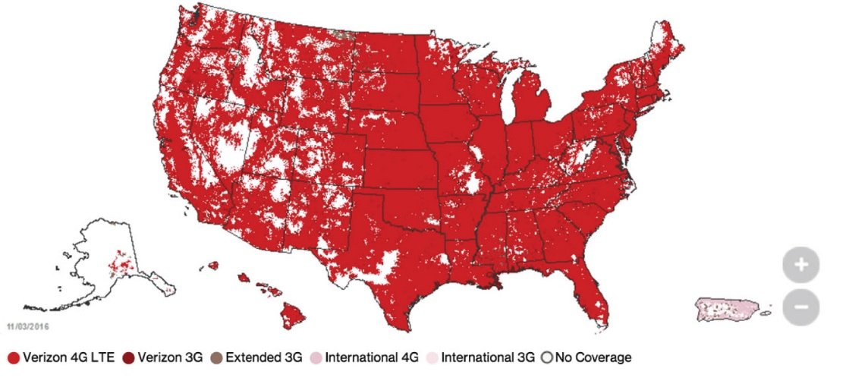
Source: Courtesy of 2015 Verizon Wireless Attribution: Fair Use

A cellular network is composed of many different technologies and devices. The challenge in supporting ubiquitous mobile communications is to find a method of sending and receiving telecommunications signals from devices that have a limited signal range. The solution that cellular networks provide is to cover a geographic area with many cellular towers dispersed in a honeycomb of cells, each roughly 7 miles (11 kilometers) across, so that wherever a device is within the area, it can connect with a tower. If a cell phone user travels from one cell to another, the system judges the cell phone’s location based on its signal strength and passes the phone connection from one cell tower to the next. The signals from the cells are transmitted to a receiver and integrated into the regular phone system.

Each cell tower has a transmitting and receiving range of 3–15 miles (about 5–24 kilometers) depending on geography and environment. Because it is not economically feasible to cover the entire planet with towers, cell phone usage is limited to a network’s coverage areas (see figure), which often focus on metropolitan areas and major highways. The inability to provide 100% coverage, combined with the limitations of working with wireless signals that are prone to interference, results in less-than-perfect quality of service for cell phone users. However, the quality and coverage continue to improve as cellular companies continue investing money in improving their networks.

Cell phone technologies have progressed through four generations of technologies (see table). Long Term Evolution (LTE) is a fourth-generation wireless broadband technology that provides high-speed Internet access over smartphones. LTE is being marketed by all of the popular cellular carriers as the fastest network speeds available. However, others are already experimenting with fifth-generation technologies that will provide data transfer rates up to a gigabit per second. It’s expected that 5G will be rolling out around 2020.

Cell Phone Generations
Generation | Defining Characteristics
1st | The original analog cell phone network
2nd | Digital cell phone service
3rd | First generation to deliver Internet connections to the mobile phone. Technologies such as EDGE provided still painfully slow speeds between 2 Mbps upwards to dozens of Mbps.
4th | Typically, LTE technology delivering broadband data rates in the dozens to hundreds of Mbps range
5th | Still in development, these technologies hope to provide gigabit per second speeds.

Selecting a cell phone service is no small task. The variables involved in the decision are many and complex. When you choose a cell phone service, there are three primary decisions to make:
- Choosing a carrier
- Choosing a plan
- Choosing the device, features, and services that you want
These decisions are interdependent. Each carrier offers different mobile phones and devices, and cellular services are related to device capabilities. There are two different strategies for selecting a cellular carrier. You can choose a phone or tablet first and then find out which carriers support it, or you can choose a carrier first and then choose one of the devices that the carrier supports. If you know of a phone or tablet that you simply must have, then the first strategy is for you. If you have a strong inclination for a specific carrier—for example, the carrier that Consumer Reports rates number one, or that your family and friends all use, or that you know has excellent coverage where you will be using the service—then the second strategy is for you. This section covers topics that will assist you in selecting a cellular carrier, plan, and device.

Reading: Cellular Carrier
A cellular carrier is a company that builds and maintains a cellular network and provides cell phone service to the public.

Why This Matters
Choosing a carrier is an important step in the process of acquiring cell phone service. Since carriers require a two-year contract or provide two-year financing on phones, it becomes difficult and costly to switch if you find you’ve made a bad choice.

Essential Information
Many carriers provide cell phone service worldwide. The most popular U.S. carriers are Verizon and AT&T, with T-Mobile and Sprint following. Different carriers offer different cell phones, features, coverage areas, and services. It is important to take your time when selecting a carrier as your choice will define your cell phone experience. It is typically costly and inconvenient to change your carrier once you’ve signed a contract.
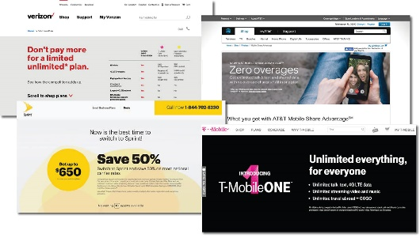
Source: Verizon, AT&T, Sprint, and T-Mobile Attribution: Fair Use

Today’s cell phone networks are all digital. The predominant digital networking standards for cell phone networks are GSM and CDMA. Global System for Mobile Communications (GSM) is the most popular international standard for mobile phones, used by over a billion people across more than 200 countries. AT&T, T-Mobile, and most international carriers use GSM. The Code Division Multiple Access (CDMA) networking standard is used in the United States, where it is in equal competition with GSM. Sprint and other smaller U.S. carriers use CDMA. Gradually, all carriers are moving to LTE 4G standards.

When choosing a carrier, it is useful to consult user survey data, such as that provided by Consumer Reports, as well as the opinions of friends. Check the coverage maps provided by the carriers’ websites to make sure that they offer the network speed you require (3G or 4G) in the areas where you live and work. Finally, compare the carriers’ network standards (GSM, CDMA, LTE), phones, rates, and plans to find out which best suit your needs in your location. Often, the hottest new models of phones launch only on one carrier. For example, Google’s Pixel phone started out only on Verizon (see video), but gradually moved to the other carriers.

Reading: Cellular Plans
A cellular plan defines the terms of service provided by a cellular carrier to which a cellular user subscribes.

Why This Matters
Cellular carriers offer service plans for every type of phone and cell network-enabled tablet user. The trick is determining your usage habits and needs. For example, how much data do you think you will download over your phone each month? What carrier do your friends and family use? How many text messages do you send each month? Would you be interested in a package deal that includes television, home Internet, home phone, and cellular?

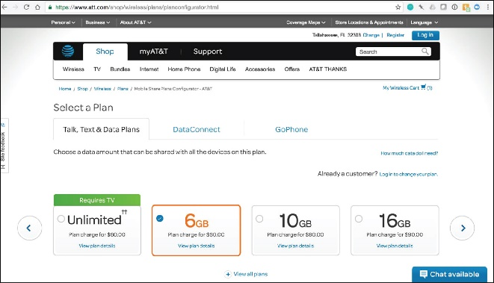
Source: Courtesy of AT&T Attribution: Fair Use

Essential Information
Most carriers have moved away from annual contracts that required customers to commit to the contract for two years in exchange for deeply discounted phones. Today, it’s all about the data. Almost all plans purchased today include talk, text, and data. Oftentimes, talk and text have no limits, but depending on how much you pay, your data access may be limited. For example, AT&T charges $60 per month for a plan that provides up to 6 GB of data. Although some carriers charge extra for going over your data quota, most of them now just throttle your connection speed way down when you hit your limit.

Phones can be purchased either by paying the full cost of the phone up front or through payment plans provided by the carrier. The payment plans serve a similar purpose as the old two-year contracts in that they keep customers obligated to the carrier until the phone is paid off.

Additional lines can be added to an account at a significantly discounted price. For example, a 4 GB plan might cost around $100 per month. Adding a second 4 GB line to the account might only add $20 per month. Additional lines may be used for additional phones for family members or perhaps for an additional device like a tablet for yourself. If you are buying top-of-the-line phones, you can count on paying around $25 per month per phone for two years. In this manner, a family of four could easily end up paying over $300 per month for cellular phones and service.

Reading: Cellular Phone
Mobile phone refers to the handset used by the subscriber to communicate on a cellular network.

Why This Matters
Advances in mobile phones have been fast and furious in recent years with manufacturers such as Microsoft/Nokia, Samsung, Motorola, Pantech, Kyocera, LG, Sony, HTC, and Apple competing intensely to gain an edge in the largest technology market. Smartphone handsets range in price from less than $100 to more than $700 for the latest and greatest smartphones. Determining which phone best suits your needs requires some time and consideration. The biggest decision for most users is whether to choose Apple’s iPhone platform or one of the many Android-based phones. The most successful phone manufacturers are Apple, which offers the iPhone, and Samsung, which offers the Galaxy-model phones running Android.

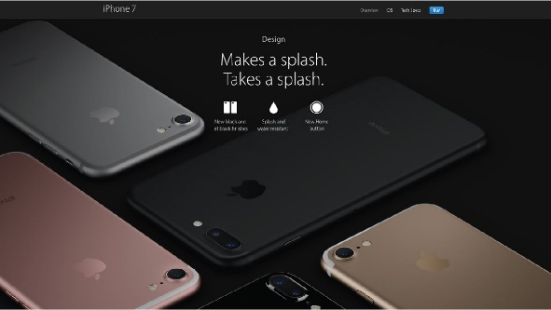
Source: Source: Apple Inc. Attribution: Fair Use

Essential Information
A mobile phone can be designed primarily for voice communication, in which case it is referred to simply as a cell phone; or it may be designed to support voice and Internet, in which case it is referred to as a smartphone.

Smartphones use a “soft” keyboard—a keyboard displayed on the touchscreen—and predictive text technology to assist with typing text. As you type, the phone guesses what word you are typing and offers to complete the word for you or to correct your spelling. Increasingly, people are dictating text into their smartphones where personal digital assistants either carry out commands or enter the text into apps.

Phones are selected by display size, network type (GSM, CDMA, 4G/LTE), processor type, features, and storage size. While smartphones are coming down in price, the real cost is in the data plan required to provide Internet access to the handset. A good smartphone will probably cost at least $500, while the data plan to support it will add up to well over that amount over a two-year period.

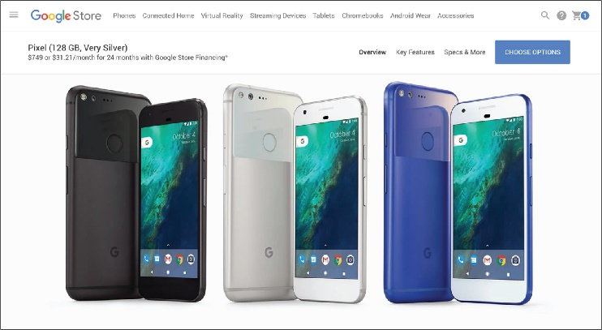
Source: Courtesy of Google Attribution: Fair Use

After selecting a carrier, plan, and phone, you may wish to select cell phone accessories, such as insurance for your phone, a case to protect your phone, a car charger, or a headset or earbuds for hands-free phoning. Some U.S. states have made hands-free headsets a requirement for using cell phones while driving to help prevent distracted driving.

Lesson 7.3: Wireless Networking

Lesson 7.3 Introduction

"Laptop and working lunch. An outside table with a silver laptop, coffee and a sandwich on it." by Rob Pearce is licensed under CC BY 2.0

Wireless data communications refers to telecommunications that take place over the air to provide data and Internet access.

Access to information anywhere, anytime has been a dream for many technology enthusiasts—a dream that has become a reality. Many wireless technologies are available for accessing data and information from various locations. Those who understand those technologies can lead more productive lives.

Many wireless technologies are used to access different types of data and information from various environments. Some, like GPS, have very specific functions. Others, such as Wi-Fi and Bluetooth, have become standards used by many every day for a variety of purposes. Combined, these wireless technologies are transforming our lives by making communication and access to information effortless from any place at any time. This section covers the most useful wireless data technologies available today.

Reading: Wi-Fi
Wi-Fi (short for wireless fidelity) is wireless networking technology that uses access points to wirelessly connect users to networks within a range of 250–1,000 feet (75–300 meters).

Why This Matters
Wi-Fi is the dominant technology that provides wireless Internet access in households, businesses, and public spaces. It provides certain benefits, such as high-speed Internet access, and suffers from some limitations, such as its relatively short range and its inability to support large numbers of users. Understanding Wi-Fi enables users to make the best use of the technology and make wise decisions when choosing an Internet service provider.

Essential Information
The Wi-Fi standards, also known as the 802.11 family of standards, were developed by the Institute of Electrical and Electronics Engineers (IEEE) to support wireless computer networking within a limited range at broadband speeds. There have been several versions of Wi-Fi, each increasingly more powerful. 802.11b provided 11 Mbps while 802.11g increased to 54 Mbps. 802.11n, the current popular version, is up to 600 Mbps. A number of other versions exist to address special purposes and increase throughput and efficiency. The most recent version in development, 802.11ay, has a peak transmission rate of 20 Gbit/s. Each new version of 802.11 is backward compatible with the previous version, but needs to be connected to devices of the same version to enjoy the faster speed.

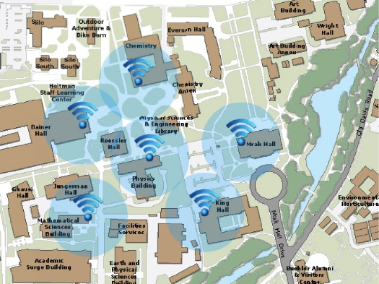
Source: Courtesy of University of California, Davis Attribution: Fair Use

Wi-Fi technology uses wireless access points that send and receive data using radio frequencies to and from computers and other digital devices equipped with Wi-Fi cards or adapters. Access points are connected to networks (via network cable) that are typically connected to the Internet. So, when connecting to an access point, a wireless user also connects to a local area network and the Internet. 802.11n Wi-Fi has a maximum range of about 820 feet (250 meters) in open areas and 230 feet (70 meters) in closed areas. Areas around access points where users can connect to the Internet are sometimes called hotspots. By positioning wireless access points at strategic locations throughout a building, campus, or city, Wi-Fi users can be continuously connected to the network and Internet, no matter where they roam on the premises. Wi-Fi is popular for businesses like Starbucks and McDonald’s as well as for home networks. Wi-Fi is even available in aircraft for connecting to the Internet while in flight. The aircraft connects to the Internet via satellite or ground-based towers and then shares the connection with passengers using Wi-Fi. While free public Wi-Fi is a great convenience, there are also increased risks from hackers.

Setting up a home Wi-Fi network requires an Internet connection (typically provided by cable TV line or phone line) and a Wi-Fi router or access point. Routers are often provided by the Internet service provider, but cost around $100 if you need to purchase your own. Routers often advertise a dual-band feature, which means they support two kinds of connections—5 GHz and 2.4 GHz—allowing for multiple devices to be supported simultaneously without slowing down the network. Routers include instructions that guide the user through the setup process using a web browser or app.

An increasing number of digital devices are incorporating Wi-Fi technology into their design. You are probably aware that laptops and desktops, smartphones, and tablets all typically include Wi-Fi capabilities. On mobile phones, Wi-Fi provides a less expensive way to connect to the Internet than through the cellular data plan. You may not be aware that some printers have built-in Wi-Fi so that you can print to them from any PC on the network. Wi-Fi capabilities can be easily added to a printer or computer by connecting a Wi-Fi adapter to the device’s USB port. Video game consoles such as the Microsoft Xbox and Sony PlayStation, as well as media devices such as TiVo, Roku, and Apple TV, use Wi-Fi to connect home entertainment systems to home PCs and the Internet. Wi-Fi technology is even moving to automobiles.

Many cellular carriers allow customers to use their cellular data plan to connect their computer to the Internet. Tethering is the process of connecting a laptop or tablet computer to a mobile phone through Wi-Fi to access the Internet. Multiple computers can be connected to the Internet using a mobile hotspot, also called Mi-Fi technology. Mi-Fi uses a small pocket-size access point (or the smartphone itself) connected to the cellular network to function as a wireless router. Several users can connect to the router to share the cellular data service.

Reading: Bluetooth
Bluetooth (named after a 10th-century Danish king) enables a wide assortment of digital devices to communicate directly with each other wirelessly over short distances.

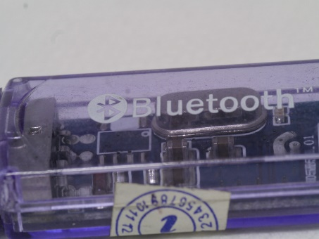

"Bluetooth dongle" by nSeika is licensed under CC BY 2.0

Why This Matters
Bluetooth is useful for passing data wirelessly over a short distance for a variety of purposes. It’s used to connect mobile phones to speakers, headphones, and earbuds; to connect phones and vehicles; to share files between computers and mobile devices; to connect keyboards and mice to computers and tablets; to connect smartwatches to mobile phones; and many other specialized needs.

Essential Information
The Bluetooth specification was developed by the Bluetooth Special Interest Group (BSIG), a trade organization composed of leaders of the telecommunications, computing, and network industries, such as 3Com, Agere, Ericsson, IBM, Intel, Microsoft, Motorola, Nokia, and Toshiba.

Bluetooth-enabled devices communicate directly with each other in pairs. Up to seven devices can be paired simultaneously. The pairings can be created automatically or manually. For example, you might use a wireless headset to chat on a cell phone stored in your backpack. Many auto manufacturers offer some form of Bluetooth connectivity in at least some of their cars. In a Bluetooth-enabled Toyota Prius, for example, when you start the car, the car automatically connects with your cell phone and displays your call info on an LCD display in the dashboard. You can scroll through your address book, make calls, and check messages by using the LCD touchscreen on the dashboard, by using controls on the steering wheel, or by speaking voice commands.

Bluetooth communicates at speeds of up to 1 Mbps within a range of up to 33 feet (10 meters). Bluetooth can also be used to connect devices to a computer network. Bluetooth and Wi-Fi compete in some areas but have unique qualities. Manufacturers are installing Bluetooth chips in a wide variety of communications and computer appliances to allow device-to-device connections. For example, six participants sitting around a conference table could exchange notes or business cards among their notebooks, tablets, or smartphones. In contrast, Wi-Fi is generally used to connect devices to a computer network and the Internet.

Bluetooth is also used as a method for hackers to illegally gain access to devices. A number of cell phone viruses have spread through Bluetooth. Also, an open Bluetooth connection on a computer can be used by a hacker to access files on the computer. For these reasons, it is good to keep Bluetooth turned off when not using it; and when it is on, set it so that it is not “discoverable” by other devices.

Reading: Radio Frequency Identification
RFID, or radio frequency identification, uses tiny transponders in devices or tags that can be attached to merchandise or other objects and read wirelessly using an RFID reader, typically for inventory and supply chain management or to facilitate commercial transactions.

Why This Matters
There are two important uses for RFID technology today: It’s used to identify and track products and is embedded in credit cards, cell phones, and other devices to enable wireless transactions at checkout counters and vending machines.

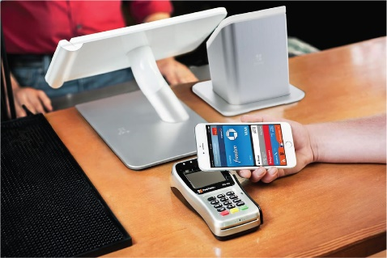
Source: Courtesy of Apple Inc. Attribution: Fair Use

Essential Information
For tracking merchandise, RFID tags are attached to products and/or crates and pallets so inventory can be tracked from the manufacturer to the retail store checkout counter. RFID tags consist of a transponder as small as a grain of sand, with an antenna, embedded on a paper tag. RFID readers may take the form of handheld devices or devices mounted in the doorways of loading docks or in conveyor belt systems. RFID may eventually replace the bar code as the primary identification system for merchandise because it is much more convenient and can relay more information. RFID systems are typically connected to central databases where inventory information is stored. As a tagged item progresses from manufacturing to warehouse to retail vendor to checkout counter, its database record is updated, providing up-to-the-minute information. This enables companies to gain better control over inventory, getting products to locations where they are needed just in time. Wal-Mart has required its suppliers to include RFID tags on all shipping crates and pallets.

Contactless payment systems make use of an RFID chip embedded in a credit card, ID card, or mobile phone to wirelessly send data to an RFID reader installed in a cash register, vending machine, toll booth, or other transaction location. Users can pay for merchandise by simply waving the credit card or smartphone over the reader, like the Apple Pay system shown in the figure. This form of telecommunications is referred to as near field communications (NFC), which is defined as wireless telecommunications that take place at a distance of about 8 inches (20 cm) or less. With lighter rules and restrictions governing credit card transactions, which no longer require signatures and receipts for small purchases, contactless payment systems are becoming widespread.

An obvious concern with contactless payment systems is wireless security. If your credit card or cell phone transmits private information through the air using radio signals, what’s to stop a thief with a card reader from stealing that information? The credit card companies assure those concerned that they have a system in place to protect private information, but some security experts remain skeptical.

Besides its use in retail inventory control and contactless payment systems, RFID is used in a number of other areas where automatic identification is useful:
- Systems that allow vehicles to autopay at highway toll booths use an RFID device mounted on the dashboard or windshield.
- Hospitals employ RFID patient wristbands to enhance patient care and staff working conditions and to save on money and prevent mistakes.
- Airlines are integrating RFID into their baggage-handling systems to more efficiently track the location of passenger baggage.
- RFID devices are used in parking lots to track how long cars are parked and to send reminders to drivers while automatically deducting parking fees from drivers’ bank accounts.
- RFID is used to track prescription medications through the supply chain and to curb drug counterfeiting and theft.
- RFID tags are being used to assist blind individuals in recognizing objects.
Other uses of RFID are more controversial. RFID chips have been embedded in the passports of international travelers. There is talk of embedding RFID tags in all automobile license plates, driver’s licenses, and even currency. RFID tags injected under the skin are used to track ex-convicts and employees in high-security facilities. Privacy advocates are concerned that RFID could be used by governments and law enforcement agencies in ways that infringe on people’s privacy and civil liberties.

Reading: Global Positioning System
A GPS, or global positioning system, uses satellites to pinpoint the location of objects on earth.

"Driving back" by orsorama is licensed under CC BY 2.0

Why This Matters
GPS technology provides useful navigation assistance in many environments for many purposes. Available in mobile phones, fitness bands, cars, aircraft, ships, and elsewhere, GPS provides a range of uses, from necessary functions, such as staying on course at sea, to fun utilities, such as tracking your run to improve your fitness. GPS has become an important part of most people’s daily lives.

Essential Information
Using a GPS receiver and a network of 24 satellites, a GPS can tell you the exact location of the receiver on the earth’s surface. GPS satellites orbit the earth in such a way that at any given time and location on earth, at least four satellites are visible to a GPS receiver. By measuring the distance from the receiver to each satellite and calculating those distances with the known position of each satellite, the receiver can determine its location on earth. Like the Internet, GPSs were originally developed for national security and later extended for public use.

Early GPS receivers were expensive and used only in environments where determining your location was a matter of life and death, such as with far-traveling ships. Now they are available as inexpensive, small handheld devices; as in-dashboard or on-dash devices for automobiles; and integrated into smartphones, smartwatches, and fitness bands.

GPS receivers are primarily used to assist travelers in getting from one place to another. GPS software can display a traveler’s location on a city map and give suggestions for the shortest routes to destinations. Many GPS devices also integrate information about local businesses and services, such as restaurants, retailers, and hospitals. Car rental companies provide GPS units to assist customers with navigating in an unfamiliar city. GPS has also been used to map the planet’s surface.

GPS is also playing a role in social media. Geotagging is the process of adding geographic identification metadata to digital media and messages. GPSs in cell phones enable this to occur automatically if the user so chooses. On the iPhone, photos posted to Facebook, Twitter, Instagram, or Flickr can automatically be tagged with the location where they were taken. Posts on Facebook and other messaging systems can also include geotags. Using a variety of GPS software, users can quickly find nearby restaurants, hotels, or other businesses.

GPS is also playing a large role in fitness bands and apps. Using GPS in a health band or smartphone, a runner can map his or her run, capturing data such as elevation, distance, and miles per hour in order to calculate calories burned.

GPSs provide convenience and safety; however, as with all technology that accesses personal data (such as a person’s location at a given time), its use may infringe on an individual’s privacy. Consider, for instance, the possibility of someone stashing a GPS device in your car or backpack in order to track your movements. Also consider the common practice of cellular carriers collecting location data automatically from users.

Module 8

Introduction
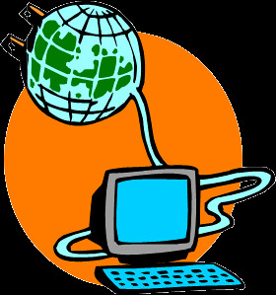
"internet" by GARRY101 is licensed under CC BY 2.0

The Internet is the world’s largest public computer network—a network of networks that provides a vast array of services to individuals, businesses, and organizations around the world.

The Internet provides a platform for billions of people to share knowledge and views. If two heads are better than one, billions of heads sharing knowledge and perceptions are powerful indeed! The Internet brings the power of global community to computing.

The Internet is becoming everyone’s computer. Increasingly, data and software are migrating from individual PCs to huge online data centers. People are becoming increasingly dependent on Internet connections to maintain relationships and for success in their careers. People interact with social networks, email, games, calendars, music, videos, and a wide assortment of apps on PCs, tablets, smartphones, and wearable technologies many times a day from wherever they may be. Cloud services from Google, Amazon, Apple, and Microsoft allow individuals to store music, media, and data in the cloud for access from all of their Internet-connected devices.

Businesses are also shifting more and more services to the cloud. Cisco predicts that by 2018 data center traffic will nearly triple on the back of cloud growth to 8.6 zettabytes annually. Cellular companies are investing heavily to roll out faster and more robust data networks to meet the skyrocketing demand for mobile data access. By 2020 the number of devices connected to the Internet will be three times as much as the global population. Whoever owns the “pipes” over which the data flows will likely end up being the wealthiest of companies.

Google, Microsoft, Amazon, and Apple continue to improve search engine capabilities with voice-controlled personal digital assistants like Siri in hopes of providing direct answers to user queries rather than long lists of links to possibly related webpages. All of these efforts will soon result in having answers to every question at our fingertips. They will also result in an increasingly heavy reliance on the Internet for information and services. How will this rapidly approaching reality impact your future career? Will your career involve providing services online? How will you use your insight about an online lifestyle to provide value to your industry?

People are using the Internet to communicate, share, learn, entertain, enhance productivity, and make new friends. Professionals use the Internet to collaborate on projects. Businesses invest in the Internet to leverage competitive advantage. Products are marketed and sold, and creative works are published and distributed over the Internet. The Internet has become an essential part of daily life for many of us.

Internet technologies support many applications and services, such as the web, email, instant messaging, social media, Google Apps, Microsoft Office Online, streaming music and video, and Bing Maps, to name a few. Software and storage are increasingly moving from PCs to the cloud.

Today’s Internet joins together networks of over a billion computers called Internet hosts. Internet hosts are servers that provide information and services to Internet users. There are over 3 billion Internet users today, roughly 50 percent of the total global population.

The Internet touches all of our lives and provides power to governments, businesses, and individuals of all political and philosophical persuasions. Such a powerful tool is bound to have significant ethical dilemmas, and indeed the Internet does. The Internet has become a favorite resource for criminals, radicals, and terrorists. It provides a global audience for lessons in hate along with a treasure trove of victims. Some governments attempt to censor Internet content and may stifle freedom of speech. Google maintains a Transparency Report that lists countries that request to have search results censored. The list contains some countries that are well known for censorship and many others that pride themselves on their respect for civil rights.

Google itself has been criticized for collecting data on its users. Governments and privacy advocates around the world are working to limit Google’s data collection. Google sees its data collection as a way to provide users with better services and raise its profit margins from advertising.

The Internet is used by some to illegally distribute copyrighted materials like music, movies, and books. The recording and motion picture industries continuously work to pass legislation to stop illegal file sharing. Bills such as the Stop Online Piracy Act (SOPA) have failed because, so far, the courts have favored Internet user privacy over Internet service provider snooping. Courts are also battling businesses that wish to collect as much user information as possible in order to better target consumers in their advertising campaigns.

The government and Internet users favor a free and open Internet where all Internet traffic is treated equally by Internet service providers—a principle known as net neutrality—but the service providers like Comcast and AT&T believe that they have the right to charge content providers according to user demand, creating a filter that blocks free and open access to all content.

The Internet provides new challenges in ethics, mostly concerning freedom of speech, privacy, and intellectual property rights. What types of speech and expression do you feel should be censored? Where should the line be drawn about what information Internet companies are allowed to collect about visitors? How can intellectual property be protected in the digital age?

Lesson 8.1: Internet Software and Protocols

Lesson 8.1 Introduction
Many different Internet technologies work together to provide information and services over the Internet, including a variety of protocols, hardware, and software.

Understanding fundamental Internet technologies enables users to get more value out of their Internet use and to make intelligent decisions regarding purchases and social issues such as privacy and freedom of speech. Depending on the service and service provider, an Internet connection might be blazing fast or snail-like slow, filtered or unfiltered, limited or unlimited. It is important to understand the underlying technologies of the Internet in order to make informed decisions about your Internet use and improve your user experience.

The Internet is a global, public network of computer networks. A computer network is a collection of computing devices connected together to share resources such as files, software, processors, storage, and printers. There are millions of privately owned networks around the world. Joining networks together into larger networks so that users on different networks can communicate creates an internetwork.

The combination of protocols, hardware, and software is what makes up the Internet. Protocols allow different types of networks to communicate. Hardware, such as cables, satellites, and routers, transfers the packets of data that travel over the Internet, such as email, webpages, photos, music, video, phone conversations, and more. Software transforms data into a form that can travel over the Internet and guides it to its destination. Combining these technologies creates billions of connections that carry Internet communications over land, under sea, and across the vacuum of space. This section discusses the most important of these technologies.

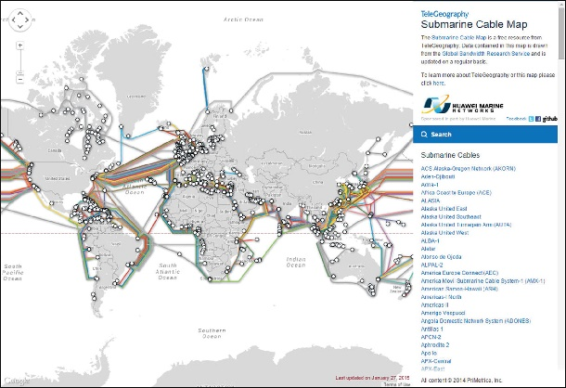
Source: © 2015, Google INEG Attribution: Fair Use

Reading: Internet History
Internet history is relatively short, dating back only to around 1970. In that time, the Internet has had as great an impact as any invention, and its story has only just begun.

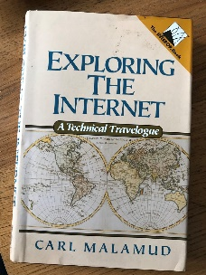

"Prehistory" by Steve Bowbrick is licensed under CC BY 2.0

Why This Matters
Understanding both the origin of the Internet and its growth from 13 connected computers to nearly a billion helps to put into perspective the huge impact it has had on civilization. In the same way that the printing press improved communication and the Industrial Revolution improved productivity, the Internet has improved both communication and productivity, making it perhaps the most singularly important invention ever.

Essential Information
In 1957, most computing was done on large mainframe computers accessed from within an organization through a network of terminals. Government agencies, universities, businesses, and other large organizations used this type of networking environment. In that same year, the U.S.S.R. surprised the world by launching Sputnik, the first artificial earth satellite. The United States viewed the launch as a challenge. The following year, President Eisenhower reacted by forming two government agencies under the Department of Defense (DOD) to advance space technologies, weapons, and communication systems: the Advanced Research Projects Agency (ARPA) and the National Aeronautics and Space Administration (NASA). Many amazing achievements were to come from these organizations, but among those that had the most social impact were placing the first man on the moon and creating the Internet.

In 1969, ARPA commissioned ARPANET for research into networking. Its initial goal was to establish closer communications for research by connecting the computer networks of four research institutions: the University of California at Los Angeles, Stanford University, the University of California at Santa Barbara, and the University of Utah. The growth of the Internet has been exponential, increasing from 13 hosts in 1970 to roughly 1,000 hosts in 1980, to 313,000 in 1990, to one hundred million in 2000, and to over a billion since. The World Wide Web, introduced in the early 1990s by Tim Berners-Lee, provided a graphical user interface to the Internet that launched the digital information revolution.

With the birth of the web, the Internet exploded, with a 341,634 percent annual growth rate in Internet hosts. Internet service providers sprouted up all over the world. With consumers flocking to the web, businesses found a powerful new marketing and sales tool. The Internet’s focus expanded from supporting primarily academic and government interests to supporting public and commercial interests. Today, nearly one half of the world’s population has Internet access. Among those who are not connected are populations that cannot afford computers or connections. This important social issue is referred to as the digital divide. There are also cultures and individuals who resist technology because of personal or religious philosophies.

Around 2003 and 2004, new web technologies and services emerged that created a paradigm shift on the web, and Web 2.0 was born. Web 1.0 was the “one-way” web, with information traveling in one direction from servers to consumers. Web 2.0 is the participatory web, where users are contributors as well as consumers.

Web 2.0 was inspired by the growing popularity of blogs. Through blogs, the web community discovered that the web was not just something to observe, but something in which to participate. Wikipedia fueled the Web 2.0 trend, and social networks like Facebook and Twitter lit it on fire.

The increase in the use of mobile devices, first smartphones and then tablets, created an even greater demand for the Internet, increasing network traffic significantly and bringing the Internet to new users in developing countries. Mobile computing brought new challenges, including bandwidth demands on wireless networks and the ability to synchronize data across multiple devices.

Cloud computing began the migration of storage, software, and services from user devices—including corporate servers, personal computers, and mobile devices—to Internet servers. Cloud computing supports access to common computing resources and data across multiple devices. Cloud computing also makes it possible for digital assistants like Siri, Google App, Alexa, and Cortana to respond to any question or command no matter where you are or what Internet-connected device you use.

Cloud computing brings our Internet history to current times. Where will the Internet take us next? The Internet of Things is gradually connecting to the Internet all kinds of objects in homes, cars, public spaces, businesses, manufacturing facilities, and elsewhere in order to better inform us of what’s occurring in the world around us. With growing amounts of valuable information flowing over the Internet and becoming accessible through apps powered by artificial intelligence, decisions as menial as where to meet friends for lunch as well as difficult challenges, such as how to curb climate change, will become easier to grapple with.

Reading: TCP/IP
The protocols on which the Internet is based are the transmission control protocol (TCP) and Internet protocol (IP); together referred to as TCP/IP.

Why This Matters
It could be argued that TCP/IP is the defining component of the Internet. Although Internet hardware and software are the most visible components, TCP/IP works behind the scenes to allow many different types of networks and devices to join together in an immense global network. TCP/IP is the protocol (actually a family of protocols) that defines how information travels across the Internet.

Essential Information
As you have learned, data is transported over the Internet in packets. A data packet is a small group of bytes that includes the data being sent and a header containing information about the data, such as its destination, origin, size, and identification number. The Internet is a packet-switching network. Internet applications divide up information, such as an email message, into small packets to make efficient use of the network. Upon arriving at their destination, the packets are reconstructed into the original message.

The Internet Protocol (the “IP” in “TCP/IP”) defines the format and addressing scheme used for the packets. Routers on the Internet use the information in the packet header to direct the packet to its destination. The Transmission Control Protocol (the “TCP” in “TCP/IP”) enables two hosts to establish a connection and exchange streams of data. TCP guarantees delivery of data and guarantees that packets are delivered in the same order in which they were sent.

The Internet Protocol requires that all devices connected to the Internet have a unique IP address. An IP address is a unique 32- or 128-bit identifier for Internet users and hosts. Read as decimal numbers, a 32-bit IP address consists of four numbers (0 to 255) separated by periods, such as 64.233.161.104. IP addresses can be static (permanently assigned to a particular computer) or dynamic (assigned to computers as needed). Servers, such as www.facebook.com, use static addresses that don’t change, while clients that connect to the Internet, like your computer or cell phone, are almost always assigned temporary IP addresses that change either with each new connection or based on some time limit. For example, an IP address assigned by Comcast to a residential Internet account will change at least once a week.

The current 32-bit IP address system (IPv4) can support 232, or roughly 4.3 billion, addresses. With a population of over 3 billion people online and growing, and many using more than one Internet-connected device, IP addresses are in short supply. Plus, the Internet of Things will significantly add to the demand. For these reasons, the Internet Assigned Numbers Authority (IANA) is in the process of moving Internet hosts to a new IP version, IPv6, which utilizes 128 bits to accommodate 3.403 × 1,038 addresses—an astronomical number of addresses, sufficient for the foreseeable future.

Reading: Domain Name System
The domain name system (DNS) maintains a database of all domain names and IP addresses used on the Internet and acts like a phonebook, supplying information to Internet nodes and routers working to get data packets to their destination.

Why This Matters
The Internet is a vast and complex system with billions of addresses, names, and servers. Keeping track of all the names and numbers is the responsibility of the DNS.

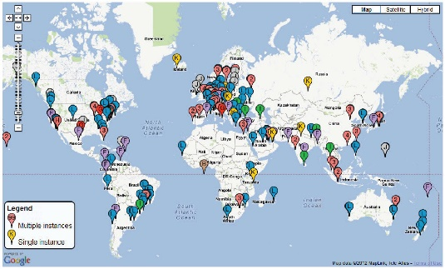
Source: Map Data 2012 MapLink, Tele Atlas Attribution: Fair Use

Essential Information
Because people are more comfortable dealing with names than numbers, IP addresses are assigned associated names called domain names. For example, the IP address 173.194.219.99 is also known by the domain name www.google.com—go ahead and try entering the IP address into your browser and see what happens. Domain names and IP addresses are managed by the Internet Corporation for Assigned Names and Numbers (ICANN), which was under the control of the U.S. federal government until recently when it was released from U.S. control to operate as an international partnership. ICANN works with accredited registrars, such as www.name.com, to register domain names to businesses, organizations, and individuals for a small yearly fee. Registering a domain name does not provide you with your own website, only with ownership of the name. Web hosting companies, like www.dreamhost.com, provide server space on which to store a website. Once a website is hosted, the name server of the hosting company can be used to associate the domain name with the actual website files. To bypass this complexity, it is advised that one company be used as both the domain name registrar and the website host.

The Internet uses the DNS to translate domain names into IP addresses. A database of addresses and names is stored on DNS servers. Internet services, such as email and the web, access DNS servers to translate domain names into numeric IP addresses.

Thirteen root DNS servers, which are mirrored and duplicated around the world, make up the foundation of the DNS. ICANN’s Root Server System Advisory Council maintains a website that shows the location of root servers worldwide and provides information on root server operations. Many other servers assist in keeping track of domain details. Should the DNS system fail or become corrupt, all Internet traffic would be affected. For that reason, the root DNS servers have been the target of attacks. Fortunately, redundancy is built into the system so that if and when some of the servers fail, others take up the load. Still, an attack that impacts most of the root DNS servers would be catastrophic.

Reading: Voice over IP
Voice over IP (VoIP) refers to technologies that support voice communications using the Internet protocol over data networks.

"Incoming call test works" by Kai Hendry is licensed under CC BY 2.0

Why This Matters
Many businesses have moved to VoIP technology, combining voice and data networks into one easy-to-manage digital network, saving the cost of installing and maintaining two separate networks. Home users are saving money with VoIP by connecting to phone services provided over high-speed Internet connections. Mobile phone users are able to save monthly minutes by talking over Wi-Fi connections.

Essential Information
VoIP has become popular in many environments, although it sometimes goes by other names. For example, Comcast offers a package called Xfinity Triple Play that offers Internet, cable television, and VoIP phone service. With this service, you can see caller ID on your television when the phone rings, and your phone conversations share the same cable as your television and Internet signals.

Cellular service providers are increasingly supporting VoIP service that allows customers to switch from the voice network to a data network. Many people use Apple FaceTime, Google Hangouts, and Microsoft Skype on desktops, laptops, tablets, and mobile phones to voice or video chat with friends. Comcast Xfinity and all of these other services use VoIP technology.

Businesses have been investing in VoIP systems for many years and saving a lot of money in the process. VoIP eliminates the need for traditional, costly phone systems by making use of the corporate data network for voice calls. VoIP also offers additional services like the ability to make phone calls and check voicemail from your computer. Many VoIP systems also support videophone service.

When a system combines voice, video, and data communications into one interface, it is referred to as unified communications. Unified communications may also boost productivity. Being able to communicate with colleagues anywhere, anytime, through any form of media can empower professionals to accomplish more in less time.

Lesson 8.2: Internet Hardware and Media

Lesson 8.2 Introduction
The Internet is frequently described in casual terms as a collection of connected computers and digital devices located all around the world, but the hardware and media that connect those computers and devices is just as vital. When users in the North America access web sites in Europe or Asia, that data travels along thousands of miles of undersea cabling, and through dozens of network routers, all working quietly in the background, 24/7, to deliver millions of files every minute. All of these devices work together to make the enormously complexity of the Internet function simply, even invisibly, for nearly all users.

Reading: Internet Backbone
The Internet backbone refers to the main Internet pathways and connections, made up of the many national and international communication networks that are owned by major telecom companies such as Verizon, AT&T, and Sprint—the same companies and networks that provide telephone service.

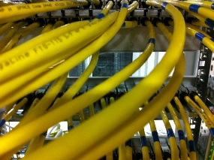

"network" by GEGENWAeRTs is licensed under CC BY 2.0

Why This Matters
The Internet backbone consists of mostly fiber-optic cables that span the globe over land and under sea to provide connections between individuals, companies, organizations, and governments. Businesses and the global economy depend on the proper functioning of the Internet backbone.

Essential Information
In the early days of the Internet, the major telecommunications (telecom) companies around the world agreed to connect their networks so that users on all the networks could share information over the Internet. The cables, routers, switching stations, communication towers, and satellites that make up these networks are the hardware over which Internet traffic flows. These large telecom companies are called network service providers (NSPs). Examples include Verizon, Sprint, British Telecom, and AT&T. The combined backbones of these and other NSPs make up the Internet backbone.

NSPs enable Internet users to connect to their networks through utility stations called points of presence (POPs). The POPs act as the hubs, and the connections they provide are the spokes connecting to users around the world. The POPs are connected to each other by the Internet backbone. Individuals, companies, and service providers such as Comcast connect to the Internet backbone through POPs. Large telecom companies, such as AT&T and Verizon, have tens of thousands of POPs throughout North America, Europe, and the Pacific Rim, each of which incorporates millions of user connections.

A router is a network device that manages network traffic by evaluating messages and routing them over the fastest path to their destination. Routers are crucial to the functioning of the Internet backbone. Email, webpages, social media updates, video, conversations, and movies all travel over the Internet in small data packets. Each packet makes its way across the Internet by traveling from router to router, with each router examining incoming data packets and intelligently sending them toward their destination based on the current network status. If there is congestion or hardware failure on one part of the network, the router chooses another route for the data. This ensures that data will reach its destination, typically within milliseconds, even when part of the network is down.

Reading: Network Architecture
Network architecture defines the manner in which devices connect and communicate with each other over a network.

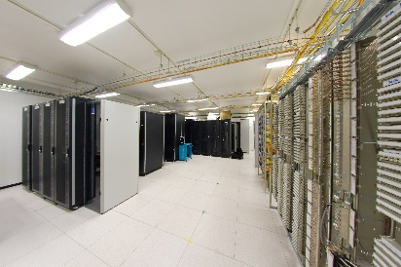

"Salle de serveurs" by Frédéric BISSON is licensed under CC BY 2.0

Why This Matters
The way in which computers connect to each other on a network impacts who may have access to and control over the data on the network. In a client/server architecture—the most common architecture on the Internet—control rests with servers that are typically owned by private corporations. These private corporations take responsibility and ownership of the data while it is on their networks and servers. In a peer-to-peer network architecture, data flows directly from end-user to end-user, limiting the exposure of data to corporate servers.

Essential Information
Client/server is a network architecture in which one computer or program (the client) makes a service request from another computer or program (the server) that provides the service. The Internet is based on client/server relationships. The Chrome web browser, for example, is a client that requests a webpage from a web server, such as www.monster.com. An email program, such as Microsoft Outlook, also acts as a client that connects to an email server to retrieve email messages.

Server computers are typically powerful computers that can accommodate many simultaneous user requests. They run 24 hours a day, seven days a week to provide Internet services and resources such as webpages and email. The service performed by the server is defined by the type of server software it runs. A server running web server software replies to webpage requests, and a server running email server software governs the distribution of email to and from the network.

Peer-to-peer (P2P) is a network architecture that does not utilize a central server but facilitates communication directly between clients with user computers acting as both client and server. Peer-to-peer networks are useful in situations where information and/or resources are not distributed from a central source but are shared directly between multiple sources. P2P networks are used primarily for communication (e.g. Skype), transactions (e.g. Bitcoin) and file sharing (e.g. BitTorrent).

The use of the peer-to-peer model to support online transactions is considered one of the top ten emerging technologies that will change the world—specifically the use of a technology called blockchain. Blockchain is the technology underlying the Bitcoin digital currency that provides a decentralized public ledger of transactions that no one person or company owns or controls. Blockchain can be used as the basis of all kinds of online transactions, providing anonymity for the buyer and seller and cutting out the middle man.

Reading: Internet Service Provider
A company that provides individuals and organizations with access to the Internet is called an Internet service provider (ISP).

Why This Matters
There are hundreds of ISPs from local to international levels. ISPs work as liaisons between Internet users and the telecommunications companies that own the Internet backbones. ISPs provide a variety of services at varying monthly rates. ISPs control the flow of data packets over the Internet in an attempt to provide consistent service to users.

Essential Information
ISPs provide Internet access to meet needs ranging from mobile phone connections to corporate connections that support thousands of users. The largest U.S. ISP is Comcast Cable, which had a head start with broadband cables running to many U.S. homes. Comcast and other telecom companies are able to provide television programming, telephone service, and Internet services, all through a single cable.

ISPs charge a monthly fee to Internet users and provide devices, such as modems, by which the user can connect to the Internet. Faster connection speeds have a higher price tag. Some ISPs place caps on how much data can be downloaded each month. Higher prices or penalties are incurred if the customer exceeds the cap.

There are a number of methods used to connect to the Internet. In the US, Cable and DSL connections are most common for home connections. Comcast, Verizon and AT&T have been battling it out to win market share, offering increasingly faster connection speeds. In recent years, Google has entered the fray, offering Gigabit (one billion bits per second) fiber connections in eight cities across the country. Verizon, AT&T and Comcast responded with fiber plans of their own. Recently, Google has developed a new wireless technology that it believes is as fast as fiber and less costly to install. All of this competition works to benefit the customers! The table below shows a variety of Internet connection technologies in use today.

Types of Internet Connections
Connection Type  Approx. Cost and Speed | Description
Cable modem  $50/month, 6 Mbps  $72/month, 25 Mbps  $115/month, 105 Mbps  No cap | Cable modem is an always-on connection that uses a cable TV connection to provide high-speed Internet service. A cable TV receiver receives the frequencies reserved for television, and a cable modem receives the frequencies used for Internet. Another box can be added to include phone service. The prices quoted here are for Internet only.
Cellular data connection  $10–$135/month, 12 Mbps (4G)  10–30 GB cap/month | Cellular data plans charge by the amount of data you download each month rather than the speed of the connection. A 3G data connection provides speeds under 1 megabit per second (Mbps) while 4G provides speeds of up to 12 Mbps. Subscribers use cellular data connections to access the Internet on their mobile phone or through a computer using tethering or a mobile hotspot.
Digital subscriber line  (DSL)  $40/month, 6 Mbps  No cap | DSL is an always-on connection that uses the customer’s phone line, but there is no dialing up and users can use the Internet and talk on the phone simultaneously. This service is similar to cable modem except that the telephone line is split to carry signals to both a DSL modem and the telephone.
Fiber  $50/month, 100Mbps  $130/month, 1Gbps4 | Available in select cities, optical fiber connections are the fastest available today. Technologies like Google Fiber, Verizon Fios, and AT&T Fiber offer Internet and TV. Prices shown for Google Fiber.
Dial-up  $10/month, 56 Kbps  No cap | Dial-up is the original method people used to connect to the Internet from home and is gradually being phased out in most areas. Dial-up is a low-speed Internet service that utilizes the customer’s existing phone line for Internet access.
Digital satellite service (DSS)  $60–$129/month  10 –15 Mbps  60–70 GB cap/month | DSS is a wireless high-speed Internet service that utilizes a satellite and satellite dish provided by companies such as HughesNet. It is faster than dial-up service but typically slower than cable modem or DSL. For this reason, it is used primarily in areas where DSL and cable are unavailable.
Broadband over power line (BPL)  [cost/speed data not yet available] | BPL utilizes existing power lines to carry Internet signals. To connect to BPL, users only have to plug a BPL modem into an electrical outlet. BPL is viewed as a good technology for delivering Internet to remote areas that may not have phone lines or cable TV but do have electricity.

Reading: The Internet of Things (IoT)
The Internet of Things (IoT) refers to the ability of physical objects to communicate over the Internet using embedded computing devices.

Why This Matters
Analyst firm Gartner predicts that there will be nearly 20.8 billion “things” on the Internet of Things by 2020. Through the use of sensors and monitors, these objects will be able to inform individuals, companies, communities, countries, and humanity in general about conditions in their environment. Many believe that the Internet of Things will provide the keys to unlock solutions to minor inconveniences, moderate disconcerting issues, and serious global threats.

Source: Courtesy of Nike Attribution: Fair Use

Essential Information
The Internet of Things began several years ago with technologies such as RFID, which allows companies to track inventory through the supply chain, and smart power meters, which provide individuals and communities with detailed information about power consumption. Just as smart meters offer new insight into ways that people can save energy, smart objects of all sorts are popping up to provide all sorts of benefits and services.

Smart objects (physical objects that contain embedded computing devices) are growing in number and variety. Fitness bands, smartwatches, and clothing gather information about the wearer and environment which is used as input for health apps that record a person’s daily physical activity level. A smart home contains smart appliances that allow the homeowner to easily monitor and manipulate lighting, security, irrigation, temperature, and any other electronically supported resource from an Internet-connected device. When smart objects are connected to the Internet, they join the Internet of Things.

Smart objects often include sensors to relay information about their environment. For example, a smart parking lot collects information from sensors in each parking space, which allows it to inform newcomers if and where a space is available. People may or may not be involved in the communication from smart objects. For example, a smart irrigation system utilizes sensors to gauge soil moisture and weather patterns in order to turn sprinklers on at just the right time for just the right duration. Manufacturers are empowering machinery with sensors and intelligence to avoid bottlenecks on the production line.

The Internet of Things is being harnessed to assist with monitoring water quality, atmospheric conditions, geological phenomena like seismic activity and ocean currents, and even the movement of wildlife. We use IoT to monitor infrastructures such as bridges, railway tracks, and on- and offshore wind farms. As already mentioned, manufacturers and communities are saving money with information from the IoT, as are the medical/healthcare and transportation sectors. Tech companies are preparing to develop a whole new generation of apps based on the information gleaned from the IoT.

The Internet of Things has caused concern in two primary areas: privacy and network bandwidth. Some networking companies are developing an entirely new network structure, apart from our Internet, to accommodate the IoT. Cisco has proposed a platform it calls the Internet of Everything that integrates the networking needs of people, processes, data, and things. Various industries are also working on assuring privacy in the IoT era. Ford, GM, Mercedes, Toyota, and several other automakers have agreed to adopt new auto-industry privacy guidelines to govern the information collected by computer systems in vehicles.

Module 9

Introduction
Web technologies are the hardware, software, and protocols that allow the web to exist.

Recall that the web, short for World Wide Web, is an Internet service that provides convenient access to information and services through hyperlinks. The emergence of the web in the early 1990s transformed the Internet from an information and communications tool accessible only to researchers and academics into what it is today: a primary source of information, communication, and entertainment for billions. Before the invention of the web, the Internet was a complicated system that was navigated primarily from a command prompt, requiring commands that needed to be learned and memorized and accessing only a limited set of documents and services. Because of its ingenious and easy-to-use design, the web has become the primary tool for accessing information and services of all kinds.

While the terms web and Internet are often used interchangeably, the two are technically different entities. You’ve learned that the Internet is a collection of hardware, protocols, and software for connecting networks. The web, on the other hand, is a service provided utilizing the Internet. One can think of it as an additional network layer that runs on top of the Internet. The Internet existed long before the web and can continue to exist without the web. The web, however, cannot exist without the Internet.

The World Wide Web was developed by Tim Berners-Lee between 1989 and 1991 in his research at CERN, the European Organization for Nuclear Research (in French, Le Conseil Européen pour la Recherche Nucléaire) in Geneva and was released to the public in the form of the Mosaic web browser in 1993. What Berners-Lee originally conceived of as an organizational tool to help keep track of his own personal documents has grown into an organizational tool with an easy-to-use graphical interface that helps billions of users share and access information on the Internet—and, in fact, allows you to take this course!

The key to Berners-Lee’s system was the ability to link together documents to allow navigation from one document to related documents. The process of “linking together” documents from diverse sources requires three components:

- A defined system for linking the documents
- Protocols that allow different computers to communicate
- Tools to help create the documents and the links between them

Tim Berners-Lee came up with all three: hyperlinks for linking documents; the Hypertext Transfer Protocol (HTTP); and HTML, a language for creating and linking documents.

The cornerstone of Tim Berners-Lee’s World Wide Web is the hyperlink. A hyperlink is an element in an online document—a word, phrase, or image—that, when clicked, opens a related online document. Relating documents to each other using hyperlinks forms a web of interrelated information that is logically arranged and easy to explore.

The protocol of the web is called HTTP. The Hypertext Transfer Protocol (HTTP) controls communication between web clients and servers. A web client, usually called a web browser, takes the form of software such as Internet Explorer/Edge, Safari, Firefox, or Chrome and is used to request webpages from web servers. A web server stores and delivers webpages and other web resources such as interactive web content.

Since Berners-Lee invented the web, many new technologies have been developed that work with his original design to deliver richer, interactive online experiences, which include animation, video, 3D views of objects and locations, music, and apps. In this section you’ll learn about web technologies from basic to state-of-the-art.

Lesson 9.1: Web Standards

Lesson 9.1 Introduction
In much the same way that Internet protocols define the format of data as it is transmitted from sender to receiver, the web has established standards that define how users access and interact with the content they choose. It is important to remember that the current standards in use across the web, such as URLs, HTML, CSS, and RSS, to name just a few, are not the only methods of handling content and media on the internet, nor even necessarily the best, but as they are widely agreed upon, they are the most efficient means of reaching the widest audience possible.

Reading: URL (Uniform Resource Locator)
A uniform resource locator, more commonly called a URL, acts as a webpage address, incorporating the domain name of the web server and the location of the webpage file on the server.

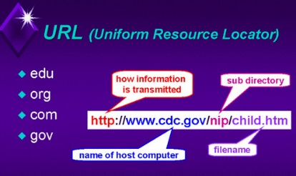

"url-22" by J_O_I_D is licensed under CC BY 2.0

Why This Matters
The URL makes it possible to attach meaningful names to otherwise technical numeric Internet addresses. Imagine having to remember 54.239.25.200 rather than www.amazon.com!

Essential Information
Webpages are identified and accessed by people using a URL. A URL acts as a webpage address, incorporating the domain name of the web server and the location of the webpage file on the server. The URL http://www.techminded.co/kenbaldauf/about/index.php can be dissected as follows:

URL Dissection
http:// | www. | techminded.co/ | kenbaldauf/about/ | index.php
Protocol | Web server | Domain name | Location on server | Requested file

The final portion of the domain name—.com, .co, .edu, .biz, and so on—is called the top-level domain (TLD). Top-level domains classify Internet locations by type or, in the case of international websites, by location. There are hundreds of TLDs. The most common are listed in the table at the bottom of this page.

URLs are translated into a numeric IP address by DNS servers located on the Internet. The domain name system was established to support the use of URLs and to translate URLs into IP addresses.

The Internet Assigned Numbers Authority, or IANA, is responsible for managing URLs and IP addresses. IANA is an affiliate of ICANN, the Internet Corporation for Assigned Names and Numbers, which is the central governing body of the Internet. Decisions made by ICANN affect everyone on the Internet.

Reading: HTML (Hypertext Markup Language)
Hypertext Markup Language is the primary markup language used to specify the formatting of a webpage.

"DSC_0005" by slavik_V is licensed under CC BY 2.0

Why This Matters
HTML provides a simple language for creating attractive webpages and is accessible to anyone with a desire to learn it. The fact that HTML is non-proprietary and simple to use, with free tools such as a text editor and a web browser, makes it a perfect tool for anyone in the world who wishes to contribute to the vast pool of information on the web.

Essential Information
A markup language is used to describe how information is to be displayed. It typically combines the information, such as text and images, with instructions for formatting. The primary markup language used to specify the formatting of a webpage is called Hypertext Markup Language (HTML). Webpages are sometimes called HTML documents. HTML uses tags to describe the formatting of a page. An HTML tag is a specific command inside angle brackets (< >) that tells a web browser how to display items on a page. Most HTML tags use opening and closing versions. The closing tag is indicated by a forward slash. HTML commands operate on whatever is between the opening and closing tags. Thus, “<strong>Welcome to my website!</strong>” tells the browser to display the phrase “Welcome to my website!” in a bold font.

Although HTML documents were originally created by typing tags and content into a text editor, today most web developers use software tools that automate much of the production of HTML code. Web development software, such as Adobe Dreamweaver, allows designers to more easily create high-quality, attractive webpages. You can also use free online tools from WordPress and Wix to create websites without knowing anything about HTML. But, learning HTML empowers users to create webpages that are unique and specific to the task.

Today’s commercial webpages use a combination of HTML, CSS, a wide variety of web programming languages, and sometimes database technologies to create webpages and sites. The latest version of HTML, HTML5, provides greater support for media and more powerful applications, and it will likely reduce the need for browser plug-ins used to view various forms of media.

Reading: CSS (Cascading Style Sheets)
Cascading Style Sheets, or CSS, allows easy application of visual styles for fonts, colors, layouts, and other page attributes to create visual themes for webpages and sites.

Why This Matters
To provide a consistent visual design and appearance across multiple pages on a website, web designers use a technology called Cascading Style Sheets. CSS uses special HTML tags to globally define typography, colors, and page layout of the webpages. So, rather than having to specify visual characteristics for each page of a website individually, formatting can be specified once and applied to all webpages. CSS styles are often defined in a separate file and applied to many pages on a website.

Source: Florida State University Attribution: Fair Use

Essential Information
Good website design includes a consistent appearance across all pages of a website. Web developers designed CSS technology to save development time, allow for easy changes to a website’s design, and allow pages to load quickly.

Before CSS, web developers were required to define the design of each page repeatedly in each HTML file in a website, using HTML tags. When the design of the site needed to be updated, each page in the site would require editing.

CSS allows the style for each page of a website to be stored in a .css file. Each page on the site links to the .css file. Changes to a .css file affect the design of all pages on the site. More advanced site designs may incorporate multiple .css files, but the advantages are the same.

CSS supports the customization of specific HTML tags. For instance, a developer can have all links on a site use a red font that turns bold when the mouse pointer hovers over them by styling the <a> HTML tag that identifies links. With CSS, developers can also create new tags that define the visual style of blocks of text. CSS also allows objects to be placed in specified locations on a page and even layered on top of each other. All visual aspects of a page can be specified in CSS, leaving HTML to define the page content. The figure above illustrates how many of today’s websites would look with HTML alone, if the CSS code were removed.

The latest version of CSS, CSS3, incorporates powerful tools that allow page designs to adjust to the size of the user’s display. Using a technique called responsive design, a single website design can adapt to accommodate a notebook display size, a tablet or smartphone display size, or a hi-def TV display size. CSS3 also supports other advanced visual design features, such as semi-transparent backgrounds, gradient fills, rounded corners, and shadow effects. CSS3, combined with HTML5, provides the necessary tools to produce webpage designs of all types.

Reading: Really Simple Syndication (RSS)
Really Simple Syndication, or RSS, is a web technology used to automatically deliver frequently updated web content, such as blogs, podcasts, and news, in a standardized fashion.

LogoRSS" by Ricardo Moctezuma is licensed under CC BY 2.0

Why This Matters
Many web users have favorite sources of information that they frequent online. A user may have a dozen or so sources of online information that are updated weekly, daily, or even several times a day. Rather than spending a lot of time visiting each source of information, RSS can be used to subscribe to those sources of information and access them all from one central RSS reader application.

Essential Information
Using RSS, subscribers can have daily updates of their favorite blogs and news services delivered to their desktop. RSS uses XML to deliver web content that changes on a regular basis. It is ideal for keeping up with blogs and online news. Programs and apps called aggregators or RSS readers can be downloaded, installed, and used to subscribe to blogs. Each time an RSS reader is launched, it collects the latest articles from the locations to which you subscribe.

Websites that support RSS feeds are often marked by a small, orange, rectangular icon showing XML or RSS, like the one shown in the top figure. Websites that support RSS feeds include The New York Times, Google News, Quotes of the Day, CNET News, Scientific American, and thousands of other popular and obscure sources. The New York Times, in particular, provides its readers with RSS feeds to all of its content. Clicking the icon typically provides the user with options for subscribing. Alternatively, you can copy the link from the RSS page into the reader of your choice to subscribe.

Podcasts and video podcasts are also distributed using RSS technology. Software called a podcast aggregator or a podcast manager uses RSS to allow you to subscribe to your favorite podcasts from one central application. RSS allows programs like This American Life to be downloaded automatically to iTunes and your iPhone. Apple iTunes is the most popular and easy-to-use podcast manager. Other podcast managers include Juice and Doppler.

Lesson 9.2: Web Software

Lesson 9.2 Introduction
One of the advantages of the web is that the wide variety of tools available for building websites can also be used for more general applications, such as those that have traditionally be purchased and installed on a user’s local machine. By building on top of the infrastructure of the Internet and the many available tools, much of the work we associate with single-user computing can be moved off the desktop and into the cloud.

Reading: Web Browser
A web browser, or just browser (sometimes called a web client), such as Chrome, Internet Explorer/Edge, Safari, or Firefox, is used to request webpages from web servers, interpret the HTML code in the webpage that is delivered, and display the content as defined by the HTML onscreen.

Why This Matters
Web browsers provide access to the millions of resources available on the Internet. Utilizing web technologies, browsers make it possible to view information in the form of text and images, watch animation and video, listen to music and audio, and interact with web apps. During the past two decades, web browsers have grown in capabilities and importance to the point where they have become a platform for all types of computing.

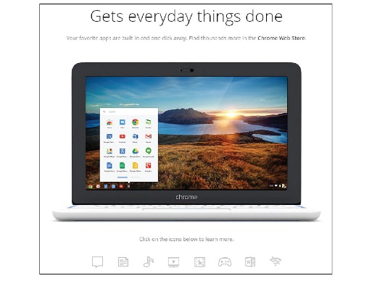
Source: Courtesy of Google Attribution: Fair Use

Essential Information
From the user’s perspective, a web browser is an easy-to-use application for finding and enjoying content on the Internet. Using hyperlinks, web surfers can easily browse through interrelated documents and media, often wandering from one topic to another. The web browser is a wonderful tool for discovery and learning because, by its nature, it presents relationships between topics that may not otherwise be apparent.

Browsing the web is such an intuitive and fluid activity that web users seldom consider what is actually occurring behind the scenes as they surf. Web browsers communicate with web servers using the HTTP protocol. When a web user types in a web address or URL or clicks a link on a page, the web browser sends a request to the web server that has the page or resources being requested. The server then provides the webpage and associated files to the browser. The web browser interprets the HTML and CSS code in the webpage file and displays the page contents according to the instructions provided by the code.

Web browsers have been designed for nearly every type of Internet-connected device. Desktop and notebook computers, tablets, smartphones, and wearables all access the web through browsers. Internet Explorer/Edge, Chrome, Safari, and Firefox are the most popular web browsers. In recent years, Google Chrome has overtaken the others in popularity. Safari is a popular mobile browser since it is the default browser on iPhones and iPads. All browsers provide similar features: tabs for open pages, bookmarks, browsing history, continuity across devices, and private browsing. The significant differences between browsers have to do with the speed in which pages are loaded, the security provided against malware and identity theft, and privacy settings, such as the option to prevent companies from tracking your web activities. Opera is a browser that is appreciated by a small percentage of users for its built-in security and privacy features.

Accessing information is just the tip of the iceberg when it comes to web browser value. Increasingly, the web browser is the platform for the most common computing uses, such as communication and applications. Google has developed the Chrome operating system that does nothing more than act as a web browser running on notebooks called Chromebooks. Using a Chromebook you can browse the web; access email through Gmail; mind your Google Calendar; work on docs, spreadsheets, and presentations with Google Apps; listen to music; watch movies; play games; read books; manage your photos; and conduct many other common computing activities using apps designed for the platform.

Reading: Web Server
The term web server refers to software that fulfills webpage requests from web clients and to the computers that run such software.

Why This Matters
The client/server architecture is fundamental to providing Internet-based services. Without servers, Internet users would have little access to information other than their own. With the increased use of cloud computing, even your own data may be inaccessible without servers. Web servers supply every item requested from a web browser, including information, movies, music, games, software, and services. Without web servers, your web browser window would always be empty.

Essential Information
Web server software runs on a variety of types of computers. Google, for example, combines tens of thousands of PCs in clusters to act as web servers for its search engines. Facebook utilizes dozens of motherboards combined in large cabinets in an energy-saving design. Facebook makes its server design available for other companies to use through an open-source program called the Open Compute Project. Servers are housed in data centers, sometimes called server farms. A server farm owned by Apple, Facebook, Microsoft, Amazon, or Google could house tens of thousands of servers.

Servers don’t necessarily have to be large collections of computers. You can set up your own PC to be a web server; you can even install web server software on a USB thumb drive and have a “server on a stick.” The point is that hardware does not define a web server; rather, the software running on the hardware does. A computer running web server software is called a web server.

The most popular web server software today is Apache, followed by Microsoft Internet Information Services (IIS) for Windows Server, and others taking less significant amounts of the market. Web server software runs on computers that are typically always powered on and connected to the Internet, with backup power supplies and redundant systems to provide uninterrupted service.

Web servers receive HTTP webpage requests from clients and retrieve the data being requested from connected file systems, forwarding that data to the web clients. Web servers typically have other software and systems tools installed to support web-related services, such as programming languages and databases.

A web hosting company or web host is a company that provides web server services to individuals and businesses interested in maintaining an online presence. Web hosting companies typically charge a monthly or yearly fee according to the amount of web traffic anticipated for the site and the amount of storage space required. Rates can be as low as $5 per month for a personal site or hundreds of dollars a month for a commercial site. Besides providing basic storage and server services, web hosts, such as Hostmonster.com, may also offer Internet and web technologies, such as FTP, SFTP, SSH, SSL, email services, and support for development platforms and languages like PHP, MySQL, Perl, Python, C, C++, Java, Ruby, and WordPress.

Reading: Web Development Software
Web development software allows developers to create webpages more easily using a word-processing-style environment and automating complex coding activities.

Why This Matters
Web development technologies have become involved and complex. Web development software, front-end frameworks, and content management systems automate the web development process, making it more manageable and accessible.

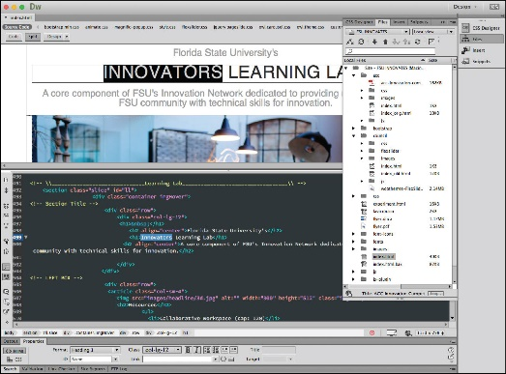
Source: Adobe Attribution: Fair Use

Essential Information
When the web was new, creating websites was the domain of techies who took the time to learn HTML and related technologies. Today, anyone who can use a word processor can create professional-quality websites with little time and effort. Web development software enables you to create HTML documents using word-processor-like software. Rather than having to type out HTML tags to create webpage formatting, you define the formatting using standard menu commands in a what-you-see-is-what-you-get (WYSIWYG) editor. WYSIWYG (pronounced “wizzie-wig”) implies that the webpage you design with the web development software will look the same when published on the web. When you save your webpage, the software creates an HTML file with the appropriate tags. Adobe Dreamweaver is particularly popular web development software that provides powerful tools for building professional interactive webpages and sites.

Many of today’s websites contain standard features that are complicated to create from scratch. These include navigation bars with dropdown menus, animation effects such as parallax scrolling (where the background scrolls slower than the foreground), and responsive features that change the page design based on the display size. Web front-end frameworks are available to provide many of the common but complicated design features. By using the CSS and JavaScript files from frameworks like Bootstrap, Foundation, Skeleton, and others, a developer gets a huge head start on the design process. In fact, most developers use frameworks rather than beginning a project from scratch. There are also thousands of visual themes available for free or to purchase that provide a wide variety of design styles on top of these frameworks.

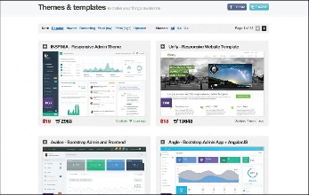
Source: Wrap Bootstrap Attribution: Fair Use

There are also online tools that make building a website as easy as point and click. Sites like wix.com and wordpress.com provide hundreds of design themes to choose from. Add your own content and images and you have your own personalized, professional website. These online tools are considered content management systems (CMS) because they store the website content in a database and load it into the visual theme only when a user requests a page. Content is loaded into the website using a convenient dashboard interface.
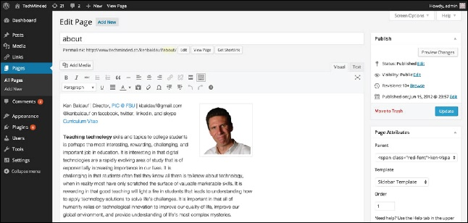
Source: Courtesy of WordPress and Ken Baldauf Attribution: Fair Use

Reading: Cookie
A cookie, sometimes called an HTTP cookie, is a small text file placed on a user’s computer by a web server in order to identify the user whenever he or she returns to visit a website.

Why This Matters
Have you ever had a webpage greet you by name? Many of today’s commercial websites are created on the fly—that is, the webpage is custom-created when the user arrives to match his or her interests. For example, if you have made purchases at Amazon.com, you may notice that each time you visit the site, you are greeted by name and presented with advertisements for products similar to those you have purchased before. Amazon and many websites uses a technology called cookies to custom-create a webpage just for you. Cookies can also be used by companies to track a web user’s online habits in order to build a customer profile on which to base behavioral targeting and advertising. Cookies enable a web server to identify visitors to websites—a useful service to those who visit websites and those who provide web content. But this ability can also be seen as a threat to a user’s security and privacy.

Essential Information
HTTP is classified as a stateless protocol. Stateless refers to the fact that a web server does not retain information (a particular state) regarding a user between visits. In other words, each time your web browser requests data from a web server, that web server has no idea who you are, what you are doing, or what you’ve previously requested of the server. The server treats every request as a new transaction and every visitor as a new visitor, no matter how many times a person has visited the site.

This is a problem for web developers and businesses who want to create relationships with the people who visit their websites. It is also an inconvenience to users who must reestablish their identity every time they visit a website. Cookies were invented to solve this problem.

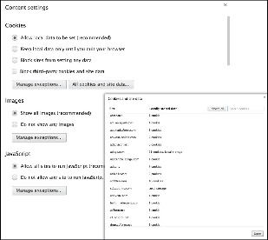
Source: Courtesy of Google Attribution: Fair Use

Today’s web browsers allow web servers to store small cookie files on your computer or mobile device. When you revisit a website, even though your computer may have a different IP address than the last time you visited, the website can recognize you by reading its associated cookie file from your PC or device. Cookie files can contain data or perhaps a unique identifier that is used to look up your personal profile in a database on the server. Information accessed through cookies can include your name, address, and other personal information, items you’ve previously purchased at the website, items you’ve viewed on the website, and the amount of time that you viewed each item. This information is obtained through tracking your activities at the website and from form data that you’ve submitted. By collecting this information over time, a detailed user profile can be developed and used to cater to your individual tastes each time you visit the website.

Some worry that cookies threaten security and privacy. While most companies track a user’s activities only within the company’s own website, some web advertisers use cookies to track a user across many websites. These types of cookies are called third-party cookies because they are not placed on a computer by the company that owns the site, but by a third-party company that provides advertisements on the site. For example, if you’re reading The New York Times online edition, the page you’re on will often deposit a cookie that comes from both The New York Times as well as DoubleClick, the ad agency that placed the ads. Tracking a user’s activities across many websites can reveal a lot of personal information. Chrome, Firefox, Internet Explorer/Edge, and Safari are working to provide users with an option for blocking third-party cookies and to offer a “Do Not Track” option for use with websites that support the option.

Cookies are also often used by professionals working in computer forensics. Cookies stored on computers confiscated by law enforcement agencies can provide evidence for use in criminal prosecutions.

Reading: Plug-in
A plug-in, also called an extension or add-on, works with a web browser to offer extended services such as audio players, video, animation, 3D graphics viewers, and interactive media.

Why This Matters
When the web was invented, its designers had no idea that it would cause such a sensation and become a platform to deliver all types of digital media and services. HTML was designed to simply show pages that include text and images. Rather than continuously upgrading HTML, web browsers, and web servers to accommodate different types of media and activities, plug-in software was developed by a variety of vendors to extend the capabilities of existing web technologies. Bucking this tradition, HTML5 was developed to support media and has reduced the need for plug-ins.

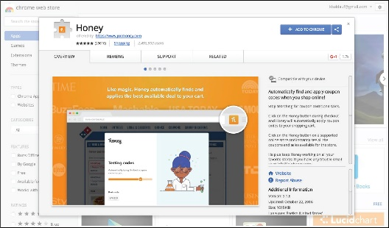
Source: Google Attribution: Fair Use

Essential Information
The web was originally designed to serve up text and image files. To employ more advanced web content, or what some in the industry call rich content, such as video and interactive media, a helper application called a plug-in may be required. A plug-in works with a web browser to offer extended services to support digital audio, digital video and animation, 3D graphics viewers, and interactive media and apps. Plug-ins are also sometimes called add-ons or extensions. When a webpage contains content that requires a plug-in, you are typically provided with the opportunity to download and install the necessary plug-in at no cost, if you don’t already have it. Adobe Flash is a popular plug-in that enables users to view animations and videos and interact with games and other multimedia content created with the Flash program.

Adobe Flash Player, Acrobat Reader, Microsoft Silverlight, and Java Runtime Environment are some popular plug-ins that you’ve probably had to download to view some web content. These plug-ins support specific kinds of documents and applications that are delivered on the web.

More recent plug-ins act more like apps for the browser. For example, there are password plug-ins that help you manage all of your passwords and automatically fill them in for you when required. There are shopping plug-ins that automatically offer you coupons to save you money when shopping online. There’s a Dropbox plug-in so that you can easily access documents stored in your Dropbox account. Check the links below to discover plug-ins and extensions for your favorite browser.

Reading: Web Programming
Web programming refers to the development of software written to run either in a web browser or on a web server, using web-based input and output.

Why This Matters

Source: Pixlr Attribution: Fair Use

Essential Information
Software is used on the web to provide a wide range of services. When you use a web search engine, your keywords are used as input for a program that searches a database for related websites. Web-based software processes all kinds of data submitted through web forms, including purchases at online stores, bids on products at eBay, insurance quotes, emails to friends, updates on Facebook, seat reservations for concerts or ballgames, and stock purchases and trades.

Web programs and software have become increasingly sophisticated. Today, many web-delivered programs, or web apps, are nearly as powerful as their desktop counterparts. Web apps offer the additional benefits of being available from any Internet-connected device and of serving as a collaborative framework for sharing data and files among multiple Internet users. Companies like Pixlr provide photo-editing software that runs in the web browser. Doodle.com produces a popular web app for polling a group to find the best time for a meeting.

Java is an object-oriented programming language that enables software engineers to create programs that run on any computer platform. JavaScript is similar to Java in that it provides functionality on webpages through programming code that is embedded in an HTML document. However, the two languages are very different. Java is a full-fledged programming language for all computing environments, but JavaScript was developed specifically for the web. Ajax, which stands for Asynchronous JavaScript and XML, is a popular and powerful web development platform used to create web apps such as Google Docs and Google Maps. Ajax allows the user to interact with a program without needing to frequently reload webpages. A special set of JavaScript functions called jQuery has become very popular for creating animated webpage effects.

JavaScript and its derivatives create programming code that runs in the browser after being delivered by the server. These are called client-side programs. Java, PHP, Perl, C++, and many other programming languages and scripting languages are used to develop software that runs on a web server using the web browser as a user interface. These are called server-side programs.

There is somewhat of a battle being waged between installed apps, also called native apps—designed for specific devices such as the iPhone, Windows Phone, or Android devices—and web apps designed to run on any device in the mobile browser. So far, installed apps are winning the battle because they are able to offer features customized to the device and also run more smoothly and quickly. Many feel that eventually web apps will acquire similar abilities. In fact, Google is betting on it!

Reading: Cloud Computing
Cloud computing delivers a variety of computing resources from the Internet as a service for free or for a fee, to relieve users from the burden of installing, maintaining, and securing those resources themselves.

Why This Matters
Pervasive and reliable high-speed Internet connections have led to a new generation of computing where computing activities take place on Internet servers accessed through a web browser. Applications like Facebook, Google Docs, Office Online, Gmail, and YouTube, as well as business applications like Salesforce and IBM Cognos, allow individuals and businesses to access powerful applications without needing to install software. Increasingly, computer processing and storage are moving off of PCs and into the cloud.

Essential Information
The beauty of cloud computing is that users access services from their own computers or mobile devices but don’t have to be concerned with installation, maintenance, or security. Cloud computing derives its name from the depiction of the Internet as a cloud in networking diagrams, a vague structure to or from which data is uploaded or downloaded without the user’s having to know the details of the process.

Amazon.com played an important role in developing the cloud-computing model. The company found that they typically utilized only 10 percent of their server resources because they had to be prepared for extremely busy periods when demand shot up to 90 percent. The company developed a cloud architecture that accommodated peaks in demand and shifted the load to other activities during slower periods. The company gained huge benefits in efficiency through its new server architecture and started leasing out server resources to outside companies. Today Amazon is not only the largest online retail store, but is also one of the largest suppliers of cloud services. Another company using the cloud computing model is Salesforce.com, which has created a popular enterprise cloud computing service that provides customer relationship management (CRM) software in the cloud.

Many people take for granted the wide variety of web apps available and the fact that their data is often stored on servers owned by companies like Facebook and Google. Not many consider the benefits of cloud computing to businesses. Businesses manage huge collections of data utilizing complex information systems that require expensive servers and an army of technicians to support them. Cloud computing offers an opportunity for businesses to outsource all of it and lease the service for a flat monthly fee. Since cloud service providers are dedicated to the business of computing, they are able to invest more in maintenance and development.

There are some drawbacks to cloud computing, mainly in the areas of access, privacy, and security. Many cloud services are only accessible when the user is connected to the Internet. So, business travelers with intermittent Internet access could suffer. However, the amount of time anyone spends without Internet access is becoming less and less, and cloud service suppliers are working to support work offline. Another issue has to do with lack of control over the data. Some worry that cloud service companies will not adequately secure their data. They may also fear that sensitive information stored in the cloud could be subject to snooping eyes. In fact, government agencies have declined some cloud services because they do not meet government regulations for privacy and security. Many cloud companies, including Amazon and Google, have worked to become certified for government use.

Reading: Cloud Services
Cloud services include computing services provided over the Internet in three categories: infrastructure, platform, and application.

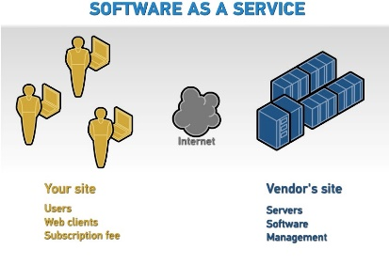

"BMC on SaaS" by Michael Coté is licensed under CC BY 2.0

Why This Matters
There are many levels at which cloud computing provides services. There are thousands of cloud applications, many of which are well known. Cloud computing can go deeper than just software; it can also offer an entire computing platform, operating system and all. Even deeper than that, it can offer hardware for storage, security, and networking.

Essential Information
The application category of cloud computing isn’t as new as you might think. It has been around in business environments for over a decade and is referred to as Software as a Service or SaaS. It is only since Web 2.0 brought technologies that allow web browsers to act like installed software, that the term cloud computing was coined. SaaS originally required software to be installed on local computers in order to access services on the Internet. With the recent release of powerful web development technologies like JavaScript and Ajax, developers were able to create full-fledged applications to run in the web browser window. This allowed users to access software simply by calling up a web address in the browser. These technologies provided the fuel to launch the cloud computing era. Today, software from basic tools like calendar apps to heavy enterprise tools like business intelligence apps run on web servers and are accessed from browsers.

Increasingly, personal computing is moving to the cloud. Amazon Drive, Apple iCloud, and Google Play services provide ample online storage for music and media that can be accessed from any Internet-connected device. Similarly, cloud services are available for businesses with large amounts of data and enterprise considerations. Amazon Web Services (AWS) is a popular cloud service for thousands of businesses.

Some cloud services offer a computing platform to access over the Internet. Platform as a Service (PaaS) provides access to an operating system desktop running in a virtual machine on a server. Using PaaS, a person could run software on a Windows PC from their Linux desktop. This setup is especially useful for developers who develop software for multiple platforms. PaaS is also useful for web hosting. Many hosting companies provide complete virtual servers for hosting customer’s websites.

Finally, Infrastructure as a Service (IaaS) provides hardware resources to users over the Internet. This is especially useful for storage. A business can outsource all its data storage with an IaaS provider that encrypts and secures the data behind a firewall. IaaS relieves a company of having to manage storage media, data backups, and security.

Reading: Cloud Model
There are several cloud models that serve various environments, including private clouds, community clouds, public clouds, and hybrid clouds.

Why This Matters
While most users are familiar with public cloud services like Google Apps or iCloud, they may not be familiar with other models of importance to businesses and organizations. There are four models for cloud computing: public, private, community, and hybrid.

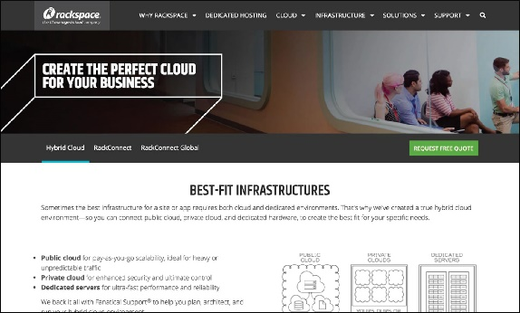
Source: Rackspace Attribution: Fair Use

Essential Information
The public cloud model makes a cloud service available to the general public. This is the model most of us use and are familiar with. The service may be free or require a monthly fee. Businesses, however, may not wish to have their cloud service shared with anyone else. In such a case, a business could set up a private cloud.

A private cloud may be created on-premises or hosted by a service provider. In either case, the cloud is provided for one company alone. Rackspace, for example, offers private cloud services for data center management. The cloud saves a business like Rackspace money by pooling server resources and growing and shrinking as needed. Many businesses are transforming their own data centers and information systems to the private cloud model.

In some cases, a private cloud may be expanded to serve multiple businesses or organizations. It then becomes a community cloud. Businesses that have common interests can experience additional savings by pooling their cloud resources. When different types of cloud services are connected, the result is a hybrid cloud.

Lesson 9.3: Web Resources

Lesson 9.3 Introduction
Web resources are many and varied, assisting individuals, businesses, and organizations with all facets of life, including education, news and information sharing, communication, travel, commerce, employment, and entertainment.

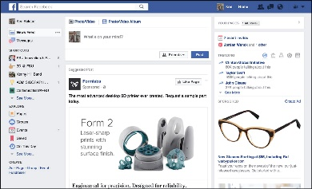

Source: Facebook; Content Courtesy of Ken Baldauf Attribution: Fair Use

Consider the many ways web resources support people in their personal and professional lives. Many web users spend a majority of their online time on Facebook, discovering interesting information about their friends (see figure). While Facebook may be the most popular web resource, there are millions of others in several categories that are useful in many ways. Knowing more about these resources helps us to make the best use of our online time to lead more efficient, effective, and fulfilling lives.

Businesses rely on web resources to function efficiently and effectively. Many businesses exist because of the web. Professionals rely on web resources to develop skills and advance in their careers. Individuals rely on the web for communication, information, and entertainment. Sometimes, web resources are just a fun way to pass or waste some time. You learned in the Apps unit how the web is becoming a platform for all types of computing activities. Increasingly, people depend on web resources to enrich all aspects of life.

Reading: Search Engine
A search engine is a valuable software tool that enables users to find information on the web by specifying words that are key to their topics of interest—keywords.

Why This Matters
The fundamental purpose of the web is to make it easier to find related content from diverse Internet sources by following hyperlinks. However, the web has become so large that many complain of information overload, or the inability to find the information they need because of the overabundance of information. To relieve the strain of information overload, web developers have provided web search engines to help organize and index web content.
Source: © 2012 Google, Inc. Attribution: Fair Use

Essential Information
Search has become the biggest application on the web. Search giant Google has become one of the world’s most profitable companies, with more than $50 billion in annual revenue. Search has become such a profitable business because it’s the one application that everyone uses. Search engine companies make money through advertisements. Because everyone uses search, advertisers are keen to pay to have their ads posted on search pages.

Google has the largest share of the search engine market with around 73 percent of the global market. Microsoft Bing is second with 9.2 percent, and China’s Baidu search engine is third with roughly 8.7 percent. Google has leveraged its market dominance to expand into many other web-based and mobile product markets. In fact, Google has become so diversified in the products it produces that in 2015 it underwent a major corporate reorganization, creating a holding company named Alphabet Inc., in which Google served as its leading subsidiary. The divisions in Alphabet are:
- Google
- Search
- Advertising
- Maps
- Apps
- YouTube
- Android
- Calico (life-extension biotech research)
- Nest (smart home appliances)
- Fiber (high-speed Internet service)
- Ventures and Capital (investing)
- X lab (research incubator—self-driving cars, delivery drones, etc.)
Most search engines use an automated approach that scours the web with “bots” (automated programs) called spiders that follow all web links in an attempt to catalog every webpage by topic. Each webpage is analyzed and ranked using unique algorithms, and the resulting information is stored in a database. Google maintains billions of indexed webpages on dozens of clusters of up to 2,000 computers each. A keyword search in a search engine isn’t a search of the web, but rather a search of a database that stores information about webpages. The database is continuously checked and refreshed so that it is an accurate reflection of the current status of the web.

Microsoft has taken a different direction with its Bing search engine. Bing has an innovative design that Microsoft calls a decision engine. Bing provides more than just a long list of links in its search results. It also provides information on related topics and services. The idea is to provide users with all the information needed to act on whatever task is related to the search. Similarly, Wolfram Alpha is an “answer engine” designed to answer factual queries. For example, you can use Wolfram Alpha to find out the difference between a tortoise and a hare, how many feet are in 120 meters, what the interest is on a 30-year mortgage at 5 percent, and which words end in “alic.”

Google is continually adjusting its search algorithm to provide better links and even direct answers to queries. Google hopes to create a “semantic web” that is able to answer any question by more precisely interpreting the meaning, or semantics, of what the user is seeking. Google Assistant is a step in that direction. Just ask Google Assistant a question and web results pop up, instantly providing useful information. Apple’s Siri, Amazon’s Alexa, and Microsoft’s Cortana are similar apps. Once provided primarily for mobile devices, these personal digital assistants are now embedded in laptop and desktop computers and in home appliances so that those who use them can speak a keyword and question nearly anywhere, any time and get an immediate response.

Reading: Internet Communications
Internet communications include text-based communications like email and instant messaging, voice communications like Voice over IP (VoIP), video communications, and a variety of group and community forums.

"Showing his drawing to her aunt in Singapore" by Carlos Ebert is licensed under CC BY 2.0

Why This Matters
The digital revolution has ushered in the age of pervasive computing, where anyone can have access to information anywhere, anytime. Equally important and influential is the growth of pervasive communication, the ability to communicate with anyone, anytime through a variety of formats. Pervasive communication is the result of advances in wireless and Internet communication technologies. These technologies are fundamentally altering the ways in which personal and professional relationships are created and nurtured.

Essential Information
Before the Internet, forms of two-way communication were limited to face-to-face, telephone, or printed word (as in mailing a letter). The Internet has broadened our communications options considerably. Today, you can phone, email, meet in person, text, update your status, video chat, send a letter, tweet, and otherwise communicate with anyone, any time, over multiple communication channels from any location. When determining the most effective and convenient manner in which to communicate, it is useful to consider the importance of what you need to communicate along with the strengths and weaknesses of the various communication channels.

There are two basic forms of communication: synchronous and asynchronous. In synchronous communication, people communicate in real time, exchanging thoughts in a fluid conversation. Face-to-face conversations, video chat, telephone conversations, online chat, and instant messaging are examples of synchronous communication. Asynchronous communication allows participants to leave messages for each other to be read, heard, or watched and then responded to at the recipient’s convenience. Answering machines, voicemail, social network posts, text messages, tweets, and email are examples of asynchronous communication.

Each form of communication should be evaluated in terms of quality, convenience, and time/delay. Typically, the quality and speed of communications compare inversely with the level of convenience. Internet and wireless communication can be categorized as text, voice, or video. With increasing amounts of voice communication traveling over the Internet, and Internet communication expanding to mobile phones, there is little need to differentiate between Internet communication and mobile phone communication when it comes to evaluating current forms of digital communication.

With all these forms of communication, it would seem that miscommunication or lack of communication would be a thing of the past. Unfortunately, people still miscommunicate and choose ineffective modes of communication. When planning communication, consider the importance of what is being communicated along with the type of person you are communicating with. When communicating with figures of authority, avoid casual language, emojis (pictures from punctuation, like smileys), texting, slang, and other casual modes of communication. Using less convenient but more effective modes of communication can go a long way in making convincing arguments and showing those you communicate with that you are serious. Remember that no form of remote communication is as powerful or meaningful as in-person, face-to-face communication.

The following table lists current forms of communication in order of convenience and effectiveness. The first listing is the most convenient but least effective, and the last is the least convenient but the most effective in getting a message across. As you read down the table, consider which elements of communication are included and missing from each form. Include subtle components of communication such as eye contact, facial expression, voice inflection, body language, and personal space.

Forms of Electronic Communication
Text Communication
Text Messaging (Asynchronous) | Communication through short text messages via cell phone or social network.
Email (Asynchronous) | Communication of text-based messages through transmission over a computer network. Email is only slightly more effective than text messaging because there is no character limit. Email supports file attachments, which makes it a useful method for transferring data.
Messaging via social media (Synchronous) | Communication through synchronous text messaging between two or more participants utilizing social media such as Facebook, Google+, or Twitter. Also useful for sharing photos, videos, and links.
Voice Communication
Voicemail (Asynchronous) | Communication by means of voice messages left on phone services or Internet services.
Phone (Synchronous) | Communication through phone conversations allows the use of voice inflection for more effective communication than text-based communications.
Internet voice (Synchronous) | Communication through Internet-based voice through services such as Skype (a free online communication tool that supports text, voice, and video) or online chat services that support voice communications.
Virtual Chat
Virtual chat (Synchronous) | Communication in an online virtual world where users are represented as avatars (animated characters) and chat via voice or text while interacting with others.
Video Communication
Video phone and chat (Synchronous) | Communication through synchronous video, typically over the Internet or private data network.
Telepresence (Synchronous) | Communication through high-quality video and audio connections over the Internet, along with large, high-definition displays to support meetings between people around the world as if they were gathered at one location.

Reading: Social Media
Social media, sometimes referred to as social networks, refers to websites that allow people to share information, ideas, photos, and other forms of media in virtual communities and to comment on items shared.

Why This Matters
The web was originally designed for information to flow in one direction, from those with the resources to publish information on the web, to the public. As web technologies evolved, the web transformed into a bidirectional information source, where those consuming content were able to easily contribute content. Once two-way communication was enabled, it was only natural that online communities would follow and websites to support those communities would emerge. Collectively, these websites are called social media. Billions of people have invested significant portions of their lives in building their online social networks and reputations.

Essential Information
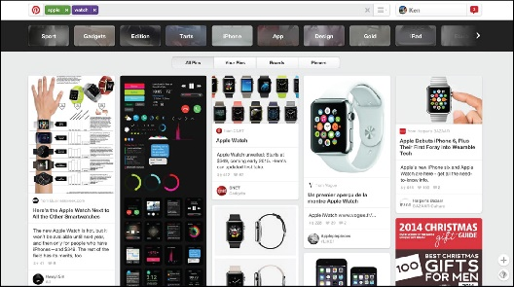
Source: Courtesy of Pinterest Attribution: Fair Use
Social media provides a convenient method for connecting and building relationships with friends and like-minded individuals online. Depending on the service, you might “friend” other users to build a community of friends, or you might “follow” other users if you are interested in reading what they post. Most social media, such as Facebook, LinkedIn, and Google+, require an account which is associated with a user profile in the community. Social media websites typically have a unique focus to differentiate themselves in the market. The table below shows some of the most popular social media platforms.

Social Media
Social Media Platform | Monthly Active Users | Description
Facebook | 1.71 billion | A general social media platform that allows members to post text, photos, or video to the news feed, which can be shared with friends, subsets of friends, individuals, or the world. Facebook supports multiple communication channels between members as well as 3rd party apps and many other features.
Google+ | 300 million | Facebook’s only halfway serious competitor Google+ was a Google-offered alternative that offered many of the same features as Facebook plus video chat with Google Hangouts and integration with Google’s other software. Google discontinued Google+ support in 2019.
Instagram | 500 million | A photo-centric social media site that allows members to edit and upload photos and video from mobile devices, using a mobile app, and share them on a variety of social networking platforms.
Twitter | 300 million | A streamlined social media platform that allows members to send and read short 140-character messages called “tweets”. Members “follow” their favorite tweeters to see what they may say next and to perhaps re-tweet a tweet. Hashtags, such as #MTVStars, are used in tweets to make it easy to follow or search for specific topics.
Snapchat | 150 million | A mobile photo/video messaging app that enables private messaging and public content. Snapchat provides more privacy than other messaging apps by implementing a self-destruct mechanism for messages.
LinkedIn | 106 million | A professional social network platform that allows members to create a professional profile that serves as an online resume. Members create professional “connections” with other members to create professional opportunities or to find a job.
Pinterest | 150 million | Another photo-centric social media platform, but this one allows members to collect images from the web to store in themed collections called boards. For example, a member might create a “Beach Destination” board to collect photos of possible vacation options for future reference or to share with friends.

Reading: Online Information
Online information refers to information of all kinds—business, personal, governmental, factual, opinionated, and even inaccurate—that is delivered over the Internet and web.

Why This Matters
The web has become a very popular resource for sharing information. In some cultures, it is the primary resource for information, beating out newspapers, books, television, and radio. Material once stored in volumes on library shelves is now available in digital form on library websites. Finding information online and being able to distinguish useful and reliable information from opinionated and inaccurate information has become a valuable skill for those wishing to stay informed.

Essential Information
Finding information on the web can be a challenge. Search engines are a valuable tool in this regard. Choosing search terms to get the desired results is a skill that grows with practice.

Unlike information published through traditional media such as newspapers, magazines, and books, much of what is published on the web has no quality control, editors, or peer review. When judging information provided on the web, always consider the source. Anonymous postings and publications should not be trusted until you identify the provider of the information. If that person or organization is unfamiliar to you, search the web for information on the provider. Providers of valid and trustworthy information on the web typically go out of their way to include references to well-known and highly regarded authorities.

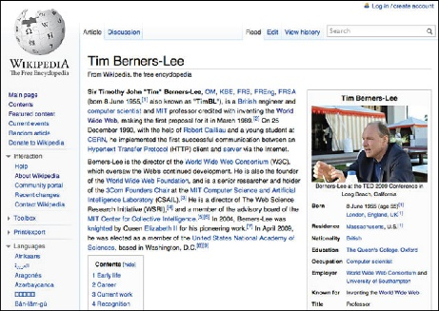
Source: Courtesy of Wikimedia Attribution: Fair Use

Wikipedia utilizes a crowdsourced model to collect, publish, and review information in an effort to create a universal online encyclopedia. Crowdsourcing refers to development models that source the work to the Internet population. While crowdsourcing has proven successful, it has been criticized for having a bias towards white male views. Wikipedia encourages all contributors to include links that support research on any topic. Although it may not be appropriate to cite a Wikipedia article as a source for research, often you can find an acceptable source in the links provided in the Wikipedia article. Encyclopedia Britannica, which is now available online, on your mobile phone, and on your tablet, is an authoritative resource for all kinds of information.
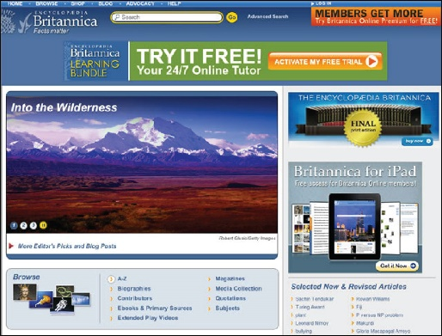
Source: © 2012 Encyclopedia Britannica Inc, All Rights Reserved Attribution: Fair Use

The following table shows the various types of information found on the web.

Types of Web Information
Traditional published works | Many publishers and libraries are creating digital forms of past and current published works. Digital libraries offer access, often free, to a wealth of books, research resources, and periodicals. Huge databases of published articles, like the one provided by LexisNexis, are available; unfortunately, many of these require a membership fee.
News | Most newspaper, magazine, radio, and television news sources now have an online presence delivering articles through webpages, blogs, podcasts, and streaming video.
Business | Most businesses have an online presence delivering information on their products and services and providing a method to purchase their wares.
Financial | Banks and other financial institutions provide information for individuals, investors, and those interested in the economy.
Government, political, and legal | All levels of governments are represented on the web, along with political and legal information from all perspectives.
Opinion | Blogs and social networks provide a platform for anyone on the web to share opinions, solicit feedback, and create discussions on any topic.
Personal | Social media has created a space for anyone to post information on their personal interests and characteristics.
Support | The web is increasingly the first place people turn when they need help with life issues. Information on the web can help you find the perfect mate, prepare for your wedding, get a job, buy a house, and prepare for your first child. All of life’s major challenges are addressed on the web.

Reading: Online News
Online news refers to newspapers, magazines, journals, news radio and television, and blogs that deliver news and information about current events on the web.

Why This Matters
The web is a powerful tool for keeping informed about local, state, national, and global news. It allows the public to actively research issues and become more knowledgeable about current events. Traditional news media deliver the news through television, radio, and newspapers. These media provide only the news that they consider of interest to the general public. Items of special or unique interest may be bumped and replaced with more general stories. In contrast, the web has an abundance of special-interest coverage. It also provides the capacity to drill down deeper into the subject matter.

Essential Information
All major newspaper, radio, and television news services have expanded to provide online news coverage. This trend has put the various forms of media in direct competition with each other as their online format expands to include text, photos, audio, and video. Bringing the news to the web is eliminating the lines of distinction between traditional newspaper, radio, and television news sources.

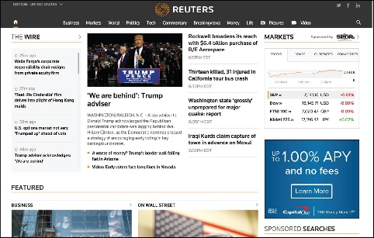
Source: Reuters Attribution: Fair Use

The leading news agencies have a strong online presence as well. Reuters, the Associated Press, the BBC, and others are sources of global news and information for media companies and the general population. While traditional news sources migrate to the web, new sources of news are emerging from online companies. News websites from Google, Yahoo!, Digg, and Newsvine provide the most popular or interesting news stories from a variety of news sources.

In a trend some refer to as social journalism or citizen journalism, ordinary citizens are more involved in reporting the news than ever before. Through online tools such as blogs, podcasts, videocasts (vcasts), discussion groups, and social media, the online community is taking journalism into its own hands and reporting the news from each individual’s perspective. Although social journalism provides us with important news we would otherwise not get, its sources may not be as reliable as mainstream media sources. As we hear the news from nonprofessional journalists, reporting without experience, training, or the strict guidelines of formal news agencies, it is important to remember that the information may be biased, misrepresented, mistaken, or perhaps even deliberately misleading.

The 2016 presidential election brought attention to the large amount of fake news stories being distributed on social media and the web. Fake news may be generated by individuals jumping to conclusions, such as when a 35-year-old Texan noticed a fleet of tour buses at a Trump rally, and tweeted about paid protesters being bused to demonstrations against President-elect Donald J. Trump. The tweet went viral, fueling a nationwide conspiracy theory, but the claim turned out to be untrue.

Fake news can also generate money for those who post it. The money is generated by ads on the pages containing the fake news. Many people around the world have made fake news their profession, preying on human gullibility and political tensions to earn upwards of $5,000 to $10,000 a month from ad clicks on their outrageously false news pages.

The proliferation of fake news online, and the possibility of bias in news from all sources, requires us to approach what we read online cautiously. Check multiple reliable sources to confirm that the news you read is accurate and true, especially for news stories that seem too outrageous to be true.

Reading: Financial Services
Online financial services support money management, loans, investments, and transactions for individuals, businesses, and organizations.

Why This Matters
Online services empower Internet users to get a better grip on their finances. Whether you are interested in opening a bank account, starting a business, balancing your budget, transferring funds, paying bills, borrowing money, lending or investing money, making purchases, paying your taxes, or any number of money-related activities, you’ll find the most convenient way of getting it done is online. In fact, in a growing number of cases, the only way to get it done is online.

Source: TaxAct Attribution: Fair Use

Essential Information
Online banking has become the default method of banking for both individuals and organizations. In fact, banks are closing their physical locations as the demand for them shrinks. Through a bank’s website, a customer can check account balances, transfer money between accounts, make payments on loans, credit cards, and other bills, and schedule automatic monthly deposits and payments.

Many lenders, government agencies, city utilities, and other service providers expect customers to pay their bills online. Some even charge extra for customers who insist on paying by check through the mail or using cash in person. Processing payments online is much less expensive for a business than processing them through the mail or in person. Payments may be made through a bank account or through the payee’s website. Since routine monthly payments typically charge penalties for late payments, it is wise to set up automatic payments so that none are overlooked.

Online services exist for all types of financial activities. Mint.com and quickbooksonline.com are online personal finance services that track your spending and income to advise you on a practical monthly budget. TaxAct.com helps millions of U.S. taxpayers file their federal and state taxes each year by offering several different options of varying expenses for filing your taxes. The software that a company like TaxAct provides for filing taxes has drastically changed the way that people file their taxes; instead of filing through an accountant, they can now do it themselves online. Zillow.com helps home seekers discover homes and mortgages that are affordable based on their savings and monthly income. Lendingtree.com and hundreds of other sites assist people with borrowing and refinancing.

Crowdfunding has become a popular way to finance a new business. Websites like Kickstarter and Indiegogo allow entrepreneurs to make a business pitch for a new service or product in order to get Internet users to invest. The investors are promised a reduced rate on the product when it is ready for market. Unfortunately, not all ventures make it that far. GoFundMe is another crowdfunding site that provides a platform for raising money for all kinds of personal needs including medical operations and social needs. Kiva applies crowdfunding to support entrepreneurs and small business owners in developing countries.

The Motley Fool, investmentadvice.org, and others are available to assist people for wise financial investments and retirement planning. E*Trade, Scottrade, Charles Schwab, and others provide tools to make investments online.

PayPal provides tools for emailing money to others and paying for services and goods online without a credit card. PayPal Here is a PayPal service that allows in-person transactions to be “rung up” on a mobile phone or tablet. Square provides a similar service and provides a credit card reader that attaches to mobile phones and tablets to allow anyone to conduct credit card transactions with a card swipe. The world of ecommerce, where business transactions are carried out by the billions everyday across the Internet, is addressed in a separate unit.

Reading: Online Education
Online education refers to websites designed to educate or support education and training.

Why This Matters
As a tool for sharing information and a primary repository of information on all subjects, the web is ideally suited for education and training. Advances in interactive web technologies further support important educational relationships between teacher and student, and among students. The web plays a major role in all levels of education. Emerge with Computers—this software you are using—is the ideal example of the power of online education! In today’s highly competitive and rapidly changing professional environments, more professionals are turning to the web to learn skills that will enhance their professional value.

Essential Information
Educational institutions of all types and sizes are seizing the web as a tool to enhance classroom education or extend it to individuals who cannot physically attend.

Primary schools use the web to inform parents of their students’ progress and grades as well as school schedules and activities. Teachers utilize online drills and exercises to reinforce classroom lessons. By high school, students have integrated the web into daily study habits.

Most college-level courses rely on the web to enhance learning. Educational support products, such as Moodle, Blackboard, Canvas, and Desire2Learn, provide an integrated web environment that includes virtual chat for class members; a discussion group for posting questions and comments; access to the class syllabus and agenda, student grades, and class announcements; and links to class-related material. Some course websites deliver filmed lectures using webcasting technologies provided by companies like Tegrity. Such environments can complement the traditional classroom experience or replace it altogether.
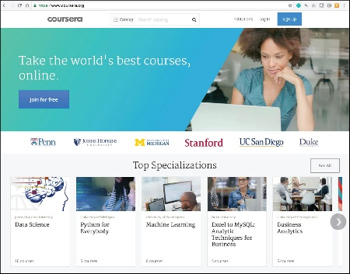
Source: Coursera Attribution: Fair Use
Conducting classes over the web with no physical class meetings is called distance education or distance learning. Many high schools and colleges offer distance learning classes, which provide a convenient method for nontraditional students to attend college. Nontraditional students include students who have job or family obligations that might otherwise prohibit them from attending college. Distance learning offers them a way of working through class material on a flexible schedule. Some schools offer entire degree programs through distance learning.

In a program it calls OpenCourseWare, the Massachusetts Institute of Technology (MIT) offers all of its courses free online. Stanford University offers a free introductory programming course on “Building a Search Engine” taught by Google cofounder Sebastian Thrun. More than 90,000 students enrolled in the course, marking the beginning of a trend known as Massively Open Online Courses, or MOOCs. Today, three primary MOOC providers—edX, Udacity, and Coursera—offer hundreds of free online courses from dozens of the country’s best universities. Students who take MOOCs do not earn credit toward a degree and have limited access to the instructor, but they benefit from the knowledge gained.

Besides MOOCs, there are a number of other educational opportunities that exist online. Khan Academy offers over 2,600 instructional videos on many subjects, especially math and science. Lynda.com, which recently purchased by LinkedIn for $1.5 billion, offers video lessons on all types of technical and software skills. iTunes U offers full courses online from numerous universities. YouTube Edu has thousands of lecture videos from professors across around the world.

Beyond traditional education, corporations such as Skillsoft offer professional job-skills training over the web. Job seekers often use these services to acquire specialized business or technical training. Some of the training leads to certification. Certification verifies a person’s skill and understanding in a particular area. It has become very important, especially for some technical skill sets, to assure an employer that a job applicant truly has the skills claimed.

Source: LinkedIn Attribution: Fair Use
Museums, libraries, private businesses, government agencies, and many other types of organizations and individuals offer educational materials online for free or for a fee. Consider eHow, the website that claims to teach you “how to do just about everything!” Certiport offers training and testing for technology certification, such as for Microsoft and Adobe products.

Module 10

Introduction
Freedom of speech refers to the ability of a person to publicly speak or publish any thought without legal constraints or repercussions.

"" by dominic bartolini is licensed under CC BY 2.0
Free speech is a fundamental right in democratic societies. The First Amendment to the U.S. Constitution guarantees citizens the right to free speech. The Internet and web have allowed people to communicate their views to a greater extent and with a broader reach than has ever before been possible, and many are taking full advantage of this freedom. Freedom of speech provides many benefits; however, some people use free speech in a dangerous and hateful fashion, placing individuals, groups, businesses, organizations, governments, countries, and perhaps even the entire human race at risk. When, if ever, does free speech go too far?

Most of us know that employers check social networks as part of their background checks for prospective employees. In 2012, some U.S. government agencies and companies started asking for Facebook usernames and passwords as part of the job interview process so they could check the applicants’ private profiles. With a tough job market, many interviewees felt obliged to go along with the request.

When newspapers reported this new hiring practice, Facebook threatened to sue the companies involved for violating member privacy. The American Civil Liberties Union (ACLU) joined the fight as well, calling the practice an invasion of privacy. Senators Richard Blumenthal and Charles Schumer called for a federal investigation into the new hiring practice. With unemployment at 8% in the U.S., Blumenthal and Schumer said that such requests amount to a form of coercion “that could set a dangerous precedent.” “In an age where more and more of our personal information—and our private social interactions—are online, it is vital that all individuals be allowed to determine for themselves what personal information they want to make public,” Schumer said. “This is especially important during the job-seeking process, when all the power is on one side of the fence.”

How do you think employers benefit from reviewing prospective employee Facebook profiles and activity? Why might some prospective employees feel that this practice inhibits their freedom of speech and invades their privacy, even when they don’t have anything to hide? Should an employer gauge the potential value of a prospective employee based on Facebook posts? Should a company have the right to fire an employee because of Facebook posts?

There are websites, blogs, YouTube videos, and social media groups to cover every conceivable topic and point of view. The Internet is used to espouse the views and beliefs of every religious and political group. The Internet has become a tool for organizing citizens around issues of injustice. In some cases, governments have cut off access to the Internet in order to gain control over a population. Governments, including the U.S., are considering the creation of an Internet “kill-switch”—a single shut-off mechanism for all Internet traffic—to use in situations of social unrest or cyberattack. The idea has strong opposition from civil rights groups that consider such an action an inhibition of free speech and civil liberties.

The web has become a platform for anyone and everyone with access to publish information and misinformation. Websites may include points of view that many find offensive and even dangerous, such as those that support or promote suicide, racism, hate, or terrorism. This section examines the social implications of freedom of speech on the Internet and how varying societies deal with controlling what is expressed online.

Lesson 10.1: Freedom of Speech on the Web

Lesson 10.1 Introduction
The Internet has the potential to be the greatest force for justice, equality, and democracy the world has ever known. It can allow everyone on Earth an opportunity to speak their mind, to raise support for causes they believe in, or to expose injustice wherever it may occur. Every day, new tools are made available, written or built, that provide new ways to interact with billions of people and to be heard, but these new tools must be used and protected if they are to endure.

Reading: Web Empowerment
Web empowerment refers to the power that the web provides for individuals to express themselves, influence others, and affect the course of society.

Why This Matters
Perhaps the largest impact of the web on all cultures is providing ordinary people with the ability to publish their views to the world. Before the web, only large companies, mass media, and governments were able to broadcast messages to the world. The web provides this ability to anyone who can access an Internet-connected computer. People are taking advantage of that power to express dissatisfaction and offer constructive—and sometimes destructive—criticism to those in positions of power. Because of this, businesses and governments are more interested in pleasing their customers and citizens than ever before.

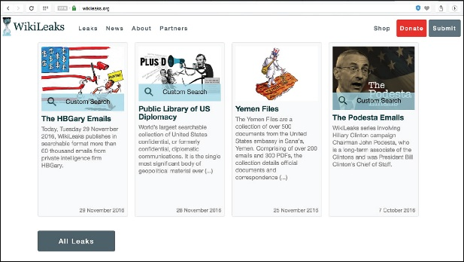
Source: WikiLeaks Attribution: Fair Use

Essential Information
The Internet has been grasped as a tool to empower those who traditionally have been without a public voice. At websites such as yelp.com, customers are able to provide opinions about a businesses’ service and products. Epinions.com provides consumer reviews about most products, which empowers customers to make wise purchasing decisions. There is no longer reason for consumers to be taken by surprise by the quality of products purchased.

Bloggers have been an important component in online public opinion and journalism. A blog, short for web log, is a website created to express one (or more) individual’s views on a given topic. Beyond consumer reviews, blogs extend to cover social editorials and even news journalism. News-reporting bloggers are sometimes referred to as citizen journalists. Mainstream media—the traditional news organizations—originally discredited citizen journalists as amateurs without credentials who operate without proper journalistic mechanisms, such as reliable sources and proper quality control and editing. Others consider citizen journalism a healthy democratic counterbalance to mainstream media, forcing more transparency and honesty in news reporting. Many mainstream media companies support citizen journalism by providing a portion of their websites for news items submitted by citizen journalists. Also, many mainstream journalists now have blogs of their own.

The proliferation of smartphones and the ability to easily transfer digital photos and videos have led to many amateur photographers having their photos and videos published. More amateur photos are gracing the front pages of newspapers and television newscasts because a member of the public with a phone was at the scene of a breaking story before the press. Sometimes those photos are used in police investigations. The FBI relied on photos submitted by pedestrians to catch the Boston Marathon bombers in 2013.

Just as the Internet and web have allowed people to stand up to businesses and news media, they have given citizens the power to be heard by the government. Blogs published secretly by citizens living under repressive governments have been instrumental in bringing international attention to their plights and influencing change.

Perhaps the best example of web empowerment is WikiLeaks. WikiLeaks is a website that publishes confidential documents leaked by employees and others in order to create more transparent business and government practices. In 2010, WikiLeaks released hundreds of thousands of leaked confidential government documents to the public. The United States government launched a criminal investigation into WikiLeaks and asked allied nations for assistance. WikiLeaks founder Julian Assange fled the country seeking a safe haven. In November 2010, a request was made for Assange’s extradition to Sweden, where he had been questioned months earlier over allegations of sexual assault and rape. Assange surrendered himself to UK police on December 7, 2010 and is currently on bail in the Embassy of Ecuador in London, unable to leave without being arrested for breaching his bail conditions.

Julian Assange inspired many dedicated followers who work to keep WikiLeaks in business. Others believe WikiLeaks has compromised U.S. national security and endangered sensitive international relations.

Reading: Net Neutrality
Net neutrality refers to a principle applied to high-speed Internet services, whereby all data is delivered to all users with equal priority.

"NetNeutrality-VS-Comcast" by Backbone Campaign is licensed under CC BY 2.0

Why This Matters
The Internet was designed to be a free and unfettered communications medium. The big telecom companies that control access to the Internet have been known to filter Internet traffic, giving certain traffic precedence. Many scholars, tech professionals, and other members of the public think the Internet should stay free—free as in net neutral. However, the telecom companies complain that their networks cannot support the amount of network traffic generated by the Internet and that bandwidth hogs must be regulated through technologies like traffic shaping. Some feel that it’s up to the federal government to decide who is right.

Essential Information
Network neutrality has been a hot topic for many years. Content and application providers, such as Yahoo!, Google, and Vonage, have engaged in legal battles with network providers, such as Comcast and AT&T, over whether the network providers have the right to charge content providers for certain services. The content and application providers are concerned that network providers are planning to prioritize what is sent over their networks, giving preference to some Internet services over others. Content providers fear that network providers will start managing the flow of information, changing the current free-flowing, “neutral” status of the Internet. They want the U.S. government to impose restrictions on the network providers to keep the flow of information unrestricted.

Comcast has been investigated by the FCC for limiting, or throttling, certain types of Internet traffic. The investigation was launched after users complained that video uploads over Comcast’s network slowed to a crawl or a standstill. After weeks of FCC hearings, Comcast admitted to limiting certain types of P2P traffic in its efforts to ensure a reliable Internet experience for its customers.

The FCC ordered Comcast to stop throttling BitTorrent video traffic. Comcast complied by implementing a protocol-independent approach to filtering that throttles any user that is hogging the network bandwidth. Later, however, a grand jury determined that the FCC does not have jurisdiction over Internet service providers.

President Obama then called on the FCC to develop “the strongest possible rules to protect net neutrality.” To that end, the President recommended that the agency reclassify ISPs so that they’re regulated more like public utilities. Echoing calls from consumer advocates, Obama also asked the FCC to explicitly ban “paid prioritization.” “Simply put: No service should be stuck in a ‘slow lane’ because it does not pay a fee,” Obama said. “That kind of gatekeeping would undermine the level playing field essential to the Internet’s growth.” The FCC successfully implemented such policies in 2016. However, President Trump and the Republican majority in House and Senate promise to repeal those rules, allowing ISPs to regulate the Internet as they please.
The battle over network neutrality has been raging for years and will most likely continue for years to come. Roughly equal numbers of individuals, groups, and corporations are on either side of the issue. Generally, Republicans and ISPs oppose government oversight to provide network neutrality while Democrats and content providers support it.

Lesson 10.2: Limits to Free Speech on the Web

Lesson 10.2 Introduction
With the unprecedented opportunities and power of expression created by the Internet and the web, comes equally significant responsibilities and potential for abuse and harm. With billions of people creating content and disseminating ideas at the same time, it is nearly impossible to know which voices are correct, and which are dangerous. Governments have a responsibility to protect their citizens from danger whenever possible, is it possible to balance the need for security against the right of free speech?

Reading: Internet Censorship
Internet censorship refers to the control of speech and other forms of expression over the Internet and web by a government or authority.

Why This Matters
Censorship may serve a useful purpose when it protects people from serious harm—but who decides what is harmful? What, if anything, should be censored? Pornography and indecent images and language? Instructions on how to make a bomb? Terrorist recruitment websites? Neo-Nazi hate messages? Anti-government sentiments and ideas? Who should decide what is censored? Finding the right balance between freedom of speech and censorship can mean the difference between a free democracy and totalitarian rule.

Essential Information
Although the First Amendment to the U.S. Constitution protects freedom of speech in the United States, there are some restrictions. Libel is the deliberate act of defamation of character by making false statements of fact. Libel and direct, specific threats are not protected under the First Amendment. Consider the 15-year-old student who was fined $4,200 for posting an embarrassing video of his schoolteacher on YouTube. Each year, hundreds of similar lawsuits are brought against individuals who post damaging untruths about individuals or companies on the web.

Laws regarding speech vary from country to country. Various forms of censorship exist around the world. Free speech and the Internet are most threatening to repressive governments whose citizens lack political and social freedom.

The Chinese government blocks its citizens from many overseas sites and arrests citizens who post obscene or subversive content on the web. Chinese law enforcement officers monitor computer users through a physical presence and through electronic surveillance. Internet cafés in China, where most citizens access the Internet, are equipped with video camera surveillance. Chinese websites like the one shown in the figure may have anime “police officers” to remind people to watch what they read and say online.
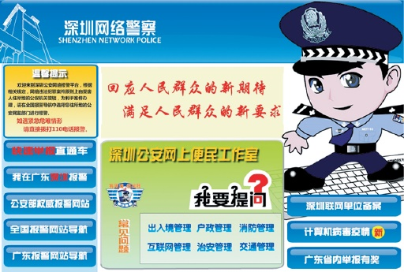
Source: Internet Surveillance Division of the Public Security Bureau in Shenzhen, People’s Republic of China Attribution: Fair Use
In 2010, Google, incensed by Chinese hackers, gave the Chinese government an ultimatum: allow Google to provide uncensored search results, or Google would pull out. After months of negotiations, Google ultimately closed its Chinese search engine—a bold move in the country with the world’s largest and fastest growing economy. But, China isn’t the only one censoring search results. Google has posted an online tool that allows users to see which governments request Google to remove content from search results and YouTube. Among the countries listed are Brazil, Germany, India, and the United States.

If you were under the impression that there is no censorship in the United States and other free democracies, think again. Some information is censored because it is deemed to be dangerous to the public. For example, it is illegal in the United States to make certain encryption technologies available to certain foreign governments. This is in an effort to keep potentially dangerous foreign governments from using U.S. technologies to decrypt national secrets. After the shootings at Columbine High School in Littleton, Colorado in 1999, the U.S. Congress passed a law mandating 20 years in prison for anyone distributing bomb-making information with the intent to cause violence. Because explosives have numerous industrial uses, many websites continue to contain bomb-making instructions. The Internet is not the only method for obtaining such information, however. Encyclopedia Britannica includes bomb-making instructions, as does a booklet published by the U.S. Department of Agriculture. The same types of explosives used by farmers to remove tree stumps were used in the Oklahoma City bombing in which 168 people lost their lives. This illustrates the difficulty of censoring information that is valuable for both legal and illegal purposes.

Censorship is a hot topic in the scientific research community as an increasing number of scientific publications are being censored on the grounds that they are a threat to national security. The National Academy of Sciences suspended the publication of an article in its journal that described the risk of terrorists poisoning the nation’s milk supply using botulinum toxin. The U.S. Department of Health and Human Services considered the information in the article useful to terrorists and prevented it from being published.

Increasingly, private web content companies are taking it upon themselves to censor materials posted through their services. You will notice that YouTube, Facebook, Flickr, and other sites try to avoid videos and photos that might be construed as dangerous or indecent. These businesses have the right to censor content on their sites because their users have signed a terms of use agreement. Apple has purged its App Store of thousands of apps that might be construed by any of its users as indecent.

These examples illustrate the difficulty of censoring public speech. Censorship typically includes an infringement on an individual’s rights in exchange for a perceived greater public good. Because definitions of concepts such as dangerous information and decency differ, any government that attempts to define these terms for its citizenry risks alienating a percentage of the population. Censorship often contradicts the basic tenets of societies that value freedom and individual rights.

Reading: Internet Decency
Internet decency refers to efforts by governments and others to rid the Internet and web of content that they consider indecent or to filter indecent content from some users.

Why This Matters
Most countries support the Internet’s ability to empower its citizens but struggle with issues regarding the perceived negative aspects of Internet access. One major concern is keeping indecent content from minors. Because the Internet does not have a rating system like motion pictures and television, theoretically, anyone who can connect to the Internet can view any content there. With increasing numbers of very young children making the Internet a part of their daily lives, it is natural for parents and others to wish to protect them from viewing content that is inappropriate and harmful.

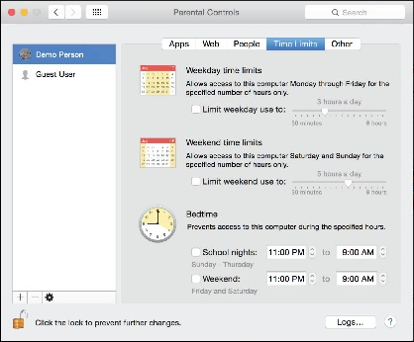
Source: Apple Inc. Attribution: Fair Use

Essential Information
Several governments have made efforts to protect their citizens from indecent web content. Australia has a commonwealth law that holds Internet service providers and Internet content hosts responsible for deleting content deemed “objectionable” or “unsuitable for minors” from their servers per a take-down notice from the government regulator the Australian Communications and Media Authority. Some Australians feel that the law has failed to reduce the availability of pornography, as it is still readily available from other countries.

The U.S. government has made similar attempts to eliminate indecent content from the web with its 1995 Communications Decency Act. Less than a year after being passed, the law was repealed due to the government’s inability to define terms such as “indecent,” “obscene,” and “lewd,” on which the law was based. One person’s obscene content may be another person’s work of art. During its brief enactment, the law had a serious impact on legitimate and useful websites that may have been considered indecent by terms of the law. Family planning websites, medical websites, and art and literature websites pulled their content for fear of prosecution. For example, it was difficult to find information regarding breast cancer on the web while the law was in effect.

The challenge of censorship is keeping certain content (such as pornography) from a subset of the population (such as minors) without encroaching upon the freedom of adults. One solution is content-filtering software. Content-filtering software like Net Nanny works with the web browser to check each website for indecent materials (defined by the installer of the software) and allow only “decent” webpages to be displayed. Windows and Mac OS offer similar parental controls to limit particular users’ time online and their access to websites and apps. Newer versions of iOS and Android offer parents the ability to restrict access to certain apps unless a passcode is entered. This is useful for parents who allow their children to play games on their phones or tablets.

Content-filtering software is ideal for situations where one person is responsible for setting the rules and defining what is allowable. For example, at home, parents may use filtering to block out what they consider inappropriate for their children. In the workplace, management may use such software to filter out non-business-related websites. Such software becomes problematic in larger democratic situations where definitions of decency may vary. For example, the 2000 Children’s Internet Protection Act requires schools and libraries that receive federal funding for technology to implement content filtering. The law created a stir in the public library system when it was discovered that filters block access to many valuable nonpornographic websites. Libraries bound by their own Library Bill of Rights, which opposes restrictions based on age, were forced to find creative strategies to meet the letter of the law while providing the maximum amount of access to adults.

Child pornography goes beyond being indecent and is unlawful in most countries. Many criminals have gone to jail for producing, publishing, and viewing child pornography. British Telecommunications (BT) has applied content-filtering software to the entire British Internet infrastructure to block access to child pornography websites.

Module 11

Introduction
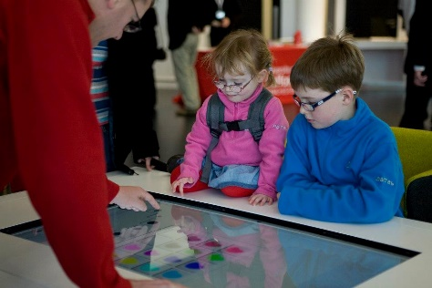

"316261_10150937090075599_538710598_21861235_1193472166_n" by University of Salford is licensed under CC BY 2.0

Digital media refers to digital technologies of all kinds that serve and support digital publishing and broadcasting, and digital audio, video, and graphics.

Digital technology and information systems are tremendously useful in many practical ways. Digital media brings information systems to life with stunning and vivid imagery, powerful sound and music, and immersive, interactive 3D environments. If technology were alive, digital media might be considered its heart and soul. Digital media provides not only a technical venue for people to express themselves through audio and visual output, but also productive tools for use in nearly every career. Digital media also provides the means to digitally publish and broadcast content traditionally distributed through television, newspapers, magazines, and books.

Consider the late Steve Jobs and Apple computers, one of the largest and most successful businesses in the world. Apple’s success has been attributed to its use of elegant product design, brilliant marketing, and CEO Steve Jobs’ driving, inspiring personality. All three of these components rely heavily on aesthetics—a commitment to beauty in appearance and function. In this, Apple raised the bar for its competition and, in a way, for businesses of all types. Steve Jobs demonstrated that it’s not just what you say, but how you say it, that influences people. His famous presentations featured beautiful graphics, music, and video. Digital media has been a major tool for Apple and other companies in designing and promoting products. The reason is simple: pictures, music, and video are able to communicate and influence where words fail.

Today, more than ever, all kinds of professionals benefit from understanding good design principles. Steve Jobs credited his design education for much of his success. As you read this unit, consider how professionals in your discipline use design in music, online publishing, graphics, and video to promote success.

You don’t need to be artistically or musically inclined to use and appreciate digital media. Computers, tablets, smartphones, media players, televisions, radios, and all kinds of special purpose devices all serve up digital media. Common examples of digital media include ebooks, online magazines and newspapers, music, movies and television shows, and video games.

Digital media is transforming how we access news and entertainment. Now, many people prefer the Internet over television for information, news, and entertainment. Today’s consumers have a preference for on-demand media, viewed or listened to at any time rather than at a time dictated by television, cinema, or radio schedules.

Another trend in today’s digital media is the empowerment of ordinary people. Digital technologies have made it easy to capture professional-quality images and video, to create music and audio recordings, and most importantly, to share them with the world. No longer is media production solely in the hands of professionals. Whether posting a video to YouTube or Twitter, a podcast to iTunes, a book to Lulu, or a photo to Facebook or Pinterest, digital media technologies and the Internet have provided a means for everyone to express themselves to the world.

Of all the industries, those that produce media—music, movies, books, photographs, and art—have been most impacted by the digital revolution. The digitization of intellectual property has transformed books, recordings, movies, and photographs into streams of bits that can be easily transferred over the Internet and shared with anyone. In many cases, Intellectual property rights have been disregarded as the public freely shares favorite tunes and movies. Piracy is a problem in the U.S., but in some overseas countries it runs unchecked as those governments turn a blind eye to businesses profiting from intellectual property theft. The movie and ebook industries apply strong digital rights management technology to content in an effort to hamper illegal distribution. But, like the music industry, they are fighting a losing battle. Are stronger laws and punishments the answer? Should the Internet be censored to stop illegal distribution? In cases of intellectual property rights, the strategies of media companies are often at odds with privacy and civil liberties.

Lesson 11.1: Digital Visual Media

Lesson 11.1 Introduction
From the time the first digital computers were built, they have been used to produce and emulate traditional print and graphic media. In many ways, the integration of digital computing and visual media was all but inevitable; typesetting and layout requires exactly the sort of precision and attention to detail that computers excel at. Once this integration of computers and visual media production began, it had a synergistic effect on both; computers allowed artists to push the boundaries of their art, and their demand for more powerful tools drove advancements in computing technology.

Reading: Digital Publications

"kindles" by michael pollak is licensed under CC BY 2.0

Digital publications include ebooks, electronic magazines, online newspapers, blogs, and other forms of traditional publishing that have moved online.

Why This Matters
The term media is closely associated with communication, and one of the most powerful forms of communication is the written word. Traditional print media uses newspapers, magazines, and books to deliver information and entertainment. The popularity of the web provides a digital platform for print media that makes it easier to distribute print publications to more readers. With the popularity of smartphones, tablets, and ebook readers, increasing numbers of people are reading digital rather than printed characters.

Essential Information
Industries involved in print publications are scrambling to adjust to a public that is reading more online than on paper. Book publishers, including textbook publishers, are creating versions of their products for distribution on digital platforms. They are concerned that they may lose control of the distribution of their products, so they lock them down with digital rights management (DRM) technologies. While the move to electronic delivery may be threatening to those in the print industry, it is also liberating to individuals. Businesses like Lulu.com and Amazon Self Publish enable anyone to publish their own books online and have them printed and bound if desired.

Newspapers across the country and around the world are shuttering print production operations and reinventing themselves as digital media companies. The new world of online news has newspapers, radio stations like NPR, and television networks competing head-to-head online with news delivered as a combination of text, audio, video, graphics, photos, and immersive media.

Magazines are moving online as well, developing interactive content that readers can manipulate on their smartphones, tablets, and computers. The digitization of print is forcing the publishing industry into a new arena where it must compete against other forms of media and carve out a niche for itself.

Reading: Ebooks
"Reader" by Andrepax is licensed under CC BY 2.0

Ebooks are books published in a digital format and viewed online or with special ebook software on a reading device—an ereader, smartphone, tablet, or PC.

Why This Matters
Increasing numbers of old books and newly published books are going through a digitization process, transforming them into ebooks. Ebooks provide many advantages to readers. They are easy to acquire, and millions can be stored on one lightweight device. Plus, software can make it easy to search in a digital book and to look up unfamiliar words. Of course, there are some disadvantages as well. Some people prefer to read from paper rather than from a computer display. Backlit displays like those used on tablets are difficult to view in bright sunlight. Epaper displays only provide black and white images. But whether you prefer reading from paper or display, ebooks are here to stay.

Essential Information
Ebooks have been around for quite a while, nearly as long as computers. However, it wasn’t until the birth of Amazon’s ebook reading device, the Kindle, in 2007 that ebooks gained more widespread acceptance. Several features of the Kindle appealed to the general public. First, the Kindle featured epaper, a display that does not include backlighting like traditional displays (see image above). Some feel that epaper is less harsh on your eyes than using a backlit display. Second, the Kindle was light and compact, similar in size and weight to a paperback book, but much thinner. Finally, Amazon created a vast library of ebooks that could be purchased and downloaded to the Kindle over a wireless network free of charge. Over the years, more ereaders entered the market, then tablets like the iPad provided a more robust alternative to ereaders. Still, many people love their ereaders for their simplicity and ease of use.

Today there are many choices for ebook reading. Smartphone and tablet apps, ereaders and all kinds of computer software can deliver ebooks. Apps like Audible provide the option of having books read to you aloud so that you can “read” while you drive or exercise.

In recent years, textbooks have begun migrating to ereaders. Top textbook publishers provide versions of their titles for the Kindle and other ebook formats. Apple has released an iPad app for authoring iBook textbooks that feature videos, media, and interactive content. The app allows educators to create textbooks for the iPad.

Many libraries now offer hundreds of titles for patrons to download to their ereaders. Although many publishers have approved the loaning of their books in electronic form, most of these publishers have placed restrictions on how many copies can be loaned at a time. So, as tablets and ereaders become more popular, ebook waiting lists are growing longer.

Courtesy of Apple Inc. Fair Use

Reading: Online Newspapers and Magazines
Online newspapers and magazines include electronic versions of print newspapers and magazines as well as online-only publications that provide news and information in an increasingly multimedia format.

Why This Matters
Ever since Gutenberg’s work on the printing press centuries ago, people have been getting their news printed on paper. All of that is changing as today more people are turning to online news and information. This trend is forcing newspapers like the Seattle Post Intelligencer to abandon traditional newsprint in favor of digital delivery in order to cut costs and increase revenues. Magazines are in a similar position as newsstand sales decrease and online views increase. Today, those in the news business are struggling to find a new online business model that can keep them afloat and eventually provide new business opportunities. Meanwhile, news consumers are finding no lack of free news and information from a multitude of sources online.

Essential Information
Every major newspaper and most minor newspapers have an online version of their publication. It is a simple matter to go online and find out what’s happening in New York, LA, Chicago, London, and hundreds of other cities at any time by viewing newspapers published online in those cities. While most of these newspapers provide access to their online editions free of charge, an increasing number are starting to charge for access or pack the online pages with numerous ads. With paper subscriptions at an all-time low, newspapers have to look online for ways to generate money. The New York Times, for example, provides free access to ten articles per month, but charges $3.75 per week for unlimited access to articles online and through mobile apps.

Online newspapers are delivered through the paper’s website, through RSS to news readers, and through apps on mobile devices including phones, ereaders, and tablets. Online newspapers generate revenue through paid advertisements, subscription charges, or both. One popular business model being explored by the Wall Street Journal and others is to provide only headline stories for free, giving full access to paid subscribers only. The Wall Street Journal charges $32.99 per month for full access, which also includes sponsored advertisements.

Many popular columnists also maintain their own blogs. The New York Times features dozens of blogs on a wide variety of topics. Blogs provide journalists with a more casual platform on which to publish their thoughts and opinions and collect responses from readers.

Like newspapers, magazines are being pressured to move online by declining subscriptions and increasing online readership. Some magazines are embracing online publishing and designing new ways for readers to interact with content. Wired, GQ, People, Time, and others have redesigned their online magazines to be interactive, incorporating animation and new approaches to navigating through articles.

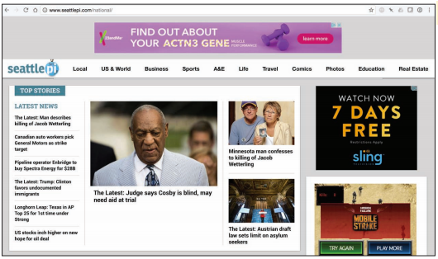
Courtesy of Hearst Seattle Media LLC. Fair Use

Reading: Digital Graphics
Digital graphics refers to digital media applications that support creating, editing, and viewing 2D and 3D images and animation.

Why This Matters
At first glance, digital graphics might appear to be the exclusive domain of artists and professional designers. In reality, people from many disciplines are finding themselves called upon or inspired to create digital artwork for personal and professional use. Easy access to powerful tools for graphics production has created a digital graphics explosion online, with many people posting photos and artwork to sites like Pinterest, Flickr, and Deviant Art, as well as on social media. Clearly, a picture is worth a thousand words, and understanding the basics of digital graphics provides both professionals and amateurs with potent tools for communication.
Courtesy of Adobe Systems. Fair Use

Essential Information
The simple fact that graphical images can be represented digitally with binary numbers has brought us digital cameras, flatbed scanners, digital cable TV, DVD movies, hi-def TV, digital video recorders, and phenomenal advances in motion picture production techniques, not to mention access to photos, animation, and video everywhere and anywhere we wish to view them—on TVs, YouTube, Vimeo, Hulu, and Flickr, and on digital devices from mobile phones to home media centers. The fundamental technology behind all of these advances rests on a small point of light or a dot of ink called a pixel.

Digital images are made up of a grid of small points called pixels (short for picture element). This is a good term to remember, as you will see it used in describing the quality of displays, printers, scanners, and digital cameras. Representing an image using bytes is simply a matter of storing the color of each pixel used in the image. Images stored in this manner are called bitmapped graphics or raster graphics.

In bitmapped graphics on a computer display, colors are expressed using numbers that represent combinations of intensities of red, green, and blue (called the RGB color palette). One or more bytes may be used to express the individual intensity of red, green, and blue. For example, 0, 0, 255 would imply no red, no green, and full intensity of blue, and the resulting color is blue.

Bitmapped graphics are ideal for representing photo-realistic images as they can capture minute details in an image. However, they do have some drawbacks in that they are difficult to edit and enlarge. Pixilation, or fuzziness, occurs when bitmapped images are made larger than the size at which they are captured

Simpler images, such as those used in clip art, can be represented using vector graphics. Vector graphics use bytes to store geometric descriptions that define all the shapes in the image. Although vector graphics are impractical for representing photo-quality images, they are preferred for creating and storing drawings. Vector graphics are easier to edit and manipulate than bitmapped graphics, and they use far fewer bytes to store an image. In the figure, you can see that vector graphics keep the same quality when they are enlarged.

Vector graphics can be combined in a series to create an animation. Animation is stored in the computer as a series of images called frames. When shown in quick succession, the frames can create the illusion of movement.

Digital graphics are stored on computers and other devices as files. Graphics files come in a variety of formats, some matched to a particular computer platform or software package.

Common Graphics File Formats
Format | Description
.bmp  (Windows Bitmap) | Used by Microsoft Windows operating systems and recognized by most graphics software. However, it is not recognized as a valid web format.
.gif  (Graphics Interchange Format) | A standard for the web. Typically used for vector graphics, it is limited in that it supports only 256 colors.
.jpg or .jpeg  (Joint Photographic Experts Group) | Another standard for the web and the default format on most digital cameras. .jpg (pronounced “jay-peg”) is typically used for bitmapped graphics and includes compression technology that allows images to be stored in less space.
.png  (Portable Network Graphics) | Developed to replace .gif on the web, this file format supports more colors than .gif, is not patented and licensed as .gif is, and employs lossless compression for higher-quality images.
.tiff or .tif  (Tagged Image File Format) | An industrial-strength format used by many professional photographers and graphics artists for high-quality graphics.

Reading: RGB Color
"Sparkfun RGB LED Panel 16x32" by lungstruck is licensed under CC BY 2.0

RGB color refers to a method of specifying color digitally, using values for the intensity levels of red, green, and blue (RGB) as combined to create all colors.

Why This Matters
The RGB method of describing colors is called the additive color model because it describes colors in terms of combining colored light. Electronic displays use the RGB model because they create images with pixels of light. Understanding how colors are expressed digitally using RGB is an essential and fundamental skill in digital graphics. Many graphics applications require the user to specify colors in terms of RGB, sometimes using hexadecimal numbers. Understanding RGB is also useful when shopping for consumer electronics such as hi-def televisions and video cameras.

Essential Information
In the RGB model of expressing color, one or more bytes may be used to express the intensity of red, green, and blue to define the color of a pixel. The number of bits used to store color is called the bit depth. If one bit is used, two colors are represented—typically black and white. If one byte is used, 256 colors can be represented—this is sometimes used for monochrome images using shades of gray. For RGB, typically three bytes are used: one each for R, G, and B. This provides for more than 16 million total possible colors (224 since there are 24 bits total). For example, the value 0, 0, 255 would imply no red, no green, and full intensity of blue—since 255 is the largest value a byte can hold. See the figure for more examples. Whenever all three bytes are set to the same value, the resulting color is a shade of gray—with 0, 0, 0 being black (no light), and 255, 255, 255 being white.

The hexadecimal number system often is used to represent colors. Hexadecimal (or hex) uses 16 digits—0 through 9 and then letters A through F. F is the highest value. Artists use two hexadecimal digits each for red, green, and blue to express colors. So #00FF00 would indicate no red, full green, and no blue, and the resulting color is green. Hexadecimal numbers are typically preceded by a pound sign to indicate that they are hex.

When creating printed color, the CMYK color model is used to define colors. CMYK stands for Cyan, Magenta, Yellow, Black. As opposed to RGB, which is referred to as the additive color model, CMYK is referred to as the subtractive color model because it describes colors created from light reflected off a surface rather than those created directly from light. CMYK may be familiar to you from its use in printer ink cartridges. You are probably also familiar with CMYK from experience with blending paints. Most kindergarten children know that orange is made from blending yellow and red—this is CMYK, the subtractive model. In RGB color, red and green combine to make yellow. Mixing colors with light is very different than mixing colors with ink or paint.

With a basic understanding of how colors are created through the additive and subtractive methods, you can progress to learning color theory. Color theory provides practical guidance for mixing and blending colors in a pleasing and effective manner. Color theory guides all kinds of digital artists and designers in creating effective color palettes for digital graphics.

Reading: Vector Graphics Software
Vector graphics software, sometimes called drawing software, provides tools to create, arrange, and layer graphical objects on the screen.
Courtesy of 2012 Adobe Systems Incorporated. Fair Use

Why This Matters
Vector graphics software is the most popular software for graphics design. It allows graphic artists and designers to layer and arrange shapes and objects, drawn figures, and even photographed objects to create composite images for commercial and artistic uses. Once learned, vector graphics software empowers novices to create professional-looking designs and enables professionals to accomplish much more than is possible with traditional media.

Essential Information
Vector graphics software uses an object-oriented approach that recognizes pictures as being made up of multiple layers of objects—some in the foreground, some in the background, and some in between. Objects in a vector graphics image can be layered and grouped into larger objects. Each object’s properties, such as color and opacity, can be adjusted.

Microsoft PowerPoint is an example of a very basic vector graphics software application. More advanced vector graphics software, such as Adobe Illustrator and CorelDRAW, provides more detailed tools to create and manipulate vector graphics. Filtering and effects tools are provided to further manipulate objects in a picture. Filter tools allow you to adjust the color of an object by altering the levels of brightness, contrast, hue, and saturation. Effects tools range from subtle effects, such as changing the sharpness or blurriness of edges within a drawing, to dramatic effects, such as changing a picture so that it looks as though you are viewing it through a glass block. When finished, vector graphics images can be exported as .gif, .bmp, .jpg, or in other graphics file formats.

Reading: 3D Modeling
3D modeling, also called ray tracing, utilizes sophisticated software graphics tools to create realistic 3D models that can be rotated and viewed from any angle in a virtual environment.

Why This Matters
As more of our lives are spent in virtual space, 3D graphics are becoming increasingly important. Engineers, architects, and designers can save time and expense by designing 3D objects in virtual space using 3D modeling software. Computer Aided Design, or CAD software, is a form of 3D modeling software that supports engineering-focused design for items intended for manufacturing. Video game designers, artists, animators, and motion picture producers use 3D modeling software to design objects for virtual space to entertain and impress an audience.

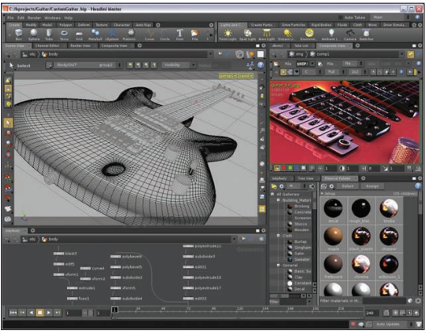
Courtesy of Side Effects Software Inc. Fair Use

Essential Information
Three-dimensional modeling takes the object-oriented approach of vector graphics to the next level. The process of changing two-dimensional objects, such as those created with vector graphics applications, into 3D models involves adding shadows and light. Three-dimensional modeling is often referred to as ray tracing because the software must trace rays of light as they would interact with the models in the real world. Three-dimensional modeling also requires that surface textures be defined. Surface textures are an important element in the interaction between light and a model.

The creation of 3D digital art takes place in a scene on a virtual 3D stage. The artist selects surface textures for each model and positions the models on the stage. The artist selects a background for the scene and a light source in order to define the shadows that provide the illusion of depth. Then, the software renders the scene. Rendering is the process of calculating the light interaction with the virtual 3D models in the scene and then presenting the final drawing in two dimensions to be viewed on the screen or printed.

3D models are used in many ways. CAD software uses 3D models to create blueprints for manufactured products. CAD software has become the primary tool of engineers and architects. It allows designers to build accurate models within the computer that reflect the physics of the real world. A design created in CAD software can be rendered as a 2D or 3D model and output as a blueprint or as a physical prototype using a 3D printer.

Courtesy of AutoDesk. Fair Use

Reading: Visualization
Visualization is a general term that refers to the use of imagery to communicate an idea. However, in the area of digital graphics, it typically refers to using imagery to experience information in a manner difficult to experience through any other medium.

Why This Matters
Visualization enables people to present information in a more accessible and meaningful manner than text and numbers and also to discover meaning in data that might not otherwise be perceived. Professionals in many fields use visualization to learn as well as to get a message across.

Essential Information
A basic example of visualization is the use of graphs and charts to illustrate numeric data—for example, a pie chart in an Excel spreadsheet. More recently, infographics have become a popular method of communicating facts in a visually meaningful and entertaining manner.

Scientific visualization uses digital graphics to provide visual representations that improve our understanding of some phenomenon. There is a wide range of applications of scientific visualization, from the presentation of football team statistics for predicting the winner of the Super Bowl to studying the interaction of subatomic particles. Scientific visualization can be used to represent quantities of raw data as pictures. Meteorologists use visualization to study weather patterns. Cardiologists use it to study irregular patterns in heartbeats. Scientific visualization can at times turn into beautiful imagery, as shown in the figure at the top of this page. The picture below, from a large gallery of visualization graphics from Eric J. Heller, illustrates the flow of electrons through a nanowire.

Reading: Animation
"SelinaMedium" by SimonJKirby is licensed under CC CC0 1.0

Animation involves displaying digital images in rapid succession to create the illusion of motion.
Advances in processing power and digital graphics technologies have allowed artists to render realistic worlds in virtual space. Computer animation plays an important role in today’s motion pictures and immersive media. Most blockbuster movies and video games owe their success to the computer programs used to create their realistic virtual environments. Simulating 3D virtual worlds is one application of digital animation. There are many other simpler applications that are equally useful. Even simple 2D animations can serve to communicate ideas more effectively than pages of text.

Essential Information
Animation and video are stored in the computer as a series of images called frames. When shown in quick succession, the frames create the illusion of movement. Television uses a rate of 30 frames per second (fps), while many videos use 24 fps.

Graphical animation can be as simple as a stick man jumping rope or as complex as a major motion picture like X-Men Apocalypse—where actors performed in front of green screens, and environments were mostly computer generated. Animated graphics employ either 2D or 3D objects, with 3D animations requiring the most advanced graphics software and processing power to create.

You may have seen simple animations on the web—simple drawings that repeat the same motion over and over, endlessly. This is the most basic form of animation, called an animated GIF (pronounced “gif”). Animated GIFs are created with simple tools that allow the artist to draw several images that, when played in succession, create the illusion of motion. More advanced animations can be created for the web using Adobe Flash, Microsoft Silverlight, and HTML5.

Three-dimensional computer animation is much more complex than 2D computer animation. 3D computer animation includes all of the complexity of 3D graphical rendering, multiplied by the necessity to render 24 3D images per second to create the illusion of movement. Three-dimensional animation software is typically packaged with 3D modeling software. Animation programs, like LightWave from NewTek and Mental Ray from Autodesk, are used by professionals to create popular animated television shows, commercials, and movies, and they range in price from $1,595 to $13,000.

Three-dimensional computer animation software can move animated characters according to the direction of the artist and director. Rather than drawing and painting individual frames, animators are more like puppeteers who direct the animated characters around the set. After the action is recorded, rendering computers apply the 3D effects and lighting to each frame. Even with powerful computers, high-quality rendering, such as that used for major animated motion pictures, takes hours per frame. Virtual actors and scenes in today’s 3D computer-generated films are nearly indistinguishable from real actors in the real world. In fact, many popular motion pictures use a blend of both.

Reading: Digital Photography
"All action" by omaniblog is licensed under CC BY 2.0

Digital photography is a form of photography that captures, stores, and manipulates photographs digitally as a series of 1s and 0s.

Why This Matters
With easy, inexpensive access to digital cameras and with smartphone cameras in nearly everyone’s hands, photography has become a favorite hobby for many people. Digital photography has made it easy for amateurs to take and share professional-quality photos and for professionals to capture and create photos unlike anything previously possible. Understanding the basics of digital photography can enrich your life and add valuable skills to your professional tool belt.

Essential Information
Digital photography and digital photo editing are sometimes referred to collectively as digital imaging. Unlike drawing software that is used to create digital graphics by defining them as a collection of shapes, digital photography creates digital graphics by capturing images as a collection of pixels, using a camera or scanner.

Digital photography has become very popular as the technology has become less expensive and has been integrated into smartphones. Nearly everyone is taking digital photos and enjoying the instant gratification of viewing images as soon as they are taken and deleting unwanted photos—features previously not possible. Many people are developing a photographer’s eye and gaining a new appreciation of the beautiful world around them.

Photo albums are transforming from dusty bound volumes on bookshelves to volumes stored on hard drives and with online services. The number of digital photos being generated is at its highest ever, and hundreds of new devices, software, and services are being introduced to the market in support of the digital photo fever. This section surveys the latest technologies for creating, editing, sharing, and printing digital photos.

Reading: Digital Camera
A digital camera is a camera that captures photographs, and sometimes video, and stores them digitally rather than on film.

Why This Matters
There are many different types of digital cameras on the market. They range from inexpensive compact cameras to professional-grade SLR (single-lens reflex) cameras. Learning what kind of camera and camera features best suit your needs can save money and provide you with the most benefits. Today many people use the digital camera features of their mobile phones.

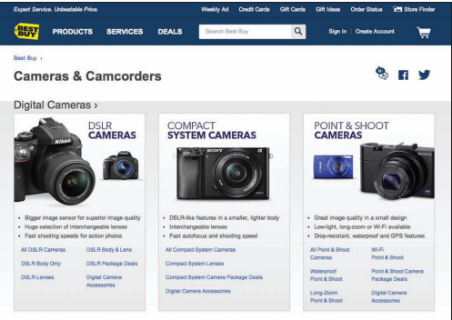
Courtesy of BestBuy. Fair Use

Essential Information
Digital photos are created or acquired using a digital camera or scanner and are saved as bitmapped images. Digital cameras are ranked by the amount of megapixels they can capture and the features they include. An entry-level camera costs between $49 and $200 and provides up to 16 megapixel images but has very few features. A midrange camera costs between $200 and $600, provides roughly 12- to 16-megapixel images, and includes lots of features to assist in producing good-looking photos. It’s also small enough to slip into your pocket. Since today’s smartphones boast digital cameras equal in quality and features to mid-range cameras, most amateur photographers are content using their phones to take photos.

Sample Smartphone Cameras
 | iPhone 7 | Galaxy S7
Front-side camera | 12 MP camera12MP wide-angle and telephoto cameras | 12 MP camera with dual pixel
Back-side camera (Selfies) | 7 MP | 5 MP
Digital zoom | 5x | 8x

A digital SLR (single lens reflex) camera uses the same mirror and lens principles as professional-grade 35-mm cameras to produce professional images, typically 16–24 megapixels. SLR cameras often use detachable lenses that may need to be purchased separately. SLR cameras are expensive—some selling for as much as $2,800—but are gradually coming down in price to the $500–$1,000 range. The following table lists digital camera specifications to consider.

Digital Camera Features
Feature | Considerations
Resolution | 6 megapixels or more for recreational use; more than 12 megapixels for serious hobbyists; and more than 16 for professionals—in general, most smartphone cameras sold today have high enough resolution to accommodate most needs.
Lens and sensor | The quality of the lens and sensor in a camera contributes to image quality. High-quality components capture the most realistic images. Good cameras boast a high-quality lens and sensor, and the result will be evident in demo photos.
Price | $49 to $200 for most recreational-grade cameras; $200 to $600 for serious hobbyists; more than $600 for professional-grade cameras
Camera size | Although some very small cameras can produce very good quality, the largest digital cameras (SLRs) offer the best quality. Small cameras offer the benefit of portability.
Display size and quality | Since digital photography uses an LCD display to line up the shot, it’s important that you get one that is large enough to see and bright enough to see in direct sunlight.
Lens type | Most people insist on a zoom lens with a range encompassing at least 38 mm to 114 mm. Digital SLR cameras have detachable lenses that can be swapped out for different effects.
Storage media | Flash memory card with a lot of capacity—roughly 1 MB per photo for good quality images
Photo file format | JPEG for recreational use; TIFF for professionals
Interfaces | USB, NTSC/PAL television connection for offloading and viewing photos
Exposure controls | Automatic, programmed scene modes, exposure compensation (for tweaking the automatic exposure)
Focus controls | Automatic for recreational use; pros will want manual control as well
Flash modes | Automatic, fill, red-eye reduction
Software | Photo editor, photo stitching (combining photos into panoramas), photo album creator, slide show
Multimedia | VGA (640 x 480), 30-fps video-clip recording
Battery | Rechargeable or disposable battery models
Other useful features | Ultracompact design, webcam capability, voice recording, wireless transfer

Reading: Photo Editing
"flickr editing" by The Brian Solis is licensed under CC BY 2.0

Photo editing is the process of altering digital photographs, using software tools.

Why This Matters
Photo-editing skills are useful for both professional tasks and personal enjoyment. Amateur photographers use photo-editing software to improve the quality of their photos, altering hue, saturation, and brightness to achieve appropriate color and remove red eye. Many artists have turned to photo editing as a way of creating interesting works of art. For professional photographers, photo editing often takes up the majority of their time. Photo-editing skills or the lack thereof can make or break a career for a professional photographer.

Essential Information
Photo-editing software—such as Adobe Photoshop and Photoshop Elements, Apple iPhoto, and Google Photos—includes special tools and effects that you can use to improve or manipulate bitmapped photograph images. Photo-editing software allows you to:
- Alter the hue and saturation of the colors in the photograph to give skin tones a healthy glow or to enrich colors in a landscape
- Smooth surfaces or remove flaws in surfaces
- Remove red eye—the effect of the camera flash on the eyes of subjects, which causes eyes to appear red in a photograph
- Smooth edges and sharpen focus
- Crop and realign photos
Photo-editing tools also include special effects, such as the ability to transform photos into watercolor paintings. Or you can use edge detection to remove an object from one photo and insert it into another.

Many of today’s photos are captured using mobile phones. Photo apps have emerged as a way to collect, edit, and share photos right from your phone. Instagram is one such app that provides a wide assortment of filters and effects that can be added to photos, which can then be shared on your favorite social network.

The ability to alter digital photos to embellish or alter one’s perception of reality has created interesting social and legal issues. Photographs can no longer be used as evidence in a court of law since it is impossible to determine if they have been edited and falsified. Some are concerned that photographs of supermodels and celebrities in magazines, altered to make them appear closer to the perception of perfection, are setting false expectations for human appearance that frustrate and disappoint.

Photo editing has become a serious concern in the news media. A photojournalist is responsible for capturing newsworthy events to help tell a story, convey the reality of a moment, and document that moment for history. Some photojournalists have been criticized for using photo-editing software to make the photos more interesting than what was originally captured by their cameras.

Reading: Photo Printing
"Emerging in shock" by fairyduff is licensed under CC PDM 1.0

Photo printing refers to the methods and resources available for transforming digital images into printed images.

Why This Matters
Although photos can be viewed on a computer screen, many people still like to have prints created from their photos—especially if they want to frame and hang them. There are several options for printing digital photos. Choosing the right one can save time, effort, and money.

Essential Information
As with most aspects of the rapidly expanding digital photo industry, options for printing photos are bountiful. Today, many printers are designed specifically for printing photos. Photo printers use photo-quality paper and toner to get professional-looking prints. Some printers allow a camera or phone to be connected directly or accept a camera’s memory card as input. Some photo printers include a small display that allows the images to be altered and edited before printing.

Although photo printers empower users to print as many photos as they please whenever they want, there are considerable drawbacks. Often, photo-quality paper and toner end up costing as much as having the photos professionally printed. It is also sometimes difficult to get professional results with home photo software and printers. For these reasons, many people find the price, convenience, and quality of professional photo-printing services irresistible.

Facebook has apps from Walgreens, CVS, and other companies that can be used to order prints of Facebook photos. Printicular is an app for iPhone and Android that will order prints of Instagram photos from a smartphone. Amazon Prime and Amazon Drive customers can use the Amazon Prints service. Many retail outlets, including Walgreens, Walmart, Target, and CVS, provide digital photo uploading and processing services from their websites. Photo-editing software like iPhoto, Shutterfly, and Snapfish provide printing services as well.

Photo kiosks are another popular option for printing digital photos. There are tens of thousands of photo kiosks in the United States. Photo kiosks read photos from CDs, USB drives, or any of the popular media cards, allow you to crop and edit each image, and then print out your photos—perhaps while you do a little shopping. Kiosks are popular for their ease of use, print quality, and speed, as well as for the amount of control they offer the user.

Reading: Online Photo Album
An online photo album is typically hosted by a service that allows members to upload photos to web servers to share with individuals or the entire web population.

Why This Matters
Since the birth of digital photography, the number of photos that people create and collect has grown rapidly. Systems have emerged to help people manage and share photos and photo albums. Online photo-album services help photographers of all kinds share photos with family, friends, and strangers if so desired. They may also include tools for photo editing and organizing files. They also typically provide a service for ordering prints online.

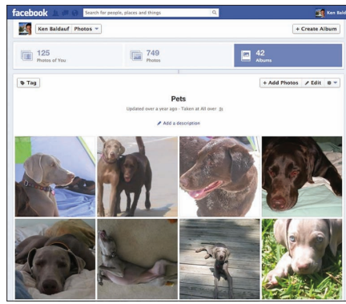
Courtesy of Ken Baldauf. Fair Use

Essential Information
The most popular online photo album services are Yahoo!’s Flickr, Google Photos, Shutterfly, SmugMug, Snapfish, and Photobucket. Social networks like Twitter and Facebook also have photo album capabilities. Membership is free for all of these services, while some offer a premium service for a fee. All of these services provide an easy method to upload photos from your computer either one at a time or in batches. Once uploaded, photos can be arranged into albums, captions and tags can be added, and the photos themselves can be edited with a limited toolset.

Since many photos are taken on mobile devices, apps are available to automatically upload mobile photos to online albums. Facebook and Twitter provide apps that allow mobile photographers to upload, store, and share their photos. Smartphone photo apps often include the ability to upload photos and other content directly to Facebook.

Photos and albums can be shared from the online service with other members that you specify, the entire member community, everyone on the web, or no one. Other users typically can download photos—under copyright restrictions that the owner specifies—and order prints. Most of these free services make their money from prints and other photo-centered merchandise.

Note that most free online photo-album services do not take responsibility for photos uploaded to their servers. If photos are lost, damaged, or destroyed due to equipment failure, then the user suffers the loss. However, some of the premium services and fee-based services do guarantee your photos from danger.

SmugMug Pro is a premium online photo-album service designed for professional photographers. It provides a secure place for photographers to store and sell their photographs. Each SmugMug client receives a customized online gallery in which to present their work.

Lesson 11.2: Digital Streaming Media

Lesson 11.2 Introduction
In much the same way that computers developed in conjunction with visual and graphic arts, computer output technologies developed alongside the advancements they enabled in music, audio, and animation. Early computer interfaces were largely text based, but the introduction of graphical user interfaces with visual and audio notifications suggested greater possibilities; bells and chimes gave way to simple MIDI music and then rich recorded audio content. Moving cursors and windows led to the development of simple animations, from which followed the creation of photorealistic 3D worlds.

Reading: Digital Audio
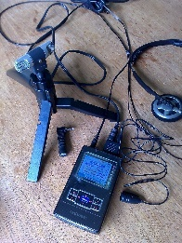
"iRiver Digital Recording" by Podknox is licensed under CC BY 2.0

Digital audio is any type of sound, including voice, music, and sound effects, recorded and stored digitally as a series of 1s and 0s.

Why This Matters
The ability to digitize sound has dramatically altered phone networks, radio, television, and the entertainment and music industries. Digital audio and music touch our lives in many ways. Understanding how sound is digitized and put to productive use helps to further understand the positive aspects of digital technologies in our lives.

Essential Information
Digital audio and music play a part in many industries. Digital phone networks digitize speech and send it as bits over cables or through the air. The radio industry is being transformed by satellite and Internet-delivered digital radio services. Digital audio in the form of voice, sound effects, and music is embedded in television programs, motion pictures, animated media, and computer games to provide high-quality and sometimes dramatic realism. The digitization of music has fundamentally altered production and distribution mechanisms within the music industry, providing musicians with powerfully creative tools (see video), improving the quality of recorded music, and providing listeners with more convenient access.

Digitized sound has many advantages over analog sound. It can be easily duplicated and transmitted without any degeneration. It can have a relatively limitless life span. It is easy to manipulate and process and can be encrypted for secure communications.

Many professionals use digital sound technology in their work. Journalists, lawyers, investigators, and other professionals whose work involves interviewing people rely on digital voice recorders to keep their facts straight. Doctors and other professionals use digital voice recorders to record notes for future transcription.

Scientists have used digital audio to study various natural phenomena. For example, the Australian Marine Mammal Research Centre uses digital recordings to study the songs of migrating whales off the coast of Australia.

Digital sound also plays an important role in law enforcement. Forensic audio uses digital processing to de-noise (remove nonessential sounds and audio interference), enhance, edit, and detect sounds to assist in criminal investigations. A spectrographic sonogram provides a visual fingerprint for various sounds in a recording. Gunshots, car engines, and voices all have a unique pattern when viewed as a spectrographic sonogram. The process of identifying a recorded human voice is known as voice-print identification. The technique is considered highly reliable and has been used as evidence in thousands of criminal cases.

Digital audio production plays an important role in music, movies, radio, television, video games, and Internet media. A sound production studio uses a wide variety of audio hardware and software to record and manipulate music and sound recordings. Studios that specialize in recording music are known simply as recording studios. Sound studios that work with motion pictures are typically referred to as production studios.

Digital audio is stored on computers and other devices as files. Audio files come in a variety of formats, some matched to a particular computer platform or software package.

Popular Digital Audio Formats
Format | Description
.wav (Waveform Audio) | Windows audio file (native)
.aiff (Audio Interchange File Format) | Apple audio file (native)
.mp3 (MPEG-1 Audio Layer 3) | Compressed audio format
.wma (Windows Media Audio) | Windows audio with compression and DRM
.aac, .m4a, and .m4p | Apple audio with compression and DRM

Reading: Sampling
Sampling is the process of capturing the value of a sound wave at regular intervals, typically thousands of times per second, to store sound and music digitally.

Why This Matters
Music is digitized through the process of sampling. Through techniques such as sampling, the world that we experience through our senses can be represented and recreated in a computer system. Understanding the process of sampling enables users to capture and store digital audio at a quality level best suited to their tastes and needs.

Essential Information
In the natural world, sound is the displacement of air particles caused by vibration and sensed by the eardrum. One way to quantify sound is by measuring air particle displacement and charting it over time to create a graph called an analog sound wave (shown in the figure). An analog signal is a signal that varies continuously over time. An analog sound wave can be transmitted electrically using varying voltages of electricity, as is done over old-fashioned telephone networks, or by using varying radio waves, as is done for AM/FM radio. Another more recent way of quantifying sound is to digitally represent sound waves with numbers through a process called analog-to-digital conversion (ADC).

ADC uses sampling to encode a sound wave as binary numbers. When you digitize, or sample, a sound wave, you measure and record its amplitude (height) at regular time intervals called the sampling rate. The shorter the time interval, the higher the sampling rate, which makes the reproduction of the sound more accurate. For example, the sampling rate for audio CDs is 44,100 samples per second, whereas the sampling rate of your voice on a digital cell phone is only 8,000 times per second.

Digitized sound is transformed back into its analog form in a process called digital-to-analog conversion (DAC). The analog signal typically causes a speaker cone or the diaphragms in headphones to vibrate to create audible sound. Although the recreated sound wave is not an exact duplicate of the original live sound, a sampling rate of 44,100 times per second is close enough to the original sound to satisfy our less-than-perfect hearing.

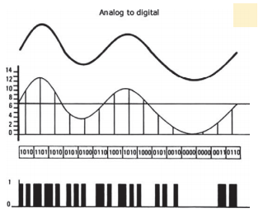
Authored by Cengage Learning. Creative Commons Attribution 4.0 International (CC BY 4.0)

Reading: Digital Audio Production
Digital audio production refers to methods of capturing, creating, editing, and enhancing digital audio.

Why This Matters
Digital audio production takes place in multimillion-dollar production studios, in homes and apartments, in all types of businesses, and out on the street. Capturing audio and music at all levels of quality and manipulating it to satisfy a need or desire is a rewarding objective of many digital audio professionals and amateur enthusiasts. Even individuals not interested in digital sound production are active in acquiring and enjoying digital sound.

Essential Information
Digital audio is acquired through a host of audio devices with analog-to-digital capability. Once in existence, a digital audio file can be copied and transferred to a variety of formats and media. Audio recordings are distributed as binary data files on CDs, embedded in motion pictures and video games, distributed over the Internet as MP3 files and other audio formats, and streamed through the air on satellite radio and hi-def radio signals.

One of the simplest ways to digitize audio is using a digital voice recorder. A digital voice recorder refers to a handheld audio recording device designed to capture and digitize sound. Digital voice recorders range in quality from simple voice recorders to high-quality stereo recorders that can be used for recording live music. They receive sound through microphones and sometimes through an audio cable. Digital voice recorders typically store more than 100 hours of audio in standard digital sound formats, which can be transferred to a computer for transcription, editing, or final production.

Although digital audio processing has many industrial and professional applications, it is most strongly connected with the music industry. Today’s recording studios are high-tech digital processing centers that use analog-to-digital converters to transform the recorded sound of voices, violins, horns, and other acoustic and electric instruments into digital signals that can then be manipulated. Musicians, sound technicians, and engineers have many tools available for creating and manipulating sound, including multitrack recording devices, mixing boards, synthesizers, samplers, drum machines, and sequencers.

Digital audio production has become a favorite pastime for amateur and semi-pro musicians and DJs. Using a MIDI (Musical Instrument Digital Interface) card and sequencing software, such as Apple’s Logic Platinum, a personal computer can become a self-contained recording studio. Easy-to-use digital recording software like Audacity for Windows and GarageBand for Mac has allowed many amateurs to create music and podcasts of high quality. Websites like Beatport provide a distribution channel for independent artists to get their homegrown music to the masses.

Courtesy of Apple Inc. Fair Use

Reading: Podcast
A podcast is an audio file that contains a recorded broadcast distributed over the Internet.

Why This Matters
Seasoned broadcasters and amateurs alike are turning to podcasting to distribute their messages. Podcasting got its name from the original Apple iPod and may contain news and information, interviews with celebrities, commercial radio programs or talk shows, music, comedy, instructional training, self-guided walking tours, academic presentations, personal discussions and commentaries, and more. Some podcasts have evolved from audio to video, offering followers a choice between the two.

Essential Information
Podcasting provides a platform for individuals wishing to share their views, humor, talents, or musical taste with the rest of the world through audio or video. Traditional radio broadcast companies such as National Public Radio, along with television and newspaper companies, are turning to podcasting to grow their businesses over the Internet. Major news agencies such as Reuters and the BBC have turned to RSS for online distribution of content along with mobile apps that streamline access to audio news.

Tens of thousands of free podcasts are available on the web. Most are regularly produced publications with new episodes available daily, weekly, or monthly. Although the iTunes store has the most popular podcast directory, there are other good sources such as Podcast Alley, Juice, and the Podcast Directory.

A podcast can be downloaded from the web and played using a media player like iTunes or transferred to a portable music player. Podcasts are also distributed using RSS technology. RSS is the technology used to distribute blogs and other regularly updated online content to which people can subscribe. Aggregator software uses RSS to allow you to subscribe to your favorite podcasts from one application. Apple iTunes is the most popular and easy-to-use podcast management software. Other podcast managers include Juice and Doppler.

Podcasting is another liberating force in our digital life. Rather than having to wait for a given time to listen to your favorite programming, podcasts allow you to listen at your convenience. Also, since podcasts are easy to produce and distribute, they give a voice to many individuals who might not otherwise be heard.

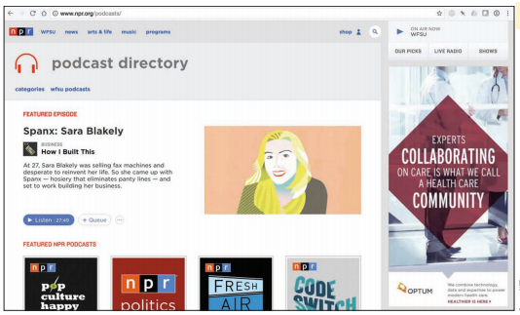
Courtesy of NPR. Fair Use

Reading: Digital Music Player
A digital music player is a mobile or desktop device that plays digital music that is stored on the device or streamed from a computer or the Internet.

Why This Matters
There are hundreds of portable and home digital music players on the market. Many music fans use their phone as their primary music player. Apps like iTunes, Google Play Music, Amazon Music, Spotify, and Pandora make it easy to listen to the music you like wherever you roam.

Essential Information
The primary platforms that deliver digital music are Apple iTunes, Google Play Music, Microsoft Groove, and Amazon Music. All of these platforms run as apps on desktop and mobile devices and feature tools that scan a hard drive for all music files and import them into a cloud-based service for access from any of the user’s devices.

Cloud music services make music accessible to the owner from any Internet-connected device, including smartphones. However, streaming music from the Internet can be costly in terms of data transfer limits and fees on cellular data plans. Cloud music plans from Google, Apple, and Amazon are inexpensive if not free. For example, Amazon Cloud Player stores 5 GB of music for free and delivers it to the Cloud Player app on Kindles, iPhones, or Android phones. For $24.99 a year, Apple’s iTunes Match service will provide online storage for ALL of your music, including tunes ripped from CDs and elsewhere. An additional benefit to cloud music is that it provides an effortless method of synchronizing and backing up a music collection.

Courtesy of Pandora. Fair Use

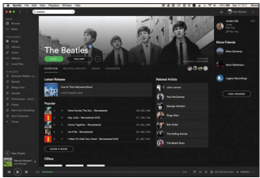

Courtesy of Spotify AB. Fair Use

Some music fans are turning away from traditional music software like iTunes, and using online music services. Pandora is a web-based music service and player that builds a streaming “radio station” around the listener’s musical tastes. Type in an artist or song, and Pandora will stream similar songs, allowing the listener to vote songs up or down and refining the play list to match the listener’s tastes. Spotify is software that is downloaded from spotify.com to play just about any album you might like to hear. Playlists can be created around artists or tunes and shared with friends on Spotify. Unlike Pandora, Spotify listeners can listen to any track anytime. Spotify makes money by playing short ads every few songs and allowing users to upgrade to a paid, ad-free, premium service.

Digital music can be enjoyed around the house, at the office, or in the car without the need for headphones. There are speaker systems designed for mobile phones and portable digital music players. For example, you can simply plug your smartphone into a dock, and the music is played through larger stereo speakers. You can use adapters or a Bluetooth wireless connection in the car to connect your smartphone to the car stereo system. Many of today’s Smart TVs also provide access to cloud-based music services.

Some digital music enthusiasts use their home PC as their primary home stereo, utilizing a wireless home network. Systems such as Sonos and Apple AirPort Express allow you to send music from your PC to powered speakers anywhere in your house.

Reading: Digital Music Distribution
Digital music distribution takes many forms to address many listening environments, including CD, online music services, mobile apps, podcasts, Internet radio, satellite radio, and HD radio.

Why This Matters
There are numerous methods of acquiring digital music today—some legal and others illegal. Understanding the options, benefits, costs, and risks of obtaining digital music is important when building a music collection.

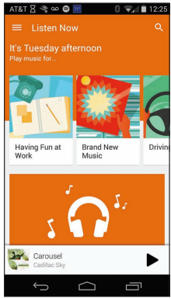
Courtesy of Google. Fair Use

Essential Information
Online music services work with the recording industry to distribute music over the Internet. There are several types of online music services, including music stores that let you buy and download music, subscription services that charge a monthly fee for access to music, and free streaming music services. Some of the more popular online music stores include Apple iTunes, Amazon Music, Google Play Music, and Microsoft Groove.

The freemium model of music distribution, allows listeners to enjoy free music online with ads, or without ads for a monthly fee. Spotify is an example of a freemium service that allows listeners to create their own playlists. Pandora is a freemium service that creates personalized radio stations.

Internet radio is similar to local AM and FM radio except that it is digitally delivered to your computer over the Internet, and there are a lot more choices of stations. Internet radio provides a means to listen to your favorite local stations online from anywhere in the world. For example, fans of the DJs and music selections on WXRT in Chicago can listen live anytime, anywhere at http://wxrt.radio.com. Similarly, the colorful programming of Tampa’s community radio station, once only reserved for residents in and around Tampa Florida, can now be enjoyed by anyone online at http://www.wmnf.org. Live365 provides access to thousands of local radio stations in more than 200 musical genres. Some Internet radio stations charge a subscription fee, but most do not.

Wi-Fi radios have emerged as music devices for the home that directly connect to Internet radio over a Wi-Fi network. Wi-Fi radios allow listeners to access thousands of radio stations on the Internet, including Internet-only stations, radio stations from other countries, and many AM/FM radio stations that simulcast online. Wi-Fi radios also allow music to be streamed from a PC connected to a Wi-Fi network.

Satellite radio is a form of subscription digital radio that receives broadcast signals via a communications satellite. Unlike traditional AM and FM radio, as long as there is no major obstruction between the receiver and the satellite, the user can listen to the same channels from any location in range, which could cover entire hemispheres of the planet. Satellite radio requires a special receiver. Many new cars come equipped for satellite radio. Satellite radio stations have also begun broadcasting their stations over the Internet. The most popular satellite radio service in the U.S. is SiriusXM, formed when the formerly separate XM and Sirius services merged. Satellite radio provides subscribers with commercial-free music, comedy, news, talk, sports programming, and specialty channels providing music or features not typically available on commercial radio. Satellite service subscription runs between $10 and $20 a month.

Most of us rely on several methods of acquiring music. The music industry is slowly zeroing in on a universal model for music distribution and consumption. Apple, Amazon, and Google have emerged as the three giants of music distribution. Microsoft is working hard to catch up. With the arrival of cloud music services provided by all four companies, users are gaining more freedom in how they can access their music. Unfortunately, music fans are still forced to commit to one service or another since moving music collections from one to another can be problematic. Music services have become tied tightly to smartphone platforms. Apple iPhone and iPad owners are likely to go with Apple’s music ecosystem, while Android users are likely to use Google. Amazon is the most open ecosystem since Amazon music can be enjoyed on any platform.

Reading: Digital Video
Digital video stores a progression of digital photographs and displays them at 24 to 30 photos, or frames, per second (fps) to give the illusion of a smoothly flowing scene.

Why This Matters
Advances in digital technologies, broadband communications, and information systems are having a profound effect on the creation, distribution, and enjoyment of video. Digital video is becoming increasingly accessible for personal enjoyment as well as professional use.

Essential Information
Both digital photography and digital video are used in a variety of research and other professional areas. Forensic graphics is used to create animations and exhibits to use in courts of law to explain theories and present evidence. By studying digital video, athletes and trainers can review athletes’ movements and determine how to perfect their abilities. Digital video is used to study pedestrian and traffic patterns. Scientists also use it to study the activity of microbes and other organisms.

Digital video is also finding a home in the hearts of consumers as a primary form of entertainment. Taking in a movie is a favorite pastime for all ages. Digital cable networks, on-demand television, and DVDs and Blu-ray have brought popular motion pictures to home television. Large super high-definition and 3D displays along with surround sound systems provide theater-quality experiences at home. Broadband Internet and service providers are bringing motion pictures, television programming, and other video services to PCs and cell phones. Digital video cameras allow us to capture the important moments of our lives in motion. YouTube has become a key medium for the world to express itself through video.

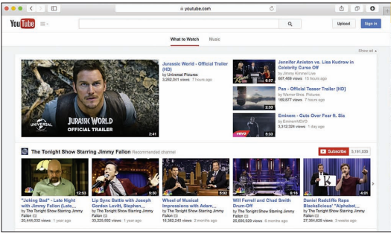
Courtesy of 2012 YouTube, LLC. Fair Use

Reading: Digital Video Camera
A digital video camera captures and stores video digitally rather than on film.

Why This Matters
Digital video cameras, sometimes referred to as camcorders, allow ordinary people to create professional-looking videos in regular-definition, high-definition, and 3D formats. Videos allow us to capture important moments in our lives from gatherings with friends to life events like weddings, graduations, and recitals. Video recording also bring out the creative side of people, inspiring us to capture the beauty and artistry of the world around us.

Essential Information
Digital video cameras are available in a wide range of prices with wide-ranging capabilities. At the low end of the spectrum are disposable camcorders that sell for less than $30. At the opposite end of the spectrum are high-definition and 3D video cameras selling for more than $1,000.

Most digital cameras and some camera phones can capture video clips at an acceptable resolution. The iPhone 7 can capture 1080p HD video recording at 30 fps or 60 fps. However, when it comes to recording soccer games, ballet recitals, and weddings, camera phones don’t have the memory capacity that is typically desired; a digital video camera is the tool for the task.

GoPro has emerged as a popular video camera brand for adventurers. The relatively inexpensive line of cameras (starting at $130) and custom-designed camera mounts allow you to film yourself biking, skiing, skydiving, surfing, and in all sorts of other extreme activities and environments.
Courtesy of Vimeo.com. Fair Use

As with digital cameras, there are important specifications to consider when purchasing a digital video camera. Size and price are major considerations. Other less obvious considerations are listed below.

Digital Video Camera Features
Feature | Description
Sensors | Digital video cameras use different types of sensors to capture the image: a charge-coupled device (CCD) sensor or a complementary metal-oxide-semiconductor (CMOS) sensor. Both types deliver high-quality images. Better cameras come with three sensors, so options may include CCD, CMOS, 3CCD, or 3CMOS.
Pixels | As with digital cameras, image quality is measured by the number of pixels in each frame. For video, 2 to 4 megapixels is typical, and some hi-def cameras have even more; for still images, 3 to 6 megapixels is typical. The type and amount of sensors have a large impact on pixel amount.
Hi-def | Some digital video cameras can capture hi-def images, which capture a larger amount of pixels—typically 3.3 or 5 megapixels. Hi-def formats include 720p, 1080i, and 1080p, shown in video camera specifications as the digital video format AVCHD (Advanced Video Codec High Definition).
3D | 3D video cameras utilize two lenses that act like our eyes to capture the world in three dimensions. 3D video requires a 3D TV to view.
Widescreen | Most new video cameras have a widescreen mode. The size ratio for standard television format is 4:3, and widescreen is 16:9. Widescreen support does not imply hi-def, although hi-def cameras all support widescreen. Having an option for both ratios is desirable.
Zoom | At least 10x optical zoom is desirable.
Low light recording | Minimum lighting specification that describes the lowest level of light acceptable for recording should be 7 lux or lower.
Storage media | Many options exist: DVD, MiniDV, Hard Disk Drive (HDD), Solid State Drive (SSD), High-Definition (HD), and Flash memory. Consider capacity and convenience when choosing media.
Image stabilization | These systems keep your image steady when your hand shakes. Optical and digital stabilization systems are available. Of the two, optical is considered smoother.
Sound | Front-mounted or top-mounted microphones for standard recording and additional “mic in” and “headphone out” jacks are useful for achieving professional-quality sound. Microphone volume control is also useful for professional quality.
Digital stills | Most video cameras offer the capability to capture still photos, although the quality of these digital photos will vary widely from camera to camera.
LCD/viewfinder | The size and quality of the LCD display on the video camera are important for framing and reviewing shots.
Ports and connectors | It is important to have the correct port or connector for transferring video to computers, televisions, and other video devices. Options include FireWire, A/V, USB, and S-Video.
Focus and exposure controls | Video cameras should support recording in all types of environments.

Reading: Video Editing
Video editing makes use of special software that allows professionals and amateurs to edit video footage by deleting scenes, combining scenes, and adding transitions and other effects to create a professional-style video production.

Why This Matters
Editing video is an important skill for amateur and professional videographers. Video editing allows you to extract the good portions of video and place them creatively in a timeline along with transitions and other effects.

Essential Information
With the increasing popularity of video recording, more people are finding it useful to edit their digital videos on their home computers. Much of the footage captured on video is often not worth saving. Video-editing software allows professional and amateur videographers to remove bad footage and rearrange the good footage to produce a professional-style video production. Popular video-editing software packages include Pinnacle Studio; Adobe products such as Premiere Elements, available for both Windows and Mac; Movie and Final Cut Pro for Apple, and Corel VideoStudio Ultimate X9 for Windows. Many of today’s camcorders include the ability to edit video directly on the camera. The tools provided are simple to use but not as powerful as video-editing software.

Digital video can be transferred to a computer directly from a video camera or smartphone or read from a DVD. Video takes up a significant amount of space on the hard drive—roughly 1 GB for one hour of video. For this reason, most home users do not store many videos on their PC, but copy them to DVD, an external drive, or the cloud, after they finish editing.

Video-editing software uses a storyline on which to build a video production. A storyline allows the videographer to arrange video scenes sequentially and to specify the transition effects between each scene. The videographer can add still images, background music, and text to the storyline as well as video scenes. When the storyline is complete, it is saved to one of many possible video formats on a hard drive and usually burned to DVD to be viewed on TV.

Apple Inc. Fair Use

The growth of online video sharing sites like YouTube and Vimeo has energized the home video industry. Now anyone can share home-recorded videos with the world, and many do. Thousands of short videos, and even commercial-quality programs, are posted on YouTube in many categories.

Digital movies, which might otherwise require hundreds of gigabytes or even terabytes of storage space, are compressed to less than 10 GB in order to fit onto a DVD. Digital video compression involves analyzing each frame of the video and storing only the pixels that change from frame to frame. A video frame might display a million pixels but only have 1000 pixels that change from the previous frame, reducing the storage requirements from a million to a thousand pixels. The process of rendering a video is time consuming, often taking many times the length of the video itself.

Lesson 11.3: Digital Interactive Media

Lesson 11.3 Introduction
"Snapshot_010" by Stefan Weiß is licensed under CC BY 2.0

Immersive media refers to digital media that involve user interaction for education, training, or entertainment.

The graphics power of today’s computers enables programmers to extend their talents into virtual worlds created within the computer. Immersive media allow users to enter and manipulate virtual objects and to interact with other users in a virtual space. Interactive media are used in many industries for many purposes. The most popular use of immersive media is for entertainment, as in computer games.

Immersive media is unique in that the audience is not passively observing the media; it is taking part in the creative or educational process. Immersive media typically combine digital audio, digital 3D graphics, and animation.

Video games make up a large portion of the immersive media market. Other forms of interactive media provide computer-based tutorials and training, and still others are commercial applications that support the sale of products and provide customer support.

The hand-eye coordination developed through the use of video games can be translated into skills in various professions. Video games have been used to help train surgeons, and Microsoft’s Flight Simulator is used by professional and amateur pilots to learn how to fly a variety of aircraft.

Companies have jumped on interactive media to assist with employee training and offer customers additional services. Online customers can examine products in 3D, travelers can take virtual tours of destinations before booking a room, furniture buyers can “try out” different fabrics on a sofa, and hair stylists can show you “the new you” before snipping.

Reading: Video Game
"Screen Shots" by SupportPDX is licensed under CC BY 2.0

A video game uses 2D or 3D interactive digital media to provide gaming entertainment for individuals or groups using handheld devices, game consoles, computers, and the Internet.

Why This Matters
Video games are a favorite pastime for increasing numbers of people, rating equally with going to the movies and watching TV. There are a number of gaming platforms, each with different types of games for varying audiences. Understanding what is available assists consumers in selecting the best gaming equipment and software to meet their interests.

Essential Information
In the area of interactive multimedia entertainment, the computer video game reigns supreme. Video games employ nearly every aspect of digital media, including audio, music, and 3D graphics. Gaming takes place on computers, mobile devices, or special-purpose gaming devices. Game consoles come equipped with a fast microprocessor that works in conjunction with a graphics coprocessor to support fast-paced gaming action. The microprocessor is specially designed to handle the high demands of live-action 3D rendering. These units also include memory, storage similar to a PC, and an optional Internet connection to connect with gamers in other locations.

The Nintendo Wii broke new ground for game consoles by introducing a wireless, motion-sensitive game controller. The motion-sensitive controller allows players to swing and move the controller to roll bowling balls; swing tennis rackets, golf clubs, or swords; or otherwise control objects in the virtual space presented on the display. The Wii and similar systems are considered social gaming systems because they are most fun when played in groups.

The quality of the video gaming experience has dramatically increased during the past several years. From thunderstorms rolling over panoramic landscapes to the minute detail of grass blades rustling in a soft breeze (see video), today’s video games use powerful algorithms to match the physics of the real world and go beyond them in games that defy the laws of physics. Fantasy games allow players to fly through virtual space. Sports games allow players to jump higher and run faster than humanly possible. Today’s computer games allow players to experience life as it might be in dreams.

The Sony PlayStation (PS) 4 and Microsoft Xbox One appeal more to the serious adult gamer. They provide more realistic virtual environments than the Wii through more powerful processing and graphics hardware. Both of these platforms offer unique games designed specifically for the console. Like the Wii, both can use body motion as a controller. The Xbox uses a device called Kinect as a motion sensor that captures body motion to control game characters. Popular adult games include Call of Duty, Destiny, Gears of War, and Madden NFL. To determine which console is best, a shopper needs to examine the game titles available for that console.

In efforts to engage teen and older gamers, games have progressively moved to more violent and sexually explicit themes. The popular Grand Theft Auto created a stir over its use of extreme violence. Some people are concerned about the negative and desensitizing effects of prolonged exposure to violence on game users.

Gaming is becoming an increasingly popular mobile activity due to high-quality handheld game devices such as the Sony PlayStation Vita and Nintendo DS.

Mobile phones have brought the gaming world to increasing numbers of adults. Using the accelerometer, an iPhone or Android phone can be tilted to control game movement. Games like Angry Birds, Fruit Ninja, and Plants vs. Zombies have saved many a smartphone user from boredom in waiting rooms and bus stops.

Social gaming has become popular on social networks. The popular social game Farmville catapulted its maker, Zynga, from a small unknown company into one of the biggest game companies. Social games are played with friends on Facebook and Google+. For example, you might have several simultaneous games of Scrabble going with your friends on Facebook, each taking turns whenever logged in.

Nintendo’s Pokemon GO introduced millions of smartphone owners to augmented reality gaming, as they wandered around town searching for Pokemon characters who appear on the screen as if they were right there on the street with you. Pokemon GO was one of the most used and profitable mobile apps in 2016, growing quickly to 50.2 million monthly active users. However, Pokemon GO was unable to keep all of those users entertained and lost roughly half of its users within the first few months.

Reading: Virtual Reality

"V reality 3" by The IET | Photo gallery is licensed under CC PDM 1.0

Virtual reality is a computer-simulated, three-dimensional environment that can be explored and manipulated by a user.

Why This Matters
Virtual reality leverages the power of computing to empower people to create alternate imaginative worlds or to model the real world. Creating virtual environments enables scientists to explore physical phenomena, designers to create 3D models, and everyday people to enjoy immersive games and social environments. Virtual reality provides a powerful tool for visualizing ideas.

Essential Information
When interactive media incorporate 3D graphical animation, the result is virtual reality. Virtual reality produces a simulated environment in which the human participant can explore and move and manipulate objects. Adding surround sound makes the interactive experience more realistic.

Immersive virtual reality refers to a simulation in which the user becomes fully immersed in an artificial, three-dimensional world that is completely generated by a computer. Using a special headset with a computer-simulated view and stereo sound, you could turn your head and pan around your virtual world. Special handheld controllers allow you to manipulate objects in the virtual world. You might move in the virtual world by physically strolling in a designated space, or by using controls to fly through the space. Headphones and 3D stereo could create the illusion of sound from various locations in the virtual space. Such technology is useful for playing realistic games, training on the battlefield, or taking a tour of a building.

Popular virtual reality kits include Oculus Rift, HTC Vive, and Sony PlayStation VR, which all use dedicated headsets and Samsung Gear VR, which utilizes a Samsung Galaxy smartphone as its processor and display. Google Cardboard works with smartphones as well, but is made out of cardboard and costs only $15.

Lighter forms of virtual reality that do not require any special hardware are used on the web and on home PCs. Software tools allow developers to create 3D environments that can be manipulated with your mouse. You are probably familiar with websites that provide a 360-degree view of a product, such as a smartphone or a car. Other websites enable you to take a tour of a home or condo anywhere in the world, see inside the human body, or be on stage with a rock band.

Virtual reality’s primary use is in video games. Today’s 3D realistic game environments offer state-of-the-art virtual reality simulations. Virtual environments range from battlefields to alien landscapes, to sports arenas, to fantasy landscapes. There are creative uses for VR as well. Google Tiltbrush allows users to paint 3D scenes and objects using a wide assortment of brushes, tools, and effects. Some in the motion picture industry are experimenting with using VR for motion pictures. Imagine being able to control the motion picture camera’s view as it sweeps you through the scenes of a movie.

Reading: Augmented Reality
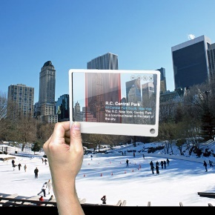

"Future of Internet Search: Mobile version" by Mac Funamizu is licensed under CC BY 4.0

Augmented reality displays computer-generated images or information over objects viewed in real time and space.

Why This Matters
Augmented reality is a mix of reality and virtual reality. It utilizes a mobile device and its camera, or a specially constructed pair of glasses, to display the real world around you with virtual objects layered on top. Augmented reality allows users to enjoy a virtual experience without blocking out the real world.

Essential Information
For years, researchers have been working on augmented reality, but the state of technology has kept it out of reach for general use. While augmented reality has been used for military purposes for years through heads-up displays or HUDs, the introduction of GPS on cell phones and wearables was the first step toward realizing augmented reality for the general population.

Innovation in map applications like Google Maps and Bing Maps brought augmented reality software the information needed to provide details about most locations. Yelp and Layar are two early apps available for smartphones that make use of augmented reality. Using the phone’s camera, users are able to view nearby businesses and attractions overlaid as text boxes on the camera image.

Another technique to produce augmented reality involves pattern matching to identify objects in an image. Google Goggles, available on Android handsets, gathers an image from the camera, analyzes its shape, and provides related information on links in textboxes displayed over the image.

Google Glass uses a pair of eyeglass frames to mount a small, transparent display at the corner of the eye. Using voice commands, the user can request information about the current environment, which is then displayed—or overlaid in the visual field. Google Glass has found favor with professionals, including physicians and mechanics, who need hands-free access to information.

Microsoft Hololens represents a major milestone in augmented reality, with its ability to overlay 3D objects in real space. Using the Hololens headset, users can play games like Minecraft, design 3D models, explore virtual landscapes, learn about scientific phenomena, work on a computer, watch a movie, and visit remotely with friends by viewing virtual objects in the local environment. Florida start-up Magic Leap raised more than $540 million to fund its new technology that tricks the brain into believing virtual objects are actually part of the physical space (see video). Clearly, augmented reality is a technology poised to leap into all of our lives.

Module 12

Introduction
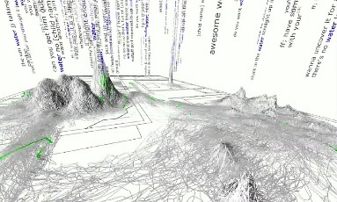
"Big Data: water wordscape" by Marius B is licensed under CC BY 2.0

Big data refers to the huge amount of data being collected and stored about individuals, items, and activities and to the process of drawing useful information from that data.

Today’s most successful enterprises are fueled by their ability to analyze large quantities of data—big data—resulting in unique and valuable insights. Businesses are adapting to a new competitive landscape where the smartest data analytics provide the greatest advantage. Accessing consumer data and being able to analyze that data have become essential to success.

A recent CloudTweaks study reported that at least 2.5 quintillion bytes of data are produced every day. In 2013, the amount of stored data was 4.4 zettabytes. A zettabyte is equal to 1 billion terabytes. It is predicted that by 2020, the amount of digital data produced will exceed 40 zettabytes or roughly 5200 GB of data for every man, woman, and child on earth and then add to that the amount of new data generated by smart things. Networking firm Cisco predicts that by 2018, the Internet of Things will generate a staggering 400 zettabytes annually.

The accelerating generation of data is far outpacing our ability to manage the information. Some experts believe that about 33 percent of all data produced by 2020 will contain valuable information. The trick is building software tools that can uncover it. Many companies are working hard to develop efficient means to transform big data into valuable, actionable information.

As you read about databases, consider strategies to manage huge amounts of global data generated by transactions, human activity and communication, market research, scientific research, media production, interactions between people and things, and all types of human endeavors. What information is worth storing? What should be discarded? Who can be trusted to store and maintain your data? Where should it be stored? Should we trust automated systems to manage our data? What actions should be taken now, to help save the world from data overload?

Data consists of raw facts, such as items in inventory, sales transactions, weather statistics, online activities of an individual, or song titles. For data to be transformed into useful information—such as quarterly profit reports, hurricane predictions, customized webpages, or a music library—it must first be organized in some meaningful way. A database is a collection of data organized to meet users’ needs. Throughout your personal and professional life, you will directly or indirectly access a variety of databases ranging from a simple list of music in your iTunes library to complex business systems used for accessing customer information, transaction data, a corporate knowledge base, and many other types of essential information.

The amount of data collected about individuals by businesses and governments has created privacy concerns for some people and groups. Businesses and marketing companies want to collect as much detailed information about individual consumers as possible so that they can market their products effectively at the lowest cost. At times, businesses have crossed the line with data collection practices and behavioral targeting, causing web users to feel that their privacy has been invaded. Governments are interested in collecting information about individuals in order to safeguard citizens from terrorists and criminals. Governments have also been known to cross the line using surveillance technologies to collect private information against the will of their citizens. In the U.S., some are calling on businesses to establish a Code of Ethical Practices for data management. Where do we draw the line between what is acceptable data collection for businesses and governments and what is not?

Another ethical dilemma related to databases has to do with the risk of private data falling into the hands of hackers and criminals. Information theft has become a multibillion-dollar industry with hackers utilizing tools to break through the security of databases in order to steal valuable information and individuals’ identities. Information security is an important consideration when designing databases.

Lesson 12.1: Databases and Big Data

Lesson 12.1 Introduction
"CardsDB" by zedic.judd is licensed under CC BY 2.0

A database is a collection of data organized to meet users’ needs.
Databases have made it possible for geneticists to map the structure of DNA and for all scientists to share their research; without databases, the human genome project would not be possible. Databases are the unsung heroes of the Internet. Without databases, there would be no Google, Amazon, eBay, or Facebook. Databases and the systems that manage them are at the foundation of all successful information services, and they are becoming increasingly important as people generate more and more data for businesses and organizations to analyze.

Databases range in size and complexity from simple personal information management (PIM) software to large industrial databases that manage petabytes of data. The larger a database, the more time is required to define the relationships between the data and its underlying structure.

Years ago, corporate data, such as inventory and sales records, was accessed only by select individuals and divisions within an organization. Data was collected into a single ledger and copied and shared as needed. Today, organizations use centralized databases and large data centers accessed from many locations and systems over networks and the Internet. A grocery store chain, for example, runs multiple applications, including transaction processing, inventory ordering, and payroll, from one centralized database system. This centralized database approach allows the chain’s management to obtain and analyze customer receipts from hundreds of stores.

The advantages of using a centralized database system are summarized in the following table. Although databases and data centers can be costly to set up and maintain, companies and organizations find that the advantages more than justify the costs.

Centralized Database Advantages
Advantage | Explanation
Reduced data redundancy | Data redundancy is the duplication of data across multiple locations.
Improved data integrity | Data integrity refers to the quality and accuracy of the data.
Easier modification and updating of data | Data is changed and updated in only one location.
Easier access to reports and data; convenience of shared data access | Many of today’s databases produce reports accessible on the web from any Internet-connected device.
Improved data security | It is easier to implement security measures in a centralized system.
Improved data storage efficiency | Having data in one location reduces storage needs.

Reading: Database Management System (DBMS)
A database management system or DBMS consists of a group of programs that manipulate the data within a database, providing an interface between the database and the user or between the database and application programs.

Why This Matters
Individuals use personal databases to store addresses and contact information, track important appointments, inventory valuables for possible insurance claims, catalog music and book collections, and store and manage other lists of personal data. All of us interact with databases over the Internet. In fact, the web itself could be viewed as the world’s largest database management system. Business systems depend on databases for daily operations and strategic planning. Database management systems serve as the user interface to data, providing data access and processing capabilities.

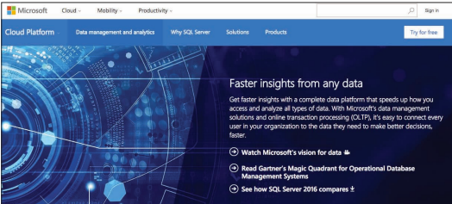
Courtesy of Microsoft Corporation. Fair Use

Essential Information
Database management systems range from small, inexpensive software packages to sophisticated systems costing hundreds of thousands of dollars. A few popular alternatives include flat file, single user, multiuser, and general-purpose and special-purpose systems. Open source databases are also available.

A flat file database stores database records in a plain text file. This method of data storage typically stores each record as a line of text and uses commas, tabs, or other indicators within the line to separate the fields within the record. The most common type of flat file format is called CSV for comma-separated values. Many specialized apps allow users to export their data into a CSV file for transfer into other similar apps. For example, Gmail users can export their contacts into a CSV file that can then be opened in Microsoft Excel or imported into another Contacts app like Microsoft Outlook.

Databases for personal computers are most often designed for a single user. Only one person can use the database at any time. Microsoft Outlook and Quicken are examples of popular special-purpose databases. These DBMSs are used to store and manipulate personal data. Outlook organizes contacts, calendars, email, and to-do lists, and Quicken is used for personal financial data.

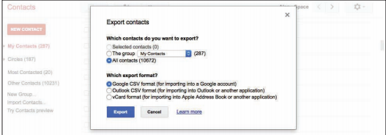
Google. Fair Use

Most small, medium, and large businesses require multiuser DBMSs that allow multiple employees to access and edit data simultaneously. These are typically referred to as database development platforms because they allow you to create a database and a DBMS for accessing and manipulating data in the database. Multiuser DBMSs utilize a unique manner of reading and writing data to provide users with simultaneous access to a shared database without the danger of overwriting each other’s data. These databases often serve as the source of information for corporate applications like payroll, invoicing, and inventory (see figure below).

Microsoft Access is one of the smaller database development platforms available for use by individuals as well as small businesses and organizations. Large corporations that manage huge quantities of data invest significantly in industrial database systems. IBM DB2, Microsoft SQL Server, and Oracle are much more powerful and expensive, and they accommodate dozens, hundreds, and even thousands of simultaneous users at multiple locations. The Internet provides the network connection that allows allow users around the world to access one common database and that makes it possible for data to be collected from nearly anywhere. A distributed database takes available data stored in multiple locations and makes it appear as a single collection.

Oracle, Sybase, and IBM databases are examples of general-purpose database management systems that can be used for many different types of applications. Microsoft is currently the market leader in this category, with Oracle following in a close second. Like many technologies, database services are moving to the cloud. Internet companies like Amazon Web Services are becoming major players in the database space alongside traditional companies like Microsoft that are also developing cloud-based database services like Microsoft Azure.
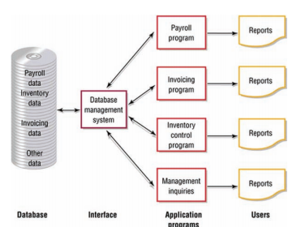
Authored by Cengage Learning. Creative Commons Attribution 4.0 International (CC BY 4.0)

Reading: Data Hierarchy
Data hierarchy refers to the manner in which data in a database is organized into sequential levels of detail.

Why This Matters
Drilling down is a popular expression that refers to viewing the details related to some circumstance. For example, if you heard that the U.S. was threatened by a hurricane, you would want to drill down into that information to find out what region of the country would be impacted. You might drill down further to track the path and intensity of the storm. Database systems support these types of inquiries by arranging data in a hierarchy. A database hierarchy typically includes levels of data—beginning with characters, numbers, or other digital information— at the lowest level. These combine to make fields, which combine to make records, which combine to make tables, which combine to create the database, as shown in the following figure.
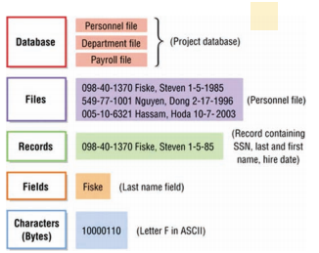
Authored by Cengage Learning. Creative Commons Attribution 4.0 International (CC BY 4.0)

Essential Information
Recall that in a computer, a byte is used to represent a character, which is the basic building block of textual information. Characters can be uppercase or lowercase letters (A, a, B, b, C, c,…Z, z), numeric digits (0, 1, 2,…9), or special symbols (![+][-]/€¥…).

In a database, characters are combined to form a field, the smallest practical unit in most databases. A field is typically a name, number, or combination of characters that in some way describes an aspect of an object (an individual, a song in a music library, an item in inventory, a photograph in an album) or activity (a business transaction, an interaction). Every field has a field name and can have either a fixed or a variable length. For example, songnumber might be the name of a field used to identify songs in a music library that requires an eight-digit code. On the other hand, artist_name might be a field that can contain varying length content such as Beyoncé (7 characters), or P!nk (4 characters). Database syntax typically requires that field names not include any spaces, so spaces may be omitted or replaced with an underscore character.

A collection of related fields that describe some object or activity is a record. You can create a more complete description of an object or activity by combining fields that represent various characteristics of objects or activities into records. For instance, a database record for music in the iTunes Store combines fields for Name, Time, Artist, Price, Release Date, Track #, and others to fully describe the track.

A collection of related records is a table, also called a file in some databases. In the above example, all iTunes music might be stored in a table named Music. Similarly, all iTunes movies might be stored in a separate but related table named Movies.

Apple Inc. Fair Use

At the highest level of this hierarchy is the database, a collection of integrated and related files or tables. Apple may store music data in one table, movie data in another, TV show data in another, and podcast data in yet another. The combination of these tables makes up the complete iTunes database.

Databases use entities, attributes, and keys to store data and information. An entity is a generalized class of people, places, or things (objects) for which data is collected, stored, and maintained. Entities are represented as tables in a database. Records are instances of an entity. For example, “tracks” would be an entity in a database, and Beyoncé’s song “Sorry” an instance of the tracks entity. An attribute is a characteristic of an entity such as the length of a track. The specific value of an attribute, called a data item – such as 3:52, can be found in the fields of the record describing an entity.

Reading: Database Key
A database key is a field in a table used to identify a record, such as EmployeeNumber.
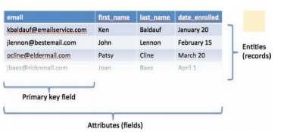
Authored by Cengage Learning. Creative Commons Attribution 4.0 International (CC BY 4.0)

Why This Matters
One of the biggest challenges in database management is ensuring that records aren’t duplicated. For example, you might sign up to get email updates for a hot new product that is soon to be released. The next time you visit the product website, you might forget that you already signed up and submit the form again. You expect that system to be smart enough to realize that you already signed up and not to email you twice. If that system utilizes database keys and has identified the email address field as a primary key, it won’t be sending you duplicate emails.

Essential Information
As you have learned, a record is made up of a collection of fields. A key is a field in a record that is used to identify the record, such as EmployeeNumber or Email_address. A primary key is a field within a database table that uniquely identifies each record. Each record in a table must have a unique entry in the primary key field. The primary key distinguishes records so that they can be easily and accurately accessed, organized, and manipulated. For example, using employee numbers as the primary key ensures that every employee is identified only once, and using email addresses as the primary key for a mailing list ensures that no email address will be emailed more than once. The IRS uses Social Security numbers as the primary key to ensure that every person with a Social Security number is accounted for at tax time, and no one is counted twice.

In some cases, multiple fields may be combined as a primary key. For example, what would iTunes use as a primary key for the music files shown in this table?

iTunes Music
Song | Artist | Album | Release date
Big Yellow Taxi | Joni Mitchell | Ladies of the Canyon | 04/17/70
Big Yellow Taxi | Counting Crows/Vanessa Carlton | Hard Candy | 07/09/02
Big Yellow Taxi | Amy Grant | House of Love | 08/14/07

The Artist field might seem like a good option for a primary key, but each artist has many tracks. The Artist field is not unique for each record. The Song title is another option. But some songs are recorded by multiple artists, so the song title may not be unique to each database record. One solution is to use the combination of artist and song title to create the primary key. This way, Joni Mitchell’s “Big Yellow Taxi” can be uniquely identified from other artists’ recordings of “Big Yellow Taxi.” If an artist has recorded the same song on multiple albums, it would be necessary to combine track title, artist, and album title as a primary key. Database designers often get around these types of challenges by assigning each record a unique ID number that acts as a primary key. For example, eBay identifies each item for sale with a unique item number.
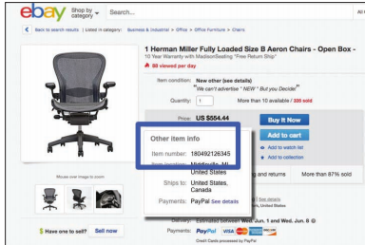
eBay. Fair Use

Reading: Relational Database
A relational database organizes data into multiple tables that are related by common fields.

Why This Matters
The data to be stored in a database often includes many categories of related information. For example, businesses typically store information on employees, inventory, customers, and sales. Storing all of this data in one large table would make for a huge and unwieldy database with many redundancies. Relational databases resolve this issue by storing data in separate tables according to logical categories, and relating the information by common fields.

Using the relationships among these tables, sales records can remain small and manageable.
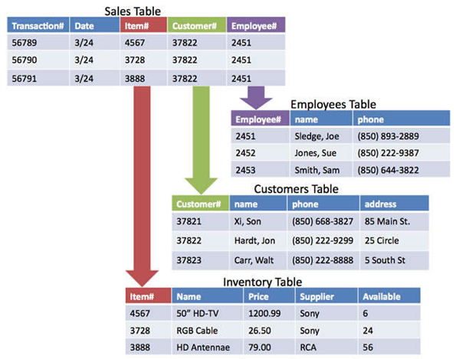
Authored by Cengage Learning. Creative Commons Attribution 4.0 International (CC BY 4.0)

Essential Information
The structure of the relationships in most databases follows a logical model. Many types of database models have been used over the years, including hierarchical, network, relational, object-oriented, and object-relational. The object-oriented model encapsulates data and database functionality together in software objects. Object-relational databases combine features of the object-oriented model with the relational model. The relational model is by far the most popular.

The overall purpose of the relational model is to describe data using a standard tabular format. In a relational database, all data elements are placed in two-dimensional tables organized in rows and columns, simplifying data access and manipulation. Notice in the figure above that the tables are related by common fields: Item#, Customer#, and Employee#. Having tables related by common elements allows them to be linked to produce useful information. This example is simplified to make it easy to understand. Typical business databases include dozens of tables with hundreds of relationships.

Relationships between tables can be illustrated through an entity relationship diagram. View the entity relationship diagram for an online auction database provided below. Notice that there are four tables in this database: Sellers, Auction Items, Bids, and Buyers. The fields included in each table are listed in the boxes. The key icon indicates the primary key for each table.

An online auction website might depend on four database tables, all related by common fields, as shown in this entity relationship diagram.
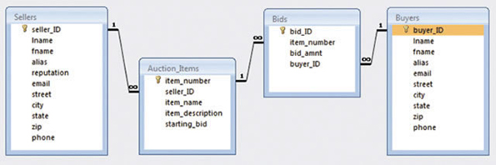
Courtesy of Microsoft Corporation. Fair Use

Notice the lines connecting the tables in the figure. These represent the relationships between the tables and indicate which fields in the tables hold common information. For example, the seller_ID field is used to connect the Sellers table to the Auction_Items table.

Also notice the 1 and infinity symbols used on the relationship lines. These indicate a special kind of relationship called a one-to-many relationship. For example, the relationship between the Sellers table and the Auction_Items table has a 1 on the Sellers side. This is because there is only one record for every seller_ID in the Sellers table, which is because seller_ID is the primary key. However, there is an infinity sign over the Auction_Items side of the relationship because each seller can have a limitless number of items up for auction—the seller_ID is not a primary key in the Auction_Items table. One-to-one and many-to-many relationships can also exist, depending on whether the field used is a primary key or not.

Lesson 12.2: Database Tools

Lesson 12.2 Introduction
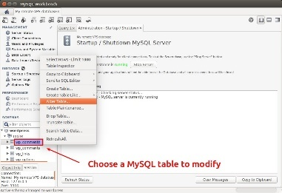
"MySQL Workbench - Modify MySQL Table" by xmodulo is licensed under CC BY 2.0

Database tools include software and techniques for analyzing, maintaining, and manipulating data in a database.

The power of a database lies in the tools utilized to manage, maintain, and manipulate the data. These tools enable investors to earn millions of dollars by buying and selling stocks at the most opportune moment. Or, they might assist you in finding great new music based on your general listening trends. The most fundamental database tools are schemas, data dictionaries, and data manipulation languages such as SQL.

Database tools exist to ensure the collection of high-quality data and to manipulate the data for some purpose. High-quality data is nonredundant, flexible, simple, and adaptable to a number of different applications. Data analysis is the process of evaluating data to identify problems with the content of a database.

The process of correcting data problems or anomalies is called normalization. It ensures that the database contains good data. Normalization usually involves breaking one table into two or more tables in order to correct a data problem or anomaly. Normalization is a very important technique in database management and is yet another advantage to using a relational database.

Data integrity refers to the quality of data: the degree to which it is accurate and up to date. There are many possibilities for inaccuracies in today’s information-rich society. Some people have been unable to get credit cards, car loans, or home mortgages because data stored about them by credit bureaus was inaccurate. In some cases, a retail store may report that someone didn’t pay his or her bills, when the bills were paid in full. These types of errors are caused by inaccurate data being entered into a database. The results are inaccurate output. This is sometimes referred to as garbage in/garbage out (GIGO). Computer systems are often blamed for such errors, but in reality, the errors are more often human.

Not only are tools designed to analyze and normalize data, but tools are also used to query, filter, and organize data to meet particular needs. Data manipulation languages, the most popular of which is SQL, are the main tools of those who work with databases.

Reading: Schema
A database schema is a graphical representation of the structure of a database.

Why This Matters
The organization of data in a database can quickly become very complicated. Schemas allow database administrators and users to visualize the structure of a database and understand the relationships between data and tables.

Essential Information
One of the first steps in creating a database is to outline the logical and physical structure of the data as well as the relationships among the data in the database. This description is called a schema (as in schematic diagram). A schema can be part of the database or a separate schema file. The DBMS can reference a schema to find where to access the requested data in relation to another piece of data. Schemas are entered into the DBMS (usually by database personnel) via a data definition language. A data definition language (DDL) is a collection of instructions and commands used to define and describe data and data relationships in a specific database.
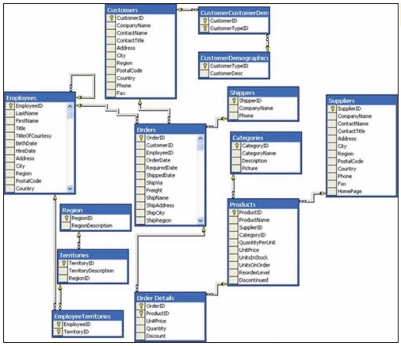
Courtesy of Microsoft Corporation. Fair Use

Reading: Data Dictionary
A data dictionary provides a detailed description of each field and table in a database.

Why This Matters
Data in a database is typically accessed by different individuals and software. A data dictionary provides specific details on the requirements of each field and table in a database, how they may be accessed, and the specific parameters and requirements imposed on the data they hold.

Authored by Cengage Learning. Creative Commons Attribution 4.0 International (CC BY 4.0)

Essential Information
An important step in creating a database is to establish a data dictionary, a detailed description of all data used in the database. The data dictionary includes information such as the name of the data item, who prepared the data, who approved the data, the date, a description, other names that may be used to refer to the data, the range of values for the data, the data type (numeric or alphanumeric), and the number of positions or amount of space needed for the data. A data dictionary provides standard definitions of terms and data elements that can be referenced by programmers, database administrators, and users to maintain data integrity.

Reading: Structured Query
Structured Query Language (SQL) is a popular data manipulation language used by the vast majority of database programmers and administrators for manipulating data to meet the needs of the users.

Why This Matters
The power of a database lies in the ability to sift, sort, and query data to answer questions and discover patterns. For example, it is useful to discover which are the most profitable stores in your retail chain, who are the least productive employees, what airline offers the best deal on a particular route, which song is most popular, and what direction the economy is headed. Queries are designed and query results are generated through the use of data manipulation languages such as SQL.

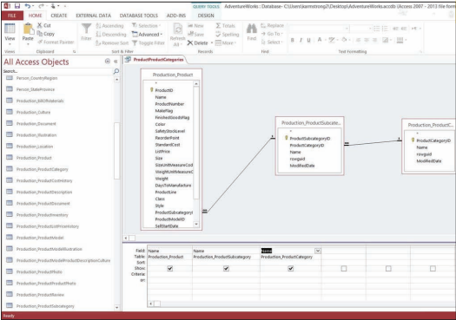
Courtesy of Microsoft Corporation. Fair Use

Essential Information
Once a DBMS has been installed and a database and table(s) created, the data can be accessed and manipulated using specific commands in various programming languages and a data manipulation language. A data manipulation language (DML) is a specific language provided with the DBMS that allows database users to access, modify, and make queries about data contained in the database and to generate reports.

In 1986, the American National Standards Institute (ANSI) adopted Structured Query Language (SQL, also pronounced “sequel”) as the standard query language for relational databases. Today, SQL is an integral part of popular databases on both mainframe and personal computers. If you visit the Books section of Amazon.com and enter a search for J. K. Rowling, when you click the search button, it is likely that software running on Amazon’s servers issues an SQL statement such as

SELECT * FROM BOOKS WHERE AUTHOR = ‘J. K. Rowling’

which would populate the webpage with all records from the BOOKS table that have J.K. Rowling listed in the author field.

SQL is actually a programming language, but it is easy for nonprogrammers to understand and use, thanks to its English-like commands. Programmers can use SQL on systems ranging from PCs to the largest servers. SQL statements also can be embedded in many programming languages, such as the widely used Javascript and PHP languages.

Examples of SQL Commands
SQL Command | Description
SELECT ClientName, Debt  FROM Client  WHERE Debt>1000 | This query displays all clients (ClientName) and the amount they owe the company (Debt) from a database table called Client, for clients that owe the company more than $1000 (WHERE Debt>1000).
SELECT ClientName, ClientNum, OrderNum  FROM Client, Order  WHERE Client.ClientNum = Order.ClientNum | This command is an example of a join command that combines data from two tables: the client table and the order table (FROM Client, Order). The command creates a new table with the client name, client number, and order number (SELECT ClientName, ClientNum, OrderNum).
GRANT INSERT ON Client to BGuthrie | This command is an example of a security command. It allows Bob Guthrie to insert new values or rows into the Client table.

Some commercial databases provide tools and wizards for automating the process of building SQL statements. Microsoft Access provides a Query tool and wizard where tables and fields are selected and criteria specified (see figure at top of page) to quickly generate SQL queries. There is also the ability to query by example (QBE), where a database entity is selected as an example of the criteria to be queried. Query wizards and QBE automate the process of writing SQL commands, making manipulating databases easier and faster for novices.

Lesson 12.3: Business Databases

Lesson 12.3 Introduction
Enterprise databases are large databases that function as the cornerstone of information systems in businesses and enterprises.

When it comes to big data, you need big technologies to manage it. Large businesses, referred to as enterprises, invest heavily in storing and processing the data that feeds numerous information systems. Data analytics support decision-making processes throughout an organization. A number of companies have arisen to assist businesses of all sizes in managing and analyzing large amounts of data.
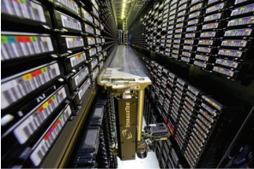
Courtesy of National Energy Research Scientific Computing Center. Public Domain

Data is the lifeblood of the enterprise, and the flow of key information to the right people at the right time is essential to the success of a business. Key technologies are used to assist in accomplishing this goal. Big businesses utilize servers in data centers to store large quantities of business-related data. A data warehouse is used to collect all types of data from a variety of resources. Data mining is used to harvest specific information to support essential business decisions and strategies. A database administrator designs, implements, and maintains the database, and trains others in its use.

Amazon.com trusts its huge multi-terabyte database to support its online transactions. To meet Amazon’s high demands, its database must provide personalized, rapid responses to customers. It is typical for huge databases to lag in response time, but not so with Amazon’s. After greeting customers with a custom-designed webpage built on the fly, the database serves up product information, user reviews, lists of recommendations, and links to more products—all in the blink of an eye. The DBMS is optimized to provide both agility and power. When the customer is ready to make a purchase, the DBMS manages the entire process.

Businesses depend on many different types of database technologies to claim a competitive advantage. Of those available, the most powerful and popular are discussed in this section.

Reading: Data Warehouse
A data warehouse is a very large database that holds important information from a variety of sources.

Why This Matters
In the corporate environment, data is generated by a variety of functional units within the business: accounting, marketing, sales, human resources, etc. Business executives combine data from many sources and analyze it to get the big picture of what is occurring in the business. Data warehouses merge data from many sources into one large database designed for analysis. Data warehouses are a crucial component of many business systems.

Essential Information
A data warehouse is a large database that holds information from a variety of sources. It is usually a subset of multiple databases maintained by an organization or individual. Data warehouses are used by many companies and organizations. A hardware store, for example, can use a data warehouse to analyze pricing trends. This can help the store determine what inventory to carry and what price to charge. With a data warehouse, all you have to do is ask where a certain product is selling well, and a colorful table showing sales performance by region, product type, and timeframe pops up on the screen. Similarly, some police departments use data warehouses to store records of events such as complaints, arrests, criminal summonses, shootings, homicides, and other incidents. The data warehouse is tapped to provide real-time information for a centralized help desk that provides detectives with the data needed to solve crimes.

A data mart is a small data warehouse, often developed for a specific person or purpose. It can be generated from a data warehouse using a database management system.

Reading: Data Mining
Data mining refers to the process of extracting information from a data warehouse or data mart.

Why This Matters
The amount of data collected by today’s corporations is far too huge to be interpreted solely by humans. Computerized tools are needed to discover irregularities and trends in data. Data mining is the application of such tools.

Essential Information
Data mining is the process of extracting information from a data warehouse or a data mart. The DBMS can be used to generate a variety of reports that help people and organizations make decisions and achieve their goals. Data mining has been used in the airline-passenger profiling system to block suspected terrorists from flying. Data mining is also used by government agencies to detect patterns of terrorist activity.

In a business setting, data mining can yield outstanding results. Often called business intelligence or BI, a term first coined by a consultant at Gartner Group, the business use of data mining can help increase efficiency, reduce costs, or increase profits. The business-intelligence approach was first used by Procter & Gamble in 1985 to analyze data from checkout scanners. Today, most companies use data mining and business intelligence to interpret valuable information provided by collected data.

Reading: Data Center
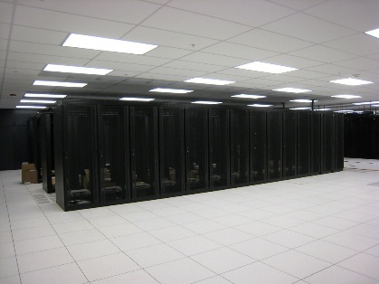

"cabinets" by bugeaters is licensed under CC BY 2.0

A data center is a climate-controlled room, building, or set of buildings that houses servers storing and delivering mission-critical information and services.

Why This Matters
The world economy is increasingly dependent on data. Much of the world’s data is stored in data centers of various sizes. Data centers are getting media attention because they consume large amounts of energy. New green technologies are being applied to help decrease the size and energy demands of the data centers that store our rapidly increasing amounts of data. Most of the energy required for a data center goes to keeping servers cool. Facebook built its European data center in Lulea, Sweden, on the edge of the Arctic Circle where it benefits from cheap electricity and year-round cool temperatures.

Essential Information
Corporate databases and database management systems are typically housed in facilities called data centers. A data center is a climate-controlled room, building or set of buildings that house servers storing and delivering mission-critical information and services. Data centers of large organizations are often distributed among several locations. Microsoft constructed a 400,000-square-foot data center in San Antonio, at a cost of $550 million. Google constructed a $600-million mega-data center in Lenoir, North Carolina, and a $750-million data center in Goose Creek, South Carolina. The Range International Information Hub in LangFang, China is currently the world’s largest data center, covering 331 acres. Clearly, storing and managing data is a serious business.

The number of data centers being constructed for big companies like Google, Microsoft, Amazon, Apple, and Facebook is rapidly increasing as computer users are storing increasing amounts of data in the cloud. Cloud computing is gradually moving all data off individual computers and onto Internet-accessed servers maintained in data centers.

While corporate and personal data sits in large supercooled data centers, the people accessing that data are typically in offices spread across the country or around the world. In fact, in the near future, the only personnel on duty at data centers may be security guards. Data centers are approaching the point of automation, where they can run and manage themselves while being monitored remotely. This is referred to as a “lights out” environment.

Module 13

Introduction
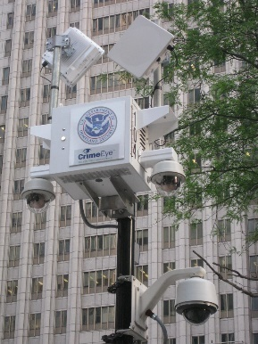
"Panopticon" by zombieite is licensed under CC BY 2.0

Privacy refers to being free from intrusion; it is the right to be left alone, to be free from surveillance, and to have control over the information collected and stored about yourself.

With the digitization of all forms of information and the increasing use of the Internet for all types of activities, it has become easy to collect detailed information about individuals. This has helped businesses to locate customers for their products, allowed government and law enforcement to monitor individuals’ behavior, and enabled criminals to find victims.

Loss of privacy is so widespread and is occurring so quickly that some believe that it is too late to do anything about it. Others are interested in maintaining some forms of privacy. Still others are embracing a transparent lifestyle, broadcasting their every action to the world.

The concept of big data emerged from the vast and exponentially-growing amount of data generated by social media, mobile devices, apps, and all the other digital tools wielded by the global population every day. Corporations, and others, are driven to collect all of that data and analyze it to gain useful insights that can be used to make better business decisions. Companies like Google, Facebook, AT&T, and many others have gotten good at collecting the data. Developing software to analyze the massive amount of data being collected is the primary challenge of the big data industry. In coming years, that challenge will become much more complex. Today, the average Internet user owns two Internet- connected devices, typically a smartphone and computer. Over the next couple of years, that number is expected to jump to seven, more than tripling the number of devices on the Internet. The bulk of new Internet devices will represent things rather than people—thermostats, security systems, televisions, electric meters, cars, refrigerators, and other appliances. These devices will increase the amount of big data by adding information like the temperature in every home at every second, the energy usage of each residence and business, eating habits, laundry habits, water usage, waste production, and more. Add this information up, and the Internet of people and things—the Internet of Everything, as Cisco calls it—becomes a source of real-time information about the state of the planet at any given moment in time.

The Internet of Things has been likened to a “global electronic nervous system, with trillions of individual sensors monitoring the status of everything of interest to humans.” IBM wants to stream all of those exabytes of data to its cloud-based cluster supercomputers to extract the maximum amount of value from the data, using analytics and neural network-powered software modeled on the human mind. With so much data being collected from each person’s life, what data, if any, should remain private? Is it worthwhile to sacrifice privacy to provide valuable insight for improving life on Earth?

Computer technology gives us the ability to collect, maintain, process, and transfer more information than ever before. This power has given rise to a seemingly endless number of public and private databases that include details about many individuals. Combined, these databases could tell a person’s life story in terms of daily activities, personal interests, and financial matters. This massive data collection, combined with surveillance technologies that include the increasing use of cameras in public places, has given rise to legitimate concerns over the invasion of privacy in the digital era. For example, Google’s Street View technology has caused a stir over privacy issues because of its 360-degree street-level imagery, which uses satellite technology to take real-time pictures of private and public locations.

Privacy issues include being free from intrusion—the right to be left alone, to be free from surveillance, and to control the information collected and stored about yourself. Information security often comes at the cost of some level of convenience and privacy. This section looks at the extent to which your privacy might be sacrificed in order to provide conveniences offered by the digital world and to increase your personal safety and national security.

Lesson 13.1: Protecting Privacy

Lesson 13.1 Introduction
Everything we do generates information about who we are as people—who we know, what we believe, what we like—and this is truer than ever with the expansion of the Internet into our daily lives. In many ways, this process is unavoidable, short of abandoning society and living in the woods. We can all take steps, however, to reduce the amount of private information we broadcast without our knowledge or consent, and we are not alone in our desire to prevent privacy from disappearing entirely.

Reading: U.S. Privacy-Protective Laws
U. S. privacy-protective laws refer to legislation designed to protect the private information of U.S. citizens.

Library of Congress Prints and Photographs Division (ppmsca-08467.-08467r). Public Domain

Why This Matters
The right to privacy has been a hotly debated topic in countries around the world for generations. Generally, free and democratic governments include laws that protect citizens’ privacy to some extent. At a minimum, in a free society, a citizen would expect to have privacy within his or her home. The level of privacy a person enjoys can vary greatly, depending on social circumstances and the political and legal position of the government on privacy issues. Digital technologies have made protecting private information more difficult than ever. Many recent privacy laws focus on digital technology challenges.

Essential Information
You might be surprised to learn that the U.S. Constitution itself contains no express right to privacy. However, the Bill of Rights (the first 10 amendments to the Constitution) refers to privacy issues. The First Amendment protects the privacy of belief; the Third Amendment protects the privacy of the home against demands that it be used to house soldiers; the Fourth Amendment protects the privacy of the person and possessions against unreasonable searches; and the Fifth Amendment protects a person from self-incrimination.

A later amendment has also been important for privacy issues. Over the years, the Supreme Court has interpreted the word “liberty” in the Fourteenth Amendment to include issues of privacy—particularly in terms of issues such as marriage, procreation, childrearing, and termination of medical treatment. Polls indicate that most Americans support this interpretation of the word “liberty.”

The free flow of digital information has created the need for a number of laws to protect the private information of individuals. When it comes to information privacy, government agencies in the United States and many other democratic countries are regulated more stringently than businesses and health care professionals. However, with the exponential growth of digital information, the government is stepping in to regulate the use of information across many industries.

The Privacy Act of 1974 is the primary law controlling what many U.S. government agencies can and cannot do with the information they hold. The primary tenets of the law include the rights of citizens to know what information certain government agencies store about them and to exercise control over the accuracy of that information and how it is used. Laws that control the handling of information by the government, businesses, and the health care industry are listed below. As technology advances provide additional means of invading individuals’ privacy, new laws will be needed. For example, as unmanned drone aircraft begin entering commercial markets, media companies and others may begin using them to gather video and photographs of private property. Some states have already banned the use of unmanned drones in expectation of just such abuses. Privacy advocates are up in arms in states where drones are being considered for use by police.

U.S. Privacy-Protective Laws
Law | Explanation
Identity Theft Protection Act of 2005 | Requires businesses to secure sensitive data physically and technologically and to notify consumers nationwide when data is compromised
Information Protection and Security Act of 2005 | Gives the Federal Trade Commission (FTC) the ability to regulate the sale of personal information
Notification of Risk to Personal Data Act of 2003 | Requires businesses to notify individuals when their personal information is stolen
Education Privacy Act of 2003 | Restricts the collection of data by federally funded schools
Sarbanes-Oxley Act (“Sarbox”) of 2002 | Fights corporate corruption by imposing stringent reporting requirements and internal controls on electronic financial records and transactions
Children’s Online Privacy Protection Act of 2000 | Gives parents control over what information is collected from their children online, and how such information may be used
Gramm-Leach-Bliley Act (GLBA) of 1999 | Requires banks and financial institutions to alert customers of their policies and practices for disclosing customer information
Consumer Internet Privacy Protection Act of 1997 | Requires data collectors to alert people that their personal information is being shared with other organizations
Health Insurance Portability and Accountability Act (HIPAA) of 1996 | Requires those in the health industry to protect the privacy of health information, and provides policies and procedures for doing so
Computer Matching and Privacy Protection Act of 1988 | Regulates cross-references of data between federal agencies
Tax Reform Act of 1979 | Controls the collection and use of certain information collected by the IRS
Right to Financial Privacy Act of 1978 | Restricts the government’s access to certain financial records maintained by financial institutions
Privacy Act of 1974 | Controls what many government agencies can and cannot do with the information they hold
Freedom of Information Act of 1966 | Gives citizens the right to view their own personal records maintained by federal agencies

Reading: Transparency
Transparency is when a person, business, organization, or government keeps little or nothing secret from the world—an approach that is supported by technologies such as lifestreaming, geolocation, and microblogging.

Why This Matters
So what is the danger in having other people know about your life, the intricacies of your day-to-day dealings, and your secret thoughts? Perhaps the solution to privacy issues is to abandon the concept of privacy altogether. If you aren’t doing anything illegal, why should you care what other people know about you? Some individuals subscribe to this philosophy, have abandoned concerns over privacy, and are leading a transparent lifestyle. Businesses, organizations, and governments may support a transparent approach in order to win the trust of the public.

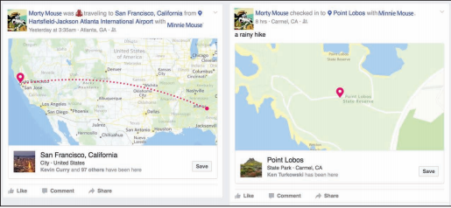
Facebook; created by Ken Baldauf (fictitious users). Fair Use

Essential Information
Some experts in the area of privacy believe that there are three scenarios regarding the relationship between technology, privacy, and society:

Full privacy: Citizens should be assured of 100% privacy. They should have absolute control over what personal information is maintained in public and private databases, and there should be no surveillance of any kind for any purpose.

Full trust: Citizens should trust governments to provide surveillance in a safe and secure manner that respects privacy rights.

Full transparency: All surveillance and information should be accessible to every law-abiding citizen. Governments and law enforcement should not maintain exclusive control over surveillance. Citizens should have the ability to turn the cameras onto authority to ensure that power is not being abused.

It may be too late for full privacy. Technology and its use have progressed past the point of regaining previous levels of anonymity. If full privacy is not attainable, some feel it would be a mistake to fully trust those in power to manage privacy responsibly. Power corrupts, and being responsible for all private information of a population would imply absolute power. Such a scenario, some fear, could lead to an Orwellian society.

Full transparency is an intriguing notion. How would society change if everyone was openly honest and had equal access to all information and surveillance? No group would hold an advantage over others because of the information it controlled. Any person could view surveillance data from any location. Everyone would hold all the cards. Although there would be little privacy, except perhaps in one’s own home, there would also be little opportunity for abuse of power, except by those who cheat.

Social media has provided tools for Internet users to lead a transparent life. Some individuals strap on video cameras and broadcast their every waking moment as a lifestream on the Internet. In a less extreme and more popular form of transparency, people are broadcasting their daily events, using microblogging sites such as Twitter, Tumblr, Instagram, and Facebook updates. Social media makes it possible to share your thoughts, your interests, your photos, your location, your friends, your personal information (like your birthday and love interests), your web activities, and your favorite organizations. Just about everything about yourself can be presented for the world to see.

One possible danger in leading a transparent lifestyle is that it gives others power over you. When people know everything about you, but you know nothing about them, they could take advantage of you. You become more susceptible to identity theft. Someone could break into your residence when they know you are out. There are many ways that the personal information people provide to others over social networks can be used, and is being used, to take advantage of those individuals.

There are also issues surrounding the division of a person’s professional life and personal life. Most people are not eager to have their boss and work colleagues analyzing their party photos on Facebook. Nor do most people want their personal friends and business colleagues intermixed in their social networks. People typically behave differently at home than they do at work. A totally transparent lifestyle would not support any division of home life and work life.

Nonetheless, there is a certain feeling of freedom that results from casting away concern for privacy and broadcasting yourself to the world: “Like me or not, I am who I am.” It is a trend that may spread voluntarily or out of necessity as privacy becomes increasingly difficult to maintain.

Lesson 13.2: Privacy Threats

Lesson 13.2 Introduction
While we produce a lot of information about ourselves simply by living in a digital society, there are those who profit from far more invasive methods of data mining. Not only do government intelligence agencies engage in sophisticated surveillance, but our privacy is continually threatened by the businesses we interact with. Much of this activity is entirely legal and expected.

Reading: U.S. Privacy-Invasive Laws
U.S. privacy-invasive laws refer to legislation that is invasive to individual privacy for a perceived greater good of the country.

Why This Matters
In the history of the United States and other developed and democratic societies, there have been times when individual privacy and civil liberties have been sacrificed for the sake of national security. These times typically strain the relationship between a government and its citizens, which is sometimes expressed through protests, violence, and arrests. It is at times such as these that citizens must be aware of government action, understand what sacrifices may be required on their part for the sake of the country, and express concern over any civil liberties and privacy that might be sacrificed unnecessarily.

Essential Information
In times of war, U.S. law allows the government to restrict privacy in an effort to capture or defeat an enemy. The Federal Wiretap Act, enacted in 1968 and expanded in 1986, sometimes referred to as Title III, sets procedures for court authorization of real-time surveillance of all kinds of electronic communications in criminal investigations. The Foreign Intelligence Surveillance Act of 1978 allows wiretapping based on a finding of probable cause to believe that the target is a member of a foreign terrorist group or an agent of a foreign power. Both laws allow the government to carry out wiretaps without a court order in emergency situations involving risk of death or serious bodily injury and in national security cases.

Such has also been the case since the attacks of September 11, 2001. The USA PATRIOT Act of 2002 gave the federal government greater access to private information and wider latitude in the treatment of suspected terrorists. It was designed to “deter and punish terrorist acts in the United States and around the world, to enhance law enforcement investigatory tools, and for other purposes.” It includes measures to “enhance surveillance procedures.”

The easing of privacy regulation in time of war causes concern for privacy advocates. They fear that in a state of panic, the government may overreact and needlessly sacrifice civil liberties and rights.

When the Information Awareness Office of the Defense Advanced Research Projects Agency (DARPA) proposed a new tracking information system called Total Information Awareness (TIA) in 2002, privacy advocates complained loudly. Total Information Awareness was designed to capture the “information signature” of people so that the government could track potential terrorists and criminals. An information signature is any unique information stored about an individual, such as information about property, address history, utility connections, bankruptcies, liens, and business filings, as well as a host of other information. Data mining techniques were to be applied to the database developed by the TIA system in order to “connect the dots” and detect potential terrorist activity.

Courtesy of the DARPA. Fair Use

What outraged privacy advocates was that this system could be used to track all citizens, not just those suspected of crimes. It was essentially a form of the “Big Brother” concept introduced by George Orwell in his book 1984. In his story, the government (Big Brother) watched over everyone in society by using information gathering and video surveillance In this Orwellian society, there was little in the way of crime, nor was there any privacy or freedom. It was like living in a prison.

In the case of Total Information Awareness, the privacy advocates won. The name of the program was changed to Terrorism Information Awareness. Shortly after that, Congress cut off funding for the program.

In 2002, following the fiasco with Total Information Awareness, the U.S. government developed a system called MATRIX (Multistate Anti-Terrorism Information Exchange). Once again the system was shut down because of privacy infringements on law-abiding citizens. A few states still use MATRIX-like technologies on the state level to help identify criminals.

In 2016, the FBI requested that Apple assist in providing access to data on the iPhone used by a shooter in the famous San Bernardino attacks. Apple’s refusal to do so kicked off a major national debate on privacy vs. protection. Ultimately, the FBI was able to hack the iPhone without Apple’s assistance, leaving the impression that Apple’s efforts to protect user privacy and data was less than perfect.

Reading: Surveillance
Surveillance is the close monitoring of behavior through electronic technologies such as wiretapping, data mining, remote video and audio monitoring, GPS, and RFID.

Why This Matters
Computer-controlled surveillance technologies, combined with ubiquitous telecommunications networks and powerful information processing systems, have made it possible to gather huge quantities of video, audio, and telecommunications signals and process them to reveal personal information. Although this is mostly done in an effort to curb crime and catch criminals, some people are concerned with the lack of oversight. Who is monitoring those individuals doing the monitoring? Will the information gathered in electronic surveillance be used to invade our privacy?

Essential Information
There are many forms of electronic surveillance, including wiretapping, data mining, video and audio surveillance, Internet monitoring, and GPS and RFID surveillance.

Wiretapping involves secretly listening in on conversations taking place over telecommunications networks, including telephone, email, instant messaging, VoIP, and other Internet communications. Wiretapping has been around as long as there have been wires to tap and now extends to wireless communications. With increased dependence on electronic communications, wiretapping has grown to be an important tool for law enforcement and a major concern for those interested in personal privacy. Laws governing wiretapping allow the government to carry out wiretaps without a court order in emergency situations involving risk of death or serious bodily injury and in national security cases.

With cooperation from Internet service providers, an FBI surveillance system called Carnivore has been used to monitor email correspondence. The system has alarmed privacy advocates and some members of Congress because of the manner in which it surveys all email on the system, not just email of suspected criminals. To avoid public criticism, the FBI switched from Carnivore to its own proprietary system, of which little is known.

In 2013, NSA contractor Edward Snowden leaked classified documents that revealed numerous global surveillance programs, many run by the NSA and the Five Eyes Intelligence Alliance (Australia, Canada, New Zealand, the United Kingdom, and the United States), with the cooperation of telecommunication companies and European governments. The revelation alerted the world to the lengths that governments have gone to in order to gather information about the public and other governments. In many cases since Snowden’s disclosures, telecom and tech companies have been discovered to be assisting governments in the collection of user information. These revelations have led to public distrust of governments and companies in areas of privacy.

Increasingly, cities are turning to networked video surveillance to monitor their streets. Video cameras in public places are assisting in capturing criminals who might otherwise escape. For example, video surveillance was critical in the investigation to find the Boston Marathon bombers in early 2013. In Chicago, a multimillion-dollar system dubbed Operation Disruption includes over 300 street-surveillance cameras with microphones.

In addition to living with permanent mounted cameras, we are now entering the era of flying cameras. Unmanned drone aircraft have become a necessity to the military for scoping out the enemy without risking life. Since the price of the technology has dropped, flying camera-bearing drones has become a favorite past time of hobbyists. The FAA is hustling to create regulations for drones in domestic airspace. High-resolution cameras attached to satellites and pointed at the earth are providing amazing new mapping technologies, as demonstrated through software such as Google Earth. Google’s high-resolution satellite cameras can capture images of objects as small as 41 cm. Government-owned satellites can get even finer resolution.

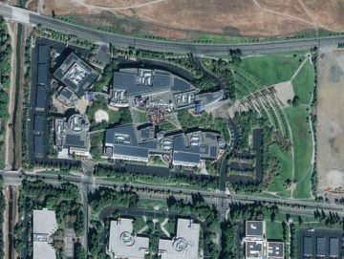

2012 Google. Fair Use

Global positioning system (GPS) and radio frequency identification (RFID) technologies are very useful, but they can also be used to invade privacy. Consider the case of a man who attached a GPS tracking device to the undercarriage of his ex-girlfriend’s car to monitor her movements. The man was picked up by police after his ex found him under her car, changing the battery on the device. He’s serving time in a California prison. GPS devices are being considered by some states for tracking ex-cons and for use in automobile license plates.

The combination of data mining, consumer and government databases, listening in on electronic communications, video and audio surveillance, satellite surveillance, and GPS and RFID location monitoring adds up to the possibility of serious invasion and abuse of basic privacy rights. Currently, at least in the United States, privacy laws and advocates work to keep government agencies in check. A second deterrent to abuse of surveillance technologies by government is a lack of funding and personnel. It takes a considerable investment to monitor video from thousands of cameras. As technology improves and surveillance becomes increasingly automated, funding and personnel will become a non-issue. We may soon be able to entrust the monitoring of surveillance data to a powerful AI (artificial intelligence) computer system. Once again, this matter becomes a case of trust: Can those monitoring society be trusted to use surveillance only in the best interest of the public without invading the privacy of law-abiding citizens?

Reading: Behavioral Targeting
Behavioral targeting uses information about a person’s behavior to inform businesses and marketers so that they can offer products that are likely to be of interest to that person.

Why This Matters
Much of the information gathered about individuals is collected without their knowledge. For example, a person might join a discount club at a local grocery store to enjoy special deals on products and to facilitate a faster checkout process. That person might not be aware that the club membership card also allows the store to digitally track his or her buying patterns. The customer may receive special mailings providing information on products that he or she typically buys. Some customers find this to be a valuable service while others consider it an invasion of privacy. With commerce moving to the web, the tracking of consumer information has become much easier.

Essential Information
Traditional marketing uses a technique known as market segmentation, where ads target customers based on their race, gender, income, education, age, and other general characteristics. Although this is often more effective than mass marketing, which advertises to everyone regardless of their social characteristics, it still can miss the mark.

The Internet allows market segmentation to take place at the level of each individual consumer. By studying a user’s web behavior, businesses can learn and even predict what the person may be interested in purchasing. This is referred to as personalized or one-to-one marketing.

The Internet acts as a supercharged tool for invisible information gathering and behavioral targeting. Through the use of cookies, companies can accumulate immense amounts of information about customers visiting their websites. Onsite behavioral targeting involves a company tracking a user’s activities on its own site. The information the company collects allows the company to custom-design a website that caters to the individual’s interests. Amazon.com uses this approach to custom-design its opening page for each visitor for whom it has data. For example, if you purchase romance novels and kitchen appliances at Amazon, the next time you visit the site, you will see promotions for other romance novels and home appliances.
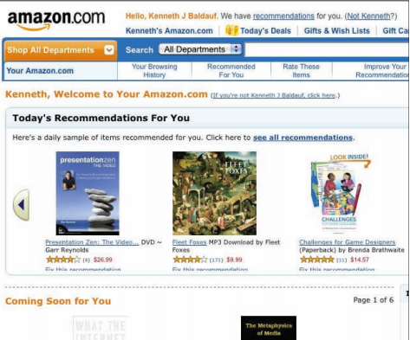
Courtesy of Amazon.com. Fair Use

Many users find onsite behavioral targeting useful while others find it a bit invasive. Even more invasive is network behavioral targeting. In network behavioral targeting, user behavior is tracked over multiple websites. Web advertising companies that provide ads to many websites, such as DoubleClick by Google, have the power to collect cross-site data about a user through the use of third-party cookies. Such information can be used to create a detailed consumer profile that can be very valuable to businesses. Browsers now offer the ability to block third-party cookies.

Facebook uses “Like” icons on over a billion websites so that its users can share with their friends the products, services, and content they like. Facebook and its partners collect this information, developing a detailed user profile for use in targeted advertising. Google+ uses a similar system. Google+ and Facebook’s Like icons are often found side-by-side on websites.

The ultimate network behavioral targeting exists at the Internet service provider level. An ISP is capable of collecting information on what every user is doing over its connections—and for ISPs like Comcast and AT&T, that can include Internet, television, and phone data. ISPs have come under fire for collecting such data. Verizon and AT&T were found utilizing a technology called super cookies to track users’ online activities through mobile web browsers. It is useful to read the privacy policy of your ISP to find out what it does with that information. Such information would be a goldmine to marketers, and there isn’t much standing in the way of ISPs mining that gold.

Network behavioral targeting is the tip of the iceberg for data aggregation companies such as LexisNexis Risk Solutions, formerly ChoicePoint. LexisNexis Risk Solutions collects and combines information from the three big credit bureaus; public records of numerous local, state, and federal government agencies; telephone records; liens; deeds; and other sources in order to develop detailed information about individuals, companies, and organizations. Over the years, the company has purchased many other personal information services, increasing its database to include drug test records, physician backgrounds, insurance fraud information, and a host of other specialized pieces of valuable personal information. Businesses and organizations contract LexisNexis for data mining to provide information on specific individuals for a variety of uses.

LexisNexis has more information about U.S. citizens than the government does. As a matter of fact, it has a multimillion-dollar contract with the Department of Justice and the IRS. FBI agents use information supplied by LexisNexis Risk Solutions in their criminal investigations. In this way, federal agencies can sidestep privacy laws that restrict the government from collecting and mining such information itself.

Module 14

Introduction
Ecommerce, or electronic commerce, refers to systems that support electronically executed business transactions.

Ecommerce has provided a fresh platform for business that has changed the way businesses and consumers think about buying and selling. Increasingly, buyers and sellers are turning to the web to buy and sell products and are enjoying the benefits. Conducting business online offers convenience and savings to both buyers and sellers. It also empowers consumers to find the best deals and service, placing additional pressure on businesses to meet consumer needs.

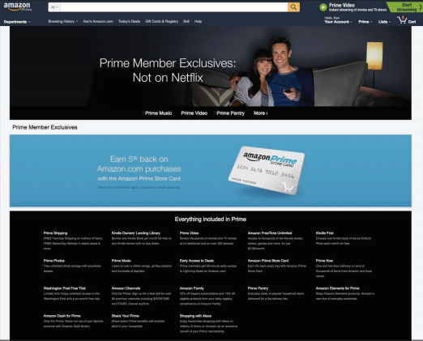
Amazon. Fair Use

The U.S. Census Bureau’s eStats Report shows that ecommerce makes up an increasingly larger percentage of overall U.S. commerce each year. However, it is getting increasingly difficult to draw a clear line between ecommerce transactions and other types of transactions. That’s because shoppers are combining online and in-store shopping to make purchases in the most convenient and economical way. Even so, online-only retailers like Amazon are experiencing double-digit annual growth, and the volume of online business transactions has gone through the roof. Shipping companies such as FedEx and UPS are raking in the profits as they expand their fleets of delivery vehicles to deliver vastly increasing amounts of merchandise. Customers can purchase merchandise with just a couple taps on a smartphone, and membership programs like Amazon Prime make online shopping more attractive by offering free shipping and other perks.
As you read about ecommerce, consider how it is affecting our lifestyles and business profits as well as commerce in general. With the convenience of ecommerce, are people purchasing more? What is the impact on the U.S. economy? On the global economy? If you were a business owner, how would you take advantage of ecommerce technologies?

An increasing percentage of commerce is conducted online. From grandparents to grade school kids, just about everyone is spending money online. Kids’ favorite meeting places used to be the playground or the mall, but today thousands are meeting, playing, and spending their parents’ money online at social sites like Club Penguin, Moshi Monsters, Animal Jam, and Webkinz World and on thousands of mobile apps. Brick and mortar businesses like Build-A-Bear Workshop are feeling the pressure from online sites and creating their own online presences—such as combearville.com, where kids can make their stuffed and plushy friends come to life in a virtual town. But young people make up only a small portion of ecommerce purchases. All generations have become comfortable shopping online. When planning travel, a night on the town, or a shopping spree, most Internet users begin with online research, and often conclude with an online purchase.

Ecommerce works to address every aspect and stage of buying and selling—from advertising products to searching for products, from managing a warehouse to arranging delivery. The buying and selling process occurs at many levels and includes numerous scenarios. It could be a multimillion-dollar deal between an auto manufacturer and an auto parts manufacturer, or it could be $5 transferred between friends on their cell phones.

Stages of the Buying and Selling Process
Buying | Selling
Realizing a need | Conducting market research
Researching products | Manufacturing products
Selecting a vendor | Marketing and advertising
Placing orders | Accepting orders
Providing payment | Processing payments
Accepting delivery | Arranging delivery
Accessing product support | Providing after-sale support

When ecommerce is carried out over mobile devices, it’s sometimes called mcommerce. Mcommerce includes purchases made directly from cellular carriers, over mobile apps, via mobile web browsers, through text messages, and over contactless payment technologies like Apple Pay. With more people accessing the Internet on mobile devices than on desktop devices, many companies are prioritizing mcommerce over all other types.

Ecommerce can bring up ethical dilemmas, especially around marketing practices that threaten consumer privacy. Behavioral targeting practices and location-based advertising, reveal activities and lifestyle choices that consumers might prefer to keep private.

Ecommerce has also provided opportunities for fraudsters and criminals. Craigslist, eBay, and even Amazon have provided criminals with avenues to sell illegally acquired goods. Fraudulent business websites and email dupe visitors into providing credit card and other information, allowing thieves to steal identities and cash. Such occurrences have become so common that they are undermining the public’s trust in ecommerce.

Ecommerce also has had a big impact on globalization. When people and businesses shop online, the entire world is their marketplace. Ecommerce levels the playing field for new and small businesses, enabling them to compete with larger established companies. However, globalization has a negative impact on some local economies. A movement has sprung up around the U.S. that encourages consumers to “buy local” rather than giving money to businesses owned by strangers located elsewhere.

Lesson 14.1: Ecommerce

Lesson 14.1 Introduction
There are three primary types of ecommerce: Business-to-Consumer (B2C), Business-to-Business (B2B), and Consumer-to-Consumer (C2C).

When you think of ecommerce, you probably think of websites like Amazon.com. B2C sites like Amazon are just the tip of the iceberg of ecommerce implementations. Some form of ecommerce is behind just about all business transactions today. Studying a variety of ecommerce implementations helps to understand the true importance of ecommerce.

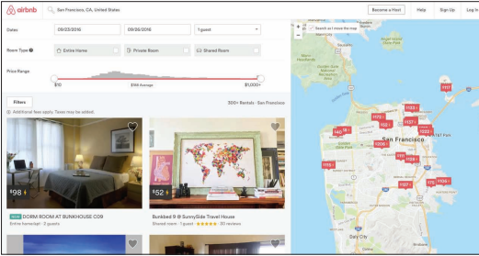
Airbnb, Inc. Fair Use

The roots of ecommerce lie in the 1970s and 1980s, when businesses extended their computer-based information systems beyond their corporate walls to connect with other companies’ systems, using electronic data interchange (EDI). EDI utilized private network services called value-added networks, or VANs, provided by telecom companies to transfer financial transactions safely and securely. Automating transactions using EDI drastically reduced the amount of paperwork and the need for human intervention.

The Internet provided the ideal platform for conducting EDI transactions as well as other forms of transaction processing between businesses. The web provided the first opportunity for businesses to conduct transactions with consumers over a computer network. Businesses and consumers alike embraced doing business online.

Today, there are three primary forms of ecommerce: B2C, B2B, and C2C. Web companies like Amazon.com represent a form of ecommerce called B2C. Business-to consumer, or B2C, ecommerce uses the web or mobile apps to connect individual consumers directly with commercial sellers to purchase products. B2C ecommerce is sometimes called etail, a takeoff on the term “retail,” as it is the online equivalent of a brick-and-mortar retail store.

Although B2C is the most visible form of ecommerce, consumers’ online purchasing power pales in comparison to the amount of merchandise and services that businesses purchase online. Business-to-business, or B2B, ecommerce supports transactions between businesses across private networks, the Internet, and the web. Because businesses conduct frequent and high-volume transactions, B2B ecommerce is especially valuable. Although ecommerce makes up only 6.4 percent of all retail purchases, it makes up 27.7 percent of wholesale purchases and 60.9 percent of manufacturing purchases. Clearly, businesses have caught on to the financial benefits of conducting business online.

The third form of ecommerce is epitomized by the popular trend of consumers selling their own belongings on sites such as eBay and Craigslist. Consumer-to-consumer, or C2C, also called peer-to-peer, ecommerce uses the web to connect individuals who wish to sell to other individuals. Although eBay supports all forms of ecommerce, many credit it with being the first C2C ecommerce website. Craigslist, the online classifieds website, is a popular C2C site with more than 50 million people selling and buying items each month.

Read on to learn a lot more about how buyers and sellers take advantage of the benefits that ecommerce offers over all three types: B2C, B2B, and C2C.

Reading: Business-to-Consumer Ecommerce
Business-to-Consumer (B2C) ecommerce uses the web or mobile apps to connect individual consumers directly with commercial sellers to purchase products.

Why This Matters
B2B ecommerce, sometimes referred to as etail, has dramatically influenced the way people shop by providing customers with product information and the ability to comparison shop online. As etail evolves, we may soon be able to click a button and have a product delivered to our doorsteps moments later by aerial drone.

Essential Information
There are several approaches to etail. A business can set up its own electronic storefront, such as www.landsend.com or www.target.com, and provide visitors access to an electronic catalog of products (that far exceeds what could be displayed in a store), an electronic shopping cart for items they wish to purchase, and an electronic checkout procedure. Another etail option is to lease space in a cybermall. A cybermall is a website that allows visitors to browse through a wide variety of products from varying etailers. Cybermalls are typically aligned with popular websites such as Yahoo!, Google, and MSN.

Ecommerce strategies are continuously evolving to offer customers more options, convenience, and savings. Consider Amazon, which began as a simple online bookseller. It then began selling other products online, much like Walmart sells products in stores. It then expanded to allow retail partners to sell merchandise through Amazon, vastly increasing its inventory and taking a percentage of all sales. Now, anyone can sell new or used items through the Amazon website, which provides shoppers with a choice of vendors for many items and with the ability to purchase used merchandise.

Amazon further extended its domain to include local services. Amazon Home Services connects homeowners with local professionals in home services including painters, plumbers, electricians, cleaners, and landscapers. Amazon vets the service providers to assure high quality.

Amazon Prime provides additional benefits to shoppers. For a $99 annual fee ($49 for students), members enjoy special discounts, free movies, books, and music, and free two-day shipping on most items—a model that Google has adopted for its etail service as well.

Google, Amazon, and other etailers are experimenting with new technologies to reduce barriers to purchases. Amazon Dash provides shoppers with programmable buttons that can be placed around the house to automatically order an item when pressed. For example, you might stick the kitty litter button on the wall next to the litter box, where you can conveniently click it when you run out of kitty litter. Amazon’s Echo device for the home features an intelligent personal assistant named Alexa that allows residents to conveniently place orders for merchandise using voice commands: "Alexa, buy more kitty litter!"
Both Google and Amazon offer same-day delivery for specific products and locations and are experimenting with drone delivery systems. The systems would be invaluable for delivering products to remote areas, but ultimately the companies hope to provide this new mode of delivery for everyone. However, drone systems have encountered pushback from the Federal Aviation Administration.

Increasingly, especially in regard to digital media, etail is being integrated with branded devices and services. Amazon sells more ebooks than paperbacks due to the ease with which ebooks are sold and downloaded to tablets, smartphones, and other devices. Apple became the largest distributor of digital music due to the large number of people using its iTunes software on their various devices.

Apple, Microsoft, Google, and Amazon are all fighting to become your primary source for purchasing or renting all kinds of media—music, books, magazines, newspapers, games, apps, movies, and television shows. These media and services are sometimes tied to devices. For example, Google’s online media store, named Play, is designed to supply media to Android mobile devices. Apple iTunes is best used on iPhones and iPads. Microsoft’s Xbox Music delivers tunes to Windows-based devices. Of the big four, Amazon is the only company that delivers digital media to all kinds of devices with equal convenience. Consumers must choose which digital “ecosystem” they wish to buy into.

Reading: Consumer-to-Consumer Ecommerce
Consumer-to-Consumer (C2C) ecommerce provides a platform for individuals to sell their belongings, products, and services to other individuals.

Why This Matters
Through the convenience and empowerment of ecommerce and the application of human ingenuity, the benefits of being able to sell products and services online has extended beyond traditional businesses to individuals. Today it’s easier than ever to make money by selling your unused stuff, or to start your own home-grown business.

Courtesy of eBay. Fair Use

Essential Information
Not too long ago, there were significant barriers that hampered the ability of people to sell online. A commercial bank account was needed to process credit card transactions. A special web hosting service was required to provide a commercial website, inventory navigation, shopping cart, and checkout services. There were legal considerations, liability concerns, and taxes to be paid, not to mention complicated shipping logistics. But, as ecommerce has grown, platforms have emerged to remove many of these barriers and empower individuals to profit from ecommerce.

Kickstarter. Fair Use

Ebay was one of the earliest such platforms to emerge. Ebay was originally designed as an online auction for individuals to sell their unwanted belongings. Over time it evolved to support all types of transactions between all kinds of people and organizations. Key to eBay’s success was its sister company PayPal, one of the earliest online payment systems, allowing regular individuals to conduct transactions by transferring funds between credit cards and bank accounts. Ebay also introduced online shoppers to the use of a reputation management system that helped build trust in sellers and buyers.

Craigslist followed eBay in establishing C2C as a significant force in ecommerce. Craigslist is a network of online communities that provides free online classified advertisements. It is a popular online marketplace for purchasing items from local individuals. Today, shoppers turn to Craigslist rather than going to the classifieds in the local paper.

Upon observing the success of eBay and Craigslist, Amazon began supporting sales from non-business entities. Many others have followed suit: Etsy, ArtFire, and Zibbet for selling handmade crafts, Lulu for self-publishing books, Soundcloud for selling music. The vast majority of C2C platforms make money by charging membership fees, taking a percentage of money from sales, or both.

Another genre of C2C, known as crowdfunding, allows entrepreneurs to solicit for investment in products. Websites like Kickstarter and Indiegogo provide investors with early access to promising products in exchange for a financial investment. Other crowdfunding applications raise money for philanthropic purposes. For example, Kiva accepts donations in small amounts (microcredit) to support new businesses in developing countries. Gofundme.com provides crowdfunding for anyone with an idea or need that can raise money. Crowdfunding platforms exist for every type of project and need from major corporate investment, to wacky inventions, to costly medical procedures. Along with the benefits provided by crowdfunding, there are significant risks. Sometimes items promised are never delivered. For this reason, reputation plays a big role in the successful use of these platforms.
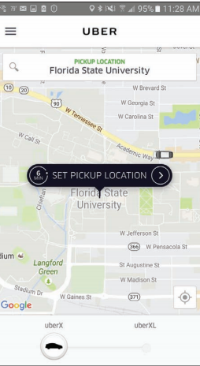
Uber Technologies. Fair Use

C2C has also impacted service industries. Perhaps Uber is the most easily recognizable example. Uber connects passengers with drivers willing to give them a ride through its easy-to-use mobile app. Founded in 2009, Uber has grown to include over 200,000 drivers around the world. Like many C2C platforms, Uber has disrupted an established industry—in this case the taxi industry.

Reading: Business-to-Business Ecommerce
Business-to-Business (B2B) ecommerce supports transactions between businesses across private networks, the Internet, and the web.

Why This Matters
Ecommerce was born out of the necessity for businesses to conduct transactions online. The earliest forms of ecommerce utilized private EDI networks to submit orders and transfer funds between businesses and banks. Over time, the online exchanges moved to the Internet, becoming more robust and supporting many business operations. Today, ecommerce is integrated into the daily operations of most businesses.
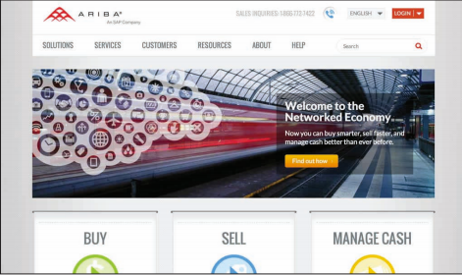
Courtesy of Ariba. Fair Use

Essential Information
Many B2B transactions are supported by the same mechanisms used in B2C. For example, a business might purchase large supplies of copy machine paper from the business solutions website provided by Office Depot. All that is required is an account that verifies your business, and you are given bulk rate pricing. You can peruse the catalog, add items to your shopping cart, and pay from your business credit account just as you would from the regular Office Depot site. In addition to standard ecommerce sites, special platforms have been developed specifically to support business needs.

A global supply management (GSM) service provides methods for businesses to find the best deals on the global market for raw materials and supplies needed to manufacture their products. There are many GSM products and services that promise to lower a business’s costs by providing connections to a wide variety of reputable suppliers, along with negotiation tools that enable a business to be assured that it is getting the best deal.

Ariba, a GSM company, advertises that its services and software can cut total supply costs by 45%. Alibaba is another GSM company that has been instrumental in building international relationships between businesses and in the global marketplace in general. GSM companies use a number of descriptive titles that include collaborative business commerce solutions and spend management services, but the gist is always the same—these services are intended to find the best deal for buyers in B2B transactions.

An electronic exchange is an industry-specific web resource created to provide a convenient, centralized platform for B2B ecommerce among manufacturers, suppliers, and customers. Some businesses join together with others in their industry to pool resources in web-based electronic exchanges. Electronic exchanges promote cooperation among competing companies for greater industry-wide efficiency and effectiveness. Through an electronic exchange, a manufacturer has access to a wide variety of industry-specific suppliers and services. Once business relationships are established among members, the electronic exchange provides the framework for fast and efficient transactions.

Covisint is an electronic exchange for a number of industries, including automotive manufacturers and healthcare. Founded by DaimlerChrysler AG, Ford Motor Company, General Motors, Nissan, and Renault, Covisint has created alliances among automotive manufacturers and suppliers and contracted several of the largest technology providers to create what Covisint claims is “the most successful business-to-business electronic exchange the world has ever seen.” Covisint members have access to online catalogs and auctions, tools that assist in quality management and problem solving, and the industry portal shown in the figure.

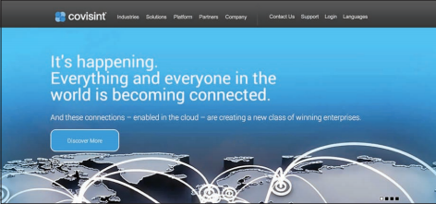
Courtesy of Compuware Corporation. Fair Use

Reading: Ecommerce Tools, Techniques, and Technologies
Ecommerce requires special tools, techniques, and technologies to address all of the stages of the buying and selling process in a manner that takes advantage of the latest innovations in computing.

Why This Matters
Buying and selling online requires new tools not required in the traditional shopping process. These include tools that get products into the public awareness, safeguard transactions, deliver products, and support financial transactions. In order to shop online efficiently and safely, one must understand these tools, techniques, and technologies.

Essential Information
Ecommerce companies must constantly consider how new breakthroughs in technology can be applied to support the buying and selling process. The level of speed and convenience provided by an ecommerce system can provide a company with a competitive advantage over its rivals. For example, the airline industry embraced QR codes and scanners to allow boarding passes to be scanned from passengers’ smartphones. Airlines that were able to provide this technology first were able to win over some customers from competitors.

The areas in which tools, techniques, and technologies are applied to empower online buying and selling include the quality of a company’s website and/or mobile app, the manner in which products are marketed, the level of customer trust a company has earned, the ease with which payments are accepted, and the speed with which products are delivered. These are the areas targeted in this section.

Reading: Ecommerce Host
An ecommerce host is a company that takes on some or all of the responsibility of setting up and maintaining an ecommerce website and system for a business.

Why This Matters
Setting up and maintaining the infrastructure necessary for ecommerce is a big job. Most companies choose to outsource these tasks to professional ecommerce hosting companies. Hosting companies manage large servers that provide all the necessary software tools to deliver ecommerce applications, including an online catalog, a shopping cart, and transaction processing. Ecommerce hosting sites maintain backups of online data and guarantee an extremely high percentage of uptime—time that the system is functioning without problems—typically above 95%. Many hosting companies also offer online marketing strategies to help ecommerce sites succeed. Put simply, ecommerce hosting sites are often better equipped to deliver a quality online presence than the businesses they serve.

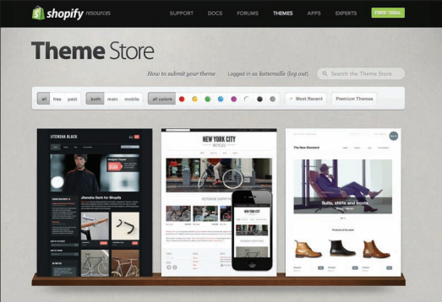
Shopify. Fair Use

Essential Information
Hosting services range in price from under ten dollars a month to thousands of dollars per month, depending on the size of the business and the services offered by the host. Companies such as Shopify provide everything needed for a simple ecommerce online business—online catalog, shopping cart, and transaction processing—beginning at about $29.95 per month. For more money you can get more storage space, accommodations for larger inventory (stock-keeping units or SKUs), lower transaction fees, and additional services. See the table below for some of the options for typical ecommerce hosting services.

Sample Web Hosting Packages
Feature | Basic | Pro | Business | Unlimited
Monthly fee | $29 | $50 | $99 | $179
Bandwidth | Unlimited
Storage | 1 GB | 5 GB | 10 GB | Unlimited
SKUs | 100 | 2500 | 10,000 | Unlimited
Transaction fee | 2% | 1% | 1% | 0%

Very large companies with more complicated systems might contract IBM or Sprint to work with their business to develop web ecommerce solutions at a considerably higher cost. For example, Office Depot contracted IBM to design and implement a complex web-based system that would accommodate transactions with customers and businesses.

Because many people shop online from mobile devices, many of today’s ecommerce hosting companies also provide mobile app development services. Companies can select to have an ecommerce website that is responsive and easily navigable on desktop or mobile devices, or an app that can be installed on iPhones, iPads, or Android devices. An installed app offers the benefit of existing as an icon on the mobile device desktop. Installed apps may also provide additional features. The Amazon app, for example, allows you to scan a bar code with your phone camera to quickly find items in its inventory. The Walmart app allows you to quickly find the aisle where a product is located in your local store.

Reading: Online Marketing
Online marketing employs many strategies to make consumers aware of goods and services available for purchase online.

Why This Matters
As people migrated to the web as their primary source of news, information, and entertainment, businesses were forced to move their advertising dollars online to garner attention. While advertising online is essential for businesses to stay afloat, it is also essential for many websites and services that offer their content for free but still need to make money. There are many methods for marketing online, including search engine optimization, online business partnerships, ad-sponsored websites, games and apps, ads on search engines, via social media and by email, and location-based ads.

Essential Information
The Internet and web provide opportunities for businesses to catch the eye of many more users than through traditional advertising media. Businesses provide informative websites for their products and services, making it much easier for customers to discover products that suit their needs. The trick for businesses is getting users to find and view their advertisements and websites.

Search engine optimization is a set of techniques that businesses use to get search engines to place their links higher in the list of search results. The ultimate goal is to be the first link returned from a user’s search on any related search term. However, competition is such that most businesses are happy just to appear on the first page of search results. To accomplish this, businesses create their webpages in a manner that allows search engines to easily identify the content and intent of the page. Then, they work to get other reputable businesses and individuals to link to their sites from their own pages in order to build a good online reputation. Search engines often use a popularity index to determine which sites are most useful and reputable, and they will place those sites high in search results.

Many free web services are financed with advertisements. Facebook, Google, Yahoo!, and other large Internet companies charge significant amounts to place ads on their sites. Some ads may be annoying and impossible to miss, as in the case of some banner ads, pop-up ads, and ads that block the page until either you close them or a certain amount of time passes. Other ads may be subtle—targeted and designed not to intrude on the user experience—such as ads placed in the margins on Google and Facebook. Not only have ads become common on websites, but they have also begun to pop up in unexpected places like games and mobile apps. Which types of ads are most effective depends on the product and the customer.
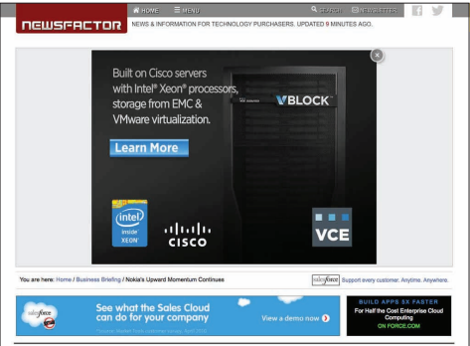
Courtesy of NewsFactor. Fair Use

Companies continue to test the limits of what their viewers will tolerate when it comes to ads. Facebook has moved from ads in the sidebar to ads embedded in the newsfeed, to silent videos in the newsfeed, and is now experimenting to see if its members will tolerate video ads with audio enabled in their timeline.

Many people have installed browser plugins called ad blockers to block online ads. Companies like Facebook have used techniques to get ads past the blockers, but shortly thereafter updates come out to counter those actions leading to what is referred to as ad wars.

You’ll probably agree that what friends say about products is much more useful than what a company says about its own products. Social media plays a large part in online advertising as companies work to get customers to spread the word about their products. Businesses can create pages on Facebook or Google+ that users can “follow” or “like.” Businesses are smart to observe what others are saying about them on social media sites. Reputation management is the practice of tracking what users are saying about a company, online and elsewhere, and working to minimize negative comments and propagate positive ones.

Businesses can also reach out to the public through email and other messaging services. If a customer has a good relationship with a particular company, then advertising items of interest may be well received. Unfortunately for the advertisers, many of their advertisements are considered spam and are either automatically filtered out by the email service or immediately trashed.
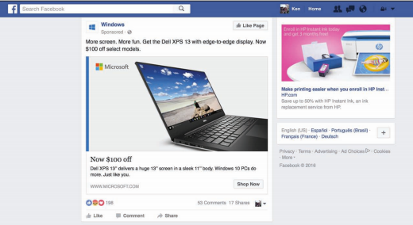
Facebook. Fair Use

Location-based advertising uses location technologies like the GPS and compass in smartphones to provide mobile users with shopping information and coupons for businesses near their current location. When users “check in” to a location on apps like Foursquare, they may be presented with a coupon for a discount. On slow days, a business may opt to run ad-hoc specials to lure passersby. Based on a customer’s profile, the deal can be customized to meet what the customer is likely to be willing to spend.

Today’s marketing practices integrate all forms of advertising into one cohesive package. Integrated marketing combines television and radio advertising, print advertising, and web advertising—especially on social media—taking advantage of the unique features of each type of media to promote and spread a common message and brand image. Many businesses are calling on professional marketing companies to assist with extending their brand presence to social media.

Reading: Online Reputation
Online reputation has become an important consideration when choosing businesses, people, products, and services to work with or purchase online.

Why This Matters
Online sellers must build their reputation in order to win over customers. Online buyers need to be cautious about whom they do business with to avoid the many hustlers and frauds who make a living taking advantage of the gullible and vulnerable. Understanding online reputation helps everyone conduct business in a safe manner.
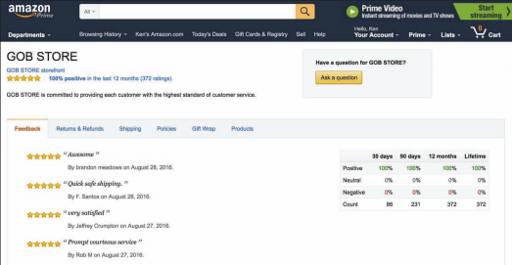
Amazon. Fair Use

Essential Information
It’s hard to know who to trust online. Technologies such as digital certificates help to identify a business as legitimate and transactions as safe, but do not ensure that you are dealing with a reputable business.

As mentioned earlier, eBay was one of the first online ecommerce platforms that offered a rating system for buyers and sellers. Such systems have become standard for online retailers and marketplaces like Amazon and Google. Not only are such rating systems useful in gaining trust in a business, but they also serve to show customer satisfaction with products and services. Although such systems can be “gamed” by some users to provide false information for the good of the company, when the feedback gets up into the hundreds or thousands of buyers, the rating is likely to indicate the quality of the product or company.

Most large businesses invest in reputation management services. In fact, a whole industry has grown up around this service. A reputation management company provides services that include analyzing the online reputation of a company and advising changes to result in improved online image, scouring the web for negative comments or image-tarnishing content and working to have the content taken down, and promoting the company in a manner that results in positive feedback.

As you consider the online reputation of businesses, consider your own online reputation. It is common practice for employers to search the web to learn what they can about the reputation of job candidates. It’s never too soon to work on your own reputation management.

Reading: Electronic Payment Systems
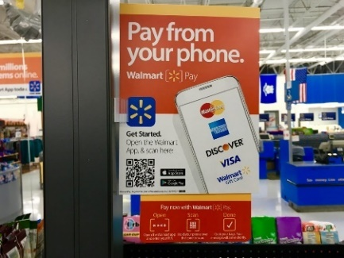
"Walmart Pay, 9/2016, Pay from your phone!, pics by Mike Mozart of TheToyChannel and JeepersMedia on YouTube #Walmart #Pay #Phone" by JeepersMedia is licensed under CC BY 2.0
Tech companies, banks, and credit card companies are all heavily invested in developing electronic payments systems based on new technologies designed to do away with cash, credit cards, and wallets.

Why This Matters
Electronic payment systems facilitate online payments in situations where buyers or sellers are unable to participate in a standard cash or credit card transaction. Apple, Google, Samsung, and others are all hoping that you’ll buy into their payment systems, so that they can support all of your financial transactions.

Essential Information
In most ecommerce transactions, the customer typically pays with a credit card number (B2C) or a merchant account number (B2B). Using a secure encrypted connection, the buyer enters the account information into a web form and submits it. The merchant’s web server passes the information along to the payment processing system, which checks the validity of the account number and the balance in the account. If the credit card checks out, the transaction is processed. The only difference between online credit card processing and in-store processing is that laws require online retailers to wait until shipping the product to deduct funds from the credit card. Because of this, etailers put a hold on the funds until the product is shipped, at which time the funds are transferred.

Electronic payment systems, sometimes called digital wallet services, provide a private and secure method of transferring funds from a bank account or credit card to online vendors or individuals. Early systems, provided by companies like PayPal, were designed to manage transactions on the web. The more recent generation of payment systems is designed for mobile payments.

Apple Pay, Google’s Android Pay, Samsung Pay, and similar technologies utilize smartphones with near field communication technology, such as RFID, to allow shoppers to swipe their phone at checkout to pay for items. With these payment systems, shoppers can pay for products by clicking a button in a mobile app. The idea is to store a user’s financial data, such as credit card information, online with one service. That service can then be used to conduct transactions that take place both online and in stores, using an app. Even Amazon and Facebook are getting into ecash, allowing customers to pay for items using their Amazon or Facebook login.

Payment systems are extending to wearable devices. Owners of Apple Watches can pay at checkout by swiping their watch over the scanner. Google’s Hands-Free app bypasses the need to get your phone out. At checkout, just say, “I’ll pay with Google,” and the cashier will confirm your identity using face recognition technology and send you on your way.

Some aren’t satisfied with streamlining transactions; they want to improve currency itself. Bitcoin is a digital currency introduced in 2008 to replace the common currencies of the world. Bitcoin transactions take place online, with vendors that accept the currency, are verified by network nodes, and recorded in a distributed ledger called a blockchain. Because Bitcoin requires no central authority, it is considered a decentralized digital currency.

Bitcoin is accepted by over 100,000 merchants worldwide. It is the standard currency of hackers on the darknet where stolen and illegal goods are bought and sold. Bitcoin is ideal for illegal transactions because it cannot be easily traced. The value of a Bitcoin varies widely.

Reading: Shipping
"IMG_0050" by techmsg is licensed under CC BY 2.0

Shipping has become a major concern for ecommerce companies seeking to maximize efficiency and effectiveness in product delivery.

Why This Matters
Amazon and Google are able to fulfill orders in two days for most products and locations, and the same day for particular items in limited locations. Both companies want to do better and are utilizing new technologies and strategies to shave time off of deliveries. Some day in the not too distant future, you will be able to click a button on the screen of your phone, anywhere in the world, and have the product handed to you in under an hour.

Essential Information
The race to see which company can deliver goods to your doorstep fastest is on! In December of 2013, Amazon captured the attention and imagination of the world when it announced that it was planning to deliver goods via unmanned aerial vehicles, better known as drones. In 2014, Google revealed that its researchers had been testing drone delivery for two years in a project named Project Wing. Since then companies around the world have been making the news with pilot programs delivering everything from medical supplies to pizzas via drone aircraft. Although implementation of drone delivery has been slowed by safety concerns from the U.S. Federal Aviation Administration and similar agencies abroad, it’s clear that this method of delivery will eventually be utilized.

Drones aren’t the only method for shaving hours or days off delivery times. Amazon has invested in a fleet of 737s to assist in taking control of its delivery systems. Rather than relying on FedEx, Amazon figures it can streamline the movement of merchandise around the country and world by owning its own airplanes. The company has also bought a fleet of trailer trucks.

Some companies are looking to crowdsource delivery. That is, they hire people heading in the right direction to deliver a package along the way, for a small payment. Amazon has been experimenting with this idea in a program named “On My Way.”

These efforts make it clear that the winners in ecommerce will be companies that are most successful at streamlining all of the components of the buying and selling process. Today, much of the focus is on delivery.

Lesson 14.2: Ecommerce Tools

Lesson 14.2 Introduction
Business systems are computer-based information systems that provide organizations with valuable information in a timely and effective manner to allow the functional areas of the enterprise to work together to achieve goals.

Decisions lie at the heart of just about everything people do. It is impossible to get through a day without making many decisions—some large, some small. In our careers, some decisions can have great significance and affect many other people. Business systems are designed to collect, store, and disseminate information needed to make good business decisions in all types of jobs and all types of professions.

Satellite television giant DIRECTV adopted business system software from a company named SAS to analyze its customer billing data. DIRECTV has complex billing systems that are used by nearly 20,000 customer service agents offering dozens or hundreds of different promotions, offers, discounts, and modified pricing plans at any given time. Put it all together and the potential for errors in billing and payments is high and could be very costly. SAS business systems software scoured all transaction data in DIRECTV’s database, and identified $10 million in revenue leakage.

DIRECTV isn’t alone. T-Mobile analyzes huge amounts of data that it collects on its customers in order to identify which customers are likely to switch to a different carrier and then make them offers to keep them happy. The Orlando Magic uses data analytics to provide fans with merchandise they like at prices they are willing to pay, making the team one of the top revenue earners in the NBA despite being the 20th largest market.

The world’s financial health is dependent on an information economy. Businesses generate profits based on how well they collect, interpret, and act on information. Not only do businesses depend on the flow of information, but governments, nonprofit organizations, research institutes, and others also benefit greatly from information management and analysis. As you read this unit, consider what information is useful for professionals in areas that interest you. How have the leaders in those industries profited from collecting and interpreting information?

There are many different business systems designed for various types of businesses, various functional areas within business, and different activities within business processes. For example, a transaction processing system, or TPS, is a business information system used to support the process of making a purchase; a management information system, or MIS, provides all types of factual information to managers to assist them with decisions; and an enterprise resource planning, or ERP, system is designed to connect all of the information systems within a business into one cohesive system.

This section covers the most common types of business systems used in today’s businesses and organizations and discusses how those information systems are developed. Whether you intend to work in a large organization, be part of a small to medium-sized business (SMB), or run your own business, knowledge of business systems is essential to your success.

Information systems are able to “connect the dots” from many data sources to provide insight into otherwise neglected facts. While this process is often unobtrusive—such as tracking market trends—it can at times intrude into individuals’ private lives. Businesses and governments are able to piece together information from many sources to build a detailed profile of an individual. Since most significant actions that people take are recorded digitally through business transactions, government records, phone records, and online activity, today’s information economy is slowly but surely eroding privacy. Although businesses may be able to offer customers a higher level of service by targeting their interests, some individuals feel that their privacy is being violated in the process.

When information systems “go bad,” they have the potential for causing major problems. Bugs in information systems, as well as human error and threats to information security, can result in identity theft, fraud, financial loss, and serious damage to a business. Some worry that society has become overly dependent on information systems and will ultimately pay the price.

Reading: Information Management
Information management refers to software and computer-based systems dedicated to collecting, storing, and manipulating data in a manner that produces useful information on which to base decisions.

Why This Matters
If there is one lesson in business that has proven to be important, it is that information is power. In business, government, or any goal-oriented endeavor, the more accurate the information you have to work with, the more efficiently and effectively you will reach your goals. The challenge is in discovering which data is important and which is insignificant. This is the era of “big data,” where our online dealings and transactions are generating enormous amounts of data each day. Our ability to collect and analyze that data to produce actionable information has become increasingly difficult, but remains one of the most valuable business activities.

Essential Information
There are thousands of different types of systems designed to manage information—millions if you count the custom-designed systems that are used in many businesses. However, most can be classified under one of four general headings: transaction processing systems, management information systems, business intelligence systems, and expert systems.

These four types of systems build one upon the other and become more complex and intelligent to serve various purposes, as shown in the opening figure on this page. A transaction processing system (TPS) serves as a foundation to the other systems. It collects information about transactions, including the sale of merchandise and services, the salaries paid to employees, and purchases of raw materials. A management information system (MIS) draws information from the database of transactions and other sources to inform managers of the state of operations such as inventory amounts, sales statistics, and product performance. A business intelligence (BI) system draws on information from an MIS, a TPS, and other sources to provide problem-specific information to assist decision makers. An expert system applies artificial intelligence techniques, drawing from information provided from other systems to aid higher-level decision making.

Since expert systems fall under the heading of artificial intelligence, they are covered in the AI section of Emerge with Computers. Other types of information management systems that are having a global impact include geographic information systems and medical and biological informatics.

Reading: Transaction Processing System
A transaction processing system (TPS) is an information system used to support and record transactions such as paying for products or paying an employee.

Why This Matters
Transaction processing takes place in many different environments, and the systems that support them are created to suit the environment. The electronic checkout system at Amazon.com is a TPS, as is the checkout system at your local bookstore or grocery store. The payroll system that calculates an employee’s pay and cuts a check is also a TPS. The ATM at your bank is a TPS, as is the keypad on a gas station pump. Newer forms of TPS include mobile payment systems that allow you to tap your smartphone against a pad at check out. The TPS is the foundation of today’s economies.

Essential Information
A transaction is a commercial exchange involving goods, services, and/or money, such as buying medical supplies for a hospital or purchasing and downloading music on the Internet. A transaction processing system (TPS) is an information system used to support and record transactions, such as paying for products or paying an employee. The transaction information collected by the TPS is fundamental to the operation of other information systems that support important decision making. For example, the company contracted to provide food services for a college campus uses a TPS to collect sales information from the cashier’s point-of-sale terminal in the school cafeteria. That sales information is then processed by another information system, such as a management information system (MIS), to determine which food items are selling best. Items that aren’t selling may be either discounted or discontinued and replaced with new items. Through this approach, the food service provider can use the transaction information to continuously improve both its service to customers and its profit margin.

Businesses and banks can collect massive amounts of consumer information from transaction data. To gain access to that information, businesses, banks, and tech companies are all competing to process your transactions. Apple would like you to use Apple Pay for your purchases; Google would like you to use Google Wallet; Samsung wants you to use Samsung Pay and banks would like everyone to use credit card-based systems. As more and more consumers embrace mobile payment systems, the competition in this area is heating up.

All forms of transaction processing systems share a common set of activities called the transaction processing cycle. The stages of the transaction processing cycle include the following:
- Data collection: Capture transaction-related data such as item number, quantity, and payment method
- Data editing: Check validity of the data entered, such as whether the item number and credit card number are valid
- Data correction: Request correction if data editing reveals invalid data
- Data manipulation: Process the transaction data and calculate totals, tax, shipping, etc.
- Data storage: Store transaction-related data in the transaction database
- Data output: Output receipts, picking lists for the warehouse, or other documents
In each step of transaction processing and in each subsystem, businesses strive to carry out the action in a streamlined manner with the least amount of effort and cost and the highest amount of speed and quality. In this way, transaction processing systems can assist a business in gaining an edge over the competition.

Reading: Management Information System
A management information system (MIS) provides routine business information to decision makers in a useful and convenient format.

Why This Matters
The primary purpose of an MIS is to help individuals, businesses, and organizations achieve their goals by providing reports and information to make better decisions. Individuals, for example, might want to get reports from their doctor on the results of a routine physical exam. A business manager uses MIS reports to maintain inventory levels so that there are no shortages or surpluses. By filtering and analyzing highly detailed data, an MIS can provide information to help people and businesses make important decisions.

Essential Information
An MIS is fueled by databases. It pulls data from one or more databases, sorts and sifts the data based on specific criteria, and produces reports of useful information. The primary source of input for a business MIS is its transaction database. Transaction processing systems record data in a database for every transaction within a business—credits and debits. An MIS can mine transaction data for interesting trends and important statistics. For example, a hotel chain may find that occupancy at its hotels that provide free wireless Internet access is 8 percent higher than in locations where there is a fee for Internet access. Using this information, management may determine that the money made from Internet access is not as much as would be gained by an 8 percent increase in occupancy, and begin offering free Wi-Fi at all hotel locations. An MIS may also access data from other internal databases, such as inventory and personnel, and external databases, such as stock market prices or weather reports.

The output of most management information systems is a collection of reports. These reports can be produced on paper or electronically. The primary types of reports are:
- Scheduled report: Produced periodically or on a schedule, such as daily, weekly, or monthly.
- Key-indicator report: Special type of scheduled report that summarizes the previous day’s critical activities and is typically available at the beginning of each workday.
- Demand report: Developed to retrieve certain information at a person’s request—in other words, these reports are produced on demand.
- Exception report: Automatically produced when a situation is unusual or requires action.
The following table lists the types of reports associated with the various functional units of a business, illustrating how MISs are integrated with all areas of an organization’s operations.

Types of MIS Reports
Business area | Reports
Financial | - Payables  - Receivables  - General Ledger  - Profitability
Human Resources (HR) | - Compensation  - HR Performance  - Retention Workforce Profile and Compliance
Order Management and Fulfillment | - Business Performance  - Billing  - Order Fulfillment
Supply Chain | - Procurement and Spending  - Supplier Performance  - Inventory
Sales | - Profits by Product  - Profits by Customer  - Competition Analysis
Service | - Service Effectiveness  - Employee Effectiveness  - Customer Insight
Contact Center | - Customer Service  - Agent Performance  - Service and Delivery Cost  - Contact Center Sales
Marketing | - Marketing Planning  - Campaign Performance  - Customer Insight

Reading: Decision Making
"What's Your Next Move?" by Maurits Verbiest is licensed under CC BY 2.0

Decision making is the key component of the problem-solving process and takes place in three stages: intelligence, design, and choice.

Why This Matters
One of the highest compliments is to be recognized by your friends and coworkers as a real problem solver. In general, problem solving is the most critical activity an individual or organization undertakes. It makes the difference between success and failure, as well as between profit and loss. Computer-based information systems are extremely valuable to individuals, businesses, and organizations in their support of making the best decisions. To understand how information systems support the decision-making process, it helps to understand the process itself.

Essential Information
Individuals, businesses, and organizations must make decisions in order to solve problems and take advantage of opportunities. The process of problem solving begins with decision making. Decision making takes place in three stages: intelligence, design, and choice. Problem solving includes and goes beyond decision making to implement a solution and monitor the situation.
- Intelligence stage: In the intelligence-gathering stage, problems and opportunities are identified and defined. Information is gathered that relates to the cause and scope of the problem or opportunity. The problem or opportunity environment is investigated, and things that might constrain the solution are identified.
- Design stage: During this stage, alternative solutions to the problem are developed. In addition, the feasibility and implications of these alternatives are evaluated.
- Choice stage: This stage involves selecting a course of action.
- Implementation stage: In this stage, action is taken to put the solution into effect.
- Monitoring stage: In this stage, the decision makers evaluate the implementation of the solution to determine whether the anticipated results were achieved and to modify the process in light of new information learned during the implementation stage. The monitoring stage involves a feedback and adjustment process.
Businesses prefer to be proactive in their problem-solving approach, seeking out potential problems before they become serious. The alternative, being reactive, puts a business at a disadvantage, always struggling to move forward.

Programmed decisions are easy ones that are made based on experience, using a rule, procedure, or quantitative method. Nonprogrammed decisions, however, deal with unusual or exceptional situations. In many cases, these decisions are difficult to represent as a rule, procedure, or quantitative method. Programmed decisions are easy to automate with a computer system, while nonprogrammed decisions often require human intelligence.

Mind mapping software serves as a powerful tool to assist in decision making. A mind map is a graphic representation of the variables and components of a problem or solution and the relationships between them. Using a mind map, decision makers can map their way to an organized solution with careful consideration to all the details.

Reading: Business Intelligence Analytics
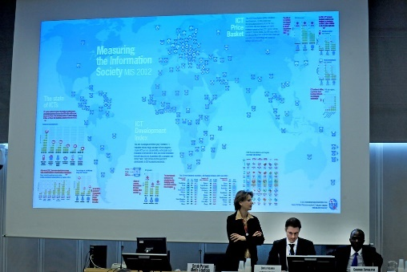
"Measuring the Information Society 2012" by ITU Pictures is licensed under CC BY 2.0

Business intelligence (BI) and analytics refer to technologies that are used to gather and report information that supports intelligent business decision making.

Why This Matters
BI is a contemporary term for an MIS designed for specific business needs. BI has become a buzzword in business because of its ability to propel a company forward. In this era of Big Data, data analytics has presented corporations with their greatest challenges and opportunities. Good business intelligence makes for smarter decision making, giving a company a strong competitive advantage.

Essential Information
Business intelligence (BI) systems analyze the information produced by MISs and provide more precise insight into business operations and opportunities. BI often focuses on key performance indicators (KPIs) to analyze a business’s health. KPIs are statistics that provide insight into the state of a business, such as sales figures and social media activity. BI is a powerful tool for providing a business with a competitive advantage. Because of this, many technology companies are selling tools centered on business intelligence. Oracle has a division called Oracle Business Intelligence, Microsoft has SQL Server Business Intelligence, and IBM has Data Warehousing and Business Intelligence. BI differs from MIS in that it not only provides reports, but also provides the ability to forecast the future based on past events. Analytics is the part of BI that performs extensive analysis of data. It may include statistical and quantitative analysis, explanatory and predictive modeling, and other analytical processes. In this manner, BI can act as an informed advisor to business decision makers.

Some BI systems display key-indicator data together on one page in a format called an executive dashboard. Executive dashboards can display graphs and charts and allow the users to drill down into the data to view more detailed reports. Management information systems providers such as Cognos, SAS, IBM, and Oracle provide real-time reporting through a dashboard-style display that allows decision makers to stay connected to dynamic changes in the business.

Reading: Geographic Information System
"toursj" by *_* is licensed under CC BY 2.0

A geographic information system (GIS) captures, manages, analyzes, and displays geographically referenced information, often utilizing maps with overlaid data.

Why This Matters
Geographic information systems allow researchers in many professions to relate abstract data to physical locations in order to understand the interplay between conditions on the ground and situations or phenomena represented by the data. GISs are useful to everyone, but they are particularly useful to professionals who work with populations or geographic phenomena and data, such as urban planners, social workers, law enforcement personnel, sociologists, geologists, meteorologists, civil engineers, and those who work in government agencies.

Essential Information
A map is the quintessential GIS, relaying geographical information—city locations, roads, distances between cities, elevations, and other information—on a graphical representation of the earth. GISs typically overlay maps with data and information related to the geographic locations. The virtual earth applications from Microsoft and Google are popular GISs. Using satellite imagery as a foundation, Google Earth and Microsoft Bing Maps overlay different types of geographic information, such as roads, traffic density, items of interest, weather, and different types of businesses. With the advent of GPS in mobile phones, GIS has gone mobile, providing travelers and pedestrians with directions and information on nearby businesses, attractions, and even friends.

While GIS systems are used by the general public every day, their real power lies in how they are leveraged in research and industry to make discoveries and inform decisions. A 911 operator uses a GIS to quickly determine the specific location of a caller with an emergency. Businesses use GISs to display sales information for a specific region of the country. Wendy’s uses ArcGIS software to determine the best location for new restaurants. The military uses GISs along with GPSs (global positioning systems) to target enemy forces. GISs are used to observe scientific phenomena, to assess the environmental impact of social action, to assist in urban planning, to assist law enforcement in identifying high-crime areas, to create effective marketing strategies, and to do many other professional activities. In any situation where a geographic location plays a role, GIS software provides strong support.

GIS software is an important tool for professionals in geography, meteorology, urban planning, criminology, and social sciences. Learning to use GIS software, such as Autodesk and packages developed by Esri, consumes large quantities of time for students studying in these areas.

Reading: Informatics
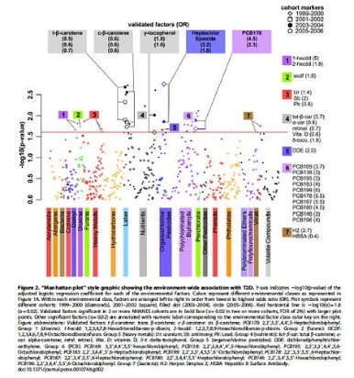
"Environement Wide Association Study" by kohane is licensed under CC BY 2.0

Informatics applies computer-based information system technologies to support traditional disciplines such as science and medicine.

Why This Matters
Traditionally, computer-based information systems have had a business focus—to provide information to decision makers to help their companies gain a competitive advantage. Today, professionals in many nonbusiness disciplines are utilizing computer systems to manage different types of information. Although informatics is a term that can be applied to all types of information systems, it is primarily used to describe the use of information systems in nonbusiness areas. Informatics is particularly popular in the sciences, where it is revolutionizing research in biology and helping to organize medical recordkeeping.

Essential Information
Bioinformatics and medical informatics are two areas where informatics has had a large impact.

Bioinformatics combines biology and computer science. Also called computational biology, bioinformatics has been used to map the human genome and conduct research on biological organisms.

Medical informatics applies information systems to traditional medical research. Medical informatics seeks to reduce medical errors and improve healthcare delivery by using computer systems and technology. The U.S. Centers for Disease Control and Prevention and the Office of the National Coordinator for Health IT have put in place several initiatives to standardize electronic health records (EHR) across the U.S. in efforts to improve public health.

Other areas of informatics include astroinformatics, organizational informatics, biodiversity informatics, cheminformatics, ecoinformatics, geoinformatics, neuroinformatics, and social informatics.

Many schools offer a degree in informatics, one that typically combines studies in a particular discipline (i.e. psychology) with studies in computing and information technologies in order to apply the technology to the particular discipline.

Reading: Enterprise Systems
Enterprise systems are information systems designed to support the functions of an enterprise, including knowledge management, content management, and customer relationship management as well as the integration of these functions into enterprise resource planning systems.

Why This Matters
Whether a business has only a few employees or is a global corporation with thousands of employees, it is important that everyone in the business have access to a common pool of information, preferably through a common user interface. Enterprise systems are designed to provide that common information framework. Enterprise is another word for business, but often it connotes a large, complex business with many interacting business units. Although enterprises are often very large global businesses, the information management practices of a large enterprise can also benefit small and medium-sized businesses. Enterprise systems are useful to businesses of every size.

Essential Information
In the several decades that computer-based information systems have been around, the role that they play in business has changed from supporting business processes to being an integral part of the process that businesses depend on to create and add value to their products and services. Today, information systems often control business processes, and good information systems provide a framework for best practices in business management. Information system developers pride themselves on understanding key elements of business practices that are most valued in an enterprise, and they design systems that provide innovative processes to give a business a competitive edge.

Information systems such as knowledge management, content management, and customer relationship management can make or break a business. These systems are considered enterprise systems because they are fundamental to an enterprise. An enterprise resource planning system is the ultimate information system in an organization because it integrates all enterprise systems into one centralized system. A structured systems development process is often used by businesses to create and maintain information systems.

Reading: Knowledge Management
A knowledge management (KM) system assists an organization in capturing, storing, and distributing knowledge for use and reuse by the organization and, sometimes, its partners and customers.

Why This Matters
Knowledge is much more valuable to the world when it is shared. Unfortunately, much of what people learn remains untapped because they don’t have the opportunity to share it. In a business environment, this can be costly. Training new employees is time-consuming and expensive. The longer an employee stays with a company, the more valuable the employee becomes because of the acquisition of corporate knowledge. If and when an employee leaves the company, it is a costly loss for the enterprise unless the knowledge the departing person has acquired can somehow remain in the enterprise. Knowledge management systems allow people to share and disperse their knowledge to help propel the group forward.

Essential Information
In the mid-1990s, it was recognized that organizational knowledge existed primarily in the minds of employees, and that there was a need to record and dispense this knowledge in a way that benefited the organization. Thus, knowledge management systems were born. When individuals in an organization share their insight, it allows others with less experience or skill to learn and become more valuable to the organization. Also, the ability to share knowledge with partners and customers fosters good communication and relationships. Although there are nontechnical approaches to knowledge management, technology has become key to collecting and distributing knowledge and to providing communications channels between knowledge holders and knowledge seekers. The term knowledge worker originated in the field of knowledge management.

Knowledge management systems are diverse. All information systems assist in managing knowledge to some extent. Some are more directly focused on dispersing knowledge. Many businesses use knowledge management systems that include social networking features to more easily allow members of the organization to post their knowledge and experiences (see figure).

Some businesses and organizations provide a knowledge base that can be queried to find solutions to product- or service-related issues. Citrix Systems, Inc., a networking software company, set up an online knowledge base for its customers that reduced calls to its call centers by 30 percent within the first month.

Other companies are experimenting with wikis that act as knowledge bases for corporate information. A collaborative framework like a wiki provides an ideal tool for collecting and sharing knowledge in an organization. A number of software companies like Traction Software and Atlassian have built businesses around developing enterprise wiki software for the purpose of corporate knowledge management.

A knowledge base often includes all of the above, merging social media, blogs, and wikis with traditional MIS systems that provide reports and charts with critical information. These services are usually provided through one central desktop portal that employees can access throughout the workday.

Reading: Customer Relationship Management
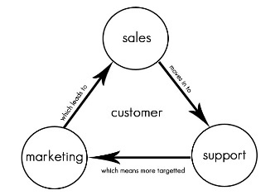
"crm" by Sean MacEntee is licensed under CC BY 2.0

Customer relationship management (CRM) refers to the use of information systems to store detailed information on prospective, current, and past customers to improve customer service and support targeted marketing.

Why This Matters
With competition in all businesses and industries at its peak, businesses and enterprises are turning to high levels of customer service to win customer loyalty. Customer relationship management (CRM) systems allow a business to track all interactions with customers, including in-store, by phone, and online, to better understand a customer’s interests and needs so that they may be fulfilled.

Essential Information
Customers appreciate personalized attention. That’s the key to CRM. CRM ensures that employees within an organization are equipped with the information necessary to treat a customer like an old friend, even if they’ve never met the customer before.

A good CRM system records all customer interaction with a business. Information on one particular customer can be accessed and entered by personnel from across an organization. Information can also be gathered automatically, such as when a customer interacts with the company’s online website. For example, when Bob Butterworth phones Sunshine Electronics’ customer support, the operator can quickly pull up Bob’s record to see that Bob phoned two weeks ago and ordered a new HDTV and deduce that this call is probably in reference to the TV. Also, Bob has spent a considerable amount of time on the Sunshine Electronics website looking at surround sound systems; perhaps the operator could interest Bob in a special deal on a new sound system.

Businesses that implement CRM systems have found significant increases in the level of customer satisfaction and retention, along with reduced operating costs. CRM systems support many areas of an enterprise, including market research, sales, marketing, customer support, and product development. CRM system developers are quick to point out that CRM software by itself will not improve customer satisfaction. CRM should be approached holistically with a heavy emphasis on training personnel on how to interact with customers.

Reading: Enterprise Resource Planning
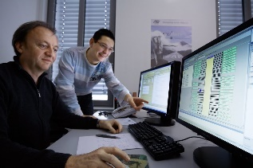
"Nissen & Velten-Entwickler an Bildschirmen" by Nissen&Velten is licensed under CC BY 2.0

An enterprise resource planning (ERP) system integrates all data processing in a corporation (enterprise) into one unified system that draws from a central database system to streamline the flow of information throughout an enterprise and provide greater efficiencies and savings.

Why This Matters
As information systems and technologies advanced over recent years, many businesses haphazardly adopted the latest and greatest technologies and eventually found themselves with overly complex systems that were expensive, difficult to maintain, and complicated to use. Many businesses found themselves dependent on several information systems designed for various business units by different vendors with a variety of compatibility issues. Enterprise resource planning is used to overhaul an information infrastructure to create one integrated system that streamlines the flow of information throughout the enterprise, allowing decision makers to implement cost-saving efficiencies.

Essential Information
An ERP system for a large business includes components for manufacturing, supply chain management, financials, projects, human resources, customer relationship management, and data warehousing. All of these systems share data, have a standardized user interface, and are centrally administered and maintained.

Supply chain management refers to the control of a product’s development process through the supply chain, which includes acquiring raw materials for manufacturing, the manufacturing process itself, shipping, storage in warehouses, delivery to vendors, vendor inventory, sales, and after-sales support. ERP is valuable in part for its role in streamlining communication and information across the supply chain. For example, an ERP could inform a customer service representative of how long it will take for a replacement part to be shipped based on on-hand inventory amounts and a supplier’s backlog. But ERP does much more than just manage the supply chain; it can include many other useful information systems.

Over the past decade, many corporations have implemented ERP systems with dramatic results. As you might imagine, adopting an ERP system is a major undertaking. Every information system in the organization is studied and redesigned. Old systems are gradually retired while the new systems are activated. For a large business, the process takes years and millions of dollars. Typically, a corporation contracts with a professional ERP vendor to manage the design and installation of the system. Popular vendors include Oracle, Microsoft, IBM/Cognos, SAS, and SAP BusinessObjects. When the transition to an ERP system is complete, employees find that they can accomplish much more in less time.

Cloud computing has had a tremendous impact on the implementation of ERP systems. New vendors of “cloud ERP” have arisen to challenge traditional ERP systems that are installed on corporate systems. Cloud ERP systems are stored on vendor web servers and can be accessed from any Internet-connected device. Some enterprises are mixing and matching systems, complementing their local ERP system with additional cloud solutions.

Benefits and Drawbacks of ERP Systems
Benefits | Drawbacks
- Improved access to data throughout the enterprise with less redundancy  - Elimination of outdated disparate systems  - Streamlined work processes  - Simplified maintenance or unified system  - Improved communication between functional areas  - Better corporate performance offering a competitive advantage | - Expense in time and money  - Learning curve and employees’ resistance to change  - Dependence on one vendor  - Failure is not an option—it typically means the collapse of the business

Reading: Systems Development
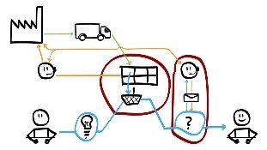
"07c mapping customer journey" by Espen Klem is licensed under CC BY 2.0

Systems development is the activity of creating new information systems or modifying existing ones.

Why This Matters
Information systems are developed to solve the problems of individuals, businesses, and organizations. Everyone who interacts with software and information systems should be involved with the process of systems development so that new systems effectively and efficiently meet everyone’s needs. Once the domain of systems analysts and computer programmers, systems development is now taking place at all levels of business, in a variety of environments, involving all types of professionals.

Essential Information
Systems development efforts can range from a small project, such as purchasing inexpensive computer software, to a major undertaking, such as installing a huge system that includes hardware, software, telecommunications systems, and databases, and which requires new computer systems personnel. Some systems development projects can involve an investment of millions of dollars but are designed to create a quick return on investment (ROI). For example, in a multimillion-dollar systems development project, Verizon Wireless integrated 13 billing systems into one to support 62 million customers and 30,000 call center agents across the country, reducing operating costs by 15 to 20 percent and saving Verizon $20 million a year.

Organizations have used different approaches to developing information systems. In some cases, these approaches are formalized and captured in volumes of documents. In other cases, less formal approaches are used. The steps of systems development vary from one organization to the next, but most approaches have six common phases: investigation, analysis, design, implementation, maintenance, and review. Combined, these stages are referred to as the systems development life cycle (SDLC).

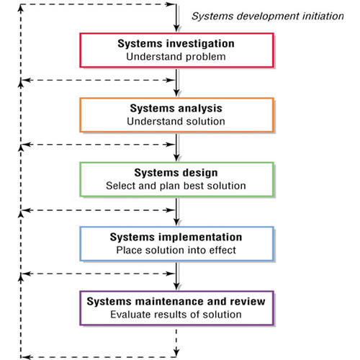
Authored by Cengage Learning. Creative Commons Attribution 4.0 International (CC BY 4.0)

The systems development process is an ongoing and cyclic activity. Once a system is developed, it is reviewed and revised as needed over the life of the system. Systems investigation and analysis look at the existing system and determine if it can and should be improved. Systems design and implementation involve modifying an existing system or developing a new one and placing it into operation. Finally, maintenance and review make sure that the new or modified system is operating as intended.

At the conclusion of each stage of the SDLC, a report may be generated to review the progress of the project. It may be decided that the project must return to a previous stage to be reworked or perhaps even scrapped. If all is going well, the project is given the green light to continue on to the next stage of development.

Many people take part in the systems development process. A systems analyst is a professional who specializes in analyzing and designing systems. A systems analyst interacts with system stakeholders, business managers, software engineers, system users, and vendors to design a system that best supports the goals of the organization.

Project management tools and techniques are often used to keep systems development projects on track. For example, a Gantt chart (shown below) may be used to track multiple project activities over time.
Courtesy of Microsoft Corporation. Fair Use

Lesson 14.3: Globalization

Lesson 14.3 Introduction
"worldwide" is licensed under CC0 1.0

Globalization refers to changes in societies and the world economy, resulting from dramatically increased international trade and cultural exchange.

The Internet and other forms of global telecommunications have supported a rapid increase in global business and business relationships. With the increase in global communications and cooperation among international businesses, our cultures and economies are becoming interdependent. Such an environment provides advantages for businesses in both developing and developed countries. It also provides new challenges and dangers.

In 2010, Google made history when it broke off relations with China and closed its offices in Beijing. Many, including some Google stockholders, called the move insane. China is well recognized as the world’s largest growing economy. While every other business was bending over backwards to do business in China, Google was pulling out. Why? Because Google was no longer willing to censor search results in accordance with Chinese law. Google gave China an ultimatum—allow us to serve uncensored search results or we shut down—and without blinking, the Chinese government chose the latter. In the years since, Google has reopened google.cn and provided visitors with warnings when searching for censored keywords. For a time, Google even provided Chinese citizens with instructions on how to circumvent the great firewall of China and avoid Chinese police.

Google in China is just one of many instances where globalization has failed. Apple has suffered severe criticism for being the most successful business in the world while ignoring dangerous or fatal conditions at its factories in China. Although Apple may have little control over conditions at the factories where its products are assembled, it is held up as an example of Western abuse of poor workers in developing countries.

As globalization creates business partners around the world, there are bound to be culture clashes and serious disagreements over how business should be conducted. What types of challenges do you imagine confront a business as it begins to expand abroad? How would you advise global corporations to contend with cultural differences? What would you recommend Apple do to correct its image problem?

The largest contributors to globalization are computers, a global telecommunications infrastructure, and the Internet. High-speed fiber-optic networks make it possible to communicate with, befriend, and collaborate with individuals around the globe as if they were sitting across the table from you. These technologies, which break the traditional barriers of time and space, have created a global community and economy.

Today, many companies use a distributed workforce, where portions of product design and production take place through a collaboration of several companies, each providing a specialized service. Companies are chosen for collaboration based on quality, reputation, and price. Location is often not a consideration due to the conveniences provided by Internet and telecommunications technologies. These global partnerships aim to produce the highest quality product at the lowest possible cost. The distributed global business model has created intense competition, especially for businesses that compete with businesses in developing countries where labor costs are much lower.

Reading: Distributed Workforce

"iGoogle Hangout" by jamjar is licensed under CC BY 2.0

A distributed workforce combines the talents of individuals from different businesses and locations to work together on a common product or project.

Why This Matters
Competition in the marketplace is fierce, and technology is the primary tool for gaining an edge. Businesses are continuously redesigning themselves to take advantage of the latest technological advances. Digital technology supports an increasingly distributed workforce, where portions of product development may be accomplished in different parts of the world. The goal is always to produce the most attractive product at the lowest possible cost. The distributed workforce requires professionals to adapt to a new work environment and routine. Knowledge workers must be fluent with communication technologies and able to collaborate well with others from diverse cultural backgrounds.

Essential Information
The Internet makes it increasingly easy to communicate and collaborate with individuals from around the world. The Internet boom of the 1990s supported the growth of telecommunications infrastructure, including the installation of many undersea cables connecting most parts of the world. These connections supported high-speed data communications and brought Internet services to many parts of the world for the first time. This set the stage for new partnerships between businesses in developed and developing nations, providing opportunities for those living in developing countries and cost savings for businesses in developed countries. Innovative software was developed to support collaboration among workers in different locations, facilitating the growth of distributed work environments.

Today, many businesses outsource portions of their work processes to take advantage of talent outside their own organization and to save money. It is not unusual for a product to be designed through a collaborative effort among several designers in different cities, to have its parts manufactured at a location overseas (offshoring), to be assembled by another company in another part of the world, to be tested by yet another company, and to be shipped and stored by yet others. The whole project is managed by the company that puts its logo on the finished product.

Participating in a distributed workforce takes unique talents. Communication and technology skills are valued. Meetings are often held online, with files shared among team members. Project management skills are particularly useful, as keeping track of the progress and budgets of multiple units is essential to ensure that no time or money is wasted.

Some companies are finding that managing work processes around the world has some drawbacks. GM, Apple, and others have been bringing manufacturing plants back to the U.S., where they can more easily communicate with other branches of the company. In particular, companies find benefits in having engineers and designers work side-by-side with manufacturing to produce better products.

Still, from all indicators, it appears that the globalization and distribution of work processes are a major part of the global economy. It is highly likely that today’s students will be interacting with individuals and businesses from around the world in their professional endeavors. It might be useful to consider acquiring skills that are unique and valuable and may not likely be offered at a lower price by others in a global market.

Reading: Outsourcing
"Outsource Task Contract Work Supplier Concept" is licensed under CC0 1.0

Outsourcing refers to a business’ use of an outside company to take over portions of its workload.

Why This Matters
Many businesses are finding that they can save significant amounts of time, effort, and money by hiring outside businesses to perform specialized tasks. A business might decide to hire IBM to create and manage its corporate information systems. Doing so might provide the business with a higher quality system and a lot fewer headaches. Another business might hire a plant in China to manufacture a component for its product and a plant in Taiwan to assemble the product. Doing so might save the company millions due to the low cost of manufacturing in these countries compared to that of the United States or the United Kingdom. Outsourcing provides benefits to some (those saving money, time, and effort and those getting the work) and hardships for others (those unable to compete with the low wages of developing countries).

Essential Information
Have you ever heard of the Y2K bug? The Y2K bug was the problem faced at the end of the twentieth century due to computer systems using only two-digit code to represent years. When the year switched from 1999 to 2000 (Y2K), most computer systems progressed from 99 to 00, going back one hundred years instead of forward one year. Consequently, many people anticipated that at the stroke of midnight on December 31, 1999, electronic systems would fail in every industry, including vital areas such as banking, medical equipment, manufacturing, and transportation.

Because there were not enough computer programmers available to prepare for Y2K, and recognizing the opportunities provided by new undersea telecom cables that joined the U.S. to India, many companies outsourced their Y2K problems to India. When the new year arrived without any significant problems, many thought that the entire Y2K scare was all hype. It is more probable that the programmers in India were responsible for saving the day.

Indian programmers earned the respect of many large U.S. corporations, as well as corporations in other developed nations, through their participation in Y2K efforts and other projects. Because Indian programmers worked for pennies on the dollar, compared to workers in the United States and other developed nations, it wasn’t long before most major companies called upon Indian programmers for many routine programming jobs. Communication lines between the United States and India became busy with IT business as teams in the two countries collaborated. Software to manage distributed project components became an urgent need, and software companies responded with sophisticated workflow packages. Workflow software empowered project managers to stay in touch with team members around the world and manage multiple project modules. Team members dispersed around the world could communicate in real time through text, voice, or video and pass around project files as though they were sharing a conference table.

Bangalore (see image) has become known as the Silicon Valley of India. Technology companies, such as Microsoft, IBM, Texas Instruments, HP, and GE, set up shop in Bangalore, building large corporate offices there. Any service that can be digitized and handled by the Indian workforce is being outsourced. Call center operations, U.S. tax returns, medical imaging analysis, news reporting, publishing, you name it—India can do it more cheaply than developed countries. Although some of the work being outsourced consists of basic, low-skill services, one can assume that higher levels of work will be outsourced as Indian education levels rise. In fact, Microsoft has opened a major research facility in Bangalore.

Although India is the biggest destination of outsourced services, Russia, the Philippines, Ireland, Israel, China, and other countries also provide outsourced services. China especially has become popular since its huge and rapidly developing population is becoming one of the world’s most valuable markets. Even the United States provides outsourced services. The difference between countries is in the type of services they can offer. The United States, with its advanced technology skills, exports services and products available nowhere else.

If you are starting to see the big picture of nations’ trading services and competing with each other in price and quality on a global scale, you are beginning to understand globalization. Enlarging the marketplace from local to global can have a profound impact on national and international economies. For example, outsourcing low-end tech jobs to India has provided a boom in India’s economy, while thousands of U.S. workers who once did the work now being outsourced have been laid off. The prosperity in India increases the demand for U.S. products in India, which in turn provides growth in some U.S. industries and creates the need to hire more labor. In the United States, there is a general shift in employment from low-skill labor to higher-skill labor and a demand for U.S. companies to be creative innovators in order to remain leaders in the global economy.

Recently, there has been a backlash against outsourcing in the U.S. Some companies have moved their call center operations back to the U.S. so their customers can communicate with individuals who are culturally the same. Other companies are moving manufacturing operations back to the states in order to have more control over the process and closer communications between corporate units. The trend of repossessing previously outsourced operations is called insourcing. Outsourcing is reaching an equilibrium as corporations determine which operations are best to outsource and which are best to keep in house.

Reading: Offshoring
Offshoring is a business practice that relocates an entire production line to another location, typically in another country, in order to enjoy cheaper labor, lower taxes, and other forms of lower overhead.

Why This Matters
Offshoring has had a major impact on manufacturing in both wealthy and developing countries. In the United States, offshoring has devastated some industries, such as the textile industry, which cannot compete with China and other countries on price. Offshoring has, for the most part, elevated the economies of developing countries that are winning the business of their wealthier global neighbors. In some industries, offshoring has created a complicated market. For example, U.S. automakers have offshored some of their production to China and elsewhere, while many Chinese auto companies have cars that are wholly manufactured in the United States. In difficult economic times, offshoring is a hotly debated practice.

Essential Information
Offshoring is somewhat different from outsourcing. With outsourcing, a portion of a work process is hired out. With offshoring, entire production lines are relocated to another country. If Bangalore, India is the current global center of outsourcing, then Beijing, China is the global center of offshoring. At the end of 2001, when China joined the World Trade Organization and agreed to follow international trade laws, it opened a floodgate for trade and innovation. Corporations around the world sought to take advantage of China’s large population, cheap labor, and high-quality production to save in manufacturing costs. Textiles, furniture, consumer electronics, and a host of other products are manufactured in China for global distribution for a fraction of the cost of manufacturing in more developed countries.

Companies that take advantage of the cost savings by manufacturing in China and in other low-cost manufacturing centers in the developing world (like Eastern Europe) gain a considerable advantage over competitors that don’t. Many business consultants recommend that U.S. companies offshore labor-intensive operations in order to stay competitive. Businesses in other developed nations are following suit. As with outsourcing, offshoring has created concerns for the labor markets in developed countries, especially in the United States. But, as with outsourcing, offshoring is predominantly used to save money on low-skill, labor-intensive manufacturing. Higher-level manufacturing still takes place in the United States. For example, General Motors may use some parts manufactured in China in vehicles assembled in Detroit.

As with India, a growing and prosperous China means increasing demand there for U.S. products. Many U.S. companies have opened branches in China in order to have first crack at the huge market that is developing there. The United States remains the world’s largest manufacturer, leading the world in aerospace, pharmaceuticals, automobiles, and other high-tech industries. Through globalization, the field of competition has broadened significantly. As with outsourcing, offshoring is forcing U.S. businesses to stay innovative and competitive.

Reading: International Business Models
.
"McDonald's in Marrakesh" by Richard Allaway is licensed under CC BY 2.0

International business models include methods of engaging in international business ranging from basic import/export to fully transnational businesses.

Why This Matters
Engaging in a global market is complicated, with many models and levels of engagement. Understanding how companies approach global business is useful for understanding the global economy and its options as well as the challenges involved.

Essential Information
With the benefits of working in the global arena come substantial challenges:
- Culture: Countries and regions have their own cultures and customs that can have a significant impact on individuals and organizations involved in global trade.
- Language: Language differences are another challenge. In some cases, it is difficult to translate exact meanings from one language to another. An exact translation of an advertising slogan, for example, might have a totally different meaning or even be offensive or disgusting to people in other countries.
- Time and distance: Time and distance issues can be difficult to overcome for individuals and organizations involved with global trade in remote locations. In other cases, they can provide an advantage. For example, outsourcing to India enables a company to work 24 hours a day because it is day in India when it is night in the United States.
- Infrastructure: People and organizations operating in developed countries expect an excellent infrastructure. In some countries, electricity may fluctuate in voltage, damaging machines and computers, or may be off for large periods of the day. Water might be dirty, and phone and Internet service might be problematic.
- Currency: The value of different currencies can vary significantly over time. Sometimes, currencies can dramatically fluctuate in a few days or less.
- State, regional, and national laws: Every state, region, and country has a set of laws that must be obeyed by individuals and organizations operating within the respective area. These laws can deal with a variety of issues, including trade secrets, patents, copyrights, protection of personal data, protection of financial data, and privacy.
Organizations participate in the global marketplace in several different ways, depending on where the organization’s operations are located and how they are managed, as shown in the following table.

Types of Organizations in the Global Economy
Company type | Description
International company | An international company maintains management and operations in its home country, exporting or importing products to and from other countries.
Multinational company | A multinational company maintains management in its home country and is supported by operations distributed across several countries. These companies typically market products specifically to satisfy the needs of their customers in different countries.
Global company | A global company is similar to a multinational company except that it markets its brand and products in the same way across all countries, regardless of cultural differences.
Transnational company | A transnational company has complex management distributed across multiple countries and operations. Often it is difficult to name a home country for a transnational business.

Module 15

Introduction
"ownership" by mikecohen1872 is licensed under CC BY 2.0

Intellectual property rights concern the legal ownership and use of intellectual property, such as software, music, movies, designs, written stories, and ideas.

Each time you use software, listen to music, read a book or newspaper article, see a movie, or sit in a comfortable chair, you are enjoying someone else’s intellectual property. The most valuable intellectual properties are typically the result of years invested in study and training. The sale of access to intellectual property provides an income for the creator and a return on his or her investment.

Intellectual property laws have been designed to legally ensure the rights of ownership to those who have created intellectual property. The digitization of intellectual property and widespread Internet use have made it very difficult to protect intellectual property from illegal distribution.

In early 2012, an intellectual property battle erupted over two pieces of U.S. legislation: PIPA (PROTECT Intellectual Property Act) was a bill floated in the Senate, and SOPA (Stop Online Piracy Act) was in the House. Both bills would have allowed the U.S. Department of Justice to seek court orders requiring Internet service providers, search engines, and online financial services to block websites that were accused of infringing on copyright. Sides were drawn between representatives seeking to protect the rights of businesses whose intellectual property was threatened and those who feared the bill would represent a significant step toward government censorship of web content. Groups protested the two bills across the country. Many websites blacked out for a day to call attention to the potential consequences of the bills. Ultimately, public pressure won out, and the bills were shelved—at least for the time being. A year later, the Cyber Intelligence Sharing and Protection Act (CISPA) was proposed, and some believed it to be another attempt at strengthening digital piracy laws. Once again, there was a call for an Internet blackout, but this time few participated. Like net neutrality, laws regarding intellectual property will continue to swing back and forth, favoring corporations one year and consumers the next depending on which political party holds office.

What negative impact do you think SOPA/PIPA would have had on the Internet and the content available there? As you read this unit, consider actions or laws that you would recommend to protect intellectual property online.

Intellectual property refers to a product of the mind or intellect over which the owner holds legal entitlement. Intellectual property includes the design of physical products as well as ideas and intangible objects such as poetry, stories, music, and new ways of doing things or making things. All forms of intellectual property have value and are owned by an individual or organization.

Because software and so many other types of intellectual property (books, music, movies, photos, works of art, etc.) are stored digitally, it is easy and convenient to copy and distribute them, sometimes without considering the creator. In the view of the creators and owners of the intellectual property, this is theft, just like stealing a physical item, such as an iPhone.
When intellectual property is copied and distributed by the public rather than by the legal distributor, it dramatically impacts the amount of money earned by the owner of the intellectual property. Rather than selling thousands of copies for thousands of dollars to thousands of fans, an artist might only be able to sell hundreds of copies for hundreds of dollars to hundreds of fans, who then make thousands of copies available to their friends. When those who own intellectual property no longer control the distribution of their product, they can no longer earn a living, they will turn to some other career, and creative capital in the country may wither.

Others argue that intellectual property is overpriced and that those who manage the industry, such as recording and motion picture companies, are making a killing while the intellectual property creators, who have signed away the rights to their intellectual property to the corporations, are given only a small percentage of the profits. It is this point of view that has driven many musicians to resist signing recording contracts and instead make their own recordings independently and sell them directly to their fans.

Digitization, the Internet, and a general failure to protect intellectual property have combined to create serious issues for the software, music, photography, art, motion picture, and publishing industries, and they are dramatically altering the way these industries operate.

Protection of intellectual property can take many forms, including copyrights, trademarks, trade secrets, and patents.

Legal Tools for Protecting Intellectual Property
Protection | Description
Copyright | Protects the words, music, and other expressions for the life of the copyright holder plus 70 years. The fair use doctrine describes when and how copyrighted material can be legally used. The Digital Millennium Copyright Act provides global copyright protection.
Trademark | Protects a unique symbol or word used by a business to identify a product or service.
Trade secret | Protects secrets or proprietary information of individuals and organizations as long as the trade secret is adequately guarded by those individuals and organizations.
Patent | Protects an invention by giving the patent holder a monopoly on the use of the invention for 20 years after the patent application is submitted.

Some believe that copyright laws are too restrictive and pose a risk to the advancement of culture. For example, in his book, Free Culture: How Big Media Uses Technology and the Law to Lock Down Culture, Professor Lawrence Lessig and his colleagues developed a legal alternative to copyright called Creative Commons, which allows intellectual property owners to more finely describe what can and cannot be done with their work.

Intellectual property theft extends beyond digital media. As cyberwarfare and cyberespionage have become a common component in international relations, intellectual property has become a major target. In recent years, dozens of attacks have targeted national defense contractors, corporations, and manufacturers, stealing valuable research and development information that could be used to compete economically or militarily. Many of these attacks have been traced back to determine their origins. Some security firms have pointed to China as a likely culprit; others say the evidence on the source of attacks isn’t clear.

Lesson 15.1: Intellectual Property Theft

Lesson 15.1 Introduction
The concept of stealing intellectual property is far more subtle and difficult to define than the theft of physical goods. You wouldn’t steal a car, but is copying a song really theft? The debate over the limits of intellectual property rights in the digital age is nearly as old as digital computing itself. Some would argue that copying a file can’t be considered theft because the original file is still accessible, and no worse for wear after being copied. Others argue that it’s not the value of the file itself at risk, but the loss in potential future revenue for the file’s creator. But what about copyrighted works created by artists who have already died? What about the increase in knowledge and cultural value when works are released into the public domain? Clearly, before we can have a meaningful discussion about intellectual property rights, we must define what intellectual property is, and what it means to steal it.

Reading: Piracy
Piracy involves the illegal copying, use, and distribution of digital intellectual property, such as software, music, and movies.

Why This Matters
The music, motion picture, and software industries claim to be losing billions of dollars in sales to piracy. Piracy ranges in degree of severity from a teenager’s downloading or uploading music on the Internet to a Chinese merchant’s selling hundreds of pirated commercial CDs and DVDs each day. The prolific amount of piracy is forcing technology industries and governments to react with repressive technologies and legislation that some feel inhibit the natural evolution of culture.

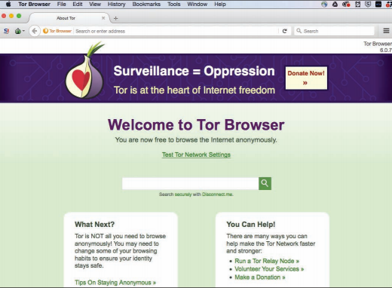
The Tor Project, Inc. Fair Use

Essential Information
Pirated software, music, and videos can be accessed through peer-to-peer networks such as BitTorrent or on the dark web, where Internet connections are anonymous, and web content is not indexed by search engines. These networks are rife with malware, adware, and hackers, and are dangerous to use, but because the technology encourages file sharing, many otherwise law-abiding citizens might feel as though it must be okay.

Organizations such as the Recording Industry Association of America (RIAA), the Motion Picture Association of America (MPAA), and the Software & Information Industry Association (SIAA) are making it known that piracy is not okay. The RIAA has been successful in shutting down or helping shut down most P2P services, including Kazaa, Limewire, and Pirate Bay. The RIAA is continuously pursuing methods for discouraging and penalizing copyright violations. The RIAA has also been instrumental in promoting legislation, such as SOPA, PIPA, and “three-strikes” laws around the world. These highly controversial laws deny users Internet access if they are accused of copyright violations three times.

Although the MPAA has not engaged in lawsuits to the same extent as the RIAA, it is gradually ramping up its efforts as movie file sharing is becoming more common. The SIAA’s Anti-Piracy Division has taken similar measures in its comprehensive, industry-wide campaign to fight software and content piracy.

International piracy is of great concern to those in the music, motion picture, and software industries. The vast majority of motion pictures sold in Russia are pirated. In Vietnam, China, and Ukraine, most software in use is pirated.

The Anti-Counterfeiting Trade Agreement (ACTA) has been proposed by the United States, the European community, Switzerland, and Japan as an international effort to fight counterfeiting and piracy. While still under debate, many fear that the agreement will infringe on consumers’ privacy and civil liberties in its efforts to reduce counterfeiting and piracy.

Reading: Plagiarism
Plagiarism involves taking credit for someone else’s intellectual property, typically a written idea, by claiming it as your own.

Why This Matters
Giving credit where credit is due and respecting intellectual property rights are foundational principles of ethical behavior. Laws, conscience, and social pressure discourage most people from plagiarizing—but convenience sometimes wins out over ethics, and rationalizations can blur the line between plagiarism and creative use of others’ work. Utilizing plagiarism out of convenience or rationalizing that a minor offense isn’t ethically wrong ends up placing otherwise law-abiding people in very embarrassing and sometimes costly situations.
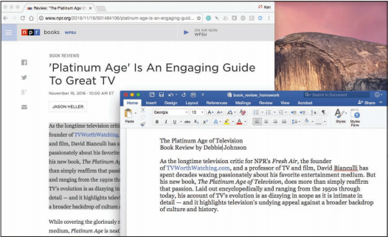
Webpage: NPR.org; plagiarized document created by Ken Baldauf as example only. Fair Use

Essential Information
Plagiarism has been an issue of legal and social concern for as long as people have produced intellectual property. Stealing others’ ideas and thoughts and presenting them as your own is a serious breach of ethics matched by serious penalties if you are caught. A student caught submitting another person’s work for a grade may face expulsion. A professional journalist, author, or researcher could face an expensive lawsuit and loss of a career.

Although plagiarism has been a social issue for a long time, the digitization of the written word, the Internet, and cut-and-paste methods of writing have made it all the more common. Some websites provide students with free research papers for class projects. Submitting papers from such websites is considered plagiarism and is subject to strict and severe penalties by schools. Software such as Turnitin and iThenticate is used by many high school and college teachers to find instances of plagiarism in electronically submitted homework files with a high rate of success. Some students find it useful to check their work for accidental plagiarism prior to turning in an assignment.

Lesson 15.2: Intellectual Property Protections

Lesson 15.2 Introduction
Digital media is a massive industry, with billions of dollars generated annually. With this much money in play, the question of the limits of intellectual property protections afforded by the law becomes hugely important, and huge sums are spent to lobby lawmakers for favorable legislation on both sides. For better or worse, laws with far-reaching implications have been passed over the past three decades that will continue to influence Internet culture for years to come.

Reading: Digital Rights Management
Digital rights management, or DRM, is technology that protects digital forms of intellectual property by restricting the number of devices and applications on which a file can be opened and the number of times that the file can be copied.

Why This Matters
Intellectual property owners will do whatever it takes to protect their property from being illegally copied and distributed. The most popular method of protecting it is through DRM. DRM can be found on some music sold online as well as on movies, ebooks, and documents stored in PDF format. Most music and movie fans are frustrated by the inconvenient side effects of DRM, which keep them from listening to or viewing legally purchased products whenever and wherever they like on any of their devices. There is concern that restrictions on digital products may become tighter, pushing DRM onto hardware so that it is impossible to make copies of any digital media.

defectivebydesign. Fair Use

Essential Information
DRM is often associated with digital audio files but is used with other forms of online intellectual property, such as digital movies and ebooks. Microsoft’s WMA and Apple’s AAC file formats include DRM technology. DRM-protected AAC files use the .m4p file extension. Users who purchase songs online may or may not receive files with DRM. There are restrictions on what players can be used with DRM-hobbled files and how those files can be copied. DRM has become extremely unpopular with consumers. Defective by Design, a grassroots organization (see figure) has campaigned to “eliminate DRM as a threat to innovation in media.” Most recording companies and music distributors now sell music without embedded DRM technology. However, DRM is still heavily used to protect motion pictures, television programs, ebooks, and documents.

Reading: Digital Millennium Copyright Act
The Digital Millennium Copyright Act (DMCA) is a U.S. copyright law designed to reduce illegal digital media copying by criminalizing the production, distribution, and use of technologies designed to circumvent DRM technologies.

Why This Matters
Digital media companies and organizations, such as the Recording Industry Association of America (RIAA) and the Motion Picture Association of America (MPAA), have aggressively lobbied the government to create stronger laws to prevent people from making illegal copies of digital forms of intellectual property. In 1998, that lobbying paid off when the Digital Millennium Copyright Act was made law. In cases such as this, where laws are created that oppose common public practice, it is common for public unrest to grow around the issue. This is certainly the case for the DMCA. A Google search reveals many anti-DMCA websites and organizations. Other companies, like DMCA.com, provide services to help enforce the DMCA.

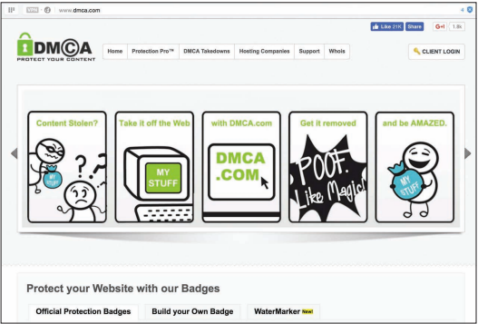
DMCA.com. Fair Use

Essential Information
On October 12, 1998, the U.S. Congress passed the Digital Millennium Copyright Act, and two weeks later President Clinton signed it into law. Since then, the DMCA has been used as a basis to shut down P2P file-sharing technologies, threaten thousands of people who have posted other people’s intellectual property on the web, impose serious fines on those caught sharing music and movies over the Internet, and even threaten to take down web-giant YouTube.

The Electronic Frontier Foundation (EFF) claims that the DMCA has unintended consequences, including impeding scientific research, jeopardizing “fair use” of intellectual property, and discouraging competition and innovation. Still, the record companies and the motion picture industry praise the DMCA for enabling them to enforce copyright law and rein in runaway piracy.

The DMCA was designed to implement treaties signed in December 1996 at the World Intellectual Property Organization (WIPO) conference in Geneva, Switzerland. The law makes it a crime to circumvent antipiracy measures built into most commercial software. So, those who purchase movies, music, ebooks, or other digital media that include DRM are breaking the law if they make copies. Also, the DMCA outlaws the manufacture and distribution of software or hardware designed to crack DRM codes. In addition, the DMCA holds Internet service providers responsible for pirated content stored in user accounts on their servers.

The DMCA also holds Internet radio companies and other webcasters responsible for paying those who hold the rights to the intellectual property being broadcast. This, in turn, has caused Internet radio services such as Pandora.com to develop business models that bring in money to pay the licensing fees imposed by the record companies.

Media companies continue to push the government for stiffer laws regarding copyright. The Prioritizing Resources and Organization for Intellectual Property (PRO-IP) Act of 2007, which was signed into law, increases civil and criminal penalties for copyright infringers.

Module 16

Introduction
"identity" is licensed under CC0 1.0

Information security refers to the protection of computers and other digital devices, information systems, data, and information against unauthorized access, use, manipulation, or destruction.

Information security is a growing concern as increasing amounts of important and private information are stored digitally on systems connected to public networks and wireless private networks. From bank account and credit account access codes, to personal medical records, to secret business strategies, to national defense initiatives, to email sent to a friend, people trust information systems to keep their most valuable and secret information safe and secure. But can information systems be trusted?

To understand how much the world is impacted by computer security issues, all one has to do is access the daily news. Consider these recent headline stories:
- Massive Cyberattack Triggers Recalls and Serious IoT Concerns
- Yahoo says 500 million accounts stolen
- FBI Warns of Possible State Election-System Hacks
- Major U.S. Hotels Hit by Point-of-Sale System Breach
- Quadrooter Bug Affects 900 Million Android Devices
- Study Finds Ransomware Hits Almost 40 Percent of Enterprises
- HummingBad Malware Infects 85 Million Android Devices
- Millions of Health Records Appear for Sale on Dark Web
- LinkedIn Passwords from 117M Accounts Hacked and Up for Sale
- Google Says Ad Injectors Infect Millions of Users
- U.S. Government Suffers Massive Cyberattack
- Russians Reportedly Hacked White House Computers Last Year
- IRS Hacked, Info on 100,000 Americans Stolen
- Adult Dating Site Hack Exposes Personal Data of Millions
- Massive Security Flaw Puts 600 Million Samsung Smartphones at Risk
- Hackers stole 21.5 million Social Security Numbers in government breach
- Fiat Chrysler recalls 1.4 million cars over remote hack vulnerability
- Over 225,000 Apple iPhone Accounts Hacked by New Malware
Cyberattacks of one kind or another are occurring continuously on the Internet, causing concern over information at every level: personal, business, and government. Consider the information of concern to you that is stored on your computer, on web servers, and in the systems of every business and organization with which you have interacted. What damage could be inflicted on you if that information was stolen, altered, or destroyed? What types of businesses are at the biggest risk of cyberattack? Why? How do cyberattacks against businesses impact you and the country? What should the government do to protect its citizens from cyberattacks? Should the government force businesses to adopt tighter security measures? Who should incur the costs of increased national cybersecurity?

Corporate and government networks and home computers are under attack, and the Internet is the battlefield. Automated criminal systems probe Internet-connected computers owned by individuals, businesses, and governments, continuously seeking security holes that might allow a hacker to infiltrate the system. The casualties of this war include your privacy, information, property, and money. Crimes that take place online, called cyber crimes, can impact personal information, corporate information, and governmental information. Valuable information and many forms of intellectual property can be compromised or stolen. Computer systems, automated industrial systems, and critical national infrastructure, such as the power grid, can be attacked and derailed. An increasing percentage of criminal activity now takes place online.

Cyber crime takes place on many levels. Pirates illegally download copyright-protected music, movies, and software. Plagiarists copy portions of online articles and claim ownership of others’ ideas. Criminal hackers illegally access computer systems to steal information, to cause problems or embarrassment for a business or organization, or to utilize hacked network resources for criminal activity. Cyber spies take part in cyberwarfare to steal government secrets or to disrupt a nation’s critical infrastructure. These represent examples of intentional crimes. Others may be unintentional. Sometimes, damage to computer systems and information occur through negligence. For example, a user may unintentionally delete files, enter incorrect and misleading data, lose archived data stored on removable media, or fail to take safety precautions like backing up data.

Total information security refers to securing all components of the global digital information infrastructure from mobile phones to PCs to automobiles, to smart home appliances, to business and government networks, to Internet routers and wireless networks. The figure shows the layers of information security and illustrates how you, the computer user, are at the heart of information security. Your recognition of security risks and the actions you take to secure the systems with which you interact are the most important components of total information security. As a computer user, you must learn about security risks at three levels: the machine level, the network level (including wireless networks), and the Internet level. As you move from the machine level toward the Internet level, you face increasing exposure and risk.

When it comes to state-affiliated cyberespionage, China and Russia have been blamed for many attacks against the U.S. but both deny all charges. The nature of cyberattacks makes it difficult to trace an attack to its exact origin. President Obama signed a cybersecurity executive order to protect the country’s critical and vulnerable infrastructure. A new branch of the Pentagon was created to focus on cyberwarfare. A legal review on the use of America’s growing arsenal of cyber weapons concluded that the president has the power to order a preemptive cyber strike if the United States detects credible evidence of a major digital attack looming from abroad. Clearly things are heating up in what has been called cyber cold wars with China and Russia.

Meanwhile the international community is working to create rules for cyberwarfare engagement similar to the Geneva Convention, which governs traditional warfare. The NATO Cooperative Cyber Defense Center of Excellence has created a set of rules named the Tallinn Manual to protect civilian targets such as hospitals, dams, and nuclear power stations from state-sponsored cyberattacks.

What steps do you think world powers should take to rein in damaging cyberattacks and prevent global cyberwarfare? How can the U.S. better protect its critical infrastructure?

Lesson 16.1: Data Loss Prevention

Lesson 16.1 Introduction
"phone security" by stockcatalog is licensed under CC BY 2.0

Machine-level security refers to actions taken to protect information on a computer that may or may not be connected to a computer network or the Internet.

Information security is implemented at multiple levels: the individual machine level, the computer network level, and the Internet level. This section examines security from the perspective of the individual machine and discusses security precautions for personal computers that may or may not be connected to a network or the Internet. While it may not be practical to lock your computer in a vault to protect your data, there are methods available to provide nearly the same level of protection. By learning how to protect stand-alone PCs, you also learn about the first line of defense for the networks to which those PCs may be connected.

The greatest threat to information on a computer is through network connections. However, information on computers not connected to a network is also at risk from people who might access that computer physically rather than remotely. The only way to fully protect a computer is to eliminate access to the machine by anyone other than the owner. Many businesses take this approach by keeping important computer systems behind locked doors, accessible only to authorized users granted access with a card swipe. Other methods of protecting data on a machine include the use of passwords and encryption. Keeping backups is essential for protecting data in case all defenses fail.

Reading: Authentication
Authentication is a security process in which the identity of a person is verified.

Why This Matters
Deciding who should have access to information and who should not is the foundation of information security. There must also be a method of determining that persons attempting to access the data are who they claim to be. That is the purpose of authentication. There are several forms of authentication, some stronger than others. Implementing authentication properly is important in protecting computers and mobile devices.

Essential Information
Access to today’s PCs is typically guarded with a username and password. In security terms, this is called authentication, which confirms the identity of a user. The table below shows the three common forms of authentication:

Forms of Authentication
Form of Authentication | Description
Something you know | Information such as a password or personal identification number (PIN)
Something you have | An item such as a phone, computer, ID card, smart card, badge, keychain fob, or other item designed to be used to authorize access to secure areas and systems
Something about you | Unique physical characteristics such as fingerprints, retinal patterns, and facial features that can be scanned and used for authentication

A username identifies a user to the computer system. Varying levels of computer access and environmental preferences are associated with a username. Although usernames can act as a form of “something you know” authentication, they are not very strong because they are typically not kept secret. Usernames can often be accessed from email addresses. A password is a combination of characters known only to the user that is used for authentication when gaining access to systems. Passwords can be an effective form of authentication if they are difficult to guess, kept confidential, and changed regularly. However, passwords are considered a weak form of authentication because they can be guessed by others to access systems without your knowledge. It is important to create passwords that are strong—that is, difficult, if not impossible, to guess. For example, johnnyb and nycjohnny would be weak passwords for John Baily from New York City. The password 92Tpo5#cCw is very strong but nearly impossible to remember. The password nyKOOLB@Y might make a good password for John, since it is strong and is also easy to remember.

It is equally important to use different passwords for different accounts and to change your passwords regularly, at least twice a year. This will thwart hackers who may already be accessing your account without your knowledge.

The large number of passwords most users have to remember is becoming problematic. Password manager software is one way to deal with it. Password manager software like 1Password, LastPass, and DashLane securely stores all of your online passwords and automatically enters them when needed. The only password the user needs to remember is the password for the password manager. Most web browsers also have the capacity to remember and auto-enter passwords, but don’t have the full functionality of password manager software. Many companies, including Google, are developing new methods of authentication that will no longer require passwords.

A number of physical devices are used in corporations and organizations to identify users and provide access to restricted areas and computer systems. These technologies make use of the “something you have” form of authentication. Sometimes, they are combined with a password to increase the security level. The most popular of these devices are ID cards and tokens that sometimes take the form of a keychain fob. ID cards may contain forms of identification in a magnetic strip or in a microchip, as is found in a smart card. A token is an object like a smart card or key fob that contains a microchip that stores ID information. The user holds the token against a reader device to gain access to a location or information systems.

A token can also take electronic form on a computer. For example, a bank may require its members to install a special bookmark in their browsers to use when logging into their online bank accounts. The bookmark is used as a token to identify the computer as an approved device for a member’s account. If the account is accessed from a different computer, the user is required to enter more detailed information to authenticate his or her identity.
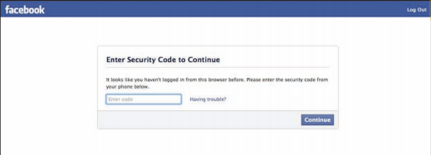
Courtesy of Facebook. Fair Use

Facebook, Google, PayPal, and other online services offer a higher level of security using 2-step verification. 2-step verification requires a combination of a password with a verification code sent to the user’s phone. Typically, the 2-step verification is only required if the account is accessed from an unrecognized computer. These systems also use digital tokens to identify and recognize approved computers. They may notify a user by email when someone attempts to access the user’s account from an unrecognized computer.

Biometrics is the science and technology of authentication by scanning and measuring a person’s unique physical features (“something about you”). Fingerprints, facial characteristics, retinal patterns, and voice patterns are commonly used in biometrics. A fingerprint scan uses the pattern of a fingerprint to authenticate a user. Fingerprint scans are an increasingly common method of authentication for access to secure areas, for validating credit card purchases, and for logging onto or unlocking devices.
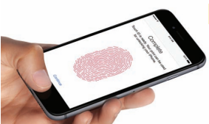
Apple Inc. Fair Use

Facial pattern recognition is a form of biometrics that uses a mathematical technique to measure the distances between points on the face. Taking a weighted sum of these measurements, software can quickly scan a database of known faces and come up with a match if one exists. Law enforcement agencies and airport security agents use facial pattern recognition software in efforts to catch criminals and terrorists. Facial pattern recognition is also being used to secure PCs and mobile devices that include cameras. Another form of biometrics, retinal scanning, analyzes the pattern of blood vessels at the back of the eye (see figure). As the field of biometrics expands, other physical characteristics, such as speaking patterns, are also being explored for use in authentication.

Reading: Encryption
Encryption is a security technique that uses high-level mathematical functions and computer algorithms to encode data so that it is unintelligible to all but the sender and recipient.

Why This Matters
With the increase in mobile computing, the possibility of losing a computer or having it stolen is very real. Data can also be stolen from computers by hackers who break through network security. Sometimes, the data stored on a mobile device is more valuable than the device itself. If that data is encrypted, it will be unintelligible to hackers and thieves who have stolen it. Data can also be stolen while it is in transit over a computer network. An increasing number of users have become concerned about government spying on telecom networks and mobile phones. Encryption techniques help safeguard data that is stored or traveling over a network.

Essential Information
Today’s PCs include security tools that can encrypt files stored on disks and flash drives. This is useful in situations where the information you are storing is confidential or valuable, and there is a possibility that your computer can be accessed by others, lost, or stolen.

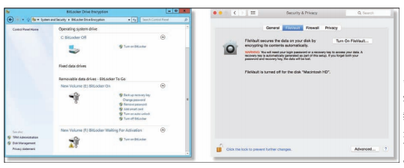
Apple Inc and Microsoft Corporation. Fair Use

Files can be encrypted “on the fly” as they are being saved and decrypted as they are opened. To open encrypted files, you must enter a password. Encryption and decryption (the process of decoding encrypted data) tends to slow down a computer slightly when opening and saving files, so encryption is not typically turned on by default. Instead, the user manually selects the files or folders that contain confidential information and marks them for encryption.

Mac OS uses the FileVault system for file encryption. FileVault uses the latest U.S. government security standard, AES-128 encryption, to safeguard confidential documents. Microsoft Windows uses BitLocker Drive Encryption, which is machine-level data encryption that can secure the entire hard drive and protect the data even if the PC is stolen. Some Windows PCs include an embedded security subsystem that stores passwords and encryption keys on a dedicated security chip on the motherboard. Storing security information in a dedicated chip rather than in a file on the hard drive offers perhaps the strongest method of personal computer security.

In addition to protecting data on storage media, encryption is also used to protect data that travels over a network. By sharing an encryption key, the sender and receiver can send encrypted data over a network and the Internet. Encryption is particularly important for wireless networks, where data can be easily intercepted. Several wireless encryption protocols exist. Wi-Fi Protected Access (WPA) is a common encryption protocol. WPA2 is the most recent and most secure version. Even with encryption, it is dangerous to send passwords and other private information over public wireless networks.

When sending confidential data over the web, users are wise to make sure the browser is using a secure connection, which can be indicated by https:// in the address bar, a green color in the address bar, and a closed lock icon in the address bar or at the bottom of the browser screen. HTTPS is a secure form of HTTP that encrypts the data submitted by users, such as passwords, credit card numbers, and other data submitted using forms on webpages.

Due to the revelations about government-surveillance-provided leaked NSA documents, encryption has become more important to many U.S. citizens. Many online services, including email, now apply encryption by default. The iPhone and Android phones provide options for encrypting data stored on the phone. If the phone is stolen, the data cannot be accessed without the owner’s PIN code. This caused controversy in 2016 when the FBI asked Apple to retrieve encrypted data from a terrorist’s iPhone, and Apple refused. Ultimately, the FBI discovered how to hack the iPhone to get at the data.

Encryption and other forms of information security, used alone, do not safeguard data 100 percent. Maximum information security is accomplished through the implementation of all computer security tools combined with safe computing practices.

Reading: Data Backup
Data backup is a process in which copies of important computer files are stored in a safe place to guard against data loss.

Why This Matters
Data may be lost due to hardware failure, human error, software corruption, hackers, malware, or natural disasters. The only method that provides protection for data against all of these disasters is to back it up! Still, many computer users do not have a regular backup procedure in place. Today’s backup technologies make backing up important data and system files easier than ever.

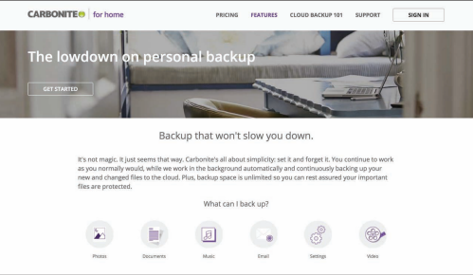
Carbonite. Fair Use

Essential Information
When you purchase a new computer, it typically comes with a system recovery disk. If operating system files become corrupted, either due to failure of the hard drive or a virus, your computer may simply not start. A system recovery disk, sometimes called a rescue disk, is used to regain access to a computer that has lost its ability to boot normally. The disk includes utility software that can be used to attempt to repair the damaged system files, recover data files, or prepare the computer for a reinstall of the operating system. Operating systems typically provide a way for users to create a system recovery disk if one is not provided by the manufacturer.

Windows PC users who find their system damaged but can start the computer can benefit from the System Restore (up to Windows 10) or File History (Windows 10) utilities. These utilities allow you to restore files that have been lost or corrupted, or to roll back the operating system to a time when the computer was without problems. Apple Mac OS provides a similar tool called Time Machine, which backs up not only system files but also data files.

In addition to backing up important system files, it is important for computer users to back up data files. Businesses typically have regular backup procedures to back up corporate data to disk drives, tape, or online storage media. Individuals typically back up their personal data files to an external drive or remote online storage.

Operating systems usually provide a backup utility for data files. Typical backup software collects the files you wish to back up into a compressed file called an archive. Some backup software provides the ability to encrypt the archive and password-protect it. Backup software typically provides the following options:

Select the files and folders you wish to back up.

Choose the location to store the archive file.

Choose whether to back up all files (a full backup), or just those that have changed since the last backup (an incremental backup).

Most backup utilities also provide a scheduling option that allows you to automatically run backup routines at specified dates and times.

Rather than creating an archive, some users prefer to create an exact copy of their data files, using a technique called mirroring. Some software provides real-time mirroring for home users. As the user saves a file, a second copy is saved to a drive connected to the home network. Businesses sometimes use a technology called redundant array of independent disks (RAID) to keep a mirror copy of all data on the system. Should the primary system fail, the RAID kicks in, allowing uninterrupted operation.

Internet-based backup services are becoming popular as more users have high-speed Internet connections. Services like Remote Data Backups, Dropbox, Mozy, SugarSync, and Carbonite provide automated backup of data continuously or periodically over an Internet connection for a monthly or yearly fee. Files that are backed up to the cloud may be accessed from any computer by the owner or by individuals the owner chooses to share the files with. Some of these services allow users to make folders or files accessible to the general public—a useful feature for sharing photos on the web. An important feature of an online backup service is that it allows you to back up your data off-site in a different location from your computer. It is smart to keep backups off-site, as keeping them on-site may expose them to the same destructive forces that wipe out the original data: fire, flood, a power surge, and so on.

With the advent of cloud computing, users are storing increasing amounts of data on Internet servers. Email, calendars, documents, photos, and other data are being saved in services provided by Google, Amazon, Microsoft, Flickr, Facebook, and other cloud apps. Google, Amazon, Microsoft, and Apple offer remote data storage for backing up files, sharing files, and accessing data from any Internet-connected computer. Microsoft offers free online storage and sharing of Microsoft Office documents with OneDrive while Apple’s iCloud provides backup options and the ability to share apps and data across Apple devices.

As data moves to the cloud, the responsibility for backing it up falls on the shoulders of the service providers. Before trusting a service provider to back up your data, make sure to read the disclaimers. The providers do not typically ensure against data loss. Ultimately, it falls to the users to keep backup copies of everything for 100 percent assurance.

Lesson 16.2: Network Security

Lesson 16.2 Introduction
Network security is concerned with addressing vulnerabilities and threats in computer networks that may or may not be connected to the Internet.

When a computer becomes connected to a network, security risks increase a hundredfold. If the network happens to be a wireless network, it is all the more vulnerable. If the network is connected to the Internet, risks increase a million times that of a stand-alone computer. In fact, for information of highest security, government agencies use computers that are not connected to agency networks or the Internet. As long as there is a network connection, there is an increased risk of unauthorized access. The primary challenge in securing a computer network is keeping user data private and accessible only by authorized persons.

This lesson discusses threats, considerations, and security for computers connected to wired and wireless networks. A later section on Internet security deals specifically with security measures for computers connected to the Internet.

Networked computers may be in a government agency; a large, medium-sized, or small business; a college campus or campus housing; an apartment building; or a home. Whenever people share computing resources remotely over a network, a system administrator assumes the responsibility of establishing which resources should be accessible to each user. A system administrator may be a person or persons hired by a corporation to manage a large computer network, or it could be a person like you, managing a home network. The topics in this section discuss the threats posed to computer networks—both wired and wireless—and the tools available to system administrators to protect the network.

Reading: Permissions
Permissions, or file system permissions, refers to the specific access privileges afforded to each network user and each system resource in terms of which files, folders, and drives each user can read, write, and execute.

Why This Matters
A multiuser system is a computer system, such as a computer network, where multiple users share access to resources. When sharing resources, users are naturally concerned about the privacy and protection of their data files. System administrators are concerned with protecting the system from intentional and unintentional damage. If a corporation owns the network, corporate management is concerned about the security and privacy of corporate information. The network administrator can control which network resources—files, folders, drives, network connections, systems, and software—each user can access and edit, by defining specific permissions for each resource and user on the network.

Essential Information
Operating systems such as Microsoft Windows, Mac OS, and Linux provide methods for associating permissions with each user account and each system resource. As each user logs on to a computer connected to the network, the permission policies are applied, and the user can access only the resources defined by those policies.

To control user access to system resources such as files, folders, and disk drives, access policies must be defined for both the resources and the users. For example, a user may be restricted to accessing only files that he or she created. Files and folders on the system must carry information that identifies their creator. This is referred to as file ownership. Users are the owners of the files they create.

The system administrator is responsible for setting the access rights of users and for setting the permissions on system resources. The system administrator can also assign permissions to groups of users. Users have the power to set permissions for the files they own.

The system administrator is typically the only user who has full access to the system. The system administrator can also define the type of access allowed. Access to files and folders can be classified as read, write, and execute. Execute permission can be applied to programs (.exe) and folders in order to control access to folders. Data files make use of read and write permissions. The following table illustrates settings for a system resource, such as a file stored on a web server accessible from the web.

File Permissions Example
 | Read | Write | Execute
Owner | X | X | X
Group | X
World | X

The ability to carry out system commands can also be restricted through user permissions. For example, Windows uses three classifications for user accounts: Administrator, Standard, and Guest. Those with Standard access can only change their own account password and associated icon. A Guest account is for someone who does not have a permanent account and needs to temporarily access computer or network resources. Guests can’t change settings, install hardware or software, or create passwords. An Administrator has full access to system commands and resources.

Home users can set permissions on their own files so that others on the network can access them or not. By default, the personal files and folders on Windows and Mac OS computers are off limits to others on a network. You can adjust file permissions for a specific file or folder by accessing its properties. On a Windows PC, you right-click and choose Properties; on a Mac, select Get Info from the File menu (see figure). Some OSs designate a special folder for sharing documents with others on the network.

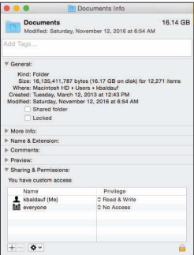
Apple Inc. Fair Use

User permissions provide a second layer of security for computer networks. Usernames and passwords and the login process are the primary way of keeping unregistered users out of the system. User permissions provide registered users with access to the files they need while restricting access to private resources. User permissions become even more important for files accessible on the Internet. Webpage files, for example, exist on a web server with permissions set to allow the world to read but not write.

Reading: Interior Threats
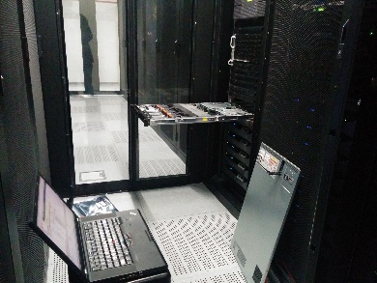
"IMG_20140814_144219" by Robert is licensed under CC BY 2.0

Interior threats are network security threats that originate from within a network, typically from registered users.

Why This Matters
Interior threats can be intentional or unintentional. Unintentional threats can occur when users make mistakes or exceed their authorization. Intentional threats come from registered users who desire to do the system harm or steal information. Interior threats can be as troublesome for corporations and organizations as hackers, malware, and other exterior threats.

Essential Information
Network users can become security threats through intentional or accidental behavior. There are many situations where innocent human mistakes result in monumental problems. Take, for example, the Taiwan stock trader who mistakenly bought $251 million worth of shares due to a typing error, causing her company a paper loss of more than $12 million. In another error, the U.S. Defense Department, Internal Revenue Service (IRS), and Justice Department have misplaced hundreds of government notebook computers, many of which contain classified government documents. In more common acts of negligence, many users provide hackers with easy access to computer systems by visiting websites designed to spread malware, downloading infected files, using passwords that are easy to guess, or storing passwords and other private information where others can access them.

People’s mistakes can lead to problems with security, accuracy, or reliability of computer systems and information. The major types of human errors include those shown in the following table.

User Mistakes That Threaten Computer Security
Type of mistake | Example
Data-entry errors | A military commander might enter into the computer the wrong GPS position for enemy troops. This data-entry error might cause friendly troops to be killed.
Errors in computer programming | A payroll program might multiply a person’s pay rate by 1.5 instead of 2 for overtime. This programming error results in a lower paycheck than the employee should receive for overtime work.
Improper installation and setup of computer systems | A person may neglect to properly set the necessary security settings to secure a wireless network.
Mishandling of computer output | A medical office might send lab results to the wrong person, so the person receiving the results has access to another person’s private medical information.
Uninformed dangerous computer activity | An employee might write down his or her password for others in the office to find, download an infected file, visit an infected website, or use an infected USB drive.
Inadequate planning for and control of equipment malfunctions | An individual’s hard drive might fail. If the person has not backed up important files recently, he or she will lose important information and have to redo work.
Inadequate planning for and control of electrical problems, humidity problems, and other environmental difficulties | A power outage could shut down an organization’s computer system. Without a backup power supply and protection from electrical surges, information and data might be lost, and equipment might be ruined.

Individuals and organizations can take a number of actions to prevent computer-related mistakes. Smart businesses and organizations automate data entry whenever possible to cut down on typing errors. For example, scanning RFID chips or bar codes rather than typing in item numbers during inventory is more accurate. Database management systems and spreadsheets can be programmed to validate data entry. Businesses typically have data backup policies and procedures as well as backup power supplies and surge protection. Businesses also employ technology experts to set up and maintain computer systems so that both the hardware and the software are safe and secure.

It is not uncommon for a business to include policies that outline how employees are to use information systems and handle data in soft and hard copy. For example, a business may have a policy that calls for employees to shred all documents that contain private information. To avoid viruses, most organizations do not allow users to install software on their corporate PC. To keep corporate data secure, some businesses don’t allow removable storage devices like USB drives. Just as today’s best businesses employ smart and thorough information security practices, individuals should do the same when managing their own personal computers and information.

Besides accidents and careless mistakes, inside threats can be intentional. Disgruntled employees pose a serious threat to computer systems and information. There have been many cases where employees expecting layoffs have taken malicious revenge on data. Those with technical expertise might create software time bombs that destroy data after they have left the organization. Consider the global impact of the leaked documents that NSA (National Security Agency) IT contractor Edward Snowden stole and exposed.

Financial gain is often the goal of internal system attacks. Employees may know of ways to transfer funds within a system or find other illegal means to benefit financially based on their knowledge of the system. Other employees might be bribed by outsiders to provide corporate secrets or database records. Whistle-blowers might want to expose injustices in the corporate or governmental system.

Reading: Network Usage Policy
A network usage policy is a document, agreement, or contract that defines acceptable and unacceptable uses of computer and network resources for a business or organization.

Why This Matters
Network usage policies are important for network owners in that they define what is permitted on the computer network and can provide legal protection for the network owner when a user breaks the law using the network. Network usage policies are important for users as they can prevent them from accidentally using the network in a way that was unintended by the network owner. It is important that network users and owners have a clear understanding of acceptable network behavior. This is particularly important in corporate networks, where using the network in inappropriate ways can be used as a basis for an employee’s dismissal.

Essential Information
To safeguard against threats to a network’s health and stability and to prevent information theft, businesses and organizations often implement network usage policies. New users are often asked to agree to the conditions of the policy before receiving a network account. Users are held liable for upholding the policies and can lose their network account or job if they violate the rules.

Employers are not legally responsible for notifying employees of network usage policies. If policies are not provided at the time of receiving network privileges, it is wise for the new user to ask what is and isn’t allowed on the network. Corporate network administrators have the right to listen in on network communications, read employee email, and electronically monitor employees’ web activities without giving notice to the employee. Employees enjoy very little legal protection with regard to privacy when using employer-owned networks. People have lost their jobs over activities that they thought were okay but that their employer thought were wrong.

Network usage policies typically warn against using the network for illegal activities. They also cover issues that may not be as obvious. For example, most college networks do not allow students to use their network account to run a business. Some businesses do not allow employees to use their business email account for personal correspondence. The following table lists some common corporate security and usage policies and examples.

Common Network Usage Policy Examples
Policy type | Examples taken from actual company policies
Network and computer use | - Users are responsible for maintaining the security of their password.  - Users are responsible for using the network facilities in a manner that is ethical, legal, and not to the detriment of others.  - It is against federal law and corporate policy to violate the license on computer software.  - Users must request permission of system administration for the installation of software and provide proof of ownership of the software license.
Email use | - Employees shall use corporate email systems only for corporate business purposes.  - Email systems shall not be used for transmission or storage of information that promotes discrimination.  - Employees must use judgment on the type of information sent through email.  - The use of network systems to send and forward chain letters and other inappropriate messages is prohibited.  - The office may access an employee’s email media.
Internet use | - The use of Internet access and the web should be restricted to corporate business purposes.  - Users shall request the permission of system administration before installing web plug-in applications.  - The use of peer-to-peer networks and file-sharing software is strictly forbidden.

Reading: Wireless Security
Wireless security refers to the unique threats and defenses associated with wireless computer networks.

Why This Matters
Wireless networks provide wonderful convenience, but, as is usually the case, with convenience comes security risks. With wireless technologies, an attacker no longer has to establish a wired connection to a network. Attackers located within the range of the wireless signal, perhaps on the floor above or in a car parked outside, can attack a wireless network to gain access.

Essential Information
Wi-Fi networks are centered on a telecommunications device called an access point. Access points are essentially routers with the capability of wirelessly connecting to Wi-Fi equipped devices. The access point sends and receives signals to and from computers on the wireless local area network or WLAN (pronounced W-lan). By default, access points are set to broadcast their presence. So, for instance, if you open up your notebook computer in a coffee shop, a message may pop up on your display, letting you know that the Starnet wireless network is within range and asking you if you would like to connect. Starnet is the SSID (service set identifier) of the wireless network. Clicking the Connect icon establishes your wireless connection with the access point. In the case of a commercial provider, you may then be asked for a credit card number to pay for the service. If an access point has no security enabled, clicking the Connect icon puts you on the network, no questions asked. By viewing the Network dialog box (see second figure), a user can view all wireless networks available and select one to connect to.

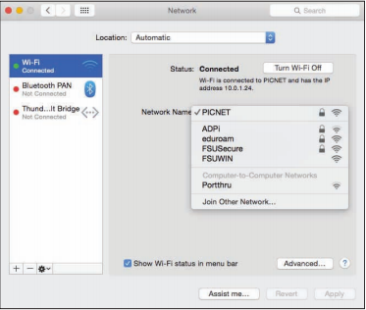
Courtesy of Apple, Inc. Fair Use

Consider the user in a small apartment who decides to set up a Wi-Fi network. Once the access point is set up, a dialog box appears on the owner’s computer with the message, “Network available, would you like to connect?” Easy, right? At the same time, the wireless-enabled computers of neighbors on either side of the user, as well as those upstairs and downstairs from the user, get a similar message. Now there are five users connected to the “private” home Wi-Fi network without the owner’s knowledge. This is a fundamental problem of Wi-Fi networks.

Neighbors may find it hard to resist free wireless network access when a pop-up message offers it. But there are other intruders who go out looking for open wireless networks. War driving is the act of driving through neighborhoods with a wireless notebook or handheld computer looking for unsecured Wi-Fi networks. Homemade war-driving kits include high-powered antennae attached to the vehicle roof, a long-lasting power supply for the computer, software such as NetStumbler that probes and scans for networks, and sometimes a GPS receiver to mark coordinates that can be shared with others over services on the web. The legality of war driving is questionable. While accessing unprotected wireless networks that owners have left open may be regarded as legal (but perhaps unethical), working to gain unauthorized access to a secured wireless network is definitely against the law.

Another common hacker trick is to set up a computer to masquerade as a free Wi-Fi network in a public space. When nearby users connect to the “network,” all of the data they send and receive can be accessed by the hacker, including passwords.

So, how can Wi-Fi network owners keep neighbors and war drivers off their private networks? Access points provide several settings that can all but bulletproof a wireless network. The access point configuration settings are accessed using an app or web browser on a network-connected computer. The web address and the password are provided in the access point’s owner’s manual. The following steps combine to offer sufficient protection for most wireless home networks:
- Change the default password for your access point to something unique.
- Add encryption to your network communications through settings on your router, preferably WPA2 encryption.
- Set your router to connect only to the MAC addresses of approved devices.
- Set your access point so it does not automatically broadcast its existence.
- When away from home, protect your wireless devices and the information they hold by following these tips:
- Avoid sending private information like passwords and credit card numbers over public Wi-Fi networks.
- Do not connect to unknown, unsecured access points in public places.
- Turn off any “auto-connect” option for connecting to wireless networks.
- Make sure that the data on your PC is not set to be readable to others on the network and that all sharing services are disabled.
- Do not accept network connection requests from users who may attempt to access your PC.
- Make sure that Bluetooth is set so that it is not “Discoverable” or “Visible” to others. Bluetooth can be used to hack onto smartphones and computers.

Lesson 16.3: Internet Security

Lesson 16.3 Introduction

"Security" by Got Credit is licensed under CC BY 2.0

Internet security refers to the unique threats and defenses associated with computers connected to the Internet.

The Internet is the most popular resource for information, communication, and digital services, and it is also the most dangerous. Criminals long ago discovered that it is much easier and safer to commit crimes in cyberspace than it is in physical space, and they have devised a wide array of traps, scams, and attacks. Internet threats and defenses become more advanced and complex every day. Internet users must learn how to protect themselves online for their own security, the security of the businesses they work for, and that of the countries in which they reside. It is likely that an unprotected PC, when connected to the Internet, will be attacked and infected within minutes.

Expanding a connection from a local area network to the Internet is akin to moving from a small town to downtown Manhattan. While your access to information is dramatically increased, so is your exposure to risk. When a computer is connected to the Internet, it becomes visible to billions of Internet users and a target to millions of attacks.

Internet connections are not a one-way street. Just as you can request information and services from servers, so too can intruders attempt to access information and services from your computer. On the Internet, everyone is just a number—an Internet (IP) address. An address such as 128.186.88.100 could be a web server, an email server, or your PC. Although you may be anonymous, your computer’s IP address is registered and known to others.

Attacks against Internet-connected computers can come in the form of direct attacks by hackers (system penetration), through malware like viruses and worms, or via spyware obtained through email, the web, or downloaded files. Internet users are also at risk of being manipulated through scams.

The four pillars of Internet security are: 1) use a firewall, 2) install software updates 3) use security software, and 4) practice safe, cautious online behavior. The checklists below provide a more detailed list of safe and secure behaviors and can be used as a quick reference to the material in this section.

Applying Software Security Tools Checklist
- Set your operating system to update automatically.
- Install or activate antivirus and antispyware software.
- Install or activate firewall software.
- Make sure that all security, antivirus, firewall, and antispyware software is set to update automatically.
- Use backup software to back up important data files automatically on a regular schedule.
- Use a security suite, such as BitDefender, McAfee Total Protection, Norton Security, or Sophos Anti-Virus for Mac, to manage all of the above.
- Install web browser security updates as soon as they are released.
- Use encryption to protect private files stored on your computer, to secure web transactions, and to secure wireless networks.
- When connected to a network, make sure that user permissions are set to share only the files you wish to share.
- If you use a home wireless network, disable SSID broadcasting on the access point, change passwords on the access point, and set it to connect with only specific MAC addresses.
- Turn Bluetooth off (set to undiscoverable) unless using it.
- Windows users can consider using Windows cleaner software to maintain the Windows Registry.
- Use spam filters on your email.

Maintaining Safe and Vigilant Online Behaviors Checklist
- Don’t type private information when connected to a public wireless network.
- Select strong passwords carefully and change them regularly.
- Do not open email attachments unless expected and scanned for viruses.
- Do not click links received in emails, text messages, or social network messages unless you are certain they are authentic and safe.
- Examine web addresses closely to make sure that they are legitimate and include https:// for forms.
- Avoid P2P file-sharing networks.
- Avoid websites set up for unethical, immoral, or indecent purposes.
- Do not allow websites to install software on your computer, unless you are certain the website is legitimate.
- Keep your computer system well organized and up to date using the housecleaning tips provided in this section.

Reading: Hacker
A hacker is an individual who subverts computer security without authorization.

Courtesy of Darren Kitchen. Fair Use

Why This Matters
In the battle between Internet users and those who attack them, it is valuable to understand the motivation of the enemy. Learning about criminal hackers, why they hack, and what tools they use enables Internet users to defend against attacks more effectively.

Essential Information
A hacker subverts computer security without authorization. Security professionals refer to this as system penetration. In reality, there are many names used to label those who unlawfully hack into secure computers and networks. The news media generally uses the term hacker. Hackers and others who wish to differentiate between law breakers and innocent techies use the term cracker, for criminal hacker, claiming that hackers do not necessarily break laws. Those in the information security industry tend to prefer the labels attacker and intruder.

Types of Hackers
Hacker | Description
Black-hat hacker | A hacker who takes advantage of security vulnerabilities to gain unlawful access to private networks for unethical purposes
White-hat hacker | An individual who considers himself/herself to be working for the common good by hacking into networks in order to call attention to flaws in security so that they can be fixed
Gray-hat hacker | A hacker of questionable ethics
Script kid or Kiddie | A person with little technical knowledge who follows the instructions of others to hack networks
Hacktivist | A hacker who hacks networks for a social cause or perceived greater good

Notice that there are ranges of ethics embraced by varying types of hackers. Not all hackers are considered unethical. Many hackers simply enjoy re-engineering technologies and gadgets so that they perform differently than originally intended. Make magazine is a publication geared toward this type of hacking. Other hackers experiment with cyberattacks and hacks so that they can better protect computer systems. This is the philosophy behind the popular hacking/security podcast Hak5. Often the line between hacking as an exploratory hobby and breaking the law is difficult to define. Some hackers are drawn over that line and face serious consequences for their crimes.

Makezine. Fair Use

Over the history of the Internet, hacking migrated from a hobby to a money-making profession. Hackers have increasingly gained access to systems for the purpose of taking control and selling access to hacked computers for illegal activities, such as sending illegal spam or launching denial-of-service attacks. In 2011, that trend took a dramatic turn towards hacktivism. Hacker collectives like Anonymous began hacking systems for perceived righteous causes. They targeted businesses and government organizations perceived by the hackers as evil. They exposed large numbers of confidential records online through websites like WikiLeaks. They did not profit financially from their exploits, but instead embarrassed companies and governments and proved that no network is safe from hackers. In 2012 and 2013, global attention was turned to cyberwarfare and espionage, where one-fifth of all cyberattacks were government sponsored. Cyberwarfare and espionage have been a growing area of government investment ever since.

Hackers have many tools at their disposal for finding vulnerable computers and gaining access to them. Attacks may also be automated in the form of malware viruses, worms, and spyware. These methods of attack can achieve many of the goals of common attacks without the need for directly manipulating a system. The following table describes some tools in the hacker’s arsenal.

Hacking Tools
Tool | Description
Key-logging software | Software installed on a computer to record all keystrokes and commands. The recording is later collected from a remote computer over the Internet and played back in order to spy on the user’s actions and sometimes to steal usernames and passwords.
Packet-sniffing software | Software that captures and analyzes all packets flowing over a network or the Internet. It can be programmed to look for personal information such as passwords and credit card numbers.
Wireless network scanning software | Software used to locate unprotected wireless networks. Once found, a hacker will try to connect to it. If unable to connect to it, wireless sniffing software can be used to capture the information being sent over the network. Encryption hacking software can be used to break common forms of encryption used on wireless networks.
Port-scanning software | Software that searches random IP addresses for open ports. Port-scanning software is allowed to run continuously, allowing the attacker to collect a list of IP addresses waiting to be hacked.
Social engineering | A technique that uses social interactions to manipulate individuals to give up personal information. For example, a social engineer might phone a person, pretending to be a system administrator in order to get that person to provide a password. A social engineer may even go dumpster diving—that is, rummaging through trash to steal credit card numbers or other personal information.

Reading: Firewall
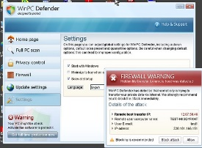
"My Virus Infected Computer" by koolkat_one is licensed under CC BY 2.0

A firewall is network hardware or software that examines data packets flowing in and sometimes out of a network or computer in order to filter out packets that are potentially dangerous.

Why This Matters
Hackers attempt to access your computer dozens of times every day. Hacker tools allow them to continuously cruise the Internet, checking computers for an open port that can be used to gain access. A firewall slams the door in hackers’ faces, turning away probes and hack attempts. A firewall can also prevent infected computers from operating under the control of a hacker. Using a firewall is one of the four pillars of information security, the others being installing software patches, using security software, and practicing safe, cautious online behavior.

Essential Information
A firewall is implemented either through the software running on a computer or through hardware such as a network router. For personal computers, firewall software is typically used and can be enabled in system security settings. Networks typically use software as well, but some larger networks employ a hardware firewall—a device connected to the network at the point where it joins the Internet. Whether implemented through software or hardware, a firewall protects all the ports of a network or PC from intruders and guards against known methods of attack.

A standard firewall checks all incoming data packets and rejects packets that are defined as dangerous or undesirable. Microsoft Windows, Mac OS, and some Linux distributions include a firewall utility. Users not using a firewall should enable the firewall as soon as possible.

Users looking for a more powerful firewall can find plenty to choose from online. Some firewalls include the ability to check outgoing as well as incoming packets. The purpose of checking outgoing packets is to keep zombie computers from carrying out the will of hackers. Zombie computers are infected computers that are being used in a botnet to attack other computers or send spam. There are millions of zombie computers on the Internet today. Using firewalls that check outgoing packets reduces online infections and spam considerably.

It is even more important to use firewalls on networks than on PCs. A firewall is installed at the point that the network connects to the Internet to protect the entire network from infection and attacks. It is a good idea to use a firewall that checks both incoming and outgoing packets because infected computers are hard to identify on a network. Network firewalls also provide settings that allow the administrator to filter particular types of network activities. For example, a campus network administrator might use a firewall to block access to P2P networks. Firewalls are also used by some governments, Internet service providers, and businesses to censor data that may not be dangerous but may be undesirable.

Reading: Software Update
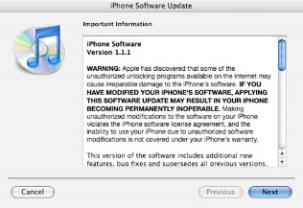
"iPhone 1.1.1" by mysistersabarista is licensed under CC BY 2.0

A software update, sometimes called a security patch, fixes software bugs and flaws and is typically distributed to software users through online software updates.

Why This Matters
Although software vendors do their best to develop secure and bug-free software, the high degree of complexity in today’s software makes it very difficult to achieve perfection. As flaws are discovered, software vendors provide updates to users that include patches to correct the bugs and flaws.

Essential Information
Software bugs in operating systems, web browsers, and other Internet software can create security holes that hackers may exploit to gain full control of a computer. These are called critical software flaws and should be patched as soon as possible to keep computers and data safe. Software updates are one of the four pillars of information security, the others being using a firewall, using security software, and practicing safe, cautious online behavior.

Most software companies offer free and regular software updates for their products. Software updates are distributed to customers over the Internet, and the process of applying them is typically automatic. Many programs use the Internet to check periodically to see if an update is available. When an update is discovered, it may be downloaded automatically or the user may be prompted to download it. In either case, the user is then asked to click to install the update.

One of the great benefits of cloud computing is that it removed the burden of software updates from users. For online software like Google Docs and Microsoft Office 365, the software company—Google or Microsoft in these cases— fixes software bugs as they are discovered, often without users ever noticing the bug.

Users are wise to set their operating system to update automatically, whenever updates become available. It takes hackers less than 24 hours after a security hole is identified, to design a method of exploiting the vulnerability. When an update is released, it becomes a race between users applying patches and hackers seeking to exploit the vulnerability.

Mobile devices including iPhones, iPads, Windows phones, and Android devices are also targets for hackers. Many Android phones have been infected with malware from free apps in Google Play and other app stores. It’s important to keep mobile device software updated to protect the devices from attacks.

It is particularly important to patch operating systems, web browsers, browser plug-ins, and other network and Internet software as soon as updates are available. The vast majority of hacker exploits take advantage of the security holes in Internet software. Keeping this software up to date and using firewall software are two of the most important steps to take to ensure information security.

Reading: Malware
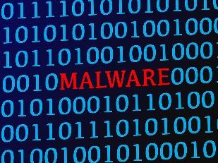
"Rotes Wort MALWARE (Schadsoftware) in blauem Binärcode aus 1 und 0 auf Bildschirm" by verchmarco is licensed under CC BY 2.0

Malware is short for “malicious software” and includes any software designed to damage, corrupt, or illegally manipulate computer resources. Common forms include viruses, worms, and spyware.

Why This Matters
Cyberattacks can take the form of software that is distributed and executed on a computer without the user’s knowledge for the purpose of corrupting or disrupting systems, stealing information, or using the system to launch further attacks. The most common of these malware programs are viruses, worms, and spyware.

Essential Information
A virus is a program that attaches itself to a file, spreads to other files, and delivers a destructive action called a payload. The payload could be the corruption of computer data files or system files, resulting in the loss of data or a malfunctioning computer. There are many different types of viruses. A worst-case scenario for damage would be the total loss of data and software. Viruses do not harm computer hardware or cause users to have to buy a new computer. Recovery might involve wiping the hard drive of all files to remove all infection, reinstalling the operating system and all software, and restoring data files from backup.

Viruses are sometimes delivered through a technique called a Trojan horse, or just a Trojan. Like the Trojan horse in Greek mythology, these Trojan horses appear to be harmless programs, but when they run, they install other programs on the computer that can be harmful. A backdoor Trojan opens up ports (back doors) on the computer to allow access to intruders. This type of virus distribution is common on Android mobile devices. A hacker loads a virus in a legitimate and desirable-looking app, posts it in an app store, and just waits for gullible users to download and install it so the virus can infect the device. While Google works to minimize dangerous apps in its Play Store, there are many other sources for Android apps online where anyone can post apps for download.

One form of malware called ransomware uses encryption to hold the user’s data captive until a ransom is paid. For example, Ransom-A, one of the first ransomware Trojans, encrypted the user’s data files and demanded $10.95 to be paid through Western Union. It threatened to delete a file every 30 minutes until the ransom was received.

A worm does not attach itself to other programs but instead acts as a free agent, replicating itself numerous times in an effort to spread to other computers or overwhelm systems. For example, within 10 minutes of its introduction, the Slammer worm had attacked more than 75,000 computers. Thirty minutes later, some believe the worm had disrupted one in five data packets sent over the Internet.

In 2010, the world saw the first worm that experts believe was designed for cyberwarfare. The Stuxnet worm was an extremely sophisticated piece of code, designed to attack industrial software and equipment. More specifically, the worm appears to have been designed to attack the centrifuges used to enrich uranium at a nuclear power plant in Iran.

Spyware is software installed on a computer without the user’s knowledge, either to monitor the user or to allow an outside party to control the computer. Spyware is so prolific that any computer that spends time on the web, if not protected, has probably contracted it. Spyware differs from viruses and worms in that it does not self-replicate. Spyware is often used for commercial gain by displaying pop-up ads, stealing credit card numbers, distributing spam, monitoring web activity and delivering it to businesses for marketing purposes, and hijacking the web browser to show advertising sites.

Spyware is distributed by deceiving the user into installing it by hiding it in legitimate apps, email attachments, webpages, or other online resources. Spyware is often installed by a virus or worm. Once on a system, spyware runs in the background, unknown to the user, carrying out the wishes of its creator. Spyware can communicate with its creator over the Internet.

Google believes that more than 5 percent of all users have at least one ad injector knowingly or unknowingly installed on their operating systems, according to a research report from Google and the University of California-Berkeley. Often simply unwanted—but sometimes outright malware—ad injector software inserts additional or replacement advertising into sites during online browsing.

A computer that carries out actions (often malicious) under the remote control of a hacker, either directly or through spyware or a virus, is called a zombie. Thousands of computers are added to the ranks of zombies each week. Zombie computers can join together to form zombie networks, or botnet armies. Botnet armies apply the power of multiple PCs to overwhelm websites with distributed denial-of-service attacks, to crack complicated security codes, or to generate huge batches of spam. It has been estimated that a very high percentage of spam originates from zombie computers.

The goal of the malware engineer is to get the user to run the software that installs the malware. Although sending malware as email attachments used to be the preferred method of distribution, today most malware is spread from webpages. A common trick is to infect a website so that when users visit the site, a pop-up instructs them to install a software update. Instead of legitimate software, malware is installed on the user’s PC. Even worse, in drive-by downloads, users aren’t even prompted to download the software. Just visiting the site infects their computer. By distributing the link to an infected website through social media or email, millions of computers can be infected. Once infected, a PC can then act as the attacker and spread malware to other PCs, either over a network or through email, social networks, instant messaging systems, shared files, or webpages (if the infected machine is a web server). Good antivirus software protects a computer from the vast majority of these types of attacks.

Sometimes, rumors of nonexistent viruses and virus hoaxes spread online. These may be an effort by hackers to get users to take unsafe actions in order to infect their devices. When you hear about a virus, it’s always a good idea to check it out online using Google and by visiting the websites below prior to taking any action. If a website pops up a message saying your computer is infected, it is most likely an effort to get you to download illegitimate “virus protection” software actually intended to infect your device.

Reading: Antivirus Software
Antivirus software, also known as virus protection software, uses several techniques to find malware on a computer system; remove it if possible; and keep additional malware from infecting the system.

Why This Matters
Implementing some form of virus protection is a necessity on all types of PCs: Windows and Macs. Without some form of virus protection, it is almost assured that an Internet-connected PC is—or will soon become—infected. Antivirus software is one of the four pillars of information security, the others being firewalls, software patches, and safe, cautious online behavior.

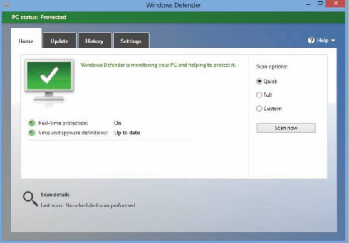
Courtesy of Microsoft Corporation. Fair Use

Essential Information
The number-one tool against malware, including viruses, worms, and spyware, is antivirus software. Antivirus software is only effective if it is continuously running to guard against attacks and if it is continuously updated with new virus information as it becomes available. For this reason, antivirus software, such as BitDefender, McAfee Total Protection, Norton Security, or Sophos Anti-Virus for Mac —which update automatically when necessary—are preferred. Antivirus software is often packaged with firewall software, backup software, and other security tools as a security software suite that covers all aspects of computer security. Most importantly, antivirus software can protect you from drive-by downloads and unsafe websites designed to infect your computer.

In addition to using antivirus software, knowledge and caution play a big part in protecting PCs against viruses and worms. Follow these practices to protect your PC from malware:
- Don’t open email or IM attachments that come from friends or strangers unless they are expected and inspected by antivirus software.
- Keep up with software patches and updates for your operating system, your web browser, your email software, and your IM software.
- Avoid clicking links sent to you through email or sent to you through text messages or social networks.
- Use caution when exploring websites created and maintained by unknown parties.
- Avoid downloading software or plug-ins from websites created and maintained by unknown parties.
- Avoid any software from untrusted sources.
- Be cautious if you use P2P file-sharing networks; they do not effectively protect users from dangerous files that are being swapped.
- Don’t download antivirus software when prompted to do so in an email or on the web—it’s often a ploy to get you to install malware.

Reading: Botnet
A botnet, or botnet army, refers to a collection of computers autonomously or automatically working together toward some goal; these are often zombie computers that are synchronized to perform illegal activities on the Internet.

Why This Matters
Botnets harness the power of hundreds of thousands of compromised computers to carry out monumental attacks over the Internet. Computers are drafted into botnet armies through the use of malware. It is possible that your computer is a soldier in a botnet army. Understanding botnets will help you to free your computer if it has been enslaved and protect your computer from becoming a zombie.

Essential Information
Millions of computers on the Internet are leading double lives. They service their users as usual without any indication that anything is amiss while they simultaneously live secretive second lives as zombie computers working in botnet armies. The Kraken botnet was one of the world’s earliest and largest in 2008, with more than 400,000 zombies carrying out its commands. It is estimated that Kraken uses its zombies to crank out more than 9 billion spam email messages per day. Another botnet, Storm, at its height in early 2008, was believed to control as many as a million computers. The ZeroAccess botnet, sometimes known as Sirefef, infected more than 2 million computers and cost online advertisers an estimated $2.7 million per month in 2013. More recently, botnets progressed from utilizing people’s computers to utilizing devices on the Internet of Things. In late 2016, a massive cyberattack took out huge swaths of the Internet throughout the U.S. by exploiting a security hole in Internet-connected devices such as security cameras.

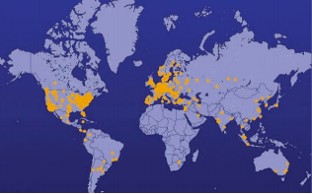
The Shadowserver Foundation. Fair Use

Devices are drafted into botnet armies when they are infected with malware. A computer under the control of an outside party working in a botnet is referred to as a zombie computer. Botnet armies are controlled by botnet command and control (C&C) servers that disperse the commands of the hackers who created them. The Shadowserver Foundation maintains a map of C&C servers worldwide that is updated daily (see figure). Botnet armies are used to distribute spam, viruses, and worms. They are also used in distributed denial-of-service attacks (DDoS) in which many computers simultaneously access a web server, making it impossible for the server to respond to legitimate requests.

The power of a botnet can surpass that of today’s most powerful supercomputers. With that kind of power, a botnet can be used to crack encryption codes and hack accounts through brute force methods. Botnet owners lease out their botnets for all kinds of online jobs. Botnet armies are a major tool in cyberwarfare. In 2007, a botnet was used to bring down the information infrastructure of the country of Estonia, in an act that the country viewed as a military attack. Since then, botnets have been behind many major outages in businesses and government agencies.

Reading: Cyberwarfare
"67718" by Catalyst Research Institute is licensed under CC PDM 1.0

Cyberwarfare extends traditional forms of warfare to the Internet and the web, including espionage, psychological warfare, and attacks.

Why This Matters
Heavy dependence on information technologies and the Internet creates a significant vulnerability for individuals, businesses, and governments. Those wishing to harm a population for political or ideological reasons may use information systems as tools in their quest and may target information systems in order to disrupt the lives of their enemies. In this manner, the Internet has become a primary tool for terrorism and international attacks.

Essential Information
Attacks over the Internet are a serious and well-known threat to nations. All of the major world powers invest significantly in guarding their online resources—including government servers that contain confidential information—and their critical national infrastructure, such as hospitals, utilities, transportation, and commerce. The U.S. Pentagon has stated that the United States reserves the right to retaliate with military force against a cyberattack and is working to sharpen its ability to track down the source of any breach. U.S. intelligence officials have accused China and Russia of systematically stealing American high-tech data for their own national economic gain. Attacks originating in China against the U.S. and its allies, and China’s complaints of being attacked by Western governments, have become so numerous that some are calling it a cyber cold war.

Smaller countries, including North Korea and Iran, have turned to cyberwarfare as a primary offensive against the U.S. and other Western countries. When it comes to cyberwarfare, the physical size of a country and its armed forces doesn’t matter.

Terrorist organizations such as al-Qaeda have made effective use of the Internet and the web for promoting their causes, recruiting new members, and terrorizing populations. There is no doubt that such terrorist organizations are also seeking to use the Internet to harm their enemies through hacking and attacking online. Cyberterrorism extends traditional forms of terrorism to the Internet and the web.

The United States Computer Emergency Readiness Team (US-CERT) was established to monitor the security of U.S. networks and the Internet and to respond to cyberwarfare and cyberterrorism. US-CERT is part of the National Cybersecurity Division of the United States Department of Homeland Security. The US-CERT website, www.us-cert.gov, gives network administrators and computer users up-to-date information on security threats and defenses. A new branch of the Pentagon has been established to defend the U.S. against cyberattacks. The Pentagon’s Cyber-Security unit is the fastest growing unit in the U.S. Department of Defense, with plans to grow from 900 on staff to more than 4,000 over the next few years.

Fighting international cyberattacks is difficult as there are currently no global cybercrime laws. The laws of one country cannot be enforced in another without the cooperation of both governments. A computer attack may be designed by hackers in country A and launched in country B to attack computers in country C. Some countries are discussing the establishment of a global cyber-crime task force, similar to the INTERPOL international police network. One step in that direction was the Council of Europe’s convention on cybercrime in 2001 and its more recent Dialogue on Internet Governance (EuroDIG). The convention on cybercrime produced a treaty that calls on countries to work together to create international laws that address cybercrime. Currently, over 49 countries have ratified the convention.

Just as traditional international warfare is governed by the Geneva Convention and other international treaties, cyberwarfare will soon be governed by its own set of international rules. The NATO Cooperative Cyber Defense Center of Excellence has produced a set of rules called the Tallinn Manual, named for the Estonian capital where it was compiled. The rules protect civilian targets such as hospitals, dams, and nuclear power stations. Hacking a dam’s computer controls to release its reservoir into a river valley is just as serious as breaching it with explosives, the authors argue, and should have similar rules and responses. They argue as well that medical computer systems should get the same protection that brick-and-mortar hospitals do.

Reading: Identity Theft
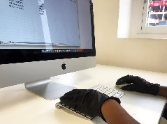
"An online fraudster commits online fraud or identity theft wearing black gloves" by Patrick Cannon Tax Barrister is licensed under CC BY 2.0

Identity theft is the criminal act of stealing information about a person to assume that person’s identity in order to commit fraud or other crimes.

Why This Matters
The U.S. Federal Trade Commission (FTC) receives hundreds of thousands of consumer fraud and identity theft complaints each year. Yearly losses to U.S. consumers total more than a billion dollars. Individuals between the ages of 18 and 29 are hardest hit by ID theft.

Essential Information
Using a person’s Social Security number (SSN), birth date, or other personal identifiers, an identity thief can apply for a new credit card in the victim’s name and have it delivered to a post office box. Identity thieves can make purchases on stolen credit card numbers, make bank withdrawals, apply for loans, or buy cars. The information could also be used for more serious crimes. For example, an illegal driver’s license might be created for use by a non-U.S. citizen to gain access to services and benefits provided only to citizens. The damage caused can be quite serious. An identity thief can also do damage to a victim’s reputation by perpetrating crimes under the victim’s identity.

Identity thieves use several methods to steal personal information. In a technique called dumpster diving, personal information can be found by going through someone’s trash. Store clerks and cashiers can steal customer credit card information when processing a sale. Phishing is a technique used to trick a person into providing personal information on a fake website that looks like a reputable website. Identity thieves might submit a change of address form for a victim in order to have personal information rerouted to their own post office box. Personal information is often stolen by stealing wallets and purses or by stealing database records from businesses. Social engineering is a technique that uses social interaction to manipulate individuals into giving up personal information. For example, a criminal may phone a system administrator, pretending to be someone else in order to get access to a network account. Criminals might also buy personal information from other thieves, using the dark web, sometimes referred to as the deep web—underground networks and marketplaces that exist on the Internet.

People can protect themselves from identity theft by being cautious with their personal information and by following these tips:
- Keep Social Security numbers private; be suspicious of anyone who asks for your SSN.
- Shred documents containing personal information prior to disposal.
- Use caution online and verify the ownership of websites that ask for personal information. Never trust links sent to you via email or other messaging services.
- Store personal information in secure locations, both in physical and digital formats.
- Use encryption to safeguard information that is stored on your computer and transmitted over networks.
- Opt out of services offered by online stores that want to store your personal information for faster checkout; each business that retains your credit card info is an additional target for hackers. Instead, utilize one central digital wallet to store your payment info such as PayPal, Apple Pay, Google Pay, or others.
- Be careful about storing digital copies of personal information on your own computer and in business and organization databases; keep these to a minimum.

Reading: Internet Fraud (3 min.)
"Wooden scrabble letters spell out fraud in a stock style photo" by Patrick Cannon Tax Barrister is licensed under CC BY 2.0

Internet fraud is the crime of deliberately deceiving a person over the Internet in order to damage them or to obtain property or services unlawfully.

Why This Matters
The FBI receives more than 200 million Internet fraud complaints each year. Hundreds of millions of dollars are stolen each year by online criminals. With increasing amounts of business taking place online, Internet fraud is more prevalent than ever. It is essential to be able to recognize common types of fraud in order to protect yourself against them.

Essential Information
The FBI and the Internet Crime Complaint Center collect data each year on cases of Internet-related fraud. A common form of Internet fraud is Internet auction fraud. Auction fraud involves being swindled by sellers or buyers on auction sites like eBay. Another common type of fraud is non-delivery of merchandise, which involves purchases from etailers that process the payment and never deliver the goods. There are numerous cases of credit card fraud and check fraud, where online customers use fraudulent checks or stolen credit card numbers to purchase items. There are also cases of phony loan company or bank websites that pretend to assist consumers with debt problems but really rob them blind.

The Nigerian letter fraud has been around for a long time. In this online scam, the victim receives an email from a prominent figure outside of the country asking for assistance, perhaps in the form of utilizing the victim’s bank account to store a large sum of money. Of course, the victim will be well compensated for the inconvenience. Although often the author of the message claims to be from Nigeria, there are many variations on the theme. Once the victim supplies a bank account number, that account is cleaned out.

Often, scammers set up fraudulent websites that appear legitimate but are actually covers for identity theft. Users may receive fraudulent emails inviting them to visit the phony website where they are asked to enter private information. Impersonating legitimate businesses on the web or in email is referred to as spoofing. Phishing scams utilize spoofed email and webpages to fool users into believing the source of the email is legitimate.

Facebook and other social networks have become major tools for fraudsters. Hacked accounts are used to trick friends into clicking links to fraudulent sites. Ads are also used to lure victims to fraudulent sites. Dating websites and Craigslist can also be used to lure victims into unsafe situations where fraud and even worse crimes are perpetrated.

Reading: Digital Certificate
A digital certificate, also called an SSL certificate, is a type of electronic business card that is attached to Internet transaction data to verify the sender of the data.

Why This Matters
Because so much of the information we send over the Internet is confidential, it is important that the identities of individuals, businesses, and organizations involved are positively verified. For example, consumers need to make sure that they are giving their credit card number to a legitimate and trustworthy business, and businesses need to confirm that the customer is the owner of the credit card being used. Transaction data must be accessed only by intended parties and not be intercepted by outsiders. Two technologies are available to assist individuals and businesses in meeting these goals: digital certificates and encryption.

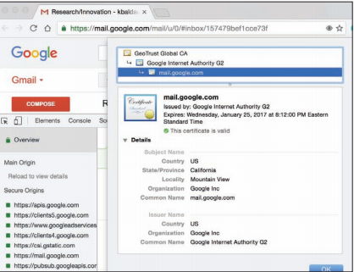
Google. Inc. Fair Use

Essential Information
Digital certificates are provided by certification authorities such as Symantec VeriSign and Thawte. They can be used to verify the sender of email and other forms of Internet communication. Digital certificates for use in encrypting web communications and credit card transactions cost the provider between $350 and $1,400, depending on the level of security and type of communications. Certificates cost more for ecommerce than for nonbusiness use. Digital certificates for personal email are provided by Thawte for free.

Digital certificate information can be accessed on any HTTPS page by clicking the lock icon in the status bar or by right-clicking the page and viewing its properties (Windows) or info (Mac). A digital certificate contains the owner’s name, a serial number, an expiration date, and a public key (see figure). The public key is used in encrypting messages and digital certificates. Encryption uses high-level mathematical functions and computer algorithms to encode data so that it is unintelligible to all but the intended recipient. Through the use of a public key (a large number) and a private key kept by the certification authority, an encrypted message can be decrypted back into its original state.

Digital certificates combined with Secure Sockets Layer (SSL) technology and a more recent version of SSL called Transport Layer Security (TLS) enable encrypted communications to occur between a web browser and web server. This combination of technologies is used to secure usernames, passwords, and credit card information when they are typed into a web form and sent to a web server. The presence of an SSL connection is usually indicated by a URL that uses https:// rather than http://. Also, a closed lock icon appears in the address line or status bar of the browser window when the connection is secure. New versions of browsers that support Extended Validation SSL go even further by showing a green background in the address bar for secure sites.

Reading: Phishing Scam

"Security-Stock-11078" by Hivint is licensed under CC BY 2.0

A phishing scam combines fraudulent email with faked websites in order to trick a person into providing private information that can be used for identity theft.

Why This Matters
There are many forms of Internet fraud designed to trick users into giving out private and valuable information. Phishing scams are some of the most difficult to detect. The more you know about the various types of phishing scams, the better protected you will be.

Essential Information
A phishing scam combines a spoofed email with a spoofed website in order to trick a person into providing private information. Spoofing is the act of impersonating a person, business, or organization on the web or through email. In a phishing scam, the hacker sends out mass emails (often using a botnet) that appear to come from a legitimate company, such as PayPal, a credit card company, or a bank. The email warns of some trouble with your account and provides a link that should be clicked to address the problem. The link may look safe—such as https://www.paypal.com/customer-service—but when you click it, it takes you to a different web address that looks just like the real PayPal login page, so you don’t notice a slightly different URL in the address box. The page looks like the PayPal page because the hacker copied the page exactly from PayPal to his or her own web server.

From this point in the phishing scam, a number of things can occur. Most commonly, the user logs in as requested. The hacker has then attained his goal of stealing the user’s login information. Then, the user may get a message like “Incorrect Password. Click here to try again.” When the user clicks to try again, the software may send the user to the login screen of the real website, where the user can log in without any trouble. The victim is totally unaware of the fraud or identity theft that has occurred.

In addition to stealing login information, and depending on how long the user can be strung along, phishing pages can also install spyware on a computer. The website www.antiphishing.org receives thousands of phishing reports each month.

Phishing tactics are getting more sophisticated. In an attack called spear phishing, private or personal information is used to target a specific individual. The fraudulent email received can be so convincing that it is impossible to guess that it isn’t a legitimate request.

In a bold scheme, several hacker tricks were combined to ultimately blackmail Monster.com users. Monster.com reported that information about 1.3 million job-seekers had been stolen from its servers. The usernames, email addresses, and other information stolen from Monster.com were used in a spear phishing scam. Each of the users received email that appeared to come from Monster.com, inviting the users to try a new “Monster Job Seeker Tool.” Those who took the bait ended up downloading ransomware that encrypted their files and demanded $300 to unlock them.

To protect yourself from phishing scams, avoid clicking links received in emails. Instead, type URLs directly into your web browser. Examine web addresses closely to make sure that they are legitimate and include an https:// for forms or a closed lock icon or green background in the address bar.

In the criminal act of pharming, hackers hijack a domain name system DNS) server to automatically redirect users from legitimate websites to spoofed websites in an effort to steal personal information. In pharming, a user may type www.paypal.com into the web browser address bar; but when the request is received at the DNS server, rather than routing the packets to the PayPal server, they are hijacked to the hacker’s web site. Pharming strikes a serious blow to the underlying architecture of the web as it is nearly impossible to detect. The ability of hackers to corrupt DNS computers could undermine the public’s faith in ecommerce and the Internet altogether.

Reading: Information Security Laws
Information security laws seek to protect the civil rights of populations from abuses of information systems and the Internet.

Why This Matters
Securing networks and the information they store takes effort by individuals, businesses, and governments. Information security is so important that the United Nations has taken an interest in managing it. The U.S. Whitehouse has also developed a Comprehensive National Cybersecurity Initiative (CNCI) to establish a front line of defense against threats to the national infrastructure.

Essential Information
A number of U.S. laws have been created for the purpose of securing information and protecting privacy. The following table lists the most important such laws.

U.S. Information Security Laws
Law | Description
Consumer Internet Privacy Protection Act of 1997 | Requires data collectors to alert people that their personal information is being shared with other organizations
Children’s Online Privacy Protection Act of 2000 | Gives parents control over what information is collected from their children online and how such information may be used
Information Protection and Security Act of 2005 | Gives the Federal Trade Commission (FTC) the ability to regulate the sale of personal information
Notification of Risk to Personal Data Act of 2003 | Requires businesses to notify individuals when their personal information is stolen
Identity Theft Protection Act of 2005 | Requires businesses to secure sensitive data physically and technologically and to notify consumers nationwide when data is compromised
Health Insurance Portability and Accountability Act (HIPAA) of 1996 | Requires those in the health industry to protect the privacy of health information and provides policies and procedures for doing so
Sarbanes-Oxley Act (“Sarbox”) of 2002 | Fights corporate corruption by imposing stringent reporting requirements and internal controls on electronic financial records and transactions
Gramm-Leach-Bliley Act (GLBA) of 1999 | Requires banks and financial institutions to alert customers of their policies and practices in disclosing customer information

